Hasil Analisis SPSS Penetapan KGD Puasa
- Uji Normalitas Kadar Glukosa Darah
NPar Tests
[DataSet1] E:\Hasil TESIS\SPSS Kadar Gula Darah_2.sav
One-Sample Kolmogorov-Smirnov Test
 |  | HariPraInduksi | HariPostInduksi | HariKe14 | HariKe28
N |  | 32 | 32 | 32 | 32
Normal Parametersª | Mean | 87.7650 | 364.8378 | 264.5625 | 173.3797
 | Std. Deviation | 8.72980 | 118.76705 | 1.12846E2 | 99.22775
Most Extreme Differences | Absolute | .182 | .201 | .139 | .239
 | Positive | .117 | .113 | .139 | .239
 | Negative | -.182 | -.201 | -.100 | -.163
Kolmogorov-Smirnov Z |  | 1.032 | 1.140 | .785 | 1.352
Asymp. Sig. (2-tailed) |  | .237 | .149 | .569 | .052
a. Test distribution is Normal.

Hipotesis:
Sig. < 0,05 : distribusi data tidak normal (data tidak terdistribusi normal)
Sig. > 0,05 : distribusi data normal (data terdistribusi normal)

Hasil Uji Distribusi Kolmogorov-Smirnov menunjukkan bahwa nila Sig. > 0,05, maka data KGD terdistribusi normal pada semua hari sampling.

- Uji Homogenitas Kadar Glukosa Darah
Oneway
Test of Homogeneity of Variances
 | Levene Statistic | df1 | df2 | Sig.
HariPraInduksi | 1.968 | 7 | 24 | .102
HariPostInduksi | 5.011 | 7 | 24 | .001
HariKe14 | 1.575 | 7 | 24 | .191
HariKe28 | 5.254 | 7 | 24 | .001

Hipotesis:
Sig. < 0,05 : data tidak homogen
Sig. > 0,05 : data homogen

Hasil Uji Distribusi Kolmogorov-Smirnov menunjukkan bahwa nila Sig. > 0,05, maka data KGD homogen pada hari pra-induksi dan hari ke-14, sedangkan pada hari post induksi dan hari ke-28 data tidak homogen.

Data terdistribusi normal namun tidak semua homogen, sehingga dilakukan uji lanjutan (Uji Statistika Duncan) untuk memperoleh kesimpulan signifikansi perbandingan tiap kelompok uji.
Hasil uji anova menunjukkan bahwa terdapat perbedaan yang bermakna (sig < 0,05) antar hari perlakuan uji.
ANOVA
 |  | Sum of Squares | df | Mean Square | F | Sig.
HariPraInduksi | Between Groups | 313.804 | 7 | 44.829 | .525 | .807
 | Within Groups | 2048.688 | 24 | 85.362
 | Total | 2362.492 | 31
HariPostInduksi | Between Groups | 341963.335 | 7 | 48851.905 | 12.301 | .000
 | Within Groups | 95310.647 | 24 | 3971.277
 | Total | 437273.982 | 31
HariKe14 | Between Groups | 299844.249 | 7 | 42834.893 | 10.831 | .000
 | Within Groups | 94915.143 | 24 | 3954.798
 | Total | 394759.392 | 31
HariKe28 | Between Groups | 275431.509 | 7 | 39347.358 | 31.690 | .000
 | Within Groups | 29799.039 | 24 | 1241.627
 | Total | 305230.548 | 31

- Hasil Uji Duncan
HariPraInduksi
KelompokTikus |  | N | Subset for alpha = 0.05
 |  |  | 1
Duncanª | Perlakuan 1 | 4 | 82.5750
 | Perlakuan 2 | 4 | 85.2700
 | Perlakuan 3 | 4 | 85.4825
 | Kontrol Positif | 4 | 86.8975
 | Kontrol Normal | 4 | 88.4550
 | Perlakuan 5 | 4 | 89.8000
 | Kontrol Negatif | 4 | 90.8650
 | Perlakuan 4 | 4 | 92.7750
 | Sig. |  | .188

Hasil Uji Post Hoc Duncan pada hari Pra-Induksi menunjukkan tidak terdapat perbedaan yang bermakna antar kelompok uji (Sig>0,05).

HariPostInduksi
Duncan
KelompokTikus | N | Subset for alpha = 0.05
 |  | 1 | 2
Kontrol Normal | 4 | 94.7575
Perlakuan 1 | 4 |  | 389.3775
Perlakuan 2 | 4 |  | 391.1475
Kontrol Positif | 4 |  | 392.0000
Perlakuan 4 | 4 |  | 396.5300
Perlakuan 5 | 4 |  | 399.7175
Perlakuan 3 | 4 |  | 413.1025
Kontrol Negatif | 4 |  | 442.0700
Sig. |  | 1.000 | .312
Means for groups in homogeneous subsets are displayed.
Hasil Uji Post Hoc Duncan pada Hari Post Induksi, menunjukkan bahwa terdapat perbedaan yang bermakna antara kelompok Normal dengan kelompok yang diinduksi STZ (Sig < 0,05).

HariKe14
 | KelompokTikus | N | Subset for alpha = 0.05
 |  |  | 1 | 2 | 3
Duncanª | Kontrol Normal | 4 | 1.1282E2
 | Kontrol Positif | 4 | 1.2613E2
 | Perlakuan 4 | 4 |  | 2.3838E2
 | Perlakuan 1 | 4 |  | 2.9235E2
 | Perlakuan 2 | 4 |  | 2.9908E2
 | Perlakuan 3 | 4 |  | 3.0092E2
 | Perlakuan 5 | 4 |  | 3.2288E2
 | Kontrol Negatif | 4 |  |  | 4.2394E2
 | Sig. |  | .767 | .100 | 1.000
Means for groups in homogeneous subsets are displayed.
a. Uses Harmonic Mean Sample Size = 4.000.
Hari ke-14 menunjukkan terdapat perbedaan yang bermakna (sig<0,05) antara kelompok kontrol negatif dengan kelompok perlakuan.

HariKe28
 | KelompokTikus | N | Subset for alpha = 0.05
 |  |  | 1 | 2 | 3
Duncanª | Kontrol Normal | 4 | 88.7400
 | Kontrol Positif | 4 | 1.2167E2 | 1.2167E2
 | Perlakuan 5 | 4 | 1.2769E2 | 1.2769E2
 | Perlakuan 4 | 4 |  | 1.4589E2
 | Perlakuan 2 | 4 |  | 1.5680E2
 | Perlakuan 1 | 4 |  | 1.6112E2
 | Perlakuan 3 | 4 |  | 1.7564E2
 | Kontrol Negatif | 4 |  |  | 4.0949E2
 | Sig. |  | .152 | .066 | 1.000
Means for groups in homogeneous subsets are displayed.
a. Uses Harmonic Mean Sample Size = 4.000.
Hari ke-28 menunjukkan terdapat perbedaan yang bermakna (sig<0,05) antara kelompok kontrol negatif dengan kelompok perlakuan.
- Hasil Uji Repeated Measure
Pairwise Comparisons
Measure:KadarGlukosaDarah
(I) Waktu | (J) Waktu | Mean Difference (I-J) | Std. Error | Sig.ª | 95% Confidence Interval for Differenceª
 |  |  |  |  | Lower Bound | Upper Bound
1 | 2 | -277.073* | 20.879 | .000 | -319.655 | -234.491
 | 3 | -176.798* | 20.040 | .000 | -217.669 | -135.926
 | 4 | -85.615* | 17.451 | .000 | -121.206 | -50.024
2 | 1 | 277.073* | 20.879 | .000 | 234.491 | 319.655
 | 3 | 100.275* | 21.587 | .000 | 56.249 | 144.302
 | 4 | 191.458* | 21.418 | .000 | 147.777 | 235.140
3 | 1 | 176.798* | 20.040 | .000 | 135.926 | 217.669
 | 2 | -100.275* | 21.587 | .000 | -144.302 | -56.249
 | 4 | 91.183* | 16.555 | .000 | 57.418 | 124.948
4 | 1 | 85.615* | 17.451 | .000 | 50.024 | 121.206
 | 2 | -191.458* | 21.418 | .000 | -235.140 | -147.777
 | 3 | -91.183* | 16.555 | .000 | -124.948 | -57.418
Based on estimated marginal means
*. The mean difference is significant at the .05 level.
a. Adjustment for multiple comparisons: Least Significant Difference (equivalent to no adjustments).
Hipotesis:
Sig. < 0,05 : terdapat perbedaan yang bermakna
Sig. > 0,05 : tidak terdapat perbedaan yang bermakna
Hasil uji repeated measure menunjukkan terdapat perbedaan yang bermakna pada data KGDP antar hari perlakuan (1: prainduksi; 2: post induksi; 3: hari ke-14; 4: hari ke-28)

Lampiran 30.Hasil Analisis SPSS Penimbangan Berat Badan Tikus
- Uji Normalitas Berat Badan Tikus
NPar Tests
One-Sample Kolmogorov-Smirnov Test
 |  |  | HariPraInduksi | HariPostInduksi | HariKe14 | HariKe28
N |  |  | 32 | 32 | 32 | 32
Normal Parametersª | Mean |  | 204.6313 | 200.7125 | 196.7969 | 202.6625
 | Std. Deviation |  | 23.80262 | 15.16621 | 30.47708 | 29.15352
Most Extreme Differences | Absolute |  | .109 | .131 | .095 | .082
 | Positive |  | .082 | .094 | .081 | .077
 | Negative |  | -.109 | -.131 | -.095 | -.082
Kolmogorov-Smirnov Z |  |  | .615 | .741 | .537 | .466
Asymp. Sig. (2-tailed) |  |  | .844 | .642 | .935 | .981
a. Test distribution is Normal.
Hipotesis:
Sig. < 0,05 : distribusi data tidak normal (data tidak terdistribusi normal)
Sig. > 0,05 : distribusi data normal (data terdistribusi normal)

Hasil Uji Distribusi Kolmogorov-Smirnov menunjukkan bahwa nila Sig. > 0,05, maka data Berat Badan Tikus terdistribusi normal pada semua hari sampling.

- Uji Homogenitas Berat Badan Tikus
Oneway
Test of Homogeneity of Variances
 | Levene Statistic | df1 | df2 | Sig.
HariPraInduksi | 1.433 | 7 | 24 | .238
HariPostInduksi | 1.594 | 7 | 24 | .185
HariKe14 | 1.261 | 7 | 24 | .311
HariKe28 | 6.933 | 7 | 24 | .000
Hipotesis:
Sig. < 0,05 : data tidak homogen
Sig. > 0,05 : data homogen

Hasil Uji Distribusi Kolmogorov-Smirnov menunjukkan bahwa nila Sig. > 0,05, maka data Berat Badan Tikus homogen pada hari pra-induksi, hari post-induksi dan hari ke-14, sedangkan pada hari ke-28 data tidak homogen.

Data terdistribusi normal namun tidak semua homogen, sehingga dilakukan uji lanjutan (Uji Statistika Duncan) untuk memperoleh kesimpulan signifikansi perbandingan tiap kelompok uji.

ANOVA
 |  | Sum of Squares | df | Mean Square | F | Sig.
HariPraInduksi | Between Groups | 4508.009 | 7 | 644.001 | 1.184 | .349
 | Within Groups | 13055.500 | 24 | 543.979
 | Total | 17563.509 | 31
HariPostInduksi | Between Groups | 988.955 | 7 | 141.279 | .552 | .787
 | Within Groups | 6141.480 | 24 | 255.895
 | Total | 7130.435 | 31
HariKe14 | Between Groups | 11910.117 | 7 | 1701.445 | 2.418 | .050
 | Within Groups | 16884.312 | 24 | 703.513
 | Total | 28794.430 | 31
HariKe28 | Between Groups | 12937.015 | 7 | 1848.145 | 3.307 | .013
 | Within Groups | 13410.740 | 24 | 558.781
 | Total | 26347.755 | 31

- Uji Duncan Berat Badan Tikus
Post Hoc Tests
HariPraInduksi
Duncan
KelompokTikus | N | Subset for alpha = 0.05
 |  | 1
Perlakuan 4 | 4 | 188.5250
Kontrol Positif | 4 | 190.5250
Kontrol Negatif | 4 | 194.4000
Perlakuan 5 | 4 | 201.7000
Perlakuan 3 | 4 | 209.5250
Perlakuan 1 | 4 | 214.3500
Kontrol Normal | 4 | 215.6000
Perlakuan 2 | 4 | 222.4250
Sig. |  | .086
Means for groups in homogeneous subsets are displayed.

HariPostInduksi
Duncan
KelompokTikus | N | Subset for alpha = 0.05
 |  | 1
Perlakuan 4 | 4 | 192.4000
Perlakuan 3 | 4 | 197.0500
Perlakuan 5 | 4 | 197.4500
Kontrol Positif | 4 | 199.0250
Kontrol Negatif | 4 | 199.7500
Perlakuan 1 | 4 | 201.4250
Perlakuan 2 | 4 | 208.2250
Kontrol Normal | 4 | 210.3750
Sig. |  | .181
Means for groups in homogeneous subsets are displayed.

HariKe14
Duncan
KelompokTikus | N | Subset for alpha = 0.05
 |  | 1 | 2 | 3
Kontrol Negatif | 4 | 1.6012E2
Perlakuan 5 | 4 | 1.8950E2 | 1.8950E2
Perlakuan 4 | 4 | 1.9175E2 | 1.9175E2 | 1.9175E2
Perlakuan 1 | 4 | 1.9450E2 | 1.9450E2 | 1.9450E2
Perlakuan 2 | 4 | 1.9850E2 | 1.9850E2 | 1.9850E2
Perlakuan 3 | 4 | 1.9988E2 | 1.9988E2 | 1.9988E2
Kontrol Positif | 4 |  | 2.0500E2 | 2.0500E2
Kontrol Normal | 4 |  |  | 2.3512E2
Sig. |  | .072 | .474 | .050
Means for groups in homogeneous subsets are displayed.

HariKe28
Duncan
KelompokTikus | N | Subset for alpha = 0.05
 |  | 1 | 2
Kontrol Negatif | 4 | 155.9250
Perlakuan 3 | 4 |  | 200.0000
Perlakuan 2 | 4 |  | 201.0000
Perlakuan 1 | 4 |  | 203.6250
Kontrol Positif | 4 |  | 204.0000
Perlakuan 5 | 4 |  | 210.2500
Perlakuan 4 | 4 |  | 215.1250
Kontrol Normal | 4 |  | 231.3750
Sig. |  | 1.000 | .113
Means for groups in homogeneous subsets are displayed.

Hasil Analisis GC-MS Ekstrak Etanol Daun Kelor

Lampiran 32. Hasil Analisis GC-MS Ekstrak Etanol Herba Sambiloto
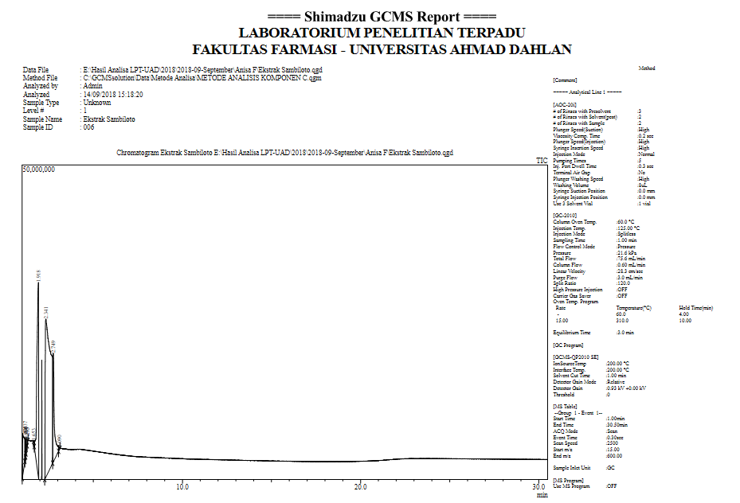

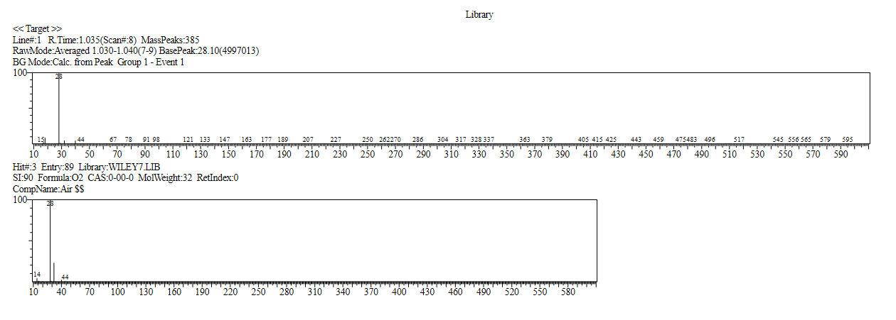

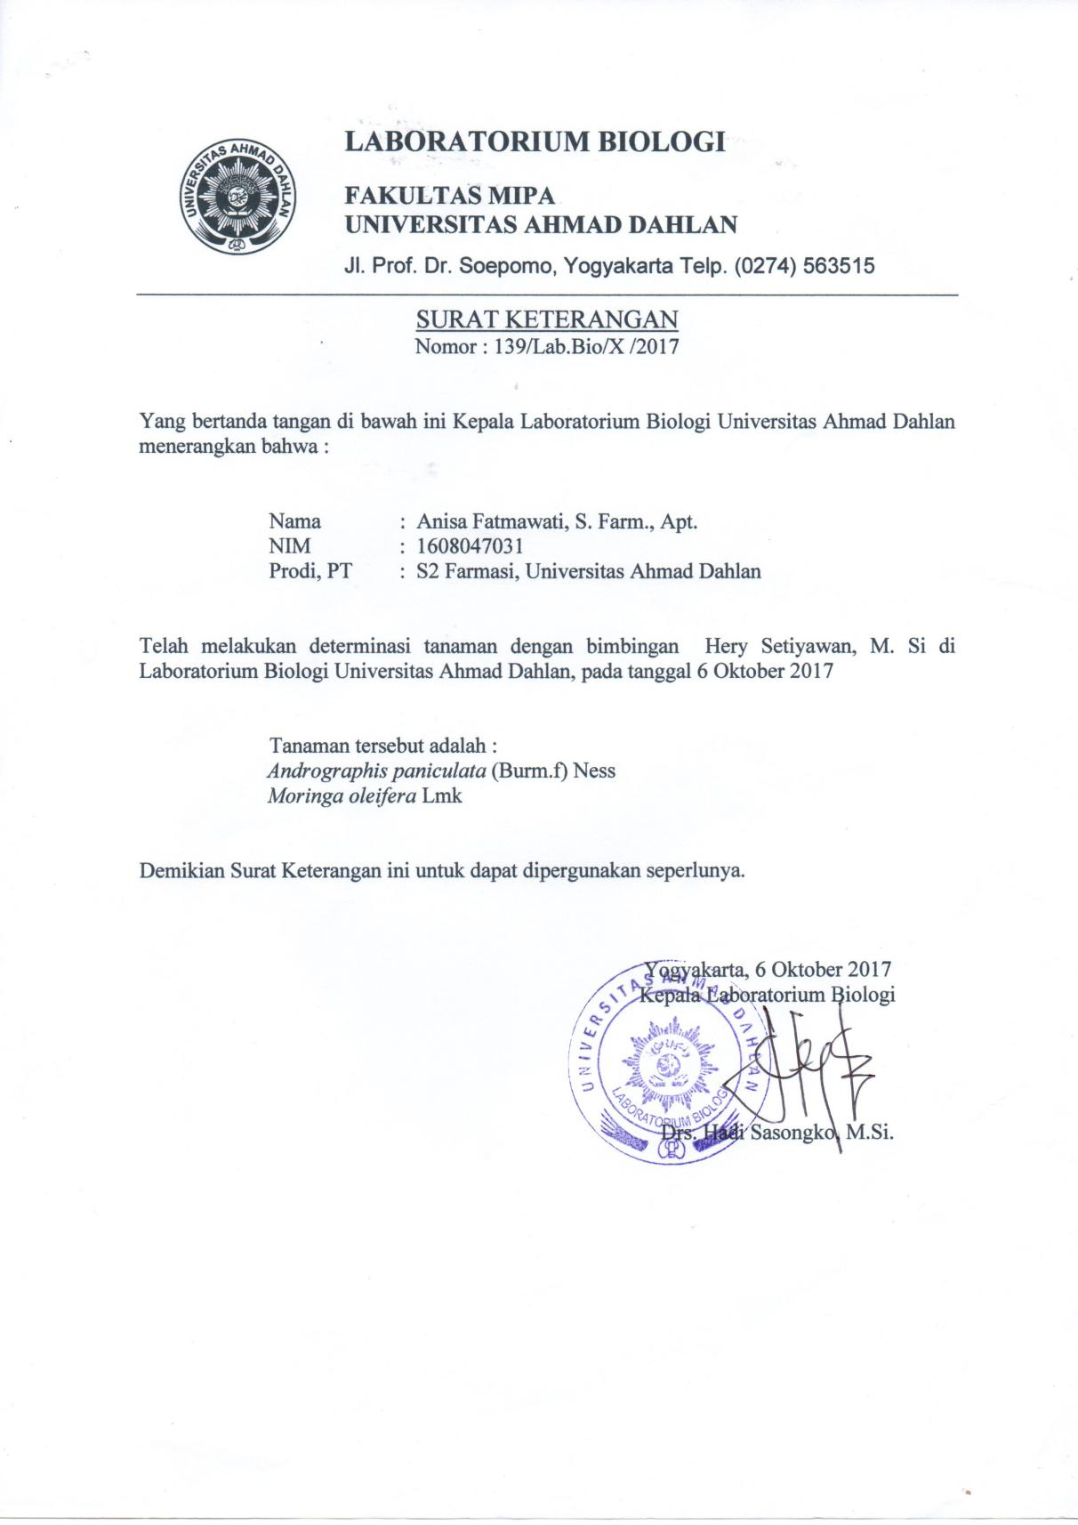

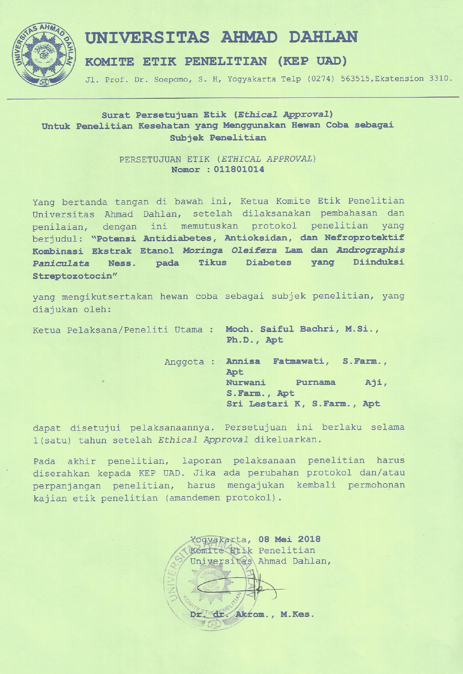
Hasil Pengujian dan Penetapan Kadar Quercetin EEDK Metode KLT-Densitometri
Kurva Baku Standar Quercetin
Seri Kadar ( ppm ) |  | AUC | Yi | ( Y- Yi ) | ( Y – Yi ) 2
50 |  | 4253,6 | 3908,35 | 345,25 | 119197,5625
100 |  | 5905,3 | 6143,4 | -238,1 | 56691,61
150 |  | 8177,8 | 8378,45 | -200,65 | 40260,4225
200 |  | 10348,1 | 10613,5 | -265,40 | 70437,16
250 |  | 13207,5 | 12848,55 | 358,95 | 128845,1025
Sampel 1 |  | 6771,0 |  | Ʃ = | 415431,8575
Sampel 2 |  | 6882,6
Sampel 3 |  | 6487,8
Persamaan: |  | Y=44.7x + 1673.3
Rumus : |  | y=bx+a |  | a = | 1673.3
 |  | x=(y-a)/b |  | b = | 44.7
Penimbangan Sampel : |  |  | 250 | mg
Volume Pelarutan : |  |  | 10 | ml | Konsentrasi Sampel= 25 mg/ml
Kadar (ppm) | Luas Area |  | Xi ( ppm ) | (X rata-rata - Xi) | (X rata-rata - Xi)2
Sampel 1 | 6771,0 |  | 114,04 | -1,280 | 1,64
Sampel 2 | 6882,6 |  | 116,54 | -3,776 | 14,26
Sampel 3 | 6487,8 |  | 107,70 | 5,056 | 25,56
 | X rata-rata |  | 112,76 | Ʃ = | 954,74
Perhitungan Kadar Quercetin menjadi mg/ gram sampel
Persamaan: |  | 100 ppm = 0,1 mg/ml
Kadar Xi rata-rata: |  | 112,76 | ppm
 |  | 0,11276 | mg/ml
Kadar Quercetin = |  | Kadar Xi rata-rata
 |  | Konsentrasi sampel
= |  | 0,11276 mg/ml
 |  | 25 mg/ml
= |  | 0,0045 mg/1 mg sampel
= |  | 4,5 mg/ gram sampel

- Foto hasil Elusi KLT Quercetin pada Sinar UV254
 | a b c d e f g h i
Hasil elusi KLT | Gambaran spot pada KLT

Seri Kadar ( ppm ) | Spot | Seri Kadar ( ppm ) | Spot | Seri Kadar ( ppm ) | Spot
50 | a | 200 | d | Sampel 1 | g
100 | b | 250 | e | Sampel 2 | h
150 | c | 1000 | f | Sampel 3 | i

Hasil Pengujian dan Penetapan Kadar Andrografolid EEHS Metode KLT-Densitometri
Kurva Baku Standar Quercetin
Seri Kadar ( ppm ) |  | AUC |  | Yi | ( Y- Yi ) |  | ( Y – Yi ) 2
100 |  | 2084,6 |  | 2074,5 | 10,1 |  | 102,01
200 |  | 2918,8 |  | 3005,5 | -86,7 |  | 7516,89
300 |  | 3925,1 |  | 3936,5 | -11,4 |  | 129,96
400 |  | 5113,2 |  | 4867,5 | 245,7 |  | 60368,49
500 |  | 5643,1 |  | 5798,5 | -155,4 |  | 24149,16
Sampel 1 |  | 2428,9 |  |  | Ʃ = |  | 92266,51
Sampel 2 |  | 2291,6
Sampel 3 |  | 2691,9
Persamaan: |  | Y= 9,3x + 1143,5
Rumus : |  | y=bx+a |  |  |  | a = | 1143,5
 |  | x=(y-a)/b |  |  |  | b = | 9,3
Penimbangan Sampel : |  |  |  | 100 mg
Volume Pelarutan : |  |  |  | 10 ml |  |  | Konsentrasi Sampel= 10 mg/ml
Kadar (ppm) | Luas Area |  |  | Xi ( ppm ) |  | (X rata-rata - Xi) | (X rata-rata - Xi)2
Sampel 1 | 2428,9 |  |  | 138,07 |  | 4,501 | 20,25
Sampel 2 | 2291,6 |  |  | 123,32 |  | 19,248 | 370,49
Sampel 3 | 2691,9 |  |  | 166,32 |  | -23,749 | 564,00
 | X rata-rata |  |  | 142,57 |  | Ʃ = | 954,74
Perhitungan Kadar Andrografolid menjadi mg/ gram sampel
Persamaan: |  |  | 100 ppm = 0,1 mg/ml
Kadar Xi rata-rata: |  |  | 142,57ppm
 |  |  | 0,14257 mg/ml
Kadar Andrografolid = |  |  | Kadar Xi rata-rata
 |  |  | Konsentrasi sampel
= |  |  | 0,14257 mg/ml
 |  |  | 10 mg/ml
= |  |  | 0,014257 mg/1 mg sampel
= |  |  | 14,257 mg/ gram sampel
= |  |  | 1,425 gram/ 100 gram sampel

- Foto hasil Elusi KLT Andrografolid pada Sinar UV254
 | a b c d e f g h i
Hasil elusi KLT | Gambaran spot pada KLT

Seri Kadar ( ppm ) | Spot | Seri Kadar ( ppm ) | Spot | Seri Kadar ( ppm ) | Spot
100 | a | 400 | d | Sampel 1 | g
200 | b | 500 | e | Sampel 2 | h
300 | c | 1000 | f | Sampel 3 | i

