Graphs & Picture

a b
10µm
c d

10µm 10µm

Figure 1. AM fungi infection in tomato root. a= root without AM fungi infection; b= internal hypha; c= vesicular; d= arbuscular.

Figure 2. AM fungi infection (%) in tomato roots and spore density (spore/g). P0= tomato without AM fungi and F. oxysporum f.sp. lycopersici infection; P1= tomato inoculated with F. oxysporum f.sp. lycopersici; P2= tomato inoculated with AM fungi; P3= tomato inoculated with AM fungi and F. oxysporum f.sp. lycopersici; P4= tomato inoculated with F. oxysporum f.sp. lycopersici and treated with benomil 0,2 g/l.

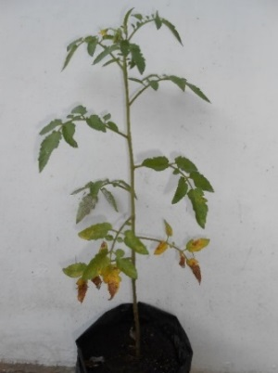
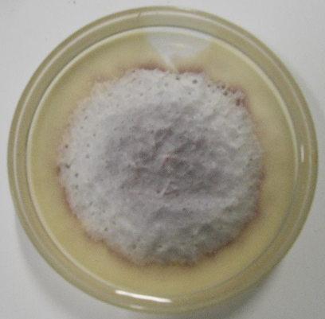

conidium

conidiophore

10µm

a b c
Figure 3. Fusarium wilt disease on tomatoes. a= F. oxysporum f.sp. lycopersici colony on PDA; b= Fusarium wilt symptom after inoculation; c= Fusarium conidiophore and conidium.

Figure 4. Percentage of disease intensity of F. oxysporum f.sp. lycopersici on tomatoes. P0= untreated plants; P1= Plants inoculated with F. oxysporum f.sp. lycopersici; P2= Plants inoculated with AMF; P3= Plants inoculated with AMF and F. oxysporum f.sp. lycopersici; P4= Plants inoculated with F. oxysporum f.sp. lycopersici followed with benomil 0,2 g/l (sprayed).

