**Statement of Originality**

**Submitted to the agriTECH**

Title of the manuscript: PERIODE TOLERANSI DARI VARIETAS KEDELAI (*Glycine max* (L.)Merill)

TOLERAN TERHADAP TINGKAT NAUNGAN

Authors: Gusmiatun

As the corresponding author I certify that this manuscript is original and its publication does not infringe any copyright.

As the corresponding author I declare that the manuscript has not been previously published, in whole or in part in any other journal or scientific publishing company. Also the manuscript does not participate in any other publishing process.

As the corresponding author I declare that all persons listed hereafter were committed in the creation of the paper and were informed about their participation.

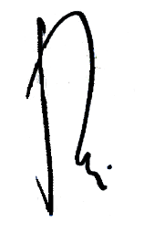 Palembang, 17 January 2022

Gusmiatun

*\*)This statement must be upload for supplementary files while submitting your manuscript*

*or sent back to agritech@ugm.ac.id email*