FIGURE LEGEND
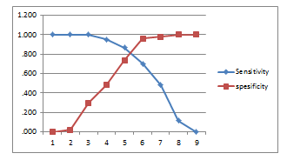

Figure 1. This figure shows the sensitivity and specificity based on a cut-off point derived from the ROC (Receiver Operating Characteristic) curve analysis

