Supplement 1: figure 1-6 and table 1-3
Figure 1. Clinical appearance, laboratory result, and empirical treatment of a hospitalized Melioidosis patient at a tertiary hospital in Yogyakarta, July 2015
^{MTZ 500 mg/ 8 h (21-27 July)}
^{MEM 1g/12 h (25-27 July)}
AK: Amikacin, AZM: Azithromycin, CAZ: Ceftazidime, CL: Colistin (Polymyxin E), CFM: Cefixime, CRO: Ceftriaxone, CTX: Cefotaxime, FLC: Fluconazole, GM: Gentamycin, IPM: Imipenem
MEM: Meropenem, MTZ: Metronidazole, Pelastin: Imipenem-Cilastatin, Leu: Leucocyte / μl

^{Leu: 21,030}
^{Leu: 27,500}
L1
L2
^{AZM 500mg/12 h (25-27 July)}
^{CRO 1g/12h (21-23 July)}

Figure 2. Clinical appearance, laboratory result, and empirical treatment of a hospitalized Meliioidosis patient at a tertiary hospital in Yogyakarta,August 2015
^{AK 500mg/12h (27 Aug-16 Sep)}
^{LVX 500mg/24h (20-25 Aug)}
^{AK 100mg/ 12h (12-27 Aug)}

^{FCL 200mg/ 24h (14 Aug-9 Sep)}
^{GM 200mg/ 24h (8-12 Aug)}
^{MTZ 500mg/8h (8-12 Aug)}
AK: Amikacin, AZM: Azithromycin, CAZ: Ceftazidime, CL: Colistin (Polymyxin E), CFM: Cefixime, CRO: Ceftriaxone, CTX: Cefotaxime, FLC: Fluconazole, GM: Gentamycin, IPM: Imipenem
MEM: Meropenem, MTZ: Metronidazole, Pelastin: Imipenem-Cilastatin, Leu: Leucocyte / μl

L7-8
L6
L5
^{Leu: 23,370}
^{Leu: 20,740}
^{Leu: 21,100}
L9
L3
L4
^{CAZ 2g/ 12h (8-12 Aug)}
Figure 3. Clinical appearance, laboratory result, and empirical treatment of a hospitalized Meliioidosis patient at a tertiary hospital in Yogyakarta, September 2015
^{IPM 1g/8h (5-22 Sep)}
^{CFM 200mg/12h (17- 22 Sep)}
Pelastin 1g/ 8 h (23 Sep- 6 Oct)
^{FCL 200mg/ 24h (14 Aug-9 Sep)}
^{AK 500mg/12h (27 Aug-16 Sep)}

AK: Amikacin, AZM: Azithromycin, CAZ: Ceftazidime, CL: Colistin (Polymyxin E), CFM: Cefixime, CRO: Ceftriaxone, CTX: Cefotaxime, FLC: Fluconazole, GM: Gentamycin, IPM: Imipenem
MEM: Meropenem, MTZ: Metronidazole, Pelastin: Imipenem-Cilastatin, Leu: Leucocyte / μl

^{Leu: 20,530}
^{Leu: 19,650}
^{Leu: 29,400}
^{Leu: 24,700}
Figure 4. Clinical appearance, laboratory result, and empirical treatment of a hospitalized Meliioidosis patient at a tertiary hospital in Yogyakarta, October 2015
Pelastin 1g/ 8 h (23 Oct- 5 Nov)
^{CL 2 tab/ 8 h (23 Oct- 31Oct)}
^{AK 250mg/12 h (21-22 Oct)}
^{LVX 500mg/24h (26 Oct-5 Nov)}
Pelastin 1g/ 8 h (23 Sep- 6 Oct)

^{Leu: 25,270}
^{Leu: 28,520}
^{Leu: 23,860}
^{Leu: 24,420}
L10
L11

AK: Amikacin, AZM: Azithromycin, CAZ: Ceftazidime, CL: Colistin (Polymyxin E), CFM: Cefixime, CRO: Ceftriaxone, CTX: Cefotaxime, FLC: Fluconazole, GM: Gentamycin, IPM: Imipenem
MEM: Meropenem, MTZ: Metronidazole, Pelastin: Imipenem-Cilastatin, Leu: Leucocyte / μl

Figure 5. Clinical appearance, laboratory result, and empirical treatment of a hospitalized Meliioidosis patient at a tertiary hospital in Yogyakarta, November 2015
^{LVX 500mg/24h (26 Oct-5 Nov)}
^{CAZ 2g/12h (16-17 Nov)}
^{AN 500mg/12h (13-15 Nov)}
^{CTX 2g/12h (6-19 Nov)}
Pelastin 1g/ 8h (23 Oct- 5 Nov)

^{Leu: 20,590}
^{Leu: 32,390}
^{Leu: 37,970}
^{Leu: 40,550}
L15
L14
L13
L12

AK: Amikacin, AZM: Azithromycin, CAZ: Ceftazidime, CL: Colistin (Polymyxin E), CFM: Cefixime, CRO: Ceftriaxone, CTX: Cefotaxime, FLC: Fluconazole, GM: Gentamycin, IPM: Imipenem
MEM: Meropenem, MTZ: Metronidazole, Pelastin: Imipenem-Cilastatin, Leu: Leucocyte / μl

Figure 6. Clinical appearance, laboratory result, antibiotics treatment of a Meliioidosis patient during the hospitalization at ICU of a tertiary hospital in Yogyakarta, December 2019
^{MEM 1g/12h (24 Nov-1 Dec)}
^{AZM 500mg/12h (24 Nov-1 Dec)}
AK: Amikacin, AZM: Azithromycin, CAZ: Ceftazidime, CL: Colistin (Polymyxin E), CFM: Cefixime, CRO: Ceftriaxone, CTX: Cefotaxime, FLC: Fluconazole, GM: Gentamycin, IPM: Imipenem
MEM: Meropenem, MTZ: Metronidazole, Pelastin: Imipenem-Cilastatin, Leu: Leucocyte / μl

Amiodarone, Vascon
^{Leu: 47,800}
^{Leu: 35,160}
^{Leu: 21,620}
^{Leu: 22,370}
Table 1. laboratory result of the melioidosis case on 21 July 2015
Laboratory examination | result
Leucocyte | 27,000/ μl
Neutrophil | 84.4%
Lymphocyte | 7.1%
Monocyte | 8.4%
Eusinophil | 0
Basophil | 0.1%
Thrombocyte | 415,000/ μl
Haemoglobin | 7.2 g/dl
BUN | 13.4
Creatinine | 1.44
Blood Glucose | 114 g/dl
Amilase | 1.76
Lipase 180 | 121
Albumin | 1.68
SGOT | 35
SGPT | 9

Table 2. Culture result of a Melioidosis patient during 130 days hospitalization at a tertiary hospital in Yogyakarta (23 July- 2 December 2015)

No | Date | Material | Result
L1 | 23 Jul 15 | Blood (2 sites) | Negative
L2 | 27 Jul 15 | Blood (2 sites) | Negative
L3 | 03 Aug 15 | Pus | Negative
L4 | 12 Aug 15 | Pus | Escherichia Coli, ESBL + (contamination)
L5 | 12 Aug 15 | Blood (2 sites) | Negative
L6 | 16 Aug 15 | Blood (2 sites) | Negative
L7 | 24 Aug 15 | Blood (2 sites) | Negative
L8 | 25 Aug 15 | Urine | Negative
L9 | 29 Aug 15 | Sputum | Streptococci
L10 | 12 Oct 15 | Blood (2 sites) | Negative
L11 | 27 Oct 15 | Blood (2 sites) | Negative
L12 | 03 Nov 15 | Pus | Negative
L13 | 11 Nov 15 | Blood (1 sites) | Negative
L14 | 15 Nov 15 | Blood (2 sites) | Negative
L15 | 20 Nov 15 | Wound swab | - Enterobacter cloacae  - Klebsiella oxytoca  - Burkholderia pseudomallei  - Pseudomonas putida

Table 3. Antimicrobial susceptibility of Burkholderia pseudomallei identified from the wound base of the Melioidosis case

Antibiotics | Result
Amikacin | Sensitive
Amoxy-Clav | Resistant
Ampicillin | Resistant
Eritromycin | Resistant
Gentamycin | Resistant
Levofloxacin | Resistant
Chloramphenicol | Resistant
Meropenem | Sensitive
Penicillin | Resistant
Cefepime | Resistant
Cefixime | Resistant
Ceftriaxone | Resistant
Cefuroxime | Resistant
Ciprofloxacine | Resistant
Sulfametoxazole | Resistant
Tetracycline | Not Done

Supplement 2: Figure 7-8

Figure 7. Chest Doppler USG, July, 30, 2019
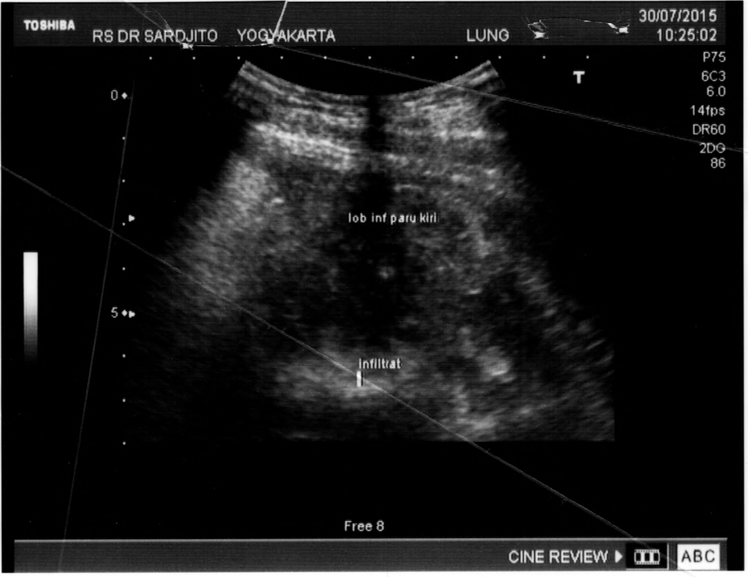

Figure 8. Abdominal Doppler USG, July, 30 2019
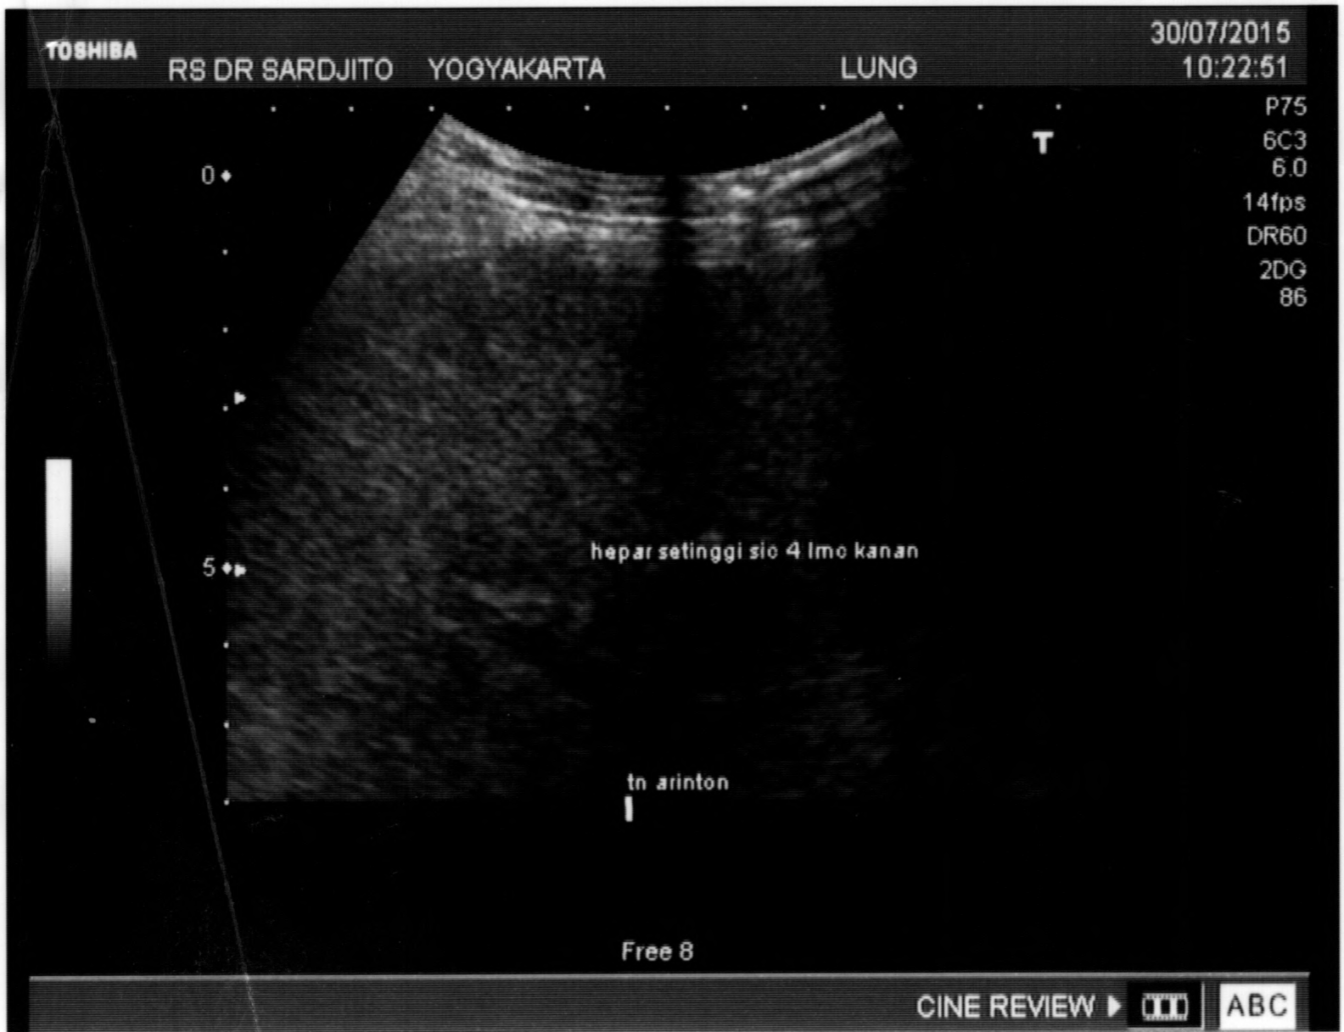

Supplement 3: Figure 9-10

Figure 9. Chest X Ray of the melioidosis case taken on Sep, 11th 2015
revealed a pneumonia on both sides of the lung,
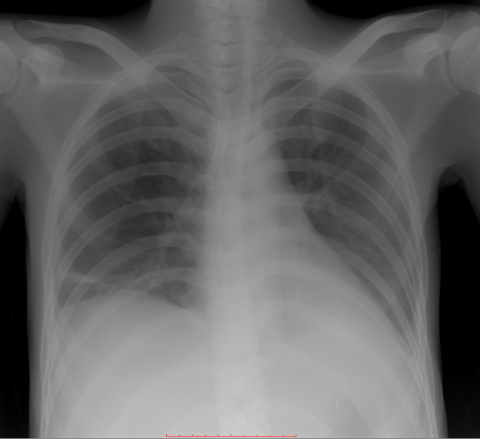

Figure 10. MSCT-Scan of the melioidosis case, taken on Aug, 7th 2015, Slide: Splenic Artery(A) Pancreas tail. The MSCT-scan shows pancreas destruction, and adhesion of the intraabdominal organs.
A

