Submission Checklist for Authors

Please read carefully the Instructions for Authors at the website of Bulletin of Animal Science (Buletin Peternakan) and then, use the following checklist below. The checklist is aimed to ensure all requirement for the submission.

☑ Manuscript must be prepared following the guideline of the Bulletin of Animal Science, especially for styles and formats.
☑ Title page must be prepared with the information of author’s affiliation and full contact addresses of corresponding author.
☑ All authors read and signed in person Bulletin of Animal Science Author Declaration Form (attached)
□ Copy of certificate for English editing service, if any (optional).
☑ Approval of Ethical clearance from legal committee/council must be mentioned in the text if the experiment use animal.

Author Declaration Form

Title of Manuscript: VARIOUS OF SACCHARIDES ADDITION OF EXTENDER RAM EFFICIENCY TO IMPROVE CRYOPRESERVATION IN SEMEN ETTAWAH CROSSBREED BUCKS WITH SEMINAL PLASMA REPLACEMENT
Corresponding E-mail: aeni001@brin.go.id.

Authors are requested to sign on the following statement form for publishing the article in Bulletin of Animal Science. Please read statements and check all check boxes.

Author Responsibility ☑
- All authors agree and approve the content of the article.
- The article is original research work and not currently under consideration by another Journal
- If the article contains material (data or information in any other form) that is the intellectual property and copyright of any person(s) other than the author(s), then permission of the copyright owner(s) to publish that material has been obtained and is clearly identified and acknowledged in the text of the paper.
- The authors followed Bulletin of Animal Science guidelines.
- See the Authorship Policy in Instructions for Authors.
- Author will be agree and responsible for the publication fee (see Bulletin of Animal Science article processing charge in the website)

Author Contributions ☑
Please indicate the specific contributions made by each author. All authors should have a contribution (please use authors’ initials, ex Mohammad Zainal Abidin as MZA).
- Conception: H., and M. R.,
- Methodology: A.H., D. A.
- Data Analysis: A.H., D. A. F. B. I. L., R. I. A., S.
- Validation: F. B. I. L., R. I. A., S.
- Writing manuscript-original: A.N., H., M.R., and P.I.S
- Writing manuscript-review/revision: A.N., H., M.R., and P.I.S
- Others:

Conflicts of Interest ☑
Please check one of two options.
☑ All authors do not have any conflict of interest
□ All authors have an interest or other relations regarding individual benefits. Please state and list the manufacturers and/or service providers with whom you have a financial relationship and describe the condition of your relationship.
………………………………………………………………………………………………………………………………………………………………………………………………………………………………………………………………

Ethical clearance approval (if use animal) ☑
All animal experiments should be reviewed by legal and formal committee to consider the animal welfare. The APPROVAL NUMBER must be indicated in methods section of article.
Approval number: 082/KE.02/SK/10/2022.

Copyright Transfer Agreement ☑
All authors of the approved article agree and understand that Bulletin of Animal Science have the copyright on all materials of approved article to publish, transmit, sell and distribute them in the journal or other media.

Bogor , 28 September 2023

No | Author’s Name | Signature
1 | Aeni Nurlatifah | 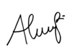
2 | Pradita Iustitia Sitaresmi | 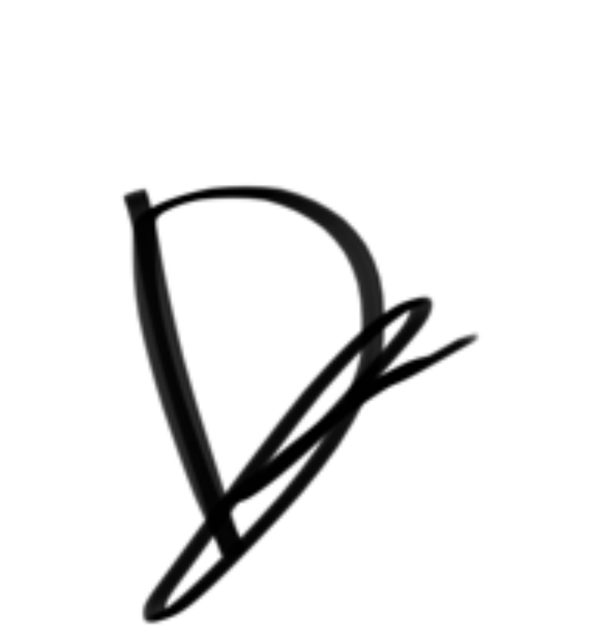
3 | Anita Hafid | 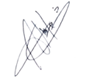
4 | Desiana Ade Mahari
5 | Florentina Bety Indah Lupitasari | 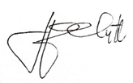
6 | Rahma Isartina Anwar | 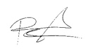
7 | Santoso | 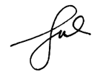
8 | Muhammad Rizal | 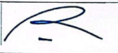
9 | Herdis | 