MICROENKAPSULATION OF CRUDE FOLIC ACID EXTRACT FROM CHAYOTE
(Sechium edule Jacq. Swartz) WITH IONIC
GELATION METHOD
Johana Novita Paulina Purba¹⁾, Herla Rusmarilin¹⁾, Zulkifli Lubis ^{2)*}
¹⁾Departement of Food Science, Faculty of Agricultural, Universitas Sumatera Utara, Medan
Departement of Food Science, Faculty of Agricultural,Institut Pertanian Bogor, Bogor
²⁾ Departement of Food Science, University of New South Wales, Sydney, Australia
^{*)}Corresponding author, e-mail address : johanapaulina0@gmail.com

ABSTRACT
Chayote is a plant which grow and develop throughout the year, contains of 93 mcg/100g folic acid. The aim of this research was to determine the ratio of sodium alginate with pectin and CaCl₂ concentration coating to produce microcapsules of crude folic acid extract. Four phases of study was done, namely the manufacture of folic acid extract, manufacture of microcapsules with ionic gelation, analysis of folic acid content in the microcapsules, and the analysis of folic acid after storage of one week. Folic acid extract was made by maceration using alcohol 70% at pH 6, preparation of the microcapsules was using sodium alginate with pectin and folic acid was analysed using HPLC. Folic acid extract showed antioxidant activity of 98,1% with folic acid of 0,16 mg/kg. Microencapsulation of folic acid extract results showed the highest antioxidant activity was formed in alginate ratio of 70% to 30% pectin and CaCl₂ concentration of 0.1 M i.e. 62.77 mg/kg. Folic acid is an antioxidant, highest antioxidant value folic acid was analyzed, treatment was in alginate ratio of 70% to 30% pectin and CaCl₂ concenration at 0.1 M i.e. 3.06 mg/kg, after one week at room temperature is became 2.39 mg/kg.
Keywords : Folic acid, chayote, microencapsulation, sodium alginate, pectin

INTRODUCTION
Difeciency of folic acid causes the body susceptible to diseases such as depression, anxiety, fatigue, insomnia, difficulty of remembering, red tongue and wounds to indigestion. In pregnant women a deficiency of folic acid increases the risk of premature delivery, low birth weight infants or neural tube defects (Bender, 2002), special treatment is required to maintain folic acid, according to Yuniati dan Almasyhuri (2012), folic acid is highly unstable, water-soluble, and easily damaged by heat.
Chayote is a functional food (Fitriani, 2013) and contain a high enough folic acid at 93 mcg/100g (USDA, 2008). Chayote is a plant which grow and develop throughout the year (Rukmana, 1998) and in North Sumatra, chayote production in 2014 reached 20,306 tons/year (BPS, 2014).
Morphology of chayote is as below (Figure 1) :
- Stem : Soft, grooved, multi-pronged, there is a spiral twisted, cassette, green.
- leaf : Single, heart shape, edging edge, tapered tip, pointed base, cassette, 4-25 cm long, 3-20 cm wide, long stalk, turning on, green.
- Seeds : Flattened, flattened, white
- Root : Riding, white-brown
- Flower : Compound, in the armpit leaves, petals titled five, grooved crown, five stamens, orange anthers, one yellow pistil.
- Fruit : Bunni, round, hanging, dimpled surface, whitish green (Depkes RI, 2000).
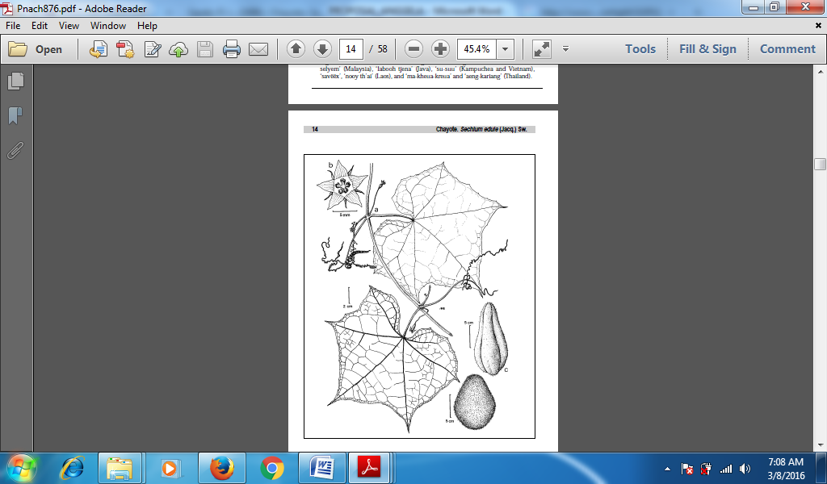
Figure 1. Sechium edule: (a) branches with leaves, tendrils and flowers and flower pistils; (b) flower; (c) fruit (Saade, 1996)

Narium alginate is biocompatible bonding agent, non-toxic when used orally, and a natural polymers bioadhesif (Tan et al., 2009). Besides a sodium alginate, pectin is also a natural polymer (Jung et al., 2013). Sodium alginate and pectin are used as a coating to protect the core material by microencapsulation using ionic gelation method (Syahron, 2016). Polyelectrolyte solutions are formed between the polyions with opposite charges, the electrostatic interaction between the charged polyions (Lankapalli and Kolapalli, 2009). Sodium alginate and pectin dispersed into the aquadest are a solution of polyelectrolytes, and ions that derived from CaCl₂ are utilized to form crosslinks. The core material of folic acid extracted from the gourd can be maintained its stability with microencapsulation by using sodium alginate polymer and pectin.
The aim of this research was to determine the ratio of sodium alginate and pectin to produce the crude folic acid extract microcapsules; to determine the best concentration of CaCl₂ which yields the best folic acid extract microcapsules from the crude folic acid extract microcapsules, and to determine the best folic acid content of microcapsules based on the best antioxidant activity.
MATERIALS AND METHODS
The equipment used consists of rotary vacum evaporator, hirox video audio microscope, and Reversed Phase High Performance Liquid Chromatography (RP-HPLC). Materials used are chayote (Sechium edule Jacq. Swartz) obtained from Berastagi Supermarket, Medan. Chemicals used in this study was 70% alcohol, alginate, pectin, and NaOH 10 N.

The study was conducted in 4 phases. The first was the manufacture of folic acid extract. The second was the manufacture of microcapsules using ionic gelation method, using a ratio of sodium alginate and pectin. The third was` the analysis of the content of folic acid in microcapsules, the content of folic acid was analyzed based on microcapsules that can retain the most powerful antioxidant. The last phase was the stability of folic acid extract microcapsules after storage for one week. Parameter analyses were: crude fiber content, water content, pH, microcapsule diameter, antioxidant activity, and folic acid content.

RESULT AND DISCUSSION

One kg of chayote flour was extracted with 70% alcohol and adjusted to pH 6 using 10 N NaOH that produced 1830 ml of crude extract of folic acid, and 978 g of chayote flour. Antioxidant activity of non-microcapsulated folic acid extract was 98.1% with folic acid content of 0.82 mg/kg, the yield was then microencapsulated into microcapsules of crude folic extract. The highest antioxidant activity (%) was analyzed by the folat acid in A₂M₂ treatment with sodium alginate ratio of 70% to 30% pectin and 0.1 M CaCl₂ concentration of 3.06 mg/kg. The content of folic acid decreased significantly from 3,06 mg/kg to 2.39 mg/kg after one week stored at room temperature (28⁰C).
The effect of the ratio of sodium alginate and pectin with CaCl₂ concentration on crude folic acid extract microcapsules can be seen in Table 1 dan Table 2.
Table 1. Effect of sodium alginate and pectin on crude folic acid extract microcapsules
Parameters observed | A
Parameters observed | A₁ | A₂ | A₃
Parameters observed | (65%:35%) | (70%:30%) | (75%:25%)
Crude fiber content (%) | 6,14 | 7,17 | 7,15
Water content (%) | 7,74 | 8,51 | 9,55
Acidity level (pH) | 4,76 | 4,76 | 3,61
Total soluble solid (TSS) (ºBrix) | 4,11 | 6,89 | 7,99
Diameter microcapsules (µm) | 460,00 | 425,56 | 349,78
Antioxidant activity | 21,44 | 44,24 | 44,44

Table 2. Effect of CaCl₂ concentration on crude folic acid extract microcapsules

Parameters observed | M
Parameters observed | M₁ | M₂ | M₃
Parameters observed | 0,05 M | 0,1 M | 0,5 M
Crude fiber content (%) | 5,87 | 7,52 | 7,07
Water content (%) | 8,04 | 8,48 | 9,28
Acidity level (pH) | 4,06 | 4,62 | 4,46
Total soluble solid (TSS) (ºBrix) | 5,54 | 7,11 | 6,33
Diameter microcapsules (µm) | 454,33 | 413,33 | 367,67
Antioxidant activity | 29,93 | 42,88 | 37,32

Crude Fiber Content

The results of variance analysis showed no significant effect on the coarse fiber content of crude folic acid extract microcapsules. The ratio of sodium alginate with pectin and the concentration of CaCl₂ had highly significant effect, crude fiber of microcapsules extract content of folic acid produced. The effect of sodium alginate ratio and pectin on crude fiber content of folic acid extract microcapsules can be seen in Figure 2 and the effect of CaCl₂ concentration on crude fiber content can be seen in Figure 3.

Figure 2. Effect of sodium alginate ratio and pectin on crude fiber content of crude folic acid extract microcapsules

Figure 3. The effect of CaCl₂ concentration on crude fiber content of crude folic acid extract microcapsules

It can be seen (Figure 2) that the higher the sodium alginate or the lower the pectin, the resulting crude fiber content will increase, because the fiber in alginate comes from the seaweed which is higher than the pectin fiber. According to Dwiyitno (2011), the total fiber content in seaweed is relatively higher than that of food stuffs derived from land plants (tubers, fruits, cereals, and nuts), besides terrestrial plant fibers typically contain more water insoluble fiber than seaweed has higher soluble fiber content. Pectin is a soluble fiber found in fruits, glucan on cereals, and gums in nuts, seeds, and seaweed (Fennema, 1976). Sodium alginate was derived from seaweed (Aslan, 1999).
It can be seen (Figure 3) there was a tendency to bind calcium alginate fiber and pectin to form a solid mikroenkapsulat texture. Calcium bonded by alginates will determine how many bonds occur to form fibers. Alginates that interact with calcium can be assumed that the fiber content is derived from the alginate concentration used (Peranginangin et al., 2015).
Water Content
There was no significant effect on water content of microcapsules extract folic acid, but each treatment factors provide highly significant effect on water content. The effect of sodium alginate ratio and pectin on water content can be seen in Figure 4, and the effect of CaCl₂ concentration on water content can be seen in Figure 5.

Figure 4. Effect of sodium alginate ratio and pectin on water content of crude folic acid extract microcapsules

Figure 5. The effect of CaCl₂ concentration on water content of crude folic acid extract microcapsules

It can be seen (Figure 4) that the higher the sodium alginate or the lower the pectin, the water content produced will increase, because pectin is very strong water binding. According to Estiasih and Ahmadi (2009), pectin added to the foodstuff can solidify a homogeneous dispersion system and increase the viscosity of the material and reduce the water content of the material. The increase in the amount of pectin can decrease the levels of water in the materials produced (Juwita et al., 2014).
Increased sodium alginate increase is also due to the water content Sodium alginate can bind many water molecules. According to Dwijayanti (2009), sodium alginate water-soluble form of fiber materials such as mesh grille can bind water molecules and hold water stronger in solution.
Low water content is good for storage of microcapsules for longer periods of time because of high water content to be a medium for growth of microorganisms such as fungi, where microorganisms can grow well with moisture content above 10% (Faradiba et al., 2013).
Acidity Level (pH)
The interaction between the ratio of sodium alginate with pectin and CaCl₂ concentration showed highly significant effect on the level of acidity (pH) of folic acid extract microcapsules. The effect of ratio of Sodium alginate with pectin and CaCl₂ on acidity level (pH) of crude folic acid extract microcapsules is shown in Figure 6.

Figure 6. The effect of sodium alginate ratio with pectin and CaCl₂ concentration on acidity level (pH) of crude folic acid extract microcapsules

Vulnerable pH of crude folic acid extract microcapsules depend on pH conditions. According to Madziva et al., (2006), the hydrogel alginate-pectin showed remarkable stability in acidic conditions and hydrogel bond would be released in alkaline conditions. Folate is susceptible to oxidative degradation induced by oxygen, light, sunlight, oxidizing, reducing and heat, causing molecules to become biologically active. Folic acid stability also depends on the pH, the reduced folate binding hydrogels are most vulnerable at pH> 8 and pH <2 and stable bonds hydrogel is in the range of pH 4-6. The durability of a food for growing microorganisms can not stand the high levels of acid (low pH) (Winarno, 2008).
Total Soluble Solid (TSS) (ºBrix)
The interaction of sodium alginate ratio with pectin and CaCl₂ concentration had highly significant effect on the total soluble solid (TSS) of crude folic acid extract microcapsules.
The higher the sodium alginate or the less pectin, the total soluble solid (TSS) will also be higher as Sodium alginate increases the total sugar. According to Dwijayanti (2009), the addition of sodium alginate can increase the total sugar in the ingredients. Alginate is a hydrocoloid compound composed of polysaccharide content, in which the polysaccharides are sugar polymers that for long chains (Fardiaz, 1989).

Figure 7. The effect of sodium alginate ratio with pectin and CaCl₂ concentration on total soluble solid (TSS) of crude folic acid extract microcapsules

Total soluble solid (TSS) decreased with increased concentrations of CaCl₂. According to Abror and Cahyaningrum (2015), this was due to the bond formed on the high concentration of CaCl₂ which weaken the excess to Ca²⁺ .
The high of crude folic acid extract microcapsules was due to the 70% alcohol extract of the squash is able to contract the flavonoids that have a hydroxyl group (sugar) better than the other solvents. According to Marliana (2005), the ethanol extract of chayote (Sechium edule jacq. Swartz) contains flavonoid compounds and according to Melodita (2011), flavonoid is a compound of phytochemical class that is polar as it has a hydroxyl group (sugar) that dissolves in polar solvents such as ethanol, methanol, acetone, water, and others. Sani et al., (2014) states that 70% ethanol extract contains flavonoid glycosides, most flavonoid compounds in plants are found in the form of glycosides which means that the flavonoid unit tends to be attached to a carbonyl group of sugars (glycine). Anggraini (2006) states that all compounds are able to extract well in 70% alcohol because it is semi polar so that all active components with different polarity can be extracted and Harbone (1988) stating that 70% alcohol can extract the flavonoids than using other solvents.
Microcapsule Form
The best form of microparticles contained in alginate ratio of 75% to 25% pectin and CaCl₂ concentration of 0.5 M that is the sphere, and the lowest was in alginate ratio of 65% and 35% pectin with a ratio of 0.05 M CaCl₂ concentration that is in irregular sphere. The more alginate or less pectin, the larger was the microcapsule. According to Tello et al., (2015), alginate increases size, whereas pectin shrinks particle size and according to Syahron (2016), the less pectin produces capsules that form nearer to the spherical shape.
Microencapsulated forms can be seen in Figure 8.
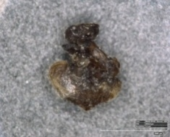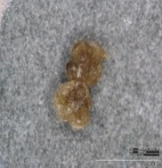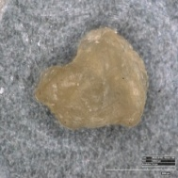
A₁M₁ (60%:35%;0,05M) A₁M₂ (60%:35%;0,1M) A₁M₃ (60%:35%;0,5M)

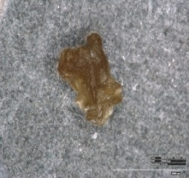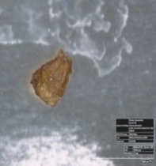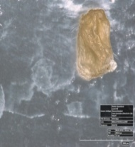
A₂M₁ (70%:30%;0,05M) A₂M₂ (70%:30%;0,1M) A₂M₃ (70%:30%;0,5M)

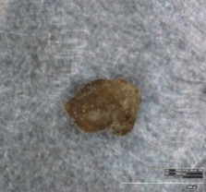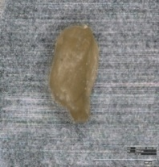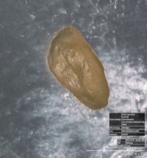
A₃M₁ (72%:25%;0,05M) A₃M₂ (75%:25%;0,1M) A₃M₃ (75%:25%;0,5M)
Figure 8. Microencapsulated forms of crude folic acid extract
Microencapsulated forms of crude folic acid extract is uneven (inclined round). Accoring to Oktaviana (2015), the tip of a tapered microcapsule due to uses a syringe with a pointed needle tip. Microcapsule surface obtained from the results of research is also uneven and potholes. According to Febriyenti et al., (2013), the surface is unevenly generated due to a non-homogeneous solution so that air bubbles are trapped inside.
Wet microcapsules are striated, and after drying becomes unstable. According to Sari et al., (2012), due to the heat transfer process during drying, the water absorbed in the wet microcapsule is pushed out so that the microcapsule structure is not strefis. Wet microcapsules and dry microcapsules of crude folic acid extract can be seen in Figure 9.
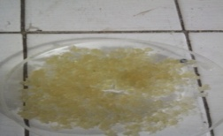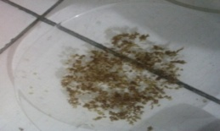
Figure 9. Wet microcapsules and dry microcapsules of crude folic acid extract

Diameter (µm)
The interaction between the ratio of sodium alginate with pectin and CaCl₂ concentration showed highly significant effect on the diameter of crude folic acid extract microcapsules. Microcapsules of crude folic acid extract by using sodium alginate with pectin ratio of 72%: 25% and the concentration of CaCl₂ 0.1 M had the highest antioxidant activity of 62.77% as can be seen in Figure 10.

Figure 10. The effect of sodium alginate ratio with pectin and CaCl₂ concentration on diameter (μm) of crude folic acid extract microcapsules

The increasing concentration of CaCl₂ physically resulted in harder and stiffer, microcapsule are more rounded. According to Jelvehgari et al., (2004), the more available of Ca²⁺ ions, the more crosslinking links that occur with sodium alginate-pectin so that the resulting structure becomes more compact and sturdy.
Increase pectin concentration result in oval capsules and relatively large size. Natural structure of pectin that has a neutral sugars such as xylose, galactose and arabinose form elongation of the capsule (Jaya et al, 2010).
On a higher viscosity, greater pressure is required to eject droplets of sodium alginate with pectin. Higher viscosity was able to maintain microcapsule form (Oktaviana, 2015). The size of the microcapsule diameter made by the conventional ionic gelation method depends on the needle diameter used during the manufacturing process (Febrianisa, 2012).
Antioxidant Activity (%)
The higher the antioxidant activity of sodium alginate can be maintained. According to Siswanti et al., (2013), the greater the concentration of sodium alginate the pore formed more tightly and higher pore density will cause the core material trapped becoming increasingly restrained (Figure 11).

Figure 11. The effect of sodium alginate ratio with pectin and CaCl₂ concentration on antioxidant activity (%) of crude folic acid extract microcapsules

The interaction between the ratio of sodium alginate with pectin and CaCl₂ concentration showed highly significant effect of antioxidant activity of crude folic acid extract microcapsules.
The increasing concentrations of Ca²⁺ makes the mikroenkapsulat more cohesive so that the antioxidant activity can be maintained. According to Seixas et al., (2013), Ca²⁺ ions form a crosslinking of the polymer chain, so the increased concentration of Ca²⁺ makes the bonds between molecules more cohesive. The antioxidant activity at 0.05 M CaCl₂ concentration increased in every ratio up to 0.5 M concentration, except the antioxidant activity in the 70%: 30% ratio of alginate and pectin with 0.1 M CaCl₂ concentration still increased but decreased again in the alginate ratio and pectin 75%: 25% at the same concentration, due to Ca⁺⁺ are entangled in the microencapsulate is excessive so that Ca⁺⁺ addition does not increase Ca⁺⁺ in the texture. This is once with Madziva et al., (2005) states that the best folic acid encapsulation was at ratio of alginate with pectin of 70%: 30% and CaCl₂ concentration of 0.1 M, at 0.1 M CaCl₂ concentration begins to weaken, and the weakest was at CaCl₂ concentration of 0.05 M. According to Sari et al., (2004), the amount of Ca²⁺ absorbed in the network has reached the maximum, then the addition of concentration will not increase the amount of Ca²⁺ into the texture.
Folic Acid
Folic acid is an antioxidant compound. Best Mikroenkapsulat is capable of maintaining a network of folic acid so it has the best antioxidant activity such as in the treatment of alginate ratio of 70% and 30% pectin with a CaCl₂ concentration of 0.1 M. According to Joshi et al., (2001), folic acid is called as a potential antioxidant because of its nature that counteract and neutralize free radicals. The content of folic acid before and after storage at room temperature for one week (mg/ kg) can be seen in Table 3.
Table 3. Folic acid content before and after storage at room temperature for one week (mg / kg)
Folic acid content | A₂M₂
Folic acid content | A₂M₂₍₁₎ | A₂M₂₍₂₎ | A₂M₂₍₃₎
Before storage | ND | 3,18 | 2,93
After storage | ND | 2,83 | 1,95
Note : ND = Not Detected
A₂M₂ = Ratio of sodium alginate :pectin 70%:30% with CaCl₂ 0,1 M concentration

The microcapsules of crude folic acid extract stored at room temperature have drastically decreased, preferably stored at refrigerator temperature to maintain a micro-encapsulated folic acid extract. According to Onayanti (2015), the viability of the core material which has been encapsulated by the method of cross-linking produces microcapsules having viability as high as the storage period of 6 weeks at refrigerator temperature (4⁰C) and at room temperature (28ºC) the viability was only 1 week.

CONCLUSION
The best folic acid content found in A₂M₂ treatment i.e. microcapsule alginate with pectin A₂ (70%: 30%) and concentration of CaCl₂ M₂ (0,1M). Storage of crude folic acid extract microcapsules preferably at cold temperatures (4ºC) to avoid damage, folic acid content after storage for one week at room temperature has decreased significantly.

REFRENCE

Abror, M. U. S., and Cahyaningrum, S. E. 2015. Pengaruh konsentrasi agen pengikat silang terhadap karakteristik pirasinamid terenkapsulasi. UNESA Journal of Chemistry. 4(1).

Angraini, A. D. 2006. “Potensi propolis lebah madu Trigona sp. sebagai bahan antibakteri”. Skripsi. Program Studi Biokimia, Bogor.

Aslan, L. M. 1999. “Budidaya rumput laut”. Penerbit Kanisius, Yogyakarta.

BPS. 2014. “Produksi Buah-Buahan Menurut Jenis Tanaman 2009-2014”. http:sumut.bps.go.id [9 Desember 2015].

Bender, D. A. 2002. “Introduction to nutrition and metabolism, Third edition”. New York. Taylor Francis: 380-384.

Depkes RI. 2000. “Inventaris tanaman obat indonesia (I). Jilid 1”. Badan Penelitian dan Pengembangan Kesehatan. Jakarta.

Dwijayanti, R. 2009. “Pemanfaatan natrium alginat sebagai fortifikasi serat dalam pembuatan minuman serbuk effervescent bercitarasa jeruklemon”. Program Studi Teknologi Hasil Perikanan, Institut Pertanian Bogor, Bogor.

Dwiyitno. 2011. Rumput laut sebagai sumber serat pangan potensial. Squalen. 6 (1) : 9-17.

Estiasih, T. and Ahmadi. 2009. “Teknologi pengolahan pangan”. Bumi Aksara, Jakarta.

Faradiba., Hasyim, N. and Zahriati. 2013. Formulasi garanul effervescent ekstrak etanol daun jambu biji (Psidium guajava LINN). Majalah Farmasi dan Farmakologi. 12(12).

Fardiaz, D. 1989. “Hidrokoloid. Laboratorium Kimia dan Biokimia Pangan. Antar Universitas Pangan dan Gizi”. Institut Pertanian Bogor, Bogor.

Febrianisa, N. 2012. “Preparasi dan Karakterisasi Bead Zink Pektinat-Kitosan Mengandung Pentokslifin”. FMIPA, Universitas Indonesia, Depok.

Febriyenti., Ben, E. S. and Prima, T. 2013. Formulasi mikrokapsul glikuidon menggunakan penyalut etil selulosa dengan metode emulsifikasi penguapan pelarut. Prosiding Seminar Nasional Perkembangan Terkini Sains Farmasi dan Klinik III. ISSN : 2339-2592.

Fennema, O. R. 1976. “Principles of food sciences”. pp.792 Marcel Dekker, Inc. New York.

Fitriani, N. L. C., Walanda, D. K. and Rahman, N. 2013. Penentuan kadar kalium (K) dan kalsium (Ca) dalam labu siam (Sechium edule) serta pengaruh tempat tumbuhnya. Journal Akad. Kim. 1(4): 174-180.

Gusdinar, T., Singgih, M., Priatni, S., Sukmawati, A. E. and Suciati, T. 2011. Enkapsulasi dan stabilitas pigmen karotenoid dari Neurospora intermedia N-1. Jurnal Manusia Dan Lingkungan. 18 (3) : 206-211.

Harbone, J. B. 1988. “The flavonoids, advances in research since 1980”. Chapman and Hall, New York.

Jaya, S., Durance, T. D., and Wang, R. 2010. Physical characterization of drug loaded microcapsules and controlled in vitro release study. The Open Biomaterial Journal. 2:9-17.

Jelvehgari, M., Mobaraki, V. and Montazam, S. H. 2014. Preparation and evaluation of mucoadhesive beads/discs of alginate and algino-pectinate of piroxicam for colon-specific drug delivery via oral route. Jundishapur Journal Nat Pharm Prod. 9(4):1-10.

Joshi, R., Adhikari, S., Patro, B. S., Chattopadhyay, S. and Mukherjee, T. 2001. Free radical scavenging behavior of folic acid: evidence for possible antioxidant activity. Elsivier. Free Radical Biology and Medicine. 30(12):1390–1399.

Juwita, W., Rusmarilin, H. and Yusraini, E. 2014. Pengaruh konsentrasi pektin dan karagenan terhadap mutu permen jely jahe. Jurnal Rekayasa Pangan dan Pertanian. 2(2):42-50.

Lankapalli, S. and Kolapalli, V. 2009. Polyelectrolyte complexes : a review of their applicability in drug delivery technology. Indian Journal Pharmaceutical Science. 7(5) : 481-487.

Madziva, H., Kailasapathy, K. and Phillips, M. 2005. Alginate-pectin microcapsules as a potential for folic acid delivery in foods. Journal Microencapsulation 22(4):343-357.

Marliana, S. D., Suryanti, V. and Suyono. 2005. Skrining fitokimia dan analisis kromatografi lapis tipis komponen kimia buah labu siam (Sechium edule Jacq. Swartz.) dalam ekstrak etanol. Biofarmasi. 3(1): 26-31.

Melodita, R. 2011. “Identifikasi pendahuluan senyawa fitokimia dan uji aktivitas antioksidan ekstrak daun cincau hitam dengan perlakuan jenis pelarut”. Skripsi. Fakultas Teknologi Pertanian. Universitas Brawijaya, Malang.

Oktaviana, W. 2015. “Karakterisasi mikropartikel natrium alginat yang mengandung serbuk getah pepaya (Carica papaya L.) yang dipreparasi dengan metode gelasi ionik”. Skripsi. Program Studi Farmasi, UIN Syarif Hidayatullah Jakarta.

Onayanti, N., R. G. Budji. and Sartini. 2015. “Uji viabilitas probiotik asal saluran pencernaan itik pedaging Anas domesticus yang dienkapsulasi dengan metode cross link”. Fakultas Matematika dan Ilmu Pengetahuan Alam, Universitas Hasanuddin, Makassar.

Peranginangin, R., A. M. Handayani, D. Fransiska, W. M. Djagal and Supriyadi. 2015. Pengaruh CaCl₂ dan alginat terhadap karakteristik analog bulir jeruk dari alginat. Ilmu dan teknologi pangan. JPB Kelautan dan Perikanan. 10(2) : 163–172.

Rukmana, R. 1998. “Budidaya tanaman labu siam (Sechium edule. Jacq swartz)”. Kanisius, Yogyakarta.

Saade, R. L. 1996. “Chayote. Sechium edule (Jacq.) Sw. promoting the conservation and use of underutilized and neglected crops. 8”. Institute of Plant Genetics and Crop Plant Research, Gatersleben/International Plant Genetic Resources Institute, Rome, Italy.

Sani, R. N., Nisa, F. C., Andriani, R. D. and Maligan, J. M. 2014. Analisis rendemen dan skrining fitokimia ekstrak etanol mikroalga laut Tetraselmis chuii. Jurnal Pangan dan Agroindustri. 2(2) : 121-126.

Sari, F. E., Trisnowati, S. and Mitrowiharjo, S. 2004. Pengaruh kadar CaCl₂ dan lama perendaman terhadap umur simpan dan pematangan buah mangga arumanis. Fakultas Pertanian. Universitas Gadjah Mada. Ilmu Pertanian. 11(1): 42-50.

Sari., Ratna., Puspita, D. and Rijal, M. A. S. 2012. Pengaruh perbandingan obat polimer terhadap karakteristik fisik dan pelepasan mikropartikel ketoprofen-kitosan. Pharma Scientia. 1(2).

Seixas, F. L., Turbiani, F. R. B., Salomao, P. G., Souza, R. P. and Gimenes, M. L. 2013. Biofilms composed of alginate and pectin: effect of concentration of crosslinker and plasticizer agents. Chemical Engineering Transactions. 32:1693-1698.

Siswanti, C. A., Roosdiana, A. and Sutrisno. 2013. Optimasi amobilisasi pektinase dari Bacillus subtilis menggunakan ca-alginat-kitosan. Kimia Student Journal. 1(2):194-200.

Syahron, Y. N. 2016. “Enkapsulasi ibuprofen dengan natriumn alginat-pektin menggunakan metode gelasi ionik”. Skripsi. Fakultas Matematika Dan Ilmu Pengetahuan Alam, Institut Pertanian Bogor.

Tan, L. H., Chan, L. W. and Heng, P. W. S. 2009. Alginate/starch composites as wall material to achieve microencapsulation with high oil loading. Informa Heath Care Journal of Microencapsulation. 26(3):263-271.

Tello, F., Cortes, R. N. F., Bustos, F. M., da Silva, V. M., Hubinger, M. D. and Grosso. C. 2015. Alginate and pectin-based particles coated with globular proteins: production, characterization and anti-oxidative properties. Elsivier. Food Hydrocoloids. 43:670-678.

U.S. Department of Agriculture (USDA), Agricultural Research Service. 2008. National Nutrient Database for Standard Reference, Release 21.

Winarno, F. G. 2008. “Kimia pangan dan gizi”. M. Brio Press, Bogor

Yuniati, H. and Almasyhuri. 2002. Kandungan vitamin B6, B9, B12 dan E beberapa jenis daging, telur, ikan dan udang laut di bogor dan sekitarnya. Penel Gizi Makan. 35(1): 78-89.

