INFLUENCE OF HEPARIN AS GRAFTER ON PERMEATION STUDY OF BLEND MEMBRANES CITRIC ACID CROSSLINKED CHITOSAN/POLYETHYLENE GLYCOL-POLY VINYL ALCOHOL (PVA-PEG)

Lusiana, R.A.^{a,}*, Pambudi,G.A.ª, Sari, F.N.ª, Widodo, D.S.,ª, Khabibi. K.ª, and Isdadiyanto, S.,^{b}
ª Department of Chemistry, University of Diponegoro
Jl. Prof. Soedarto Tembalang Semarang, 00000
^{b} Department of Biology, University of Diponegoro
Jl. Prof. Soedarto Tembalang Semarang 00000

* Corresponding author, tel/fax : +62-87739443843, email: retno.lusiana@live.undip.ac.id

ABSTRACT

Heparin, an active sulfate group material, is used as blood anticoagulant, grafted on a chitosan blend membrane cross-linked with citric acid/poly (vinyl-alcohol)-poly (ethylene glycol) (PVA-PEG) to increase the active side and improve blend membrane surface structure. Artificial membrane was tested on permeation process towards urea and creatinine. Membrane surface modification using heparin showed increase in permeation ability towards urea and creatinine. Negative charge orientation from sulfate group in heparin was believed to improve blend membrane surface structure. Overall, modified membrane from grafting reaction using heparin resulted to excellent biocompatibility membrane, and the membrane can be used as hemodialysis candidate.
Keywords: heparin, membrane modification, permeability, compatibility

ABSTRAK

Heparin, suatu senyawa bergugus sulfat yang biasa digunakan sebagai antikoagulan, dicangkokkan pada membran campuran kitosan taut silang asam sitrat-PVA/PEG untuk meningkatkan sisi aktif membran. Membran yang dibuat dikarakterisasi kemampuan permeasi pada urea dan kreatinin.Dari hasil karakterisasi didapatkan bahwa membran modifikasi menunjukkan kenaikan kemampuan permeasi baik terhadap urea maupun kreatinin. Muatan negatif gugus sulfonat dipercaya meningkatkan kemampuan permukaan membran untuk melaksanakan proses permeasi. Selain itu, membran termodifikasi heparin juga meningkatkan biokompatibiti membrane dan dapat dijadikan sebagi kandidat membran hemodialisis..
Kata kunci: heparin, modifikasi membran, permeasi, kompatibiliti

INTRODUCTION

High urea and creatinine in blood indicates kidney failure and the need of hemodialysis process to remove it. The most important part of hemodialysis process is semi permeable membrane. Chitosan has been widely used as a base for biomedical because of its non toxic, inert, and compatible characteristics. Chitosan ability to dissolve in dilute acid enables it to form thin layer membrane, however its stretching ability and elasticity are not good enough. In addition, function group in chitosan is not effective as bonding interaction provider (active side) for the target compound [1] and positive charge of amine groups caused complement activation when contacted with blood [2].
In order to increase chitosan membrane mechanical strength, blending with other polymers such as polydimethylsiloxane (PDMS), polysulfone (PSF), polyvinylalcohol (PVA) and polyethersulfone (PES) was conducted [3-5]. PVA blend was widely developed for medical and pharmacy needs because of its high non toxic, non carcinogen, and elasticity characteristics [6,7]. According to Amiji [9] and Ming Chien and Ting-Yu [10] membrane permeability towards creatinine and urea increased in proportion to the increasing of hydrophilic groups in the membrane. In addition, active side quantity and type in the surface and pore lane also determined the permeation speed of target compound (urea, creatinine) [11].
Citric acid (CA) and heparin are widely used as anticoagulant. Although CA has low molecular weight thus it cannot be directly used as anticoagulant membrane. In the other side, CA is an electrophilic agent with three quite reactive –COOH groups. Cross-linked between chitosan and citric acid will be resulted to carrying compound with -COO- that functions as membrane active side [12]. The greater the active sides on membrane surface facing source media, the greater the targets that will be captured and carried through the membrane. Interconnection between chitosan amine groups and citric acid will reduce of positive charge on the compound when it is used as a membrane.
Heparin acts indirectly in coagulant system by binding antithrombin, antithrombine inactivates thrombin. In high dosage, heparin can inhibit the growth of thrombin [13]. Heparin has function groups such as hydroxyl, carboxylic, and sulfonic groups that work effectively when mobilized into membrance surface [14]. In addition, those groups can function as active sides of permeate catcher provider. Some studies regarding heparin modification to increase membrane compatibility have been conducted [15-17]. According to Zhu et al., 2005 procedure, modification with direct immerse system is relatively effective to create complex bonds between membrane and heparin. Li et al., [15] conducted heparin modification through direct immobilization with the help of carbodiimide (EDC). This system was successfully create covalent bonds between membrane and heparin.
In this study, we have developed citric acid crosslinked chitosan to increase chitosan active sides. In order to increase membrane mechanical and porosity, blending using PVA-PEG was conducted. Then membrane modification was conducted using heparin which functioned as active sides and coagulant. Anticoagulant activity was evaluated using protein adsorption. Membrane permeated ability was evaluated to determine membrane flux speed towards permeate. Thus we expect the compound resulted from this study can be used as a candidate of hemodialysis membrane.

EXPERIMENTAL SECTION
Materials
All reagent and solvent required in this experiment were obtanined commercially and were used without purification. The materials used were: chitosan can be obtained from Biotech Surindo, Cirebon, Indonesia, with deasetilasi degree of 87% (Mw499.000 Da), PVA (99,7% Mw 133.000) was gained from Fisher Scientific, PEG (Mw 3800), acetate acid (glasial, 99,6%), citric acid (CA, AR) , aquades, H₃PO₄ (HP, AR), Na₂HPO₄(DHPD,AR), picric acid (PA, AR), creatinine , urea, 4-aminobenzaldehida, HEP (5000 IU/ml, Mw) were purchased from E. Merck

Instrumentation
The membrane instrument used for the transport consisted of two cylindrical chambers glass clamped together with the membrane held between them. The effective volume of each chamber was 50 mL and the effective diameter of the membrane was 25 mm. Instrument is applied for analysis includes FTIR spectrometry (Shimadzu Prestige-21), thermogravimetric analyzer (Perkin Elmer) was used to measure the thermal weight loss of the membrane at the temperature range of 30-900 ° C with heating rate of 5 °C/min under nitrogen stream, Scanning Electron Microscopy (JSM-6360 LA). analytical balance, UV-spectrophotometer (Shimadzu), pH meter (Hanna), tensile strength.

Procedure
Preparation of blend membranes
Pure chitosan membrane, cross-linked membrane, and polymer blend membrane were prepared using phase inversion system. Chitosan and modified chitosan (1.5% w/v) were dissolved into 2% acetate acid with 24 hours of stirring. PVA-PEG were dissolve into warm distillation water to made 1.5% solution. 10 mL of chitosan, modified chitosan and of modified chitosan/PEG-PVA solution was cast on petri dish and dried in oven on 50-70°C temperature to form thin membrane. The formed membrane was neutralized with 10 mL 0,03M NaOH. Membrane was removed from the dish and washed with distilled water until it’s neutral and dried with air.

Membrane modification with heparin
Modified chitosan/PVA-PEG blend membrane was soaked in acetate buffer pH 4 that contained 10 mL of Heparin 100 IU/ml for 24 hours. Then it was washed three times using phosphate buffer pH 7,4 and dried at room temperature.

Membrane characterization
Membrane was tested qualitatively, its tensile strength, thickness and weight, biodegradation, water absorption, FTIR function groups, surface morphology test with SEM, heat stability (TGA/DTG), and pore BET measurement.

Permeability studies
In this research, single solution permeated process was conducted by solving metabolite such as urea (500 ppm) or creatinine (15 ppm) in 50 mL phosphate buffer into source phase and phosphate buffer without metabolite as acceptor phase. For mixed solution, permeated process was done by adding some metabolites: urea (500 ppm), creatinine (15 ppm) and albumin (1000 ppm) into 50 mL phosphate buffer into source phase and phosphate buffer without metabolite into acceptor phase which were completed with magnetic stir respectively. Those two phases were stirred at room temperature during permeated process. Solute permeability which passed membrane was measured by spectrophotometer UV-VIS at one hour interval time until 6 hour.
Urea concentration was determined by p-dimethylaminobenzaldehyde (DAB) under acid environment as the complex which wavelength was measured as 425 nm (Ehrlich’s reagent). Creatinine reacted to picric acid-NaOH and formed colored complex that absorbed radiation in 486 nm wavelength (Jaffe method). Color formation speed was in proportion directly to creatinine concentration in the sample. Albumin (bovine serum albumin/BSA) was analyzed using Biuret method. 1 mL sample solution was mixed with 2 mL complex solution, protein would cause the solution to form violet color. Complexion reaction was remained for 15 minutes at room temperature and solution absorbance was measured at 525 nm wavelength.

RESULTS AND DISCUSSION

Qualitative characterization
Membrane film is thick (10 ± 3 x 10⁻² mm), flexible, and clearly transparent.

HEP grafting reaction on surface membrane
Reaction of citric acid crosslinked chitosan and heparin modification can be seen in Scheme 1. Citric acid crosslinked towards chitosan reaction was started when group protonation of –NH₂ turned into –NH³⁺ resulted from the addition of acid catalyst occurred, this reaction lasted quickly. Therefore N atom had positive charge and was easily attacked by lone pair of electron owned by –COOH group from citric acid, the reaction in this stage lasted slowly. In addition, ion H⁺ (catalyst) was resulted which was reformed again in the last stage reaction (scheme A).
Grafting reaction mechanism with heparin was started from amine group protonation which was not cross-linked with citric acid, then attacked by –SO₃ group from heparin. Either citric acid or heparin could give active side addition on membrane surface through –COOH group and –SO₃. The number of oxygen atom with high electronegativity could create hydrogen reaction with creatinine and urea. In order to see the successfulness of cross-linked reaction and heparin grafted heparin we used spectrophotometer FTIR (Figure 2).
FTIR analysis result on chitosan membrane showed typical absorption at 3425 and 2877 cm⁻¹ which were –OH and –NH group, twin absorption on 1651 and 1597 cm⁻¹ which showed primary amine group (-NH₂) and showed on the peak of 1427, 1381, and 1327 cm⁻¹ which showed C-O group. FTIR analysis result on citric acid crosslinked chitosan showed wide absorption at 3300-3400 cm⁻¹ that indicated –NH primary group changed into secondary or tertiary and those absorption groups could not be separated from –OH group. The loss of twin absorption into sharp absorption was at 1650 cm⁻¹ which was C=O group from carboxylate chain. In the citric acid crosslinked chitosan result, there was no peak which showed –NH or –NH₂ group, but C=O group from citric acid showed up. The FTIR data was same with Bagheri, et al., 2015.
FTIR analysis result of chitosan cross-linked with PVA blend showed no group difference compared to FTIR result of chitosan cross-linked without PVA integration. Meanwhile FTIR analysis result of citric acid crosslinked chitosan grafted with heparin PVA integration, the peak was formed at 3448 cm⁻¹ which were –OH group, at 1627 and 1481 cm⁻¹ showed C=O and C-O groups, as well as 894 and 478 cm⁻¹ that were –SO₃ group.

Membrane mechanical strength: tensile strength
Membrane tensile strength measurement showed membrane’s strength and elasticity that can be seen from tensile strength and strain strength measurement in Table 1. Chitosan membrane had tensile strength of 1,50 MPa with increasing length of 16,40 %, Citric acid crosslinked chitosan it was 2,73 MPa with increasing length of 112%. PVA blend membrane had the highest tensile strength and longest length increase, which was 2,79 MPa and 197,72 %, meanwhile with PVA/PEG blend was 119,3 %. Heparin grafting decreased tensile strength into 1,11 MPa with increasing length of 33,61%.
Chitosan modification using citric acid, PVA and PEG blend turned the membrane became more elastic. This was possible because of intermolecular interaction between chitosan molecular chain and modifier compound therefore it built cavity between molecules. This cavity increased membrane’s elasticity and flexibility. PVA plasticity characteristic made the membrane more elastic. From all of the data in Table 3.1, we know that modification towards chitosan, either by cross-linking or blending can increase membrane’s elasticity. By increasing membrane mechanical characteristic, it is expected that the material can withstand the pressure when it is used in permeated process.

Swelling membrane
Water absorption by membrane is important to study membrane ability in conducting permeated function towards permeate (urea, creatinine). Urea and creatinine are compounds dissolved into water system, if the membrane is able to absorb water it means that the membrane can absorb compounds dissolved in water system. Water absorption test was conducted by soaking membrane in phosphate buffer solution for 6 hours. Water absorption measurement in the membrane was done by weighing membrane initial weight and after soaking for 3 and 6 hours. Water absorption data can be seen in Table 1.
Measurement result showed that chitosan modification increased water absorption percentage until 100-150%. Citric acid, PVA, and PEG are hydrophilic compounds. The addition of these compounds increased hydrophilicity of pure chitosane membrane and the membrane is expected to increase permeated function. Heparin addition decreased water absorption from Citric acid crosslinked chitosan/PVA-PEG membrane as 12,4 %. From table 1 we know that water absorption capacity is related to tensile strength and length increase from membrane, the higher water absorption levels the higher the tensile strength.

Scanning electron microscopy (SEM)
SEM figure represented the morphology of membrane surface. In figure A membrane surface morphology from pure chitosan was smooth, no membrane pores. After modified with PVA-PEG, the blend membrane had more pores (Figure B). It was in accordance with PEG characteristics that could increase membrane porosity. High and evenly spread porosity in all membrane surface was predicted to increase permeated capacity towards permeate. In Figure C, it showed surface membrane modification towards heparin, causing frayed fibers on some parts of the membrane.

Heat stability (TGA)
In order to find out the detailed difference between chitosan and cross-linked chitosan and polymer blend, we prepared thermogram as in Figure 3. Weight reduction in chitosan occurred in three temperature ranges. The first process was endothermic at approximately 30-100 °C and weight decrease was 18%. The second weight decrease was at range 120-180°C and 190-320°C, and weight decrease was until 80%.
Thermogravimetric of citric acid crosslinked chitosan membran was conducted at temperature range of 30-900°C at heating rate 5°C/minute. From the thermogram of citric acid crosslinked chitosan, it showed that three levels of compound weight reduction were started from 30 -520 °C. The first reduction was related to water evaporation at outer surface of the sample and gases which were easily evaporated like CO, CO₂ generated from –COOH polymer groups termination. Water evaporation was associated with compound’s hydroxyl content. In this level the reduction was only 10% at temperature range of 30-100°C. The second weight reduction was an endothermal process which was related to compound depolymerization into polymer with less molecular weight and the monomers . This stage occurred at temperature range of 200-350 °C and lost its water as much as 40%. Absorbed water inside the compound was also evaporated at this temperature. The last weight reduction was exothermic at temperature range of 350-520 °C with loss reduction reached 40%. At this temperature range further decomposition occurred towards polymer and opening of glucopyranose ring into smaller elements. Cross-linked group in chitosan base molecule causes compound’s thermal stability temperature rose. There’s like same with the thermogram in Fahmi and Fouda, 2004 [8].
Thermogram from polymer blend membrane was nearly identical with cross-linked membrane thermogram. There were three temperature reductions started at 30°C, but the last stage showed that after blending with polymer, cross-linked membrane’s thermal resistance increased until 600°C.

Permeation study
Hemodialysis membrane strength lies in its ability to pass small molecular weight compounds (urea and creatinine) and not to pass medium and large molecular weight compounds such as B₁₂ and albumin. Excessive urea and creatinine in our body will disturb metabolism process therefore it must be removed from body metabolism system. In our body, those compounds are carried over with B₁₂ and albumin. In order to remove the compounds, a membrane which can really pass the two compounds without disturbing other compounds is needed
Membrane ability to pass certain compounds is caused by its ability to swell in an appropriate solvent with certain value to be permeated media of target compound (Ulbricht, 2006). From Figure 4, the percentage of urea and creatinine permeated was increasing in proportion to the longer time the membrane contacted with the compound solvent. From all of the permeated processes that had been done, the result were always a consistent data which showed urea permeated percentage was higher than creatinine permeated percentage. Urea has molecular weight 60 g/mol, atomic radius 1,8 Å, creatinine 113 g/mol, molecular size 3 Å, cyanocobalamin molecular weight is 1300 g/mol [4].
From the data, it showed that urea molecular weight is the smallest, therefore urea molecular size was also smaller than the other compounds. Urea’s small size caused urea’s mobility became bigger and it could easily enter membrane pore compared to bigger size creatinine. Thus the number of urea that can enter the membrane was higher than creatinine. It was in accordance with the theory by Riggs and Smith (1997)^{[19]} which said that compound’s size diffused into a membrane affected the speed of compound permeated. The smaller the particle, the faster the diffusion speed and permeated time will be shorter.
From Figure 5, it is clearly showed that modified chitosan membrane gives higher creatinine permeation percentage compared to pure chitosan membrane. Permeated speed was fast from the initial process up to the 6th hour, and standard point was not reached yet. Permeation significant difference compared with chitosan showed that group modification function through cross-linked reaction with citric acid could add more active sides of membrane material. Citric acid crosslinked chitosan blend membrane with PVA/PEG could not give any creatinine permeation increase, but it increased membrane mechanical and hydrophilicity characteristics. Function group modification on membrane surface using heparin was capable to increase creatinine permeated percentage. It indicated that there were active group additions on membrane surface. The number of active sides on the membrane surface increased membrane’s permeated percentage.
From the permeated result, it is showed that the longer the permeated time the higher the percentage of urea permeated (Fig. 6). The longer the membrane contacted with the solution, the higher the number of molecular target which could diffuse and can be caught by membrane active group and compound releasing into acceptor phase also raised. Membrane ability to conduct permeation towards urea was generally higher than creatine. Urea permeation towards chitosan membrane and modified chitosan was 17-37%. The highest percentage was in modified membrane using heparin, and the lowest was in pure chitosan membrane.
It is generally showed that permeated mechanism by modified chitosan membrane was better than permeated mechanism by pure chitosan membrane for urea and creatinine. The highest permeated was in membrane grafted with heparin. Therefore it can be said that chitosan modification with appropriate group function can increase pure chitosan membrane performance (Fig. 7).

CONCLUSION
The main purpose of this study is to find material with high permeated ability. We have demonstrated it by creating material from modifying chitosan through cross-linked, blend, and grafting reaction. In this study we focused on studying compound additional function as the provider of active sides. From the obtained data, it can be concluded that group modification through cross-linked reaction with citric acid and grafting reaction with heparin could increase membrane permeated ability. The entrance of carboxylate group and sulfate on the chitosan base chain added active sides of chitosan membrane.

ACKNOWLEDGEMENTS
Thanks to The Directort General of Higher Education, Ministry of Education and Culture, INDONESIA.

REFERENCES
1 | Wang, Y.X., Robertson J.L., Spillman W.B., and Claus, R.O., 2004, Effect of the Chemical Structure and the Surface Properties of Polymeric Biomaterials on Their Biocompatibility, Pharm. Res., 21 (8), 1362-1373
2 | Anitha, A., Rejinol, S., Bumgardner, J.D., Nair, S.V., and Jayakumar, R., 2012, Approaches For Functional Modification Or Cross-Linking Of Chitosan, Chitosan-Based Systems For Biopharmaceuticals:Delivery, targeting and polymer therapeutics, John Wiley & Sons
3 | Rutnakornpituk, M., Ngamdee P., Phinyocheep, 2006, Preparation And Properties Od Polydimethylsiloxane-Modified Chitosan, Carbohy.Polym, 63, 229-237
4 | Costa-Junior, E.S., Barbosa-Stancioli, E.F., Mansur, A.A.P., Vasconcelos, W.L., dan Mansur, H.S., 2009, Preparation and Characterization of Chitosan/Poly(vinylalcohol) Chemically Crosslinked Blends for Biomedical Applications, Carbohy. Polym., 76, 472-481
5 | Ran, F., Nie, S.Q., Li,J., Su, B.H., Sun, S.D., and Zhao, C.S., 2011, Biocompatibility Of Modified Polyethersulfone Membranes By Blending Amphiphilic Triblock Copolymer Of Poly (Vynil Pyrrolidone)-B-Poly(Methyl Methacrylate)-B-Poly(Vynil Pyrrolidone), Act. Biomater, 7,3370-3381
6 | Badr, I.H.A., M. Gouda, R. Abdel-Sattar, dan Hossam E. M. S., 2014, Reduction Of Thrombogenicity Of PVC-Based Sodium Selective Membrane Electrodes Using Heparin-Modified Chitosan, Carbohy. Polym., 99, 783-790
7 | Lusiana, R.A., 2014, Sintesis Senyawa Turunan Kitosan melalui Reaksi Cangkok dan Taut Silang dan Aplikasinya sebagai Membran Biokompatibel Hemodialisis, Disertasi, Kimia, Universitas Gajah Mada
8 | Fahmy, H.M., and Fouda, M.M.G, 2008, Crosslinking Of Alginic Acis/Chitosan Matrices Using Polycarboxylic Acid And Their Utilization For Sodium Diclofenac Release, Carbohy. Polym, 73, 606-611
9 | Amiji, M.M., 1995, Permeability And Blood Compatibility Properties Of Chitosan-Poly(Ethylene Oxide) Blend Membranes For Haemodialysis, Biomater., 16, 593-599
10 | Ming-Chien, Y., and Ting-Yu, L., 2003, The Permeation of Polyacrylonitrile/Polyvinylidine fluoride Blend Membranes, J.Sci. Membr., 226, 119-130
11 | Lusiana, R.A., Siswanta, D., and Mudasir, 2016, Preparation Of Citric Acid Crosslinked Chitosan/Poly(Vynil Alcohol) Blend Membranes For Creatinine Transport, Indones.J.Chem, 16,2,144-150
12 | Abdel-Mohsen, A. M., Aly A. S., Hrdina R., Montaser A. S., dan Hebeish A., 2011, Eco-Synthesis of PVA/Chitosan Hydrogels for Biomedical Application, J. Polym. Environ., 19, 1005-1012
13 | Roy, A. dan Vikram K., 2012, Anticoagulation In Haemodialysis, JIMSA, 25, 107-109
14 | Ma, Lang, Baihai Su, Chong Cheng, Zehua Yin, Hui Qin, Jiaming Zhao,  Shudong S., dan Changsheng Z., 2014, Toward Highly Blood Compatible Hemodialysis Membranes Via Blending With Heparin-Mimicking Polyurethane: Study In Vitro And In Vivo, J. Membr. Sci., 470, 90–101
15 | Li, L., Chong C., Tao X., Min T., Weifeng Z., Shudong S., dan Changsheng Z., 2012, Modification Of Polyethersulfone Hemodialysis Membrane By Blending Citric Acid Grafted Polyurethane And Its Anticoagulant Activity, J.Membr. Sci., 405–406, 261–274
16 | Zhu, A.P., Ming, Z.,and Jian, S., 2005, Blood Compatibility Of Chitosan/Heparin Complex Surface Modified Eptfe Vascular Graft, App. Sur. ci, 241, 485-492
17  18  19. | Gao, A., Liu, F., dan Xue, L., 2014, Preparation and Evaluation of Heparine-immobilized Poly (Lactic Acid) (PLA) Membrane for Hemodialysis, J. Membr.Sci., 452, 390-399  Bagheri, M., Younesi, H., Hajati, S., and Borghei, S.M., 2015, Application Of Chitosan-Citric Acid Nanoparteicles For Removing Chromium (VI), J.Bio.Macromol., 80, 431-444  Riggs, J.A., and Smith, B.D., 1997, Facilitated transport of small carbohydrates through plasticized cellulose triacetate membranes evidence for fixed site jumping transport mechanism, J.Am.Chem.Soc., 119, 2765-2766.

LAMPIRAN
A
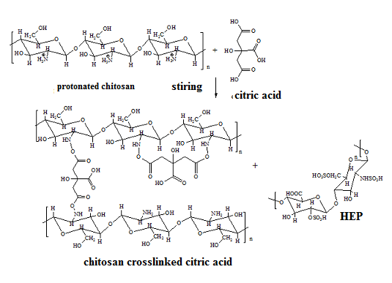
B

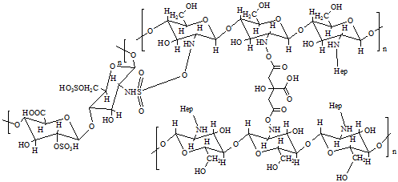

Fig. 1. Illustration of the possible reaction sites of chitosan with citric acid (a) heparin modification (b) (Lusiana, et al., 2016)

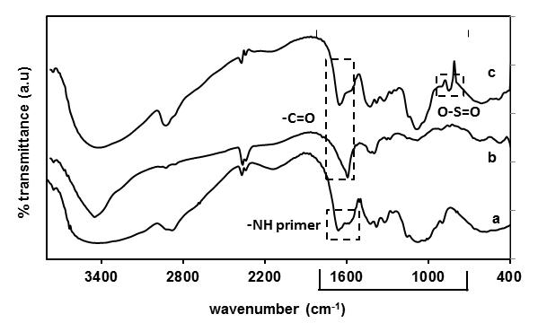

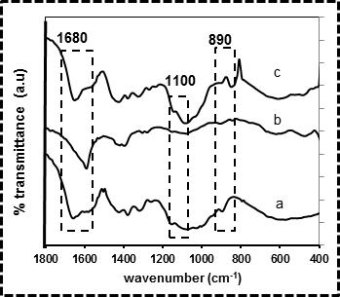

Fig. 2. . FTIR spectra of chitosan (a) citric acid crosslinked chitosan (b) heparin modification (c)

Tabel 1. Data of strain strength (F max), tensile strength, and swelling on various membranes

Membrane type | Sweeling | Tensile Strength (MPa) | Strain at F Max (%)
Chitosan (CS) | 104 | 1,11 | 16,40
Chitosan-citric acid (CS.CA) | 260 | 2,73 | 112,41
CS.CA/PVA (CS.CA-1) | 275 | 2,79 | 197,72
CS.CA-1/PEG (CS.CA-1/2) | 234 | 2,54 | 119,93
CS.CA-1/2-hep (CS.CA-1/2-Hep) | 205 | 1,50 | 33,61

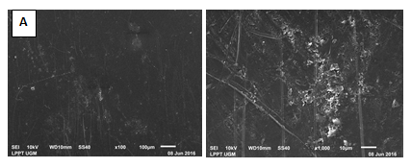
Fig. 3. SEM Images from Chitosan (A) modified chitosan blend membrane without heparin (B) and after mobilized with heparin (C)

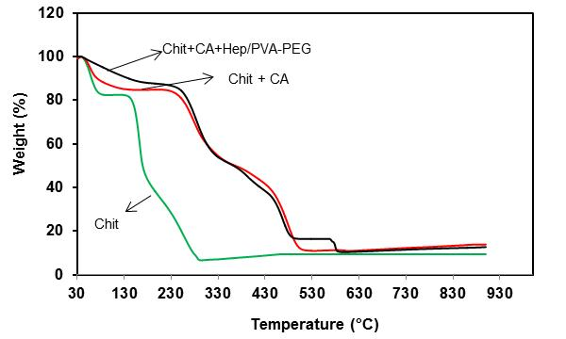
Fig. 4. Thermogram TGA from various membrane

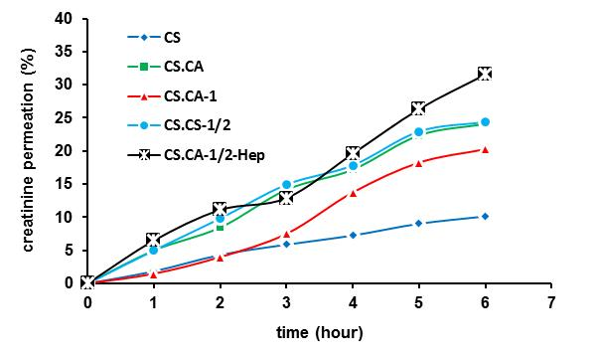
Fig. 5. Creatinine permeation through of the membranes

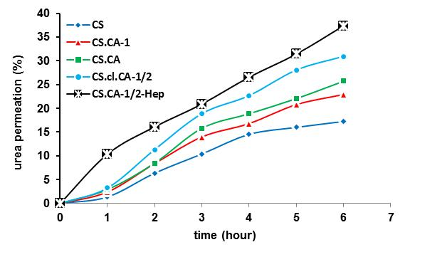
Fig. 6. Urea permeation through of the membranes

Fig. 7. Comparation of permeability percentage of the membranes

