**Supplementary Files**

**Molprobity and proQ Results for 1CF3**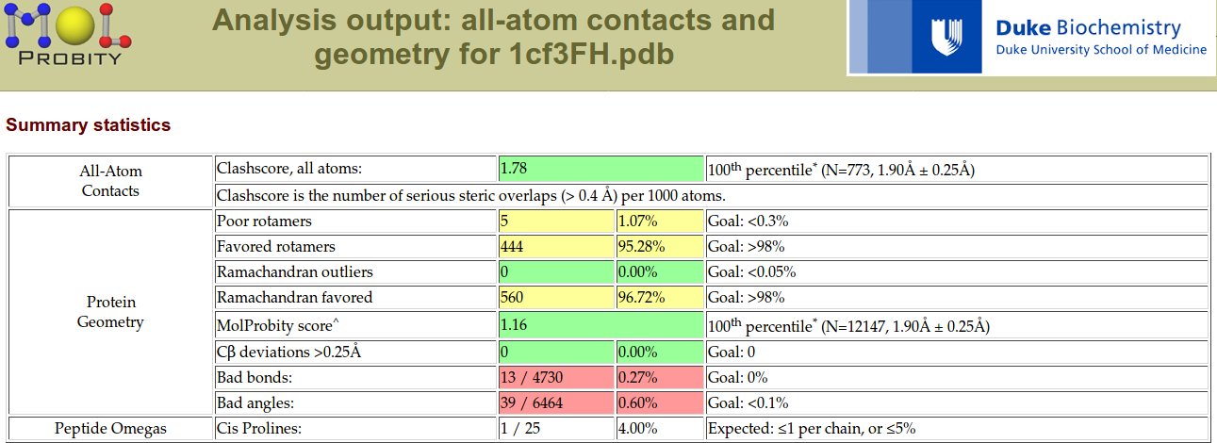

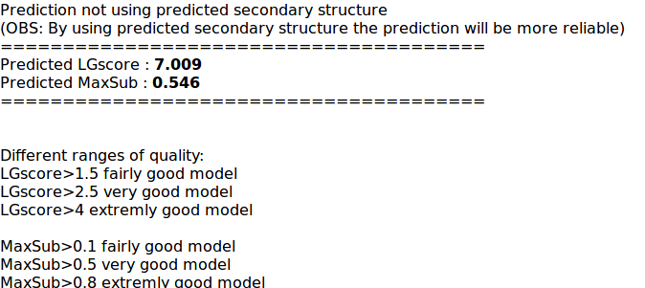

**Molprobity and proQ for 5NIT**

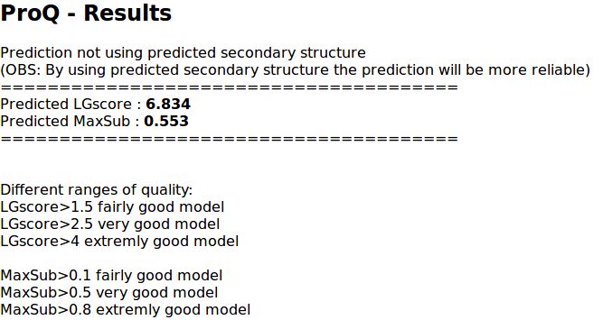

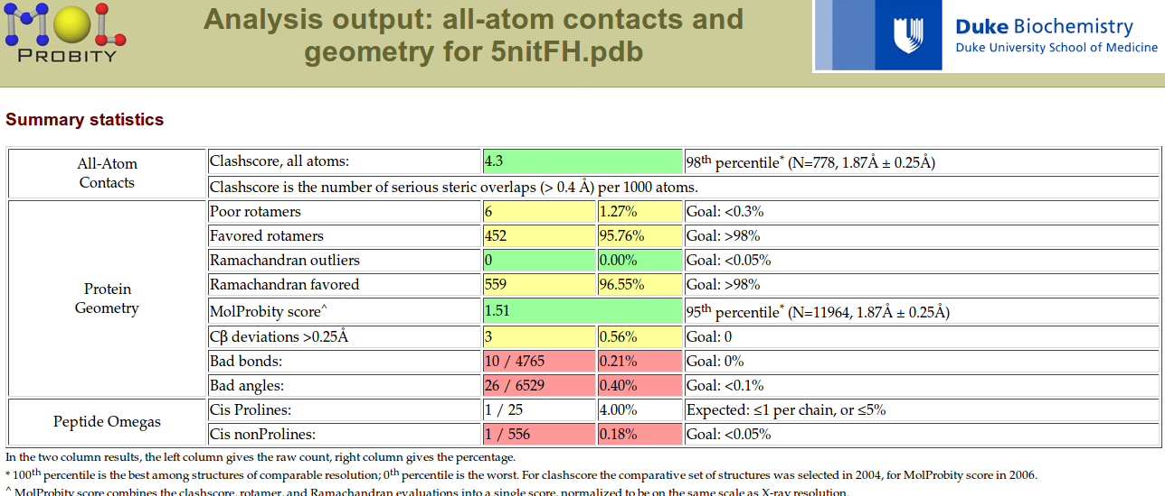

**Molprobity and proQ for GOD_IPBCC_1CF3**

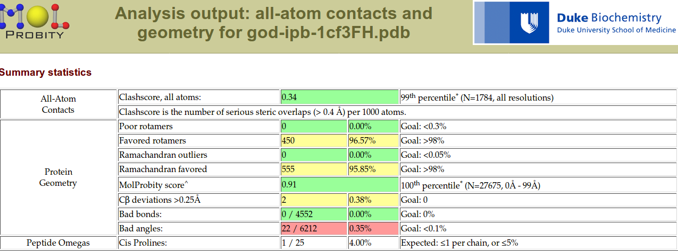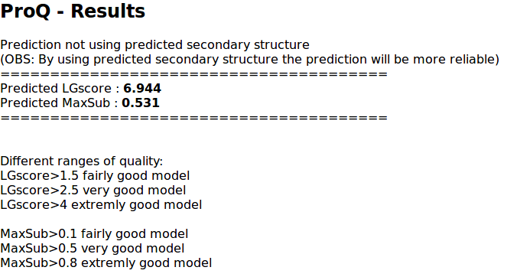

**Molprobity and proQ for GOD_IPBCC_5NIT**

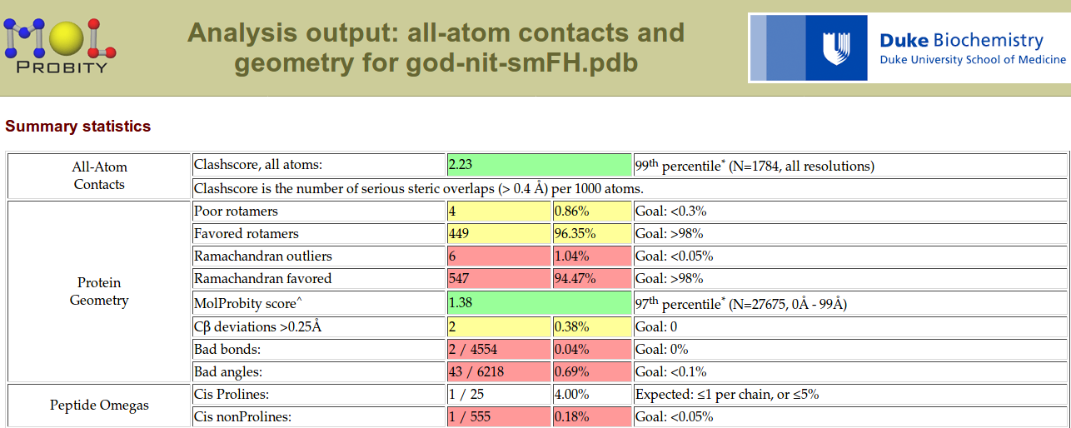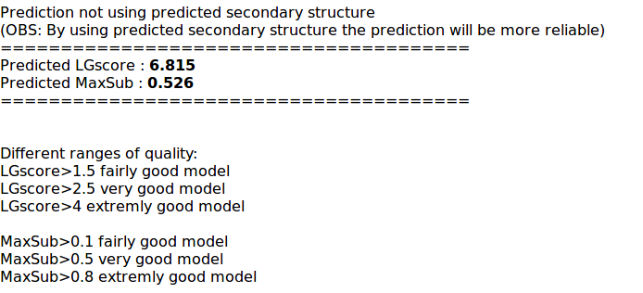

**Pfam domain architecture search within the sequences of GOD_IPBCC_1CF3**

