A | B
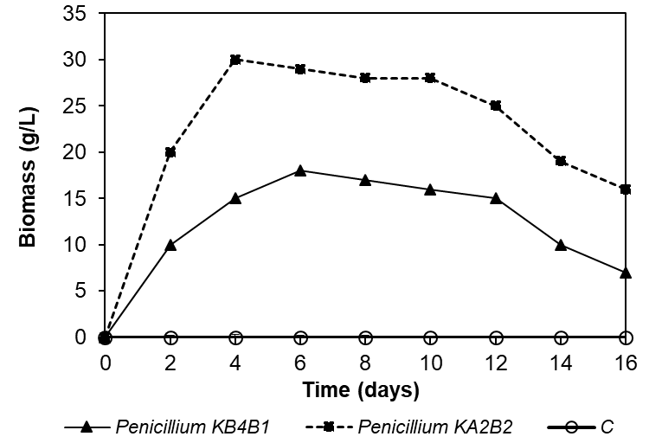 | 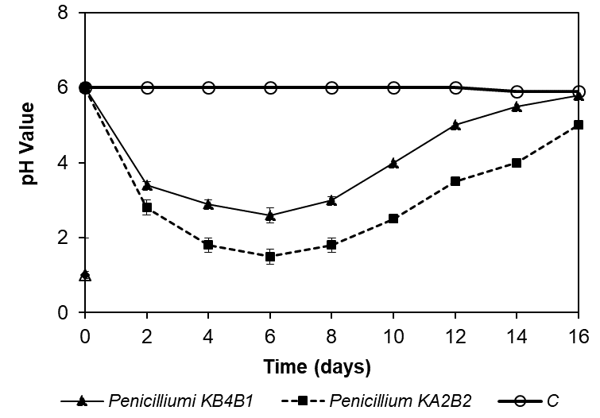
C
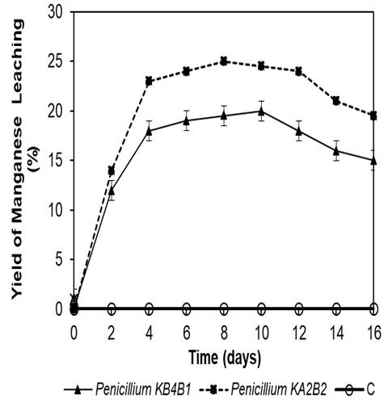

Fig 1. Changes in biomass (A); pH value (B); and manganese yield (C); between Penicillium KB4B1 and Penicillium KA2B2 at a pulp density of pyrolusite of 0.02 g/cm³ during 16 days of leaching.

A
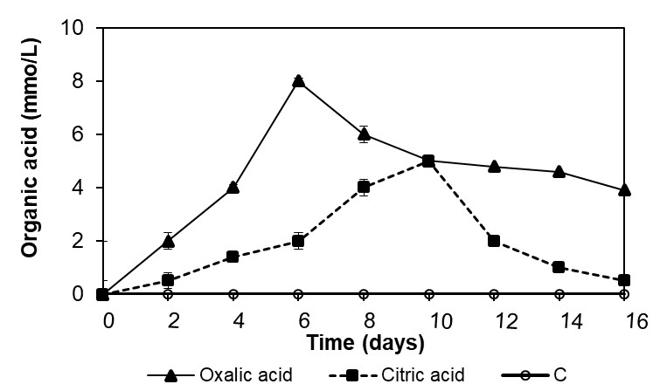
B
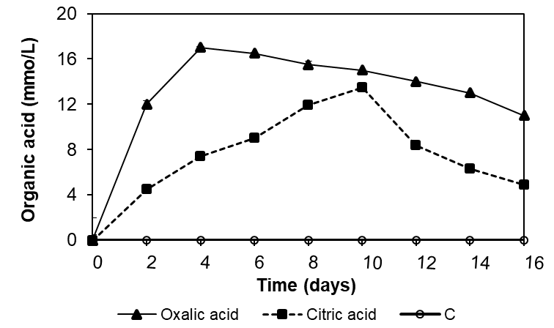

Fig 2. Organic acid production in Penicillium KB4B1 (A) and Penicillium KA2B2 (B) at pulp densities of pyrolusite of 0.02 g/cm³ in the 16-day leaching process.

Table 1. Macroscopic characters of two selected fungi isolated from sulfurous river sediment
Strain | On CYA |  |  | On MEA
Strain | Surface colony color | Reverse colony color | Diameter (mm) | Surface colony color | Reverse colony color | Diameter (mm)
KA2B2 | Green-gray | Orange to bright yellow | 3.6 | Green | Orange to bright yellow | 14.3
KB4B1 | Dark green | Green | 33.3 | Dark green | Yellow | 33.3

Table 2. Microscopic characters of two selected fungi isolated from sulfurous river sediment
Strain | Conidiophore Branching Pattern | Metulae | Phialide | Conidia | Stipes
KA2B2 | mono-verticillate | compact terminal | Ampuliform | <10 µm, globose, smooth-walled | Rather long, smooth-walled, vesiculate
KB4B1 | Mono-verticillate | tuberculate | Cylindrical, short, and wide neck | <10 µm, globose, smooth-walled | Relatively short

