(a) | (b)
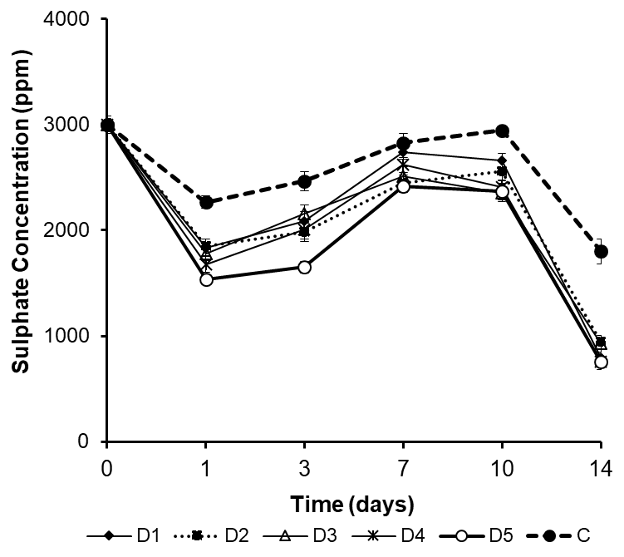 | 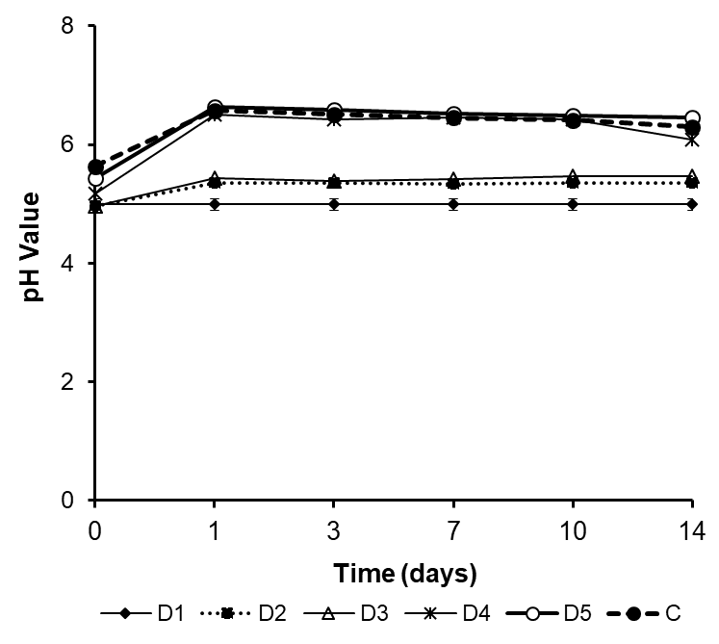
(c)
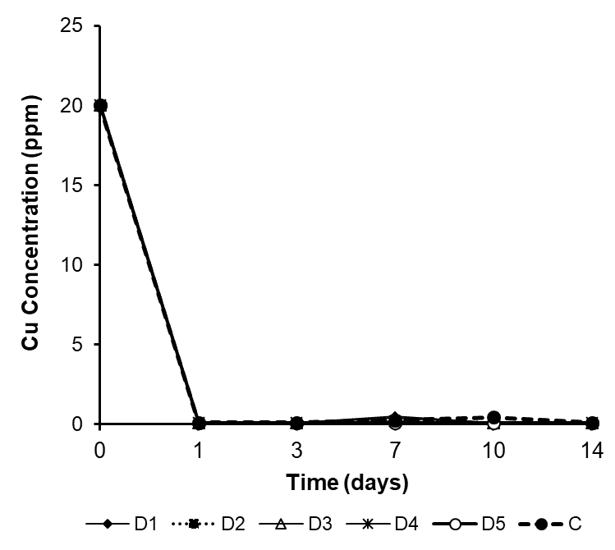

Fig. 1. The effect of zeolite doses on the changes of pH value, the removal of both sulphate and Cu concentrations as a function of time at batch experiment. The treatments of D1, D2, D3, D4 and D5 were added with zeolite at doses of 20, 40, 60, 80 and 100 g/L, respectively, whereas control (C), without zeolite addition

(a) | (b)
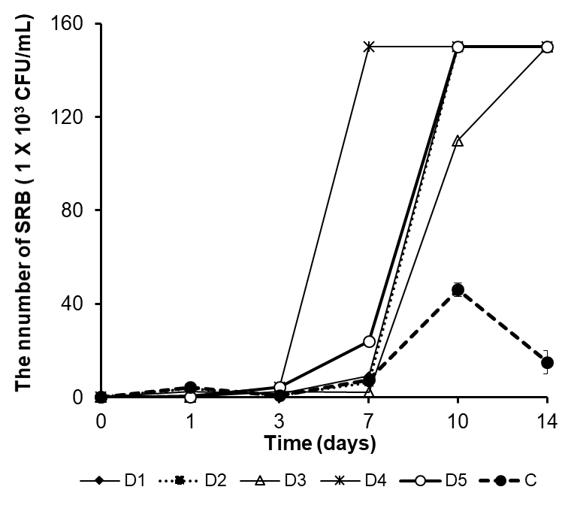 | 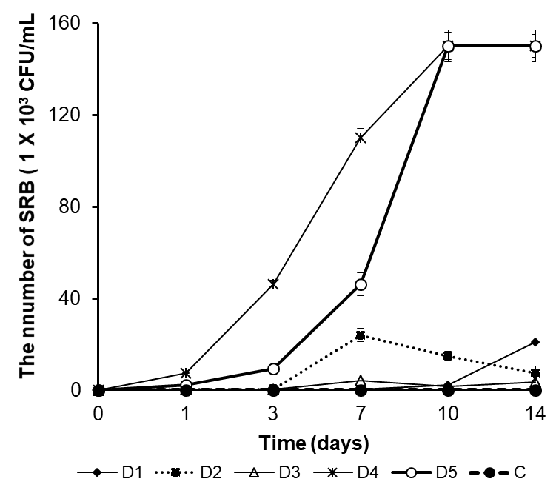

Fig. 2. The effect of zeolite doses on the growth of SRB consortium in the batch experiments, (a). planktonic phase, (b) biofilm phase. The treatments of D1, D2, D3, D4 and D5 were added with zeolite at doses of 20, 40, 60, 80 and 100 g/L respectively, whereas control (C) without zeolite addition.

.

(a)
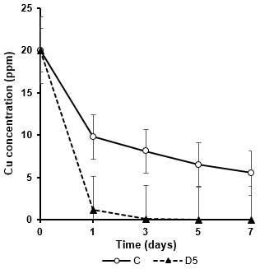
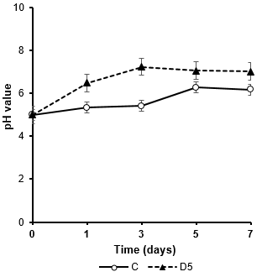(c)

(b)
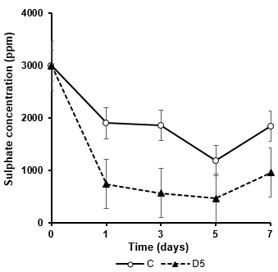

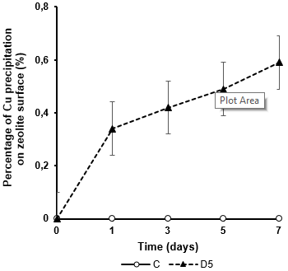
(d)

Fig. 3. The performance of the fixed-bed anaerobic bioreactor for the treatment of AMD using the sulphate reducing bacteria consortium from Sikidang Crater Sediment in the number of 1.5 x10⁵ cells/mm² and natural zeolite dose of 100 g/L with hydraulic retention time of 7 days at 30º C. (a). The change of pH values, (b) Sulphate concentration, (c). Cu concentration, (d). Percentage of Cu precipitation on zeolite surface at zeolite dose of 100 g/L. D5: zeolite dose of 100 gr/L and C: without zeolite addition.

(a)
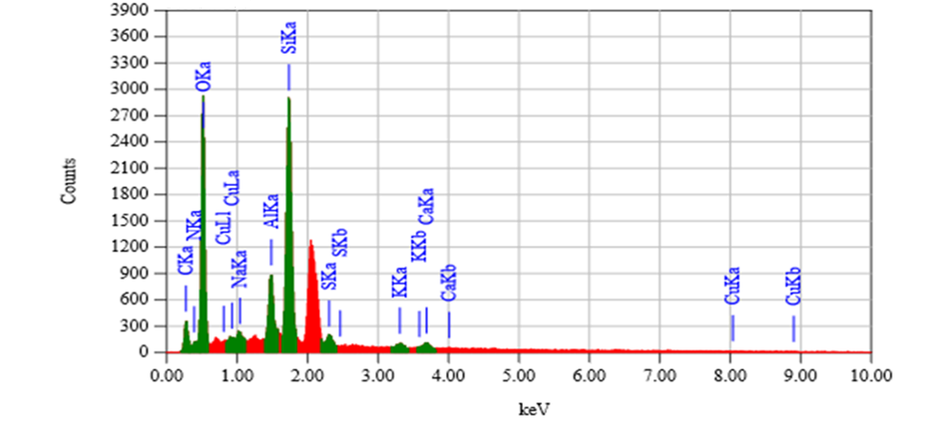
(b)
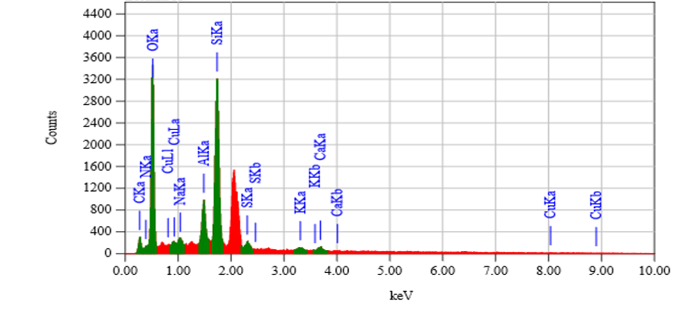
Fig. 4. EDX spectra of SRB consortium as biofilm attached on surface of zeolite particle after interacting with copper in the fixed-bed anaerobic bioreactor. SRB Biofilm formation after 1 day operation (a) and 7 days operation (b)
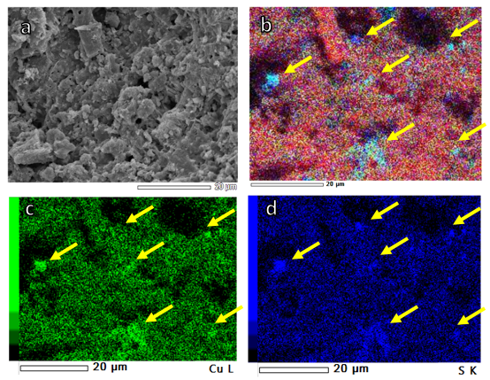

Fig. 5. SEM image of the consortium of SRB biofilms (a), EDX mapping image of CuS compound, (b)-(d). Cu and S element, yellow arrow indicated precipitated of solid CuS

