Cytotoxic Sesquiterpenoid from the stem bark of Aglaia harmsiana (Meliaceae)

Hersa Milawati¹, Desi Harneti¹, Unang Supratman^{1,2,*}
¹Department of Chemistry, Faculty of Mathematics and Natural Sciences, Universitas Padjadjaran, Jatinangor 45363, Indonesia.
²Central Laboratory, Universitas Padjadjaran, Jatinangor 45363, Indonesia.

E-mail: unang.supratman@unpad.ac.id

Table of Contents
Figure S1. ¹H-NMR Spectra of (1) (500 MHz in CDCl₃)
Figure S2. ¹³C-NMR Spectrum of (1) (125 MHz in CDCl₃)
Figure S3. DEPT-135° Spectrum of (1) (125 MHz in CDCl₃).
Figure S4. HMQC Spectrum of (1).
Figure S5. ¹H-¹H-COSY Spectra of (1).
Figure S6. HMBC Spectrum of (1).
Figure S7. NOESY Spectra of (1).
Figure S8. HRTOF-MS Spectrum of (1).
Figure S9. IR Spectrum of (1).
Figure S10. ¹H-NMR Spectra of (2) (500 MHz in CDCl₃)
Figure S11. ¹³C-NMR Spectrum of (2) (125 MHz in CDCl₃)
Figure S12. DEPT-135° Spectrum of (2) (125 MHz in CDCl₃).
Figure S13. HMQC Spectrum of (2).
Figure S14. ¹H-¹H-COSY Spectra of (2).
Figure S15. HMBC Spectrum of (2).
Figure S16. NOESY Spectra of (2).
Figure S17. HRTOF-MS Spectrum of (2).
Figure S18. IR Spectrum of (2).
Figure S19. ¹H-NMR Spectra of (3) (500 MHz in CDCl₃)
Figure S20. ¹³C-NMR Spectrum of (3) (125 MHz in CDCl₃)
Figure S21. DEPT-135° Spectrum of (3) (125 MHz in CDCl₃).
Figure S22. HMQC Spectrum of (3).
Figure S23. ¹H-¹H-COSY Spectra of (3).
Figure S24. HMBC Spectrum of (3).
Figure S25. NOESY Spectra of (3).
Figure S26. HRTOF-MS Spectrum of (3).
Figure S27. IR Spectrum of (3).

Figure S1. ¹H-NMR Spectra of (1) (500 MHz in CDCl₃)

Figure S2. ¹³C-NMR Spectrum of (1) (125 MHz in CDCl₃)

Figure S3. DEPT-135° Spectrum of (1) (125 MHz in CDCl₃).
Figure S4. HMQC Spectrum of (1).

Figure S5. ¹H-¹H-COSY Spectra of (1).
Figure S6. HMBC Spectrum of (1).
Figure S7. NOESY Spectra of (1).
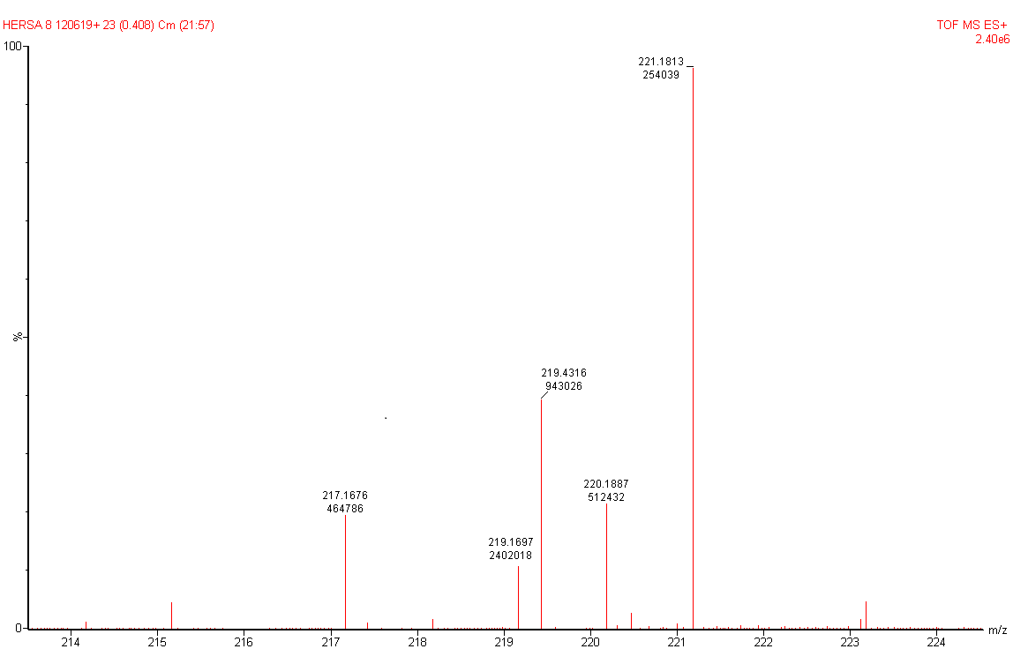
Figure S8. HRTOF-MS Spectrum of (1).

Figure S9. IR Spectrum of (1).

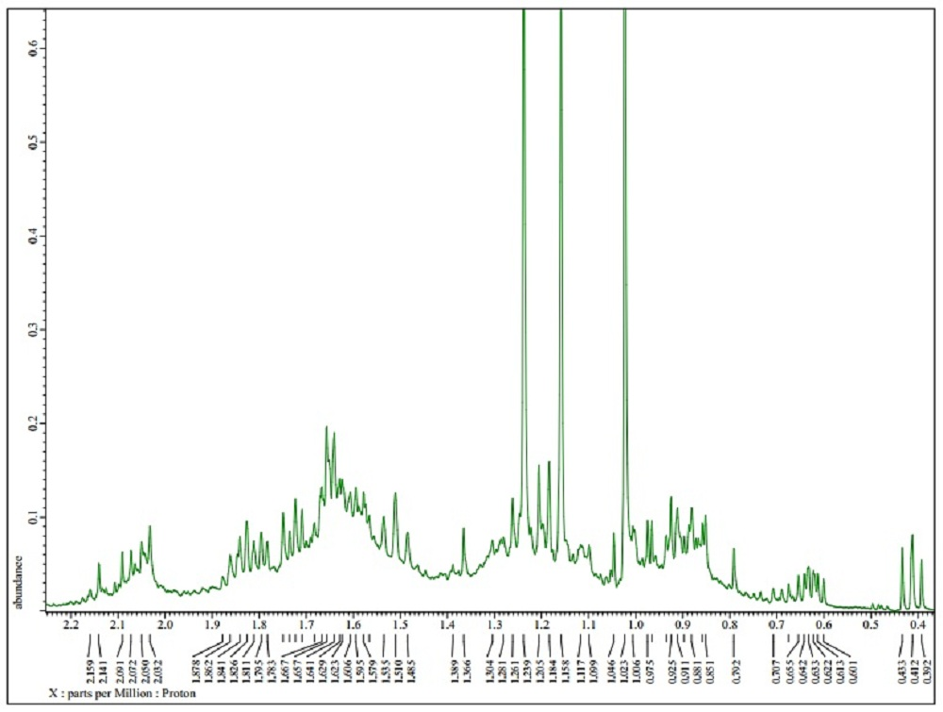
Figure S10. ¹H-NMR Spectra of (2) (500 MHz in CDCl₃)

Figure S11. ¹³C-NMR Spectrum of (2) (125 MHz in CDCl₃)

Figure S12. DEPT-135° Spectrum of (2) (125 MHz in CDCl₃).

Figure S13. HMQC Spectrum of (2).

Figure S14. ¹H-¹H-COSY Spectra of (2).
Figure S15. HMBC Spectrum of (2).
Figure S16. NOESY Spectra of (2).
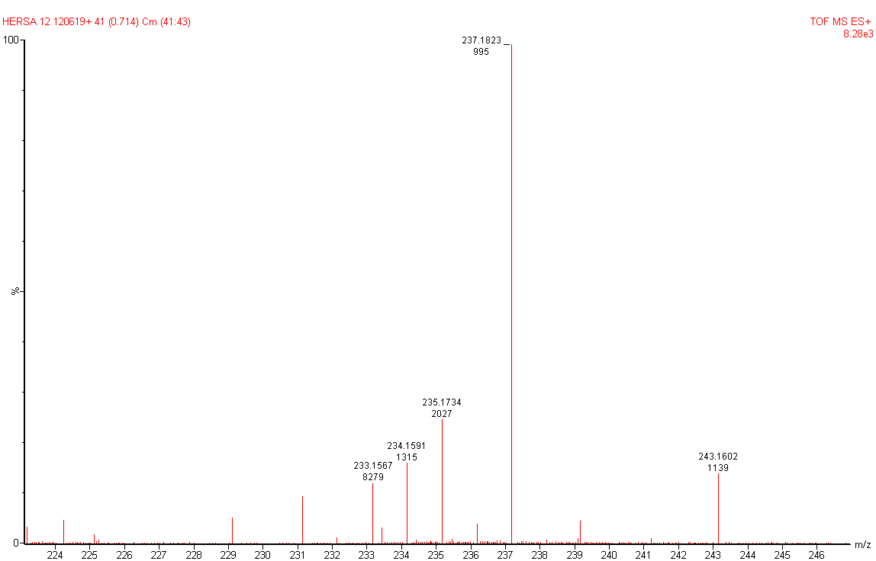
Figure S17. HRTOF-MS Spectrum of (2).

Figure S18. IR Spectrum of (2).

Figure S19. ¹H-NMR Spectra of (3) (500 MHz in CDCl₃)
Figure S20. ¹³C-NMR Spectrum of (3) (125 MHz in CDCl₃)

Figure S21. DEPT-135° Spectrum of (3) (125 MHz in CDCl₃).

Figure S22. HMQC Spectrum of (3).

Figure S23. ¹H-¹H-COSY Spectra of (3).
Figure S24. HMBC Spectrum of (3).
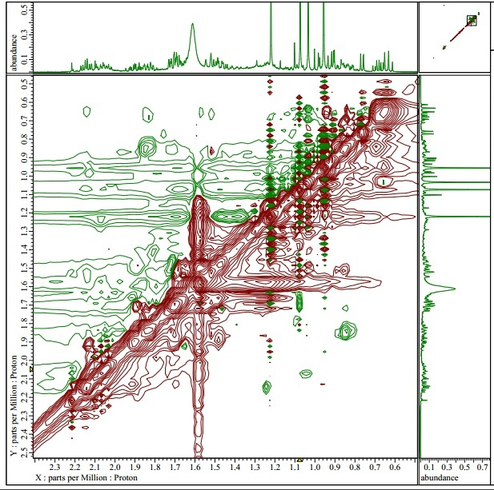
Figure S25. NOESY Spectra of (3).

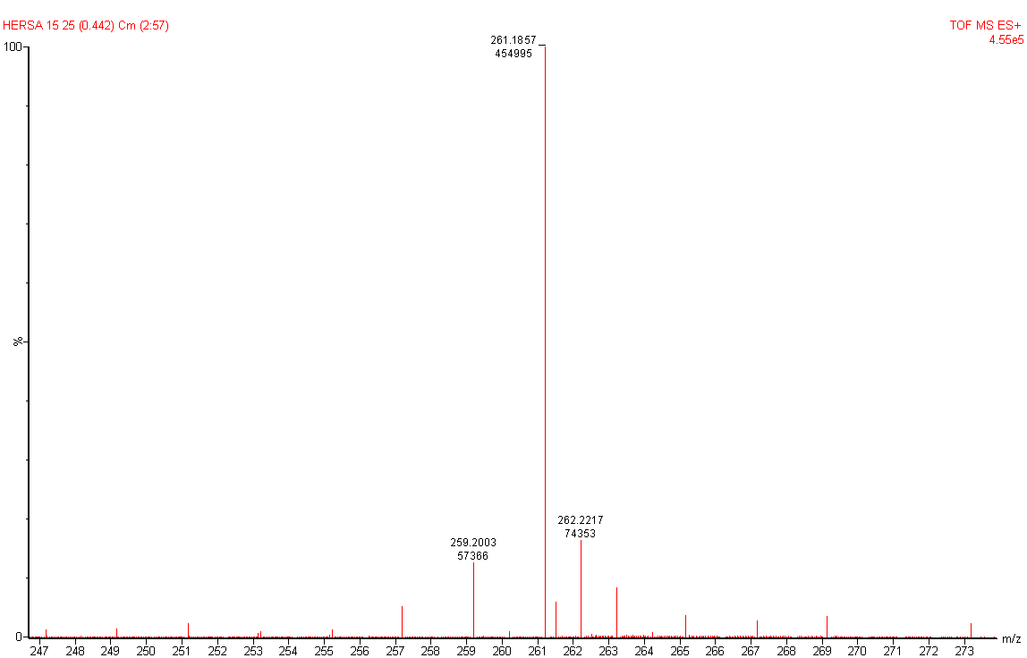
Figure S26. HRTOF-MS Spectrum of (3).

Figure S27. IR Spectrum of (3).

