Supplementary Information (SI)
SI 1:
The photoreduction of Ag (I) from radiophotography wastewater
  - Making of standard solution

Concentrations (mg/L) | Absorbances
2  4  6  8  10 | 0.071  0.139  0.193  0.254  0.310

  - Photoreduction of Ag⁺ from radiophotography wastewater catalyzed by TiO₂

Weight of TiO₂ (mg) | Initial weight of Ag in the wastewater (mg/1000 mL) | Initial weight of Ag in the 250 mL (mg/250 mL) | Residual weight of Ag in the 250 mL (mg) | Reduced weight of Ag (mg) | Weight of Ag in 1 g of catalyst (mg/g)
150  300  450 | 1502.5  1502.5  1502.5 | 375.625  375.625  375.625 | 110.479  95.747  146.252 | 265.146  279.878  229.373 | 1.77  0.93  0.51

  - Calculation of Ag⁺ photoreduction from radiophotography wastewater catalyzed by TiO₂
Initial concentration of Ag in the radiophotography wastewater:
y = 0.0297x + 0.0155
0.194 = 0.0297x + 0.0155
x = $\frac{0.1785}{0.0297}$
x = 6.01
Cs = 6.01 x 250
= 1502.5 mg/L
So, the concentration of Ag in the 250 mL of sample is 375.625 mg/L.
TiO₂ with 150 mg of weight
y = 0.0297x + 0.0155
0.068 = 0.0297x + 0.0155
x = $\frac{0.0525}{0.0297}$
x = 1.767
Cs = 1.767 x 250
= 441.91 mg/L
Final weight of Ag⁺ = Concentration of Ag⁺ in the filtrate x Volume of
filtrate (L)
= 441.91 mg/L x 0.250 L
= 110.479 mg
Reduced weight of Ag = Initial weight of Ag⁺ – residual weight of Ag⁺
= 375.625 mg - 110.479 mg
= 265.146 mg
Weight of Ag in catalyst (mg/g) = $\frac{reduced weight of Ag}{catalyst weight of {TiO}_{2}^{}}$
= $\frac{265.146 mg}{150 mg}$
= 1.77 mg
TiO₂ with 300 mg of weight
y = 0.0297x + 0.0155
0.061 = 0.0297x + 0.0155
x = $\frac{0.0455}{0.0297}$
x = 1.532
Cs = 1.532 x 250
= 382.99 mg/L
Final weight of Ag⁺ = Concentration of Ag⁺ in the filtrate x Volume of
filtrate (L)
= 382.99 mg/L x 0.250 L
= 95.747 mg
Reduced weight of Ag = Initial weight of Ag⁺ – residual weight of Ag⁺
= 375.625 mg – 95.747 mg
= 279.878 mg
Weight of Ag in catalyst (mg/mg) = $\frac{reduced weight of Ag}{catalyst weight of {TiO}_{2}^{}}$
= $\frac{279.878 mg}{300 mg}$
= 0.93 mg
TiO₂ with 450 mg of weight
y = 0.0297x + 0.0155
0.085 = 0.0297x + 0.0155
x = $\frac{0.0695}{0.0297}$
x = 2.340
Cs = 2.340 x 250
= 585.01 mg/L

Final weight of Ag⁺ = Concentration of Ag⁺ in the filtrate x Volume of
filtrate (L)
= 585.01 mg/L x 0.250 L
= 146.252 mg
Reduced weight of Ag = Initial weight of Ag⁺ – residual weight of Ag⁺ = 375.625 mg – 146.252 mg
= 229.373 mg
Weight of Ag in catalyst (mg/mg) = $\frac{reduced weight of Ag}{catalyst weight of {TiO}_{2}^{}}$ = $\frac{229.373 mg}{450 mg}$
= 0.51 mg

SI 2: Calculation of band gap energy using edge absorption theory
2.1 Calculation result of SR-UV for TiO₂ photocatalyst
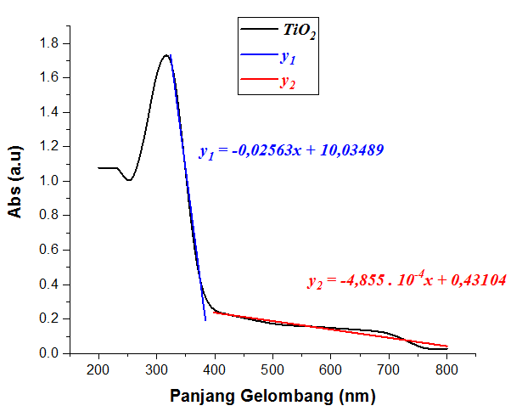

Wavelength (nm)

y₁ = y₂
-0.02563x + 10.03489 = -4.855 x 10⁻⁴x + 0.43104
10.03489-0.43104 = -4.855 x 10⁻⁴x + 0.02563x
9.60385 = 0.0251445x
x = $\frac{9.60385}{0.0251445}$
x = 381.94 nm
E (Joule) = $\frac{h.c}{λ}$
= $\frac{{6.63 x 10}^{-34} J.s . 3 x {10}^{8}m.s^{-1}}{{3.8194 x 10}^{-7} nm}$
= $\frac{{1.989 x 10}^{-25} J.s. m.s^{-1}}{{3.8194 x 10}^{-7} nm}$
= 5.207 x 10⁻¹⁹ J
E (Joule) = $\frac{E(Volt)}{6.24151 x {10}^{18}}$
E (Volt) = 5.207 x 10⁻¹⁹ J . $6.24151 x {10}^{18}$
= 3.25 eV

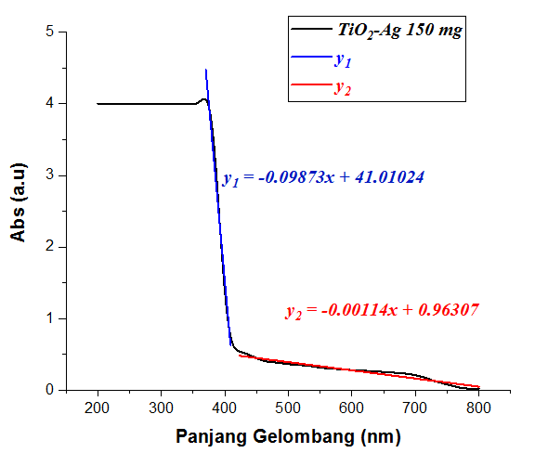
2.2 Calculation result of SR-UV for TiO₂/Ag photocatalyst (150/1.767 mg)

Wavelength (nm)

y₁ = y₂
-0.09873x + 41.01024 = -0.00114x + 0.96307
41.01024-0.96307 = -0.00114x + 0.09873x
40.04717 = 0.09759x
x = $\frac{40.04717}{0.09759}$
x = 410.36 nm
E (Joule) = $\frac{h.c}{λ}$
= $\frac{{6.63 x 10}^{-34} J.s . 3 x {10}^{8}m.s^{-1}}{{4.1036 x 10}^{-7} nm}$
= $\frac{{1.989 x 10}^{-25} J.s. m.s^{-1}}{{4.1036 x 10}^{-7} nm}$
= 4.847 x 10⁻¹⁹ J
E (Joule) = $\frac{E(Volt)}{6.24151 x {10}^{18}}$
E (Volt) = 4.847 x 10⁻¹⁹ J . $6.24151 x {10}^{18}$
= 3.02 eV

2.3 Calculation result of SR-UV for TiO₂/Ag photocatalyst (300/0.933 mg)
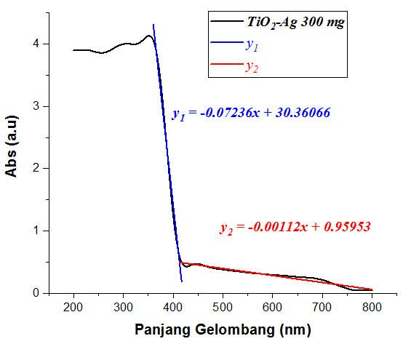

Wavelength (nm)

y₁ = y₂
-0.07236x + 30.36066 = -0.00112x + 0.95953
30.36066 – 0.95953 = -0.00112x + 0.07236x
29.40113 = 0.07124x
x = $\frac{29.40113}{0.07124}$
x = 412.70 nm
E (Joule) = $\frac{h.c}{λ}$
= $\frac{{6.63 x 10}^{-34} J.s . 3 x {10}^{8}m.s^{-1}}{{4.1270 x 10}^{-7} nm}$
= $\frac{{1.989 x 10}^{-25} J.s. m.s^{-1}}{{4.1270 x 10}^{-7} nm}$
= 4.8194.10⁻¹⁹ J
E (Joule) = $\frac{E(Volt)}{6.24151 x {10}^{18}}$
E (Volt) = 4.8194 x 10⁻¹⁹ J . $6.24151 x {10}^{18}$
= 3.00 eV

2.4 Calculation result of SR-UV for TiO₂/Ag photocatalyst (450/0.509 mg)
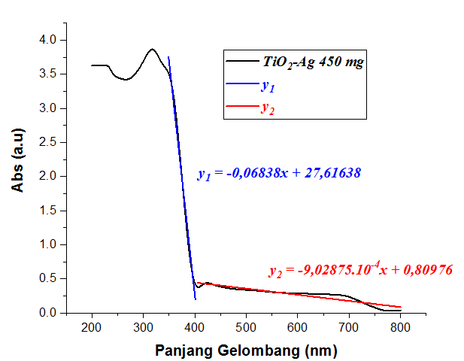

Wavelength (nm)

y₁ = y₂
-0.06838x + 27.61638 = -9.02875 x 10⁻⁴x + 0.80976
27.61638 – 0.80976 = -9.02875 x 10⁻⁴x + 0.06838x
26.80662 = 0.06747x
x = $\frac{26.80662}{0.06747}$
x = 397.31 nm
E (Joule) = $\frac{h.c}{λ}$
= $\frac{{6.63 x 10}^{-34} J.s . 3 x {10}^{8}m.s^{-1}}{{3.9731 x 10}^{-7} nm}$
= $\frac{{1.989 x 10}^{-25} J.s. m.s^{-1}}{{3.9731 x 10}^{-7} nm}$
= 5.0061 x 10⁻¹⁹ J
E (Joule) = $\frac{E(Volt)}{6.24151 x {10}^{18}}$
E (Volt) = 5.0061 x 10⁻¹⁹ J . $6.24151 x {10}^{18}$
= 3.12 eV

SI 3: Caracterization Result of XRD
3.1 Difractogram of TiO₂

Measurement Conditions:

Dataset Name TiO2
File name E:\DATA PENGUJIAN\Pengujian 2019\Mei\Nahzim\TiO2\TiO2.rd
Comment Configuration=Reflection-Transmission Sp
Goniometer=PW3050/60 (Theta/Theta); Mini
Measurement Date / Time 5/9/2019 11:23:00 AM
Raw Data Origin PHILIPS-binary (scan) (.RD)
Scan Axis Gonio
Start Position [°2Th.] 5.0084
End Position [°2Th.] 89.9744
Step Size [°2Th.] 0.0170
Scan Step Time [s] 10.1500
Scan Type Continuous
Offset [°2Th.] 0.0000
Divergence Slit Type Fixed
Divergence Slit Size [°] 0.2500
Specimen Length [mm] 10.00
Receiving Slit Size [mm] 12.7500
Measurement Temperature [°C] -273.15
Anode Material Cu
K-Alpha1 [Å] 1.54060
K-Alpha2 [Å] 1.54443
K-Beta [Å] 1.39225
K-A2 / K-A1 Ratio 0.50000
Generator Settings 30 mA. 40 kV
Diffractometer Type XPert MPD
Diffractometer Number 1
Goniometer Radius [mm] 200.00
Dist. Focus-Diverg. Slit [mm] 91.00
Incident Beam Monochromator No
Spinning Yes

Main Graphics. Analyze View:

Peak List:

Pos. [°2Th.] | Height [cts] | FWHM Left [°2Th.] | d-spacing [Å] | Rel. Int. [%]
25.1301 | 1575.25 | 0.2007 | 3.54376 | 100.00
27.2658 | 20.99 | 0.2007 | 3.27084 | 1.33
28.2320 | 6.70 | 0.1506 | 3.16105 | 0.43
36.7986 | 95.77 | 0.1673 | 2.44248 | 6.08
37.5962 | 334.97 | 0.0669 | 2.39247 | 21.26
38.4318 | 105.29 | 0.2007 | 2.34236 | 6.68
41.3423 | 5.10 | 0.8029 | 2.18393 | 0.32
47.8685 | 501.85 | 0.1338 | 1.90032 | 31.86
52.2461 | 2.40 | 0.1004 | 1.75093 | 0.15
53.6934 | 284.62 | 0.1171 | 1.70711 | 18.07
54.9072 | 286.25 | 0.0836 | 1.67221 | 18.17
61.9399 | 51.45 | 0.1673 | 1.49816 | 3.27
62.5450 | 227.81 | 0.1338 | 1.48512 | 14.46
68.5963 | 93.18 | 0.1338 | 1.36812 | 5.92
70.1619 | 103.65 | 0.1171 | 1.34138 | 6.58
74.8830 | 171.14 | 0.1171 | 1.26809 | 10.86
75.8810 | 36.14 | 0.1224 | 1.25284 | 2.29
80.6568 | 9.15 | 0.4015 | 1.19125 | 0.58
82.5637 | 73.51 | 0.1673 | 1.16850 | 4.67

3.2 Difractogram of TiO₂/Ag (150/1.767 mg)

Main Graphics. Analyze View:

Peak List:

Pos. [°2Th.] | Height [cts] | FWHM Left [°2Th.] | d-spacing [Å] | Rel. Int. [%]
25.2678 | 866.34 | 0.2175 | 3.52475 | 100.00
27.3999 | 11.04 | 0.4015 | 3.25513 | 1.27
36.9949 | 51.26 | 0.2342 | 2.42997 | 5.92
37.7881 | 211.63 | 0.2342 | 2.38077 | 24.43
38.5505 | 69.22 | 0.2007 | 2.33542 | 7.99
47.9354 | 257.91 | 0.0669 | 1.89782 | 29.77
53.8196 | 168.79 | 0.1506 | 1.70340 | 19.48
55.0099 | 165.61 | 0.3011 | 1.66933 | 19.12
62.0610 | 31.67 | 0.1338 | 1.49553 | 3.66
62.6149 | 129.77 | 0.1673 | 1.48363 | 14.98
68.6971 | 55.63 | 0.2007 | 1.36636 | 6.42
70.1959 | 63.55 | 0.1673 | 1.34082 | 7.33
74.0345 | 12.14 | 0.2007 | 1.28051 | 1.40
74.9830 | 99.36 | 0.2007 | 1.26665 | 11.47
75.9788 | 25.24 | 0.2007 | 1.25251 | 2.91
80.9764 | 4.24 | 0.6691 | 1.18735 | 0.49
82.6274 | 59.95 | 0.1224 | 1.16680 | 6.92

3.3 Difractogram of TiO₂/Ag (300/0.93 mg)

Main Graphics. Analyze View:

Peak List:

Pos. [°2Th.] | Height [cts] | FWHM Left [°2Th.] | d-spacing [Å] | Rel. Int. [%]
25.2592 | 1087.19 | 0.2007 | 3.52594 | 100.00
36.9089 | 73.77 | 0.2007 | 2.43543 | 6.79
37.6928 | 246.26 | 0.1224 | 2.38459 | 22.65
37.7750 | 250.46 | 0.0836 | 2.38156 | 23.04
38.4671 | 84.06 | 0.2007 | 2.34029 | 7.73
47.9823 | 366.45 | 0.1004 | 1.89608 | 33.71
53.7824 | 199.31 | 0.1171 | 1.70449 | 18.33
55.0057 | 236.11 | 0.0816 | 1.66806 | 21.72
62.0247 | 35.67 | 0.1673 | 1.49632 | 3.28
62.6250 | 156.99 | 0.1171 | 1.48341 | 14.44
68.6572 | 76.40 | 0.1004 | 1.36706 | 7.03
70.2697 | 82.73 | 0.1171 | 1.33959 | 7.61
75.0281 | 113.47 | 0.1004 | 1.26600 | 10.44
75.9904 | 31.86 | 0.1338 | 1.25234 | 2.93
82.6029 | 57.01 | 0.1338 | 1.16805 | 5.24

3.4 Difractogram of TiO₂/Ag (450/0.51 mg)

Main Graphics. Analyze View:

Peak List:

Pos. [°2Th.] | Height [cts] | FWHM Left [°2Th.] | d-spacing [Å] | Rel. Int. [%]
25.1932 | 1204.81 | 0.1338 | 3.53502 | 100.00
27.3402 | 13.11 | 0.2007 | 3.26211 | 1.09
36.8265 | 60.20 | 0.2007 | 2.44069 | 5.00
37.6652 | 265.19 | 0.0669 | 2.38825 | 22.01
38.4377 | 77.14 | 0.1673 | 2.34201 | 6.40
47.9267 | 391.90 | 0.0816 | 1.89658 | 32.53
48.0490 | 266.04 | 0.0816 | 1.89674 | 22.08
53.7986 | 225.35 | 0.1632 | 1.70260 | 18.70
54.9364 | 239.77 | 0.1428 | 1.67000 | 19.90
61.9873 | 48.66 | 0.1224 | 1.49589 | 4.04
62.5483 | 171.12 | 0.1020 | 1.48382 | 14.20
68.6414 | 72.92 | 0.1632 | 1.36620 | 6.05
70.1653 | 88.32 | 0.1020 | 1.34022 | 7.33
74.8996 | 110.78 | 0.1224 | 1.26680 | 9.19
75.1727 | 69.64 | 0.1224 | 1.26601 | 5.78
75.9150 | 31.36 | 0.2448 | 1.25236 | 2.60
82.5714 | 58.15 | 0.2040 | 1.16745 | 4.83

SI 4: Caracterization Result of FTIR
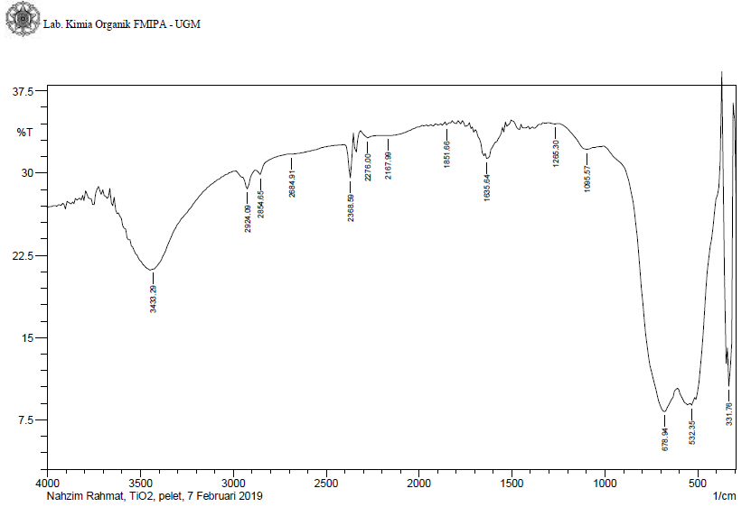
4.1 Spectra of TiO₂

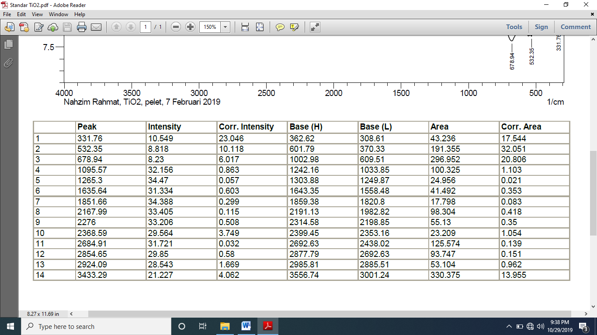

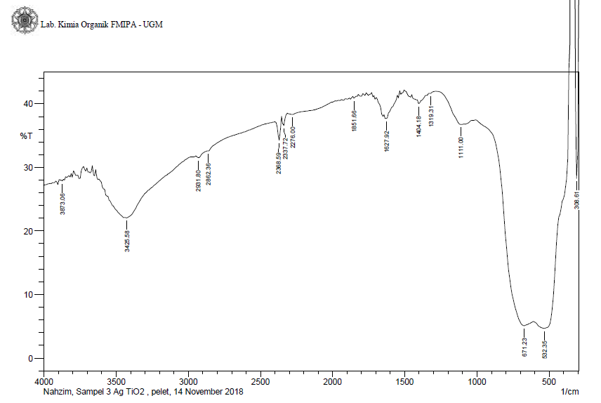
4.2 Spectra of TiO₂/Ag (150/1.77 mg)

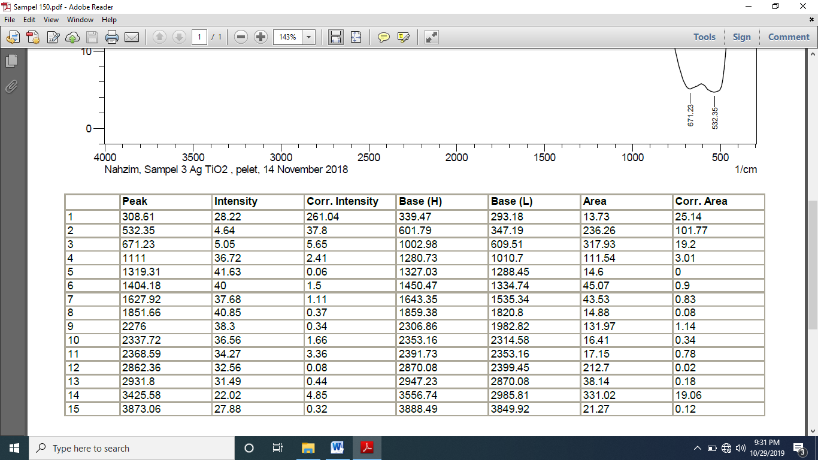

4.3 Spectra of TiO₂/Ag (300/0.93 mg)

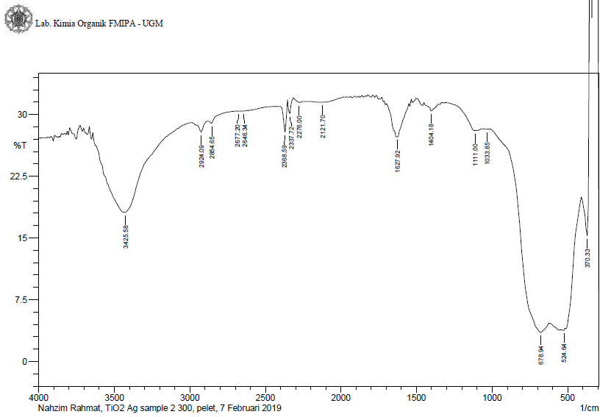

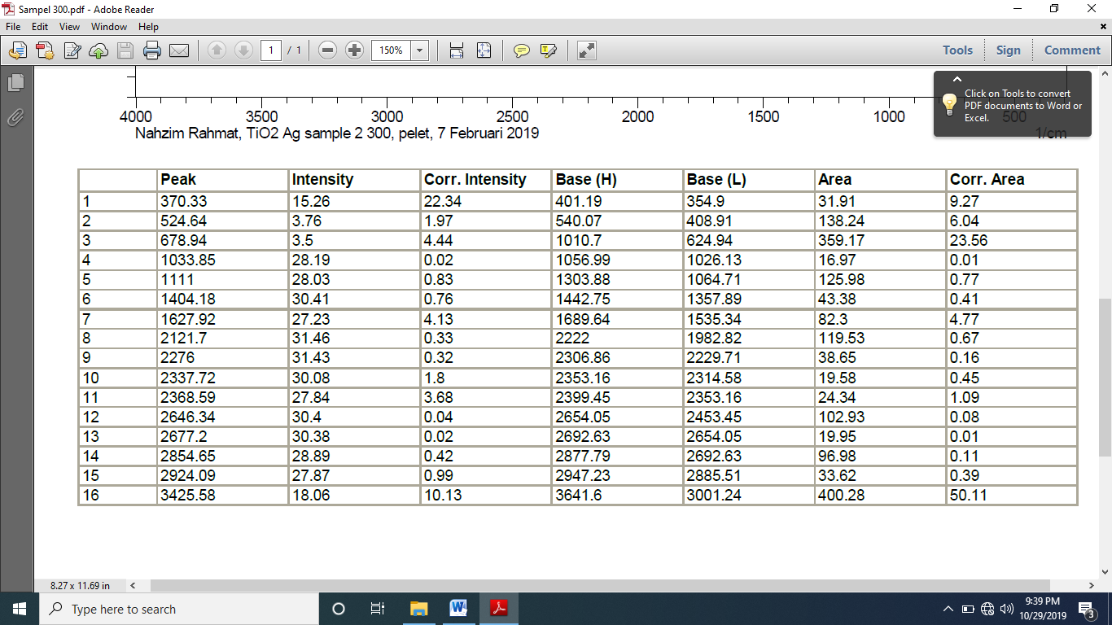

4.4 Spectra of TiO₂/Ag (450/0.51 mg)

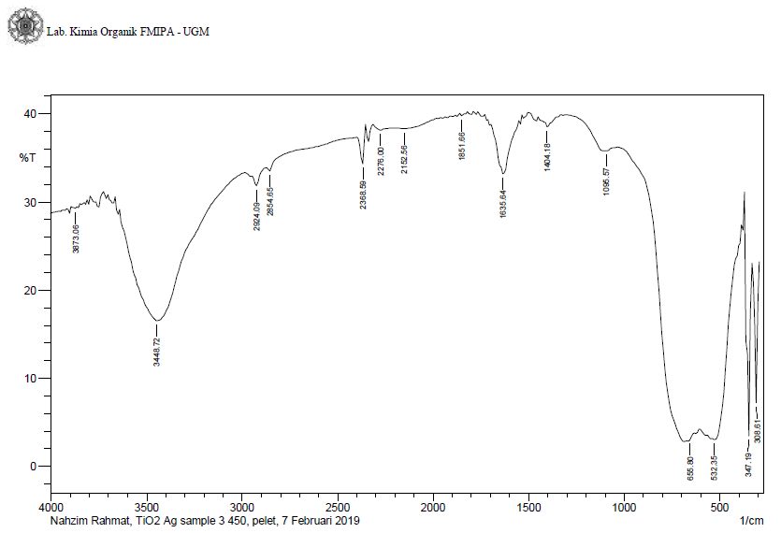

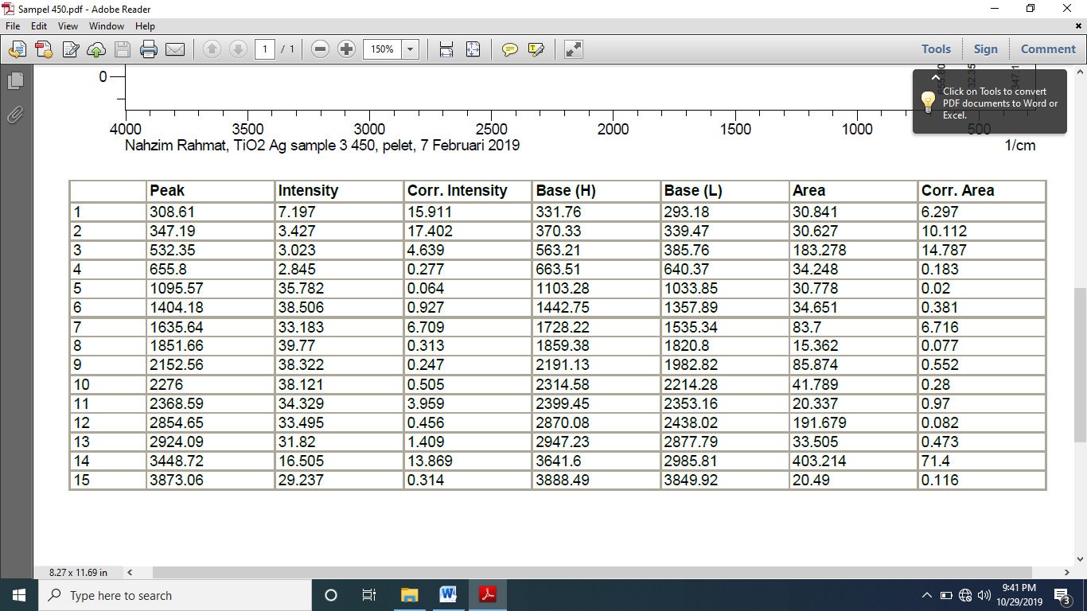

SI 5: Measurement result of inhibition zone
Additional information:
Blank disk diameter : 6 mm
Sample : TiO₂/Ag (I) with 0.3 g/L of the doses
TiO₂/Ag (I) with 0.50 g/L of the doses
TiO₂/Ag (I) with 0.7 g/L of the doses
TiO₂/Ag (I) with 1 g/L of the doses
Ampicillin : as a positive control with 10 µg of concentration.
Blank Disk : as a negative control with aquades.
Fungi for susceptibility test : Candida albicans.
Test Method : Agar Disc Diffusion Test (Kirby-Bauer)

Table V.1. The effect of visible light irradiation time and dosage of TiO₂/Ag (I) on the antifungal activity of Candida albicans
Sample Dosages | Irradiation time (hours)
Sample Dosages | 1 | 3 | 5 | 7 | 10
Sample Dosages | Inhibition zone (mm)
Control (+)* | 24.01 mm | 24.01 mm | 24.01 mm | 24.01 mm | 24.01 mm
Control (-)** | 0 mm | 0 mm | 0 mm | 0 mm | 0 mm
0.3 g/L | 1.01 mm | 1.03 mm | 2.05 mm | 1.03 mm | 1.02 mm
0.5 g/L | 1.02 mm | 1.03 mm | 4.05 mm | 1.06 mm | 1.05 mm
0.7 g/L | 1.02 mm | 1.03 mm | 3.02 mm | 1.03 mm | 1.04 mm
1 g/L | 1.02 mm | 1.04 mm | 3.01 mm | 1.04 mm | 1.04 mm
*ampicillin as a positive control
**aquades as a negative control
Tabel V.2. The effect of UV light irradiation time and dosage of TiO₂/Ag (I) on the antifungal activity of Candida albicans
Sample dosages | Irradiation time (hours)
Sample dosages | 1 | 3 | 5 | 7 | 10
Sample dosages | Inhibition zone (mm)
Control (+)* | 24.00 mm | 24.00 mm | 24.01 mm | 24.01 mm | 24.01 mm
Control (-)** | 0 mm | 0 mm | 0 mm | 0 mm | 0 mm
0.3 g/L | 1.03 mm | 1.06 mm | 1.96 mm | 1.24 mm | 1.23 mm
0.5 g/L | 1.05 mm | 1.06 mm | 5.12 mm | 1.25 mm | 1.23 mm
0.7 g/L | 1.02 mm | 1.04 mm | 3.03 mm | 1.22 mm | 1.04 mm
1 g/L | 1.02 mm | 1.04 mm | 3.01 mm | 1.04 mm | 1.04 mm
*ampicillin as a positive control
**aquades as a negative control

Tabel V.3. The effect of visible light irradiation time and dosage of TiO₂ on the antifungal activity of Candida albicans
Sample Dosages | Irradiation time (hours)
Sample Dosages | 1 | 3 | 5 | 7 | 10
Sample Dosages | Inhibition zone (mm)
Control (+)* | 24.00 mm | 24.00 mm | 24.00 mm | 24.00 mm | 24.00 mm
Control (-)** | 0 mm | 0 mm | 0 mm | 0 mm | 0 mm
0.3 g/L | 0.00 mm | 0.00 mm | 0.00 mm | 0.00 mm | 0.00 mm
0.5 g/L | 0.00 mm | 0.00 mm | 0.00 mm | 0.00 mm | 0.00 mm
0.7 g/L | 0.00 mm | 0.00 mm | 0.00 mm | 0.00 mm | 0.00 mm
1 g/L | 0.00 mm | 0.00 mm | 0.00 mm | 0.00 mm | 0.00 mm
*ampicillin as a positive control
**aquades as a negative control

Tabel V.4. The effect of UV light irradiation time and dosage of TiO₂ on the antifungal activity of Candida albicans
Sample dosages | Irradiation time (hours)
Sample dosages | 1 | 3 | 5 | 7 | 10
Sample dosages | Inhibition zone (mm)
Control (+)* | 24.00 mm | 24.00 mm | 24.00 mm | 24.00 mm | 24.00 mm
Control (-)** | 0.00 mm | 0.00 mm | 0.00 mm | 0.00 mm | 0.00 mm
0.3 g/L | 2.01 mm | 2.01 mm | 2.01 mm | 2.00 mm | 2.00 mm
0.5 g/L | 2.01 mm | 2.01 mm | 2.01 mm | 2.00 mm | 2.00 mm
0.7 g/L | 2.01 mm | 2.01 mm | 2.01 mm | 2.00 mm | 2.00 mm
1 g/L | 2.01 mm | 2.01 mm | 2.01 mm | 2.00 mm | 2.00 mm
*ampicillin as a positive control
**aquades as a negative control

SI 6: Inhibition zone images of TiO₂/Ag photocatalyst on various irradiation treatments
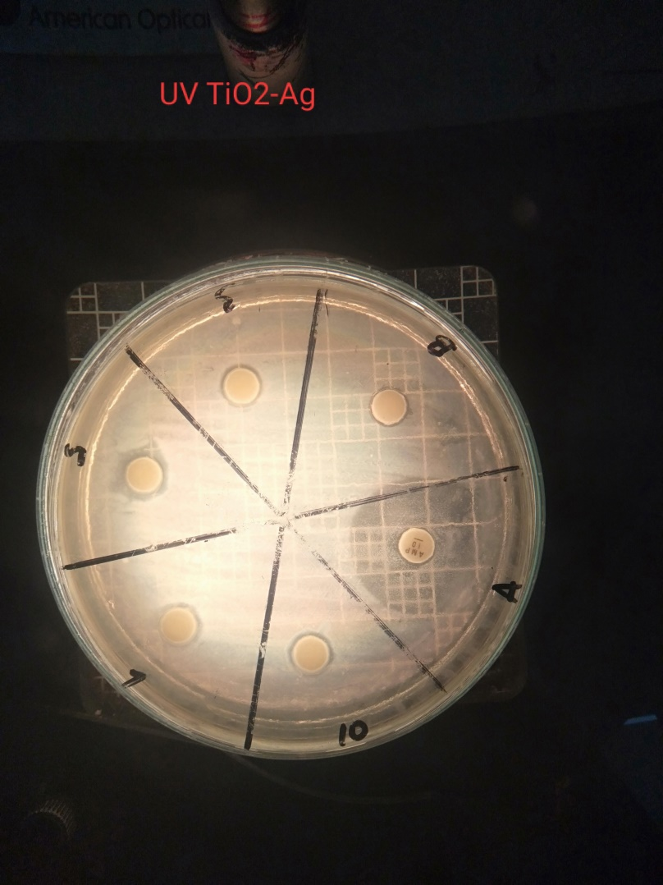
Control (-)
Control (+)
0.7 g/L
1 g/L
0.5 g/L
0.3 g/L

Figure VI.1. Inhibition zone of TiO₂/AgNPs (I) on UV light irradiation
for 5 h on the Candida albicans

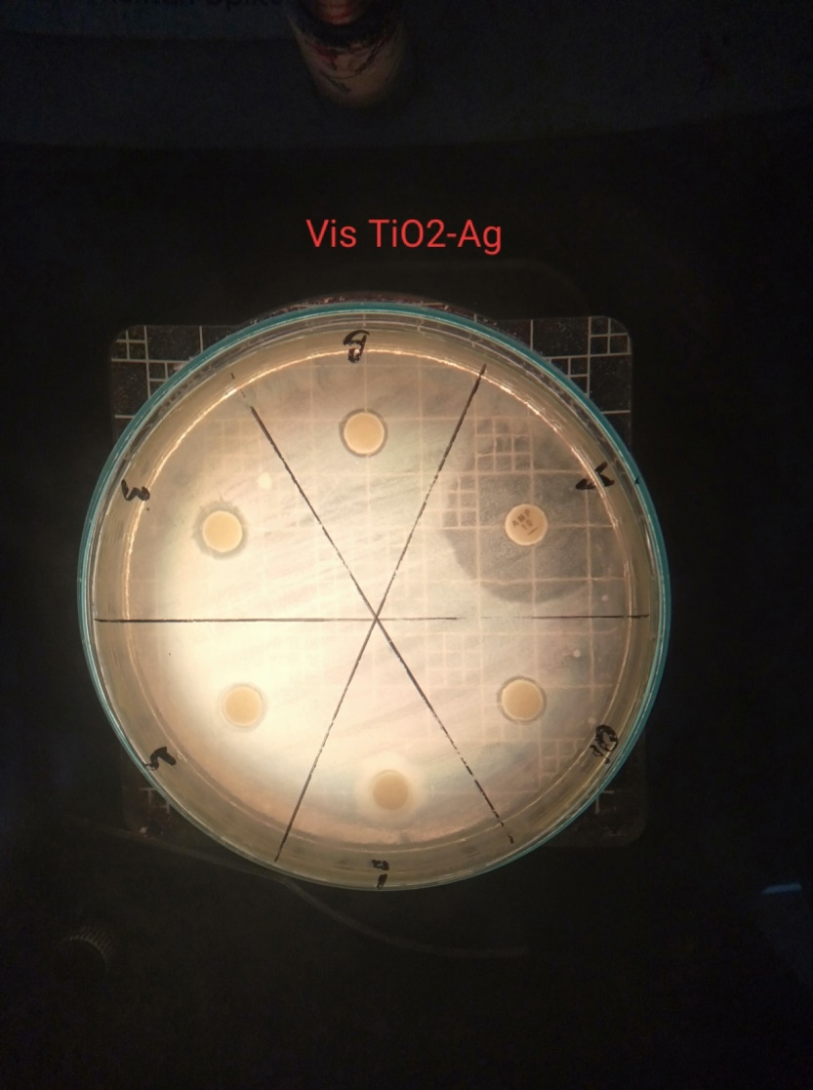
0.5 g/L
Control (-)
0.7 g/L
1 g/L
0.3 g/L
Control (+)

Figure VI.2. Inhibition zone of TiO₂/AgNPs (I) on visible light irradiation
for 5 h on the Candida albicans

SI 6: Inhibition zone images of TiO₂ photocatalyst on various irradiation treatments
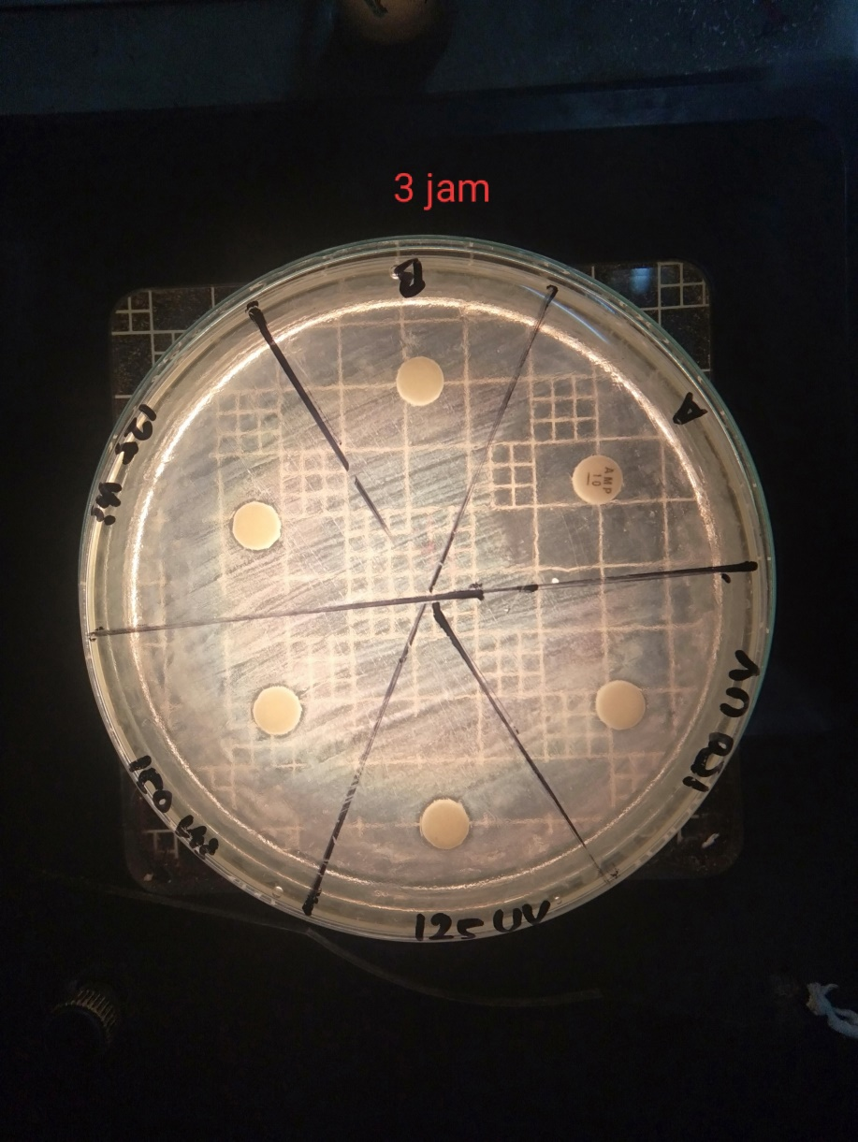
1 g/L
Control (+)
Control (-)
0.3 g/L
0.7 g/L
0.5 g/L

Figure VI.3. Inhibition zone of TiO₂ on visible light irradiation for 5 h on the Candida albicans

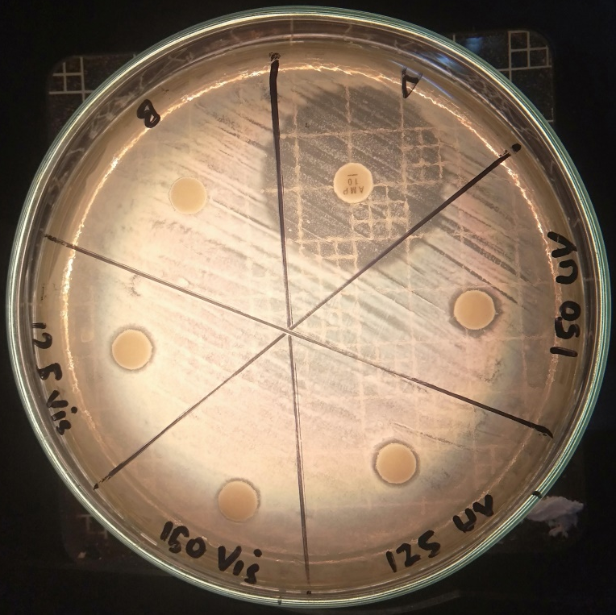
0.7 g/L
1 g/L
Control (+)
Control (-)
0.5 g/L

0.3 g/L

Figure VI.4. Inhibition zone of TiO₂ on UV light irradiation for 5 h on the Candida albicans

SI 7: EDX Spectra
7.1 EDX Spectra of TiO₂
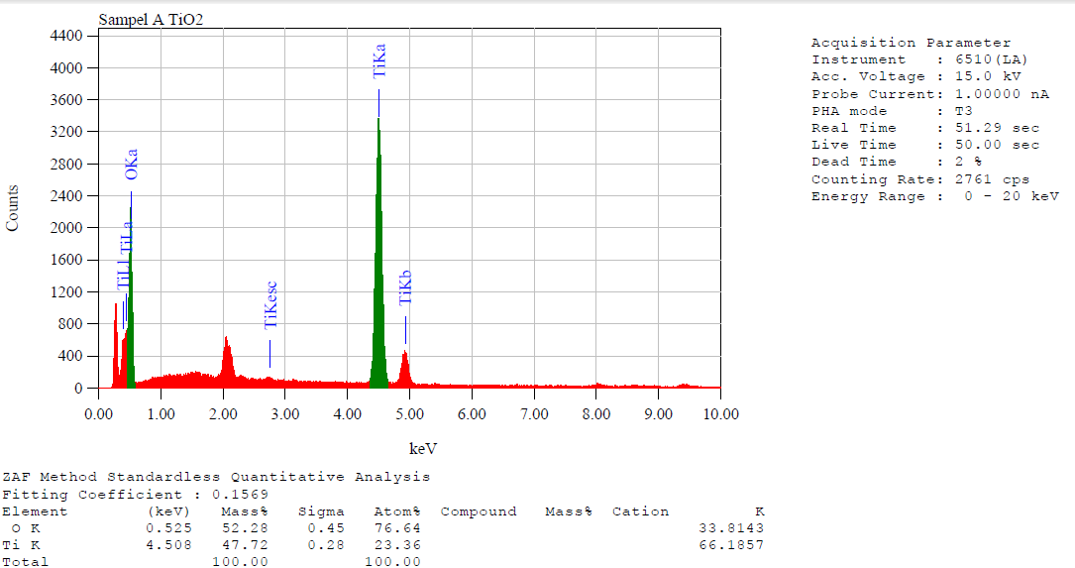

7.2 EDX Spectra of TiO₂/Ag (I)

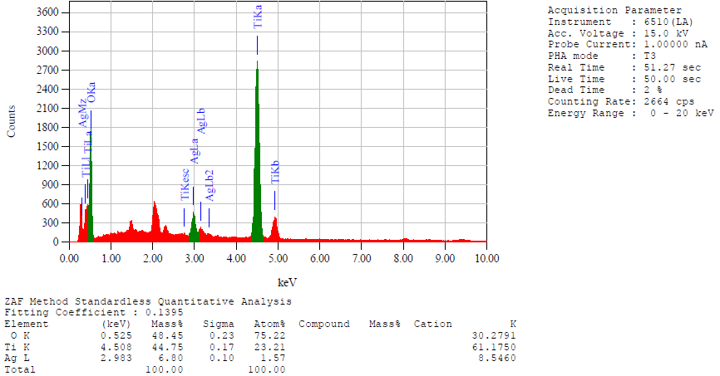

7.3 EDX Spectra of TiO₂/Ag (II)
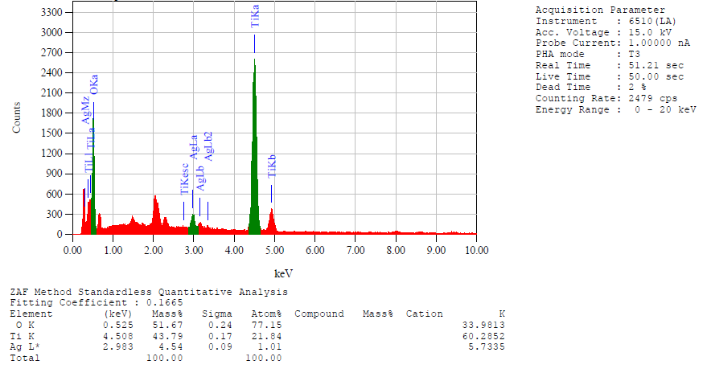

7.4 EDX Spectra of TiO₂/Ag (III)
