SUPPLEMENTARY MATERIALS
The major constituent isolated as pale yellowish powder (mp 231 – 253 ºC) from Andrographis paniculata (whole plant) was identified as andrographolide 1 (Figure 1)^{1,2}. The IR spectrum of 1 shows a strong peak at 1724.46 cm⁻¹ representing a lactone-type carbonyl stretch while a weak sharp peak at 3391.91 cm⁻¹ indicates the presence of free hydroxyl group. Another characteristic peak of medium intensity observed at 1675.46 cm⁻¹ shows the presence of alkenyl C=C stretch. The ¹³C NMR spectrum of 1 (Table 1) displayed 20 carbons, attributed to a carbonyl (δ 172.6), two quaternary olefins (δ 129.8 and 148.8), an olefinic methylene (δ 109.2), an olefinic methine (δ 149.3), two oxymethines (δ 66.8 and 80.9), two oxymethylene (δ 65.0 and 76.1), two quaternary aliphatics (δ 40.0 and 43.7), an aliphatic methine (δ 56.4), five aliphatic methylenes (δ 25.2, 25.7, 29.0, 38.1 and 39.0), and two methyl carbons (δ 15.5 and 23.2). Its ¹H NMR spectrum (Table 1) showed signals typical of olefinic methine and methylene protons at δ 6.85 (td, J=6.8, 1.7 Hz, H-12) and 4.89/4.67 (s, H-17) respectively. Furthermore, the characteristic signals for two oxymethine protons were seen at δ 3.41 (dd, J=9.6, 6.0 Hz, H-3) and 5.01 (d, J= 6.1 Hz, H-13), while signals typical for two oxymethylene protons were seen at δ 4.46 (dd, J=10.2, 6.1 Hz, H-15a)/4.16 (dd, J=10.2, 2.0 Hz, H-15b) and 4.12 (d, J=11.1 Hz, H-19a)/3.37 (d, J= 10.8 Hz, H-19b). These ¹H and ¹³C NMR spectroscopic data were consistent with those of the known andrographolide.
The relative configurations at the six stereogenic centers of 1 were determined based on its NOE spectral data. The strong NOE correlation (Figure 2) between olefinic proton H-12 and protons H-9/H-11b/H-17b established the cis-orientation of H-12/H-9, and trans-orientation of H-12/H11b and H-12/H-17, while correlation of protons H-11a and H-14 showed the trans-orientation of H-12/H-14 and cis-orientation of H-12/carbonyl at the lactone ring. Furthermore, spatial correlation between proton H-5 and protons H-1b/H-3/H-7a/H-9 results in ring strain and confirmed the protons arrangement in the bicyclic ring of 1 skeleton as cis-orientation. Next, the correlation between hydroxyl protons H-3b and H-19b established the cis-orientation of 19-CH₂ and 3-OH group. However, the configuration of 14-OH and 19-OH is supported only by a single NOE correlation. The ambiguity in the configuration warrants further experiments. Based on the NOE correlations, the relative configuration of the six stereogenic centers in 1 could be deduced as 3R, 4R, 5S, 9R, 10R, and 14S as shown in Figure 3.
The chromophoric derivatization of 1 at room temperature using 2-naphthoyl chloride or benzoyl chloride as chromophore proceeded via S_{N}2 nucleophilic substitution reaction (Scheme 1). The three hydroxyl groups in andrographolide act as active sites in this reaction. Based on its position, the allylic hydroxyl group at carbon C-14 (secondary alcohol) is more acidic compared to those at carbons C-3/C-19, therefore it can be easily deprotonated. In the presence of trimethylamine as base at room temperature, derivatization of 1 with both benzoyl and 2-naphthoyl chlorides was only achieved at C-14 instead at C-3 or C-19 at the end of the reaction. However, by increasing temperature of the reaction to 40 °C (increasing the kinetic energy), the activation energy of reaction system has decreased and successfully introduced chromophore at both C-14 and C-19 of 1. This fact indicated that steric hindrance around hydroxyl group at C-3 and C-19 of 1 has caused the nucleophilic attack to both the chromophores to be less susceptible. Structural characterization of all derivatives was carried out by NMR analysis in acetone-d₆. Table 1 shows the chemical structures of andrographolide derivatives (2 – 5) while Table 2 shows the ¹H and ¹³C NMR spectral details of the compounds. Derivatives 2, 3 and derivatives 4, 5 were obtained from single reaction of different chromophores used for derivatization. Other supplementary information are given in pages 8-19.

References
(1) Hossain, M. S.; Urbi, Z.; Sule, A.; Rahman, K. M. H. Sci. World J. 2014, 2014, 1–28.
(2) Chen, L.; Zhu, H.; Wang, R.; Zhou, K.; Jing, Y.; Qiu, F. J. Nat. Prod. 2008, 71 (5), 852–855.

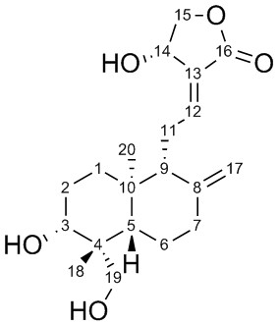

Figure 1. Chemical structure of andrographolide with carbon numbering. The configuration was determined using single-crystal technique from the previous studies.

Total mass isolated: 396mg
Physical properties: pale-yellowish, powder.
Molecular mass: 350.45
CHN Analysis:
 | Theoretical | Experimental
Carbon | 240.20 | 238.66
Hydrogen | 30.30 | 29.35
Nitrogen | 0

Scheme 1.
Reaction mechanism of chromophoric derivatization of Andrographolide

Table 1. Chemical structures of andrographolide derivatives (2 – 5). Product 2, 3 and product 4, 5 were obtained from single reaction of different chromophores used for derivatization.
 | Derivative | Mass (mg) | Molecular mass (g/mol) | Substitution
 |  |  |  | H’’ | H’’’
 | 2 | 5.10 | 454.4565 | -
 | 3 | 3.12 | 558.6691
 | 4 | 4.68 | 504.6321 | -
 | 5 | 7.48 | 658.8091
Figure 2. Key NOESY correlations of 1.

Table 2. The NMR spectral data of 1 and its derivatives.
No | Andrographolide 1 |  | 14-O-benzoyl adrographolide 2 |  | 14,19-O-dibenzoyl andrographolode 3 |  | 14-O-(2-naphthoyl) andrographolide 4 |  | 14,19-O-di(2-naphthoyl) andrographolide 5
No | δ_{H} (mult., J=Hz) | δ_{C} | δH (mult., J=Hz) | δ_{C} | δ_{H} (mult., J=Hz) | δC | δ_{H} (mult., J=Hz) | δ_{C} | δ_{H} (mult., J=Hz) | δ_{C}
1 | 2.43 (ddd, J=12.9, 3.7, 2.5)  2.04 (td, J=12.6, 4.7) | 39.0 | 2.37 (br dd, J=11.7, 3.3)  2.01 (m) | 37.6 | 2.42 (br dd, J=11.5, 3.3)  2.07 (m) | 37.8 | 2.39 (br dd, J=11.4, 4.2)  2.07 (m) | 38.5 | 2.44 (m)  2.09 (m) | 38.8
2 | 1.78 (m) | 29.0 | 1.72 (m) | 28.1 | 1.72 (m) | 27.8 | 1.73 (m) | 29.0 | 1.74 (m) | 28.8
3 | 3.41 (dd, J=9.6, 6.0) | 80.9 | 3.39 (dd, J=9.7, 5.9) | 79.6 | 3.42 (m) | 776 | 3.41 (m) | 80.9 | 3.44 (m) | 78.5
4 | - | 43.7 | - | 42.6 | - | 42.5 | - | 42.3 | - | 43.5
5 | 1.32 (m) | 56.4 | 1.31 (m) | 55.0 | 1.41 (m) | 54.8 | 1.32 (m) | 55.9 | 1.44 (m) | 56.9
6 | 1.38 (qd, J = 12.7, 4.1)  1.78 (m) | 25.2 | 1.31 (m)  1.81 (m) | 23.8 | 1.41 (m)  1.82 (m) | 22.4 | 1.32 (m)  1.82 (m) | 25.2 | 2.10 (m)  1.68 (m) | 26.0
7 | 1.29 (m)  1.80 (m) | 38.1 | 1.75 (m)  1.26 (m) | 36.8 | 1.65 (m)  1.27 (m) | 37.1 | 1.77 (m)  1.29 (m) | 37.7 | 1.87 (m)  1.45 (m) | 38.0
8 | - | 148.8 | - | 147.9 | - | 148.0 | - | 148.9 | - | 149.0
9 | 1.92 (dd, J=10.8, 2.4) | 57.4 | 2.02 (m) | 55.7 | 2.01 (m) | 55.9 | 2.08 (m) | 56.7 | 2.13 (m) | 55.7
10 | - | 40.0 | - | 38.7 | - | 39.1 | - | 39.7 |  | 40.0
11 | 2.63 (ddd, J=16.8, 7.1, 3.8)  2.58 (ddd, J=17.1, 10.8, 6.8) | 25.7 | 2.68 (ddd, J=16.7, 6.6, 3.7)  2.54 (ddd, J=17.2, 10.6, 7.1) | 25.1 | 2.74 (dq, J=16.8, 3.3)  2.60 (m) | 25.2 | 2.73 (ddd, J=16.8, 6.3, 3.4)  2.61 (m) | 26.1 | 2.76 (m)  2.67 (m) | 26.2
12 | 6.85 (td, J=6.8, 1.7) | 149.3 | 6.99 (td, J=6.8, 1.7)- | 149.6 | 7.02 (td, J=6.9, 1.6) | 149.5 | 7.04 (td, J=7.2, 1.8) | 150.6 | 7.06 (td, J=7.0, 1.5) | 150.6
13 | - | 129.8 | - | 134.6 |  | 133.5 | - | 127.7 | - | 127.2
14 | 5.01 (d, J= 6.1) | 66.8 | 6.32 (br d, J=6.1) | 68.8 | 6.35 (br d, J=6.0) | 68.9 | 6.41 (br d, J=6.1) | 69.8 | 6.43 (br d, J=6.0) | 69.9
15 | 4.46 (dd, J=10.2, 6.1)  4.16 (dd, J=10.2, 2.0) | 76.1 | 4.72 (dd, J=11.1, 6.1)  4.45 (dd, J=11.1, 1.9) | 71.3 | 4.53 (m)  4.47 (m) | 71.3 | 4.78 (dd, J=11.2, 6.2)  4.53 (dd, J=11.2, 1.9) | 72.3 | 4.79 (dd, J=11.0, 6.0)  4.54 (dd, J=11.0, 2.0) | 72.3
16 | - | 172.6 |  | 173.8 |  | 168.6 | - | 183.3 | - | 169.6
17 | 4.89 (s)  4.67 (s) | 109.2 | 4.83 (d, J=1.3)  4.58 (d, J=1.3). | 107.8 | 4.85 (s)  4.61 (s) | 107.7 | 4.87 (d, J=1.2)  4.66 (br s) | 108.7 | 4.87 (br s)  4.68 (br s) | 108.7
18 | 0.75 (s) | 15.5 | 0.63 (s) | 14.4 | 0.73 (s) | 13.8 | 0.64 (s) | 15.4 | 0.78 (s) | 23.4
19 | 4.12 (d, J=11.1)  3.37 (d, J = 10.8) | 65.0 | 4.06 (d, J=10.9)  3.25 (br d, J=10.7) | 63.4 | 3.94 (d, J=4.7)  4.74 (m) | 65.7 | 4.06 (dd, J=10.5, 1.6)  3.25 (t, J=10.8) | 64.3 | 4.59 (d, J=11.5)  4.50 (d, J=12.0) | 66.8
20 | 1.22 (s) | 23.2 | 1.19 (s) | 22.6 | 1.26 (s) | 22.4 | 1.20 (s) | 23.5 | 1.33 (s) | 14.8
1’[1”] |  |  | - | 124.6 |  | 124.7 | 8.71 (s) | 132.1 | 8.70 (s) [8.62 (s)] | 132.1 [131.5]
2’[2”] |  |  | 8.05 (dd, J=8.4, 1.4) | 129.4 | 8.01 (dd, J=8.3, 1.3) | 129.3 [129.5] | - | 125.6 | - | 125.6 [125.6]
3’[3”] |  |  | 7.54 (tt, J=7.5, 1.5) | 128.7 | 7.57 (m) | 128.5 [128.7] | 8.13 (d, J=7.8) | 125.8 | 8.12-7.97 (m) | 125.8 [126.0]
4’[4”] |  |  | 7.68 (tt, J=7.5, 1.5) | 133.6 | 7.64 (m) | 132.8 [133.5] | 8.06-8.03 (m) | 129.4 | 8.12-7.97 (m) | 129.2 [129.1]
5’[5”] |  |  | 7.54 (tt, J=7.5, 1.5) | 128.7 | 7.50 (dq, J=7.3, 1.5) | 130.8 | - | 136.7 | - | 136.7 [136.4]
6’[6”] |  |  | 8.05 (dd, J=8.4, 1.4) | 129.4 | 8.02 (dd, J=8.3, 1.3) | 148.0 [149.5] | 7.71 (td, J=7.5, 1.1) | 128.7 | 7.67 (t, J=8.0)  [7.68 (t, J=8.0)] | 128.7 [128.6]
7’[7”] |  |  | - | - | - | - | 7.66 (td, J=7.5, 1.1) | 129.6 | 7.61 (t, J=7.0)  [7.61 (t, J=7.0)] | 129.6 [129.4]
8’[8”] |  |  | - | - | - | - | 8.06-8.03 (m) | 128.0 | 8.12-7.97 (m) | 127.9 [127.7]
9’[9”] |  |  | - | - | - | - | 8.06-8.03 (m) | 130.2 | 8.12-7.97 (m) | 130.3 [130.2]
10’[10”] |  |  | - | - | - | - | - | 133.5 | - | 133.5 [133.4]
C=O |  |  | - | 165.5 | - | 165.6 [166.0] | - | 169.6 | - | 167.0 [166.7]
Andrographolide

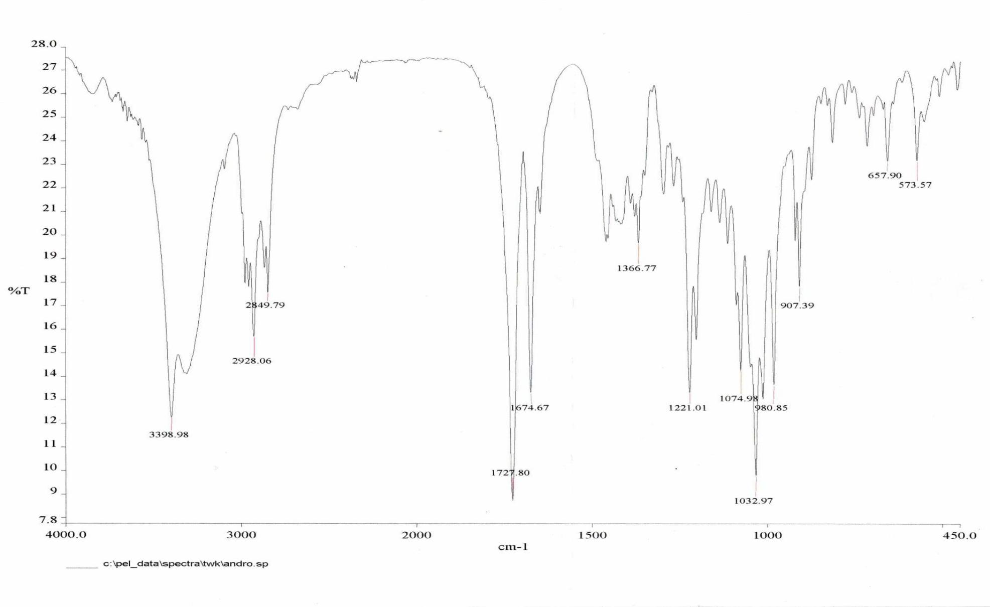

14-O-benzoyl adrographolide 2

14,19-O-dibenzoyl andrographolode 3

14-O-(2-naphthoyl) andrographolide 4

14,19-O-di(2-naphthoyl) andrographolide 5

