**Supporting Information**

**VIRTUAL SCREENING OF INDONESIAN MEDICINAL PLANT AND ZINC DATABASES FOR POTENTIAL INHIBITORS OF THE RNA-DEPENDENT RNA POLYMERASE (RdRp) OF 2019 NOVEL CORONAVIRUS**

**Table S1. Hydrogen bond occupancy of between ligand and receptor.**

Remdesivir (RDM)

|  |  |  |  |  |
| --- | --- | --- | --- | --- |
| **Acceptor** | **Donor** | **Percentage (%)** | **Distance (Å)** | **Angle** |
| TYR_560@O | LIG_1079@H34: @O33 | 97.5 | 2.6466 | 158.6022 |
| ASP_559@OD2 | LIG_1079@H42: @O41 | 87.73 | 2.6095 | 164.6033 |
| ASP_701@OD1 | LIG_1079@H36: @O35 | 65.33 | 2.572 | 167.4986 |
| ASP_559@OD1 | LIG_1079@H40: @O39 | 61.66 | 2.5706 | 168.1091 |
| ASP_701@OD2 | LIG_1079@H36: @O35 | 33.79 | 2.5828 | 167.1641 |
| LIG_1079@O37 | ARG_496@HH22: @NH2 | 18.55 | 2.8256 | 156.0252 |
| LIG_1079@O33 | CYS_563@H: @N | 14.74 | 2.922 | 159.5935 |
| LIG_1079@O37 | ARG_496@HH12: @NH1 | 12.22 | 2.8363 | 154.439 |
| ASP_559@OD1 | LIG_1079@H42: @O41 | 10.71 | 2.5992 | 166.0198 |

ZINC1529045114

|  |  |  |  |  |
| --- | --- | --- | --- | --- |
| **Acceptor** | **Donor** | **Percentage (%)** | **Distance (Å)** | **Angle** |
| LIG_1079@O11 | ARG_496@HH11: @NH1 | 45.55 | 2.8161 | 160.3069 |
| LIG_1079@N7 | ARG_565@HH21: @NH2 | 30.18 | 2.8914 | 151.6928 |
| ASP_701@OD1 | LIG_1079@H23: @O15 | 29.6 | 2.6544 | 162.9622 |
| ASP_393@OD2 | LIG_1079@H26: @N9 | 29.58 | 2.8336 | 154.8585 |
| ASP_564@OD2 | LIG_1079@H15: @N4 | 28.95 | 2.7219 | 159.6432 |
| ASP_559@OD1 | LIG_1079@H7: @O7 | 23.96 | 2.6534 | 165.5095 |
| ASP_701@OD2 | LIG_1079@H21: @O14 | 22.52 | 2.7076 | 159.0275 |
| ASP_701@OD1 | LIG_1079@H21: @O14 | 19 | 2.7394 | 158.8832 |
| LIG_1079@O15 | SER_700@HG: @OG | 17.66 | 2.783 | 158.7613 |
| LIG_1079@O17 | ARG_565@HH11: @NH1 | 13.74 | 2.914 | 159.1019 |
| ASP_393@OD1 | LIG_1079@H26: @N9 | 13.26 | 2.8326 | 157.1251 |
| TYR_560@O | LIG_1079@H5: @O6 | 12.98 | 2.712 | 158.0925 |
| ASP_564@OD1 | LIG_1079@H16: @N4 | 12.92 | 2.7262 | 161.7094 |
| ASP_559@OD2 | LIG_1079@H16: @N4 | 12.63 | 2.7354 | 162.14 |
| ASP_564@OD1 | LIG_1079@H15: @N4 | 12.57 | 2.7371 | 159.6196 |
| ASP_564@OD1 | LIG_1079@H23: @O15 | 12.47 | 2.6626 | 161.8866 |
| ASP_559@OD2 | LIG_1079@H15: @N4 | 12 | 2.742 | 163.0233 |

ZINC169730811

|  |  |  |  |  |
| --- | --- | --- | --- | --- |
| **Acceptor** | **Donor** | **Percentage (%)** | **Distance (Å)** | **Angle** |
| ASP_702@OD2 | LIG_1079@H7: @O7 | 80.78 | 2.6585 | 163.4954 |
| ASP_702@OD2 | LIG_1079@H5: @O6 | 45.58 | 2.6486 | 162.1343 |
| LYS_492@O | LIG_1079@H25: @N4 | 32.53 | 2.8454 | 160.469 |
| LIG_1079@N5 | SER_490@HG: @OG | 25.2 | 2.839 | 158.8034 |
| ARG_494@O | LIG_1079@H24: @N4 | 22.69 | 2.8325 | 151.8958 |
| LIG_1079@N3 | SER_490@HG: @OG | 22 | 2.7854 | 158.4971 |
| ARG_494@O | LIG_1079@H21: @O11 | 18.99 | 2.6927 | 162.3982 |
| ASP_701@O | LIG_1079@H5: @O6 | 18.38 | 2.7158 | 161.0261 |
| LIG_1079@O1 | ARG_777@HH21: @NH2 | 17.89 | 2.817 | 153.8028 |
| LIG_1079@O1 | ARG_777@HH11: @NH1 | 17.45 | 2.8169 | 153.3582 |
| LIG_1079@O7 | SER_755@H: @N | 17.21 | 2.9072 | 150.621 |

9-Ribosyl-trans-zeatin

|  |  |  |  |  |
| --- | --- | --- | --- | --- |
| **Acceptor** | **Donor** | **Percentage (%)** | **Distance (Å)** | **Angle** |
| GLU_752@O | LIG_1079@H3*: @O3* | 37.66 | 2.7351 | 162.4237 |
| GLU_752@O | LIG_1079@H2*: @O2* | 29.31 | 2.7178 | 160.6939 |
| ASP_702@OD2 | LIG_1079@H3*: @O3* | 23.14 | 2.6916 | 164.9356 |
| TRP_558@O | LIG_1079@H5*: @O5* | 15.34 | 2.7385 | 158.6033 |
| ASP_702@OD2 | LIG_1079@H2*: @O2* | 15.24 | 2.6704 | 159.5671 |

**Table S2. The results of cluster analysis.**

Remdesivir (RDM)

|  |  |  |  |  |  |  |
| --- | --- | --- | --- | --- | --- | --- |
| #Cluster | Frames | Frac | AvgDist | Stdev | Centroid | AvgCDist |
| 0 | 20000 | 1 | 1.696 | 0.337 | 10516 | 0 |

ZINC1529045114

|  |  |  |  |  |  |  |
| --- | --- | --- | --- | --- | --- | --- |
| #Cluster | Frames | Frac | AvgDist | Stdev | Centroid | AvgCDist |
| 0 | 20000 | 1 | 1.788 | 0.32 | 8765 | 0 |

ZINC169730811

|  |  |  |  |  |  |  |
| --- | --- | --- | --- | --- | --- | --- |
| #Cluster | Frames | Frac | AvgDist | Stdev | Centroid | AvgCDist |
| 0 | 20000 | 1 | 1.834 | 0.385 | 13887 | 0 |

9-Ribosyl-trans-zeatin

|  |  |  |  |  |  |  |
| --- | --- | --- | --- | --- | --- | --- |
| #Cluster | Frames | Frac | AvgDist | Stdev | Centroid | AvgCDist |
| 0 | 20000 | 1 | 1.821 | 0.472 | 14033 | 0 |

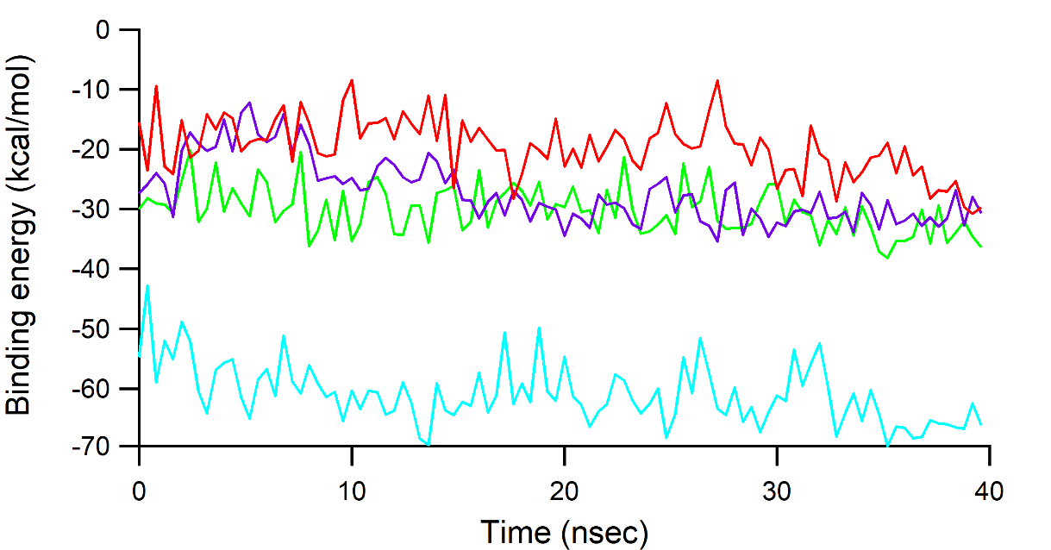

**Fig. S1.** Plot of MM-PBSA binding energy (kcal/mol) versus time in which RDM, ZINC1529045114, ZINC169730811, and 9-Ribosyl-trans-zeatin assigned as red, green, blue, and purple, respectively