Nr. | Reviewer | Revision
1 | In the introduction: the author did not explain in detail the urgency  and novelty of the research. The authors developed a validation method for  analysis using HPLC. However, there are very many studies on the validation  of HPLC, except for the development of eluent compositions used with  specificity according to the target compound. Unfortunately not described in  the introduction. | Additional of reason and novelty have been added in the introduction. | The use of hyphenated gas chromatography and mass spectrometry is limited in several laboratory especially in Indonesia. Therefore, a variation of HPLC method has been explored in this study by using specific eluent variant composition (acetonitrile-bidistilled water, and methanol) to get the optimum elution of anthraquinone. New composition of solvent has been developed. Therefore, this research could contribute as an alternative for selecting solvent using HPLC for detecting anthraquinone in Eleutherine americana (Aubl.) Merr. ex K. Heyne.
2 | In addition, the reference used is not up to date. |  | The revision has been done (number 8)
3 | In the experimental section: the tools and materials used are not  described in detail, including the source of the materials and tools. | The source of materials has been added in Experimental Section | Sample (ethanol extract, hexane fraction, water fraction, and ethyl acetate fraction of the bulbs of Eleutherine americana (Aubl.) Merr. ex K. Heyne) which was provided by the Biology Pharmaceutical Lab Bandung Institute of Technology. HPLC-grade acetonitrile, HPLC-grade Methanol, bidistilled water, and micropore membrane 0.45 µm were purchased from Sigma-Aldrich (St. Louis, MO, USA).
4 | “A standard solution containing 6 µg/mL was injected to the HPLC with  the system stated above for 6 replicates.” what is the standard solution  do you meant? | The standar solution has been added in the text | A standard solution of anthraquinone containing 6 µg/mL was injected into the HPLC with the system stated above for 6 replicates
5 | The use of the unit format and decimal numbers do not comply with  international standards. | We have revised accomplice to International Standard | Comma (,) has been replaced by point (.) for decimal numbers
6 | In the discussion, the author discusses too many methods, too many  repetitive words and sentences. Novelty's findings are not described in  detail, so it is difficult to understand the ultimate goal of this study. | We have revised the repetitive sentence and elaborate the novelty finding | Repetition of “the next parameter” in each paragraph has been deleted  Based on the results, acetonitrile-bidistilled water (50:50) gave the best result, and therefore it was chosen to be the mobile phase in this research. This result revealed a new composition of solvent using in HPLC for determining anthraquinone.
7 | Quality of the chromatogram in Fig 1 needs improvement. | The quality has been improved | 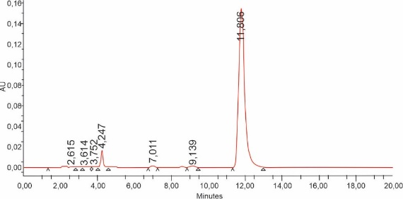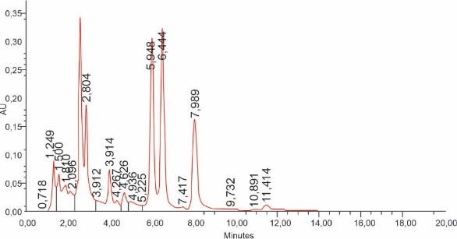
8 | Add the number of references to a minimum of 20 references and 80% of  those are up to date (last 10 year published). | The reference has been added with updated | REFERENCES  - Insanu, M., Kusmardiyani, S., Hartati, R., 2014. Recent Studies on Phytochemicals and Pharmacological Effects of Eleutherine americana Merr., Procedia Chem., 13, 221-228.  - Kuntorini, E.M., Misrina. M.D., 2016. Anatomical structure and antioxidant activity of red bulb plant (Eleutherine americana) on different plant age, Biodiversitas., 17(1), 229-233.  - M. Malmir, R. Serrano, O. Silvia, 2017, Antimicrobial Research: Novel Bioknowledge and Educational Programs, Formatex Research Center, Badajoz.  - Yusiasih, R., Pitoi, M.M., Ariyani, M., Koesmawati, T.A., Maulana, H., 2019, Anthraquinone in Indonesia infusion tea: analysis by HPLC-UV and risk assessment., 6(19), 1-9.  - European Food Safety Authority, 2012. Reasoned Opinion on the Review of Existing Maximum Residue Levels (MRLs) for Anthraquinone According to Article 12 of Regulation (EC) No 396/2005, EFSA Journal, 10(6), 2761.  - Deliberto, S.T., Werner, S.J., 2016. Review on Anthraquinone for Pest Management and Agricultural Crop Protection, Pest Management Sci., 72(10), 1813-1825.  - Bahtiar, A., Chumala, D.Y., 2018. Dayak Onions (Eleutherine bulbosa (Mill.) Urb.) Bulbs Extracts Reduces Blood Pressure of Hypoestrogen Model Rats by Controlling Lipids Profile, Int. J. Morphol., 36(3),1016-1021.  - Rani, V.S., Nair, B.R., 2015. Pharmacognostic and Physiochemical Evaluation of Bulbs of Eleutherine bulbosa (Miller) Urban, a Medicinal Plant, Int. J. Pharmacogn. Phytochem., 4(3), 273-277.  - Paramapojn, S., Ganzera, M., Gritsanapan, W., Stuppner, H., 2008. Analysis of Naphthoquinone Derivatives in the Asian Medicinal Plant Eleutherine americana by RP-HPLC and LC-MS, J. Pharm. Biomed. 47 (4-5), 990-993.  - Kumar, R.B., 2017, Application of HPLC and ESI-MS techniques in the analysis of phenolic acids and flavonoids from green leafy vegetables (GLVs). J Pharm Anal., 7(6), 349-364.  - USP-NF, 2014. United States Pharmacopeia, 43^{ed}., United States Pharmacopeial Convention, Rockville.  - Dixon, J.M., Taniguchi, M., Lindsey, J.S., 2005. PhotochemCAD 2. A Refined Program with Accompanying Spectral Databases for Photochemical Calculations, Photochem Photobiol., 81(1), 212-213.  - Suresh, R., Anarthanan, S.V.J., Manavalan, R., Valliappan, K. 2010. Aspects of validation in HPLC method development for pharmaceutical analysis-comparison of validaton requirements by FDA, USP, and ICH. Int J Pharm Sci Drug., 1(2), 123-132.  - AOAC International, AOAC Guidelines for Single Laboratory Validation of Chemical Methods for Dietary Supplements and Botanicals. https://www.aoac.org/aoac_prod_imis/AOAC_Docs/StandardsDevelopment/SLV_Guidelines_Dietary_Supplements.pdf, 2013 (accessed 21 April 2019).  - ALACC, Guidelines for Laboratories Performing Microbiological and Chemical Analyses of Food, Dietary Supplements, and Pharmaceuticals,https://www.aoac.org/aoac-accreditation-guidelines-for-laboratories-alacc.2017. (accessed 21 December 2018).  - Chen, D.L., Hu, M-G., Liu, Y-Y., Li R-T., Yu, M., Xu, D., et al., 2018. New Naphthalene Derivatives from the Bulbs of Eleutherine americana with Their Protective Effect on the Injury of HUVECs, molecules, 23(9): 2111.  - Xu, L., Chan, C-O., Lau, C-C., Yu, Z., Mok, D.K.W., Chen, S., 2012. Simultaneous determination of eight anthraquinones in Semen Cassiae by HPLC-DAD, Phytochem Anal, 23(2):110-6.  - Wei, S-Y., Yao, W-X., Ji, W-Y., Wei, J-Q., Peng, S-Q., 2013. Qualitative and quantitative analysis of anthraquinones in rhubarbs by high performance liquid chromatography with diode array detector and mass spectrometry, Food Chem., 141(3), 1710-5.  - IARC. IARC Monographs on the evaluation of carcinogenic risks to humans. Volume 101.https://monographs.iarc.who.int/wp-content/uploads/2019/04/mono100A-2.pdf. 2013. (accessed 12 March 2021).  - Duval, J., Pecher, V., Poujol, M., Lesellier, E., 2016. Research advances for the extraction, analysis and uses of anthraquinones: a review. Ind Crops Prod, 94, 812–33.

