Submission number BM21-024
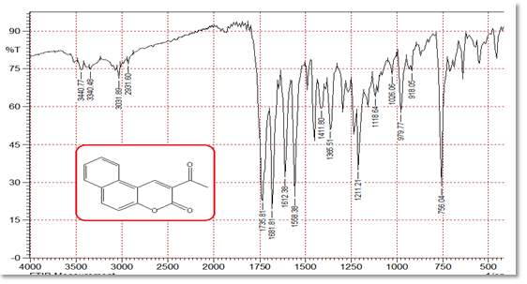
IR spectrum of the compound 3
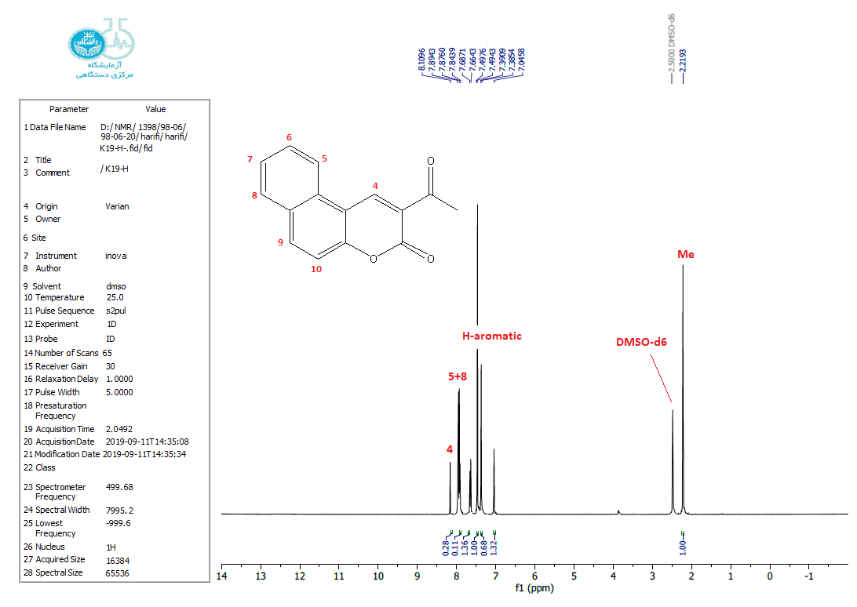
¹H NMR spectrum of the compound 3

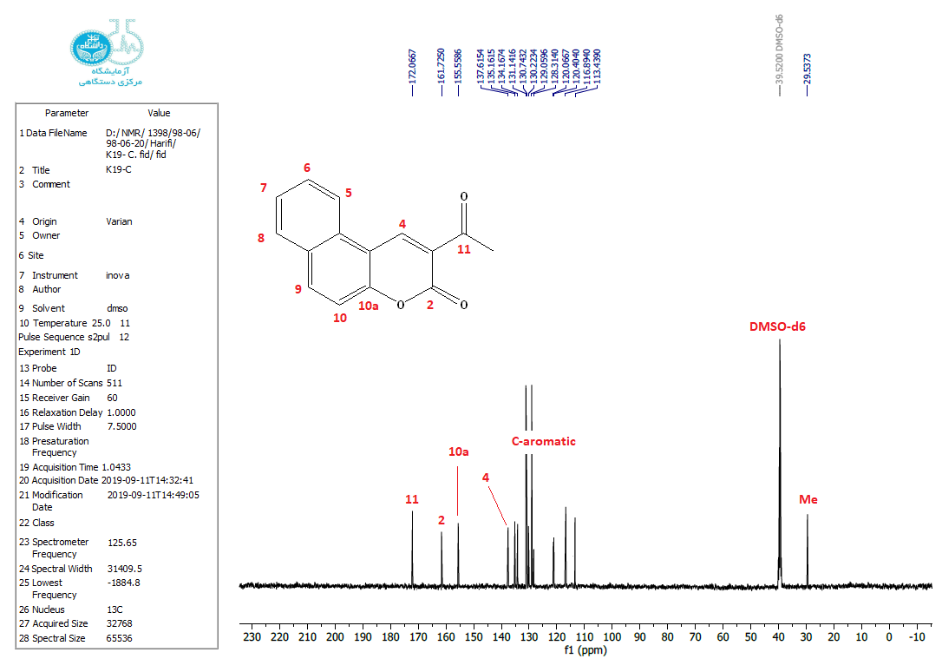
¹³C NMR spectrum of the compound 3

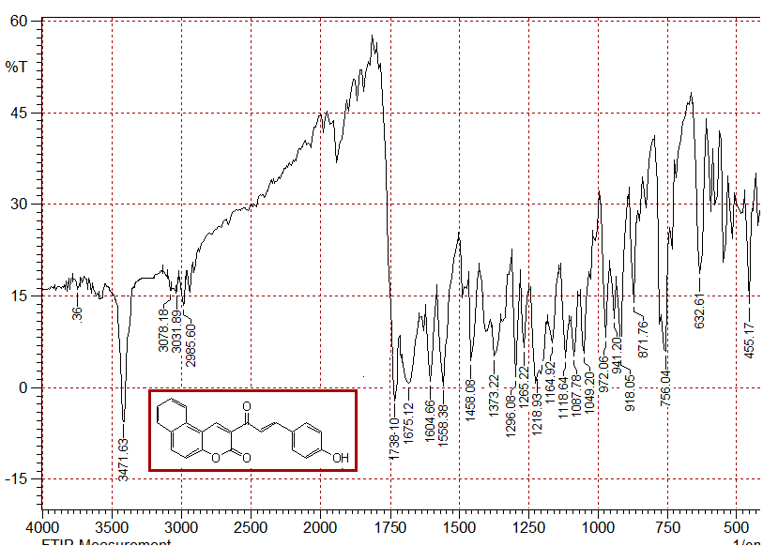
IR spectrum of the compound 4

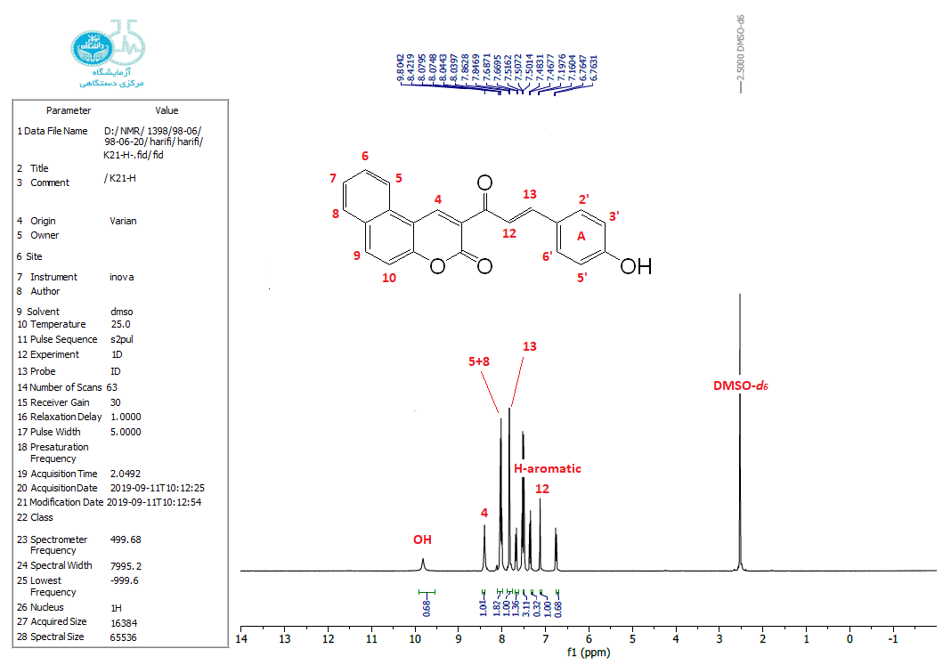
¹H NMR spectrum of the compound 4
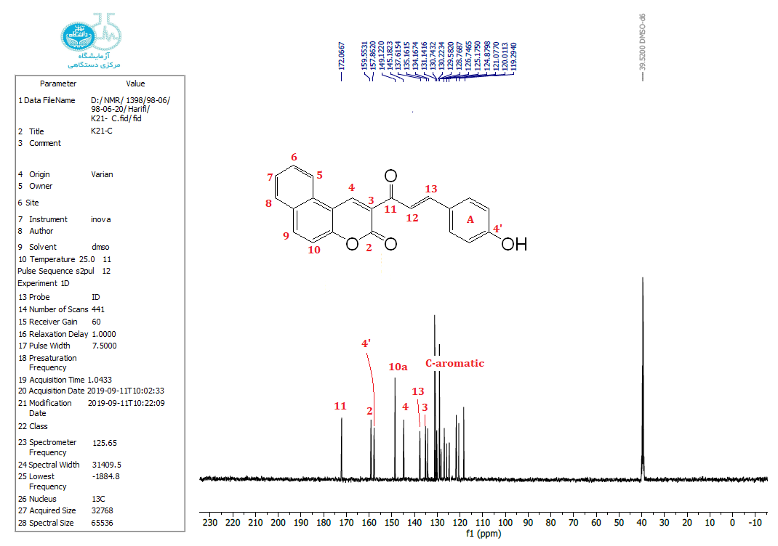
¹³C NMR spectrum of the compound 4
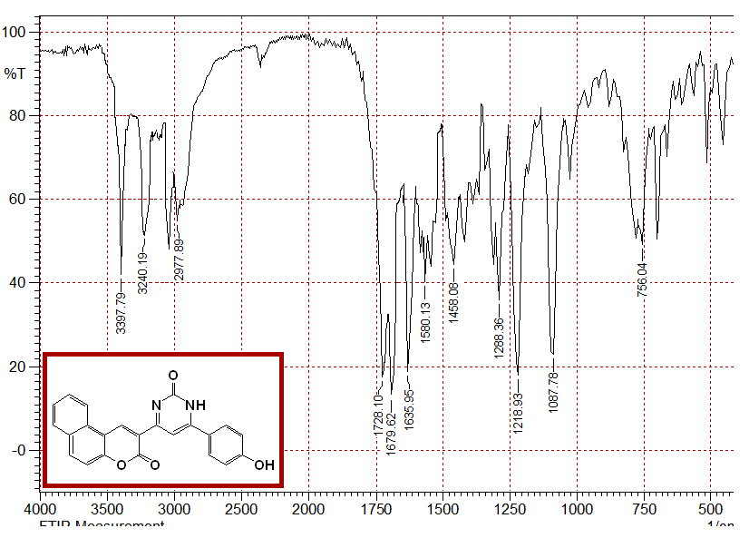
IR spectrum of the compound 5

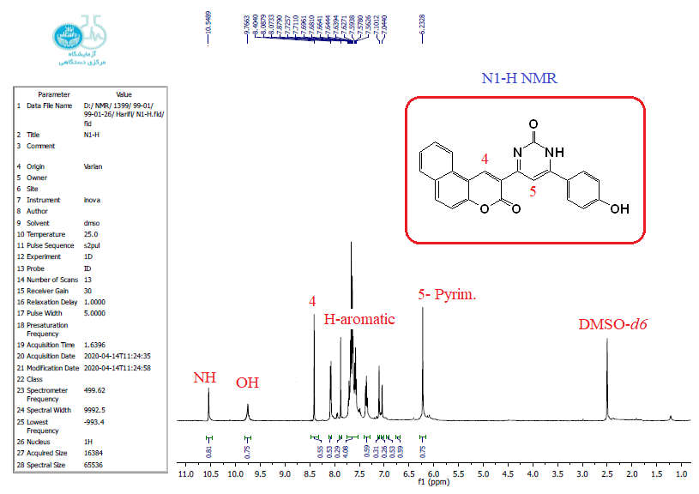
¹H NMR spectrum of the compound 5
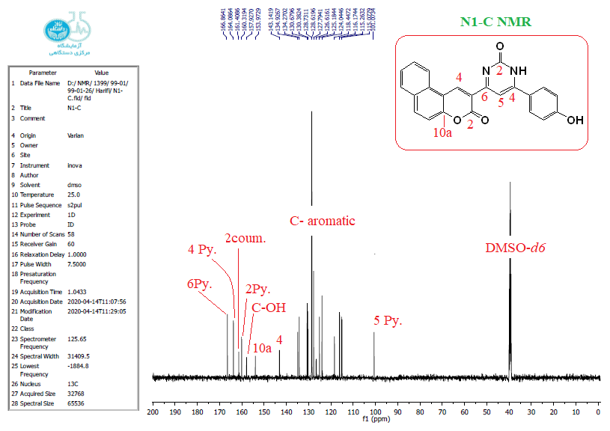
¹³C NMR spectrum of the compound 5
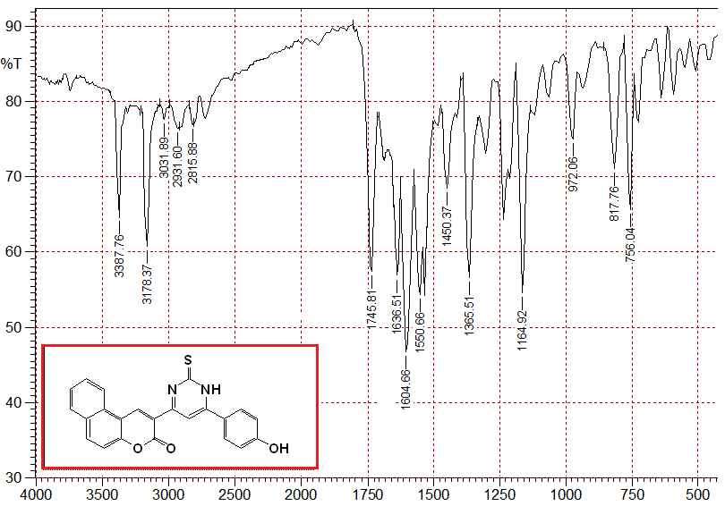
IR spectrum of the compound 6
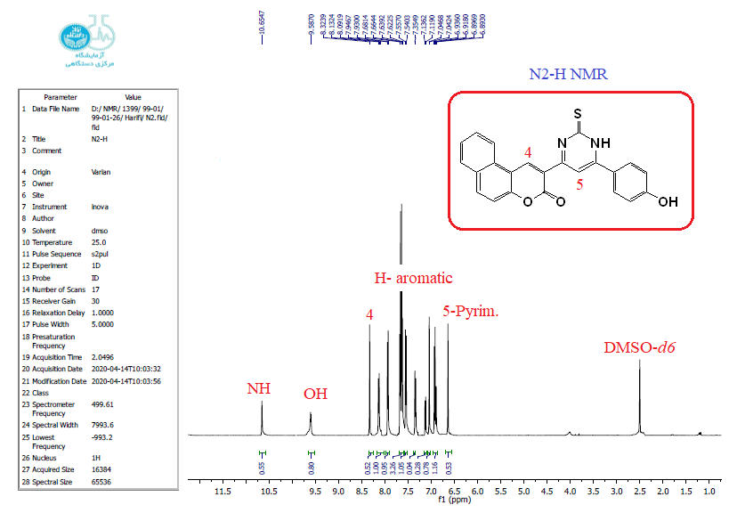
¹H NMR spectrum of the compound 6
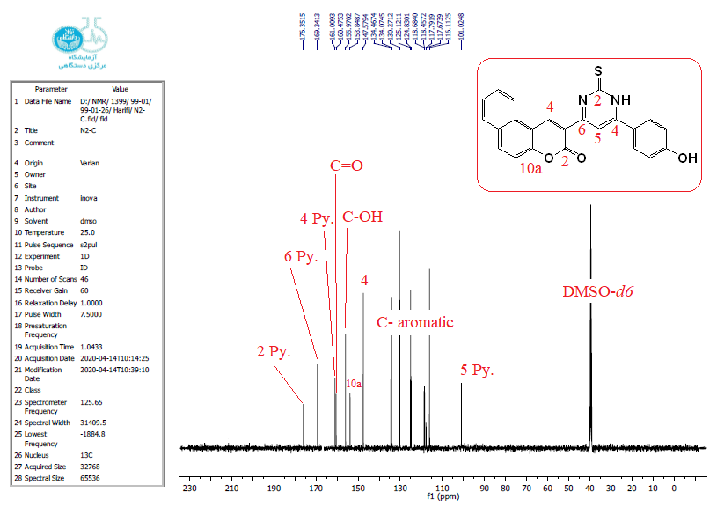
¹³C NMR spectrum of the compound 6

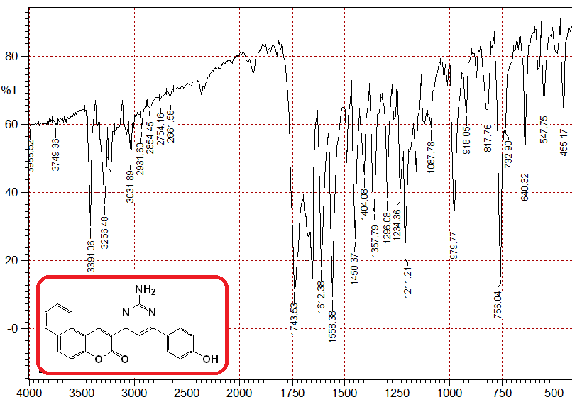
IR spectrum of the compound 7

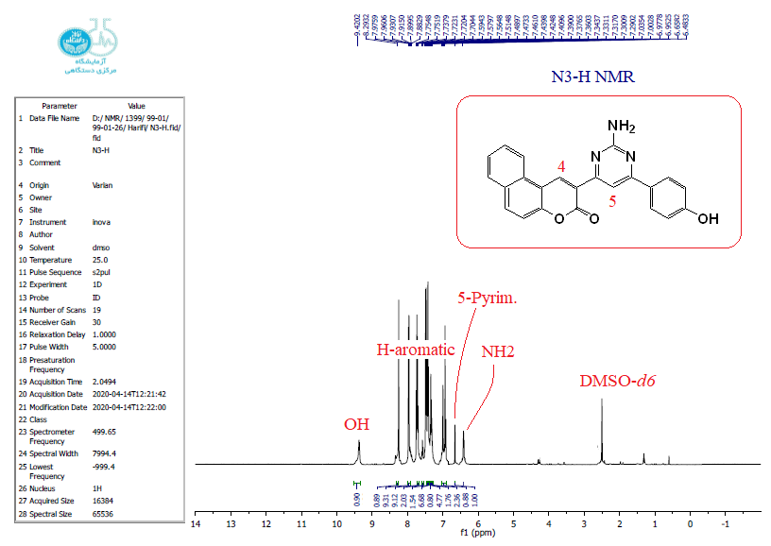
¹H NMR spectrum of the compound 7
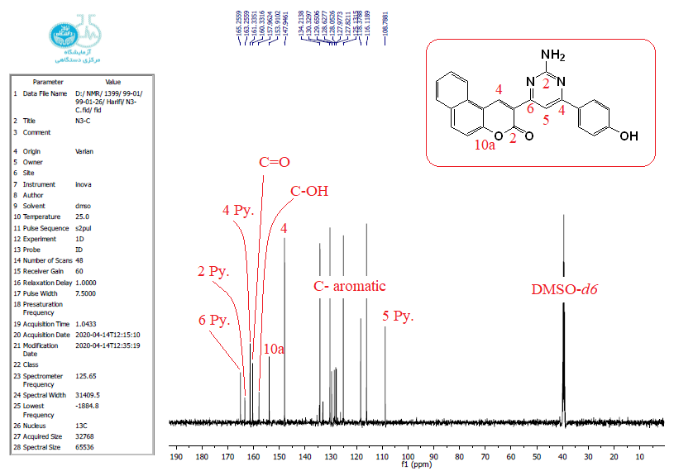
¹³C NMR spectrum of the compound 7

