**SUPPLEMENTARY INFORMATION:**

**Exploring the Potency of *Nigella* *sativa* seed in Inhibiting SARS-CoV-2 Main Protease Using Molecular Docking and Molecular Dynamics Simulation**

**Table S1.** Secondary metabolites in *Nigella sativa* seeds curated from the literature. 2

[**Table S2.** Lipinski’s rule of five results for secondary metabolites in   
*N. sativa* seeds 8](#_Toc76107843)

**Table S3.** Binding energy scores of secondary metabolites in *N. sativa* to Mpro. 10

**Table S4.**  median values of ligands bound to Mpro. 12

[**Fig. S1**. Optimized geometry of the representative secondary metabolites in   
*N. sativa* 13](#_Toc76107846)

[**Fig. S2.** Overlaying between crystal and re-docking structures of N3 (a)   
and leupeptin (b) 14](#_Toc76107847)

**Fig**. **S3.** Trajectory of  values of several ligands binding to Mpro 15

**Fig. S4.** RMSD plots of Mpro in apo and ligand-bound forms and the ligands 16

**Fig. S5.** RMSF plots of Mpro in apo and ligand-bound forms 17

[**Fig. S6.** Non-bonded interactions between ligands and the binding site   
residues of Mpro before and after MD simulations 18](#_Toc76107851)

**Note:** Significance Test on  Values 19

**Table S1.** Secondary metabolites in *Nigella sativa* seeds curated from the literature.1–8

| **No.** | **Secondary Metabolites** | **2D Structure** | **Charge\*** | **References** |
| --- | --- | --- | --- | --- |
|  | *Monoterpenoid hydrocarbons* |  |  |  |
|  | *α*-Thujene |  | 0 | 1 |
|  | *α*-Pinene |  | 0 | 1 |
|  | Sabinene |  | 0 | 1 |
|  | *β*-Pinene |  | 0 | 1 |
|  | Myrcene |  | 0 | 1 |
|  | *α*-Phellandrene |  | 0 | 1 |
|  | *p*-Cymene |  | 0 | 2 |
|  | Limonene |  | 0 | 1 |
|  | *γ*-Terpinene |  | 0 | 1 |
|  | *Monoterpenoid ketones* |  |  |  |
|  | Fenchone |  | 0 | 1 |
|  | Dihydrocarvone |  | 0 | 1 |
|  | Carvone |  | 0 | 2 |
|  | Thymoquinone |  | 0 | 2 |
|  | *Monoterpenoid alcoholss* |  |  |  |
|  | *α*-Terpineol |  | 0 | 2 |
|  | *p-*Cymene-8-ol |  | 0 | 1 |
|  | Carvacrol |  | 0 | 2 |
|  | Thymol |  | 0 | 3 |
|  | *Diterpenoids* |  |  |  |
|  | Dithymoquinone |  | 0 | 2 |
|  | *Sesquiterpenoid hydrocarbones* |  |  |  |
|  | *α*-Longipinene |  | 0 | 1 |
|  | Longifolene |  | 0 | 1 |
|  | *Phenyl propanoid compounds* |  |  |  |
|  | Estragole |  | 0 | 1 |
|  | Anisaldehyde |  | 0 | 1 |
|  | *trans*-Anethole |  | 0 | 2 |
|  | Myristicin |  | 0 | 1 |
|  | Dillapiole |  | 0 | 1 |
|  | Apiole |  | 0 | 1 |
|  | *Vitamin E* |  |  |  |
|  | *α*-Tocopherol |  | 0 | 3 |
|  | *γ*-Tocopherol |  | 0 | 3 |
|  | *β*-Tocotrienol |  | 0 | 3 |
|  | *Phytosterols* |  |  |  |
|  | Avenasterol-5-ene |  | 0 | 4 |
|  | Avenasterol-7-ene |  | 0 | 4 |
|  | Campesterol |  | 0 | 4 |
|  | Citrostadienol |  | 0 | 4 |
|  | *β*-sitosterol |  | 0 | 3 |
|  | Cycloartenol |  | 0 | 4 |
|  | Stigmastanol |  | 0 | 4 |
|  | Gramisterol |  | 0 | 4 |
|  | Lophenol |  | 0 | 4 |
|  | Obtusifoliol |  | 0 | 4 |
|  | *Saponin* |  |  |  |
|  | *α*-Hederin |  | -1 | 2 |
|  | 3-O-[*β*-D-xylopyranosyl-(1→2)-alpha- L-rhamnopyranosyl-(1→2)- *β* -D-glucopyranosyl]-11-methoxy-16,23-dihydroxy-28-methyl olean-12-enoate |  | 0 | 5 |
|  | Stigma-5,22-dien-3-*β*-D-glucopyranoside |  | 0 | 5 |
|  |  |  |  |  |
|  |  |  |  |  |
|  |  |  |  |  |
|  |  |  |  |  |
|  |  |  |  |  |
|  | *Triterpenoids* |  |  |  |
|  | Cycloeucalenol |  | 0 | 4 |
|  | *β*-amyrin |  | 0 | 4 |
|  | Butyrospermol |  | 0 | 4 |
|  | Cycloart-23-methyl-7,20,22-triene-3*β*,25-diol |  | 0 | 5 |
|  | Melanthigenin |  | -1 | 4 |
|  | 24-Methylene-cycloartanol |  | 0 | 4 |
|  | Taraxerol |  | 0 | 4 |
|  | Tirucallol |  | 0 | 4 |
|  | *Flavonols* |  |  |  |
|  | Quercetin 3-glucosyl-(1→2)-galactosyl-(1→2)-glucoside |  | -1 | 6 |
|  | Quercetin 3-(6''''-feruloylglucosyl) -(1→2)-galactosyl-(1→2)-glucoside |  | -1 | 6 |
|  | Kaempferol 3-glucosyl-(1→2)-galactosyl-(1→2)-glucoside |  | -1 | 6 |
|  | *Alkaloids* |  |  |  |
|  | Nigeglanine |  | 0 | 7 |
|  | Nigellamine A1 |  | 0 | 2 |
|  | Nigellamine A2 |  | 0 | 2 |
|  | Nigellamine A3 |  | 0 | 2 |
|  | Nigellamine A4 |  | 0 | 2 |
|  | Nigellamine A5 |  | 0 | 2 |
|  | Nigellamine B1 |  | -1 | 8 |
|  | Nigellamine B2 |  | -1 | 8 |
|  | Nigellamine C |  | 0 | 2 |
|  | Nigellidine |  | -1 | 2 |
|  | Nigellicimine |  | 0 | 2 |
|  | Nigellicimine-N-oxide |  | 0 | 2 |
|  | Nigellicine |  | -1 | 2 |
|  | Nigellidine-4-O-sulfite |  | 0 | 4 |

**Table S2.** Lipinski’s rule of five results for secondary metabolites in *N. sativa* seeds

| **No.** | **Secondary Metabolites** | **Lipinski’s Rule of Five** | | | | |
| --- | --- | --- | --- | --- | --- | --- |
| **MW (g/mol)** | **MlogP** | **H-bond Acceptor(s)** | **H-bond Donor(s)** | **Violation(s)** |
| *Monoterpenoid hydrocarbons* | | | | | | |
|  | *α*-Thujene | 136.23 | 4.29 | 0 | 0 | 1 |
|  | *α*-Pinene | 136.23 | 4.29 | 0 | 0 | 1 |
|  | Sabinene | 136.23 | 4.29 | 0 | 0 | 1 |
|  | *β*-Pinene | 136.23 | 4.29 | 0 | 0 | 1 |
|  | Myrcene | 136.23 | 3.56 | 0 | 0 | 0 |
|  | *α*-Phellandrene | 136.23 | 3.27 | 0 | 0 | 0 |
|  | *p*-Cymene | 134.22 | 4.47 | 0 | 0 | 1 |
|  | Limonene | 136.23 | 3.27 | 0 | 0 | 0 |
|  | *γ*-Terpinene | 136.23 | 3.27 | 0 | 0 | 0 |
| *Monoterpenoid ketones* | | | | | | |
|  | Fenchone | 152.23 | 2.30 | 1 | 0 | 0 |
|  | Dihydrocarvone | 152.23 | 2.20 | 1 | 0 | 0 |
|  | Carvone | 150.22 | 2.10 | 1 | 0 | 0 |
|  | Thymoquinone | 164.20 | 1.08 | 2 | 0 | 0 |
| *Monoterpenoid alcoholss* | | | | | | |
|  | *α*-Terpineol | 154.25 | 2.50 | 1 | 1 | 0 |
|  | *p-*Cymene-8-ol | 150.22 | 2.11 | 1 | 1 | 0 |
|  | Carvacrol | 150.22 | 2.82 | 1 | 1 | 0 |
|  | Thymol | 150.22 | 2.82 | 1 | 1 | 0 |
| *Diterpenoids* | | | | | | |
|  | Dithymoquinone | 328.4 | 1.74 | 4 | 0 | 0 |
| *Sesquiterpenoid hydrocarbons* | | | | | | |
|  | *α*-Longipinene | 204.35 | 5.65 | 0 | 0 | 1 |
|  | Longifolene | 204.35 | 5.65 | 0 | 0 | 1 |
| *Phenyl propanoid compounds* | | | | | | |
|  | Estragole | 148.20 | 2.67 | 1 | 0 | 0 |
|  | Anisaldehyde | 137.14 | 1.12 | 2 | 0 | 0 |
|  | *trans*-Anethole | 148.20 | 2.67 | 1 | 0 | 0 |
|  | Myristicin | 192.21 | 1.70 | 3 | 0 | 0 |
|  | Dillapiole | 222.24 | 1.40 | 4 | 0 | 0 |
|  | Apiole | 222.24 | 1.40 | 4 | 0 | 0 |
| *Vitamin E* | | | | | | |
|  | *α*-Tocopherol | 430.71 | 6.14 | 2 | 1 | 1 |
|  | *γ*-Tocopherol | 416.68 | 5.94 | 2 | 1 | 1 |
|  | *β*-Tocotrienol | 410.63 | 5.68 | 2 | 1 | 1 |
| *Phytosterols* | | | | | | |
|  | Avenasterol-5-ene | 412.69 | 6.62 | 1 | 1 | 1 |
|  | Avenasterol-7-ene | 412.69 | 6.62 | 1 | 1 | 1 |
|  | Campesterol | 400.68 | 6.54 | 1 | 1 | 1 |
|  | Citrostadienol | 426.72 | 6.82 | 1 | 1 | 1 |
|  | *β*-sitosterol | 414.71 | 6.73 | 1 | 1 | 1 |
|  | Cycloartenol | 426.72 | 6.92 | 1 | 1 | 1 |
|  | Stigmastanol | 416.72 | 6.88 | 1 | 1 | 1 |
|  | Gramisterol | 412.69 | 6.62 | 1 | 1 | 1 |
|  | Lophenol | 400.68 | 6.54 | 1 | 1 | 1 |
|  | Obtusifoliol | 426.72 | 6.82 | 1 | 1 | 1 |
| *Saponin* | | | | | | |
|  | *α*-Hederin | 750.96 | 1.46 | 12 | 7 | 3 |
|  | 3-O-[*β*-D-xylopyranosyl-(1→2)-alpha- L-rhamnopyranosyl-(1→2)- *β* -D-glucopyranosyl]-11-methoxy-16,23-dihydroxy-28-methyl olean-12-enoate | 989.15 | -2.27 | 20 | 10 | 3 |
|  | Stigma-5,22-dien-3-*β*-D-glucopyranoside | 574.83 | 3.85 | 6 | 4 | 1 |
| *Triterpenoids* | | | | | | |
|  | Cycloeucalenol | 426.72 | 6.92 | 1 | 1 | 1 |
|  | *β*-amyrin | 426.72 | 6.92 | 1 | 1 | 1 |
|  | Butyrospermol | 426.72 | 6.82 | 1 | 1 | 1 |
|  | Cycloart-23-methyl-7,20,22-triene-3*β*,25-diol | 442.72 | 6 | 2 | 2 | 1 |
|  | Melanthigenin | 472.70 | 4.97 | 4 | 3 | 1 |
|  | 24-Methylene-cycloartanol | 440.74 | 7.12 | 1 | 1 | 1 |
|  | Taraxerol | 426.72 | 6.92 | 1 | 1 | 1 |
|  | Tirucallol | 426.72 | 6.82 | 1 | 1 | 1 |
| *Flavonols* | | | | | | |
|  | Quercetin 3-glucosyl-(1→2)-galactosyl-(1→2)-glucoside | 788.66 | -6.64 | 22 | 14 | 3 |
|  | Quercetin 3-(6''''-feruloylglucosyl) -(1→2)-galactosyl-(1→2)-glucoside | 964.83 | -6.01 | 25 | 14 | 3 |
|  | Kaempferol 3-glucosyl-(1→2)-galactosyl-(1→2)-glucoside | 772.66 | -6.2 | 21 | 13 | 3 |
| *Alkaloids* | | | | | | |
|  | Nigeglanine | 202.25 | 1.91 | 1 | 0 | 0 |
|  | Nigellamine A1 | 633.77 | 8.13 | 7 | 0 | 2 |
|  | Nigellamine A2 | 634.76 | 7.52 | 8 | 0 | 1 |
|  | Nigellamine A3 | 628.80 | 7.79 | 8 | 0 | 1 |
|  | Nigellamine A4 | 600.74 | 7.01 | 8 | 0 | 1 |
|  | Nigellamine A5 | 648.79 | 7.45 | 8 | 0 | 1 |
|  | Nigellamine B1 | 679.75 | 6.77 | 10 | 1 | 2 |
|  | Nigellamine B2 | 680.74 | 6.17 | 11 | 1 | 2 |
|  | Nigellamine C | 530.65 | 6.27 | 7 | 0 | 1 |
|  | Nigellidine | 294.35 | 3.28 | 2 | 1 | 0 |
|  | Nigellicimine | 203.24 | 2.56 | 3 | 0 | 0 |
|  | Nigellicimine-N-oxide | 219.24 | 1.80 | 3 | 0 | 0 |
|  | Nigellicine | 246.26 | 1.60 | 3 | 1 | 0 |
|  | Nigellidine-4-O-sulfite | 374.41 | 3.32 | 5 | 1 | 0 |

**Table S3.** Binding energy scores of secondary metabolites in *N. sativa* to Mpro. Binding energy scores were obtained from molecular docking.

| **No** | **Ligand** | **Affinity / kcal.mol-1** |
| --- | --- | --- |
|  | N3 | -9.1 |
|  | Nigellidine-4-O-sulfite | -8.2 |
|  | Taraxerol | -7.8 |
|  | Nigellidine | -7.8 |
|  | Nigellamine A2 | -7.7 |
|  | Nigellamine A3 | -7.7 |
|  | Melanthigenin | -7.7 |
|  | Leupeptine | -7.6 |
|  | Nigellamine A5 | -7.5 |
|  | Butyro-spermol | -7.5 |
|  | Stigma-5,22-dien-3-beta-D-glucopyranoside | -7.5 |
|  | *β*-amyrin | -7.4 |
|  | Dithymoquinone | -7.3 |
|  | Nigellamine A4 | -7.2 |
|  | *β*-Tocotrienol | -7.2 |
|  | Cycloart-23-methyl-7,20,22-triene-3beta,25-diol | -7.2 |
|  | Cycloeucalenol | -7.2 |
|  | Nigellamine C | -7.2 |
|  | Avenasterol-7-ene | -7.0 |
|  | Campesterol | -6.8 |
|  | Gramisterol | -6.8 |
|  | 24-Methylene-cycloartanol | -6.7 |
|  | Avenasterol-5-ene | -6.7 |
|  | Tirucallol | -6.7 |
|  | Nigellicine | -6.6 |
|  | Cycloartenol | -6.6 |
|  | *β*-sitosterol | -6.6 |
|  | Citrostadienol | -6.5 |
|  | *α*-Tocopherol | -6.4 |
|  | Obtusifoliol | -6.3 |
|  | Stigmastanol | -6.2 |
|  | Lophenol | -6.1 |
|  | Nigeglanine | -5.9 |
|  | Nigellicimine-N-oxide | -5.6 |
|  | Nigellicimine | -5.5 |
|  | *γ*-Tocopherol | -5.4 |
|  | Apiole | -5.4 |
|  | Dillapiol | -5.4 |
|  | Longifolene | -5.3 |
|  | Myristicin | -5.2 |
|  | *α*-Longipinene | -5.1 |
|  | Thymoquinone | -4.9 |
|  | Dihydrocarvone | -4.9 |
|  | Carvone | -4.8 |
|  | Carvacrol | -4.8 |
|  | *p-*Cymene-8-ol | -4.8 |
|  | *α*-Phellandrene | -4.7 |
|  | *p*-Cymene | -4.6 |
|  | *α*-Terpineol | -4.6 |
|  | Thymol | -4.6 |
|  | *γ*-Terpinene | -4.6 |
|  | Sabinene | -4.6 |
|  | Limonene | -4.5 |
|  | Trans-anethole | -4.4 |
|  | Anisaldehyde | -4.4 |
|  | Estragole | -4.4 |
|  | *α*-Pinene | -4.4 |
|  | Fenchone | -4.3 |
|  | *α*-Thujene | -4.3 |
|  | *β*-Pinene | -4.2 |
|  | Myrcene | -4.0 |

**Table S4.**  median values of ligands bound to Mpro.

|  |  |  |  |  |
| --- | --- | --- | --- | --- |
| **No** | **Ligand** | **/ kcal.mol-1** | | |
| **Q1** | **Median** | **Q3** |
| 1 | N3 | -64.6 | -61.7 | -60.1 |
| 2 | Leupeptin | -43.96 | -41.8 | -40.2 |
| 3 | Nigellamine A2 | -47.6 | -43.9 | -42.3 |
| 4 | Nigellamine A3 | -45.7 | -36.2 | -32.7 |
| 5 | Melanthigenin | -34.0 | -32.8 | -31.7 |
| 6 | Nigellidine-4-O-sulfite | -29.0 | -26.5 | -24.6 |
| 7 | Taraxerol | -18.8 | -16.1 | -14.7 |
| 8 | Nigellidine | -16.8 | -12.9 | -10.6 |

|  |  |
| --- | --- |
| Nigellamine B2 | Taraxerol |
|  |  |
| Thymol | Nigellidine-4-O-sulfite |
|  |  |
| Nigeglanine | Nigellamine C |

**Fig. S1**. Optimized geometry of the representative secondary metabolites in *N. sativa*. Geometry optimization was performed by using a semiempirical method of PM6.

|  |  |
| --- | --- |
|  |  |
| (a) | (b) |

**Fig. S2.** Overlaying between crystal and re-docking structures of N3 (a) and leupeptin (b). The RMSD value on the heavy atoms of crystal and redocking structures of N3 is 1.50 Å and 1.47 Å for that of leupeptin. The blue colour denotes crystal structures, whereas the green colour is redocking structures.

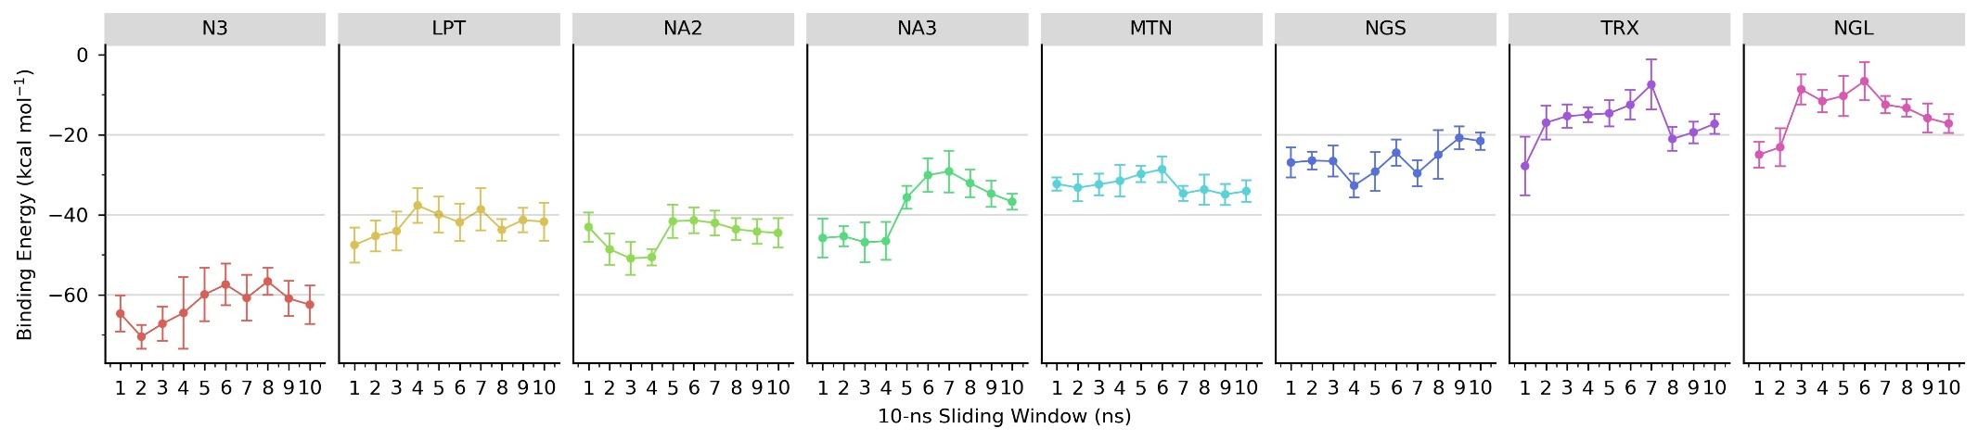

Fig. S3. Trajectory of  values of several ligands binding to Mpro. Each data point was generated from every 10 ns MD trajectory. The ligands include N3 inhibitor, leupeptin (LPT), and secondary metabolites in *N. sativa* seeds. They are nigellamine A2 (NA2), nigellamine A3 (NA3), melanthigenin (MTN), nigellidine-4-O-sulfite (NGS), taraxerol (TRX), and nigellidine (NGL).

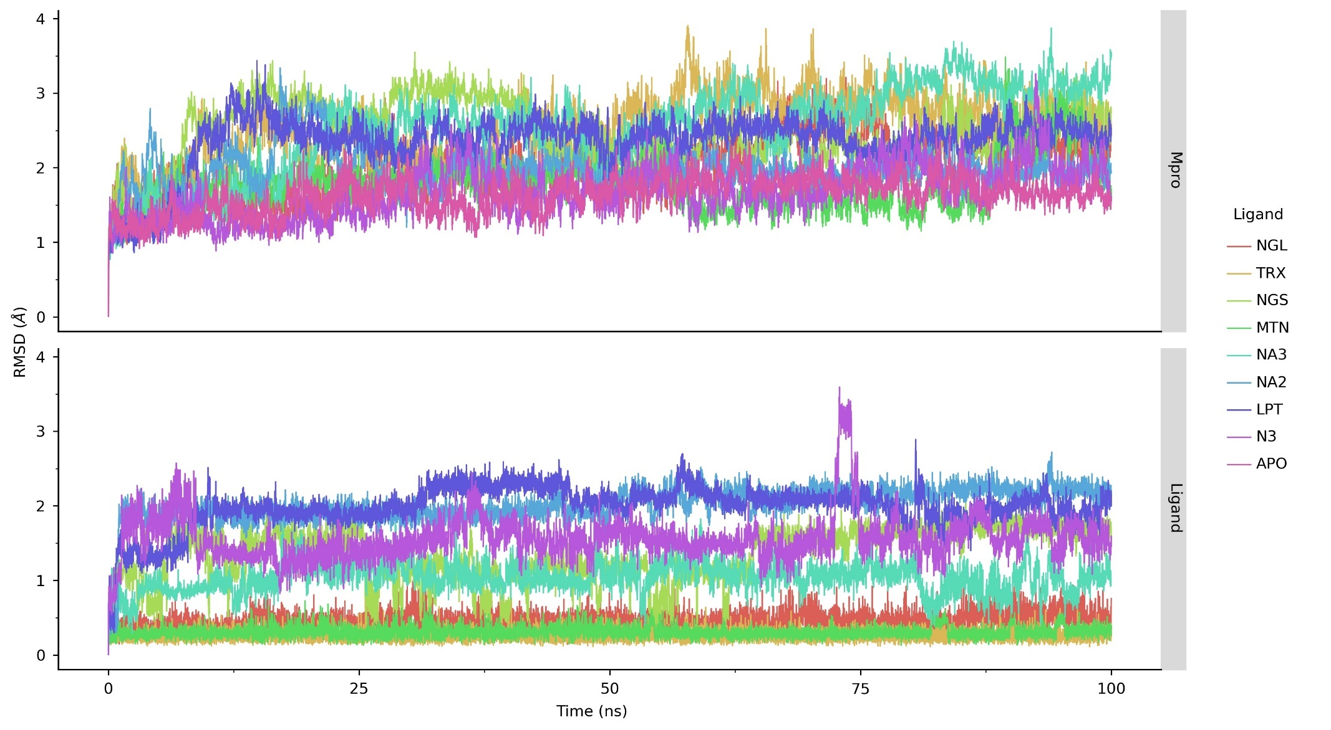

**Fig. S4.** RMSD plots of Mpro in apo and ligand-bound forms and the ligands. The top panels are RMSD plots of the protein, whereas the lower panels are RMSD plots of ligands. The ligands are N3 inhibitor, leupeptin (LPT), and secondary metabolites in *N. sativa* seeds, including nigellamine A2 (NA2), nigellamine A3 (NA3), melanthigenin (MTN), nigellidine-4-O-sulfite (NGS), taraxerol (TRX), and nigellidine (NGL).

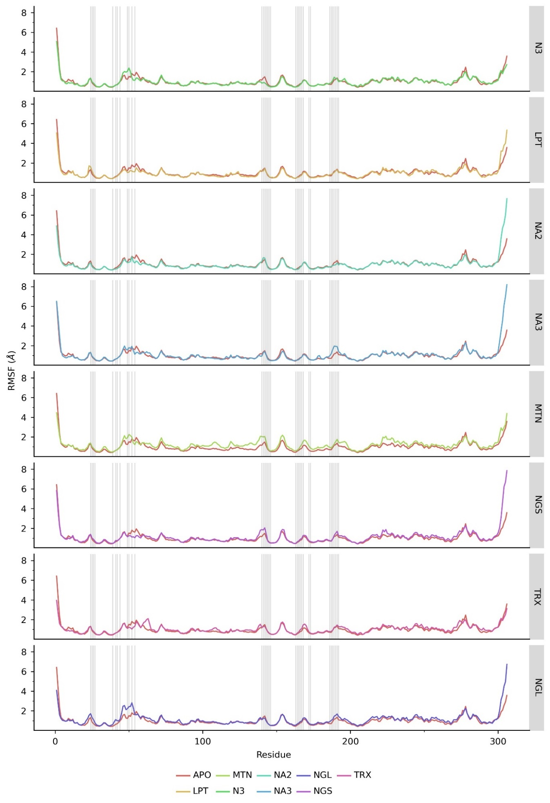

**Fig. S5.** RMSF plots of Mpro in apo and ligand-bound forms. The ligands are N3 inhibitor, leupeptin (LPT), and secondary metabolites in *N. sativa* seeds, including nigellamine, A2 (NA2), and A3 (NA3).

|  |  |  |  |
| --- | --- | --- | --- |
|  | **Molecular Docking** |  | **Molecular Dynamics Simulation** |
| **Leupeptin** |  |  |  |
|  |  |  |  |
| **N3** |  |  |  |
|  |  |  |  |
| **Nigellamine A2** |  |  |  |
|  |  |  |  |
| **Nigellamine A3** |  |  |  |

**Fig. S6.** Non-bonded interactions between ligands and the binding site residues of Mpro before and after MD simulations. For MD simulations, the non-bonded interactions were extracted from the last frame of the MD trajectories.

**Note: Significance Test on**  **Values**

Below are the results of significance tests on  values of several ligands to Mpro. These ligands are N3, leupeptin (LPT), nigellamine A2 (NA2), nigellamine A3 (NA3), and melanthigenin (MTN). Based on the Shapiro test, binding energy data is normally distributed (*p*-value = 9.34 × 10-2; *α* = 5%). Nonetheless, according to the Bartlett test, the data lack variance homogeneity (*p*-value = 2.33 × 10-3). Therefore, we performed a non-parametric significance test, the Kruskal-Wallis rank-sum test.

Kruskal-Wallis rank sum test

data: deltaG by Ligand

Kruskal-Wallis chi-squared = 19.278, df = 3, p-value = 0.0002395

Since the Kruskal-Wallis rank-sum test showed the significant difference of  values among ligands (*p*-value = 2.40 × 10-4), we conducted Dunn’s multiple comparison test with the Bonferroni method as the post hoc test. The result suggests that the binding energy values leupeptin, nigellamine A2, and nigellamine A3 to Mpro are not significantly different.

Comparison of  by group

(Bonferroni)

Col Mean-|

Row Mean | LPT MTN NA2

---------+---------------------------------

MTN | -3.194259

| 0.0042*

|

NA2 | 0.994619 4.188879

| 0.9598 0.0001*

|

NA3 | -1.013746 2.180512 -2.008366

| 0.9321 0.0877 0.1338

alpha = 0.05

Reject Ho if p <= alpha/2

**References**

1. B. Nickavar, F. Mojab, K. Javidnia, M. A. R. Amoli, *Zeitschrift Fur Naturforschung - Section C Journal of Biosciences* **58** (2003) 629–631.

2. M. A. Khan, M. Afzal, *Inflammopharmacology* **24** (2016) 67–79.

3. E. M. Yimer, K. B. Tuem, A. Karim, N. Ur-Rehman, F. Anwar, *Evidence-Based Complementary and Alternative Medicine* **2019** (2019).

4. A. Ahmad, A. Husain, M. Mujeeb, S. A. Khan, A. K. Najmi, N. A. Siddique, Z. A. Damanhouri, F. Anwar, *Asian Pacific Journal of Tropical Biomedicine* **3** (2013) 337–352.

5. B. K. Mehta, V. Pandit, M. Gupta, *Natural Product Research* **23** (2009) 138–148.

6. I. Merfort, V. Wray, H. H. Barakat, S. A. M. Hussein, M. A. M. Nawwar, G. Willuhn, *Phytochemistry* **46** (1997) 359–363.

7. T. Yuan, P. Nahar, M. Sharma, K. Liu, A. Slitt, H. A. Aisa, N. P. Seeram, *Journal of Natural Products* **77** (2014) 2316–2320.

8. T. Morikawa, F. Xu, K. Ninomiya, H. Matsuda, M. Yoshikawa, *Chemical and Pharmaceutical Bulletin* **52** (2004) 494–497.