**Support information;**

Table S1. Recovery rate (%) according to the difference in extraction solvents

|  |  |  |  |
| --- | --- | --- | --- |
| **Compound** | **Recovery rate (%)1)** | | |
| **Methanol** | **Methanol/water**  **(50/50, v/v)** | **Water** |
| Kasugamycin | 58.4±2.6 | 90.2±2.1 | 96.3±2.7 |

1) Triplicate recovery average ± RSD

Table S2. Recovery rate (%) by loading volume of SCX SPE cartridge after matrix application

|  |  |  |  |  |  |
| --- | --- | --- | --- | --- | --- |
| **Loading volume** | **Recovery rate (%)** | | | | |
| **Loading** | **Water**  **10 mL1)** | **Methanol 10 mL1)** | **5% NH4OH in methanol 10 mL2)** | **Total** |
| 1 mL | - | - | - | 95.5 | 95.5 |
| 2 mL | - | - | - | 101.2 | 101.2 |
| 3 mL | - | - | - | 97.4 | 97.4 |
| 4 mL | - | 24.5 | - | 69.5 | 94.0 |

1) Washing

2) Elution

Table S4. LC/MS/MS calibration curve of working solution at various concentrations range

|  |  |  |  |  |  |  |
| --- | --- | --- | --- | --- | --- | --- |
|  | STD #1 | STD #2 | STD #3 | STD #4 | STD #5 | STD #6 |
| Concentration  (μg/mL) at volume 500 μL | 0.005 | 0.008 | 0.01 | 0.05 | 0.08 | 0.1 |
| Matrix (μL) | 500 | 500 | 500 | 500 | 500 | 500 |

Table S5. Recovery rate and MLOQ for chlorantraniliprole in *Achyranthes japonica Nakai* root

|  |  |  |  |  |
| --- | --- | --- | --- | --- |
| **Herbal medicine** | **Fortification**  **(mg/L)** | **Recovery**  **(%)a)** | **C.V.(%)b)** | **MLOQ**  **(mg/kg)** |
| *Achyranthes japonica* Nakai | 0.04 | 97.2 | 8.8 | 0.04 |
| 0.4 | 86.3 | 2.8 |

a) Mean values of triplicate samples with standard deviations

b) CV (coefficient of variation, %) = standard deviation/average × 100



Fig. S1. The MS-MS iron scan and fragmentation of kasugamycin

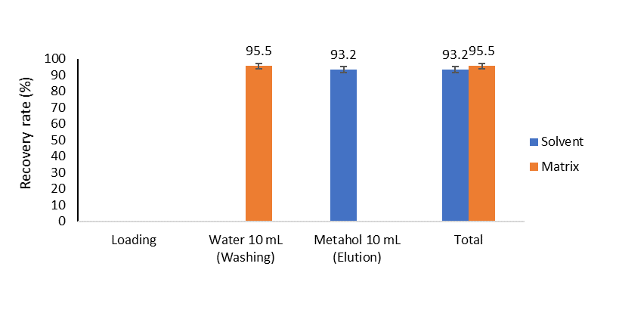

Fig. S2. Recovery rate (%) elution purified by silica SPE cartridge

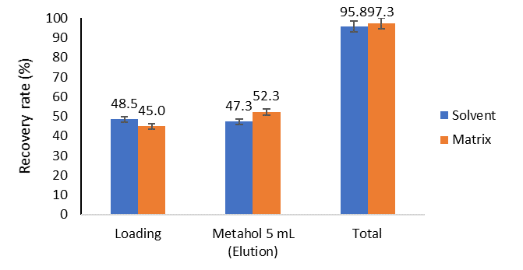

Fig. S3. Recovery rate (%) of elution purified by HLB SPE cartridge

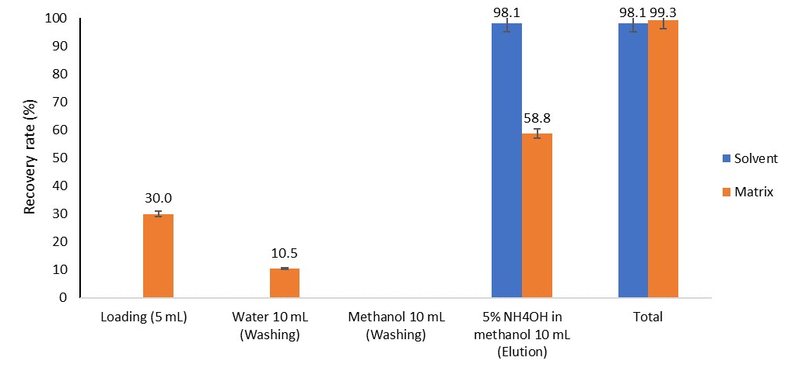

Fig. S4. Recovery rate (%) of elution purified by SCX SPE cartridge