SYNTHESIS AND MOLECULAR DOCKING STUDIES OF NEW DISPIROPYRROLIDINES ON WEST NILE VIRUS NS2B-NS3 PROTEASE

Nadia Mohamed Yusoff¹, Hasnah Osman¹, Mohd. Zaheen Hassan^{1,2}, Mohamed Ashraf Ali^{1,3}, Yeong Keng Yoon^{4,5}, Ezatul Ezleen Kamarulzaman⁶, Muhammad Solehin Abd Ghani¹, Unang Supratman⁷ and Mohamad Nurul Azmi^{1*}

Procedure for The Preparation of Compounds

  - General procedure for synthesis of (3E,5E)-3,5-bis(substitutedarylidene)-1-phenethyl piperidin-4-one (1a-c)
The procedure of preparation of dibenzylidene-1-phenylethylpiperidine-4-ones 1a-c was reported previously by our group [1]. 1-phenylethyl-4-piperidone (1.0 equiv.) and appropriate aldehyde (2.0 equiv.) were dissolved together in ethanol (10 mL) and 30% sodium hydroxide (5 mL; prepared in ethanol). The reaction mixture was stirred for 2-6 hours at room temperature until completion (TLC). The mixture was then poured into crushed ice. The precipitated solid was filtered, washed with water and purified by recrystallization. The spectroscopic data were compared with the literature [1].

(3E,5E)-3,5-dibenzylidene-1-phenylethyl-4-piperidinone (1a). 1-phenylethyl-4-piperidone (1.22 g, 6.0 mmol) and benzaldehyde (1.27 g, 12.0 mmol) were dissolved together in ethanol (10 mL) and 30% sodium hydroxide (5 mL; prepared in ethanol) according to the general procedure above. The precipitated solid was filtered, washed with water and purified by recrystallization to give a bright yellow solid (2.12 g, 94.6%), M.p. 167-170 ˚C. FTIR (ATR, cm⁻¹): 3026 (w, C-H), 1669 (s, C=O), 1608 (s, C=C), 1181 (m, C-N). ¹H-NMR (500 MHz, DMSO-d₆): δ_{H}, ppm 2.70 (2H, t, J= 7.5 Hz, 8-CH₂), 2.81 (2H, t, J= 7.5 Hz, 7-CH₂), 3.88 (4H, s, 2-CH₂, 6-CH₂), 7.14-7.23 (5H, m, H-10, H-11, H-12, H-13, H-14), 7.42-7.51 (10H, m, H-17, H-18, H-19, H-20, H-21), 7.58 (2H, s, H-15). ¹³C-NMR (125 MHz, DMSO-d₆): δ_{C}, ppm 33.3, 54.5, 58.3, 126.3, 128.6, 129.0, 129.2, 129.7, 131.0, 134.3, 135.1, 135.3, 140.5, 187.4. HRMS (TOF-ES⁺): m/z 380.2139 (MH⁺ C₂₇H₂₆NO⁺ requires 380.2009).

(3E,5E)-3,5-bis(4-methylbenzylidene)-1-phenylethyl-4-piperidinone (1b). 1-phenylethyl-4-piperidone (1.22 g, 6.0 mmol) and 4-methylbenzaldehyde (1.44 g, 12.0 mmol) were dissolved together in ethanol (10 mL) and 30% sodium hydroxide (5 mL; prepared in ethanol) according to the general procedure above. The precipitated solid was filtered, washed with water and purified by recrystallization to give a yellow solid (2.19 g, 90.1%), M.p. 118-121 ˚C. FTIR (ATR, cm⁻¹): 3024 (w, C-H), 1668 (s, C=O), 1606 (m, C=C), 1174 (m, C-N). ¹H-NMR (500 MHz, DMSO-d₆): δ_{H}, ppm 2.36 (6H, s, 22-CH₃), 2.71 (2H, t, J= 7.5 Hz, 8-CH₂), 2.81 (2H, t, J=7.5 Hz, 7-CH₂), 3.86 (4H, s, 2-CH₂, 6-CH₂), 7.14-7.24 (5H, m, H-10, H-11, H-12, H-13, H-14), 7.29 (4H, d, J= 8.5 Hz, H-18, H-20), 7.40 (4H, d, J= 8.50 Hz, H-17, H-21,), 7.58 (2H, s, H-15). ¹³C-NMR (125 MHz, DMSO-d₆): δ_{C}, ppm 21.5, 33.3, 54.6, 58.4, 126.3, 128.7, 129.0, 129.9, 131.0, 132.4, 133.5, 135.2, 139.6, 140.5, 187.3. HRMS (TOF-ES⁺): m/z 408.2324 (MH⁺ C₂₉H₃₀NO⁺ requires 408.2322).

(3E,5E)-3,5-bis(4-methoxybenzylidene)-1-phenylethyl-4-piperidinone (1c). 1-phenylethyl-4-piperidone (0.61 g, 3.0 mmol) and 4-methoxybenzaldehyde (0.82 g, 6.0 mmol) were dissolved together in ethanol (5 mL) and 30% sodium hydroxide (3 mL; prepared in ethanol) according to the general procedure above. The precipitated solid was filtered, washed with water and purified by recrystallization to give a yellow solid (1.13 g, 85.4%), M.p. 143-146 ˚C, Lit. mp 147 ˚C. FTIR (ATR, cm⁻¹): 3023 (w, C-H), 1667 (s, C=O), 1596 (m, C=C), 1166 (m, C-N); ¹H-NMR (500 MHz, DMSO-d₆): δ_{H}, ppm 2.73 (2H, t, J= 7.5 Hz 8-CH₂,), 2.82 (2H, t, J= 7.5 Hz, 7-CH₂), 3.82 (6H, s, 22-OCH₃), 3.84 (4H, s, 2-CH₂, 6-CH₂), 7.04 (4H, d, J= 8.5 Hz, 18-CH, 20-CH,), 7.15-7.25 (5H, m, 10-CH, 11-CH, 12-CH, 13-CH, 14-CH), 7.45 (4H, d, J= 8.5 Hz, 17-CH, 21-CH), 7.56 (2H, s, H-15). ¹³C-NMR (125 MHz, DMSO-d₆): δ_{C}, ppm 33.3, 54.7, 55.8, 58.5, 113.7, 114.8, 126.3, 127.7, 128.7, 129.0, 132.2, 132.9, 134.9, 140.6, 160.5, 187.1. HRMS (TOF-ES⁺): m/z 440.2399 (MH⁺ C₂₉H₃₀NO₃⁺ requires 440.2226).

1.2 General procedure for synthesis of spiropyrrolidines 5 and 6
3,5-bis(substitutedarylidene)-1-phenethylpiperidin-4-one 1 (1.0 equiv.) was refluxed together with appropriate isatin 4 or 5 (1.0 equiv.) and sarcosine 6 (2.0 equiv.) in methanol (20 mL) for 4-7 hours. After completion of reaction, excess solvent in mixture was removed under reduced pressure and cooled before poured on to crushed ice. Products obtained were filtered, washed with water and purified by recrystallization.

1-Methyl-4(phenyl)pyrrolo-(spiro[2.3'']oxindole)-spiro[3.3']-5'-(phenylmethylidene)-1'-phenylethyl-4'-piperidinone (5a). 3,5-bis(substitutedarylidene)-1-phenethylpiperidin-4-one 1a (0.10 g, 0.26 mmol) was refluxed together with appropriate isatin 3 (0.04 g, 0.26 mmol) and sarcosine (2) (0.05 g, 0.52 mmol) in methanol (20 mL) according to the general procedure above. Products obtained were filtered, washed with water and purified by recrystallization to give pale yellow solid (Yield = 0.13 g (89.6%), M.p. 117−120 ˚C. FTIR (ATR, cm⁻¹): ν 3346 (w, N−H), 3027 (w, C−H), 1697 (s, C=O), 1599 (m, C=C), 1182 (m, C−N). ¹H-NMR (500MHz, DMSO-d₆) δ_{H}, ppm: 1.76 (1H, d, J=12.5 Hz, 7-CH_{2a}), 2.00 (s, 3H, N-CH₃), 2.34-2.45 (m, 4H, 2′-CH₂, 6′-CH₂), 3.06 (dd, 1H, J=2.4, 2.5 Hz, 5-CH_{2a}), 3.20-3.25 (m, 2H, 7′-CH_{2b}, 8′-CH_{2a}), 3.36 (*overlap signal, 1H, 5-CH_{2b}), 3.82-3.86 (m, 1H, 8′-CH_{2a}), 4.64-4.68 (m, 1H, H-4), 6.65-7.33 (19H, m, ArH), 10.46 (s, 1H, NH). ¹³C-NMR (125 MHz, DMSO-d₆) δ_{C}, ppm: 32.0, 34.1, 45.2, 53.9, 56.2, 56.3, 59.1, 64.6, 75.2, 108.7, 120.7, 125.8, 126.75, 126.85, 126.91, 128.18 128.20, 128.46, 128.47, 128.6, 128.9, 129.1, 129.1, 130.0, 132.9, 134.5, 136.6, 138.4, 140.0, 143.4, 176.6, 198.2. HRMS (TOF-ES⁺): m/z 554.2899 (MH⁺ C₃₇H₃₆N₃O₂⁺ requires 554.2803).

1-Methyl-4(-4-methylphenyl)pyrrolo-(spiro[2.3'']oxindole)-spiro[3.3']-5'-(4–methyl phenylmethylidene)-1'-phenylethyl-4'-piperidinone (5b). 3,5-bis(substitutedarylidene)-1-phenethylpiperidin-4-one 1b (0.10 g, 0.26 mmol) was refluxed together with appropriate isatin 3 (0.04 g, 0.26 mmol) and sarcosine (2) (0.05 g, 0.52 mmol) in methanol (20 mL) according to the general procedure above. Products obtained were filtered, washed with water and purified by recrystallization to give pale yellow solid (Yield = 0.13 g (88.7%), M.p. 192−195 ˚C. FTIR (ATR, cm⁻¹): ν 3397 (w, N−H), 3023 (w, C−H), 1694 (s, C=O, 1605 (m, C=C), 1177 (m, C−N). ¹H-NMR (500MHz, DMSO-d₆) δ_{H}, ppm: 1.78 (d, 1H, J=12.5 Hz, 7′-CH_{2a}), 1.98 (s, 3H, N-CH₃), 2.27 (d, 6H, J=5.8 Hz, 2×CH₃), 2.33-2.46 (m, 4H, 2′-CH₂, 6′-CH₂), 3.05 (dd, 1H, J=2.4, 2.5 Hz, 5-CH_{2a}), 3.17-3.22 (m, 2H, 7′-CH_{2b}, 8′-CH_{2a}), 3.26 (*overlap signal, 1H, 5-CH_{2b}), 3.78-3.82 (m, 1H, 8′-CH_{2b}), 4.58 (dd, 1H, J=7.4, 7.5 Hz, H-4), 6.63-7.26 (18H, m, ArH), 10.36 (s, 1H, NH). ¹³C-NMR (125 MHz, DMSO-d₆) δ_{C}, ppm: 20.6, 20.9, 32.1, 34.1, 44.8, 54.0, 56.3, 56.4, 59.1, 64.5, 75.2, 108.6, 120.6, 125.8, 126.88, 126.93, 128.2, 128.5, 128.4, 128.8, 129.0, 129.1, 130.2, 131.7, 132.1, 135.3, 135.7, 136.6, 138.8, 140.1, 143.4, 176.6, 198.2. HRMS (TOF-ES⁺): m/z 582.3081 (MH⁺ C₃₉H₄₀N₃O₂⁺ requires 582.3115, 604.2894 (MNa⁺ C₃₉H₃₉N₃NaO₂⁺ requires 604.2935).

1-Methyl-4(-4-methoxyphenyl)pyrrolo-(spiro[2.3'']oxindole)-spiro[3.3']-5'-(4-methoxy phenylmethylidene)-1'-phenylethyl-4'-piperidinone (5c). 3,5-bis(substitutedarylidene)-1-phenethylpiperidin-4-one 1c (0.10 g, 0.26 mmol) was refluxed together with appropriate isatin 3 (0.04 g, 0.26 mmol) and sarcosine (2) (0.05 g, 0.52 mmol) in methanol (20 mL) according to the general procedure above. Products obtained were filtered, washed with water and purified by recrystallization to give pale yellow solid (Yield = 0.13 g (88.9%), M.p. 130-133 °C. FTIR (ATR, cm⁻¹): 3289 (w, N-H), 2934 (w, C-H), 1706 (s, C=O), 1580 (m, C=C), 1247 (m, C-O), 1173 (m, C-N). ¹H-NMR (500 MHz, DMSO-d₆): δ_{H}, ppm 1.76 (1H, d, J=12.5 Hz, 7′-CH_{2a}), 1.97 (3H, s, N-CH₃), 2.31-2.46 (4H, m, 2′-CH₂, 6′-CH₂), 3.04 (1H, dd, J=2.3, 2.4 Hz, 5-CH_{2a}), 3.16-3.19 (2H, m, 7-CH_{2b}, 8-CH_{2a}), 3.40 (1H, *overlap signal, 5-CH_{2b}), 3.72 (3H, s, OCH₃), 3.76 (1H, *overlap signal, 8′-CH_{2b}), 3.82 (3H, s, OCH₃), 4.57 (1H, dd, J=7.5, 7.5 Hz, H-4), 6.64-7.26 (20H, m, ArH), 10.38 (1H, s, NH). ¹³C-NMR (125.8 MHz, DMSO-d₆): δ_{C}, ppm 32.6, 34.5, 45.0, 54.7, 55.4, 55.7, 55.8, 56.7, 57.1, 59.8, 64.8, 75.9, 109.1, 121.1, 126.3, 127.4, 127.5, 127.6, 127.7, 128.7, 128.9, 129.0, 130.6, 130.8, 131.2, 132.2, 132.9, 132.9, 137.0, 140.6, 143.9, 177.2, 198.6. HRMS (TOF-ES⁺): m/z 614.3027 (MH⁺ C₃₉H₄₀N₃O₄⁺ requires 614.3019).

1-Methyl-4(phenyl)pyrrolo-(spiro[2.3'']-5''-chlorooxindole)-spiro[3.3']-5'-(phenylmethyli dene)-1'-phenylethyl-4'-piperidinone (6a). 3,5-bis(substitutedarylidene)-1-phenethyl piperidin-4-one 1a (0.10 g, 0.26 mmol) was refluxed together with appropriate 5-chloroisatin 4 (0.04 g, 0.26 mmol) and sarcosine (2) (0.05 g, 0.52 mmol) in methanol (20 mL) according to the general procedure above. Products obtained were filtered, washed with water and purified by recrystallization to give pale yellow solid (Yield = 0.15 g (95.4%), M.p. 131-134 ˚C. FTIR (ATR, cm⁻¹): ν 3244 (w, N−H), 3027 (w, C−H), 1698 (s, C=O), 1615 (m, C=C), 1182 (m, C−N). ¹H-NMR (500MHz, DMSO-d₆) δ_{H}, ppm: 1.74-1.77 (d, 1H, J=12.6 Hz, 7′-CH_{2a}), 2.02 (s, 3H, N-CH₃), 2.37-2.44 (m, 4H, 2′-CH₂, 6′-CH₂), 3.09-3.12 (dd, 1H, J=2.4, 2.5, Hz, 5-CH_{2a}), 3.22-3.25 (m, 2H, 7′-CH_{2b}, 8′-CH_{2a}), 3.37 (*overlap signal, 1H, 5-CH_{2b}), 3.80-3.84 (1H, m, 8′-CH_{2b}), 4.63-4.67 (m, 1H, H-4), 6.66-6.83 (1H, m, ArH), 7.11-7.37 (19H, m, ArH), 10.57 (s, 1H, NH). ¹³C-NMR (125 MHz, DMSO-d₆) δ_{C}, ppm: 32.0, 34.2, 45.1, 54.0, 56.3, 56.4, 59.1, 65.1, 75.2, 110.3, 125.0, 125.9, 126.8, 126.9, 128.27, 128.34, 128.5, 128.6, 128.7, 129.17, 129.23, 129.1, 130.1, 133.1, 134.3, 137.2, 138.1, 140.0, 142.4, 176.3, 198.2. HRMS (TOF-ES⁺): m/z 588.2390 (MH⁺ C₃₇H₃₅³⁵ClN₃O₂⁺ requires 588.2413).

1-Methyl-4(-4-methylphenyl)pyrrolo-(spiro[2.3'']-5''-chlorooxindole)-spiro[3.3']-5'-(4-methylphenylmethylidene)-1'-phenylethyl-4'-piperidinone (6b). 3,5-bis(substitutedary lidene)-1-phenethyl piperidin-4-one 1b (0.10 g, 0.26 mmol) was refluxed together with appropriate 5-chloroisatin 4 (0.04 g, 0.26 mmol) and sarcosine (2) (0.05 g, 0.52 mmol) in methanol (20 mL) according to the general procedure above. Products obtained were filtered, washed with water and purified by recrystallization to give pale yellow solid (Yield = 0.13 g (84.4%), M.p. 186−189 ˚C. FTIR (ATR, cm⁻¹): ν 3180 (w, N−H), 3025 (w, C−H), 1691 (s, C=O), 1607 (m, C=C), 1182 (m, C−N). ¹H-NMR (500 MHz, DMSO-d₆) δ_{H}, ppm: 1.75 (d, 1H, J=12.5 Hz, 7′-CH_{2a}), 2.01 (s, 3H, N-CH₃), 2.30 (d, 6H, J=11.6 Hz, 2×CH₃), 2.36 (s, 2H, 6′-CH₂), 2.42-2.46 (m, 2H, 2′-CH₂), 3.08 (dd, 1H, J=1.8, 1.9 Hz, 5-CH_{2a}), 3.17-3.22 (m, 2H, 7′-CH_{2b}, 8′-CH_{2b}), 3.39 (*overlap signal, 1H, 5-CH_{2b}), 3.76-3.80 (m, 1H, 8′-CH_{2b}), 4.60 (dd, 1H, J=7.4, 7.4 Hz, H-4), 6.64-7.40 (19H, m, ArH), 10.54 (s, 1H, NH). ¹³C-NMR (125 MHz, DMSO-d₆) δ_{C}, ppm: 20.6, 20.9, 32.0, 34.1, 44.6, 54.0, 56.3, 56.4, 59.0, 64.9, 75.2, 110.1, 124.8, 125.8, 126.8, 128.2, 128.3, 128.4, 128.8, 128.9, 129.1, 129.2, 130.1, 131.5, 132.2, 135.0, 135.8, 137.1, 139.1, 139.9, 142.3, 176.2, 198.1. HRMS (TOF-ES⁺): m/z 616.2735 (MH⁺ C₃₉H₃₉³⁵ClN₃O₂⁺ requires 616.2726), 638.2595 (MNa⁺ C₃₉H₃₈³⁵ClN₃O₂Na⁺ requires 638.2545).

1-Methyl-4(-4-methoxyphenyl)pyrrolo-(spiro[2.3'']-5''-chlorooxindole)-spiro[3.3']-5'-(-4-methoxyphenylmethylidene)-1'-phenylethyl-4'-piperidinone (6c). 3,5-bis(substitute darylidene)-1-phenethylpiperidin-4-one 1c (0.10 g, 0.26 mmol) was refluxed together with appropriate 5-chloroisatin 4 (0.04 g, 0.26 mmol) and sarcosine (2) (0.05 g, 0.52 mmol) in methanol (20 mL) according to the general procedure above. Products obtained were filtered, washed with water and purified by recrystallization to give pale yellow solid (Yield = 0.11 g (81.3%), M.p. 187-190 °C. IR (ATR, cm⁻¹): 3297 (w, N-H), 2943 (w, C-H), 1709 (s, C=O), 1578 (m, C=C), 1250 (C-O), 1172 (C-N). ¹H-NMR (500 MHz, DMSO-d₆): δ_{H}, ppm 1.76 (d, 1H, d, J 12.5 Hz, 7-CH_{2a}), 2.00 (s, 3H, N-CH₃), 2.37-2.43 (m, 4H, 2′-CH₂, 6′-CH₂), 3.10 (dd, 1H, J=2.4, 2.5 Hz, 5-CH_{2a}), 3.16-3.21 (m, 2H, 7′-CH_{2b}, 8′-CH_{2a}), 3.38 (*overlap signal, 1H, 5-CH_{2b}), 3.73 (s, 3H, OCH₃), 3.75 (*overlap, 1H, 8′-CH_{2b}), 3.78 (s, 3H, OCH₃), 4.60 (dd, 1H, J=7.65, 7.55 Hz, H-4), 6.65-7.27 (17H, m, ArH), 10.55 (s, 1H, NH). ¹³C-NMR (125.8 MHz, DMSO-d6): δ_{C}, ppm 32.5, 34.6, 44.8, 54.7, 55.4, 55.7, 56.8, 57.2, 59.7, 65.2, 75.8, 110.5, 124.8, 125.3, 126.3, 128.3, 128.4, 128.7, 128.8, 128.9, 129.7, 130.5, 130.6, 131.3, 132.7, 135.1, 135.9, 137.5, 139.0, 140.5, 142.8, 176.8, 198.5. HRMS (TOF-ES⁺): m/z 670.2453 (MNa⁺ C₃₉H₃₈ClN₃O₄Na⁺ requires 670.2449).
  - Selected of Spectroscopic Data HRMS, IR and NMR Spectra

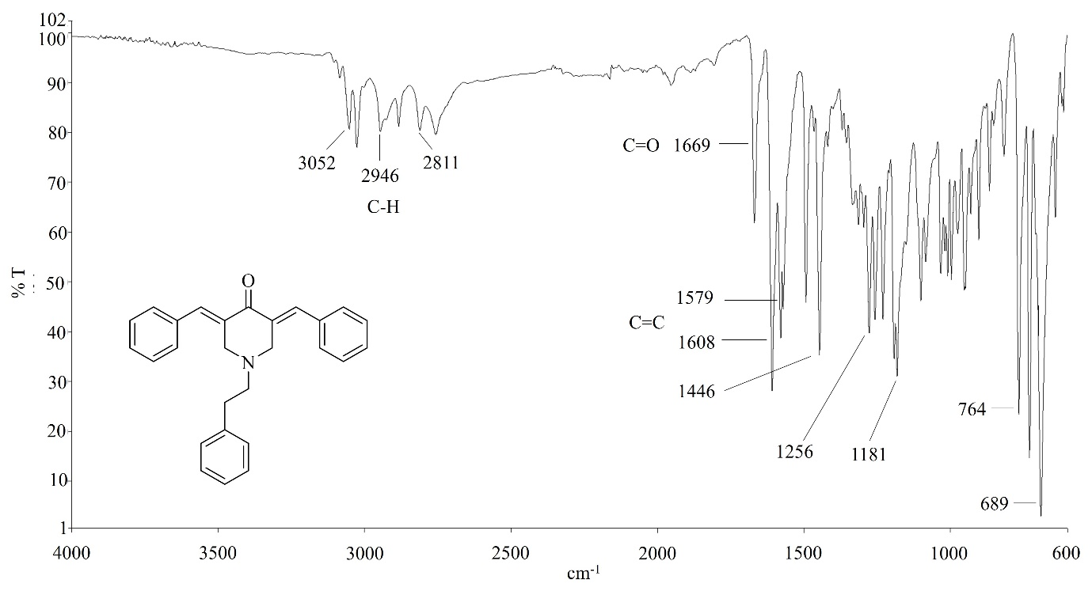
S1: IR Spectrum for Compound 1a
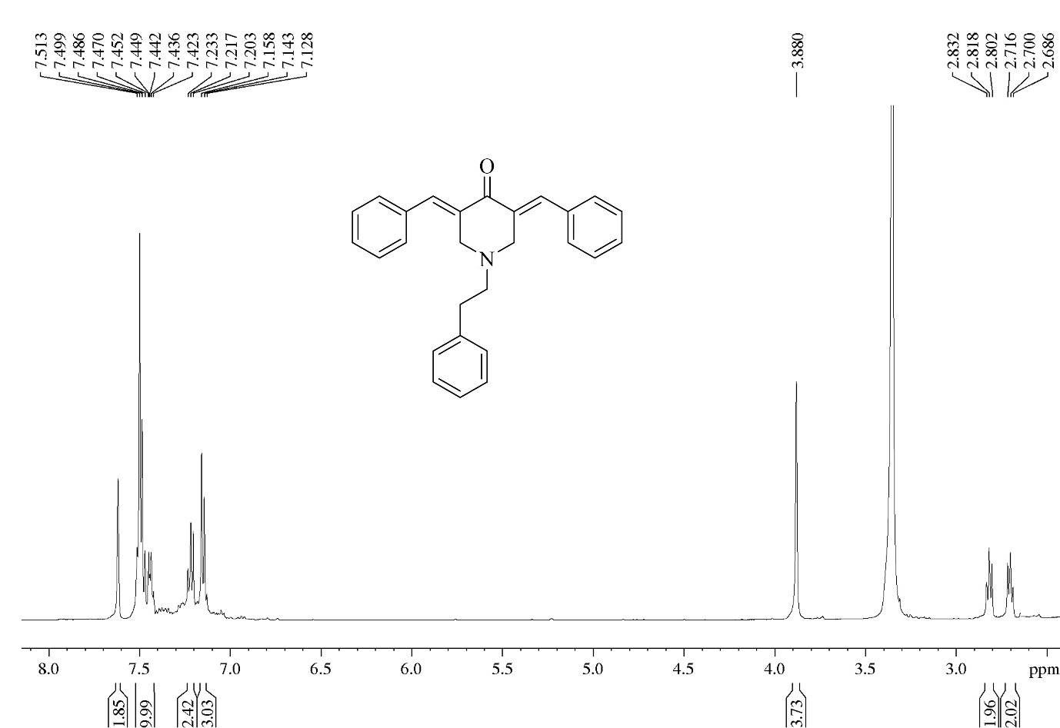
S2: ¹H NMR Spectrum for compound 1a
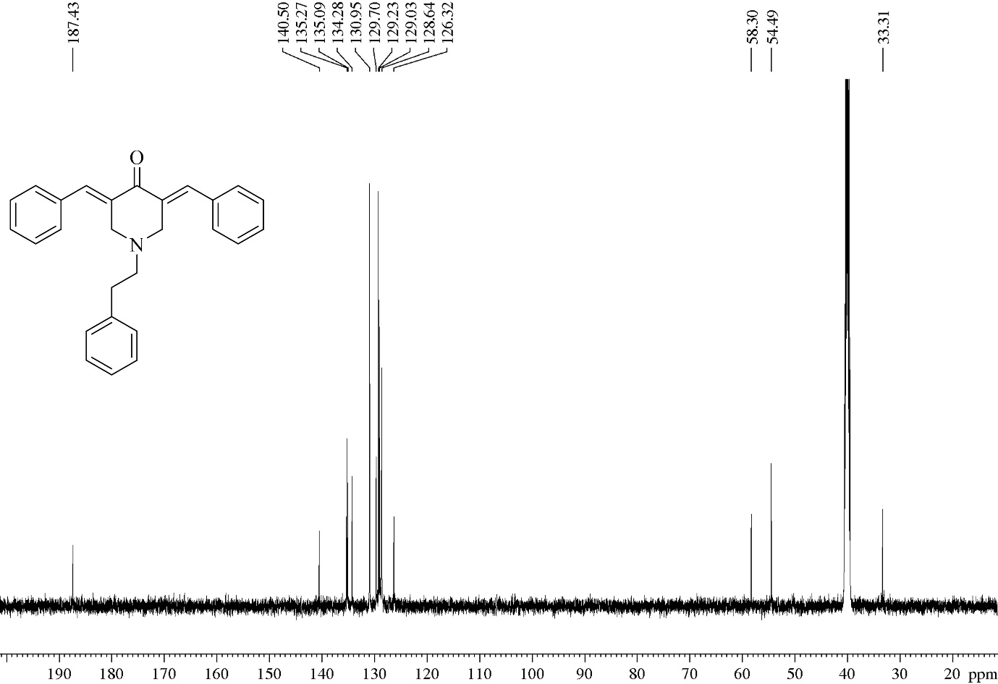
S3: ¹³C NMR Spectrum for compound 1a

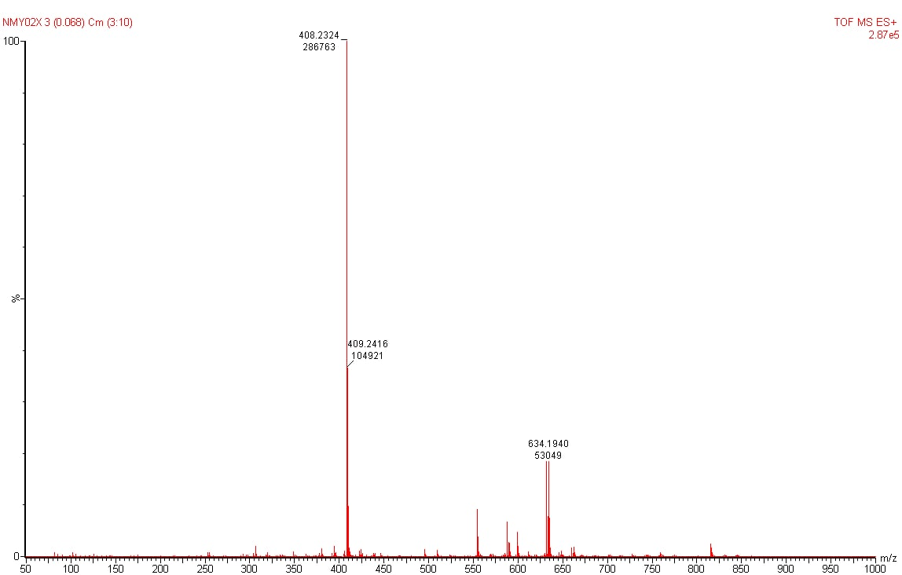
S4: HRMS Spectrum for Compound 1b

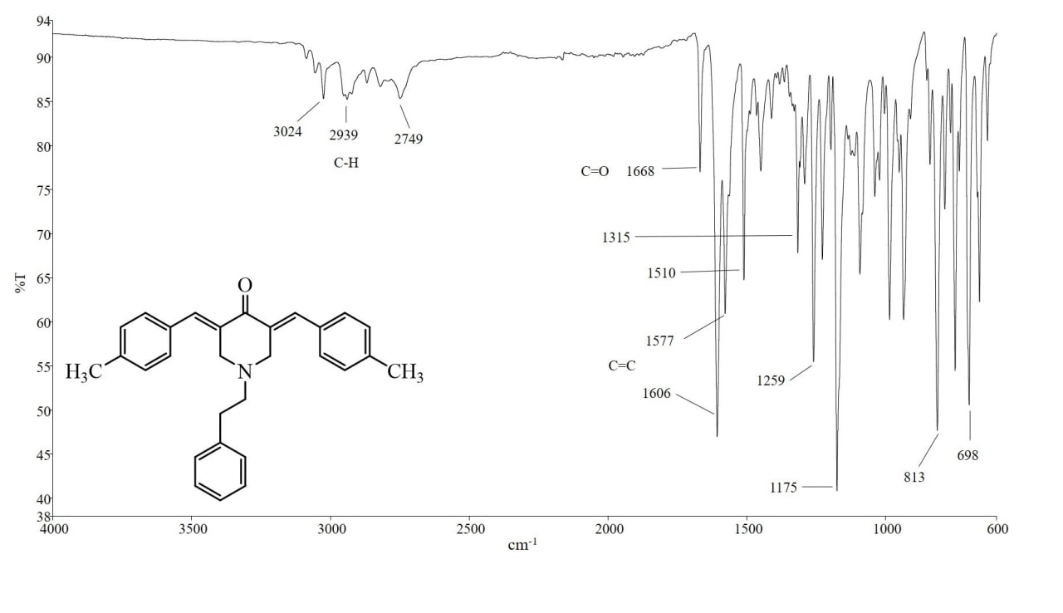
S5: IR Spectrum for Compound 1b

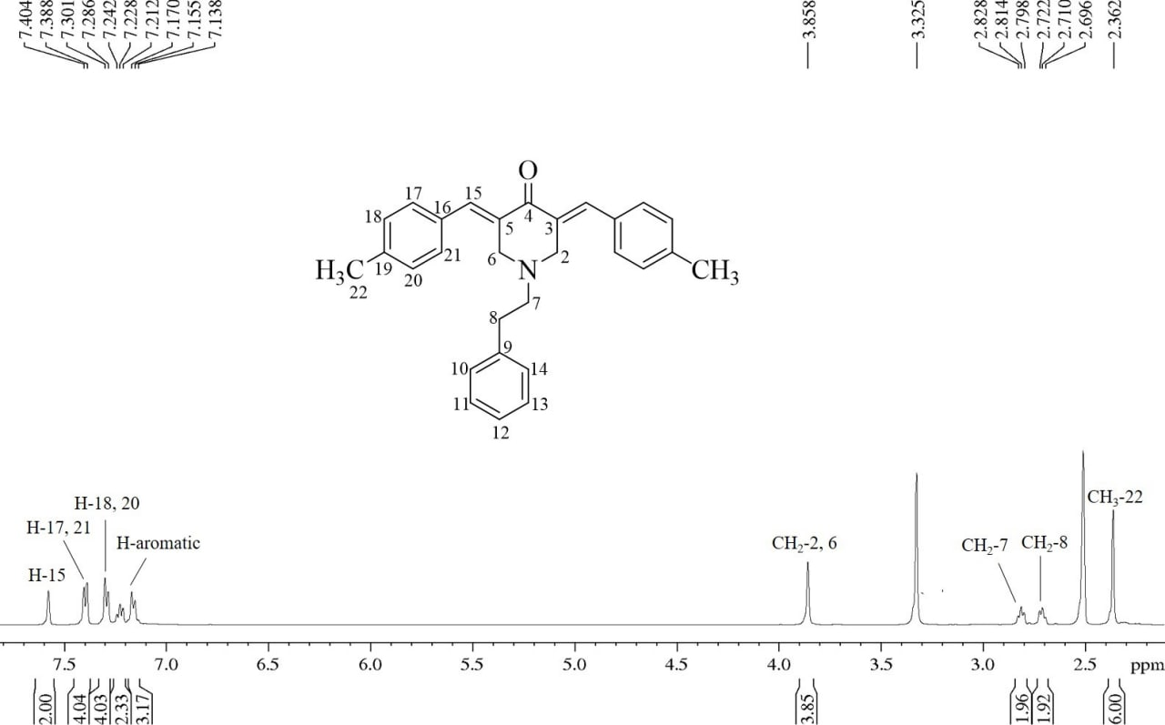
S6: ¹H NMR Spectrum for compound 1b

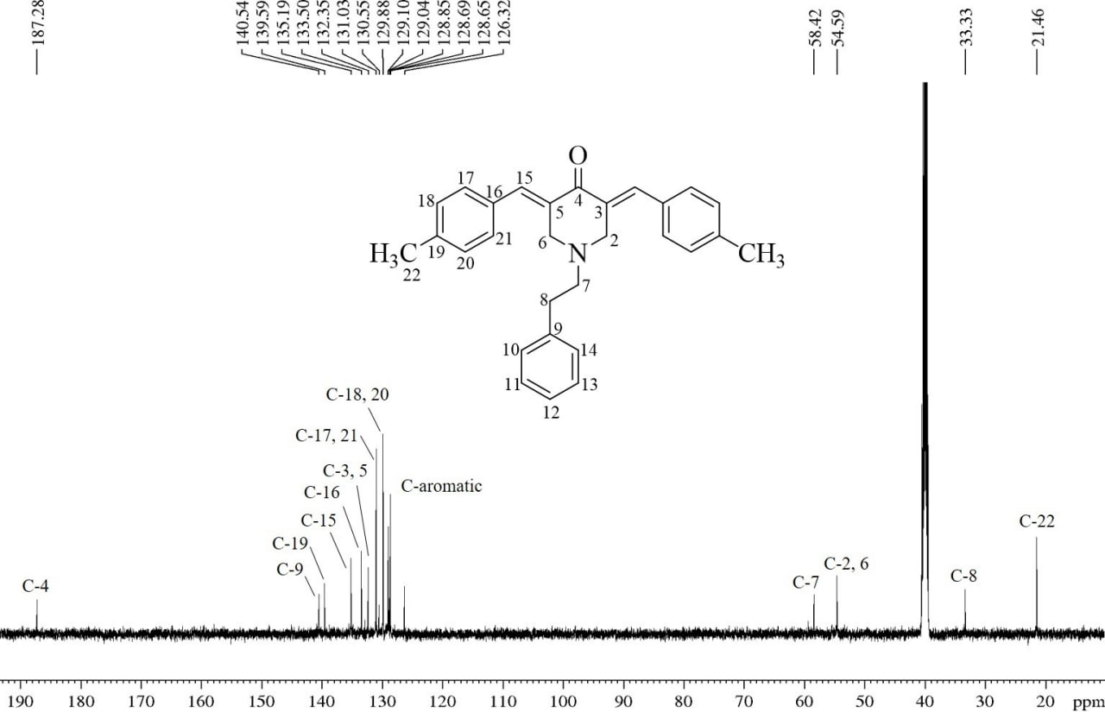
S7: ¹³C NMR Spectrum for compound 1b

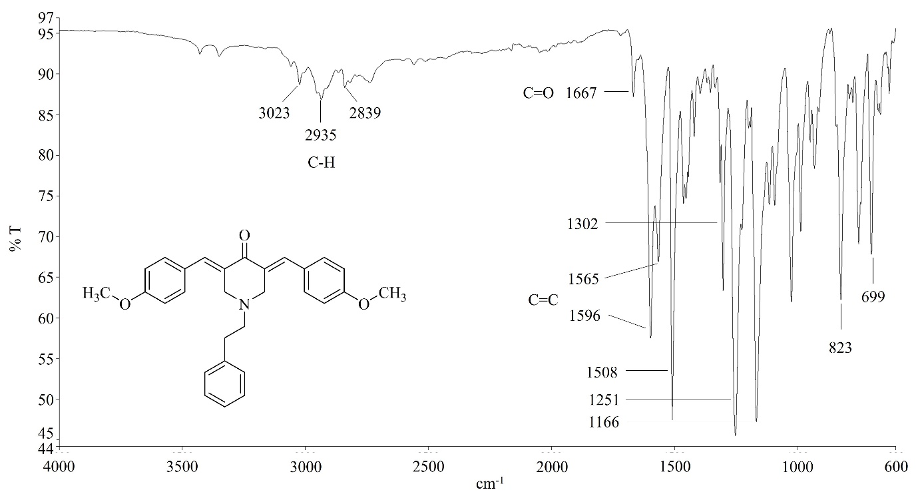
S8: IR Spectrum for Compound 1c

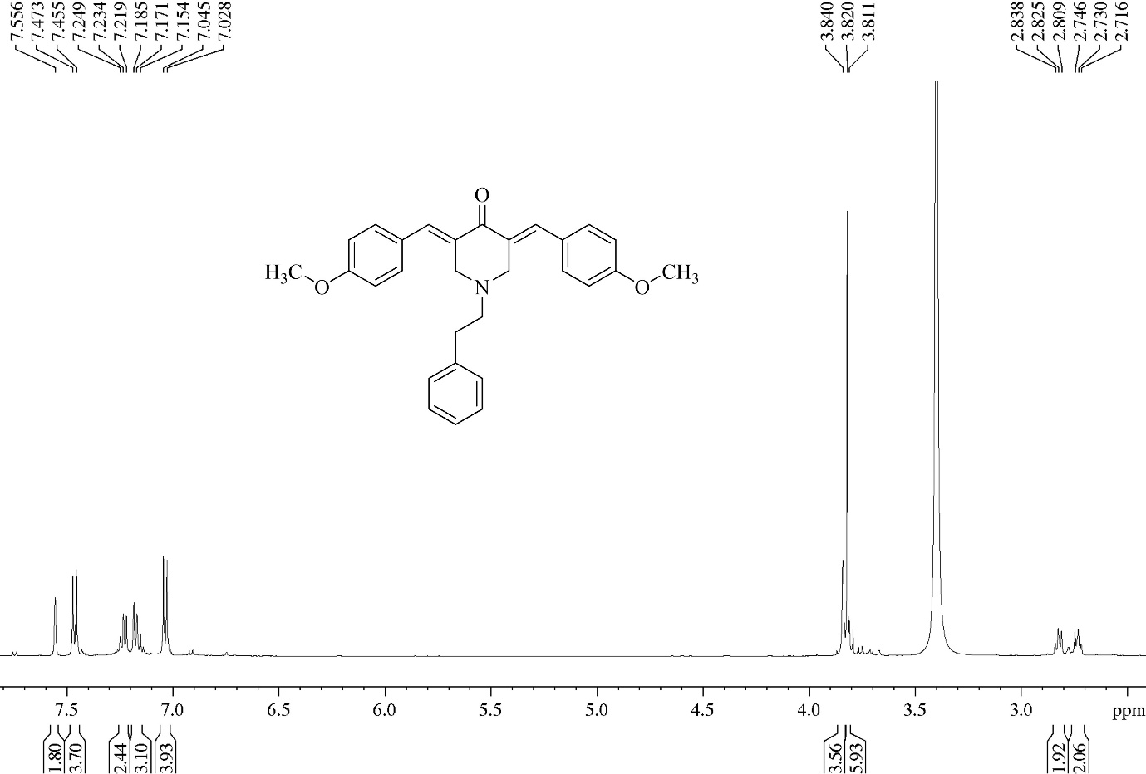
S9: ¹H NMR Spectrum for compound 1c

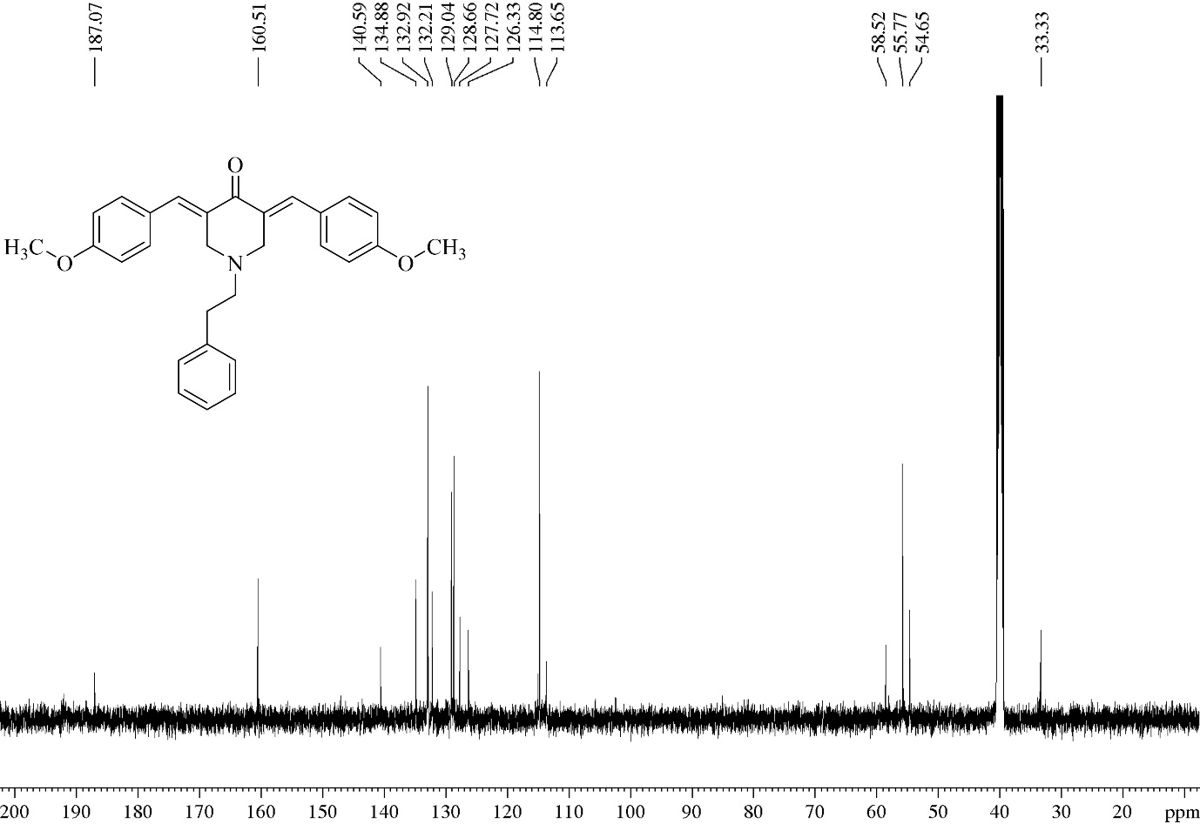
S10: ¹³C NMR Spectrum for compound 1c

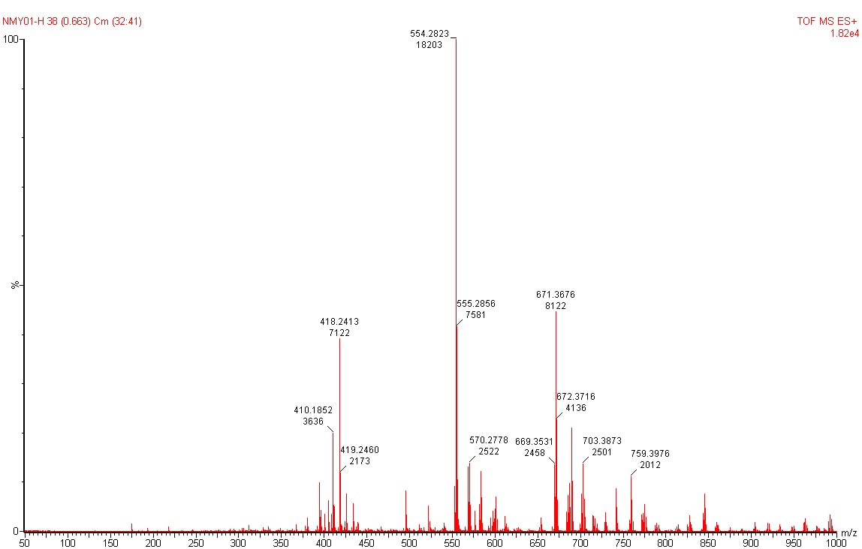
S11: HRMS Spectrum for Compound 5a
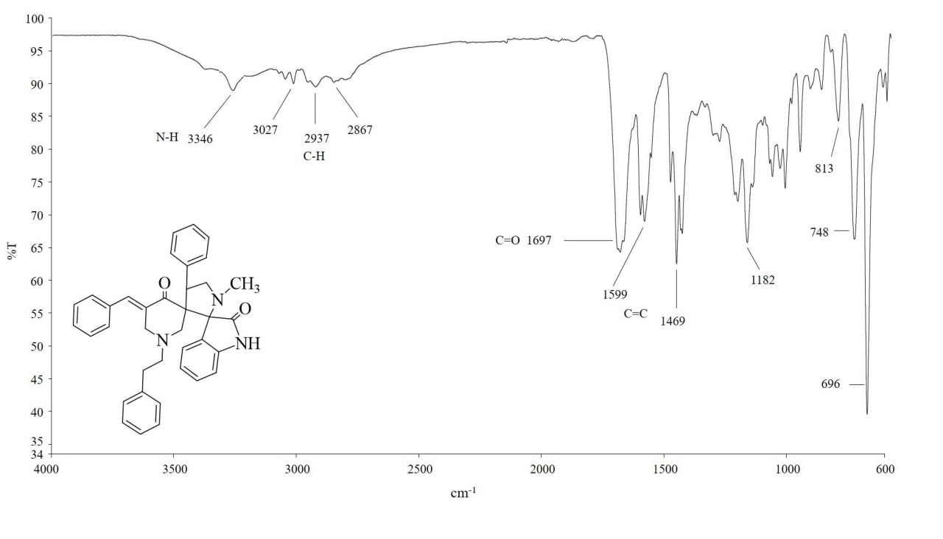
S12: IR Spectrum for Compound 5a

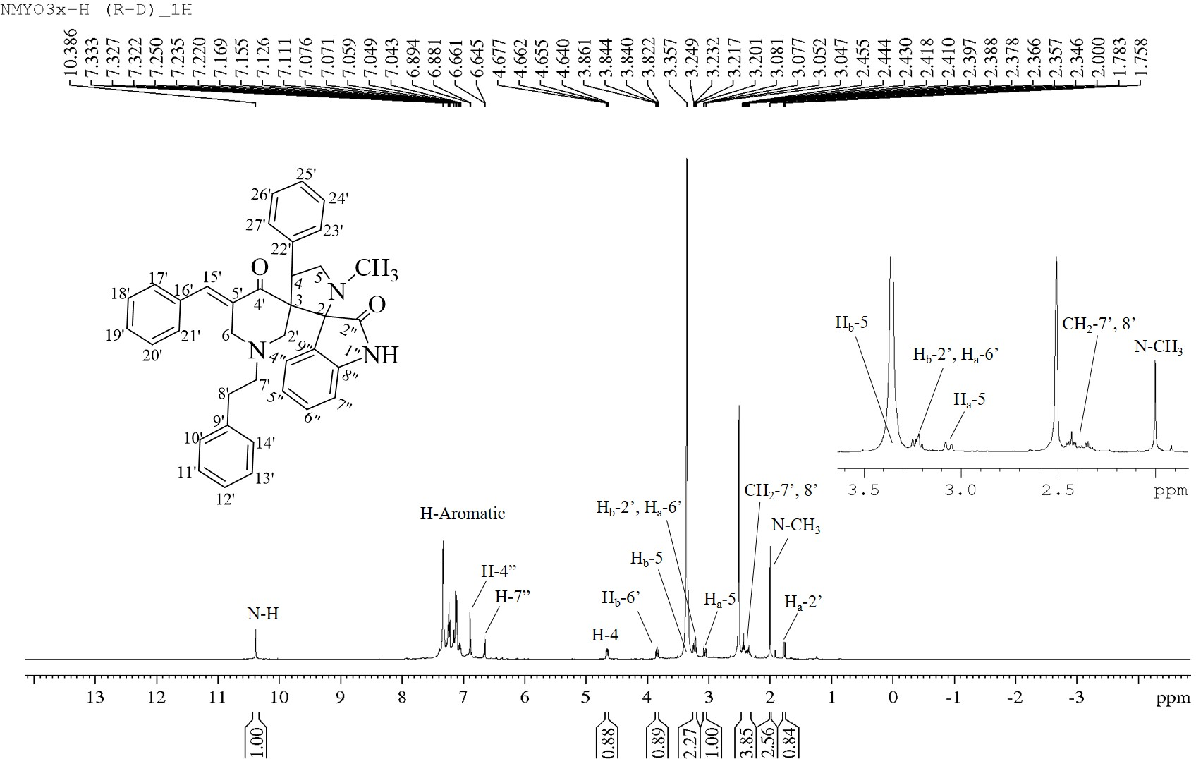
S13: ¹H NMR Spectrum for compound 5a

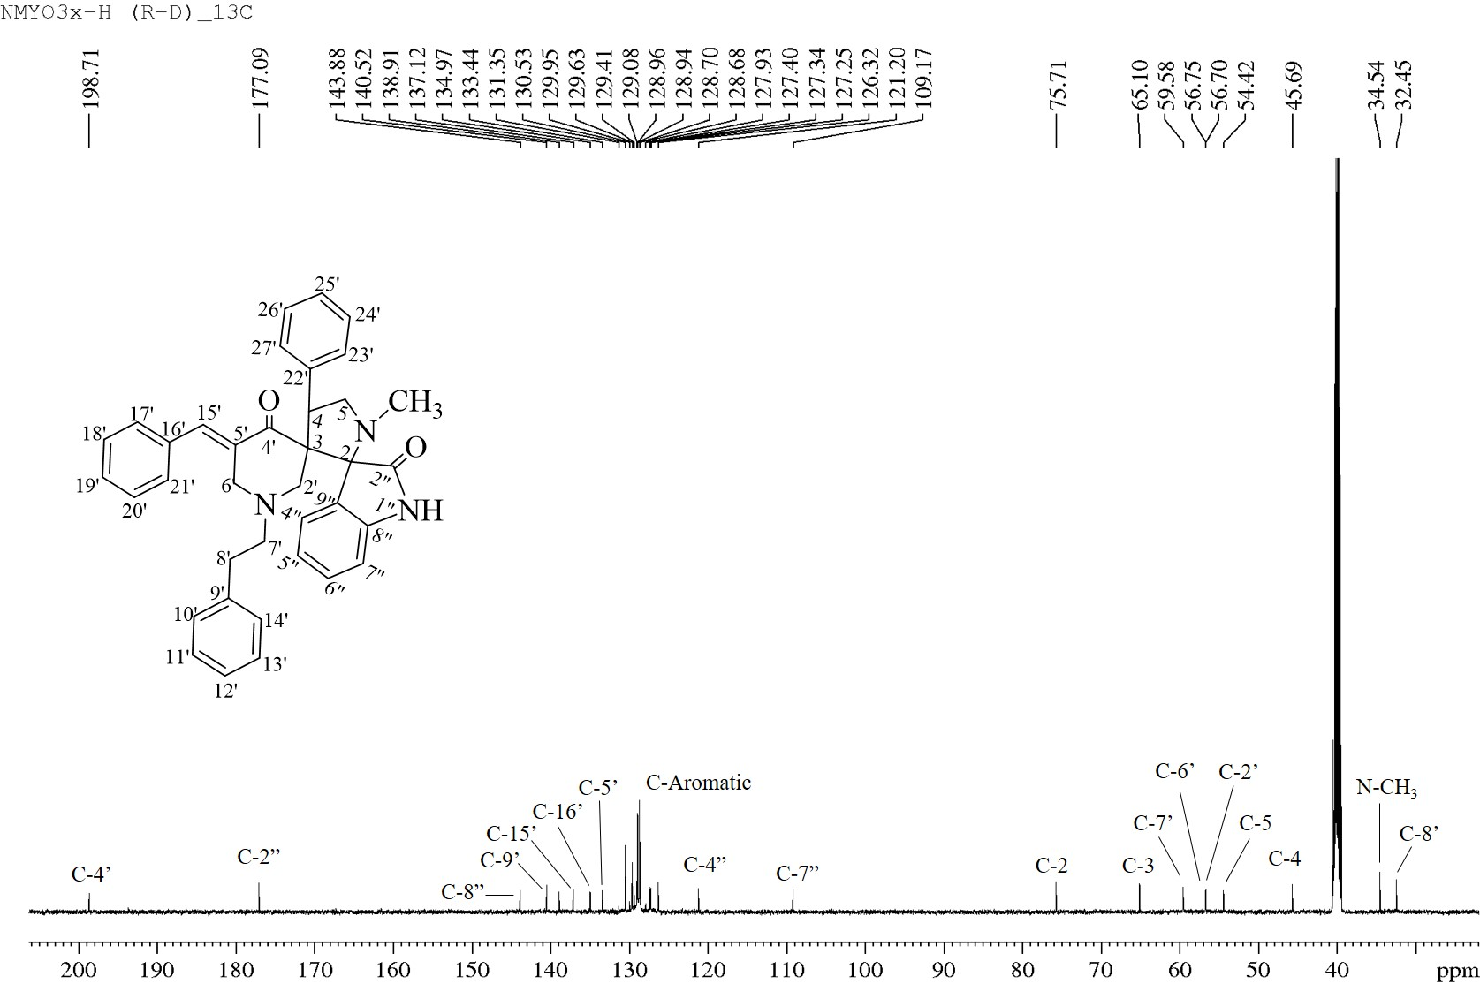
S14: ¹³C NMR Spectrum for compound 5a

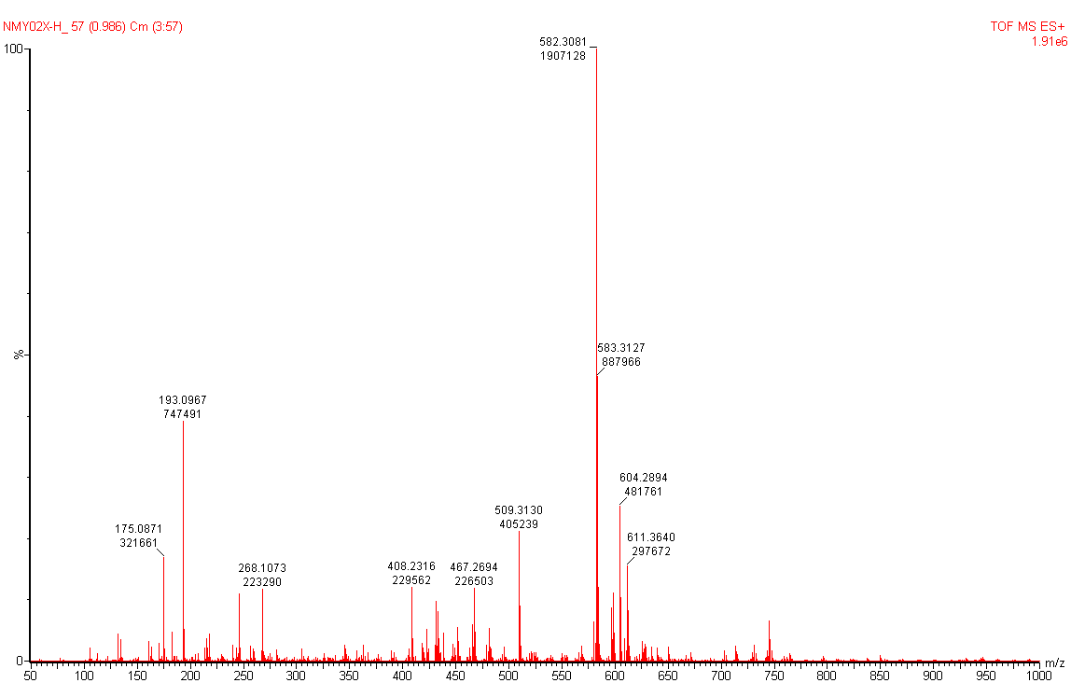
S15: HRMS Spectrum for Compound 5b
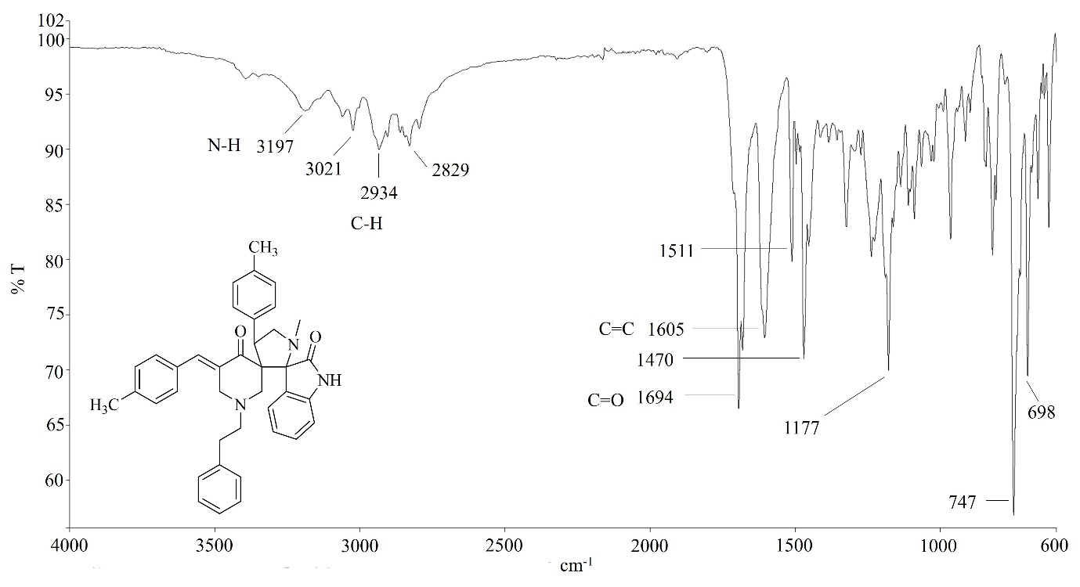
S16: IR Spectrum for Compound 5b

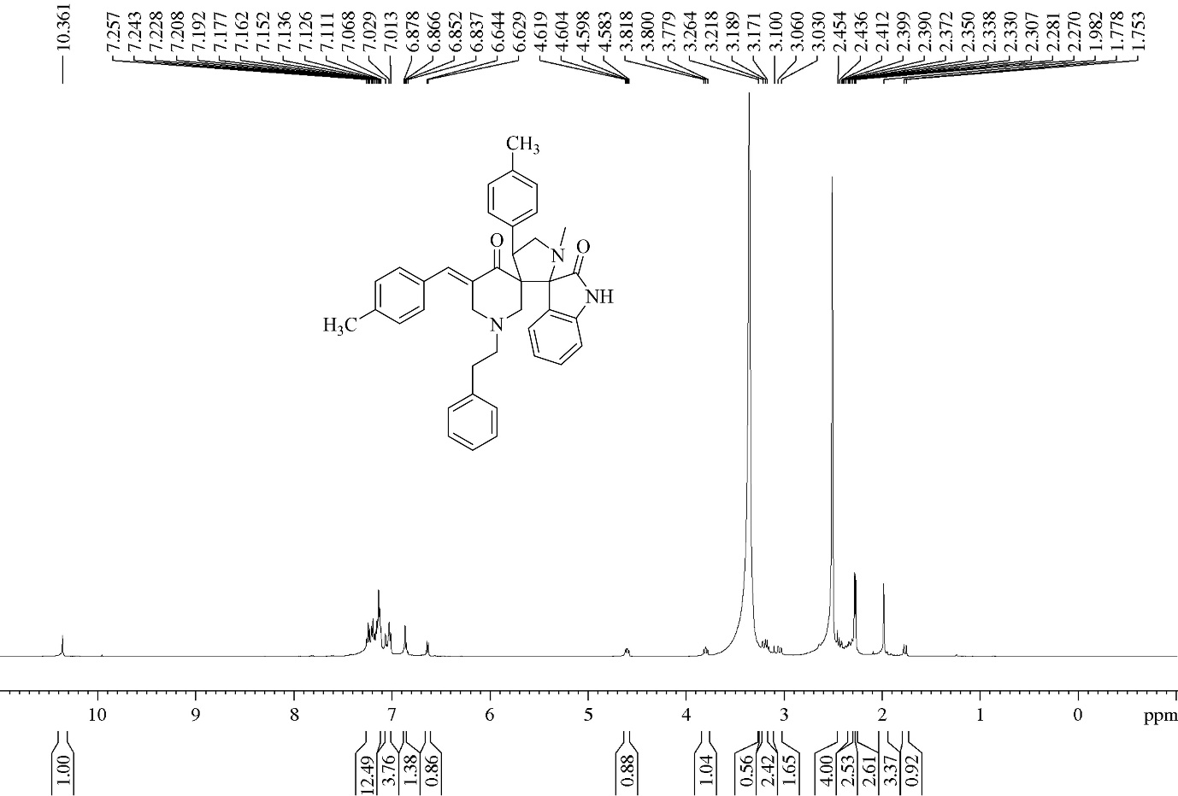
S17: ¹H NMR Spectrum for compound 5b

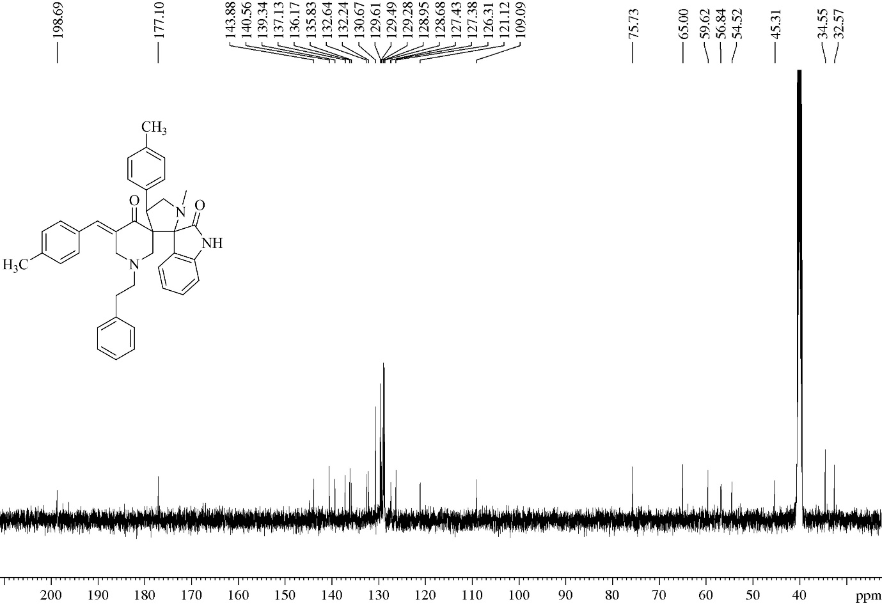
S18: ¹³C NMR Spectrum for compound 5b

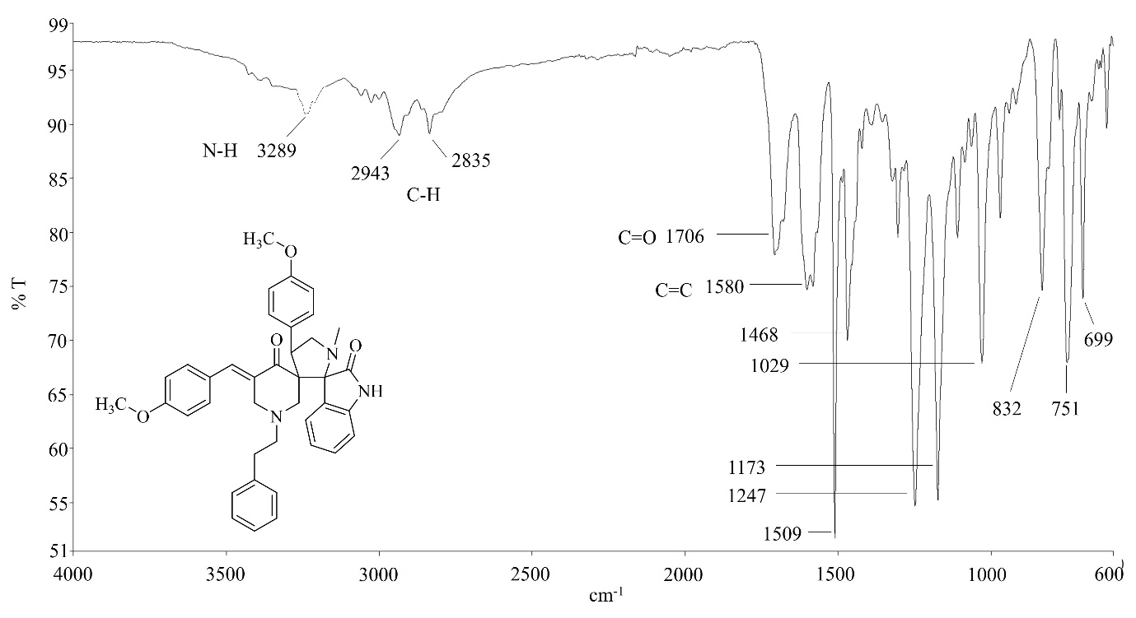
S19: IR Spectrum for Compound 5c

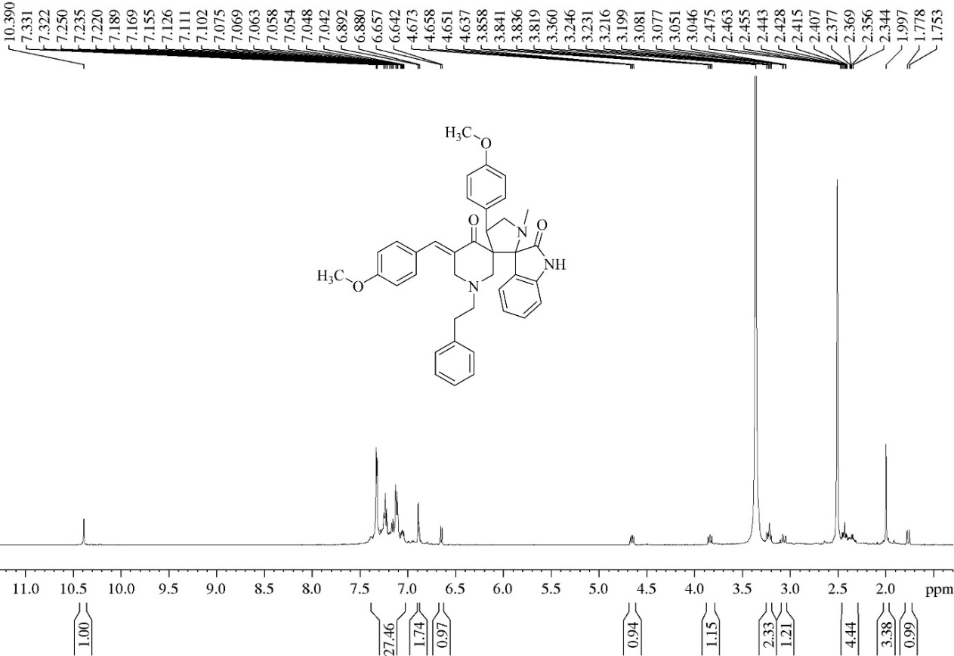
S20: ¹H NMR Spectrum for compound 5c

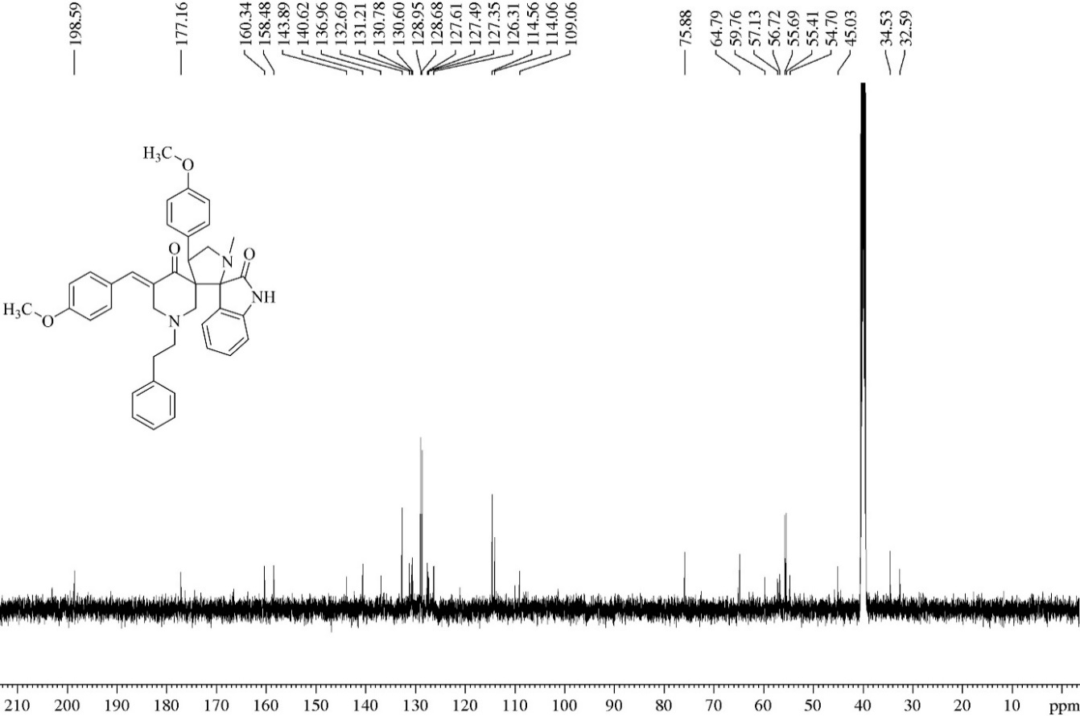
S21: ¹³C NMR Spectrum for compound 5c

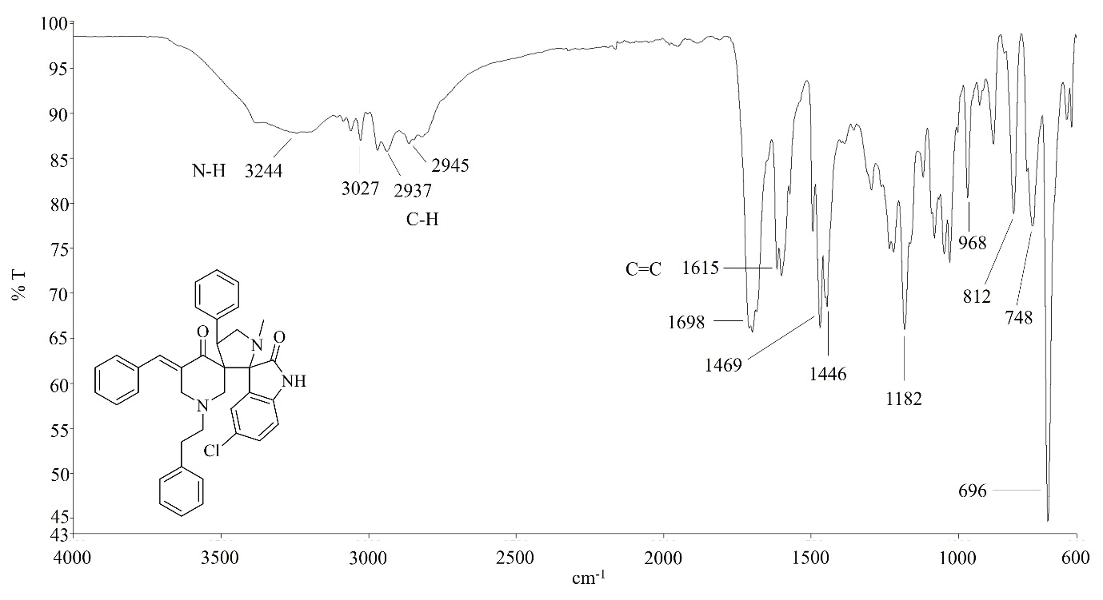
S22: IR Spectrum for Compound 6a

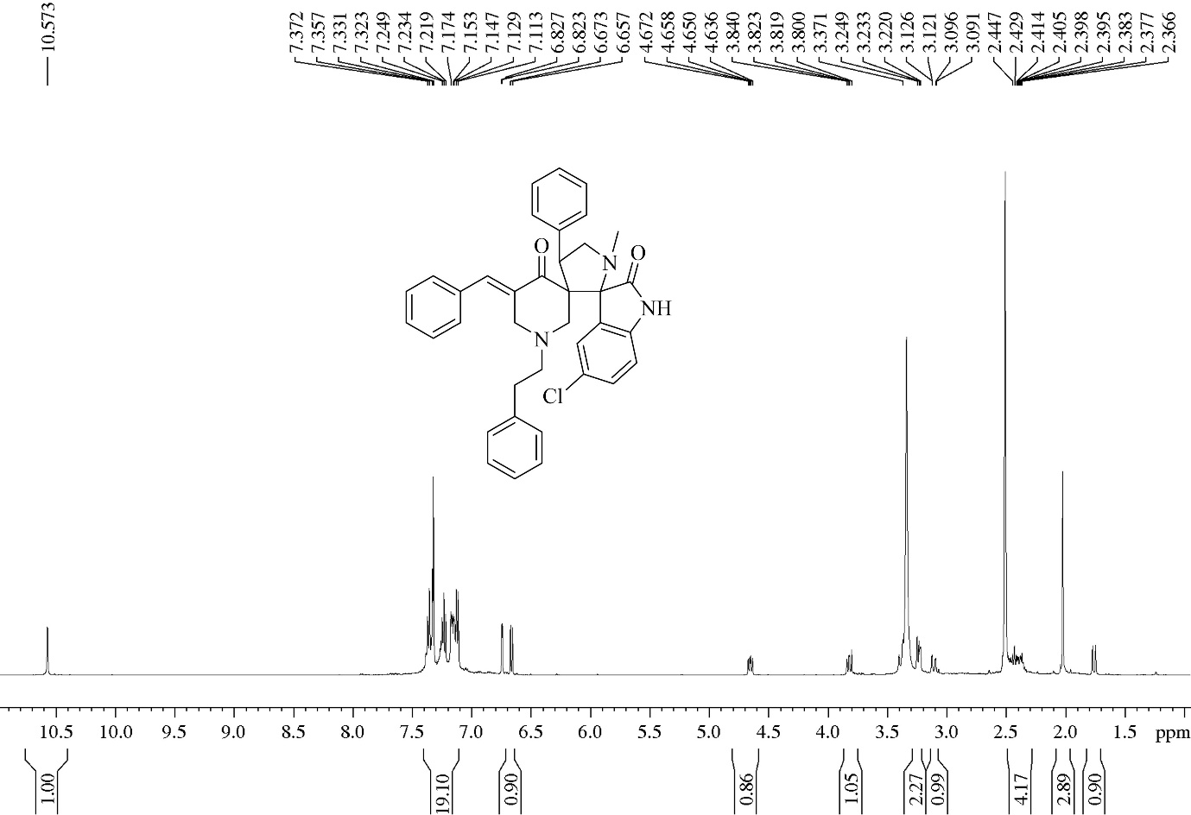
S23: ¹H NMR Spectrum for compound 6a

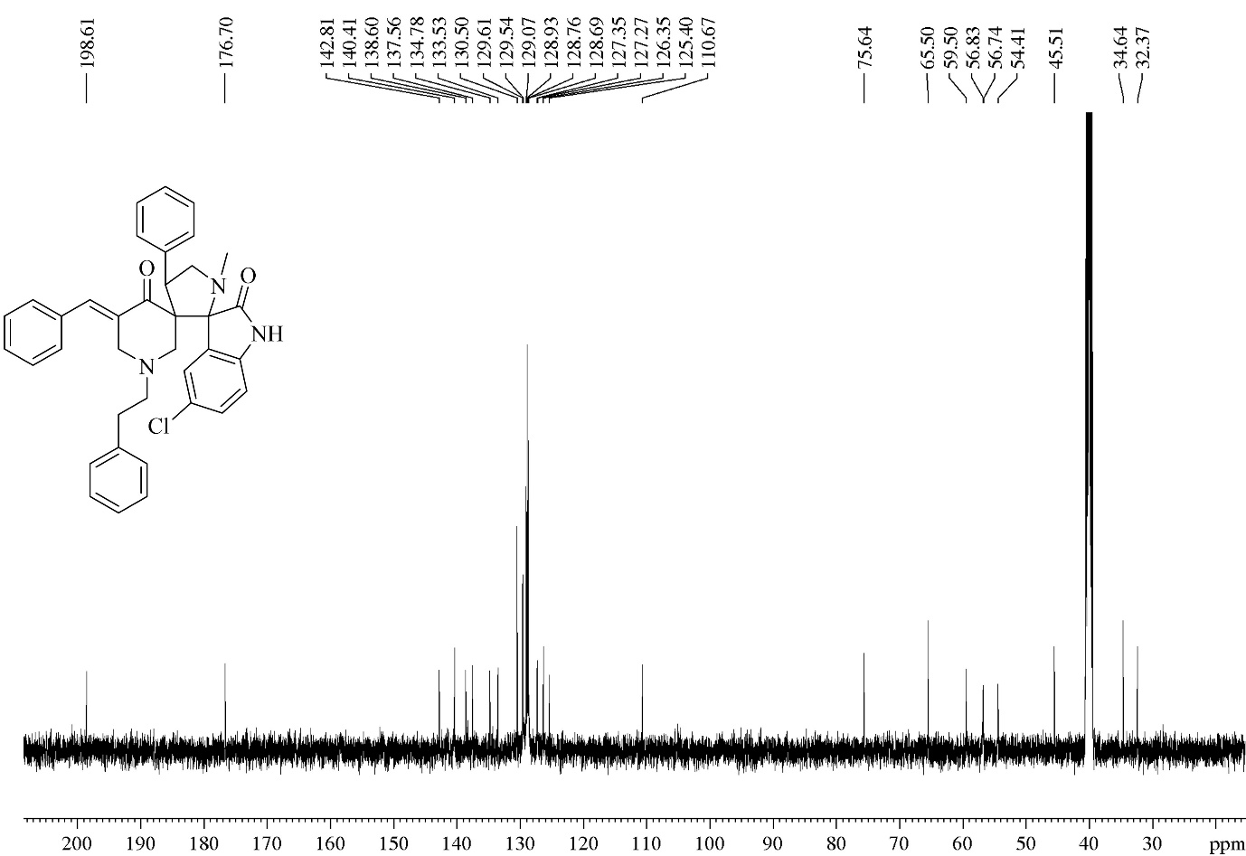
S24: ¹³C NMR Spectrum for compound 6a
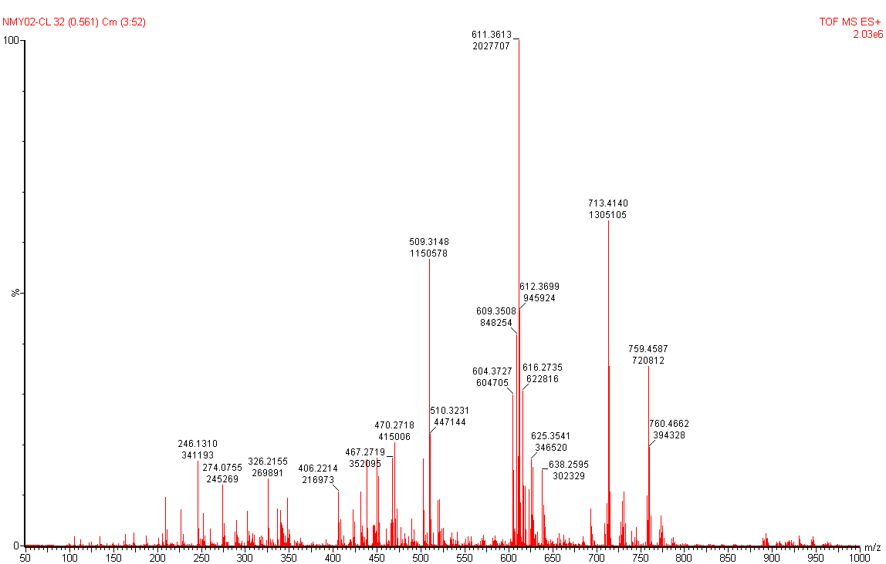
S25: HRMS Spectrum for Compound 6b

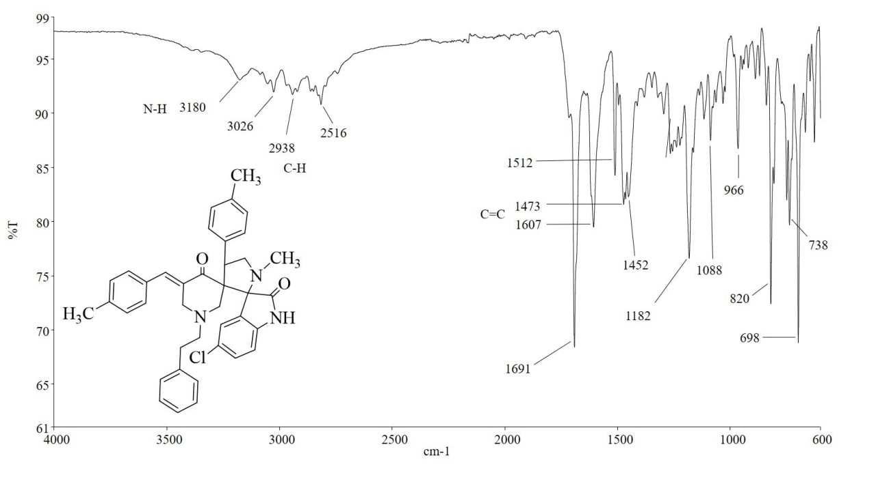
S26: IR Spectrum for Compound 6b

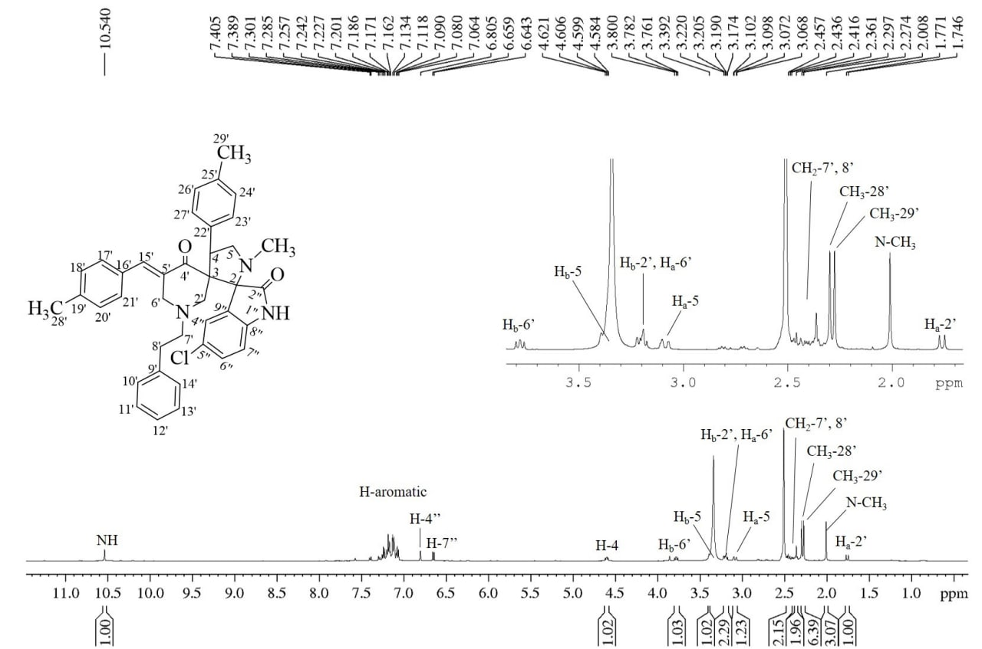
S27: ¹H NMR Spectrum for compound 6b

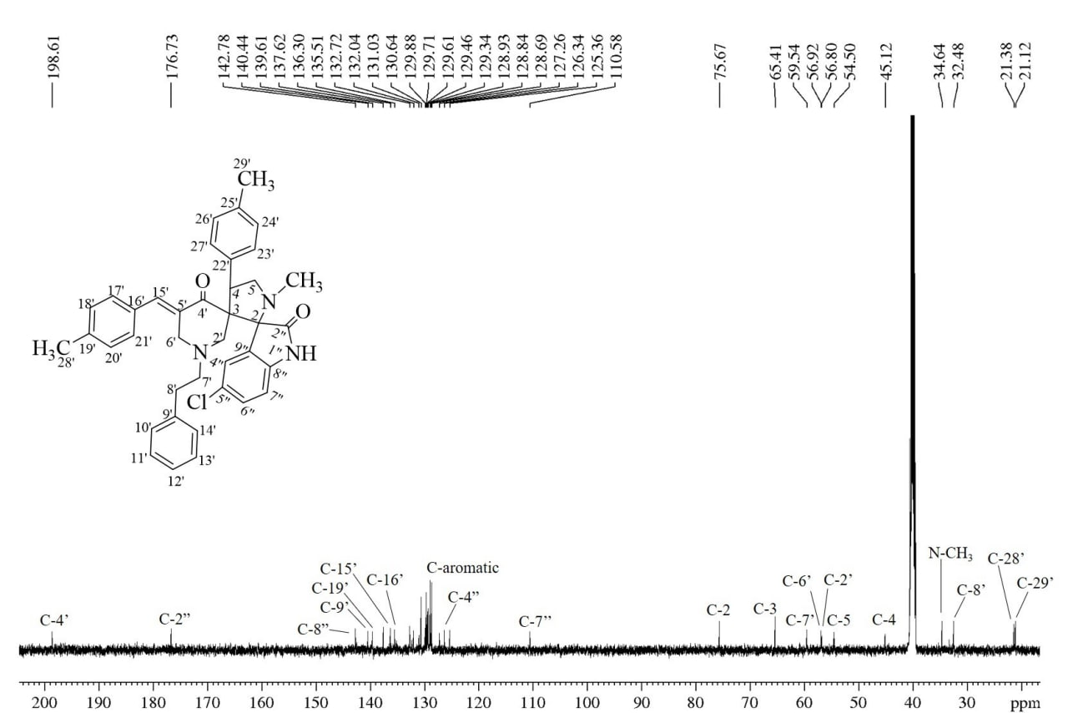
S28: ¹³C NMR Spectrum for compound 6b

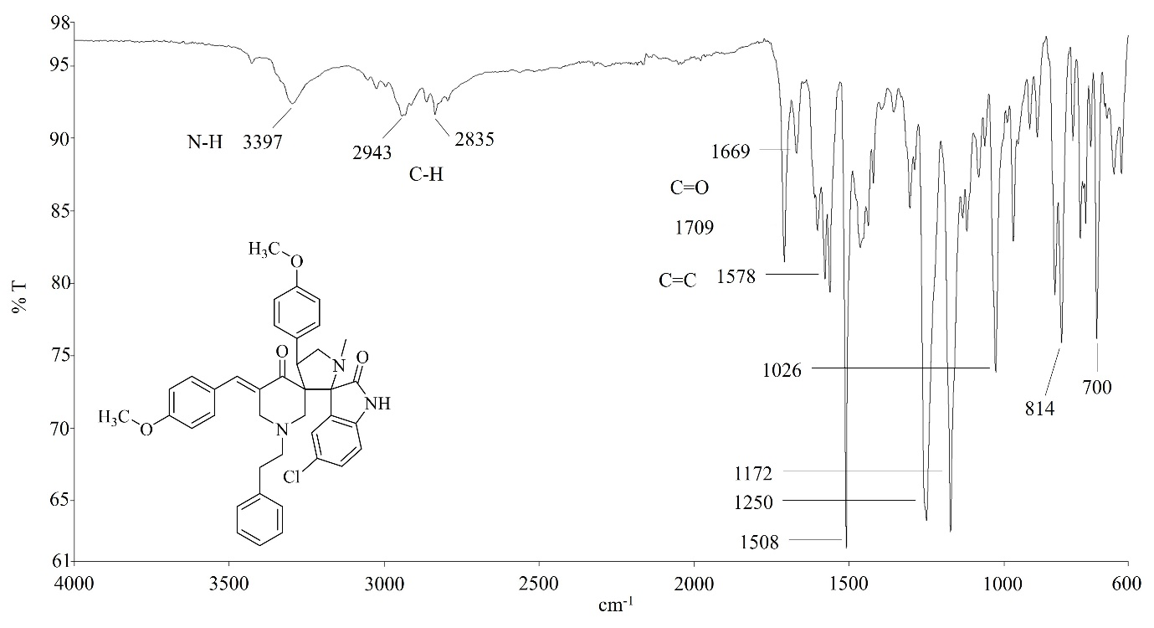
S29:IR Spectrum for Compound 6c
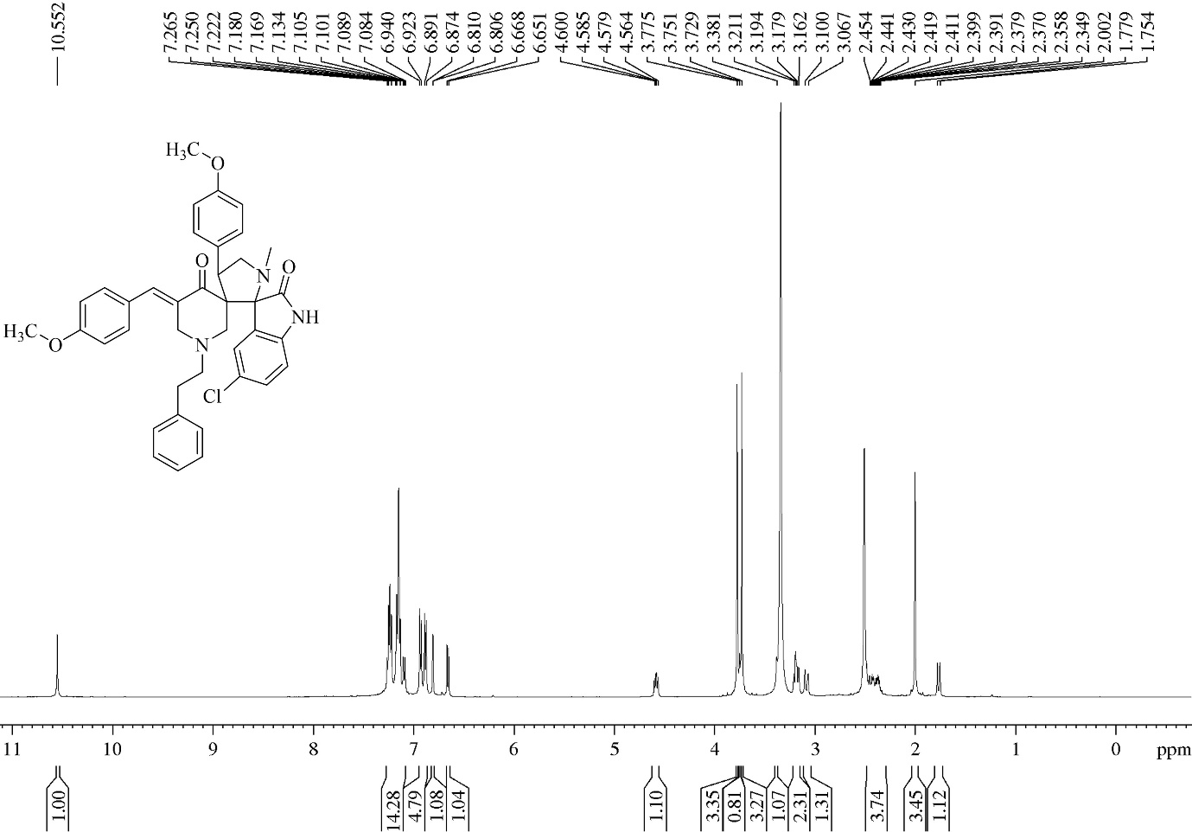
S30: ¹H NMR Spectrum for compound 6c
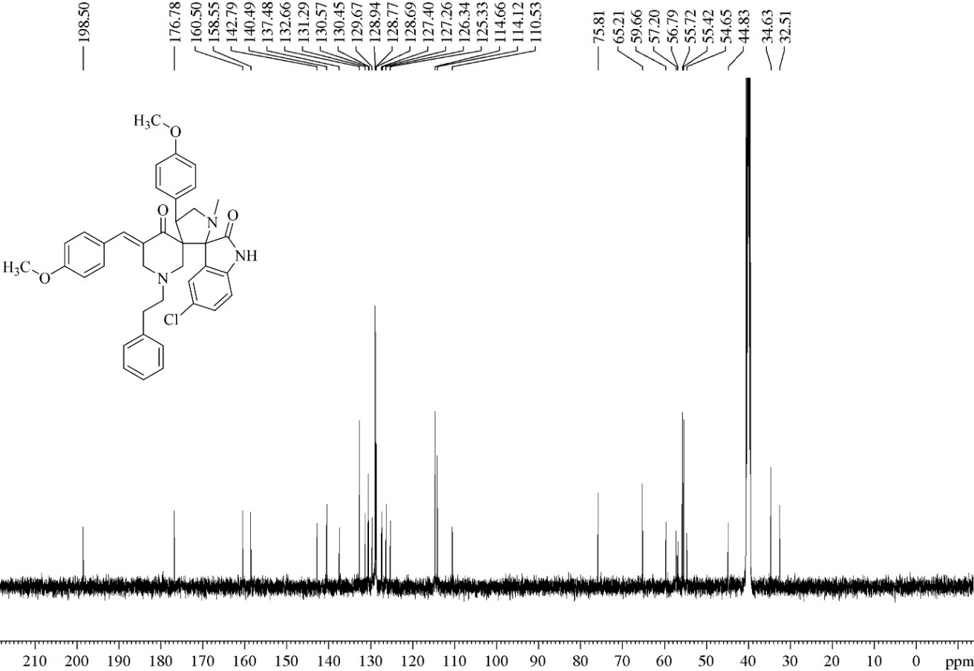
S31: ¹³C NMR Spectrum for compound 6c
References
- Ashraf Ali, M., Sanjeevi Lakshmipathi, V., Beevi, F., Suresh Kumar, R., Ismail, R., Soo Choon, T., Chee Wei, A., Keng Yoon, Y. and Basiri, A., 2013, Antimycobacterial Activity: Synthesis and Biological Evaluation of Novel Substituted (3E, 5E)-3, 5-diarylidene-1-phenethylpiperidine-4-one Derivatives. Lett. Drug Des. Discov., 10(5), 471-476.

