Supplementary Data

Cytotoxic Sesquiterpenoids from the stem bark of Aglaia simplicifolia

Ghina Izdihar¹, Al Arofatus Naini¹, Desi Harneti¹, Rani maharani^{1,2}, Nurlelasari¹, Tri Mayanti¹, Agus Safari¹, Kindi Farabi¹, Unang Supratman^{1,2,*}, Mohamad Nurul Azmi³, Yoshihito Shiono⁴

¹Department of Chemistry, Faculty of Mathematics and Natural Sciences,
Universitas Padjadjaran, Jatinangor 45363, Indonesia
²Central Laboratory of Universitas Padjadjaran, Jatinangor 45363, Indonesia
³School of Chemical Sciences, Universiti Sains Malaysia, 11800 Minden,
Penang, Malaysia
⁴Department of Bioresources Engineering, Faculty of Agriculture
Yamagata University, Tsuruoka-shi, Yamagata 997-8555, Japan

*Corresponding author. Tel./Fax: +62-22-7794391,
E-mail: unang.supratman@unpad.ac.id

Table of Contents
Fig S1. HRTOF-MS spectrum of (1)
Fig S2. FT-IR spectrum of (1)
Fig S3. ¹H-NMR spectra of (1) (500 MHz in Acetone-d6)
Fig S4. ¹³C-NMR and DEPT- 135º spectrum of (1) (125 MHz in CDCl3)
Fig S5. HRTOF-MS spectrum of (2)
Fig S6. FT-IR spectrum of (2)
Fig S7. ¹H-NMR spectra of (2) (500 MHz in Acetone-d6)
Fig S8. ¹³C-NMR and DEPT- 135º spectrum of (2) (125 MHz in CDCl3)
Fig S9. HRTOF-MS spectrum of (3)
Fig S10. FT-IR spectrum of (3)
Fig S11. ¹H-NMR spectra of (3) (500 MHz in CDCl₃)
Fig S12. ¹³C-NMR and DEPT 135º spectrum of (3) (125 MHz in CDCl₃)
Fig S13. HRTOF-MS spectrum of (4)
Fig S14. FT-IR spectrum of (4)
Fig S15. ¹H-NMR spectra of (4) (500 MHz in CDCl₃)
Fig S16. ¹³C-NMR spectrum of (4) (125 MHz in CDCl3)
Fig S17. DEPT-135° Spectrum of (4) (125 MHz in CDCl3)
Fig S18. HMQC spectrum of (4)
Fig S19. ¹H-¹H-COSY spectra of (4)
Fig S20. HMBC spectrum of (4)
Fig S21. NOESY spectra of (4)

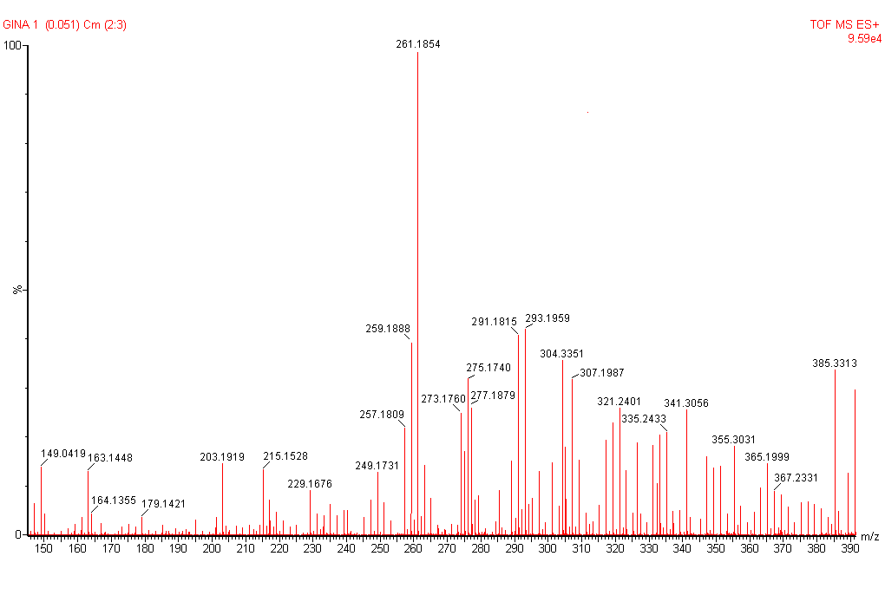
Fig S1. HRTOF-MS spectrum of (1)
3362.559
2853.739
1456.636
1378.358
1727.507
1257.395
1054.389
871.228
852.198
700.493
600.361

Fig S2. FT-IR spectrum of (1)

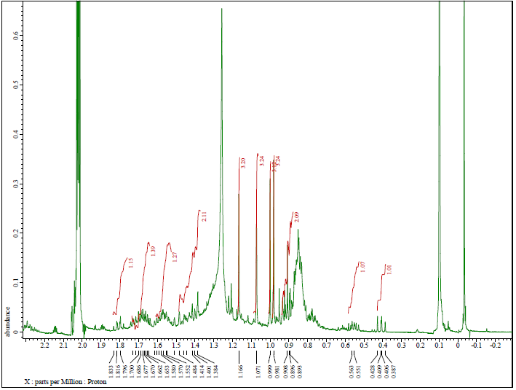

Fig S3. ¹H-NMR spectra of (1) (500 MHz in Acetone-d6)
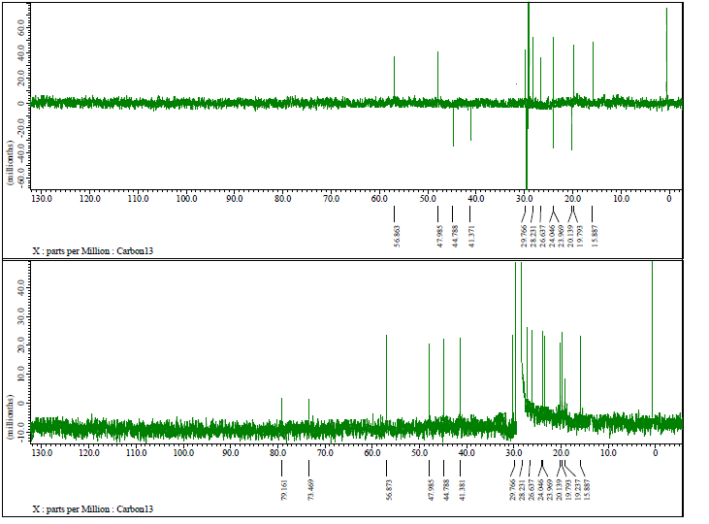

Fig S4. ¹³C-NMR and DEPT- 135º spectrum of (1) (125 MHz in CDCl3)

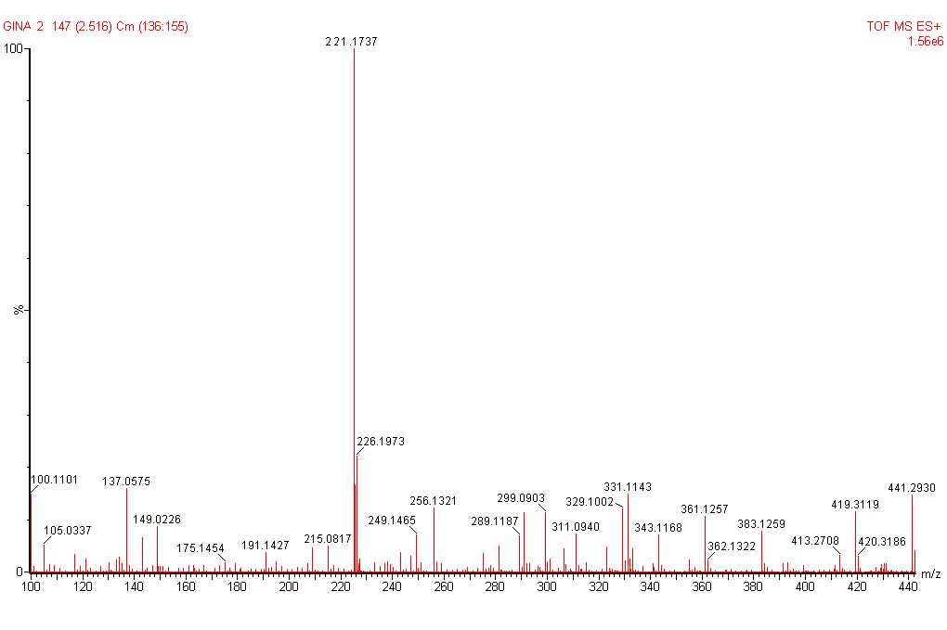
Fig S5. HRTOF-MS spectrum of (2)
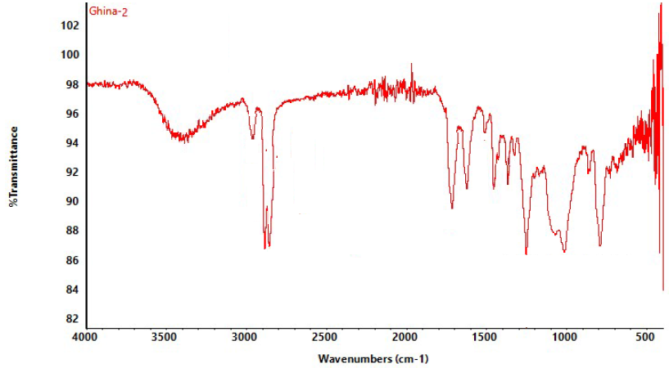
3362.559
3088.457
1721.667
1613..473
1463.333
1386.324
1078.947
1250.323
872.669
734.587

Fig S6. FT-IR spectrum of (2)
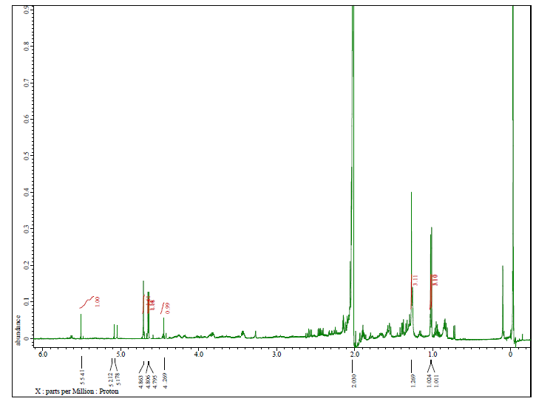
Fig S7. ¹H-NMR spectra of (2) (500 MHz in Acetone-d6)

Fig S8. ¹³C-NMR and DEPT- 135º spectrum of (2) (125 MHz in CDCl3)
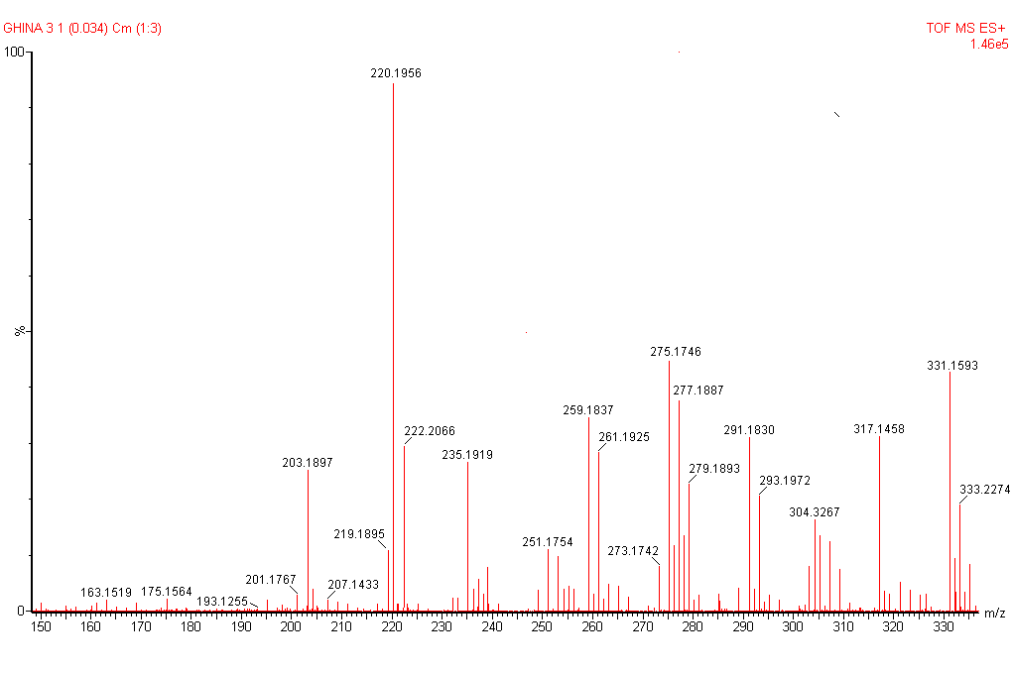
Fig S9. HRTOF-MS spectrum of (3)
3369.290
2917.772
2917.772
1720.682
1451.175
1378.966
1258.144
1019.513
965.064
796.987
698.678
553.868

Fig S10. FT-IR spectrum of (3)

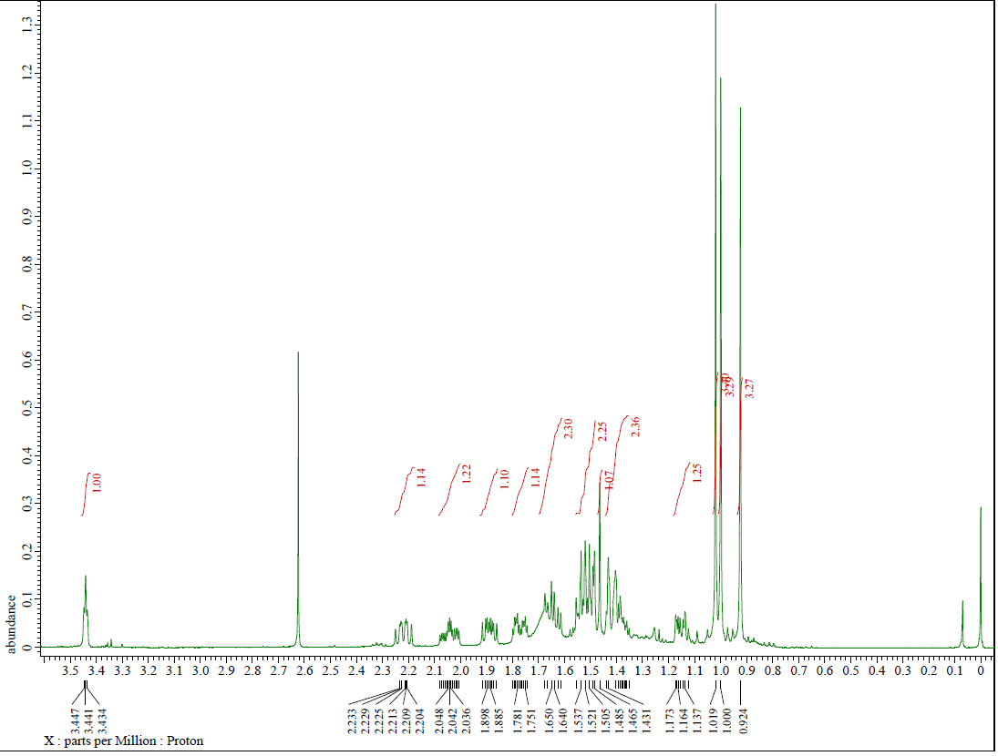
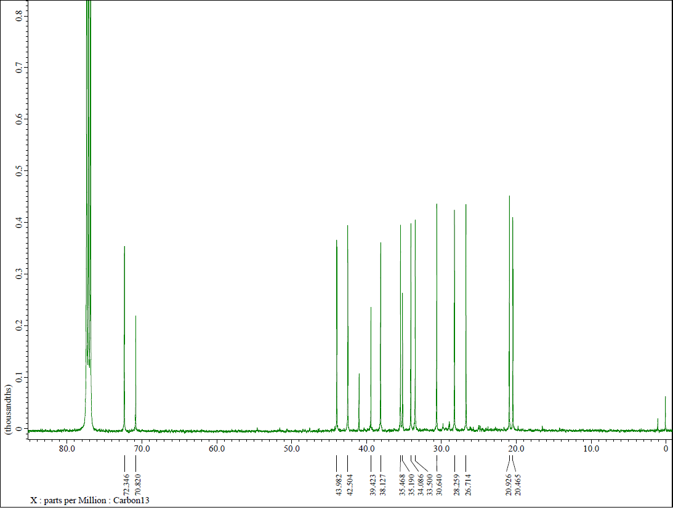
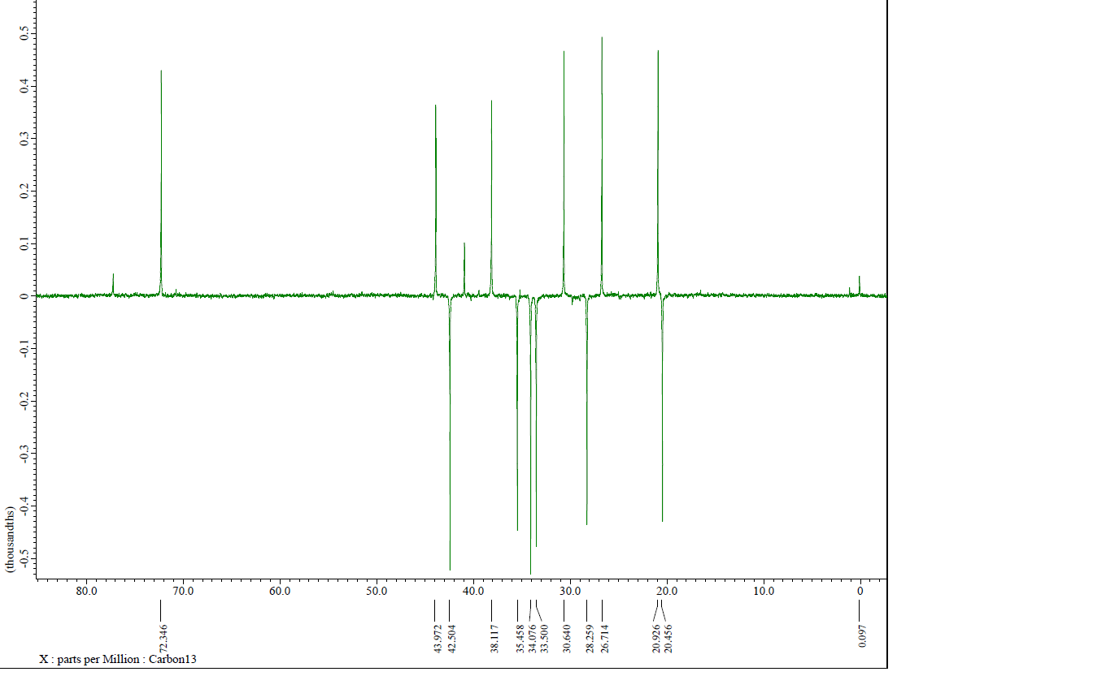
Fig S11. ¹H-NMR spectra of (3) (500 MHz in CDCl₃)

Fig S12. ¹³C-NMR and DEPT 135º spectrum of (3) (125 MHz in CDCl₃)
Fig S13. HRTOF-MS spectrum of (4)
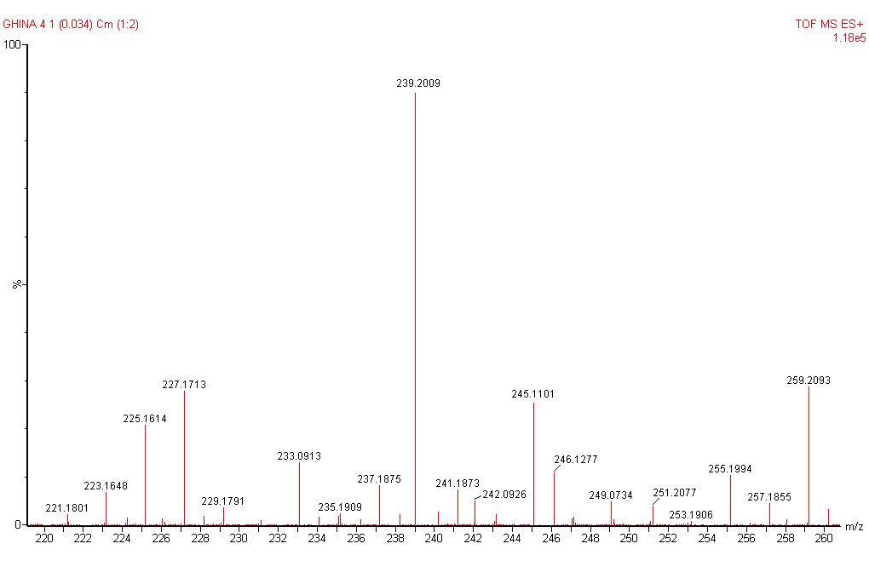
3340.105
2918.983
2850.846
1544.178
1416.963
1015.451
791.098

Fig S14. FT-IR spectrum of (4)

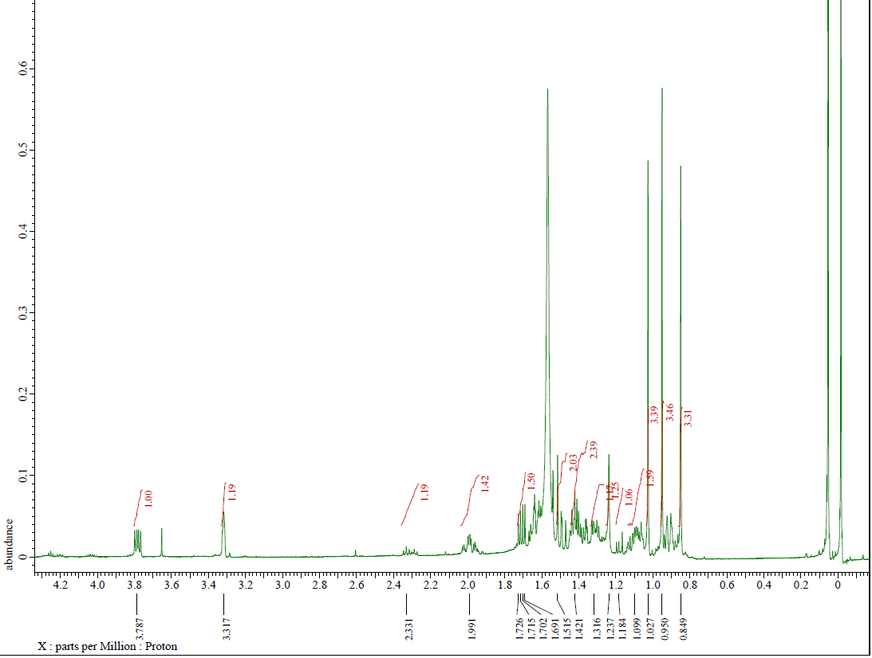
Fig S15. ¹H-NMR spectra of (4) (500 MHz in CDCl₃)
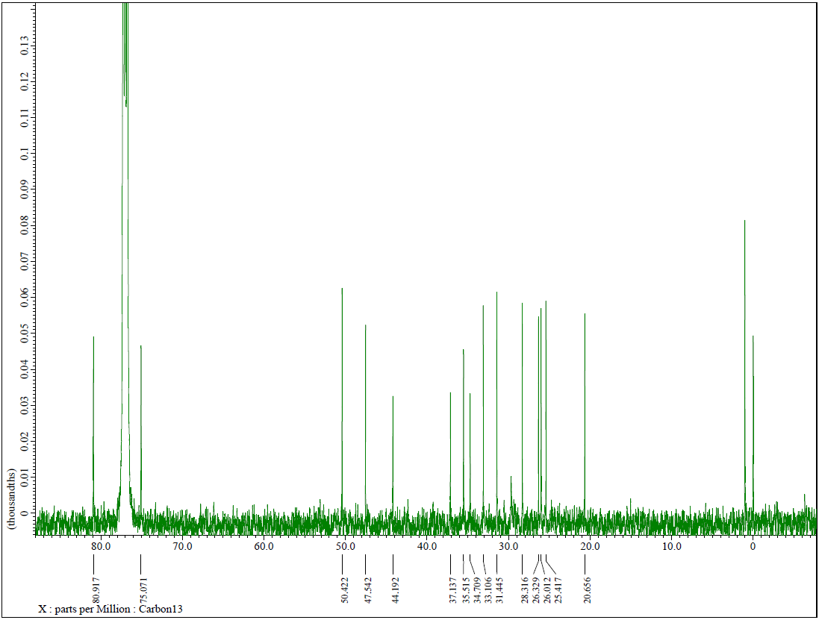
Fig S16. ¹³C-NMR spectrum of (4) (125 MHz in CDCl3)
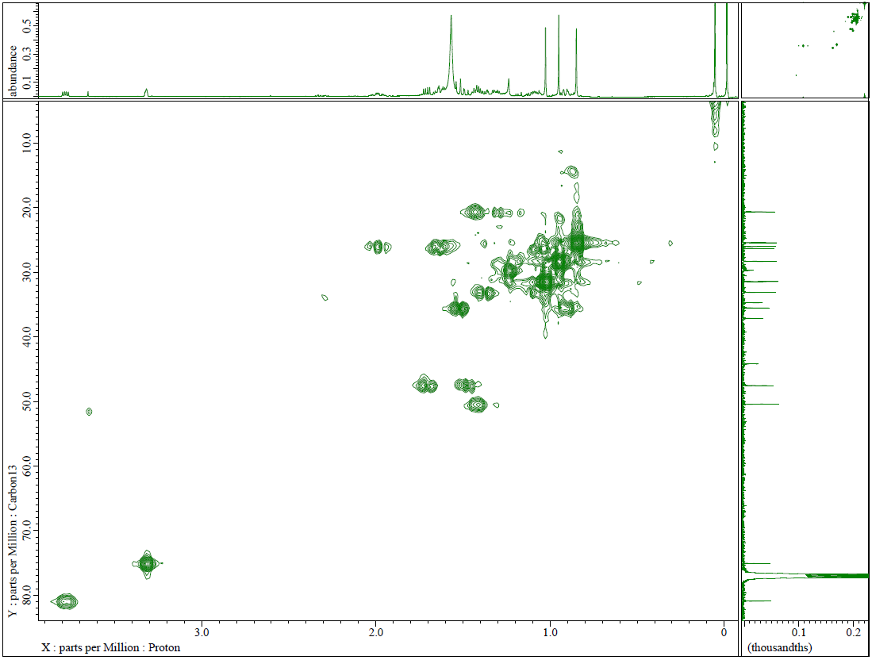
Fig S17. DEPT-135° Spectrum of (4) (125 MHz in CDCl3)
Fig S18. HMQC spectrum of (4)
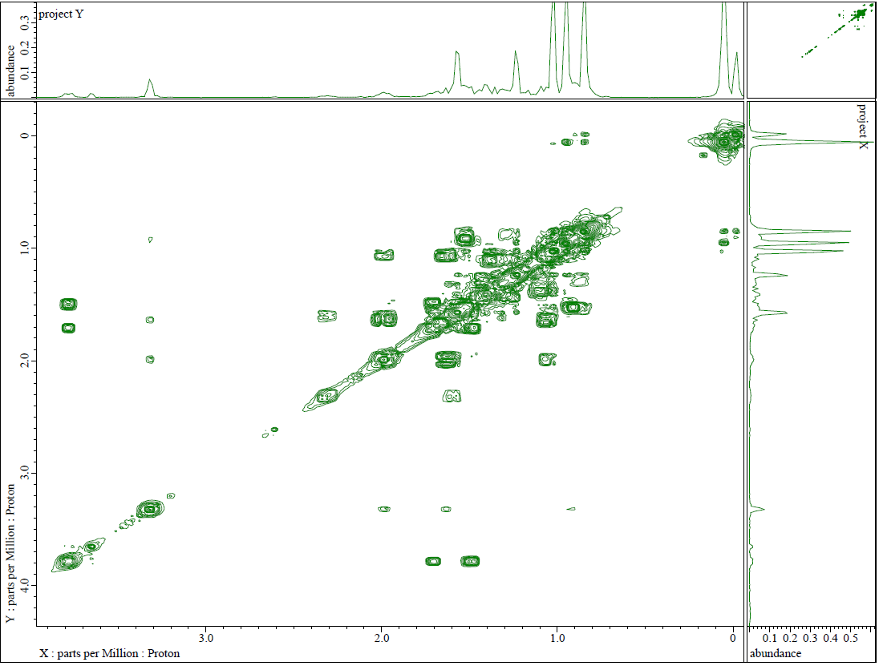

Fig S19. ¹H-¹H-COSY spectra of (4)
Fig S19. ¹H-¹H-COSY spectra of (4)
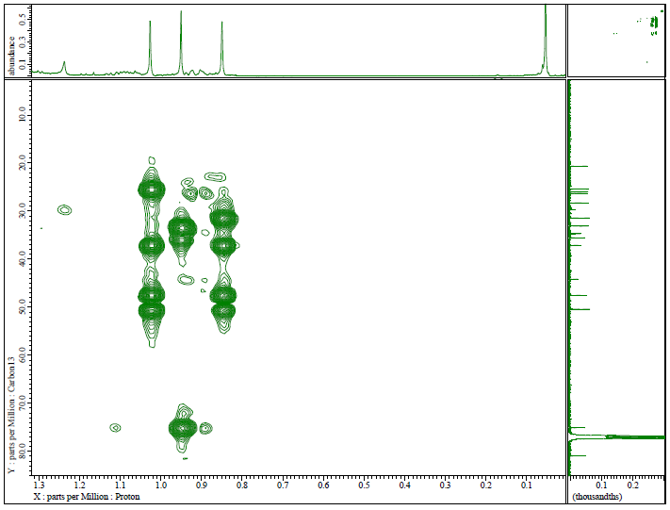
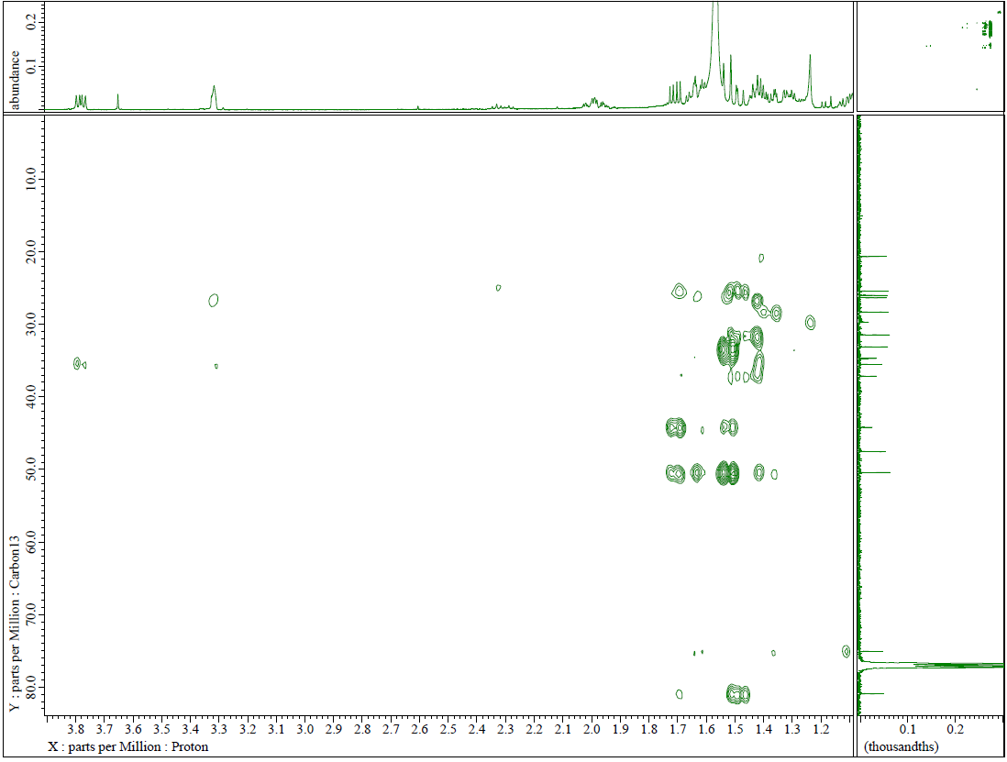
Fig S20. HMBC spectrum of (4)

Fig S20. HMBC spectrum of (4)
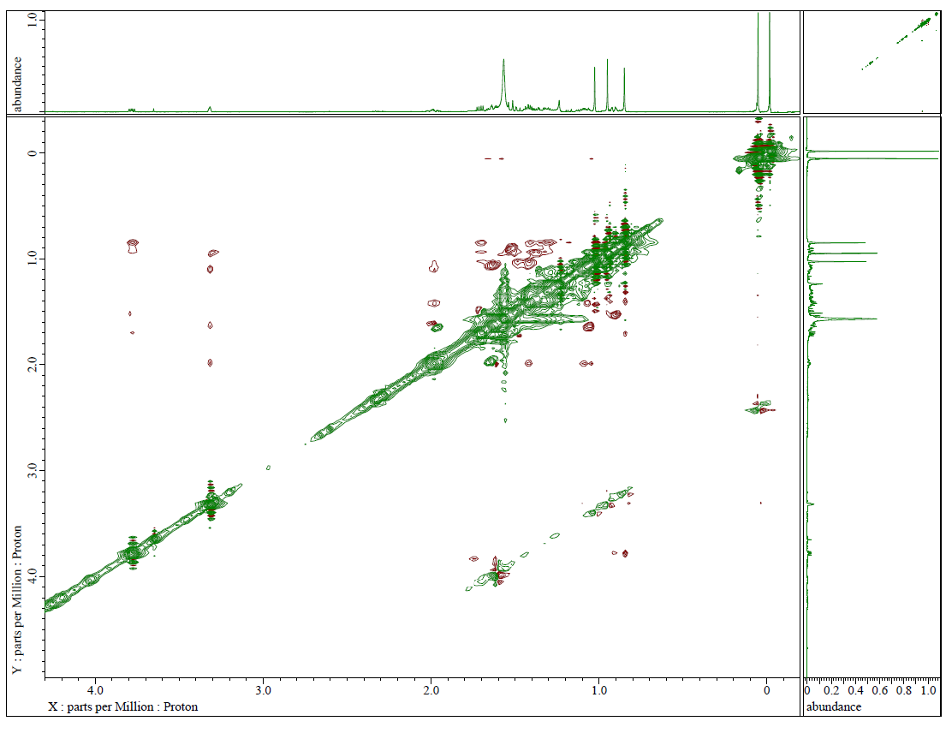
Fig S21. NOESY spectra of (4)

