Supplementary Information

DENSITY FUNCTIONAL THEORY STUDY OF INTERMOLECULAR INTERACTION BETWEEN AMYLUM AND CELLULOSE
Raynardthan Pontoh¹, Vania Edita Rarisavitri¹, Christine Charen Yang¹, Maximilliam Febriand Putra², Daru Seto Bagus Anugrah^{1*}
¹Undergraduate program, Biotechnology Study Program, Faculty of Biotechnology, Atma Jaya Catholic University of Indonesia, BSD Campus, Tangerang 15345, Indonesia
²Undergraduate program, Food Technology Study Program, Faculty of Biotechnology, Atma Jaya Catholic University of Indonesia, BSD Campus, Tangerang 15345, Indonesia
*Corresponding Author, e-mail: darufile@gmail.com or daru.seto@atmajaya.ac.id

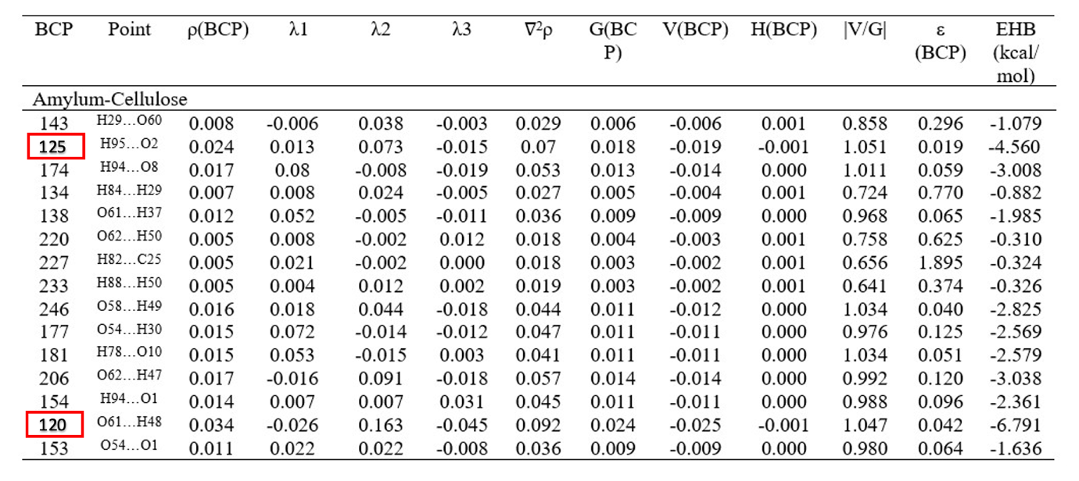
CP: critical point; BCP: Bond critical point; $ρ$: Electron density (a.u.); ﻿∇²ρ: Laplacian of electron density (a.u); G: Lagrangian kinetic energy (a.u); H: Hamiltonian kinetic energy or electronic energy density (a.u); V: Potential energy density (a.u); ε: Ellipticity of electron density (a.u); λ₁, λ_{2,} λ₃ : Components of Laplacian in x/y/z (a.u); E_{HB}: Hydrogen bond energy (kcal/mol).

Table S1 Topological parameters of the complex cellulose-amylum.
Figure S1 Energy optimization of various positions of cellulose-amylum complexes: a) position2, b) position3, c) position4, d) position1.

