SYNTESIS OF MESOPOROUS SILICA FROM BEACH SAND BY SOL-GEL METHOD AS A Ni SUPPORTED CATALYST FOR HYDROCRACKING OF
WASTE COCONUT OIL

Siti Salamah¹, Wega Trisunaryanti^{2*}, Indriana Kartini², Suryo Purwono³
^{1.}Department of Chemical Engineering, Faculty of Industrial Technology, Universitas Ahmad Dahlan Yogyakarta
^{2.}Department of Chemistry, Faculty of mathematics and Natural Science, Universitas Gadjah Mada, Yogyakarta, Indonesia
^{3.}Department of Chemical Engineering, Faculty of Engineering, Universitas Gadjah Mada, Yogyakarta, Indonesia
* Corresponding author, tel/: 0811256055, email: wegats@mail.ugm.ac.id

ABSTRACT

Synthesis and characterization of Ni/Mesoporous Silica catalyst were inspected. The mesoporous silica (MS) was synthesized from silica extracted from Parangtritis beach sand using dodecyl amine (DDA) as template with sol gel method. The catalysts were synthesized by impregnating MS with Ni metal of 1,5, and 10 wt.%, and were denoted as Ni/MS1, Ni/MS5, and Ni/MS10. The activity and selectivity of these catalysts were assessed in hydrocracking of waste coconut oil (WCO) in a semi-batch stainless steel reactor system at 450 ⁰C for 2 H with a flow of hydrogen gas 20 ml/min and liquid products were analyzed using GC-MS. The results showed that catalyst Ni/MS1, Ni/MS5, and Ni/MS10 have specific surface areas of 130.5 m²/g, 195.9 m²/g, and 203.9 m²/g compared to standard Ni/SBA-15 with specific surface area of 381.3 m²/g. The average pores were 12.30 nm, 9.8 nm, 11.12 nm and 8.67 nm. The hydrocracking WCO has total convertion 95.8 %, 82.4 %, 85.2 % and SBA-15 88.7 %. Liquid fractions produced were 38.8 wt.%, 43.3 wt.%, 50.2 wt.% and Ni/SBA-15 46.7 wt.% which contain gasoline of 37.09 %, 39.76 %, and 44.27 %, respectively. It could be deduced that Ni/MS10 has great performance with reusability until 4 times and still produce gasoline of 40.73 %.

Keywords: Beach sand, Catalyst, Hydrocracking, Mesoporous silica, Selective gasoline

INTRODUCTION
The waste of coconut oil (WCO), which is one of the most frequently used cooking oils with over 3.5 MT/annum consumption (2.5% of world vegetable cooking oil production), can be considered a promising alternative for renewable energy sources [1]. The population growth per year led to increased coconut oil used in many sectors, either in households, restaurants, or the food industry. The increased usage of coconut oil has caused the accumulation of its waste in the environment. This type of waste was reported to contain toxic and carcinogenic compounds that may kill and contaminate many living organisms, mainly marine, and return to humans through the food chain. For that, the processing is needed to reduce environmental pollution caused by WCO [2].
The fatty acid methyl ester (FAME) content in WCO can be used as a biofuel. It was demonstrated that unsaturated fatty acids could be converted to alkenes via a tandem isomerization-decarboxylation pathway using a ruthenium carbonyl catalyst. Such promising dual-function catalysts could lead to hydrocarbon production for liquid biofuels without high hydrogen or energy requirements, though the use of limited materials, such as Ru, potentially limits economic and environmental feasibility [3]. Biofuels from WCO can be more environmentally friendly than those made from food crops, such as palm oil. Biofuel is one of the renewable energies to solve the source of energy problems. A suitable performing catalyst is required to convert a sufficiently high methyl ester content in WCO. The hydrocarbon produced from this process has similar compounds to those found in petroleum fuel, in which it has higher energy density, lower viscosity, and higher stability [2].
Conversion of waste coconut oil into hydrocarbon requires an acidic catalyst that has optimal activity, stable at high temperatures, and has selectivity for the desired product. Among many types of catalyst available, mesoporous silica has drawn much attention for the past years because of its high porosity properties and better performance. Many synthesis routes achieved mesoporous silica material [4].
Beach sands have a silica composition, depending on their geographical location. Beach sand is an example of carbonate sand with a silicon dioxide content of 72-84% [5]. Higher silica content could increase the economic value of beach sand if converted into a more valuable product. Furthermore, silica-based material shows excellent promises in the adsorbent and catalyst industry if converted into mesoporous material [6]. There are many synthesis routes to achieve mesoporous silica material i.e. hydrothermal, sol gel and sonochemistry. According to [7 for optimal results the hydrothermal process takes a long time up to 48 hours. The synthesized mesoporous silica catalysts from beach sand with sonochemistry method can be used for hydrocracking WCO; the results obtained are selective catalysts for the diesel fraction [8]. Sol-gel method done to synthesize mesoporous silica from Lapindo mud using CTAB template yielded mesoporous silica with a surface area of 877.39 m²/gr. Sol-gel method had a relatively fast processing time and could be done in a low temperature [1,7].
Several studies of catalyst synthesis have been carried out among them is nickel load to silica-alumina for Co methanation [9]. [10] synthesized mesoporous silica catalyst from TEOS material for hydrocracking palm oil, producing diesel fraction. The synthesized mesoporous silica catalysts from beach sand can be used for hydrocracking WCO, the results obtained are selective catalysts for the diesel fraction [8].
Metal precursors are needed to increase active sites in a catalyst, thus increasing the activity and selectivity of the catalyst. The Ni metal particle size was the parameter influencing the activity of the catalyst [10].
The synthesis Ni-nanoparticle inside SBA-15 channel for dry reforming. Ni metal has high activity and abundant low cost [11]. The investigated Ni-Mo loaded on amine-functionalized mesoporous silica (MS) with a CTAB template. Two types of catalysts were prepared and evaluated for their catalytic activity in the hydrocracking of WCO, and the results showed a higher level of gasoline 43 Wt.% was produced [1]. No research has yet confirmed whether catalyst produced from beach sands has activity and selectivity to hydrocarbon gasoline fraction. This research used Parangtritis beach sand as a source of silica. The silica content was synthesized into mesoporous silica using a dodecyl-amine (DDA) template and impregnated with Ni metal as Ni/MS catalyst. The Ni metal content weight was used as variations. The Ni/MS catalyst has better characteristics than the MS catalyst alone. The produced Ni/MS catalyst's activity was assessed in the hydrocracking process of waste coconut oil into gasoline fraction.

EXPERIMENTAL SECTION
Materials
The materials used in this study were silica extracted from Parangtritis beach sand, dodecyl amine supplied by Fisher Scientific, distilled water, HCl produced by Mallinckrodt, NaOH produced by VWR Chemicals, AgNO₃, C5H5N, Nickel nitrate, and silica standard produced by Sigma Aldrich, and SBA-15 produced by Green Stone Swiss Co. Ltd. Waste coconut oil obtained collectively from the food shop.
Instrumentation
The functional group in silica, as well as the presence and disappearance of the DDA template from silica, was observed and analyzed using Fourier-Transform Infra Red Spectrometer (FTIR) using the KBr disc technique. Pore size and volume were analyzed using N₂ gas sorption analysis which was carried out using Quanthachrome NOVA touch. Adsorption and desorption isotherms were measured by the multipoint method. The total surface areas were calculated by the BET method. BJH desorption model was used to provide pore size distribution. The mesoporous silica crystallinity was analyzed using X-ray diffraction (XRD) analysis and was performed using Rigaku Miniflex 600 with Cu Kα monochromatized radiation source (λ = 1.54 ºA), operated at 30 kV, 10 mA, scan speed 10°/min, and scan range 2-80°. Morphology of mesoporous silica was characterized using Scanning Electron Microscope (SEM) and Transmission Electron Microscope (TEM) to analyze its pores structure [12]. The acidity of sand, silica, and mesoporous silica were analyzed using gravimetric base adsorption. In this research, pyridine was used as base probe molecules. The acidity was calculated with the following formula, where W C₅H₅N is the weight of adsorbed pyridine vapor (g), W_{Y} is the weight of mesopore silica and M C₅H₅N is the molecular weight of pyridine (79.01 g/mol).
$$Acidity=\frac{W C_{5}H_{5}N}{W_{Y}× {M C}_{5}H_{5}N}×1000\frac{mmol}{g}$$
Procedure
The mesoporous silica produced with silica was extracted from Parangtritis beach sand which contains SiO₂ using the Reflux method. Mesoporous silica was synthesized from previously extracted silica using the sol-gel method with DDA surfactant as a template [6].
Mesoporous silica (MS) was synthesized from previously extracted silica using the Sol-Gel method with DDA surfactant as a template. First, powder SiO₂ was dissolved in a solution of 1.5 M NaOH and stirred at a temperature of 40 °C for 30 minutes to obtain soluble sodium silicate. Next, sodium silicate was added dropwise to 0.05 M DDA solution under rotation speed of 120 rpm at room temperature and stirred for 40 minutes. The solution was left under a static condition at room temperature for 18 hours[13]. The product was then filtered and washed with distilled water until filtration reached the pH value of 6. Finally, it was dried at 50 °C for 4 hours. The dried product was then calcined at 600 ºC for 5 hours with a heating rate of 5 ºC/min to remove the surfactant template.
The catalyst Ni/MS from mesoporous silica (MS) was prepared by impregnating nickel nitrate in a ratio of 1 wt. %, 5 wt. %, and 10 w. % to MS for 24 hours at a temperature of 30 °C, then drying in the oven for 24 hours at 100 °C. Next, the catalyst was calcined at a temperature of 500 °C for 5 hours with nitrogen gas and oxidized for 4 hours at 450 °C with a hydrogen gas stream.

Sample Characterization
The functional group in catalyst Ni/MS and the presence and disappearance functional group from MS were observed and analyzed using Fourier-Transform Infrared Spectrometer (FTIR) using the KBr disc technique. In addition, the acidity of sand, silica, and mesoporous silica were analyzed using gravimetric base adsorption. In this research, pyridine was used as base probe molecules. The acidity was calculated with the following formula, where WC5H5N is the weight of adsorbed pyridine vapor (g), WY is the weight of the catalyst, and M C5H5N is the molecular weight of pyridine (79.01 g/mol).
Pore size and volume were analyzed using N2 gas sorption analysis, conducted using Quanthachrome NOVA touch. Adsorption-desorption isotherms were measured by the multipoint method. The total surface areas were calculated by the BET method. BJH desorption model was used to provide pore size distribution.
The mesoporous silica crystallinity was analyzed using X-ray diffraction (XRD) analysis, and the study was performed using Rigaku Miniflex 600 with Cu Kα monochromatized radiation source (λ = 1.54 ºA), operated at 30 kV, 10 mA, scan speed 10°min-1, and scan range 2-80°.
Morphology of mesoporous silica was characterized with Scanning Electron Microscope (SEM-EDX) mapping and Transmission Electron Microscope (TEM) to analyze its pore structure.

Catalytic Performance in Hidrocracking Waste coconut oil
Hydrocracking of waste coconut oil was done by putting 0.1 grams of Ni/MS and 10 grams of waste coconut oil into the oil container. Waste coconut oil sample and catalyst were put into a semi-fixed batch hydrocracking reactor. The reactor with Od 25 cm; id = 5 cm, length =36 cm), holder at feed long 10 cm, OD 5 cm.
The catalytic activity of mesoporous silica was evaluated in hydrocracking waste coconut oil by a reactor. The reactor was set at a temperature of 450 °C per 2 hours with a flow of hydrogen gas of 20 ml/min. The liquid produced by hydrocracking waste coconut oil was analyzed by Gas Chromatography-Mass Spectrometer (GC-MS, Shimadzu QP2010S).
The product conversion was determined gravimetrically by using calculation as written in the equation below [12]:
Liquid fraction LF (wt.%) = Wp/(WF ) x 100 % (1)
Residue (wt.%) = WR/WF x 100 % (2)
Coke (wt.%) = (WC2-WC1)/WF x 100 % (3)
Gas = 100-(Lf + coke + residue) (4)
Selectivity (w%) = Ac/AT x 100 % (5)
where Wp is the weight of the product, Wf is the weight feed, WR is the unconverted weight product (g), Wc1 is the weight of catalyst before hydrotreatment (g), Wc2 is the weight of catalyst after hydrotreatment (g), Ac is GC-MS area of the compound, and AT is the total GC-MS area.
RESULTS AND DISCUSSION
Characterization of Ni/Mesoporous Silica Catalyst
The synthesized Nickel mesoporous silica (MS) was divided into three samples: Ni/MS1, Ni/MS5, and Ni/MS10 and Ni/SBA-15 for standard. The first sample, MS1, used Ni impregnation of 1 wt.%. Ni/MS5 and Ni/MS10 used nickel impregnation of 5 wt.% and 10 wt.% to MS, respectively. After the samples were processed using the wet impregnation method, Ni/MS1, Ni/MS5, and Ni/MS10 were left for 24 hours. The samples drying for 24 hours at 100 ℃ were calcinated, reduced, and then characterized by FTIR, as shown in Figure 1. The broadband at a wavenumber of 460-3447 cm⁻¹ showed.
The broadband at a wavenumber of 460 cm⁻¹ showed bending vibration, indicating the presence of Si-O-Si. An influentially strong intensity band at 1090 cm⁻¹ represented Si-O-SI stretching; this is due to the interaction of the O-H group originating from the water found on the Ni/MS surface through hydrogen bonds. It was generally known that the 450 – 1300 cm⁻¹ range was the unique silica band [6]. The broadband at a wavenumber of 1632 cm⁻¹ showed bending Si-OH as there were new bands at 1635 cm⁻¹ and a strong band at 3437 cm⁻¹. This phenomenon is in accordance with the study [14]. The broadband at a wavenumber of spectra MS and Ni/SBA-15, which represented water O-H bending and O-H stretching, represented silanol (Si-OH) and Siloxane functional (Si-O-Si), respectively [15]. The impregnation process of Ni metal does not destroy or affect the functional group of MS.
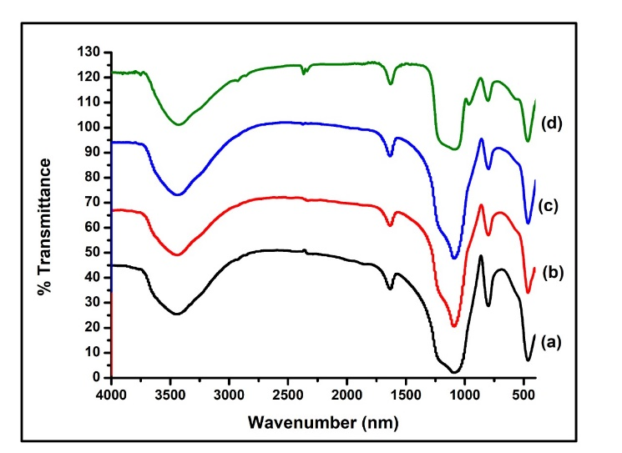
Fig.1. Infra-Red spectra of (a) Ni/MS1, (b) Ni/MS5, (c)Ni/MS10 catalyst, (d) Ni/SBA-15

Acidity Analysis
Using the gravimetric acidity test, Ni/MS catalyst surface acidity was determined using pyridine as a base probe molecule. The results are 1.02 mmol/g for MS, 1.34 mmol/g for Ni/MS1 and 1.55 mmol/g for Ni/MS5, Ni/MS10 1.74 and Ni/SBA-15 2.09 mmol/g. The higher acidity of Ni/SBA-15 and Ni/SM10 showed its potential as a catalyst that requires acid sites, such as hydrocracking. The greater the nickel impregnation, the increase the acidity. This is due to the uneven distribution of the pores on the layer surface of the material [14].
The data show that Ni/MS catalyst has a higher total acidity value compared to MS. The increase in total acidity is caused by metals deposited on the carrier, which will give acidic sites. The number of acidic sites will affect pyridines adsorbed on the catalyst surface. In addition, the increased metal contents will give more acidic sites, which will increase the probability of pyridine adsorption on the catalyst surface. This phenomenon showed that Ni/MS catalysts could be used as hydrocracking catalysts.

Catalyst Crystallinity analysis
Ni/MS catalyst crystallinity was examined using XRD, Figure 2. Excluding Ni/MS1, Ni/MS5, and Ni/SBA-15, it was found that MS has an amorphous silica mesoporous phase [15]. While the catalyst with impregnated Ni 5 Wt.% and 10 wt.% showed crystals, this was because the increase in the metal content of Ni showed a crystal diffractogram pattern with crystal peaks appearing at 2ɵ = 44; 52˚, and 76 (111), (200) and (220) (JCPDS card no. 00-004-0850). These results indicate that these peaks are characteristic peaks of NiO. This indicates the presence of sufficient nickel oxide to form face center cubic NiO crystals. This is in accordance with research [14].
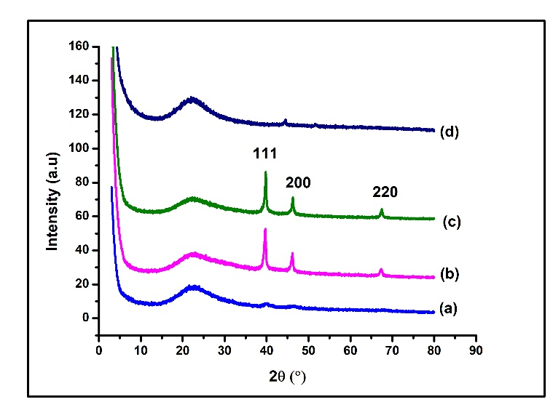
Fig. 2. Diffraction pattern of (a) Ni/MS1, (b) Ni/MS5, (c) Ni/MS10, and (d) SBA-15 catalyst

Morphology of Ni/MS1, Ni/MS5, Ni/MS10 catalyst
SEM was used to further confirm the morphological structure of the synthesized material at a magnification of 5000 times with an energy of 15 kV, and EDX was used to determine the amount of impregnated Ni metal concentration. The morphology of MS, Ni/MS1, Ni/MS5, Ni/MS10, and Ni/SBA-15 are shown in Figures 3 and 4.
In Figure 3 (a) is the morphology of silica sand, and b, Mesoporous silica (c) is the morphology of Ni/ MS1, (d)Ni/MS5, (e) Ni/MS10, and (f) Ni/SBA-15, which are uniformly bundled macroscopic structures. The morphology type of MS is an aggregate shaped like a coral, while the morphological type Ni/SBA-15 is an aggregate that is shaped like a rod [15]. On the surface of the MS catalyst, all MS pores are seen, which characterize the amorphous carrier material. In the Ni/MS1 and Ni/MS5 pictures, agglomeration of the impregnated metal appears to occur.
In Ni/MS10, the embedded Ni metal enters the pores and spreads evenly on the catalyst surface. This is related to the results of the XRD analysis that the metal-bearing Ni is 10%. This is according to research [14]. The characteristics of Ni metal which is embedded in a porous material will form NiO, which is in the pores and on the surface of the pores, causing agglomeration[16].
The morphology of the catalyst is quite different from that of silica. On the silica surface, after being treated with a nickel catalyst metal, the surface morphology becomes more visible. This is due to the dispersal of nickel catalyst metal on the entire surface to close the previously tenuous particle space.
EDX app is very useful to see the distribution of each type of atom on the catalyst's surface. In figure 4. The red, blue, and green colored dots are identified as silica, oxygen, and nickel. The Ni/MS10 shows that the Ni atoms are evenly distributed, but there is an agglomeration of the Ni atoms in clusters. Metal agglomeration is not expected because it reduces the surface area of ​​the catalyst metal, which is expected to interact with the feed during the catalyst activity test. This is in accordance with research [11,16]. Ni atom precursors are difficult to direct into the mesoporous channels; NiO is detected both inside and outside the pores causing poor dispersion due to redistribution and agglomeration.

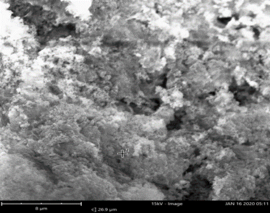  (a) | 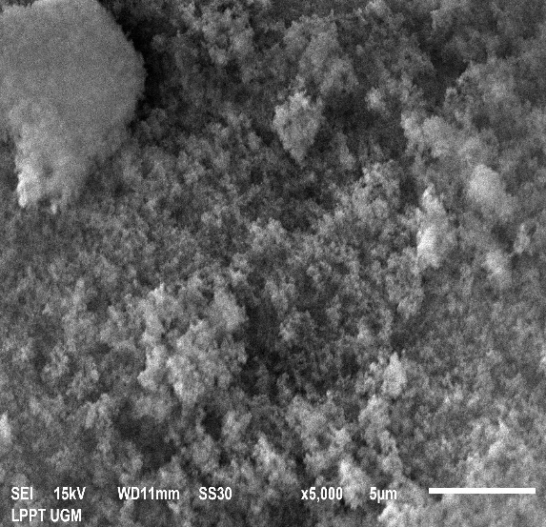  (b)
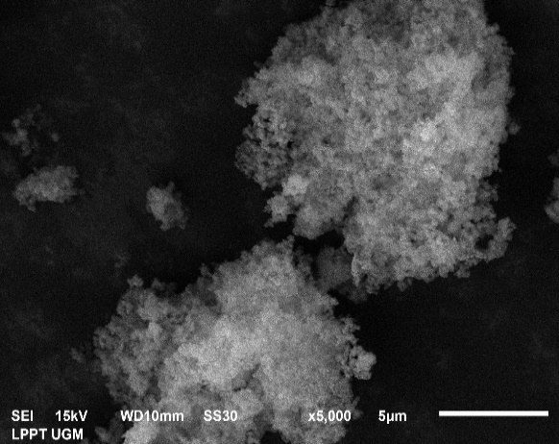  (c) | 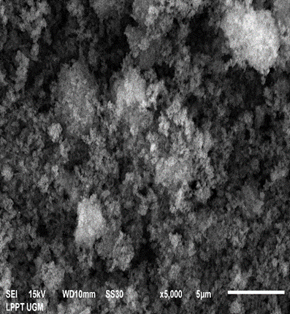  (d)
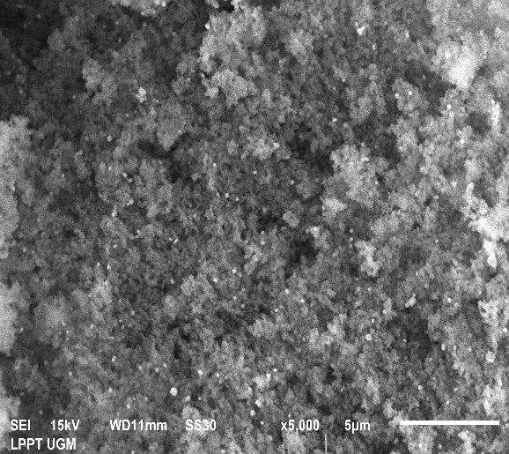  (e) | 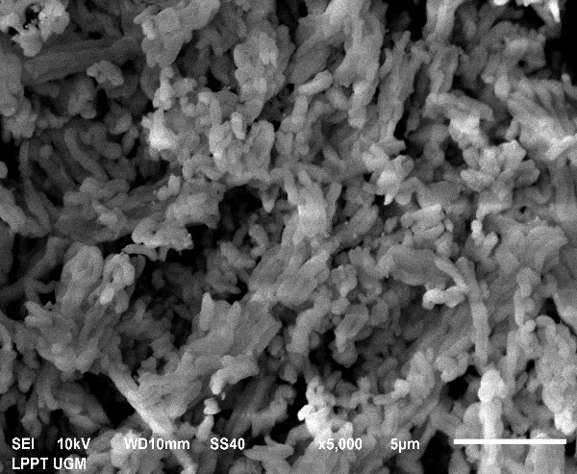  (f)
Fig.3. Morphology of catalyst a. silica, b. MS, c. MS, Ni/MS1, d. Ni/MS5, e. Ni/MS10, f.Ni/SBA-15

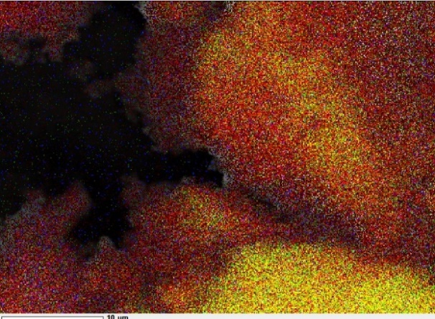  a | 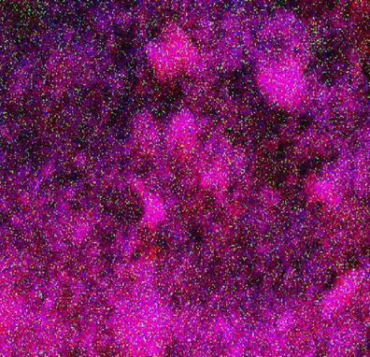
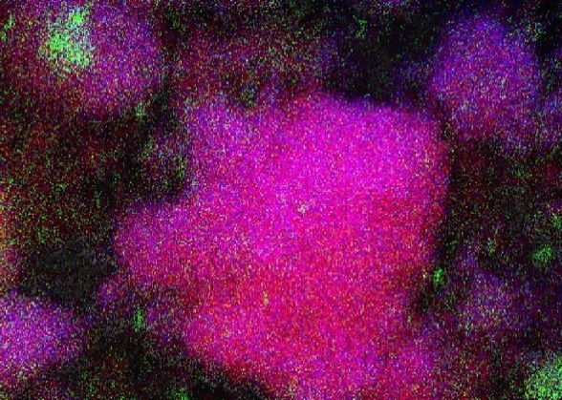
Fig.4. EDX-Mapping morphology of a. Ni/MS, b. Ni/MS5, and c. Ni/MS10 catalyst

Gas Sorption Analysis Catalyst
The synthesized catalyst Ni/MS were analyzed using Gas Sorption Analyzer (GSA) to determine their porosity character. The isotherm graph and specific surface area were calculated using the BET equation. Pore volume, average pore diameter, and pore size distribution were calculated using BJH.
The results of characterization by GSA determine the classification of mesoporous materials based on their pore size according to the material classification [17]. The results of the characterization of GSA are in Table 1

Table 1. The porosity property of Ni/MS catalyst
Samples | Specific Surface Area  (m²/g) | Total pore volume (cm³/g) | Average Pore Diameter  (nm)
Silica (S) | 9.4 | 0.006 | 19.12
MS | 122.8 | 0.14 | 4.65
Ni/MS1 | 130.5 | 0.37 | 12.30
Ni/MS5 | 195.9 | 0.47 | 9.80
Ni/MS10 | 203.9 | 0.52 | 11.12
Ni/SBA-15 | 381.2 | 0.80 | 8.70

The results showed that MS has a larger surface area than silica sand. MS also shows a pore diameter of 122.8 m²/g, which indicates that MS is a mesoporous material. This indicates that the synthesis of MS from DDA-printed Parangtritis beach sand was successfully carried out.
Metal impregnation into MS will increase the surface area of ​​MS; the larger the metal is carried, the surface area will increase. For example, for 10 wt %Nimetal, there is an increase in surface area of ​​60% and has a surface area of ​​203.9 m²/g, which is lower Ni/SBA-15 has 381.2 m²/g. As the surface area increases, more reactants are adsorbed, and the possibility of a reaction occurring is greater. The impregnation of metals causes the increase in the physical properties of the catalyst into the MS pores, the entry of metals into the carrier increases the active site. This is related to the acidity data the higher the Ni content, the more active sites.
The greater the total metal content, the surface area and pore volume will increase. This phenomenon is probably due to the metal being evenly distributed in the carrier system even though there is a slight buildup at certain pore channel positions. Evenly in the carrier system, although there is a slight buildup in certain pore channel positions. The adsorption-desorption isotherm of N₂ gas on the surface of the Ni/MS catalyst is shown in Figure 5. The desorption isotherm shows a hysteresis loop starting at a P/P0 relative pressure of about 0.5. This indicates that the relative pressure is brought to 0.5. Nitrogen gas is adsorbed on the monolayer. When the relative pressure starts to be in the range of 0.5 to 1, a multilayer arrangement of nitrogen gas occurs on the active Ni/MS surface. The isotherm pattern according to IUPAC type HIV [12,17].
The hysteresis loop formed in the desorption adsorption isotherm has an HIV pattern, the HIV loop hysteresis indicates that the Ni/MS catalyst has a smaller pore mouth size than the pore body size or is called a bottle-shaped pore, the bottle-shaped pore causes the nitrogen gas desorption process to run faster. Slowly so that the amount of nitrogen gas adsorbed and adsorbed at the same pressure is much different. The increase in pore diameter is caused by the space between the layers of the crystal lattice planes, which increases the distance between the crystal lattice planes and causes an increase in the pore diameter. The expansion of the metallic Ni in MS causes the diameter range to increase, more gas molecules can enter, thus causing the formation of a more porous structure between layers, thereby contributing to an increase in surface area and porosity. All three catalysts have the same mesoporous, which is characterized by the presence of a hysteresis loop [18].
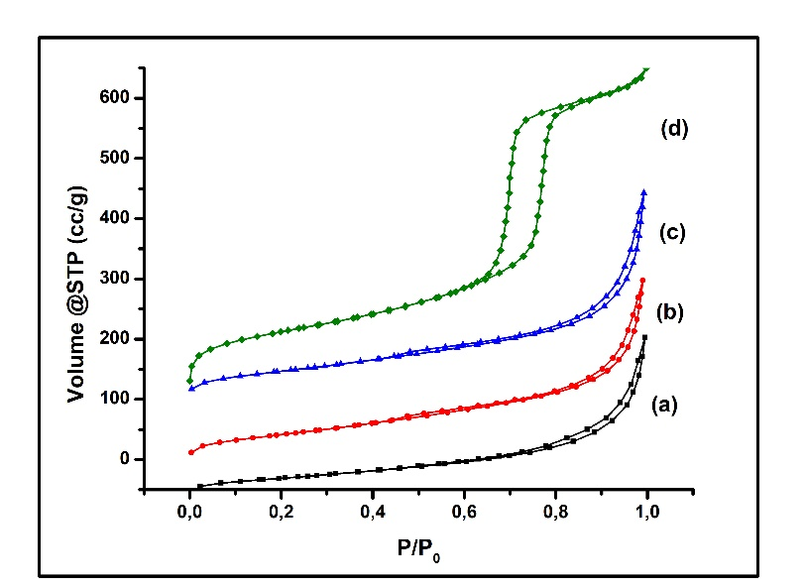
Fig.5. Adsorption-desorption isotherm of the N₂ graph a. Ni/MS1, b. Ni/MS5,
c. Ni/MS10 and d. Ni/SBA-15 catalyst

Based on Figure 6 shows Ni/MS1,5 and Ni/MS10 catalysts have a fairly wide pore size distribution, ranging from 1-10 nm. This corresponds to the pore size range of the mesoporous material, which is 2-50 nm [12]. This means that the Ni/MS catalyst has the expected mesoporous. In the catalyst, there is also a distribution of pores in the micropore region. Therefore, the obtained Ni/MS catalyst is Ni/MS with micropore and mesoporous sizes or hierarchical mesopores [19]. In Ni/MS5, there is a widening of the pores and irregular pores.
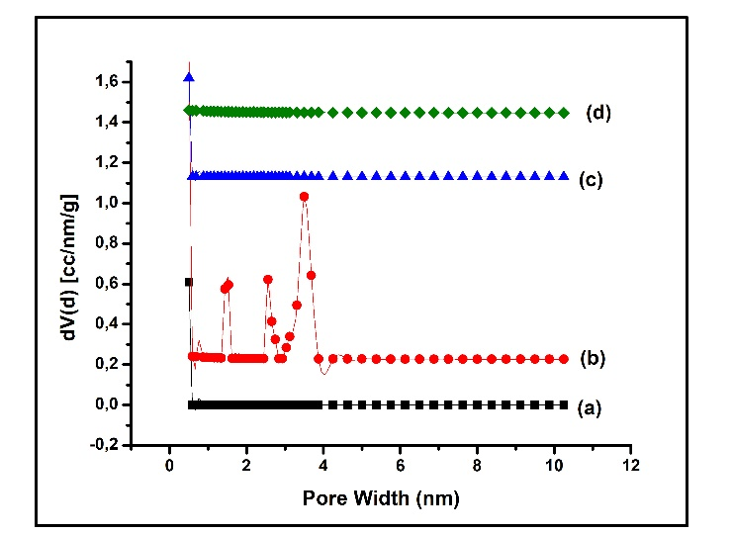
Fig.6. Pore size distribution graph of (a) Ni/MS1, (b) NI/MS5, (c) Ni/MS10, and (d) Ni/SBA-15 catalyst

Figure 6 visualizes the pore size catalyst distribution, which has a reasonably wide pore size distribution. It ranges from 1-10 nm, following the pore size range of the mesoporous, which is 2-50 nm meaning that MS is mesoporous as expected. Besides that, there is also the distribution of pores in the micropore region. This indicates that the Ni/MS obtained is micropore and mesopore-sized, referred to as hierarchical mesoporous [14,16]. Types are in accordance with the data in Figure 4, causing a decrease in pore diameter smaller from Ni/MS10 catalyst.

Characterization Using TEM
TEM image is needed to ensure that the synthesized MS has pore gaps according to the results of the GSA analysis. The TEM image in Figure 7 appears to have clear pores like wormholes. The use of nickel made the pore structure of Ni/MS irregular. Pores with a wormhole-like structure were obtained [20,21]. TEM images are needed to ensure that the synthesized NI/MS has a pore gap according to the results of the GSA analysis. The TEM image is in figure 7.
The presence of Ni metal forms more pores with an irregular pore shape similar to a wormhole; this is in accordance with research [12,17]. As a result, the surface area becomes larger, and the pore radius increases. The number of pores formed due to the spread of Ni gives the effect of increasing pore volume according to the added Ni. The study results using variations in the percentage of Ni showed a significant change in the performance of the catalyst obtained. This is in accordance with Figure 4; with the addition of 10% Ni metal, agglomeration occurs in severe.
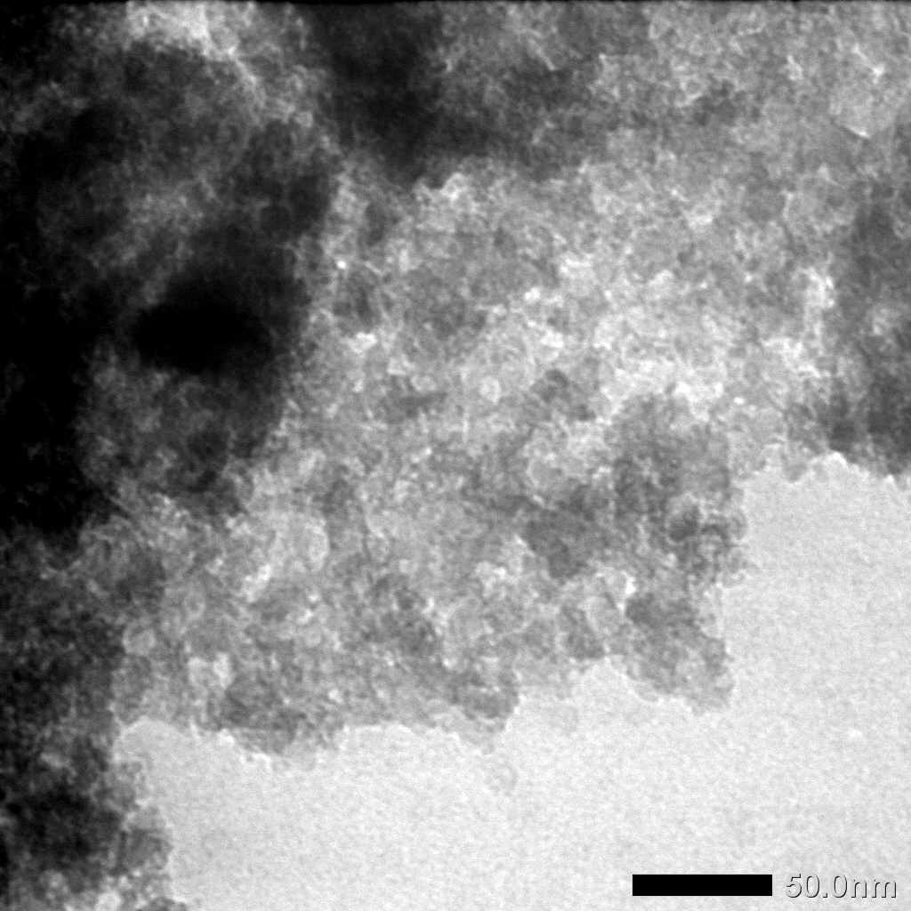  a | b
c | 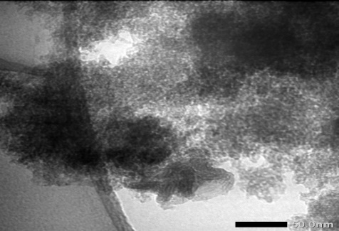  d
Figure 7. Morphology TEM of a. MS, b. Ni/MS1, c. Ni/MS5, and d. Ni/MS10 catalyst
b

Catalytic Performance In Hydrocracking of waste coconut oil.
This study tested the catalytic activity of MS, Ni/MS1, Ni/MS5, and Ni/MS10 catalysts. The bait used in this research is waste coconut oil. The hydrocracking process was carried out at a temperature of 450 ℃ and with a variation of the weight ratio of catalyst: feed 1:100 and H₂ gas flowed with a flow rate of 20 mL/min to find the catalyst with the best activity and selectivity. The catalytic activity can be seen in Table 3 below. The Ni/MS10 has a higher surface area than silica and Ni/MS1 and Ni/MS5. Activity Ni/MS1, Ni/MS5, Ni/MS10 has a liquid fraction of 38.8 %;43.2% and 50.2%.
The catalyst produces the highest liquid product produced by the Ni/MS10 catalyst. It is due to the entry of Ni metal into the pores of MS. Besides that, Ni metal has an active site that helps in the hydrocracking process. Ni metal in the hydrocracking process is used as the active site due to unpaired electrons in the d orbitals. The unpaired electron in the d orbital will homolytically dissociate hydrogen gas which will be needed in the hydrocracking process and will also function as an active hydrogenation site as well as a Bronsted-Lowry acid site [13] Ni/MS10 catalyst has a higher liquid product than MS; this is related to the higher acidity value of Ni/MS10. Where the higher the acidity value of a catalyst, the higher the liquid product will be. This is because an increase in the total acidity of a catalyst can increase the number of acid sites that play an essential role in attracting hybrid ions (H⁺), which play a role in the initiation process in the hydrocracking process. This is following the research carried out [11], which states that after the metal impregnation process and having a high total acidity can increase the liquid product in the hydrocracking process.
In addition, the presence of metallic Ni reduces the product gas. This is because the used waste coconut oil has been successfully converted into a liquid product [21]. Therefore, the Ni/MS1 catalyst compared to the liquid product MS has decreased, and the amount of gas formed increases. This is probably due to the metal Ni/MS1 catalyst not being well distributed and agglomeration occurring so that waste coconut oil, as the feed, cannot be desorbed by the catalyst or is retained on the catalyst causing gas formation. This is in accordance with research [4.11].
The main components of used waste coconut oil are petroselinic acid and palmitic acid, where C18 and C16 of the two fatty acids will be cracked into shorter hydrocarbon chains if oxygen is removed, or vice versa creates shorter fatty acid chains [8]. In the hydrocracking process, the used waste coconut oil is converted into liquid, gas, and coke fractions, the data of which can be seen in Table 2. Ni/MS10 catalyst showed superior performance in producing liquid fraction but was still able to avoid over-cracking. Indicated by the relatively low gas fraction produced. This phenomenon can be caused by the excellent catalyst pore structure, where the mesopores on the catalyst surface allow the feed to enter the catalyst while releasing the product easily.
In this study, the liquid product was analyzed using GC-MS which can be seen in Table 3. Gas Chromatography (GC) serves as a separator, then the gas chromatography analysis data in the form of a chromatogram which shows the number of components that have been separated from the liquid fraction is detected using a mass spectrometer (MS). The liquid product was obtained from the hydrocracking process of waste coconut oil.
The surface area was higher, and the location of the acid site could be responsible for this phenomenon, where the acid site of Ni/MS could reside deep beneath the catalyst. While the feed and product could come in and out easily, the chance of the feed finding the active site before they exit the catalyst becomes slimmer. This hypothesis seems to be responsible for the relatively high amount of oxygenated product [21,22].

Table 2. Hydrocracking products of waste coconut oil
Hydrocracking catalyst | Conversion ( Wt.% ) |  |  |  | Total Conversion  ( Wt.% )
Hydrocracking catalyst | Liquid product | Gas product | Residue | Coke | Total Conversion  ( Wt.% )
MS | 41.2 | 51.2 | 6.2 | 1.4 | 93.7
Ni/MS1 | 38.8 | 55.3 | 4.2 | 1.7 | 95.8
Ni/MS5 | 43.2 | 37.8 | 17.5 | 1.9 | 82.4
Ni/MS10 | 50.2 | 33.3 | 14.8 | 1.7 | 85.2

Table 3. Selectivity of the Ni/MS1, Ni/MS5, and Ni/MS10 Catalyst
Hydrocracking catalyst | Liquid fraction ( Wt % )
Hydrocracking catalyst | Gasoline(C₅-C₁₂) | Diesel  (C₁₃-C₁₇) | oxygenated product
Ni/MS1 | 37.09 | 0.0 | 1.71
Ni/MS5 | 39.76 | 0.24 | 3.20
Ni/MS10 | 44.27 | 0.51 | 5.42

The catalyst obtained in this synthesis is selective for the gasoline fraction, the most selective being the Ni/MS10 catalyst. This is probably due to the large surface area and high acidity. The increase in total acidity occurs because the metals deposited on the carrier will provide acidic sites. The acidity and contribution of different catalysts will make catalysts that have different activities and selectivity. A suitable condenser is required for the hydrogenation of oxygen-containing components. The pore size in the catalyst mesoporous region will help the reactants and intermediates to overcome the limited diffusion of adsorption at the metal sites [4,11]. The selectivity pattern in the gasoline fraction of the Ni/MS1, Ni/MS5, and Ni/MS10 catalysts, the most optimal is the Ni/MS catalyst has 50.2 % in the liquid fraction. This shows that the development of Ni metal influences the cracking process. This indicates that this metal carrier in MS can undergo deoxygenation, decarboxylation, and decarboxylation reactions [1].
Several reactions occur simultaneously in the cracking process with a catalyst. The cracking occurs by breaking the C-C bond in the compound. According to [3], the cracking reaction of used waste coconut oil goes through 3 stages, namely hydrodeoxygenation, decarbonylation, and decarboxylation, according to the reaction mechanisms in Figure 8.
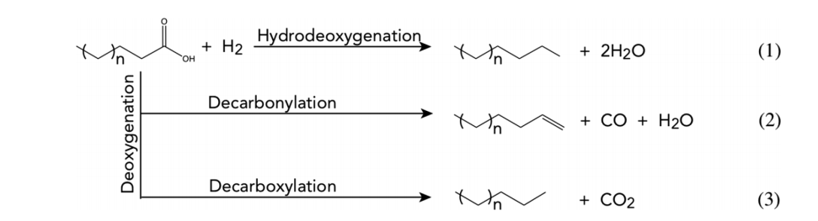
Fig. 8. Hydrocracking reaction mechanisms of waste coconut oil decarboxylation

According to the reaction mechanisms in Figure 8, hydrocarbon compounds occur through hydrodeoxygenation and deoxygenation reactions. Also, through decarboxylation, CO₂ by-products will be formed; when the fatty acid deoxygenation process occurs, decarboxylation and hydrodeoxygenation reactions often occur. This reaction occurs through a catalyst. The decarboxylation and decarbonylation reactions occur simultaneously to form alkane and alkene products. The number of products that are selective for the chain gasoline fraction with carbon atoms from 5 to 12 (C5 – C12) shows that in this process of hydrocracking used waste coconut oil with a flow of hydrogen gas of 20 ml/min the possibility of hydrodeoxygenation and decarboxylation reactions occur [13,20].

The reusability of Ni/MS1, Ni/MS5, Ni/MS10 catalyst for hydrocracking of WCO
The stability test of the Ni/MS catalyst was conducted 4 times for hydrocracking using WCO at a temperature of 450 ℃ and a weight ratio of 1:100 catalyst: feed. For 4 running, Ni/MS1, Ni/MS5, Ni/MS10 catalysts produced excellent activity and selectivity with high conversion rates. The Ni/MS10 catalyst activity increased with the use of the catalyst for 4 runnings and decreased on the 4 runs. The results of the analysis can be seen in Figure 9.

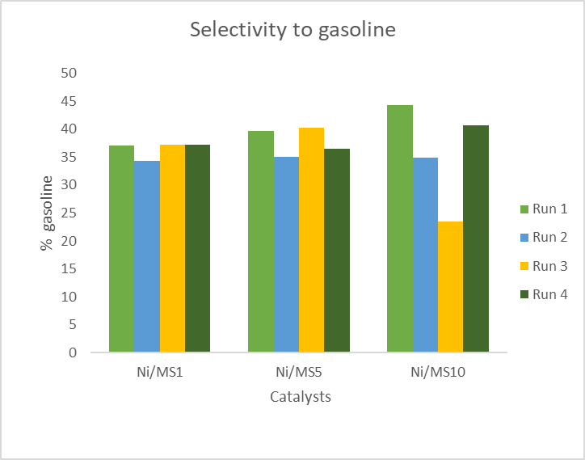
Fig.9. The reusability of catalyst from hydrocracking of WCO

The stability test results of GC-MS analysis on selectivity in the gasoline fraction show that the Ni/MS5 and Ni/MS10 catalyst is relatively stable from running from 1 to 4. This is probably due to the overall character of the catalyst, namely metallic properties, acidity, surface area, pore volume, pore diameter, and reaction mechanism. Ni/MS10 catalyst has the highest acidity and surface area. Coke formation was also seen to decrease, indicating stability against coke poisoning. Increasing the amount of coke on the surface of the catalyst can cover the catalyst's active site where the deoxygenation mechanism occurs. The deactivation of the catalyst that occurs is caused by the formation of coke deposited on the active site of the catalyst. The residue increased with the reuse of the Ni/MS catalyst.
The morphological structure of the Ni/MS catalyst before and after the stability test in this study was characterized using a Transmission Electron Microscope (TEM) observed at 100 nm magnification. Ni/MS catalyst before and after hydrocracking is shown in Figure 10. It can be seen in Figure 10 a1, b1, and c1 are catalysts before hydrocracking which shows that the material is still not agglomerate. In Figure 10 a2, b2, and c2, that is, after the fourth use, it shows black spots and clumping. Clumping that occurs indicates the presence of a sintering process. The sintering process can occur due to the use of too high a temperature, where the temperature is too high, causing the aggregation of Ni metal [11,12,14]. The black stain that is visible is nickel which is getting darker. This indicates that coke formation affects the deactivation of the catalyst [12]. This result is also in accordance with the coke level in Table 4, which shows the increasing amount of coke, and in Figure 10 b, and c shows that there are quite dark black spots. Coke formation was also seen to increase, indicating stability against coke poisoning. Increasing the amount of coke on the catalyst surface can cover the active catalyst site where the deoxygenation mechanism occurs. The deactivation of the catalyst that occurs is caused by the formation of coke deposited on the active site of the catalyst. The residue increased with the reuse of the Ni/MS catalyst.
Table 4. Distribution of catalyst reusability in hydrocracking WCO
Catalyst | Conversion (wt %) |  |  |  | Total conversion (wt.% )
Catalyst | Liquid product | Gas product | Residue | Coke | Total conversion (wt.% )
Ni/SM1¹ | 38.8 | 55.3 | 4.2 | 1.7 | 95.8
Ni/SM1² | 38.3 | 27.6 | 32.1 | 2 | 67.9
Ni/SM1³ | 39.9 | 32.1 | 26.1 | 2 | 73.9
Ni/SM1⁴ | 49 | 34.8 | 12.4 | 3.8 | 87.6
Ni/SM5¹ | 43.2 | 37.8 | 17.5 | 1.9 | 82.4
Ni/SM5² | 37.7 | 33.8 | 27.2 | 1.3 | 72.8
Ni/SM5³ | 46 | 28.9 | 22.5 | 2.6 | 77.5
Ni/SM5⁴ | 41.8 | 42 | 15.9 | 0.3 | 84.1
Ni/SM10¹ | 50.2 | 33.3 | 14.8 | 1.7 | 85.2
Ni/SM10² | 37.8 | 29.8 | 31.5 | 0.9 | 68.5
Ni/SM10³ | 25.5 | 52.7 | 20.9 | 0.9 | 79.1
Ni/SM10⁴ | 40.7 | 19 | 34.1 | 1.3 | 81
¹The first hydrocracking
²The second hydrocracking
³The third hydrocracking
⁴The fourth hydrocracking

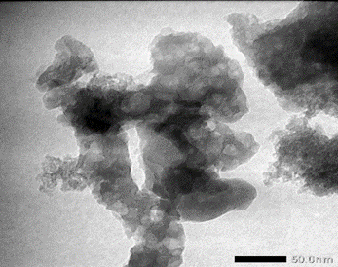  a1 | 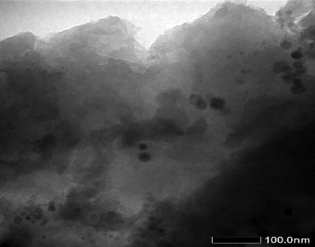  a2
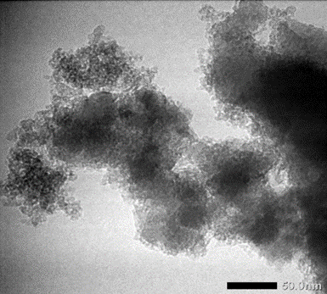  b1 | 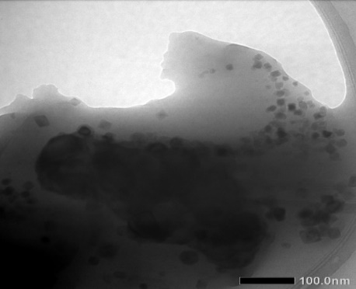  b2
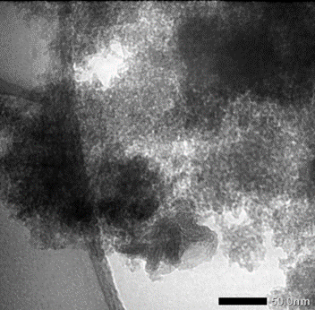  c1  C1 | 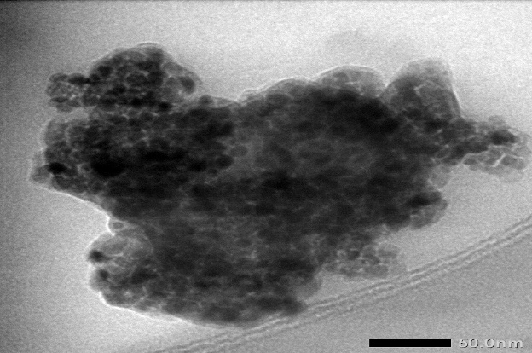  c2  C2
Fig.10. Morphology of TEM before and after hydrocracking.

Coke is a by-product formed during the hydrocracking process. Coke can reduce the activity of the catalyst because coke can cover the active site of the catalyst, causing the breakdown of long-chain hydrocarbons to be lower. This causes a decrease in the activity of the catalyst. It can be seen in the picture on the stability test, an increase in coke due to the use of a catalyst.

CONCLUSION
The Ni/mesoporous silica catalyst was successfully synthesized from Parangtritis Beach sand using dodecyl Amina as a template. The catalysts were synthesized by impregnating MS with Ni metal of 1, 5, and 10 wt% weight variations and were denoted as Ni/MS1, Ni/MS5, and Ni/MS10. These catalysts had specific surface areas of 130.5 m²/g, 195.9 m²/g, and 203.9 m²/g, while standard Ni/SBA-15 had a specific surface area of 381.2 m²/g. The average pores were 12.30 nm, 9.8 nm, and 11.12 nm, while Ni/SBA-15 had 8.7 nm. The hydrocracking WCO has total convertion 95.8 %, 82.4 %, 85.2 % and SBA-15 88.7 %.The activity catalyst has liquid fractions produced were 38.8 wt.%, 43.3 wt.%, and 50.2 wt.%, which contain gasoline (C5-C12) of 37.09%, 39.76%, and 44.27%, respectively. Therefore, it could be deduced that Ni/MS10 has exceptional performance with reusability until 4 times running and still produce gasoline of 40.73%.

ACKNOWLEDGEMENTS
The authors would like to thank the General Director of Higher Education, Ministry of Education and Culture Indonesia, for the financial support under the scheme of Universitas Gadjah Mada Doctoral Dissertation Research (PDD) grant under contract number 208/UN.1/DITLIT/DITLIT/PT/2021).

CONFLICT OF INTEREST
The authors declare no conflicts of interest in this paper.

AUTHOR CONTRIBUTIONS
First Author: Conducted the experiment and data collection and analysis, drafted manuscript.
Corresponding Author: Write manuscript and proofreading.
Co-Author: as a data analysis consultant. All authors helped shape the research, analysis, and manuscript.

REFERENCES
- W. Trisunaryanti, S. Larasati, T. Triyono, N. R. Santoso, and C. Paramesti, 2020, Selective production of green hydrocarbons from the hydrotreatment of waste coconut oil over Ni- And NiMo-supported on amine-functionalized mesoporous silica, Bulletin of Chemical Reaction Engineering & Catalysis, vol. 15, no. 2, 415–431, doi:10.9767/bcrec.15.2.7136.415-431.
- Nanda Soil. Rachita Rana , Howard N. Hunter C., Zhen Fang d, Ajay K. Dalai B. , Janusz A. Kozinski (2020), Hydro thermal catalytic processing of waste cooking oil for hydrogen -rich syngas production. Chemical Enginering Science,195,935-945.
doi:/10.1016/j.ces.2018.10.039
- A. Yıldız, J.L. Goldfarb, and S. Ceylan, 2019, Sustainable hydrocarbon fuels via “one-pot” catalytic deoxygenation of waste cooking oil using inexpensive, unsupported metal oxide catalysts, Fuel, 263, 116750. doi:10.1016/j.fuel.2019.116750
- Nuntang, S., Yousatit, S., Yokoi, T. & Ngamcharussrivichai, C., 2019, Tunable mesoporosity and hydrophobicity of natural rubber/hexagonal mesoporous silica nanocomposites, Microporous and MesoporousMaterials,275,June2018,235–243. https://doi.org/10.1016/j.micromeso.2018.09.004,.
- R. Irzon, 2018, Komposisi Kimia Pasir Pantai di Selatan Kulon Progo dan Implikasi terhadap Provenance Geochemical Character of Coastal Sediments from Southern Kulon Progo with Implications for Provenance, vol. 19, no. 1,31–46. http://dx.doi.org/10.33332/jgsm.geologi.v19i1.267
- Salamah, S., Trisunaryanti, W., Kartini, Purwono, S., 2021, Synthesis and characterization of mesoporous silica from beach sand as silica source”, Proceeding The 4th International Conference on Chemical & Material Engineering, IOP.Conf.Series: Material Science and Engineering Indonesia. doi:10.1088/1757-899X/1053/1/012027.
- Thahir,.R.,Wahab.,A.W.,N.L,Nafie and Raya,I (2019), Synthesis Of Mesoporous silica SBA-15 Through Surfactan Set-UP and Hydrothermal Proces, Rayasan Journal.Chem., Vol.12, No3, pp 1117-1126.
- Salamah S., Trisunaryanti W., Kartin I., Suryo Purwono,2021, Hydrocracking Of Waste Coconut Oil Into Biofuel Using Mesoporous Silica From Parangtritis Beach Sand Synthesis By Sonochemistry, Silicon Journal, https://doi.org/10.1007/s12633-021-01117-0
- Miyao T, Sakurabayashi S., et.al., 2015, Preparation and catalytic activity of mesoporous Silica-coated Ni-Alumina base catalyst for selective CO methanation, Catalysis Communications, 58, 93-96, doi: 10.1016/j.catcom.2014.09.005
- Wijaya K., Saputri, W.,D., Aziz I.,T.,A., Wangsa, Heraldy E.,Hakim L., Suseno A., Utami M.,2021, Mesoporous silica preparation Using Sodium Bicarbonate as template and Application of the silica for Hydrocarcking of used waste cooking oil into Biofuel, J Silicon, doi: 10.1007/s12633-021-00946-3
- S. Qiu, Q. Zhang, W. Lv, T. Wang, Q. Zhang, and L. Ma, 2017, Simply packaging Ni nanoparticles inside SBA-15 channels by co-impregnation for dry reforming of methane, RSC Adv., 2017, 7, 24551–24560, doi:10.1039/c7ra00149e
- Trisunaryanti W., Sumbogo,S.,D., Mukti.,R.,R.,Kartika.,I.A.,Hartati.,Triyono.2021, Performance of low‑content Pd and high‑content Co, Ni supported on hierarchical activated carbonfor the hydrotreatment of Calophyllum inophyllum oil (CIO).Reaction Kinetic,Mechanisme and catalysis. doi:/10.1007/s11144-021-02060-2
- H. Y. Lin and Y. W. Chen,.2005, Preparation of spherical hexagonal mesoporous silica, J. Porous Mater., vol. 12, no. 2, 95–105, doi:10.1007/s10934-005-6766-y
- Komaruzzaman,M.,F.,Yap,Y.Hin.,Y.,Derawi D.,2020, Green diesel production from palm fatty acid distillate over SBA-15 supported Nickel/Cobalt Catalyst, Biomass and Bioenergy, 134, 1-8. doi:10.1016/j.biombioe.2020.105476.
- S. Lin et al., 2011, Direct synthesis without addition of acid of Al-SBA-15 with controllable porosity and high hydrothermal stability, Microporous Mesoporous Mater., vol. 142, no. 2–3, pp. 526–534, doi:10.1016/j.micromeso.2010.12.043.
- N. Wang, X. Yu, K. Shen, W. Chu, and W. Qian, 2013, Synthesis, characterization and catalytic performance of MgO-coated Ni/SBA-15 catalysts for methane dry reforming to syngas and hydrogen, International Journal of Hydrogen Energy, 38, 9718-9731, doi:10.1016/j.ijhydene.2013.05.097
- T. R. Pauly, Y. Liu, T. J. Pinnavaia, S. J. L. Billinge, and T. P. Rieker, 1999,Textural mesoporosity and the catalytic activity of mesoporous molecular sieves with wormhole framework structures,” J. Am. Chem. Soc., vol. 121, no. 38, 8835–8842, doi:10.1021/ja991400t.
- F. J. Sotomayor, K. A. Cychosz, and M. Thommes, 2018, Characterization of Micro/Mesoporous Materials by Physisorption: Concepts and Case Studies,Acc. Mater. Surf. Res, vol. 3, no. 2, 34–50.
- B. Coasne, 2016, Multiscale adsorption and transport in hierarchical porous materials, New J. Chem., vol. 40, no. 5,4078–4094, doi: 10.1039/c5nj03194j.
- S. Nuntang, S. Yousatit, T. Yokoi, and C. Ngamcharussrivichai,2019, Tunable mesoporosity and hydrophobicity of natural rubber/hexagonal mesoporous silica nanocomposites,” Microporous Mesoporous Mater., vol. 275, no. June, 235–243, doi:10.1016/j.micromeso.2018.09.004.
- Kusumastuti, H., Trisunaryanti, W., Falah, I.I. & Marsuki, M.F., 2018, Synthesis of mesoporous silica-alumina from lapindo mud as a support of Ni and Mo metals catalysts for hydrocracking of pyrolyzed α-cellulose, Rasayan Journal of Chemistry, 11, 2, 522–530. doi:10.1016/j.biombioe.2020.105476
- Li, L., Ding, Z., Li, K., Xu, J., Liu, F., Liu, S., Yu, S., Xie, C., Ge, X., 2016. Liquid hydrocarbon fuels from catalytic cracking of waste cooking oils using ultrastable zeolite USY as catalyst. J. Anal. Appl. Pyrol. 117, 268–272. doi:10.1016/j.jaap.2015.11.006

