Supporting Information

Evaluation of the Biological Activities of *A. paniculata* (Burm.f.) and *Peperomia pellucida* (L.) Kunth as a Source of Antiplasmodial Compounds

Nurhayati Bialangi1, Mohamad Adam Mustapa2, Yuszda K Salimi1, Weny J.A Musa1, Ari Widiyantoro3, Agus Malik Ibrahim4, Boima Situmeang4* and Julinton Sianturi5

**General information**

Commercial grade solvents were used unless stated otherwise. Solvents for chromatography were distilled prior to use. Analytical thin layer chromatography (TLC) was performed on Kieselgel 60 F254 glass plates and Octa Desyl Silane (ODS) RP-18 (Merck). Spots were visualized by 10% sulfuric acid in ethanol. Silica column chromatography was performed on silica gel G60 (Merck) (230-400 mesh) and ODS RP-18.

Optical rotations were recorded with an ATAGO AP-300 polarimeter. InfraRed (IR) spectra were measured by using a PerkinElmer spectrum-100 FT-IR spectrometer in KBR. 1H, 13C and two-dimensional NMR spectra were measured with a JEOL JNM A-500 (500 MHz) spectrometer at 296 K. Chemical shifts (δ) are reported in parts per million (ppm) relative to the respective residual solvent peaks (CD3OD: *δ* 4.78 in 1H-NMR). Chemical shifts (δ) are reported in parts per million (ppm) relative to the respective residual solvent peaks (CDCl3: δ7.26 in 1H and 77.20 in 13C NMR; CD3OD: *δ* 4.78 in 1H-NMR and 49.20 in 13C NMR). The following abbreviations are used to indicate peak multiplicities: s singlet; d doublet; dd doublet of doublets; t triplet; m multiplet. Coupling constants (*J*) are reported in Hertz (Hz). Mass spectra were recorded using a Waters Xevo QTOF mass spectrometer.

U:\Sianturi\Boima paper\malaria journal\etnophamacology\New folder\Presentation21.tif

**Scheme S1.** Isolation procedures of compound **1**-**2**



**3β-Hydroxy-24-ethyl-5,22-cholestadiene** **(1)**

A white crystal, m.p 150–152 °C; [α]D -38.6 (c 0.3, CHCl3); IR (KBr)*vmax* 3401, 2861 1457 and 1039 cm⁻¹; 1H NMR (500 MHz, Chloroform-d). δ 1.08 (m, 1H, H-1), 1.84 (m, 1H, H-1'), 1.49 (m, 1H, H-2), 1.81 (m, 1H, H-2'), 3.52 (m, 1H, H-3), 2.28 dd, *J* = 2.0, 5.2 Hz, 1H, H-4), 2.30 (dd, *J* = 2.0, 5.2 Hz, 1H, H-4'), 5.35 (d, *J* = 5.2 Hz, 1H, H-6), 1.54 (m, 1H, H-7), 1.96 (m, 1H, H-7'), 1.46 (m, 1H, H-8), 0.94 (m, 1H, H-9), 1.46 (m, 1H, H-11), 1.49 (m, 1H, H-11'), 1.15 (m, 1H, H-12), 1.95 (m, 1H, H-12'), 1.03 (s, 1H, H-14), 1.07 (m, 1H, H-15), 1.56 (m, 1H, H-15'), 1.26 (m, 1H, H-16), 1.67 (m, 1H, H-16'), 1.13 (m, 1H, H-17), 0.67 (s, 3H, H-18), 1.00 (s, 3H, H-19), 2.02 (m, 1H, H-20), 0.92 (d, *J* = 9.5 Hz, 1H, H-21), 5.16 (dd, *J* = 8.5, 15.0 Hz, 1H, H-22), 5.00 (dd, *J* = 8.5, 15.0 Hz, 1H, H-23), 1.53 (m, 1H, H-24), 1.45 (m, 1H, H-25), 0.84 (d, *J* = 6.4 Hz, 3H, H-26), 0.82 (d, *J* = 6.1 Hz, 3H, H-27), 1.15 (t, *J* = 3.2 Hz, 1H, H-28), 0.80 (t, *J* = 6.0 Hz, 1H, H-29); 13C NMR (125 MHz, Chloroform-d). δ 37.4 (C-1), 31.8 (C-2), 72.0 (C-3), 42.5 (C-4), 140.9 (C-5), 121.9 (C-6), 32.1 (C-7), 21.3 (C-8), 50.3 (C-9), 36.7 (C-10), 21.3 (C-11), 39.9 (C-12), 42.5 (C-13), 56.9 (C-14), 24.5 (C-15), 28.4 (C-16), 56.1 (C-17), 12.1 (C-18), 19.5 (C-19), 40.7 (C-20), 21.2 (C-21), 138.5 (C-22), 129.5 (C-23), 51.4 (C-24), 31.8 (C-25), 21.3 (C-26), 19.1 (C-27), 25.6 (C-28), 12.2 (C-29); HR-TOFMS *m/z* 413.3748 [M+H]+, (calculated for C29H48O, *m/z* 412.3704). In agreement with published data.[1]



**3β-hydroxy-9-lanosta-7,24E-dien-26-oic acid** **(2)**

A white crystal, m.p 162–165 °C; [α]D +15.6 (c 0.3, EtOH); IR (KBr)*vmax* 3241, 1701 1633 and 1120 cm⁻¹; 1H NMR (500 MHz, Methanol-d). δ 1.54 (m, 2H, H-1), 1.59 (m, 2H, H-2), 3.49 (dd, *J* = 4.0, 12.0 Hz, 1H, H-3), 1.45 (m, 1H, H-5), 1.85 (m, 2H, H-6), 5.26 (dd, *J* = 3.0, 6.5 Hz, 1H, H-7), 2.18 (m, 1H, H-9), 1.40 (m, 2H, H-11), 1.32 (m, 2H, H-12), 1.40 (m, 2H, H-15), 1.96 (m, 2H, H-16), 1.47 (m, 1H, H-17), 0.96 (s, 3H, H-18), 0.89 (s, 3H, H-19), 1.61 (s, 1H, H-20), 0.85 (d, *J* = 6.5 Hz, 3H, H-21), 1.51 (m, 2H, H-22), 2.02 (m, 2H, H-23), 5.98 (t, *J* = 7.8 Hz, 3H, H-24), 2.48 (s, 3H, H-27), 1.08 (s, 3H, H-28), 0.73 (s, 3H, H-29), 1.70 (s, 3H, H-30); 13C NMR (125 MHz, Methanol-d). δ 35.5 (C-1), 28.1 (C-2), 77.1 (C-3), 38.8 (C-4), 48.5 (C-5), 23.1 (C-6), 119.6 (C-7), 147.4 (C-8), 48.4 (C-9), 35.8 (C-10), 22.8 (C-11), 33.4 (C-12), 43.5 (C-13), 52.7 (C-14), 34.7 (C-15), 28.5 (C-16), 53.3 (C-17), 24.7 (C-18), 17.1 (C-19), 35.9 (C-20), 18.4 (C-21), 35.0 (C-22), 25.5 (C-23), 144.3 (C-24), 128.6 (C-25), 171.8 (C-26), 12.6 (C-27), 29.5 (C-28), 23.7 (C-29), 30.8 (C-30); HR-TOFMS *m/z* 455.3571 [M-H]⁻, (calculated for C30H48O3, *m/z* 456.3503). In agreement with published data.[2]

**Nuclear Magnetic Resonance** (**NMR**) **of Isolated Compound** **1**-**2**

**1H NMR (CDCl3, 500 MHz)**

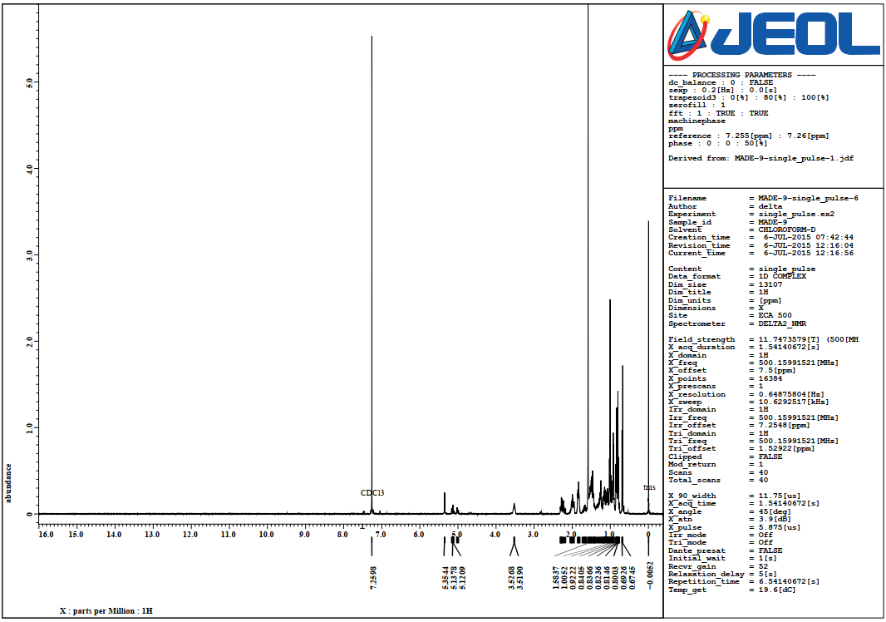



**1H NMR-Expansion (CDCl3, 500 MHz)**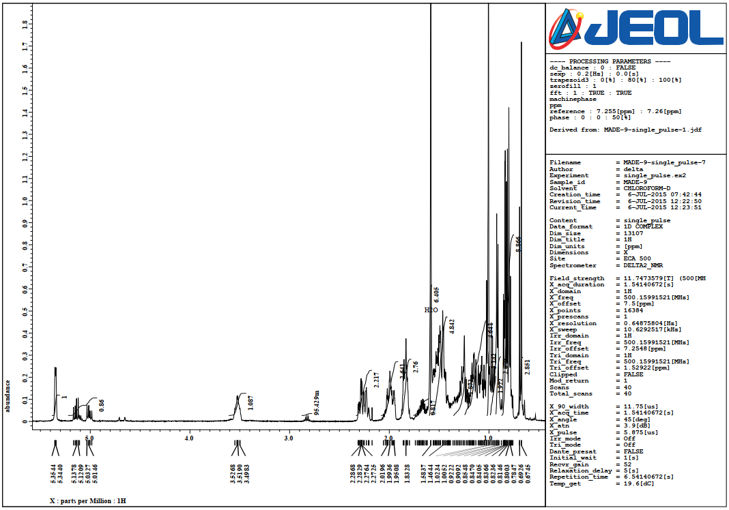



**13C NMR (CDCl3, 125 MHz)**

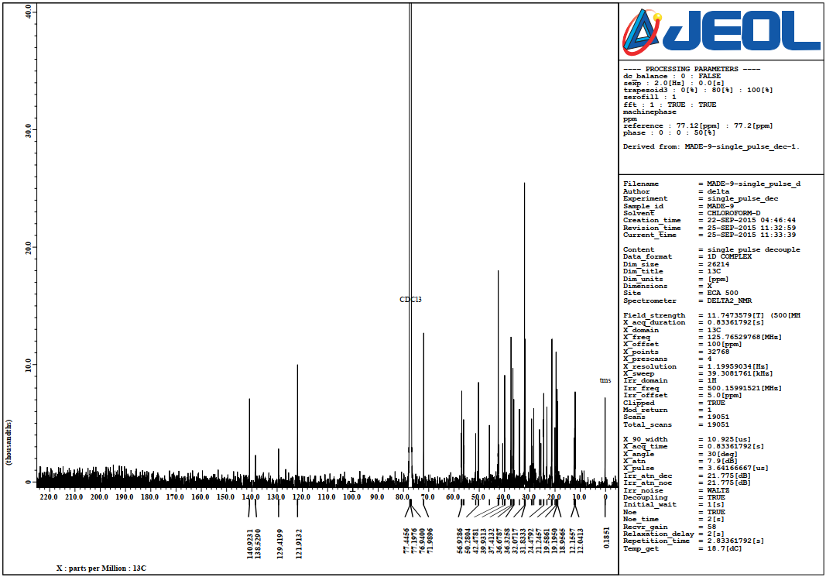



**13C NMR and DEPT 135 (CDCl3, 125 MHz)**

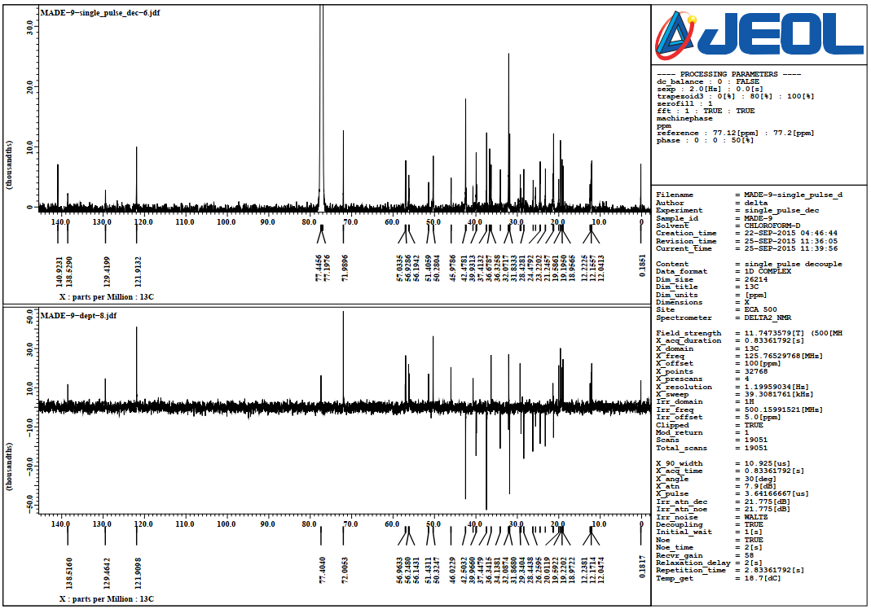



**1H NMR (CD3OD, 500 MHz)**

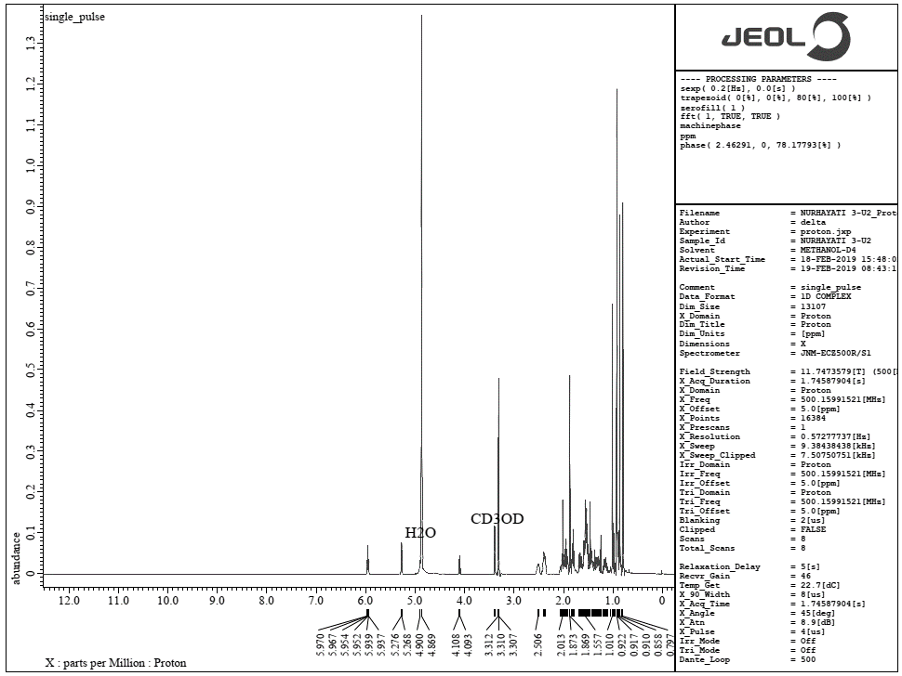



**1H NMR-Expansion (CD3OD, 500 MHz)**

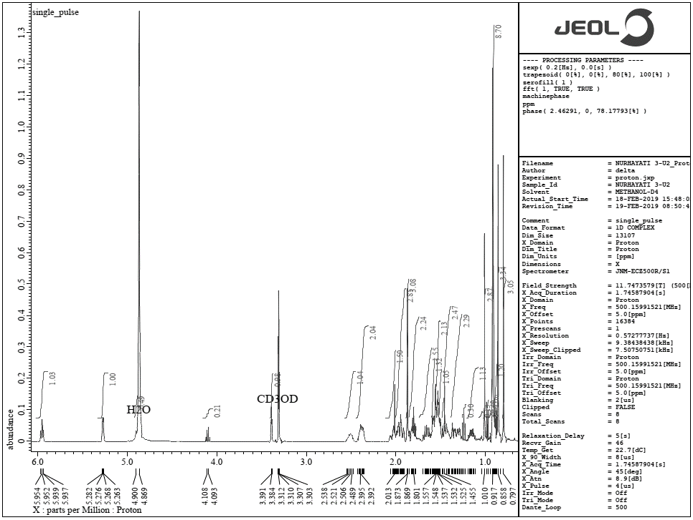



**13C NMR (CD3OD, 125 MHz)**

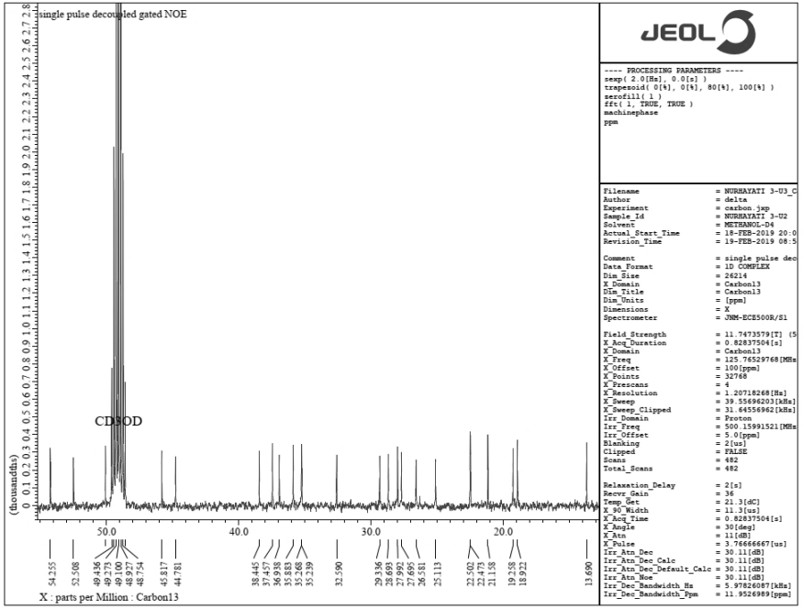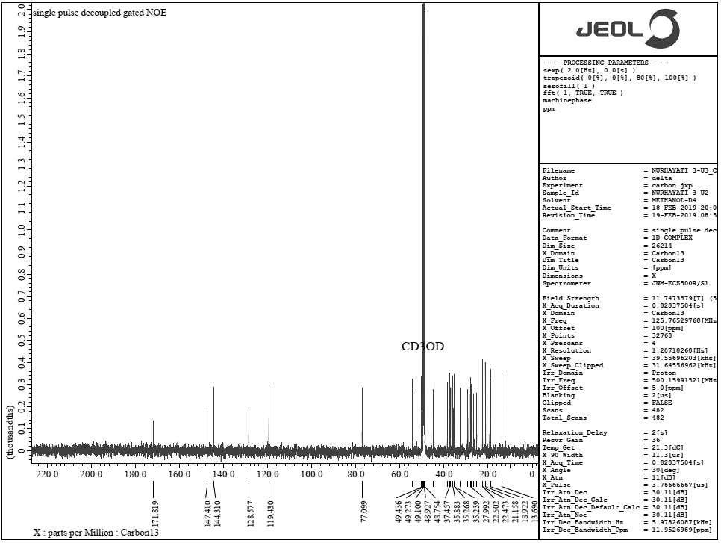



**DEPT 135 and 13C NMR (CD3OD, 125 MHz)**

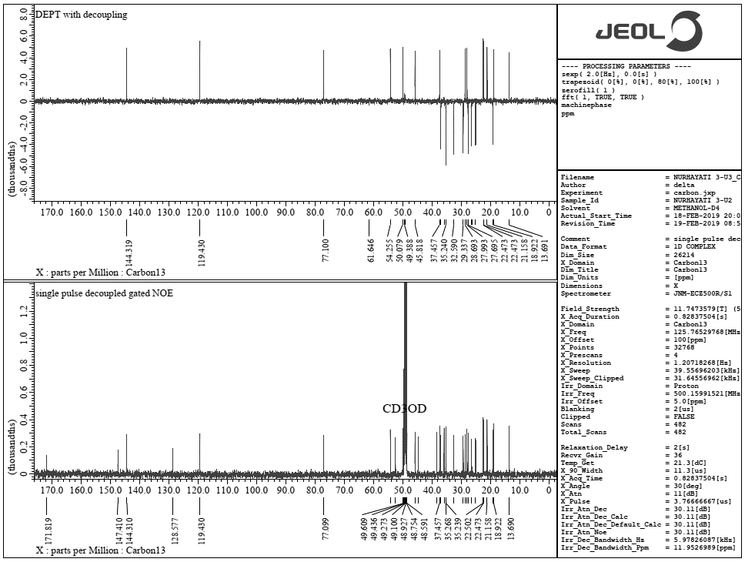



**HSQC NMR (CD3OD, 500 MHz)**

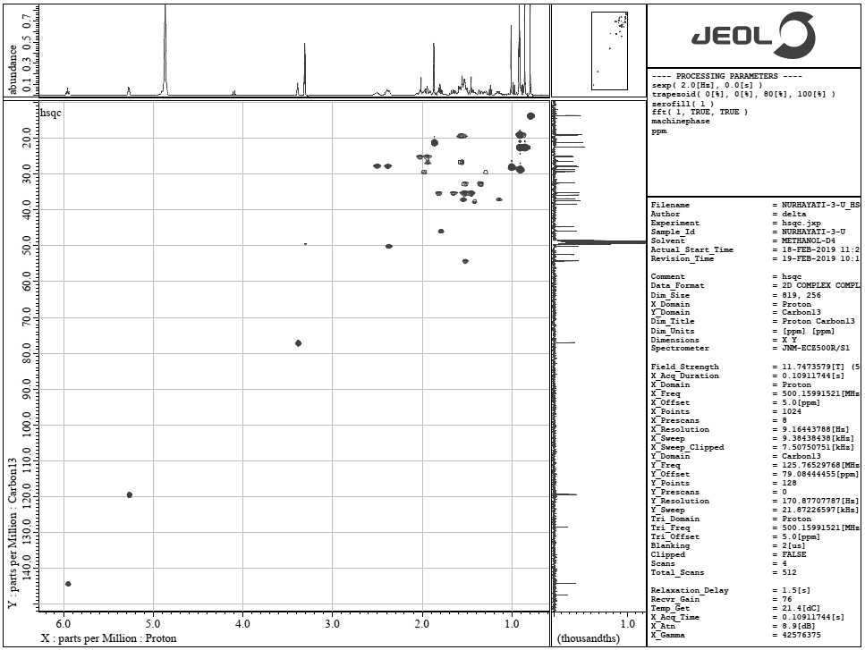



**HSQC NMR (Expansion, CD3OD, 500 MHz)**

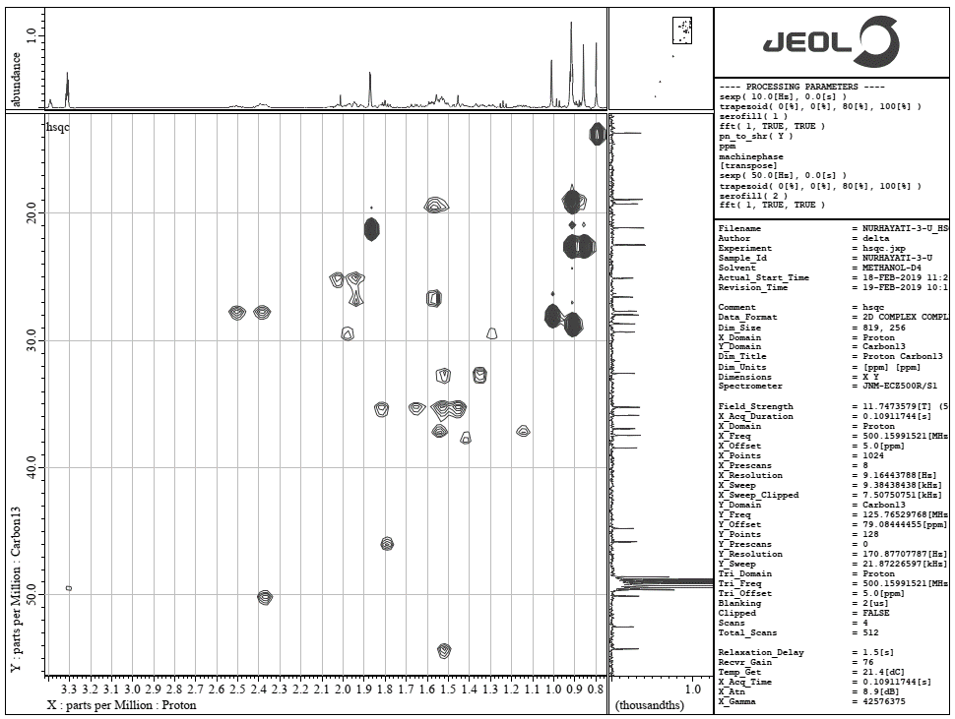



**HMBC NMR (CD3OD, 500 MHz)**

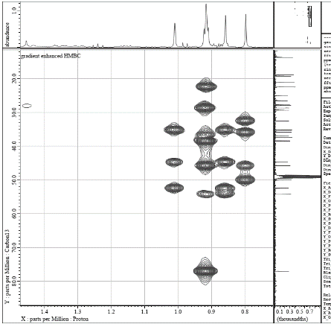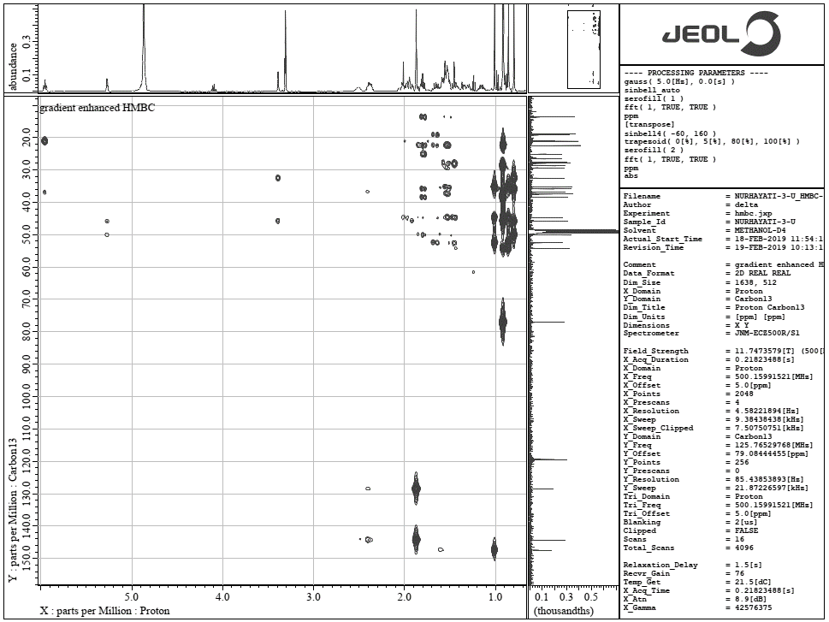





**Figure S1.** *In vivo* test of the PP extract against malarial parasite *Pb* ANKA strain in BALB/c albino mice. (a) ED50 value of the PP extract in mice. (b) Parasitemia rates after the fourth day of treatment. (c) Chemosuppression of parasitemia from day 0 to day 4. (d) Inhibition rates after the fourth day of treatment. (e) Survival mice treated with 0.5% CMC-Na as a negative control, the PP extract at various doses (1, 10 and 100 mg/kg/body) and chloroquine as a positive control. Bars in Figure S1b and S1d indicate the parasitemia and parasite growth inhibition rates treated with 0.5% CMC-Na (NC) (grid), CQ (horizontal) and the PP extract at a daily dose of 1 mg/kg/body (pencil striped), 10 mg/kg/body (herringbone) and 100 mg/kg/body (halftone), while in Figure S1c and S1e indicate parasitemia reduction from day 0 to day 4 and survival of mice treated with 0.5% CMC-Na (pink), CQ (carmine) and the PP extract at a daily dose of 1 mg/kg/body (green), 10 mg/kg/body (blue) and 100 mg/kg/body (red). SD is indicated by the error bars. \*\*\**p* < 0.001, \*\*\*\**p* < 0.0001.

**U:\Sianturi\Boima paper\malaria journal\etnophamacology\New folder\sp.tif**

**Figure S2**. Survival rates of untreated parasites (0.2% DMSO) and parasites treated with compounds **1**–**2** at a concentration of 0.78 to 100 g/mL and CQ (1 M) are shown. Bars indicate parasite survival rates. Untreated parasites (NC - grid), CQ (horizontal) and compounds **1**–**2** at a concentration of 100 g/mL (white), 50 g/mL (small striped), 25 g/mL (checkerboard), 12.5 g/mL (brick), 6.25 g/mL (halftone), 3.125g/mL (big striped), 1.56 g/mL (hexagon) and 0.78 g/mL (black). All experiments were performed in triplicate (*n* = 3). Standard Deviation (SD) is indicated by the error bars. \**p* < 0.05, \*\**p* < 0.01, not significant (ns).

**Statistical analysis**

Experiments were performed independently in triplicate and average are presented. Statistical analysis was performed by unpaired two-tailed *t*-test using GraphPad Prism. The statistics were significant when \**p* < 0.05, \*\**p* < 0.01 and \*\*\**p* < 0.001

**Table S1**. *In vitro* Antiplasmodial activity of plant extract against *Plasmodium falciparum*.[3]

|  |  |
| --- | --- |
| **IC50 Value (g/mL)** | **Category of activity** |
| <10 | Promising |
| 10-20 | Moderate |
| 20-40 | Good |
| 40-70 | Marginally potent |
| >70 | Poor |

**References**

1. Greca, M. D.; Monaco, P.; Previtera, L. Stigmasterols from *Typha latifolia*. *Journal of Natural Products*. **1990**, *53*(6), 1430-1435. DOI: [10.1021/np50072a005](https://doi.org/10.1021/np50072a005)

2. Isaka, M.; Chinthanom, P.; Sappan, M.; Supothina, S.; Vichai, V.; Danwisetkanjana, K.; Boonpratuang, T.; Hyde, K. D.; Choeyklin, R. Antitubercular Activity of Mycelium-Associated Ganoderma Lanostanoids. *Journal of Natural Products*. **2017**, *80*(5), 1361-1369. DOI: 10.1021/acs.jnatprod.6b00973.

3. Kamaraj, C.; Kaushik, N. K.; Mohanakrishnan, D.; Elango, G.; Bagavan, A.; Zahir, A. A.; Rahuman, A. A.; Sahal, D. Antiplasmodial potential of medicinal plant extracts from Malaiyur and Javadhu hills of South India. *Parasitol Res*. **2012**, *111*(2), 703-15. DOI: 10.1007/s00436-011-2457-6