Development of Voltammetry Analysis Method of Iron Metal Ions by Solid-State Membrane with Carbon Nanotube

Suyanta^{1*}, Sunarto¹, Regina Tutik Padmaningrum¹, Karlinda¹, Illyas Md. Isa², Rahadian³, Qonitah Fardiyah⁴ and Fredy Kurniawan⁵

¹ Departemen Pendidikan Kimia, FMIPA Universitas Negeri Yogyakarta, Yogyakarta, Indonesia
² Nanotechnology Research Centre, Faculty of Science and Mathematics, Universiti Pendidikan Sultan Idris, 35900 Tanjong Malim, Perak, Malaysia
³Departemen Pendidikan Kimia, FMIPA Universitas Negeri Padang, Padang, Indonesia
⁴Departemen Kimia, FMIPA Universitas Barwijaya, Malang, Indonesia
⁵Departemen Kimia, FSAD, Institut Teknologi Sepuluh Nopember, Surabaya, Indonesia
*E-mail: suyanta@uny.ac.id

Abstract
This study was aimed to develop a method for metal analysis in continuous integration using voltammetry techniques. The research subject was Fe(II) ions. The objects of research were linearity, scan rate, repeatability of readings, and the presence of Fe(II) levels in well water samples. In this study, a selective electrode was developed with a solid membrane voltammetry system using differential pulse voltammetry measurement. The results showed the regression line of voltammetry method, y = 36.507ln (x) + 990.73, with a correlation value of 0.9627, the optimum scan rate was 20 mV/s, and within five repetitions of each measurement for one electrode, it showed good repeatability. Meanwhile, the result of regression with the UV-Vis spectrophotometric method for Fe(II) was y = 0.20438x - 0.06987 with a correlation value of 0.99583. The voltammetry method was found to be much better than the UV-Vis method because it was able to be used for analysis up to a concentration 6.35 x 10⁻⁴ ppm (or 1.00 x 10⁻¹¹ M), while the UV-Vis method was only able to analyze up to 1.5 ppm (or 2.36 x 10⁻⁵ M). So, the technique that was develop can be use analysis of Fe(II) is better than another method.

Keywords: Fe(II)ion; spectrophotometry; voltammetry; nanotube carbon; solid-state membrane

- INTRODUCTION
Waste is unnecessary substance disposal from the production process both industrial and domestic, which if not processed properly can cause environmental pollution. Substances commonly found in chemical industrial wastes are Ag, Cd, Co, Fe, Cr, Cu, Ni, Zn [1]. Iron (Fe) a metal that is strong, tough and easily formed, so it is often used in life. Iron metal ions are often found in various water. Iron ion levels that exceed the normal threshold can cause smelly water, skin and eye irritation, damage to the intestinal wall and even cause long-term death [2].
Many techniques have been developed to detect the content of iron (ion) in many samples using instruments such as UV-VIS spectrophotometers, AAS, ICP-MS and ICP-AES. The AAS method is less sensitive for the determination of copper and iron because of the high detection limit, which is 800 - 900 ppm. The ICP-MS and ICP-AES methods require very expensive devices [3]. Because of the limitations of these methods, another method is needed for better iron determination. The Potentiometry method with the use of ion-selective electrodes as working electrodes is a fairly inexpensive and practical analysis method, that can provide good sensitivity and selectivity. Based on a previous study [4], copper and iron electrodes found to be quite sensitive with a detection limit reaching to 10⁻⁶ M. Ganjali et al. [5] had synthesized a particular compound made of 4-methyl-hidrazino benzothiazole hydrobromide and hydrazine hydrate. This compound has a complex set of copper and iron, so it was able to selectively react with copper and iron ions.

The development of the analysis of metal ions including Fe (II) using voltammetry has been carried out, both ionically and molecularly in compounds, especially with electrometry systems[6-8]. The development of voltammetry analysis techniques using carbon nanotubes has also been developed. The voltametric determination of cadmium, iron and lead was carried out by Deswati et al. [9]. The determination of several heavy metal ions by means of differential anidic stripping voltammetry pulse was conducted by Thanh et al. [10] and the development of the analysis of Cd, Cu, Pb and Zn ions in seawater was carried out by Deswati et al [11].
The use of carbon nanotubes as an ion selective electrode is not only for the analysis of metal ions, but also for the analysis of non-metals, especially organic compounds. The analysis of phenols and their derivatives by voltammetry using carbon nanotubes was developed by Evtyugin and Porfir’eva[12]. The determination of voltammetric tyrosine, acetaminophen and ascorbic acid compounds with carbon nanotube electrodes was developed by Madrakian et al. [13]. The characteristic of glutamate with biosensors of carbon nanotube electrodes was studied by Nurashikin Abd Azis et al. [14].
Iron determination by UV-VIS technique generally uses various complexing compounds. The complexes used include ferrocene [15]. Another compound that has a similar structure is 1,10-orthophenantroline. Therefore, in this study, the iron ion-selective electrode was developed by 1.10-orthophenantroline as an active ingredient of the membrane and the basic matrix of carbon nanotubes and analyzed by means of differential pulse voltammetry.

- EXPERIMENTAL SECTION
The subject of this study was Fe(II) ions in well water and the objects were linearity, scan rate, repeatability of readings, and the presence of Fe(II) levels in well water samples.

Materials
All reagents used in this study were analytical reagent grade. Carbon nanotube powder (Timesnano) and paraffin (Uvasol, Merck), Fe(II) sulfate (Sigma-Aldrich), 1.10-orthophenantroline (Merck), potassium chloride (Merck), and potassium nitrate (Merck) were used as received. Stock solutions of iron ions were freshly prepared by dissolving an appropriate amount of Fe(II) sulfate in distilled deionized water. The sample of well water were collected from some area in the Yogyakarta State University, Indonesia.

Instrumentation
The differential pulse voltammetry was performed with EDAQ Potentiostat, (Australia). All experiments were carried out in a single compartment electrochemical cell with a carbon-paste working electrode, saturated Ag/AgCl reference electrode and Pt wire counter electrode. The reference and counter electrodes refer to previous research conducted by Farahi et al. [16]. These electrodes were immersed in 40 mL buffer solution (also as supporting electrolytes) at various pH and amount of Fe(II) solution. The pH value was determined using glass electrode Orion 915600, USA. The spectroscopy method was conducted using Spectrophotometer UV-VIS Shimadzu, 2450 Series.

Procedure
The procedure of experiment is include 3 part, that are electrode preparation, voltammetry analysis (differential pulse voltammetry) and data analysis.
Electrode preparation
The modified carbon paste electrodes were a homogenized mixture of 1.10-orthophenantroline, carbon nanotube, and solid paraffin with a ratio 4:3:3 in mass composition in paste form. The modified carbon paste electrodes were packed firmly into a teflon tubing (id = 4 mm). Electrical contact to the paste was established via a copper wire at one end of the tubing, while the other end acted as disc electrode. Before measurement, the disc electrode was smoothened on a piece of weighing paper. This method refers to Suyanta [17].

Voltammetry analysis (differential pulse voltammetry)
The Fe(II) ion analysis was developed using differential pulse voltammetry. This technique was found to be useful in analyzing metals ions. This technique was develop by several reseachers [18-19]. With differential pulse voltammetry techniques, the current is measured at two points for each pulse, just before the application of the pulse and at the end of the pulse. The difference between the two measured currents for each pulse is plotted against the base potential [20]. Voltammetry data in the form of peak adsorption currents were changed in the current study because of the various scan rate, repeatability and various concentration studied in this research.
The conditions applied during the accumulation of the analyte including accumulation of potential (initial -1000 mV, final 0 mV), accumulation of time, and pH of the solution (7,32) referred to the previous studies by Suyanta [17]. The conditions on the determination of Fe(II) by spectrophotometry (the maximum wavelength of 400–600 nm and pH 3,5) refer to the thesis research by Khasanah and Sunarto [21].

Data Analysis
The results of the study on solutions of various concentrations were determined by the linear concentration region and a calibration curve between the high currents of the peak versus the concentration. This analysis was done to determine the linearity and the correlation between the standard solution calibration curve and its samples. The analysis technique was used for the voltammetry and spectroscopy methods.

- RESULTS AND DISCUSSION
Characterization of Fe(II) Carbon Paste Electrode System in Differential Pulse Voltammetry
The active ingredient 1.10-orthophenantroline membrane as the modifier of the carbon paste electrode influenced the Fe(II) voltammogram. The results of the voltammogram of the iron ion measurements are shown in Fig. 1.
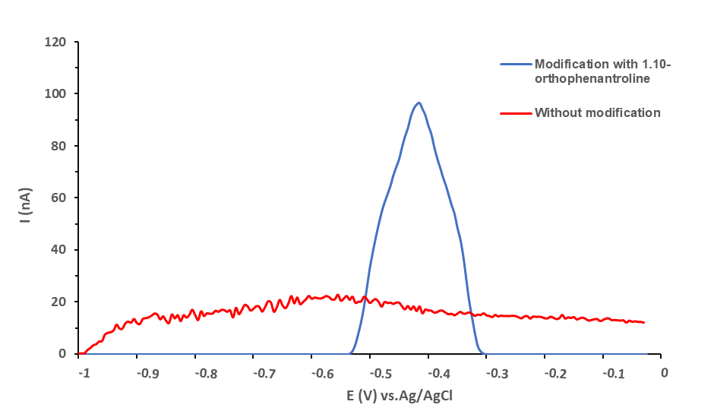

Fig 1. The difference in the voltammogram curve at the working electrode with and without 1.10-orthophenantroline modification.

Fig. 1 shows that the modified electrode of 1.10-orthophenantroline carbon paste gave a peak current response to Fe(II) solution, at a potential of -0.4550 V vs. Ag/AgCl with a current value of 94.839 nA, while an electrode without modification did not give any rise to a peak. Thus the electrode was able to censor the presence of Fe(II) ions properly.

Linearity
The linear concentration area of the modified carbon paste electrode was studied to determine the area (range) of concentration which provided a linear relationship between the height of the peak current and the concentration of Fe(II) (10⁻⁷ – 10⁻¹¹ M). The corresponding voltammograms are shown in Fig.2.
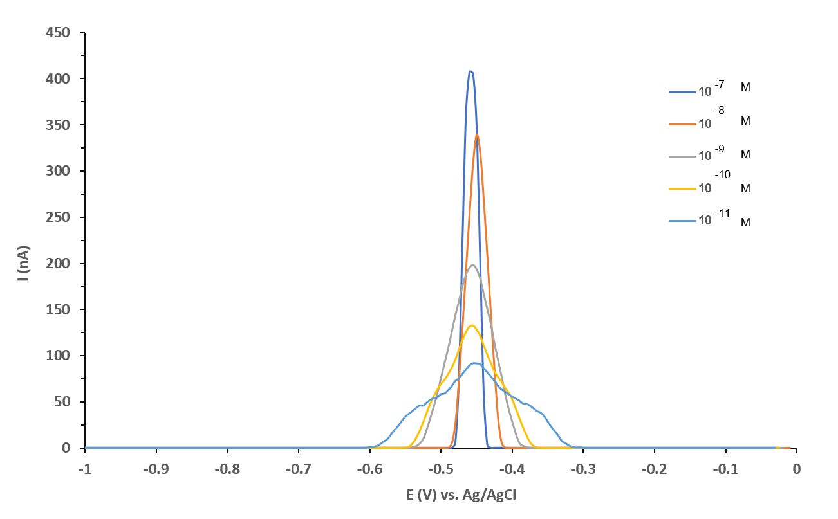

Fig 2. The voltammogram curve of the modified working electrode at various concentrations.
Based on Fig. 2, it appears that the presence of Fe(II) ions at various concentrations can be censored by the electrode properly. The greater the concentration of Fe(II) ions, the higher the voltammogram. The standard potential value of Fe metal is -0.44 Volt [22]. Should in research the difference in concentration does not affect the potential. The results showed a shift in the potential value, because the standard potential determination used pure Fe metal, while in this study used a modified 1.10-orthophenanthroline solid membrane electrode and formed a complex, thereby affecting the potential value.
If the voltamogram in Fig. 2 created a relationship between the concentration and the measurement current value, a linear graph would be formed. The relationship between the concentration and the current is listed in table 1.

Table 1. The measurement result of the Fe(II) current at various concentrations

Concentration (M) | Current (nA)
1.0 x 10⁻⁷ | 408.735
1.0 x 10⁻⁸ | 339.427
1.0 x 10⁻⁹ | 198.210
1.0 x 10⁻¹⁰ | 132.870
1.0 x 10⁻¹¹ | 91.712

Based on Table 1, a curve was made between the concentration of Fe(II) solution and the height of the peak current produced. The result is shown in Fig. 3.

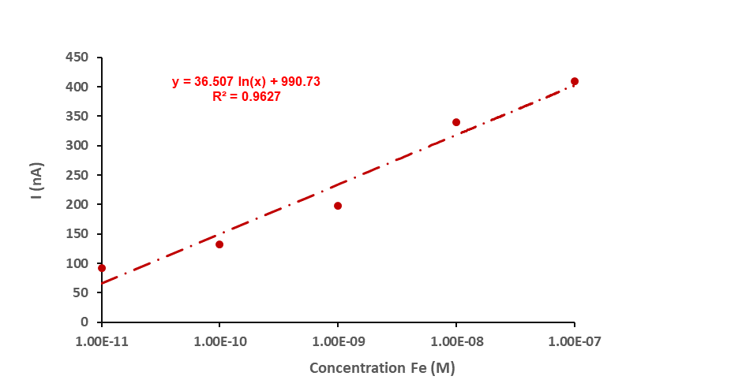
Fig 3. The relationship between the concentration of Fe(II) solution and the high current

Based on the results of this study, it can be seen that the current is comparable with the concentration. This relationship is mathematically expressed through the regression line equation which is calculated with the value, y = 36.507 ln (X) + 990.73 and the value of r = 0.9627. The linearity of the UV-Vis spectroscopy method was expressed by the line equation, y = 0.2044x - 0.0698, with the value of r = 0.9959, as seen in the calibration curve shown in Fig. 4 [21].
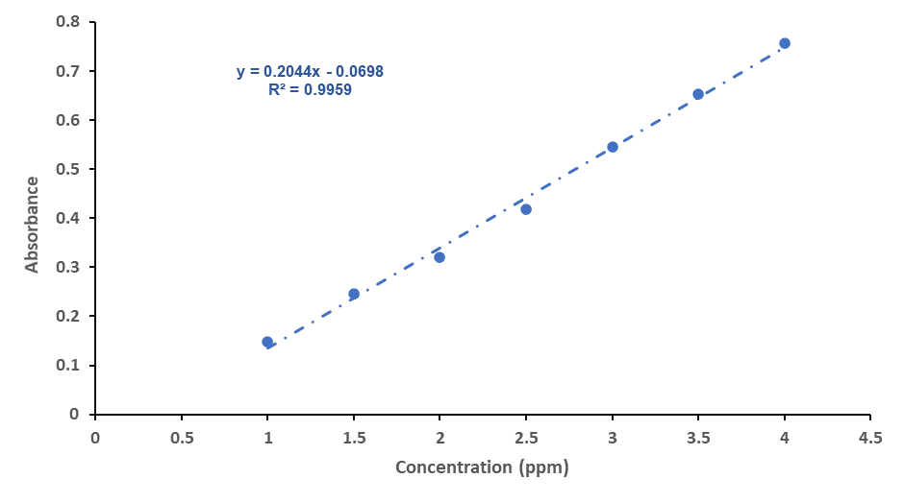

Fig 4. Iron(II) -fenantrolin calibration curve.
The results of the study show the value of r ≥ of 0.95 which indicates a linear criterion for both techniques. Thus both techniques are good methods of analysis.

Scan Rate
In differential pulse voltammetry, the height and width of the peak of the current are affected by the speed of reading [23]. The related measurement results are shown in Fig. 5.
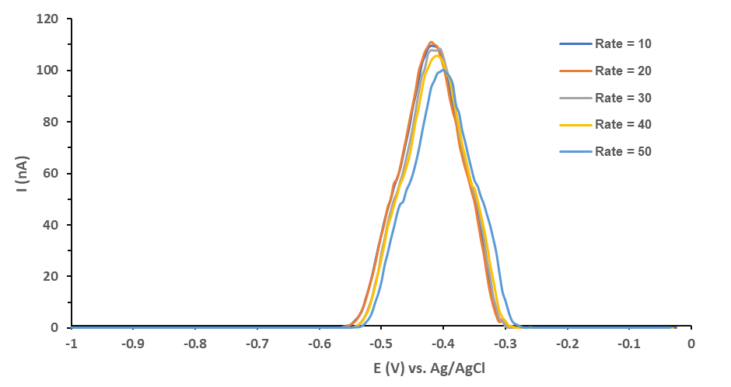
Fig 5. The effect of the difference in the adsorption rate of Fe(II) from the modified working electrode at a concentration of 1x10⁻¹¹ M and a maximum current of 200 nA.
Fig. 5. shows that the scan rate affects the peak current. The peak currents that occur at reading speeds of 10, 20, 30, 40, and 50 mV/s have different currents. In addition, at variations scan rate, there is a potential shift in each measurement, although not large, this may be due to the instability of the electric current flowing in the voltameter and kinetic limitations in the electrochemical reaction. The results of the current measurements at various scan rates can be seen in Table 2.

Table 2. The measurement result of the current at various scan rates
Scan rate (mV/s) | Current (nA)
10 | 109.411
20 | 111.028
30 | 107.554
40 | 105.678
50 | 100.185
Fig. 5 and Table 2 shows that the higher the scan rate, the smaller the current value obtained. The optimum scan rate is when the voltammogram is not widened and the peak current is high. In this study, the optimum reading scan rate was 20 mV/s. According to Yulianto and Setiarso [24], the higher the scan rate, the higher the peak current generated, because, with a high scan rate the diffusion layer that is formed will be thin, this causes the transfer of electrons around the surface of the modified solid membrane electrode to take place properly. Conversely, if the scan rate is small, the smaller the peak current generated, a small the scan rate will make the diffusion layer thicker on the electrode surface, so that it can inhibit the electron transfer process on the electrode surface. The scan rate selection refers to previous research conducted by Suyanta et al. [25].

Repeatability Results of the Elektrode
The repeatability of the modified carbon paste electrodes was studied by comparing the peak currents at optimum conditions. The measurements were carried out 5 times with one electrode under solution conditions and fixed measurements. The measurement results are shown in Fig. 6.

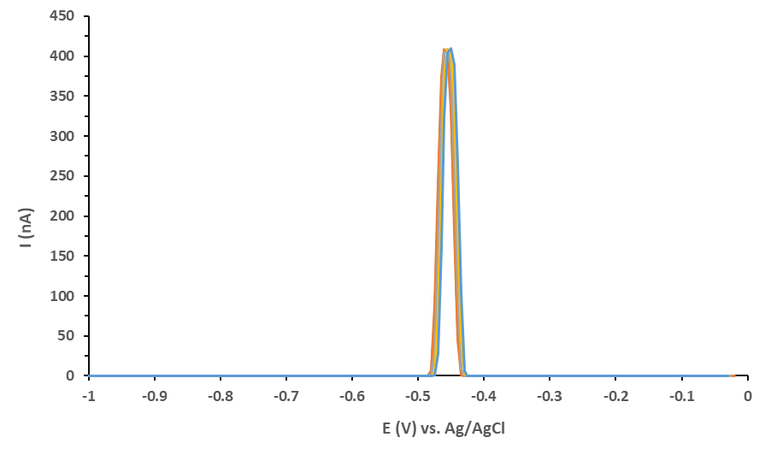
Fig 6. The voltammogram curve of the modified working electrode, measured 5 time at a concentration of 1.00 x 10⁻⁷ M.
The results of the measurements that were repeated 5 times show that the peak current was stable (constant), indicating that the modified 1.10-orthophenantroline carbon paste electrode had a good reproducible repetition. According to Silva et al. [26], the electrodes that presented good precision showed that there was no matrice effect that affected the electrodes for detection.
The measurement results show that the potential value shifts to the right, although it is not significant. This indicates a kinetic limitation in the electrochemical reaction of Fe(II) in the 1.10-orthophenanthroline modified carbon paste electrode. The complexation reaction is

2Fe²⁺(aq) + 3C12H8N2(aq) [Fe(C12H8N2)3]²⁺(aq)
or
Fe²⁺ + 3 o-Phen → [Fe(o-Phen)3]²⁺ [21]

The Measurement Result of Fe(II) in the Well Water
The 1.10-orthophenantroline modified electrode then was applied to determine the content of Fe(II) in well water. The results of the well water measurements are shown in Fig. 7.
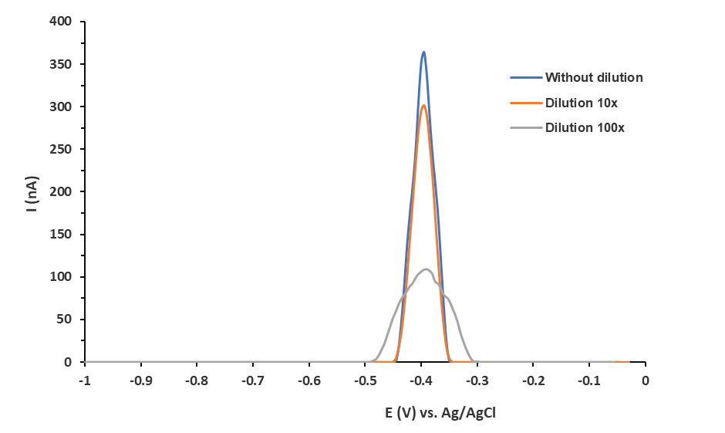
Fig 7. Voltammogram of Fe(II) content in well water

The results of the measurements of the well water samples show that the iron content in well water was very small. According to the iron voltammogram, the current which was obtained from the analysis was above 350 nA. With this current value, the concentration of Fe(II) ions in well water, if calculated according to the above regression conditions has concentration of 2.3x10⁻⁹ M.

Comparison of Validation Results
The comparison of the validation result was aimed to determine the best method of determining Fe(II), between the UV-Vis or the voltammetry spectrophotometry method. Comparison of the correlation coefficient and analytical ability for Fe(II) for the UV-Vis spectrophotometry method and the voltammetry method can be seen in Table 3.

Table 3. Comparison of the value of correlation coefficients and the ability of analysis of Fe(II) with UV-Vis spectrophotometry and voltammetry method

Metal Ion | Correlation coefficient |  | Limit detection
Metal Ion | Voltammetry method | Spectrophotometry method | Voltammetry method | Spectrophotometry method
Fe(II) | 0.9627 | 0.9959 | 1.00 x 10⁻¹¹ M | 2.36x10⁻⁵ M

The results of the study shows that the voltammetry method was better at measuring the content of Fe(II) in solution and also in the well water compared to the UV-Vis spectrophotometry method. The more sensitive method (the lower the detection limit) was demonstrate a better analysis process.

- CONCLUSION
Based on the current research, it can be concluded that the modification of the carbon paste electrodes by mixing with the modifier 1.10-orthophenantroline shows a very good peak current response to Fe(II) solution. This is proven by the low detection limit of 1.00 x 10⁻¹¹ M and regression line equation y = 36.507 ln (x) + 990.73 with r value of 0.9627, optimum rate of 20 mV/s, and stable repeatability (reproducible). In addition, the voltammetry method was found to be better than the UV-Vis spectrovotometry method for the analysis of Fe(II) in solution and in well water.

- ACKNOWLEDGMENTS

We would like to thank those who have contributed to our research, the team and the research assistants. We would also like to express gratitude to the Yogyakarta State University which was a pleasant place to conduct our research also give the budget of this research.

- AUTHOR CONTRIBUTIONS

Suyanta conducted the experiment and prepared the manuscripts. Ilyas Md. Isa provided the experiment materials. Regina Tutik Padmaningrum and Qonitah Fardiyah analyzed the data. Sunarto, Rahadian, Fredy Kurniawan, Illyas Md. Isa, and Qonitah Fardiyah revised the manuscript. Karlinda helped in carrying out the experiment. All authors agreed to the final version of this manuscript to publish in the journal.

References

[1] Pratiwi, A., Yusuf, B., and Gunawan, R., 2015, Analisis Perubahan Kadar Logam Tembaga (Cu) pada Penambahan Ion Perak (Ag) dengan Metode Elektrokoagulasi, JKM, 13 (1), 1–3.

[2] Soemirat S, J., 2018, Kesehatan Lingkungan, Revisi Edisi, Yogyakarta, Gadjah Mada University Press.
[3] Saumik Samanta, Ryan Cloete, Jean Loock, Riana Rossouw, and Alakendra N Rouchoudhury, 2021, Determination of Trace Metal (Mn, Fe, Ni, Cu, Zn, Co, Cd and Pb) Concentrations in Seawater Using Single Quadrupole ICP-MS: A Comparison between Ofﬂine and Online Preconcentration Setups, Minerals, 11, 1289.

[4] Illyas Md Isa, Mohamad Idris Saidin, Mustaffa Ahmad, Norhayati Hashim, Sazelli A. Ghani, and Suyanta M. Si., 2028, Development of New Copper(II) Ion-Selective Poly(vinyl chloride) Membrane Electrode Based on 2,6-Diacetylpyridine- (1R)-(-)-Fenchone Diazine Ligand, Int. J. Electrochem. Sci, 8, 11175 - 11185.

[5] Ganjali, M.R., Norouzi, P., Shamsolahrari, L., and Ahmadi, A., 2006, PPb Level Monitoring of Lanthanium by a Novel PCV-membrane Sensor Based on 4-methyl-2-hydrazinobenzothiazole, Sens. Actuators, B, 114 (2), 713–719.

[6] Gregory March, Tuan Dung Nguyen, and Benoit Piro, 2015, Modified Electrodes Used for Electrochemical Detection of Metal Ions in Environmental Analysis, Biosensors, 5, 241-275.

[7] Gerardo Salines and Bernardo A. Frontana-Uribe, 2022, Electrochemical Analysis of Heavy Metal Ions Using Conducting Polymer Interfaces, Electrochem, 3, 492-506.

[8] Putra, B.R., Darusman, L.K., and Rohaeti, E., 2013, Carbon Paste Electrode Hexadecyltrimethyl Ammonium Bromide Modified Natural Zeolite for Chromium(VI) Detection, Indones. J. Chem., 13 (2), 122–128.

[9] Deswati, Suyani, H., Safni, Loekman, U., and Pardi, H., 2013, Simultaneous Determination of Cadmium, Copper and Lead in Sea Water by Adsorptive Stripping Voltammetry in the Presence of Calcon as a Complexing Agent, Indones. J. Chem., 13 (3), 236–241.

[10] Thanh, N.M., Hop, N.V., Luyen, N.D., Phong, N.H., and Toan, T.T.T., 2019, Simultaneous Determination of Zn(II), Cd(II), Pb(II), and Cu(II) Using Differential Pulse Anodic Stripping Voltammetry at a Bismuth Film-modified Electrode, Adv. Mater. Sci. Eng., 2019, 1826148.

[11] Deswati, Suyani, H., and Safni, 2012, The Method Development of Analysis Cd, Cu, Pb and Zn in Sea Water by Absorptive Stripping Voltammetry (ASV) in the Presence of Calcon as Complexing Agent, Indonesia. J. Chem., 12 (1), 20–27.

[12] Evtyugin G.A. and Porfir’eva A.V., 2021, Determination of Organic Compound in Aqueous-Organic and Dispersed Media Using Electrochemical Method of Analysis, Journal of Analytical Chemistry, Vol 76, No 10, 890-905.

[13] Madrakian, T., Haghshenas, E., and Afkhami, A., 2014, Simultaneous Determination of Tyrosine, Acetaminophen and Ascorbic Acid Using Gold Nanoparticles/Multiwalled Carbon Nanotube/Glassy Carbon Electrode by Differential Pulse Voltammetric Method, Sens. Actuators, B, 193, 451–460.

[14] Nurashikin Abd Azis, Illyas Md Isa, Norhayati Hashim, Mohamad Syahrizal Ahmad, Siti Nur
Akmar Mohd Yazid, Mohamad Idris Saidin, Suyanta M.Si, Rahadian Zainul4, Alizar Ulianas,
Mawardi Mawardi, Siriboon Mukdasa, 2020, Synergistic Effect of Zinc/aluminium-layered Double Hydroxide-Carbon Nanotubes Paste Electrode in the Electrochemical Response of Dopamine, Acetaminophen, and Bisphenol A, Int. J. Electrochem. Sci., 15, 9088 – 9107.

[15] Douglas A. Skoog, F. James Holler, and Stanley R. Crouth, 2017, Principles of Instrumental Analysis, Thomson Brook/Cole, Canada.

[16] Farahi, A., Lahrich, S., Achak, M., El Gaini, L., Bakasse, M., and El Mhammedi, M.A., 2014, Parameters Affecting the Determination of Paraquat at Silver Rotating Electrodes Using Differential Pulse Voltammetry, Anal. Chem. Res., 1, 16–21.

[17] Suyanta, Sunarto, Sari, L.P., Wardani, N.I., and Isa, I.M., 2014, Differential Adsorptive Stripping Voltammetric Determination of Ultra Trace Lanthanum(III) Based on Carbon Paste Electrode Modified with 3-methyl-2-hydrazinobenzothiazole, Int. J. Electrochem. Sci., 9, 7763–7772.

[18] Mohadesi, A., Teimoori, E., Taher, M.A., and Beitollah, H., 2011, Adsorptive Stripping Voltammetric Determination of Cobalt(II) on the Carbon Paste Electrode, Int. J. Electrochem. Sci., 6, 301–308.

[19] Arancibi, V., Nagles, E., García-Beltrán, O., and Hurtad, J., 2018, Adsorptive Stripping Voltammetric Determination of Lead and Cadmium in Natural Waters in the Presence of Rutin Using a Nafion–mercury Coated Film Electrode, Int. J. Electrochem. Sci., 13, 8711–8722.

[20] Wang, H.Y., Pan, M.I., Oliver Su, Y.L., Tsai, S.C., Kao, C.H., Sun, S.S., and Lin, W.Y., 2011, Comparison of Differential Pulse Voltammetry (DPV)-A New Method of Carbamazepine Analysis with Fluorescence Polarization Immunoassay (FPIA), J. Anal. Chem., 66 (4), 415–420.

[21] Khasanah, S.R.N., and Sunarto, 2018, Perbandingan Validasi Metode Analisis Ion Besi Secara Spektrofotometri Sinar Tampak dengan Pengompleks KSCN dan 1,10-ortofenantrolin, J. Elemen. Kim., 7 (3), 105–115.

[22] Irdhawati, Suryani, R., Mbatu, T., and Sahara, E., 2018, Analisis Logam Fe Teknik Voltammetri Pelucutan Anodic Pulsa Diferensial dalam Tanaman Pakcoy dari Perkebunan Sayur; Bedugul Bali, J. Kim. Valensi, 4 (2), 168-173.

[23] Sandford, C., Edwards, M.A., Klunder, K.J., Hickey, D.P., Li, M., Barman, K., Sigman, M.S., White, H.S., and Minteer, S.D., 2019, A Synthetic Chemist’s Guide to Electroanalytical Tools for Studying Reaction Mechanism, Chem. Sci., 10 (26), 6404–6422.

[24] Yulianto, E., and Setiarso, P., 2014, Pembuatan Elektroda Pasta Karbon Termodifikasi Kitosan untuk Analisis Logam Cr(VI) dengan Ion Pengganggu Fe(II) dan Zn(II) Secara Cyclic Stripping Voltammetry. UNESA J. of Chem. (UJC), 3 (3), 60–73.

[25] Suyanta, Sunarto, Padmaningrum, R.T., Karlinda, Isa, I.Md., and Rahadian, 2021, Development of Voltammetry Analysis Method of Copper Metal Ions by Solid-state Membrane with Carbon Nanotube, Indones. J. Chem., 21 (2), 332-339.

[26] Silva, T.A., Wong, A., and Fatibello-Filho, O., 2020, Electrochemical Sensor Based on Ionic Liquid and Carbon Black for Voltammetric Determination of Allura red Colorant at Nanomolar Levels in Soft Drink Powders, Talanta, 209, 120588.

