Supplementary Information

##### The Dependence of Boron Concentration in Diamond Electrode for Ciprofloxacin Electrochemical Sensor Application

Ilmi Nur Indriani Savitri1, Prastika Krisma Jiwanti2,*, Ilmanda Zalzabhila Danistya Putri1, Irkham3, Yasuaki Einaga4, Ganden Supriyanto1, Yew Hoong Wong5,6, Sachin Kumar Srivastava7, Che Azurahanim Che Abdullah8

1Department of Chemistry, Faculty of Science and Technology, Universitas Airlangga, Surabaya 60115, Indonesia

2Nanotechnology Engineering, Faculty of Advanced Technology and Multidiscipline, Universitas Airlangga, Surabaya 60115, Indonesia

3Department of Chemistry, Faculty of Mathematics and Natural Sciences, Universitas Padjadjaran, Sumedang 45363, Indonesia

4Department of Chemistry, Keio University, 3-14-1 Hiyoshi, Yokohama 223-8522, Japan

5Department of Mechanical Engineering, Faculty of Engineering, Universiti Malaya, Kuala Lumpur 50603, Malaysia

6Centre of Advanced Materials, Faculty of Engineering, Universiti Malaya, Kuala Lumpur 50603, Malaysia

7Department of Physics, Indian Institute of Technology Roorkee, Roorkee, Haridwar, Uttarakhand 247667, India

8Department of Physics, Faculty of Science, Universiti Putra Malaysia (UPM), Serdang 43400, Malaysia

* Corresponding author, email: [prastika.krisma@ftmm.unair.ac.id](mailto:prastika.krisma@ftmm.unair.ac.id)

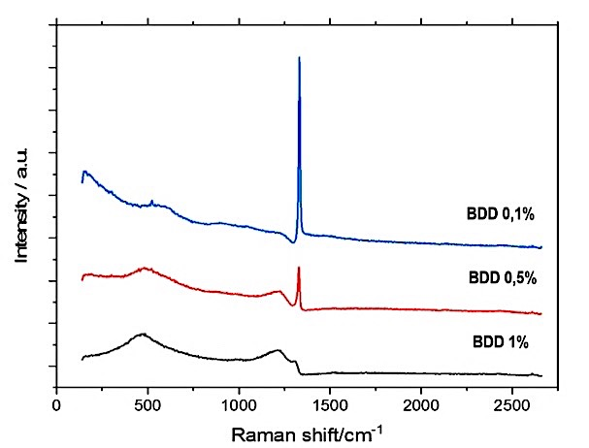

**Fig S1.** Raman spectra of BDD electrodes with a boron concentration of 0.1%, 0.5%, and 1%

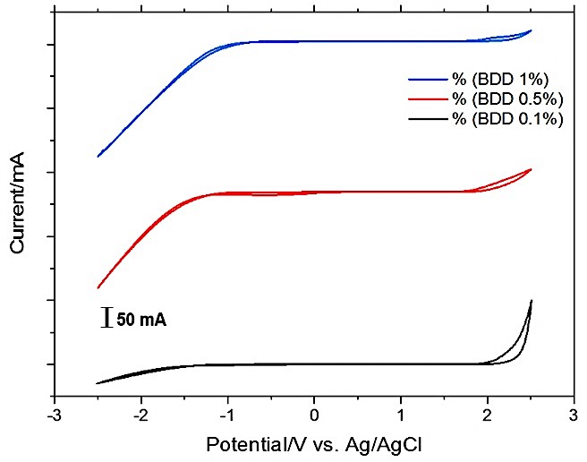

**Fig S2.** CV curves of the BDD electrodes with a boron concentration of 1% (blue), 0.5% (red), and 0.1% (black), with potentials rangingfrom -2.5 to 2.5 V in an aqueous solution of 0.1 M H2SO4 at a scan rate of 100 mV.s-1