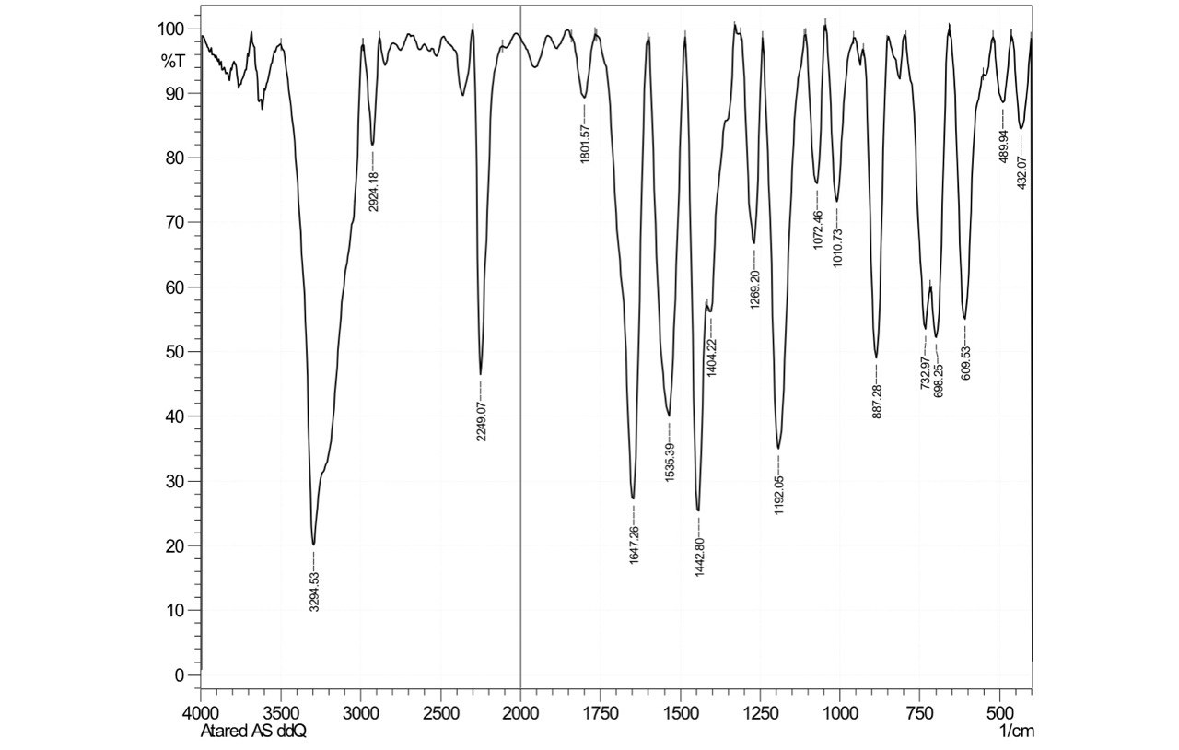

Figure 1. Infra-Red spectrum of compound I

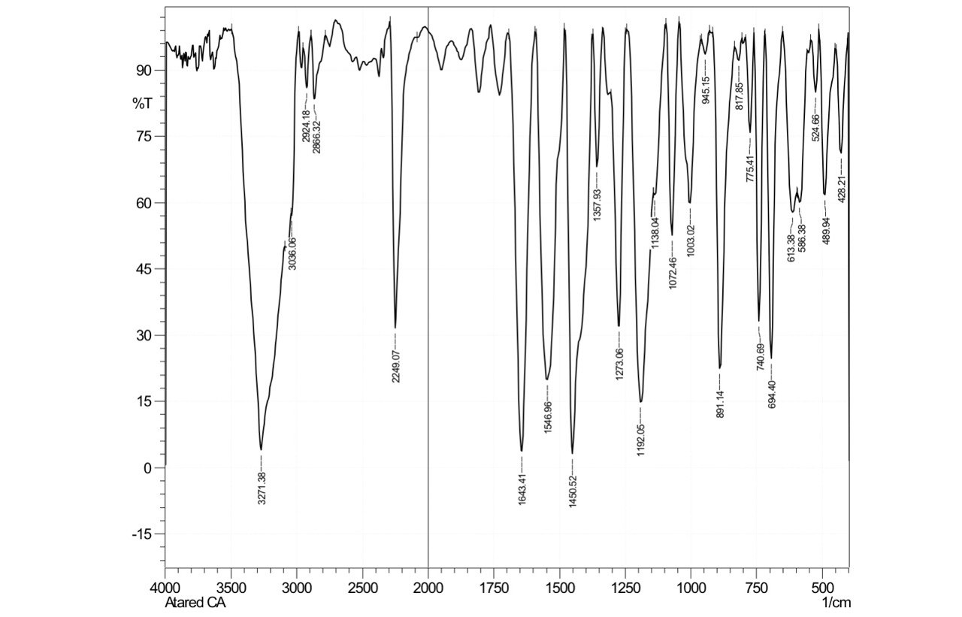

Figure 2. Infra-Red spectrum of compound II

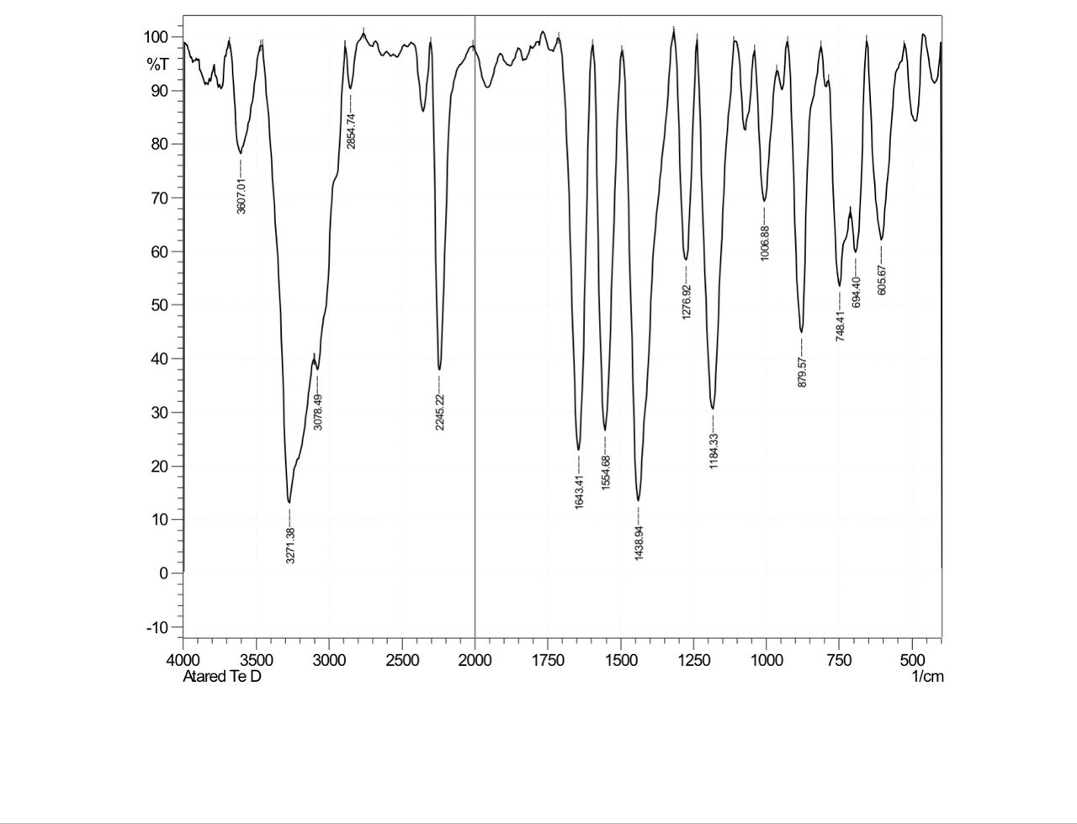

Figure 3. Infra-Red spectrum of compound III

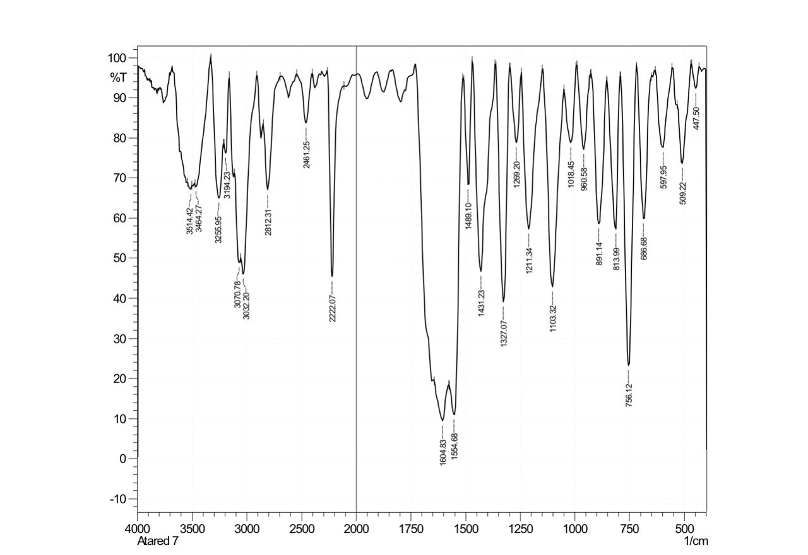

Figure 4. Infra-Red spectrum of compound IV

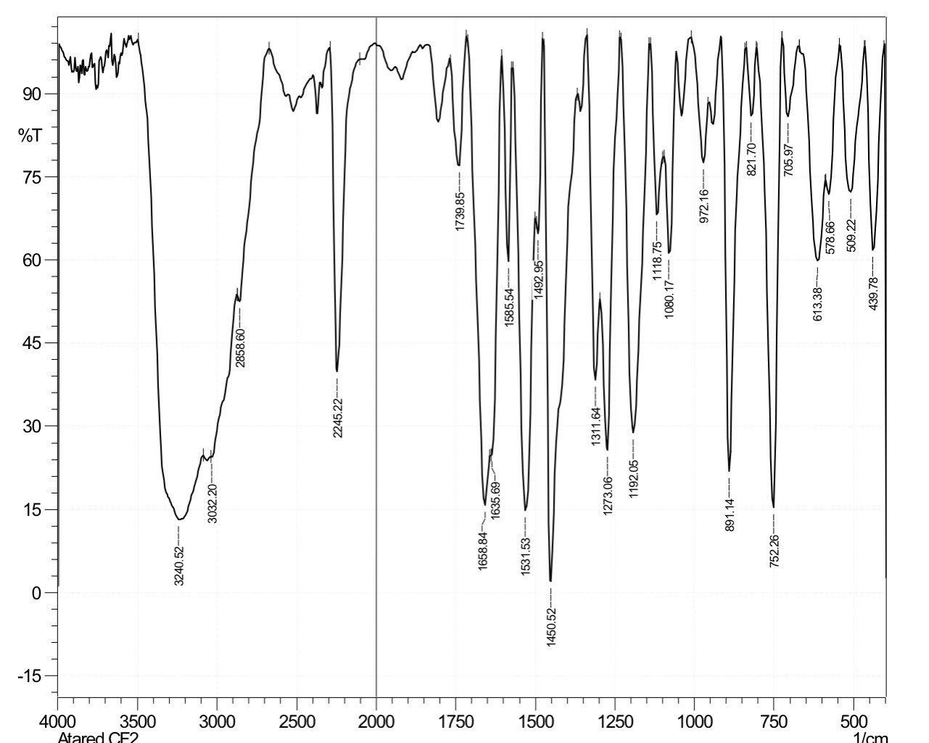

Figure 5. Infra-Red spectrum of compound V

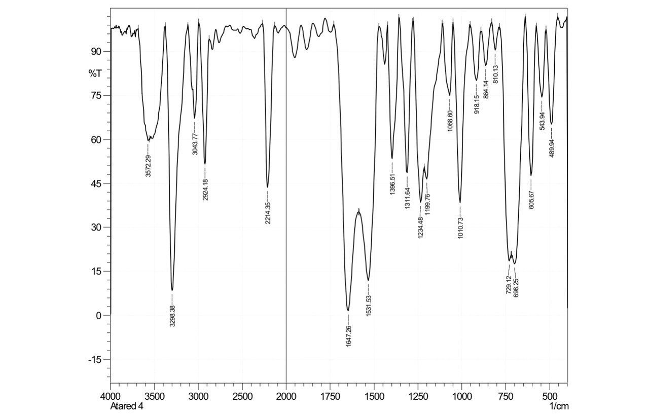

Figure 6. Infra-Red spectrum of compound VI

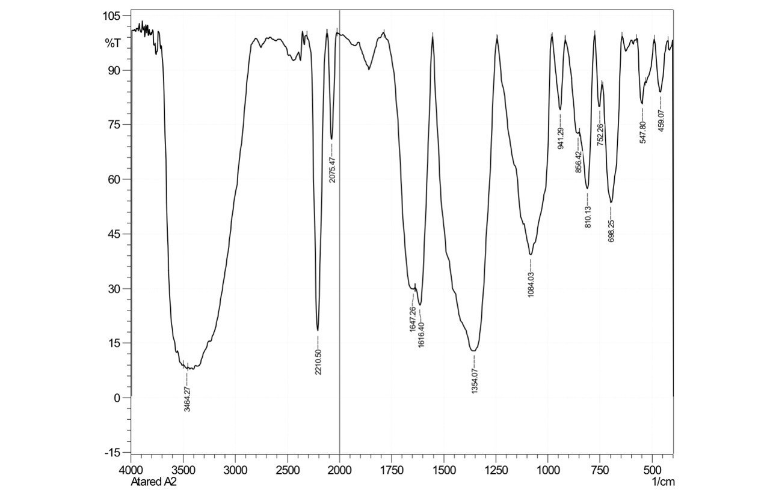

Figure 7. Infra-Red spectrum of compound VII

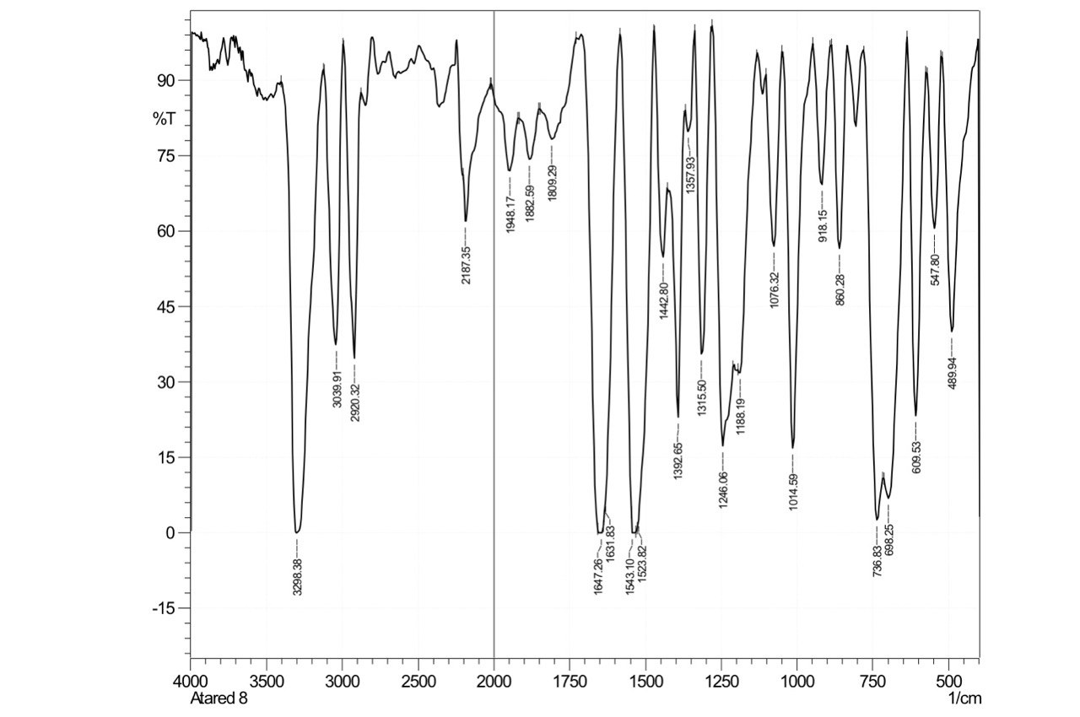

Figure 8. Infra-Red spectrum of compound VIII



-a-



-b-



-c-

Figure 9. The UV-Visible spectra for a- CT complexes (I-V), b- CT complexes

(VI_VII) , c- CT complex VIII.



Figure 10. 1H NMR spectrum of compound I



Figure 11. 1H NMR spectrum of compound II



Figure 12. 1H NMR spectrum of compound III



Figure 13. 1H NMR spectrum of compound IV



Figure 14. 1H NMR spectrum of compound V



Figure 15. 1H NMR spectrum of compound VI



Figure 16. 1H NMR spectrum of compound VII



Figure 17. 13C NMR spectrum of compound I



Figure 18. 13C NMR spectrum of compound II



Figure 19. 13C NMR spectrum of compound III



Figure 20. 13C NMR spectrum of compound IV



Figure 21. 13C NMR spectrum of compound V



Figure 22. 13C NMR spectrum of compound VI

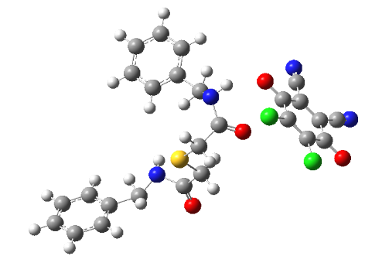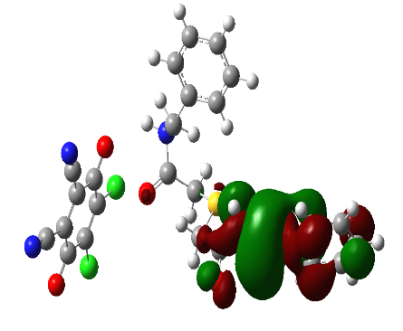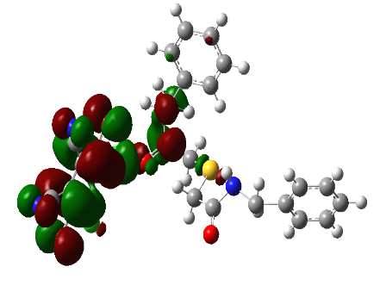

Figure 23. Molecular structure and molecular orbitals (HOMO) and (LUMO) of compound I

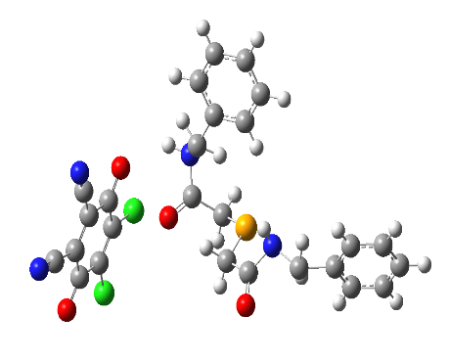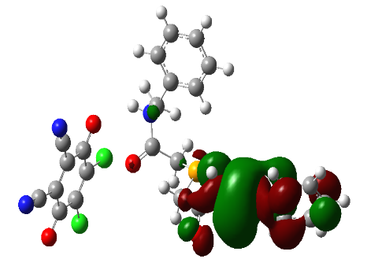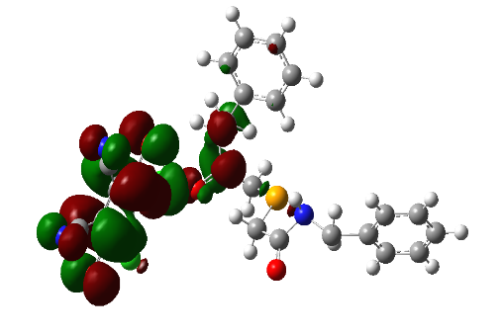

Figure 24. Molecular structure and molecular orbitals (HOMO) and (LUMO) of compound II

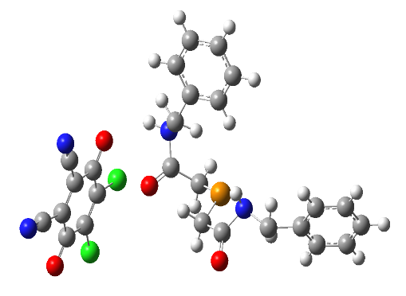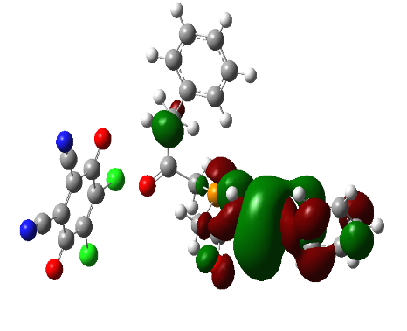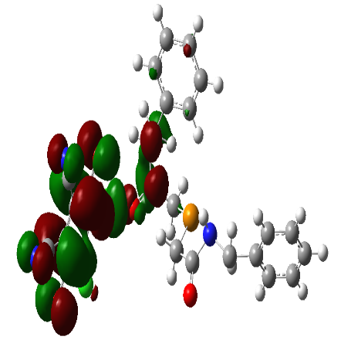

Figure 25. Molecular structure and molecular orbitals (HOMO) and (LUMO) of compound III

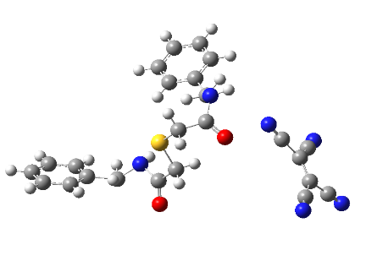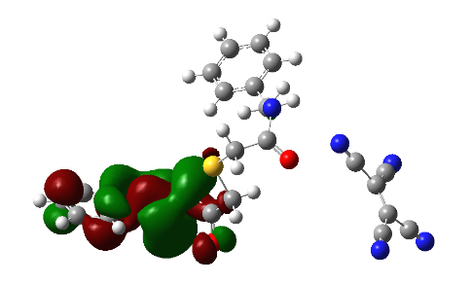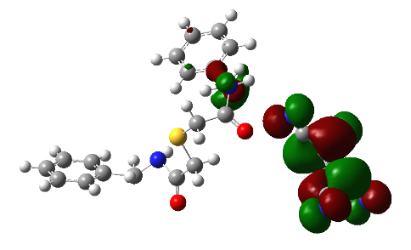

Figure 26. Molecular structure and molecular orbitals (HOMO) and (LUMO) of compound VI

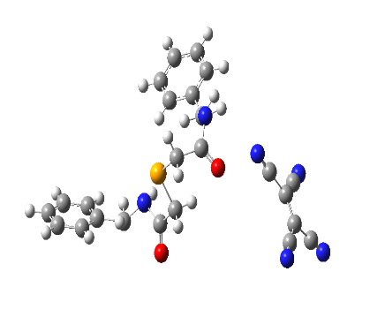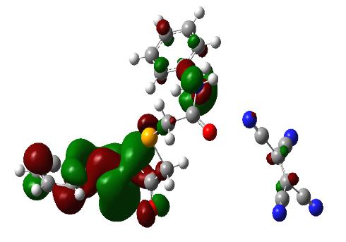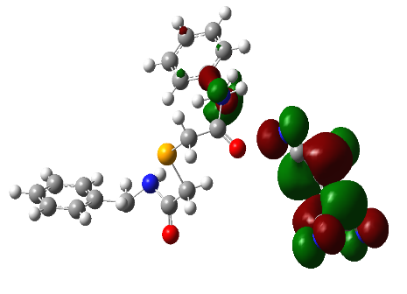

Figure 27. Molecular structure and molecular orbitals (HOMO) and (LUMO) of compound VII

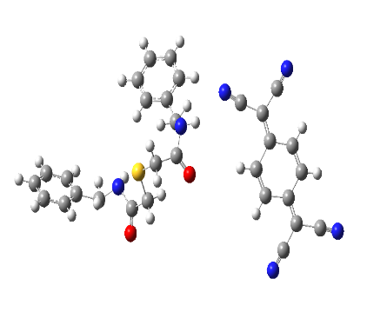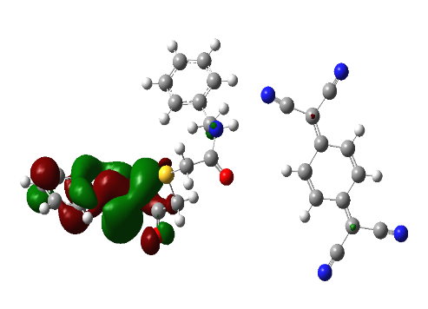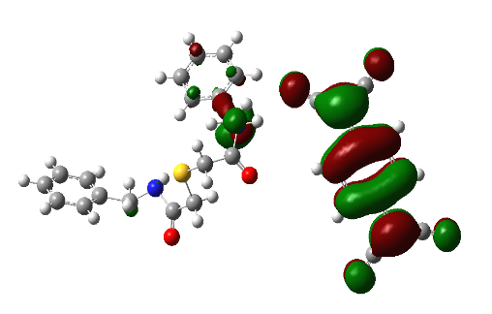

Figure 28. Molecular structure and molecular orbitals (HOMO) and (LUMO) of compound VIII

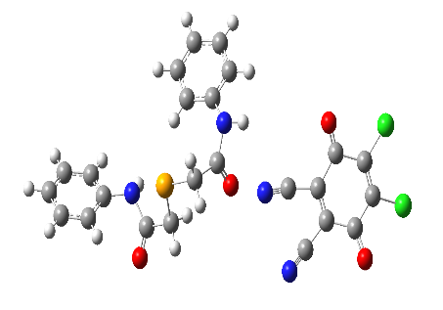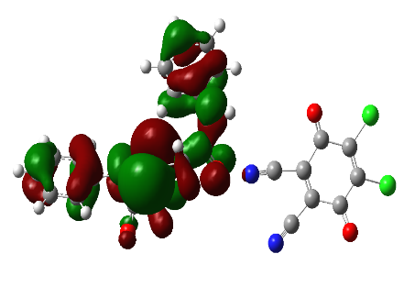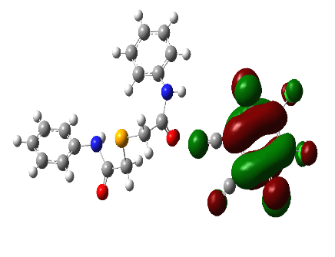

Figure 29. Molecular structure and molecular orbitals (HOMO) and (LUMO) of compound IV

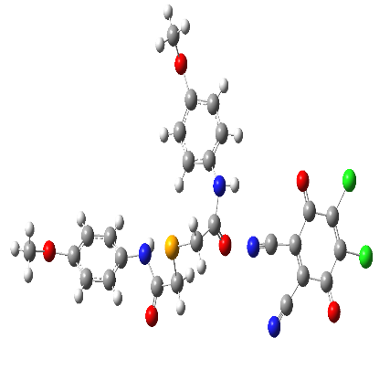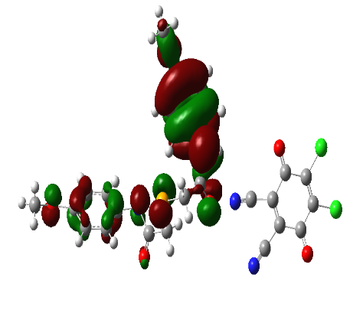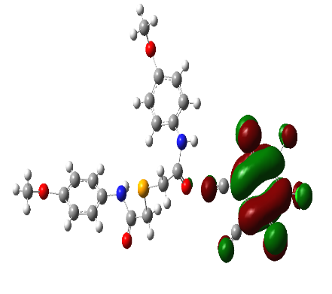

Figure 30. Molecular structure and molecular orbitals (HOMO) and (LUMO) of compound V