Supplementary File
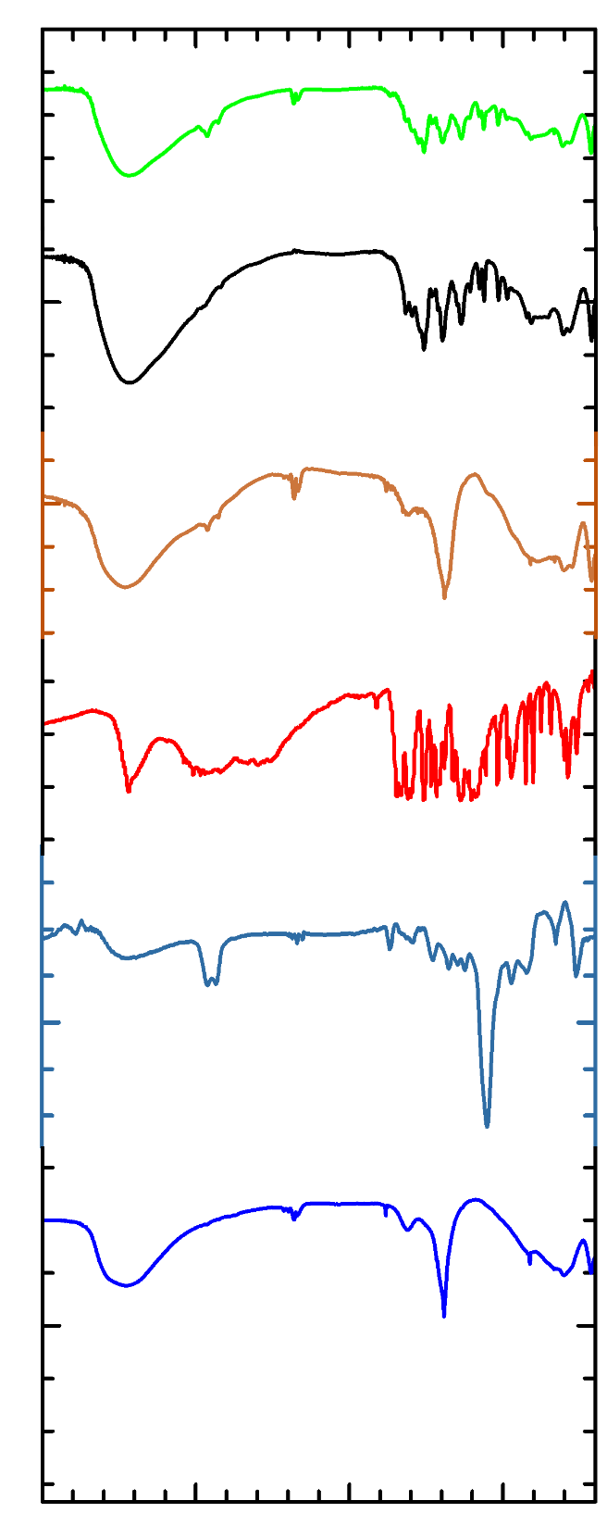
LDH-FA-T80

LDH-FA

LDH-T80

FA

Tween-80

LDH

430
600
1633
1385
3450
Wavenumber/cm⁻¹
4000
3000
2000
1000
1098
1738
2862
2925
3400
1428
1595
1665
1692
3430
2852
2926
3469
1106
1032
2855
2925
3455
1597
1400
1522
1467
3438
1274
821
1218
853
1234
689
806
853
752
1269
Fig S1. FTIR spectra of LDH, Tween-80, FA, LDH-T80, LDH-FA and LDH-FA-T80 nanocomposites

