Potential of Normalized Difference Vegetation Index in Estimating Soft Clay Area in the Paddy Field Environment

Abstract Mapping of soft clay area in the paddy field environment needed fast and current information on the soft clay location and spatial data in order to arrange the best way to recovery the soil. However, in situ soft clay area observation was expensive and labor intensive. Remote sensing based vegetation index had the potential for rapidly estimating soft clay area over large area. This study examined the use of Normalized Difference Vegetation Index (NDVI) to estimate soft clay areas in the paddy cultivation area of Kedah, Malaysia. Ground-based data were collected from the study area during fieldwork activity and NDVI index produced from Landsat 8 data. Kappa statistic analysis showed that the NDVI in the period of before paddy planting had the highest accuracy values with the overall classification accuracy (85%) and kappa coefficient (0.84). Total area of the soft clay from the highest was showed in the period of before paddy planting (1.856,97 ha) followed by after paddy planting (656,73 ha) and harvest (401.85 ha) periods, respectively. As whole, the study concluded that NDVI was a good indicator of soft clay area estimation in paddy cultivation areas.

Key words: Normalized Difference Vegetation Index, Paddy cultivation, Remote sensing, Soft clay

Abstrak Pemetaan lahan tanah jerlus di lingkungan persawahan padi membutuhkan informasi yang cepat dan terkini mengenai lokasi tanah jerlus dan data ruang dalam penyusunan langkah terbaik untuk memulihkan masalah tanah jerlus. Tetapi, peninjauan tanah jerlus secara in situ adalah mahal dan membutuhkan banyak tenaga kerja. Penginderaan jauh melalui indeks tumbuhan mempunyai potensi untuk memperkirakan lahan tanah jerlus pada lahan yang luas dengan cepat. Penelitian ini menguji penggunaan indeks “Normalized Difference Vegetation Index (NDVI)” untuk memperkirakan lahan tanah jerlus pada daerah penanaman padi di Kedah, Malaysia. Data lapangan dikumpulkan dari lokasi penelitian sewaktu aktivitas kerja lapangan dan indeks NDVI dihasilkan daripada data Landsat 8. Analisis Statistik Kappa menunjukkan bahwa NDVI pada periode sebelum penanaman padi mempunyai nilai ketepatan tertinggi dengan nilai ketepatan keseluruhan (85%) dan nlai koefisien Kappa (0,84). Jumlah keluasan lahan tanah jerlus daripada yang tertinggi ditunjukkan oleh periode sebelum penanaman padi (1.856,97 ha), diikuti oleh periode setelah penanaman padi (656,73 ha) dan periode panen (401.85 ha), secara berurutan. Secara keseluruhan, penelitian ini menyimpulkan bahwa NDVI ialah petunjuk baik untuk perkiraan lahan tanah jerlus di daerah penanaman padi.

Kata kunci : Normalized Difference Vegetation Index, Penanaman padi, Penginderaan jauh, Tanah jerlus

1. Introduction
Soft clay was infertile soil and affected rice production. In Kedah, Malaysia, 8.107 ha of total paddy field areas could not be harvested due to this problem (New Strait Time 2013). Because of this, the rice production in this country has decreased. Soft clay area was characterized with bare area and sometimes patches of water around paddy field area. Water body or bare area was features in the paddy environment that could been identified as the link with soft clay area. However, to obtain accurate ground-based observations of soft clay area over large regions were difficult, labor intensive, expensive and time consuming. This difficulty in obtaining large scale land cover data through traditional ground-based sampling networks, thus it had led to several studies investigated at the application of remote sensing technique for large scale land assessments (Jamali et al. 2011; Shafian & Maas 2015). In the current study, the remote sensing technique was applied for the mapping soft clay area in large scale.
Satellite imagery captured land cover area which was affected by soil or vegetation characteristics. This was the basis of using remote sensing to estimate the land cover in various studies. Results from many studies also showed the great capacity of spectral bands derived vegetation indices in monitoring both soil surface and vegetation. Over the years, vegetation indices had been used in estimating the land cover response to its spatial and temporal variations (Mallick et al. 2009; Holzman et al. 2014). Recently, there was limited work done to study the applicability of Landsat 8-based Normalized Difference Vegetation Index (NDVI) in estimating soft clay area at different paddy cultivation periods. The main objective of this study was to investigate the potential Normalized Difference Vegetation Index (NDVI) in estimating soft clay area in the paddy environment. Specifically, this study aimed to use ground-based soft clay data to evaluate the derived Landsat 8 Normalized Different Vegetation Index (NDVI) in the estimation of soft clay area at different paddy cultivation periods and tested the accuracy of the study using kappa statistic. Findings from this study were expected to give further our understanding and applicability of remote sensing technique in the estimation of spatial and temporal variations of soft clay area.

2. The Methods
Study area
Study area was located in MADA paddy cultivation area (Region-III), Kedah, Malaysia (Fig. 1). It consisted of three regions namely B-III Region (6°6'00.00"N and 100°27'00.00"E), C-III Region (6°3'00.00"N and 100°24'00.00"E) and D-III Region (6°3'00.00"N and 100°30'00.00"E). The total area of study was about 16.284,60 ha. This area had been experiencing low rice yield, with an average production of < 2 ha-1 season-1 due to the soft clay problem. Soft clay was characterized with high compressibility and low strength. The low soil strength value lead to decline ground pressure capability of agricultural machines.
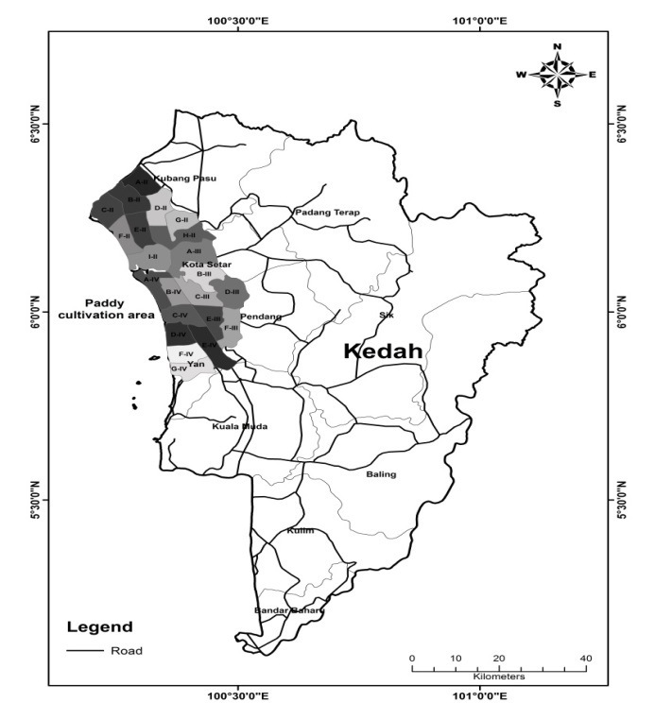
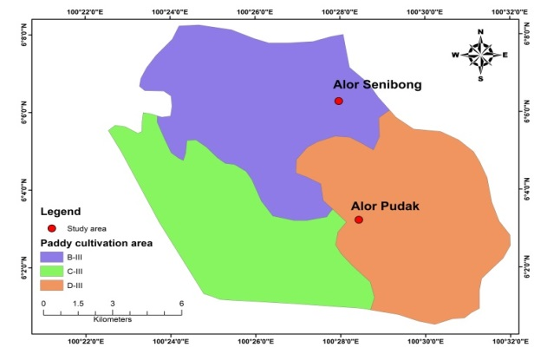

Figure 1. Location of study area
Satellite data
Landsat 8 Operational Land Imager (OLI) satellite data was downloaded from the USGS Earth Explorer website. Landsat 8 OLI & Thermal Infrared Sensor (TIRS) consisted of nine spectral bands with a spatial resolution of 30 meters for bands 1 to 7 and 9, 15 meters for panchromatic band 8 and 100 meters for thermal bands 10 and 11. In this study, satellite data was used in three difference periods of the paddy cultivation such as before paddy planting (30/10/2016), after paddy planting (17/12/2016) and harvest (17/02/2017) periods. This was done to compare and obtain the best result for estimating soft clay areas in the study area.

Atmospheric correction
Atmospheric correction was a process for minimizing negative effects on satellite images before they could be used for the land cover analysis such as fog, dust, tiny particle and others disturbances on the atmosphere. It consisted of two main processes: (i) top of Atmosphere (TOA) reflectance and (ii) TOA reflectance with sun angle correction. Top of Atmosphere (TOA) reflectance was a conversion of the digital number (DN) from radiance to reflectance values. In the current study, atmospheric correction was calculated using the formula from USGS (U.S. Geological Survey) in equation 1.
R_{l'} = M_{l}Q_{cal} + A_{r} (1)
Where:
R_{l'} = TOA reflectance without sun angle correction,
M_{l} = Parameter “REFLECTANCE_MULT_BAND_x” in metadata file.
Q_{cal} = Standardized pixel number.
A_{r} = Parameter “REFLECTANCE_MULT_BAND_x” in metadata file.
R_{l} = R_{l'} / cos(sun zenith angle) or R_{l} = R_{l'} / sin(sun elevation angle)
R_{l} = TOA reflectance, R_{l'} = TOA reflectance without correction.
Sun elevation angle = Parameter “SUN_ELEVATION” in metadata file.
Sun zenith angle = 90 - Sun elevation angle.

Normalized difference vegetation index (NDVI)
Satellite images were downloaded in several periods of paddy cultivation such as before paddy planting, after paddy planting and harvest period of 2016-2017 year. In the most of studies, normalized difference vegetation index (NDVI) had been used to studied canopy growth and fertility of plants (Gopalapillai & Tian 1999). The near-infrared band from NDVI index was a sensitive in the alteration of chlorophyll content thus it could be used to determine each of land cover in a certain area accurately. In the current study, the capability of NDVI index for assessing land cover was a very useful for determination of soft clay features in study area in a faster way. Because of the soft clay had unique characteristics such as bare area or water body around paddy field areas. This would made it became measureable using NDVI index. NDVI was calculated for each of satellite image using the near-infrared band 5 and red band 4 from spectral bands of Landsat 8 images as shown in equation 2. NDVI values ranged from -1 to 1. For the dense canopy or vegetation area, NDVI value showed the value near 1, while for bare area or water body showed the value near -1. NDVI values were classified in accordance the classification from Rouse et al. (1974). GIS analysis was used to extract NDVI values corresponding to the selected soft clay points located in study area and to pair them with the corresponding ground-based soft clay data which obtained in the field. Overall of GIS analysis was done using ArcGIS software Ver. 10.
NDVI = (NIR (band 5) – Red (band 4)) / (NIR (band 5) + Red (band 4)) (2)

Accuracy assessment
Sampling activity was conducted to obtain ground-based data of soft clay locations in the study area. Total of 31 coordinates had been successfully recorded using DGPS Trimble Geo XM. This was used for validating NDVI maps which had been produced using GIS. Kappa statistic was applied in this study for the accuracy assessment. Kappa statistic formula has been shown in equation 3 which referred from Jensen (1996).
(Total x Sum of correct) - Sum of the all the (Row total x Column total)
(Total squared - Sum of the all the (Row total x Column total)

k =
(3)

Where:
k = Kappa coefficient

3. Result and Discussion
Normalized difference vegetation index (NDVI) classification: According to the map in Figure 2, the NDVI value ranged from 0 to 0,9. The value of less than 0,2 showed water body or bare area. While, for values 0,2-0,4, 0,4-0,6 and 0,6-0,9 showed sparse vegetation, moderate vegetation and dense vegetation, respectively. In the current study, soft clay areas were exhibited with the value less than 0,2. This was because in the real condition, soft clay areas were characterized with patches of water in paddy field which did not have paddy grew in the surface of soil. Thus, the soft clay value can be predicted to have a similar value with water body and bare area. This low value was presented in the map with blue color. Bambang and Ahmad (2014) explained water body or bare area had a lower NDVI value than vegetation area. Chlorophyll affected the NDVI value. This was because the chlorophyll absorbed more sun light in the visible spectrum, especially in red spectrum. GIS analysis obtained total of soft clay area in the period of harvest (401.85 ha) was a slightly lower than the period of after paddy planting (656,73 ha) and before paddy planting (1.856,97 ha) (Table 1). This decrease was because in the period of after paddy planting, the most of soft clay areas were covered with water from irrigation. While, in the period of harvest and before planting, paddy fields were in drying condition thus it increased the number of reflectance of soft clay area which received by satellite.
There was a great change at dense vegetation class (NDVI 0,6-0,9) after paddy planting period, it represented with increasing total area of the class (8,881.65 ha). This showed paddy plants have grown with high density thus it raised NDVI value. This result was consistent with the finding of Ajith et al. (2017) who found the NDVI value in paddy field area during the growing season was around 0,81. For the harvest period, the sparse vegetation class (NDVI 0,2-0,4) was a predominant in study area. It covered approximately of 48% of the total area. Mosleh and Hassan (2014) noted the NDVI value of the paddy field in Bangladeshi during harvest season was around 0.45. This value was a slightly higher than the current study. Several aspects such as location of area and species of paddy affected the NDVI value. The variation of paddy species could reflect distinct chlorophyll and NDVI values.

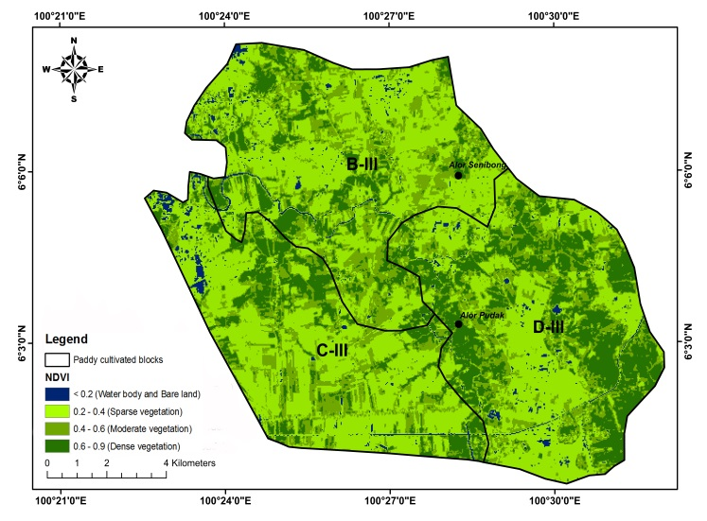
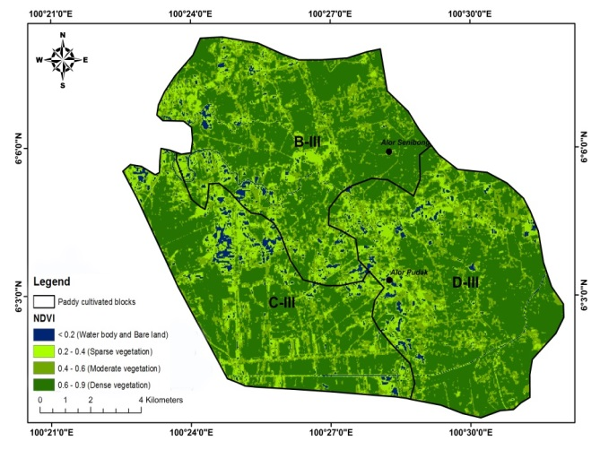
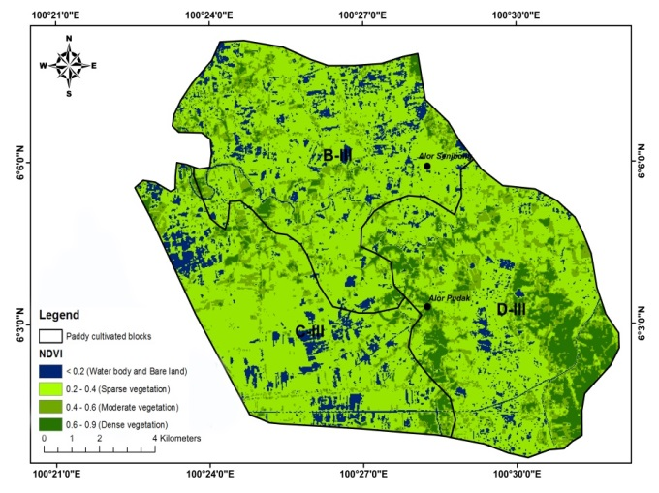

Figure 2. NDVI for the study area in the period of before paddy planting (a), after paddy planting (b) and harvest (c)

Table 1. The total area of NDVI class in three periods of paddy planting
NDVI Class | Period of paddy planting
NDVI Class | Before planting (ha) | After planting  (ha) | Harvest  (ha)
Water body or bare area  (< 0.2) | 1,856.97 | 656,73 | 401,85
Sparse vegetation  (0,2 - 0,4) | 10,480.23 | 2,487.24 | 7,870.23
Moderate vegetation  (0,4 - 0.6) | 2,512.26 | 4,258.98 | 4,523.58
Dense vegetation  (0,6 - 0,9) | 1,435.14 | 8,881.65 | 3,488.94

Accuracy assessment
The accuracy assessment of this study was analyzed by using kappa statistic (Table 2). Kappa statistic was measured with kappa coefficient (k) which generally ranged from 0 to 1, the zero value for the lowest accuracy value while one value showed the highest accuracy. In the current study, the highest accuracy value was showed in the period of before paddy planting with the overall classification accuracy (85%) and kappa coefficient (0,84). The accuracy value generally depended on the spectral reflectance of the land cover (Kamaruzaman et al. 2009). Result of study revealed the spectral reflectance of soft clay area was in the NDVI range of 0 - 0,2. According to Rouse et al. (1974), this range was classified as the water body or bare area. Soft clay could be studied more accurate in the period of before paddy planting as compared with others two periods. This was because soft clay areas would be more detected when paddy fields were in dried condition.
Soft clay areas commonly appeared with bare spots around the paddy field which consisted of patches of water. In the period of after paddy planting, the most of soft clay areas were covered with water due to paddy fields were drained for the paddy growth. Because of this condition, soft clay areas were not able to be identified by the multispectral satellite. While, in the harvest period, soft clay areas were completely dried thus the satellite could not differ soft clay area and others dried areas. As whole, for the best accuracy, this study recommended the determination of soft clay area was conducted in the first period or before paddy planting.

Table 2. The overall classification accuracy, kappa accuracy and kappa coefficient for NDVI index
Index | Period | Overall classification accuracy (%) | Kappa accuracy  (%) | Kappa coefficient  (k)
NDVI | Before paddy planting | 85,00 | 83,67 | 0,84
 | After paddy planting | 15,00 | 9,53 | 0,10
 | Harvest | 51,25 | 49,23 | 0,49
4. Conclusion
Result of study concluded that the NDVI index had a potential for mapping soft clay area in the study area. The best estimation of NDVI index for mapping soft clay area was showed in the period of before paddy planting with the overall classification accuracy (85%) and kappa coefficient (0,84). Total area of the soft clay from the highest was showed in the period of before paddy planting (1.856,97 ha) followed by after paddy planting (656,73 ha) and harvest (401.85 ha) periods, respectively. The identification of soft clay area affected by the spectral reflectance of land cover. Soft clay areas would be more detected when paddy fields were in dried condition. Soft clay areas were characterized with the waterlogged condition and patches of water around the paddy field area, thus it would made them to be detectable through the NDVI analysis.

Acknowledgements
Authors wished to thank Universiti Kebangsaan Malaysia (UKM) and the Faculty of Science and Technology for providing the infrastructure to ensure the success of this research. This research was conducted with UKM research grant ETP-2015-003. The study was conducted in MADA region in collaboration with MADA and Green Frontier Technology Sdn Bhd.

References
Ajith, K., Geethalakshmi, V., Ragunath, K. P., Pazhanivelan, S. & Dheebakaran, G. (2017). Rice yield prediction using MODIS - NDVI (MOD13Q1) and land based observations. Int. J. Curr. Microbiol. App. Sci Vol. 6(12). pp. 2277-2293.
Bambang R. & Ahmad, B. S. (2017). Identification of paddy field using Landsat image in Karawang Regency, West Java. IOP Conf. Series: Earth and Environmental Science. Vol. 54(1). pp. 1-8.
GopalaPillai, S. & Tian, L. (1999). In-field variability detection and yield prediction in corn using digital aerial imaging. Trans. ASAE. 42. pp. 1911-1920.
Holzman, M. E., Rivas, R. & Bayala, M. (2014). Subsurface soil moisture estimation by VI-LST method. IEEE Geosci Remote Sens Lett. Vol. 11. pp. 1951-1955.
Jamali, S., Seaquist, J. W., Ardo, J. & Eklundh, L. (2011). Investigating temporal relationships between rainfall, soil moisture and MODIS-derived NDVI and EVI for six sites in Africa. Savanna. Vol. 21. pp. 547-553.
Jensen, J. R. (1996). Introductory digital image processing: a remote sensing perspective (2nd ed.). New York: Prentice hall, Inc., Upper saddle river, N.J.
Kamaruzaman, J., Hasmadi, M. I. & Nurul, H. M. A. (2009). Spectral separability of tropical forest tree species using airborne hyperspectral imager. J. of Environmental Science & Engineering. Vol. 3(1). pp. 37-41.
Mallick, K., Battacharya, B. K. & Patel, N. K. (2009). Estimating volumetric surface moisture content for cropped soils using a soil wetness index based on surface temperature and NDVI. Agr Forest Meteorol. Vol. 149. pp. 1327-1342.
Mosleh, M. K. & Hassan, Q. K. (2014). Development of a remote sensing-based “Boro” rice mapping system. Remote Sens. Vol. 6(3). pp. 1938-1953.
New Straits time. (2013). online (www.nst.com.my), Berita Jun 2013.
Rouse, J. W., Haas, R. H., Schell, J. A. & Deering, D. W. (1974). Monitoring vegetation systems in the great plains with erts. In Proceedings of Third ERTS Symposium. pp. 309-317.
Shafian, S. & Maas, S. J. (2015) Index of soil moisture using raw Landsat image digital count data in Texas High Plains. Remote Sens. Vol. 7. pp. 2352-2372.

