

Publisher
Faculty of Geography, Universitas Gadjah Mada
Bulaksumur, Yogyakarta, Indonesia 55281
Email: ijg@ugm.ac.id Web: https://jurnal.ugm.ac.id/ijg

Statement of Originality and conflict of interest declaration

Title of the manuscript : Greenhouse Gas Pollution Based on Energy Use and Its Mitigation Potential in the City of Surakarta, Indonesia

Authors : Prabang Setyono, Widhi Himawan, Cynthia Permata Sari, Totok Gunawan,
Sigit Heru Murti

As the corresponding author I certify that this manuscript is original and its publication does not infringe any copyright.
As the corresponding author I declare that the manuscript has not been previously published, in whole or in part in any other journal or scientific publishing company. Also the manuscript does not participate in any other publishing process. I also declare there is no conflict of interest.
As the corresponding author I declare that all persons listed hereafter were committed in the creation of the paper and were informed about their participation.

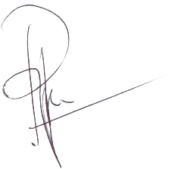

August 13th, 2019

Prabang Setyono

^{*)}This statement must be uploaded as a supplementary files while submitting your manuscript.

