Testing a Detailed Classification Scheme For Land-cover/ Land-use Mapping of Typical Indonesian Landscapes: Case Study of Sarolangun, Jambi and Salatiga, Central Java

Projo Danoedoro¹, Irvan Nurrahman Ananda¹, Candra Sari Djati Kartika², Assyria F Umela², Alvidita Beatrix Indayani²
¹Remote Sensing Laboratory, Faculty of Geography, Universitas Gadjah Mada, Yogyakarta, Indonesia
²Cartography Laboratory, Faculty of Geography, Universitas Gadjah Mada, Yogyakarta, Indonesia
projo.danoedoro@geo.ugm.ac.id, ananda.irvankpj08@gmail.com, candrakartika@ugm.ac.id , afumela@gmail.com, alviditabeatrixindayani@gmail.com

Abstract Land-cover/land-use (LCLU) mapping is an important activity to produce very useful information to support various sectors, such as land supply, spatial planning, disaster mitigation, and agricultural development. In Indonesia, a LCLU classification scheme has been developed at a scale of 1: 50,000, but it still requires an evaluation due to its advantages and limitations. This study tried to apply a classification scheme for LCLU-based on SNI 7645-1 2014 for two regions in Indonesia with different landscape characteristics, i.e. Sarolangun in Jambi and Salatiga and surroundings in Central Java.. The trial was conducted by developing methods of Landsat-8 satellite image analysis and interpretation combining digital processing and manual delineation. Based on this research, a number of 52 LCLU classes were identified in Sarolanguni and 32 classes were found in Salatiga and surrounding areas. The validation showed that the LCLU map of Jambi region reached 80.75.% of total accuracy, while that of Salatiga and surroundings reached 88.7%. Different accuracies found related to the number of classes produced, the pattern of relationship between LCLU with the existing landform characteristics, and the quality of images due to cloud cover.
Key words: detailed land-cover/land-use classification scheme, Landsat-8, image analysis, visual interpretation.

Abstrak Pemetaan penutup/penggunaan lahan merupakan kegiatan penting untuk menghasilkan informasi yang sangat berguna dalam mendukung berbagai sektor, seperti penyediaan lahan, perencanaan tata ruang, mitigasi bencana, dan pembangunan pertanian. Di Indonesia, skema klasifikasi penutup/penggunaan lahan telah dikembangkan pada skala 1: 50.000, tetapi masih memerlukan evaluasi terkait keunggulan dan keterbatasannya. Studi ini mencoba menerapkan skema klasifikasi untuk penutup/penggunaan lahan berdasarkan SNI 7645-1 tahun 2014 untuk dua wilayah di Indonesia dengan karakteristik bentanglahan yang berbeda, yaitu Sarolangun di Jambi dan Salatiga di Jawa Tengah. Uji coba ini dilakukan dengan mengembangkan metode analisis citra satelit landsat-8 serta interpretasi yang menggabungkan pemrosesan digital dan interpretasi manual. Berdasarkan penelitian ini, sejumlah 52 kelas penutup/penggunaan lahan telah diidentifikasi di Jambi dan 26 kelas ditemukan di Salatiga dan sekitarnya. Uji akurasi menunjukkan bahwa peta penutup/penggunaan lahan wilayah Sarolanguni mencapai akurasi keseluruhan sebesar 80.75%, sedangkan akurasi keseluruhan peta wilayah Salatiga dan sekitarnya mencapai 88,7%. Perbedaan tingkat akurasi yang ditemukan itu terkait dengan jumlah kelas yang dihasilkan, pola hubungan antara penutup/penggunaan lahan dengan karakteristik bentuklahan yang ada, serta kualitas citra karena tutupan awan
Kata kunci : skema klasifikasi penutup/penggunaan lahan rinci, Landsat-8, analisis citra, interpretasi visual.
1. INTRODUCTION
1.1 Background and Problem in Land-cover/Land-use Classification Systems
Land cover / land-use (LCLU) information is very important for various development sectors, because it can be used to describe human pressure on land (Young, 1998; Danoedoro, 2008; Di Gregorio, 2016). Nowadays, LCLU mapping cannot be separated from remote sensing technology (Martinez and Mollicone, 2012), because mapping based only on field surveys is considered as slow, inefficient and unable to keep up with the demands of rapid updating needs. On the other hand, the availability of remote sensing technology with various methods of image acquisition, data analyses, and classification/interpretation has been reported to provide very diverse mapping results as viewed from its accuracy aspects (Ehlers et al., 2003; Danoedoro, 2006; Szuster et al., 2011; Zhang and Zhu, 2011; Moreno and Larriva, 2012). Previous studies carried out by Feng and Flewelling (2004), Danoedoro (2008), Ferance et al. (2014), Dwiputra et al. (2016), Danoedoro et al. (2019), Putri and Danoedoro (2019) showed that in addition to the analysis and interpretation methods, the classification scheme used as a reference also played an important role in the accuracy of the resultant LCLU maps. Different accuracies among LCLU maps generated using different classification scheme might lead to incompatibility between adjacent maps.

In terms of the classification schemes used in Indonesia, there is an LCLU classification scheme recently developed and it has been nationally standardized to SNI 7645-1 of 2014 (BSN, 2014). This SNI classification scheme, although entitled as “land-cover classification”, actually includes land-use categorization. The classification scheme was designed for visual interpretation, although it implicitly requires digital image processing in its preparation (Danoedoro et al., 2019). This SNI has very detailed LCLU categorization specifications for medium scale (1: 50,000 and 1: 25,000), with a total number of classes reaching 103 categories, accommodating the diversity of LCLU and landscapes in Indonesia. This SNI classification system also clearly differentiated land-cover from land-use, like the one developed by ITC (van Gils et al., 1991) and Danoedoro (2008)

The large number of LCLU classes in the SNI 7645-1 also implies the need for specific approach in interpretation and mapping, particularly based on remotely sensed imagery. Many classes in the SNI 7645-1 are implicitly related to supporting landscape condition, including climate, rocks, topography, soils, hydrology and human activities, as viewed from landscape ecological context (van Gils et al., 1990). In this perspective, landform was frequently used as a basis for terrain analysis of landscape (van Zuidam and van Zuidam-Cancellado, 1983), to be combined with vegetation or other land-cover information (Danoedoro, 2003).

With respect to the aforementioned background, the problem can be formulated that the detailed and complicated SNI classification scheme requires a study of its advantages and limitations when applied to the remotely sensed interpretation and analysis in regions with different landscape characteristics, including landforms. Sarolangun Regency in Jambi Province (Sumatera Island) and Salatiga and surrounding areas in Central Java show striking landscape differences, so they could become test areas for this purpose.
1.2. Research Objective
This study aimed to evaluate the applicability of a detailed LCLU classification scheme for mapping at a scale of 1: 50,000 using landscape-ecological approach in two regions of Indonesia with different landscape characteristics, namely Jambi Province and Central Java Province. Jambi was represented by Sarolangun regency, while Central Java was represented by Salatiga and surroundings. The study was conducted using Landsat-8 OLI multispectral imagery that was paired with panchromatic band. The expected goal of this study was to confirm the accuracy of the LCLU map at an acceptable level, which is 80% or more, as well as a description of the advantages and limitations of the SNI 7645-1 LCLU classification scheme to be applied systematically in all regions of Indonesia.

2. APPROACH, MATERIALS AND METHODS
2.1. Approach
Conceptually, the LCLU mapping method used in this study was based on a landscape-ecological approach (van Gils et al., 1990). Through this approach, the main key to interpretation and re-interpretation was finding the answer "why is an LCLU category existing at a particular place or location, and what factors control its existence?" (Danoedoro, 2019). In order to understand LCLU phenomena in an area, image analysts must explore the relationship between land characteristics and certain types of LCLU. Land characteristics were studied through image-based terrain analysis using landform or geomorphological approach (van Zuidam and van Zuidam-Cancelado, 1983), and were technicaly processed using interpretation strategy in the form of interpretive overlays (Aronoff, 2005). By this strategy, general terrain units were delineated first, while more detailed units followed, until they reached the specified details on the mapping scale (1: 50,000), or the land-facet equivalent in the terrain hierarchy according to Huggett and Cheesman (2001). Based on the terrain units, delineation of LCLU polygons were carried out. More detailed LCLU categories according to the SNI 7645-1 specification could be inferred logically through an analysis of the relationship between LCLU and landform-deducted terrain characteristics (Danoedoro, 2003).

2.2. Materials
This research made use of multispectral Landsat-8 OLI imagery (30 m spatial resolution) covering coastal, blue, to far infrared or SWIR2 regions (as many as seven bands), supported by 100 m thermal infrared bands, and 15 m panchromatic band. The image dataset was then presented at 15 m pixel size to serve as a basis for mapping at a scale of 1: 50,000. The images of Sarolangun Regency area were recorded in between 2016-2018, while the image of Salatiga and its surrounding was supported by imagery of 2019 as the only source, due to the required quality and newness. In addition to the Landsat 8 OLI imagery, this study also utilized Sentinel 2A and SPOT-6/SPOT-7, which were recorded in 2018 to patch up Landsat's cloud-covered coverage. The images from Google Earth recorded by various sensors and scales were used to fill in the remaining data gaps, as a result of cloud coverage on the three types of imagery previously mentioned. Survey equipment consisted of hemispherical cameras, measuring band and ruler, GPS receiver, and sample sheets equipped with Survey123 software for field work; while ENVI and ArcGIS softwares were used to process images and heads-up digitization or visual interpretation.
This study made use of SNI 7645-1 as a classification scheme reference. The logic of categorization in the classification scheme is presented in Figure 1. Examples of imagery covering some parts of Salatiga and its surrounding that used in this study are presented in Figure 2.

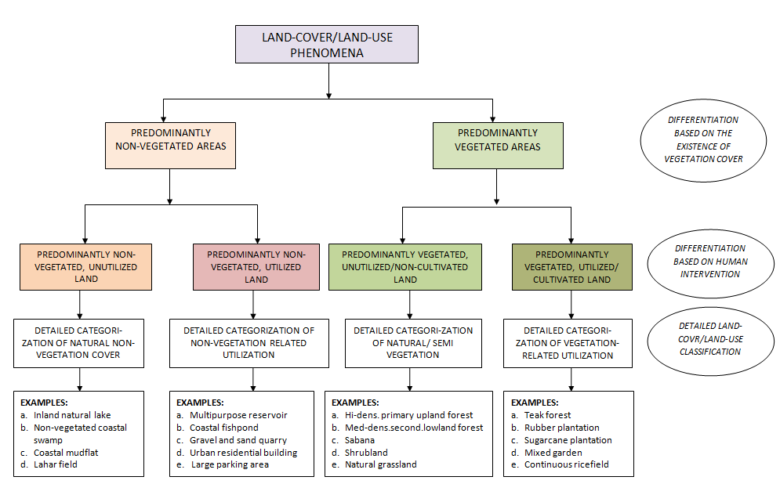
Figure 1. The logic of categorization of LCLU according to SN 7645-1 of 2014. In the bottom rows, examples of classes are specified for 1:50,000 scale.

2.3. Methods
2.3.1. Processing and Analysis Stages
All stages of image processing and analysis or interpretation are summarized in Figure 3. In this figure, the stages comprised (a) data preparation, (b) radiometric and geometric corrections, (c) preliminary visual interpretation, (d) spectral transformation in terms of forest cover density mapping or vegetation indices, (e) fieldwork preparation, (f) field data collection, (g) post-fieldwork and re-interpretation, and (h) accuracy assessment.

2.3.2. Image Correction and Calibration
Following the data preparation, according to Figure 2, the mapping process was preceded by geometric and radiometric corrections, which were the pre-processing stage. Geometric correction was required if the downloaded images did not meet the specified geometric quality, i.e. root mean square errors (RMSE) ≤ 0.5 pixels. To evaluate the geometric quality of the involved images, a set of ground control points (GCP) was taken from the image’s features appearing clearly on the RBI topographic map at 1:25,000 scale, constructing a table of image’s columns and rows and corresponding x-y coordinates. Based on these pairs, the RMSE was computed.
Radiometric correction was needed to convert the original pixel value of the image (DN or digital number) to at-surface reflectance, as the basis for vegetation index calculation. Correction to at-surface reflectance referred to the method developed by Chaves Jr. (1996) and Eastman (2017) as shown in equation (1)
$ρ=\frac{(Π*(L_{λ}-L_{haze}))}{(τ_{v}*(E_{o}*Cos\left(T_{Z}\right)*τ_{z}+E_{down})}$ (1)

where is at-surface reflectance in percent, L_{λ} is the image spectral radiance, L_{haze} is scattered spectral radiance recorded as the minimum one by the sensor, τ_{v} is the atmospheric transmittance or optical thickness of the atmosphere, E_{o} is the solar spectral irradiance which takes into account the Earth-Sun distance in specific Julian day, T_{z} is the incindent angle of the direct solar flux to the Earth surface, and E_{down} is downwelling spectral irradiance due to the scattered solar flux in the atmosphere.

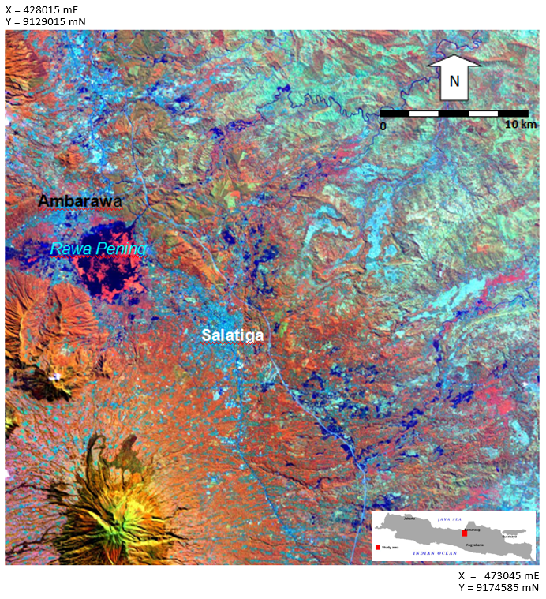
Figure 2. Study area of Salatiga and its surrounding as shown in Landsat 8 OLI pan-sharpened false color composite image recorded in 25 June 2019.
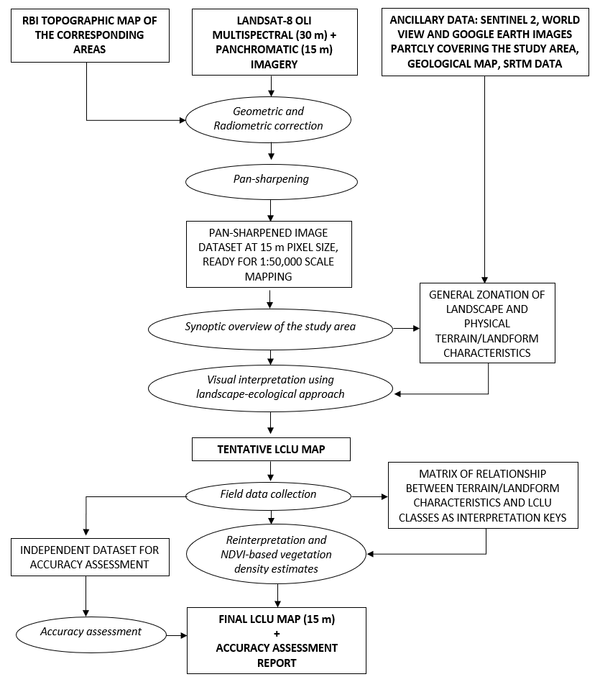
Figure 3. Summary of method used in this study, applied to both study areas

2.3.3. Image Pan-sharpening
The pan-sharpening process involved multispectral images of blue up to far infrared and panchromatic bands. According to Danoedoro et al. (2018), the pan-sharpening method chosen was the Gram-Schmidt or Principal Component (PC), depending on which gave a better result, when correlated with the original multispectral images. HSV (Hue-Saturation-Value) and Brovey methods that were less able to maintain the quality of the original spectral values (Liu and Mason, 2016) were not used in this study. Gram-Schmidt pan-sharpening involved four steps. First, simulation of high-resolution panchromatic band based on multispectral bands with lower spatial resolution. Second, the Gram-Schmidt transformation was applied to the simulated panchromatic band and the multispectral band, where the simulated panchromatic band was treated as the first band. Third, the original high-resolution panchromatic band was then replaced by a simulated Gram-Schmidt band. Fourth, the Gram-Schmidt transformation was then reversed. All these steps were undertaken using image processing software.

2.3.3. Vegetation Index
The authors used NDVI (Normalized Difference Vegetation Index) in this study, which based on the study of Dewa and Danoedoro (2017) provides more stable accuracies for various levels of vegetation density, number of canopy layers, and the types of radiometric correction used. The NDVI is formulated as follows
$NDVI= \frac{{.ρ}_{NIR}-ρ_{RED}}{ρ_{NIR}+ ρ_{RED}}$ (2)
Where ρ_{RED} and ρ_{NIR} indicate the reflectance (after radiometric correction) of vegetation in red and near infrared bands respectively. The NDVI was only applied to forest areas, and correlated with the results of field measurements based on vertical upward (bottom-up) photography (Umarhadi et al., 2018) of vegetation plots of a certain size A², according to the McCoy (2005) formula, whose length of the field measurement (A) consider the spatial resolution of the image (Rs) and the root mean square error (RMSE) geometric correction results, as shown in equation (3):
$A=Rs(1+2*RMSE)$ (3)
Correlation and regression analysis between NDVI values and vegetation canopy density values from field measurements were then used to transform NDVI values in forest polygons, and then were classified into three categories: dense (> 70%), moderate (30-70%) and sparse (<30 %).

2.3.4. Field Survey
The field survey followed the results of preliminary interpretation, and it comprised two main activities, namely (a) collection of field data samples or samples for re-interpretation, which could not be obtained directly from the images, to support detailed information according to the LCLU SNI 7645-1 classification scheme; and (b) collection of field samples as validators for accuracy assessment. We collected both types of samples separately, in order to keep the independency between the two. The re-interpretation samples were used to construct the re-interpretation keys through analysis of the relationship between land characteristics and LCLU classes, and analysis of the measurement results of vegetation canopy density using vegetation index transformation. The validator samples that were collected separately focused on taking the LCLU types or classes in the form of polygons, and they were used after the re-interpretation process had been completed.

This study collected field samples for re-interpretation using stratified random sampling strategy (Burt et al., 2009), referring to the tentative LCLU map generated from pre-field interpretation. In this stratified random sampling, the number of samples followed Slovin formula (Ryan, 2013), where the number of sample n was specified as a function of the total population N (which means the total number of tentative LCLU polygons) and the value e representing level of significance, as shown in equation (4):
$n=\frac{N}{1+Ne^{2}}$ (4)
Once the number of samples has been specified, it was then distributed proportionally to the number classes or categories and the number of polygons of each class. Therefore, higher percentage of particular class in the map required more samples and vice versa.

Based on the specified number and location of samples, field observation and measurement were carried out. The samples for accuracy assessment used slightly different method. Firstly, the number of validation samples was determined to quadruple the number of classes, and evenly distributed. Secondly, each validating sample was taken in the form of polygon, in order to accommodate the required minimum number of points (pixels) to be built as a confusion matrix (Danoedoro, 2015). Practically the authors made use larger size of polygons with respect to the minimum mapping unit (MMU) size, which was set to 2 mm x 2mm. The MMU setting was decided with respect to the Indonesian Geospatial Information Agency (BIG) regulation which requires a relatively detailed MMU to support topographic mapping. During field observation, we collected data related to landscape characteristics including coordinates, village name, landform class, elevation, slope steepness and aspects, surface drainage, land-cover type, crop rotation, and all other terrain attributes which were considered as having influence to the existence of particular LCLU categories (Danoedoro, 2003). This was done due to the fact that the categorization of the LCLU in the SNI 7645-1 is very detailed for the scale of 1:50,000.

2.3.5. Post-field Analysis and Re-interpretation
Implementation of the landscape-ecological approach is shown in the following description of the post-fieldwork analysis and re-interpretation. Post-fieldwork analysis was intended to build the re-interpretation keys. Technically, the data of each sample was broken down based on the land characteristics (geology/parent materials, landform and relief, soil characteristics, slope steepness, etc.). After that, we correlated them with the existing LCLU classes found in the field. In practice, a matrix consisted of terrain/landform classes (rows) versus SNI’s LCLU classes (columns) was created. In each cell, dots representing the relative strength of correlation were added, so that general ideas about terrain-land-use relationship could be obtained. More dots in a matrix cell indicated a stronger qualitative relationship between represented terrain/landform characteristics and the LCLU class.

Based on this analysis, we found the pattern of relationships between each LCLU category and the land characteristics represented by the terrain units or landform units. The LCLU was then associated with the appearance of land-cover in the composite imagery as a guidance. Thus, the re-interpretation process could determine which polygons required to be re-interpreted because they were logically incorrect. This included redrawing of boundaries during the interpretive overlays. LCLU classes in areas that were not sampled due to the time and/or access limitation could also be determined based on this re-interpretation keys.

2.3.6. Accuracy Assessment
This study also carried out an accuracy assessment based on confusion or error matrix (Congalton and Green, 2019. Kappa coefficient calculation was not included here, due to the findings of Pontius Jr. (2011). Based on the accuracy assessment results, an evaluation of the number of classes obtained, the complexity of the landscape, as well as the number of samples taken, was made to draw conclusions from the conducted studies.
3. RESULTS AND DISCUSSION
3.1. Overview of Research Areas
Since a landscape-ecological approach for the SNI’s LCLU mapping was considered as the most suitable method in this study, this discussion started with the physical terrain setting of the study area. According to the image synoptic overview, interpretation and field observation, supported by relevant thematic maps, the research areas represent two geologically different regions in Indonesia. Sarolangun Regency in Jambi Province is a large land area, with moderate variation in landforms, where the landform units are also large in comparison to those in Java. Generally speaking, the Sarolangun area in Jambi can be classified into four terrain zones. These five zones are (a) eroded hills with old volcanic origin, (b) crater, volcanic cones, volcanic slopes, and volcanic foot slopes, (c). eroded anticlinal mountains, eroded anticlinal hills, anticlinal valley, synclinal valley, hogback, and cuesta in the central and southern area, (d) lakes, volcanic plains, swamps, back swamps, alluvial plains, and floodplain. The geology of Sarolangun in Jambi province is composed of felsic to mafic rock materials. The igneous rocks identified were granite and andesite, while sedimentary rocks consisted of andesite breccia, conglomerates, quartz sandstones, arkose sandstones, greywacke sandstones, and alluvium. During the field survey activities, there were more varieties of soil types, i.e. andosols, regosol, red-yellow podzolic, latosol, and lithosol.

On the other hand, the Salatiga and its surrounding areas in central Java developed in relatively young geological setting. Northern and east-northern parts consist of tertiary age rocks, while the majority are volcanic areas of quarternary age. The existing landforms are mostly derived from three main volcanoes, namely Ungaran volcano, Telomoyo-Soropati, and Merbabu, with elevation reaching up 2000 meters or more. All of these volcanoes generate volcanic products that are intermediate in characters, thus producing soils that are relatively neutral. Exceptions were found in the area of fluvial-origin landforms around the Lake Rawa Pening, which are slowly undergoing a process of eutrophication to form a lacustrine valley with a small portion of peat, alluvial and gleisol soils. Longitudinal from north to south of the Salatiga research area and beyond, there are low hills with sedimentary rocks areas formed by marine deposits, especially calcareous sandstone and mudstone, interleaved by breccia. Soil types found in Salatiga and its surrounding are regosol, lithosol, latosol, mediteran, alluvial, gleysol, and grumusol. This varied landscape produced contrasting types and densities of vegetation, e.g. natural forests, shrubs, teak forest, tea and rubber plantations, mixed gardens, rice fields, dry fields and settlements.

These two different physical terrain characteristics were closely related to the LCLU types found in both study areas, which meant that a landscape-ecological approach was strongly required to identify and to map the LCLU classes with respect to the SNI 7645-1 categorisation. With a smaller area, Salatiga and its surrounding showed more complex landscape than that of Sarolangun region. Therefore an analysis of terraian/landform – LCLU relationship should follow in order to build a set of re-interpretation keys.

3.2. Image Correction and Pan-sharpening Results
The results of the geometric evaluation of the Landsat-8 OLI imagery showed a relatively good RMSE value, which is on average around 0.43 pixels for scenes covering Sarolangun area and 0.31 pixels for the Salatiga and surrounding areas. Radiometric correction to at-surface reflectance for the Jambi Province still required inter-scene calibration, due to uneven distribution of clear and deep water objects in all scenes as references. On the other hand, Salatiga and surrounding areas did not require inter-scene calibration since it is only covered by one image scene.

In the two regions with different landscapes, pan-sharpening using the Gram-Schmidt method gave almost the same results as the PCA method, where the correlation coefficients between original and the pan-sharpened bands reached > 0.85. Based on those results, the pan-sharpening results using the Gram-Schmidt method were chosen. Example of pan-sharpening results for the Salatiga and its surrounding areas is presented in Figure 4.

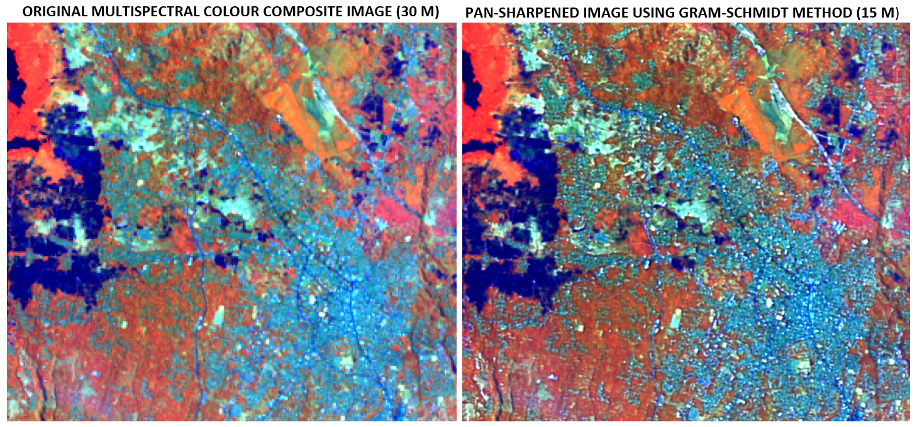
Figure 4. Comparison between original multispectral image at 30 m spatial resolution (for 1:100,000 scale print out) and pan-sharpened image at 15 m spatial resolution (for 1:50,000 scale print out) covering small part of the study area. The colour composite uses near infrared-middle infrared – blue bands, which are assigned with red, green and blue)

3.3. Interpretation and re-interpretation results.
We applied the landscape-ecological approach using interpretive overlay strategy (Aronoff, 2005). By this strategy, observation and delineation was carried out with respect to the physical terrain/landform appearance first, followed by the delineation of more detailed LCLU classes within each landform unit. LCLU classes were then logically inferenced based on the correlation between the two. In some cases, we did not delineate the landform units first, as far as the boundaries between two or more units were very obvious on the images. The visual interpretation was carried out using on-screen digitization. Therefore, the classification of LCLU categories was decided based on the terrain/landform – LCLU relationship.
Following the interpretation stage, we undertook field work using field data collection sheets containing information on dates, coordinates, name of the village (if any), tentative interpretation results, and a list of types of landforms, lithology, and other terrain characteristics such as slope, soil texture, and other factors that were presumed to influence the existence of LCLU in the area. Vegetation canopy density was measured using bottom-up photography, to be correlated with the NDVI in the forest areas. The resultant regression equations were then used to estimate forest density in the entire study areas. The fieldwork in Sarolangun area found that oil palm plantations were scattered in various locations and almost did not correlate with land characteristics, except in very high elevation and steeper slopes. Rubber was mainly found in the area with elevations less than 700 meters, rice fields were mainly located in flat to undulating terrains (except for volcanic areas), and dry fields as well as mixed gardens were found in various land characteristics, especially where water availability is relatively limited. In terms of mining areas, artisanal gold mines were common in Jambi, mainly in old volcanic areas adjacent to rivers, so that they showed patterns following drainage systems, while coal mining has occurred in sedimentary rocks areas and at relatively low elevations. Oil exploration was also found in the structural-origin landform.

Fieldwork in Salatiga and its surrounding areas found that the size of mapping units were relatively smaller than that of Sarolangun region, which means closer to specified MMU. The volcanic-origin and the structural-origin landforms control the existence of LCLU categories. In the volcanic origin landforms, natural forest in terms of high-medium density secondary upland forest, plantation forest (pine), tea plantation, dry field with vegetables, rice field with various crop rotations were predominant, besides urban settlement and industrial areas. On the other hand, shrub, plantation forest (teak), dry field with cash-crops, and rainfed rice field were frequently found in the structural-origin landforms. However, mixed garden, homestead garden, and rural settlement existed in nearly any landform.

Based on a number of 243 samples for Sarolangun and 64 samples for Salatiga and surroundings, a matrix of relationships between land characteristics and LCLU classes can be arranged. Table 1 depicts an example for terrain characteristics and LCLU classes in the Salatiga and its surrounding. Based on the Table 1, a matrix of relationship between terrain/landform units and the LCLU classes is presented in Table 2 and Table 3, using Salatiga area as an example in this report, due to the smaller table size. We found that the relationship between terrain characteristics and the LCLU classes were less obvious in Sarolangun area, but it looked more patterned for Salatiga and its surrounding. This was due to the fact that pressure of human on the environment in Java Island is more intensive, so that more detailed terrain units had to be specified in order to distinguish a set of controlling factors from another. That is why the mapping unit size in Central Java, which is represented by Salatiga and its surrounding looked much smaller, because the LCLU classes varied significantly in smaller areas, and these followed the high variation in terrain characteristics for the same area. We undertook the re-interpretation process using Tables 1, 2 and 3 as a guidance. According to the tables, when several LCLU classes existed in the same terrain/landform unit, separation between the classes were carried out based on their photomorphic appearance, supported by the use of available higher spatial resolution imagery including Sentinel, SPOT6/7 and Google Earth images covering some parts of the study area.

Table 1. Terrain/land characteristics – LCLU classes relationship found in Salatiga and its surrounding
No | Terrain/landform unit | Terrain characteristics |  |  |  |  | Predominant LCLU classes found in the unit
No | Terrain/landform unit | Soil depth | Soil texture | Surface drainage | Surface Water Availability | Slope Steep-ness | Predominant LCLU classes found in the unit
1 | Volcanic cone and upper slopes | • | coarse | Very good | - | ••••• | Plantation forest, Volcanic barren land, tea plantation
2 | Parasitic cone and volcanic neck | • | coarse | Very good | - | •••• | High density highland foret, medium density highland forest, mixed garden, homestead garden
3 | Volcanic middle slopes, slightly dissected) | •• | Moderate | Good | • | •••• | Plantation forest, homestead garden, Tea estate, dry fields
4 | Volcanic middle slopes, highly dissected | • | Moderate | good | • | •••• | homestead garden, Tea estate, dry fields, Plantation forest, Mixed garden, Continues rice field
5 | Volcanic lower and footslopes, slightly dissected) | •••• | Mode- fine | moderate | ••• | ••• | homestead garden, continuous rice field, rice field interleaved w/ cash crops, dry fields, Mixed garden
6 | Volcanic lower and footslopes, moderately dissected (V42) | ••• | Mode-fine | moderate | ••• | ••• | homestead garden, continuous rice field, rice field interleaved w/ cash crops, dry fields, Mixed garden, Rural settlement, Urban settlement
7 | Fluvio-volcanic footplain | •••• | fine | Moderate-slow | •••• | • | continuous rice field, rice field interleaved w/ cash crops, dry fields, Mixed garden, Rural settlement, Urban settlement
8 | Other volcanic remnant hills | •• | coarse | good | • | ••• | Mixed garden, homestead garden, dry field
9 | Moderately dissected denudational hills) | • | coarse | good | - | ••• | Mixed garden, homestead garden, dry field, Urban settlemet, Indusrial areas
10 | Highly dissected denudational hills | • | v.coarse | v.good | - | ••• | Homestead garden, mixed garden, Dry field, plantation forest
11 | Slightly dissected footslopes) | •• | Moderate | good | •• | •• | Mixed garden, homestead garden, dry field, Industrial areas
12 | Highly dissected footslopes | • | coarse | good | • | •• | Mixed garden, homestead garden, urban settlement
13 | Alluvial plain | ••••• | v.fine | poor | ••••• | • | continuous rice field, Mixed garden, homestead garden, urban settlement, industrial areas
14 | Alluvial fan | ••••• | fine | Moderate- | ••••• | • | Mixed garden, homestead garden, continuous ricefield, ricefield interleaved w/ cashcrops, rural settlement, urban settlement
15 | Natural levee | ••••• | Fine-moderate | Moderate-poor | •••• | • | continuous ricefield, ricefield interleaved w/ cashcrops, rural settlement urban settlement
16 | Valley bottom and other depression | ••••• | fine | poor | ••••• | • | Natural lake, continuous ricefield, ricefield interleaved w/ cashcrops, rural settlement urban settlement
17 | Plateau, slightly dissected | ••• | Moderate-fine | moderate | • | •• | Plantation forest, mixed garden, homestead garden, rural settlement, urban settlement
18 | Plateau, moderately dissected | •• | Moderate -fine | moderate | • | •• | Plantation forest, mixed garden, homestead garden, dry field
19 | Complex structural hills) | • | Very coarse | Very good | - | ••• | Mixed garden, homestead garden, urban settlement
20 | Fault zone | • | very coarse | Very good | • | •••• | Mixed garden, homestead garden, urban settlement
Notes: for soil depth: • = shallow, ••••• = very deep. For surface water availability: •=very poor, •••••=very good, For slope steepness: - =completely flat, • = somewhat flat, ••••• = extremely steep.
Table 2. Matrix of relationship between terrain/landform units and SNI7645-1 LCLU classes in Salatiga and its surrounding
 |  |  | SNI 7645-1 LCLU CLASSES
 |  |  | W20 | L11 | PV25 | UR11 | UR12 |  | BD21 |  | BD25 | BD27 | HF16 | LF25 | LF26 | SB71 | SB72 | HG82 | HG84 |  | FP11 |  | FP12 | FP14 | FP15 | FP16 | PL21 | PL22 | PL23 |  | PL24 |  | AF31 | AF33 | DR41 | DR42 | RF51 | RF52 | HM61 | HM63
1 | Volcanic cone and upper slopes
2 | Parasitic cone and volcanic neck
3 | Volcanic middle slopes, slightly dissected
4 | Volcanic middle slopes, highly dissected
5 | Volcanic lower and footslopes, slightly dissected
6 | Volcanic lower- and foot slopes, mode-rately dissected
7 | Fluvio-volcanic footplain
8 | Other volcanic remnant hills
9 | Moderately dissect-ed denud. hills
10 | Highly dissected denudational hills
11 | Slightly dissected footslopes
12 | Highly dissected footslopes
13 | Alluvial plain
14 | Alluvial fan
15 | Natural levee
16 | Valley bottom and other depression
17 | Plateau, slightly dissected
18 | Plateau, moderately dissected
19 | structural hills
20 | Fault zone
Notes: Codes for relationship: : strong relationship; : moderate relationship; : low relationship; (blank): no relationship
W20 |  | Natural lake |  |  |  |  |  | HF16 |  | Secondary upland forest, low density |  |  |  |  |  |  |  |  |  | FP12 |  | Sweitenia mahogany plantation forest |  |  |  |  |  |  |  | AF31 |  | Rural community forest
L11 |  | Lahar/lava field |  |  |  |  |  | LF25 |  | Secondary lowland forest, medium density |  |  |  |  |  |  |  |  |  | FP14 |  | Acacia auriculiformis plantation forest |  |  |  |  |  |  |  | AF33 |  | Mixed garden
PV25 |  | Asphalt/concrete/paved soil surface |  |  |  |  |  | LF26 |  | Secondary lowland forest, low density |  |  |  |  |  |  |  |  |  | FP15 |  | Albisia falcataria plantation forest |  |  |  |  |  |  |  | DR41 |  | Dry field with cash crops
UR11 |  | Uban settlement building |  |  |  |  |  | SB71 |  | Dense shrub |  |  |  |  |  |  |  |  |  | FP16 |  | Pinus mercusii plantation forest |  |  |  |  |  |  |  | DR42 |  | Dry field with horticulture/vegetables
UR12 |  | Rural settlement building |  |  |  |  |  | SB72 |  | Medium density shrub |  |  |  |  |  |  |  |  |  | PL21 |  | Rubber plantation |  |  |  |  |  |  |  | RF51 |  | Continuous rice field
BD21 |  | Industrial and commercial building |  |  |  |  |  | HG82 |  | Alang-alang (Imperata cylindrica) |  |  |  |  |  |  |  |  |  | PL22 |  | Coffee plantation |  |  |  |  |  |  |  | RF52 |  | Rice field interleaved with cash crop or fallow
BD25 |  | Stadium |  |  |  |  |  | HG84 |  | Other herbaceous vegetation (Eichhornia crassipes) |  |  |  |  |  |  |  |  |  | PL23 |  | Cocoa plantation |  |  |  |  |  |  |  | HM61 |  | Homestead garden
BD27 |  | Other non-settlement building |  |  |  |  |  | FP11 |  | Teak (Tectona grandis) plantation forest |  |  |  |  |  |  |  |  |  | PL24 |  | Tea plantation |  |  |  |  |  |  |  | HM63 |  | Green belt and urban green open space

Table 3. Matrix of relationship between terrain/landform units and LCLU classes in Sarolangun, Jambi (classes LF26 up to RF52 are put below)
 |  | LCLU CLASSES (ACCRODING TO SNI 7645-1 OF 2014)
 |  | WL20 | WL30 | WR50 | WO60 | LO50 | WO32 | WO42 | LM11 | LM12 | LM13 | UR11 | UR12 | BD21 | BD27 | HF11 | HF12 | HF13 | HF14 | HF15 | HF16 | LF21 | LF22 | LF23 | LF24 | LF25
1 | Eroded hills w/old volcanic origin
2 | Volcanic crater and cones
3 | Volcanic upper and middle slopes
4 | Volcanic foot slopes
5 | Eroded anticlinal mountains
6 | Eroded anticlinal hills
7 | Anticlinal valley, synclinal valley
8 | Hogback
9 | Cuesta
10 | Volcanic plains
11 | Lakes
12 | Swamps
13 | Back swamps
14 | Alluvial plains
15 | Floodplains
 |  | LF26 | PF32 | PF33 | PF34 | PF35 | PF36 | SB71 | SB72 | GR84 | NV10 | FP11 | FP12 | FP14 | FP15 | FP16 | FP18 | PL21 | PL26 | PL27 | AF31 | AF33 | DR41 | DR42 | RF51 | RF52
1 | Eroded hills w/ old volcanic origin
2 | Volcanic crater and cones
3 | Volcanic upper and middle slopes
4 | Volcanic foot slopes
5 | Eroded anticlinal mountains
6 | Eroded anticlinal hills
7 | Anticlinal valley, synclinal valley
8 | Hogback
9 | Cuesta
10 | Volcanic plains
11 | Lakes
12 | Swamps
13 | Back swamps
14 | Alluvial plains
15 | Floodplains
For the description of eac LCLU class, see Table 4.

Table 4. Description of each SNI 7645-1 classes found in Sarolangun Regency, Jambi shown in Table 3
Short code | Description | Short code | Description | Short code | Description
WL20 | Natural lake | HF14 | Highland secondary forest, high-density | GR84 | Other herb
WL30 | Inland lake and swamp | HF15 | Highland secondary forest, medium-density | NV10 | Other Natural/semi natural vegetation
WR50 | River water body | HF16 | Highland secondary forest, low-density | FP11 | Teak forest
WO60 | Other water bodies | LF21 | Lowland primary forest, high-density | FP12 | Mahogany forest
LO50 | Other barren land | LF22 | Lowland primary forest, medium-density | FP14 | Acacia forest
WO32 | Other freshwater pond | LF23 | Lowland primary forest, low-density | FP15 | Albisia forest
WO42 | Other water reservoir | LF24 | Lowland secondary forest, high-density | FP16 | Pine forest
LM11 | Sand, soil and rocks quarry | LF25 | Lowland secondary forest, medium-density | FP18 | Other forest plantation
LM12 | Open mining area -- gold | LF26 | Lowland secondary forest, low-density | PL21 | Rubber plantation
LM13 | Other open mining area | PF32 | Peat swamp primary forest, medium-density | PL26 | Oil palm plantation
UR11 | Urban settlement building | PF33 | Peat swamp primary forest, low-density | PL27 | Other plantation
UR12 | Rural settlement buidling | PF34 | Peat swamp secondary forest, high-density | AF31 | Community forest
BD21 | Industrial and commercial building | PF35 | Peat swamp primary forest, medium-density | AF33 | Mixed garden
BD27 | Other non-settlement building | PF36 | Peat swamp primary forest, low-density | DR41 | Dry field with cash crops
HF11 | Highland primary forest, high-density | SB71 | Bush and shrub | DR42 | Dry field with vegetables
HF12 | Highland primary forest, medium density | SB72 | Shrub | RF51 | Continuous rice field
HF13 | Highland primary forest, low-density | GR81 | Grassland | RF52 | Rice field interleaved with cash crops

Based on the re-interpretation results, the final LCLU maps were produced for Salatiga and surroundings (Figure 5) and Sarolangun (Figure 6). Figure 5 shows that the LCLU phenomena in Salatiga and its surrounding looked quite complex, in the sense that 32 classes could be found in such small area. On the other hand, Figure 6 shows that although the LCLU phenomenon in Sarolangun region looked quite complex on one side, but there are also several LCLU classes spreading without being limited by the terrain characteristics, such as primary/secondary upland forests with various density, palm oil plantation, and shrubs. In addition, the size of the mapping unit containing mix of all LCLU classes in Sarolangun was relatively large and was above the minimum mapping unit (MMU), which set at 2 mm x 2 mm. This was due to the fact that the individual LCLU according to SNI classes were smaller than the set MMU, but several small classes formed repetitive mixtures over large areas., resulting more general appearance of LCLU on the map. Figure 6 depicts LCLU classes in the Salatiga and its surounding, which showed spatial distribution of relatively complex LCLU classes, and they were strongly controlled by the terrain characteristics. The presence of tea and rubber plantations, teak forest plantation and rice fields were good examples where terrain characteristics such as elevation, landform, slope, soil and surface water availability play as the main controlling factors.

3.4. Accuracy Assessment Results
Accuracy assessment was carried out using 241 validator samples for the Jambi region and 128 validator samples for the Salatiga and surrounding areas. Based on the accuracy assessment, this study found that the overall accuracy of the LCLU map for Sarolangun area was 80.75%; while the overall accuracy of the LCLU map for the Salatiga and surrounding areas reached 88.7%. Table 5 shows that the greater number of classes in the Jambi region results in a lower level of accuracy, while the smaller number of classes in the Salatiga and surrounding areas gives a higher level of accuracy.

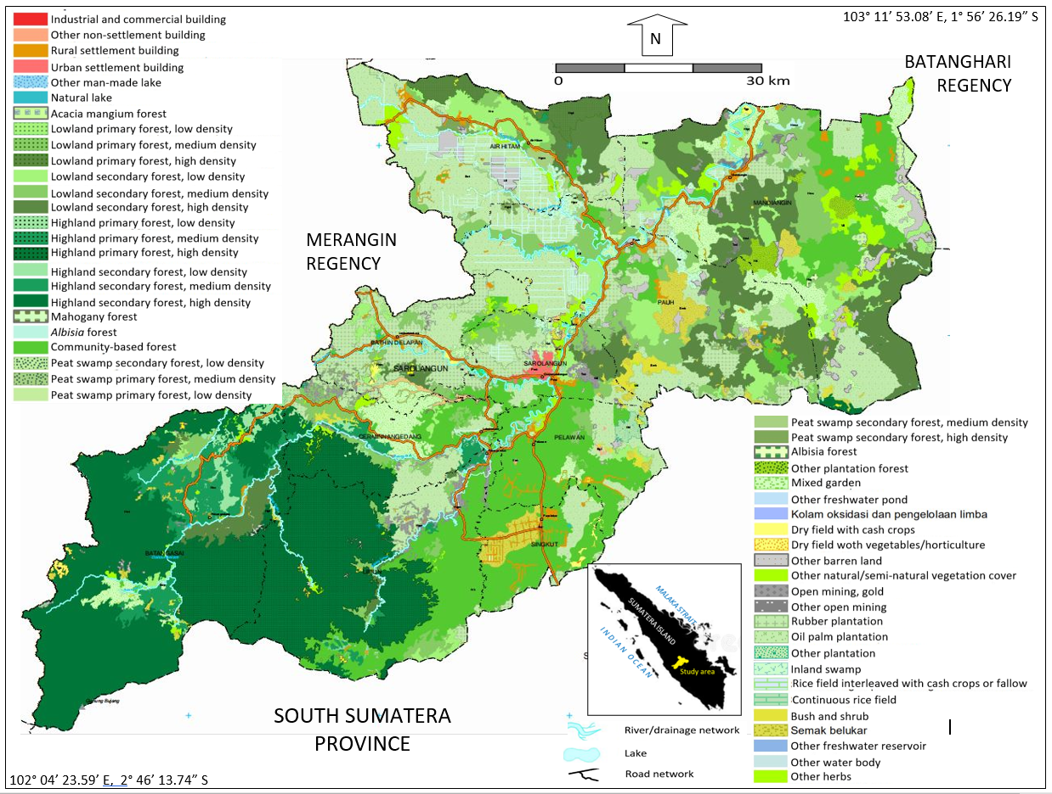

Figure 5. LCLU map of Sarolangun, Jambi Province. The original scale is 1:50,000

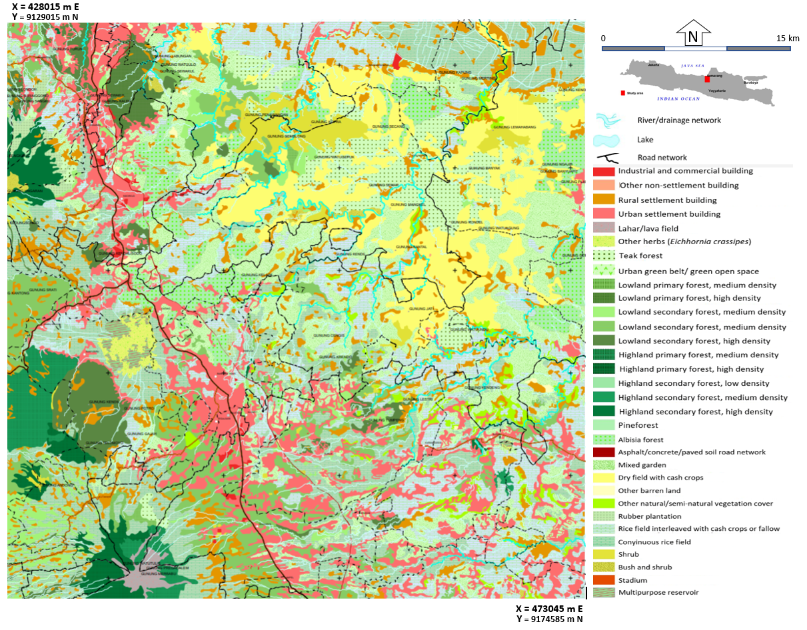
Figure 6. LCLU map of Salatiga and its surrounding area. The original scale is 1:50,000

Table 5. Accuracy assessment in relation with the landscape chateristization in two study areas
 | Sarolangun Regency,  Jambi Province | Salatiga and Its Surrounding,Central Java)
Landscape complexity | medium | high
Terrain characteristics in general | Varied, from young-old volcanic origins, tertiary/pre-tertiary sedimentary rocks, vast alluvial plains, marine/coastal landforms | Mostly quarternary volcanic-origin landforms in the west side and tertiary sedimentary (structural origin) landforms in the east
LCLU and terrain characteristics correlation | Medium - high | high
Mapping unit size (compared to MMU) | large | small
Number of LCLU classes found | 87 | 32
Overall accuracy achieved | 80.75 % | 88.7%

Despite the lower landscape complexity level, the Sarolangun LCLU map actually produced a lower level of accuracy, while the Salatiga and its surrounding LCLU map gave the opposite result. This can be explained that in the Jambi region there were far more LCLU classes (52) than Salatiga and surroundings (32), so that very high accuracy values are more difficult to achieve. On the other hand, the correlation between various LCLU classes and land characteristics is stronger in Salatiga and surroundings –in the sense that more LCLU classes could only be found in particular landforms, in addition to the presence of a smaller number of classes, so that the ecological landscape approach for this area became more effective. These combined factors caused easier re-interpretation process and lead to higher accuracy results. Moreover, although several types of imagery had been patched up, the Sarolangun area still partly covered by cloud, making the interpretation less accurate.
All these findings were consistent with the results of previous research such as Ehlers et al. (2004), Danoedoro (2006), Dwiputra et al. (2016), and Putri et al. (2019) which showed that the large number of classes tends to provide lower accuracy, due to the increase of misclassification risk. These results were also consistent with the finding in different fields like the ones found by Li et al. (2016) and Sugimori (2019). When we compared the results with the research findings of Danoedoro et al (2019) and Ananda et al. (2019) for other Sumatra regions, this study also showed that the classification scheme according to SNI 7645-1 of 2014 can be applied to detailed LCLU mapping on a scale of 1: 50,000, with a minimum accuracy of around 80%.
It should also be noted that this study did not cover coastal areas with mangrove and aquaculture classes, which could also be found in the coastal areas of both Jambi and Central Java Provinces. Although LCLU classes in coastal ecosystems show several controlling environmental factors that could be used as a basis for landscape-ecological approach, a further study concerning this issue should be carried out in order to generalise the findings.
3.5. Advantages and Limitations
This study found that there were several advantages and limitations of the SNI 7645-1 classification scheme in LCLU mapping. The advantages were (1) the categorization in SNI 7645-1 could be achieved by visual interpretation based on landscape ecological approach. Almost all classes could be recognized and delineated well because they rely on a combination of photomorphic appearance and controlling physical factors (in the form of terrain or landforms). This means that the SNI 7645-1 classification scheme could be operated in various regions with different ecosystem characteristics and does not rely solely on the appearance of land cover on the image. This was inseparable from the initial concept of preparing a classification scheme, which was designed specifically for mapping based on visual interpretation; (2) conceptually, the large number of classes in SNI 7645-1 based on the landscape ecology approach would facilitate the process of conversion or translation to other classification systems. This was due to the fact that the other classification schemes usually have a smaller number of classes. In addition, conversion is also easier because it is accompanied by information that involves controlling factors in the form of land characteristics.

In terms of limitations, very large number of classes in SNI 7645-1 caused the achieved classification accuracy not to be very high. With 32 classes for Salatiga and its surrounding areas and 52 classes for Sarolangun region, the overall accuracy > 80% was sufficient. However, LCLU classification accuracy of 90% or above could guarantee that the produced maps are supportive for land-use planning and decision making process. In addition, the landscape ecological approach requires mastery of ecological aspects related to geology, geomorphology, soil, hydrology and its relation to LCLU. This can only be done by trained and/or experienced interpreters.
4. CONCLUSIONS AND RECCOMENDATION
Based on this research, the authors concluded that the LCLU classification scheme that is standardized as SNI 7645-1 of 2014 can be applied with adequate accuracy to map LCLU in Indonesia’s inland ecosystems with different landscape characteristics, based on pan-sharpened Landsat imagery at 15 m spatial resolution or at1:50,000 scale. The achieved accuracies for the two different study areas were more than 80%. Besides, the detailed LCLU classification and mapping at 1: 50,000 scale could be achieved using image interpretation in combination with digital analysis for pre-processing and vegetation density estimates, in integration with landscape-ecological approach incorporating terrain analysis of the landscape.

The applicability of SNI 7645-1 for LCLU mapping also implied the advantages and limitations that need to be underlined. Logically, the large number of classes facilitates conversion to other classification systems, but on the other hand also makes it difficult to achieve very high classification accuracy. The landscape-ecological approach --which is the backbone of SNI 7645-1 implementation-- facilitates the identification, delineation and classiﬁcation of various LCLU classes, but on the other hand also demands mastery of concepts related to geology, geomorphology, soil and hydrology in the perspective of land use, which could not easily found in most LCLU projects.

Acknowledgement
The authors wish to thank Indonesian Geospatial Information Agency (BIG) for involving us in the LCLU survey in Jambi Province. We would also like to express our gratitude to the Faculty of Geography for giving permission to carry out an independent research in Salatiga and its surrounding. Contributions from Dr. Sigit Heru Murti, Dr. Prima Widayani, Dr Pramaditya Wicaksono, and Dr. iswari Nur Hidayati of the geographical Information Science Department are also acknowledged.

References
Ananda, I.N., Umela, A.F., Ratnasari, N., Putri, D.A. Wulandari, Y.S., Danoedoro, P. (2019) Development of Land-cover Spatial Database using Satellite Imagery: Lesson Learned from Southern Part of Sumatera. Proceeedings SPIE 11311, Sixth Geoinformation Science Symposium 2019, Yogyakarta, Indonesia.
Aronoff, S. (2005). Remote Sensing for GIS Managers. New York: John Wiley and Sons
Burt, J.E., Barber, G.M., Rigby, D.L. (2009). Elementary Statistics for Geographers, Third Edition. New York: John Wiley and Sons
BSN (Badan Standardisasi Nasional). Standar Nasional Indonesia No. 7645-1 tahun 2014 tentang Klasifikasi Penutup Lahan. Bagian I: Skala Kecil dan Menengah. Jakarta.
Chavez Jr. P. S. (1996). Image-Based Atmospheric Corrections - Revisited and Improved. Photogrammetric Engineering & Remote Sensing, 62 (9), pp. 1025-1036.
Congalton, R.G. and Green, K. (2019). Assessing the Accuracy of Remotely Sensed Data: Principles and Practices. 3rd Edition, Boca Raton: Lewis Publishers
Danoedoro, P. (2003). Multisource Classification for Land-use Mapping based on Spectral, Textural, and Terrain Information using Landsat Thematic Mapper Imagery: A Case Study of Semarang-Ungaran Area, Central Java. Indonesian Journal of Geography, 52 (2), pp 81-106.
Danoedoro, P. (2006). Extracting Land-Use Information Related to Socio-Economic Function from Quickbird Imagersy: A Case Study of Semarang Area, Indonesia. Proceedings of the Map Asia Conference, Bangkok
Danoedoro, P. (2008). Physical Planning and the Need for Versatile Land-use Information: A Geoinformation Technology Perspective on the Classification System Development. In C. Knie & Shanawaz , Geograhical Information Science for Urban and Regional Development in Asia and Africa (pp. 1 - 9). Cologne: Department of Geography, University of Cologne, Germany.
Danoedoro, P. (2015). Pengaruh Jumlah dan Metode Pengambilan Titik Sampel Penguji Terhadap Tingkat Akurasi Klasifikasi Citra Digital Penginderaan Jauh. Prosiding. Simposium Sains Geoinformasi ke-4, 27-28 Oktober 2015 di Yogyakarta
Danoedoro, P. (2019). Multidimensional Land-use Information for Local Planning and Land Resources Assessment in Indonesia: Classification Scheme for Information Extraction from High-Spatial Resolution Imagery. Indonesian Journal of Geography, 51(2), August 2019 pp. 131 - 146
Danoedoro, P., Ardiansyah, T., and Adiwijoyo. (2018). Perbandingan Hasil Klasifikasi Per-piksel dan Klasifikasi Berbasis Objek Menggunakan Citra Alos Pan-sharpened: Studi Kasus Daerah Pinggiran Kota Yogyakarta. Paper, presented at the 20th Indonesian Geographers Association Annual Meeting Manado
Danoedoro, P., Ananda, I.N., Wulandari, Y. Umela, A.F. , Rasyidi, E.R. , Pahlefi, M.R. , Ramadaningrum, D.R., Kulsum, I. I. Juniansah, A., Tyas, B.I. Rosalina, L., and Narmaningruma, D.A. (2019). Developing interpretation methods for detailed categorisation-based land-cover/land-use mapping at 1:50,000 scale in Indonesia. Proceedings of SPIE 11372, Sixth International Symposium on LAPAN-IPB Satellite 2019, Bogor, Indonesia
Dewa, R.P., and Danoedoro, P. (2017). The Effect of radiometric correction on the accuracy of vegetation canopy density estimate using several Landsat-8 OLI’s vegetation indices: A case study of Wonosari area, Indonesia. IOP Conf. Series: Earth and Environmental Science 54 (2017) 012046
di Gregorio, A. (2016). Land Cover Classification System: Classification concepts. Software version 3. Rome: Food and Agriculture Organization of the United Nations
Dwiputra, A. J., Suharyadi, R., and Danoedoro, P. (2016). Pengaruh Jumlah Kelas dan Skema Klasifikasi terhadap Akurasi Informasi Penggunaan Lahan Hasil Klasifikasi Berbasis Objek dengan Teknik Support Vector Machine di Sebagian Kabupaten Kebumen Provinsi Jawa Tengah. Majalah Geografi Indonesia. 30 (2), pp 120-133
Eastman, J. R. (2017). TerrSet Tutorial. Worchester, MA: Clark University
Ehlers, M., Gahler, M., and Janowsky, R. (2003). Automated Analysis of Ultrahigh Resolution Remote Sensing Data for Biotope Type Mapping: New Possibilities and Challenges. ISPRS Journal of Photogrammetry and Remote Sensing, 1252, pp 1-12.
Feng, C.C., and , Flewelling, D.M. (2004). Assessment of Semantic Similarity between Land Use/Land Cover Classification Systems Feature Based Approach, Relative Importance Approach. Computers, Environment and Urban Systems 28 (2004), pp 229–246.
Feranec, J. , Solin, L., Kopecka, M., Otahel, J., Kupkova, L., Stych, P., Bicik, I., Kolar, J., Cerba, O., Soukup, T., and Brodsky, L. (2014). Analysis and Expert Assessment of the Semantic Similarity Between Land Cover Classes. Progress in Physical Geography, 38 (3), pp 301-32.
Huggett, R. And Cheesman, R. (2001). Topography and Environment. London: Prentice Hall.
Li, Z., Zhou, Z., Zhang, S., and Jiang, H. (2016). Comparison of the Accuracy and Performance of Different Numbers of Classes in Discretised Solution Method for Population Balance Model. International Journal of Chemical Engineering . 2016, Article ID 8743105, pp 1-6
Liu, J. G. and Mason, P. J. (2016). Essential Image Processing and GIS for Remote Sensing: Techniques and Applications, 2nd edition. London: John Wiley and Sons.
Martínez, S. and Mollicone, S. (2012). From Land Cover to Land Use: A Methodology to Assess Land Use from Remote Sensing Data. Remote Sensing. 2012 (4), pp 1024-1045.
McCoy, R. (2005). Field Methods in Remote Sensing. New York: Guilford Press.
Moreno, A.J.P, and De Larriva, E.M. (2012). Comparison between New Digital Image Classification Methods and Traditional Methods for Land-cover Mapping. In: Giri, C.P. (ed) Remote Sensing of Land-use and Land-cover. Principles and Applications. New York: CRC Press.
Pontius J, R.G. (2011). Death to Kappa: birth of quantity disagreement and allocation disagreement for accuracy assessment. International Journal of Remote Sensing, 32 (15), pp 4407-4429
Putri, E. A. W., and Danoedoro, P. (2019). Comparing Per-pixel and Object-based Classification Results using Two Different Land-cover/Land-use Classification Schemes: A Case Study using Landsat-8 OLI Imagery. Proceedings, SPIE 11372, Sixth International Symposium on LAPAN-IPB Satellite, 2019, Bogor, Indonesia.
Ryan, T. P. (2013) Sample Size Determination and Power. John Wiley & Sons.
Sugimori, S. (2019). Evaluating the Overall Accuracy of Additional Learning and Automatic Classification System for CT. Applied. Science. 9 (82), pp. 1-9
Szuster, B.W. Chen, Q., and Borger, M. (2011). A Comparison of Classification Techniques to Support Land Cover and Land Use Analysis in Tropical Coastal Zones. Applied Geography 31 (2011): pp 525-532.
Umarhadi, D., Danoedoro, P., Wicaksono, P. and Widayani, P. (2018). The Comparison of Canopy Density Measurement Using UAV and Hemispherical Photography for Remote Sensing Based Mapping. Proceedings of the 4th International Conference on Science and Technology (ICST), Yogyakarta, Indonesia
van Gils, H., Zonneveld, I.S., van Wijngaarden, W., Kannegieter, A., and Huizing, H. (1990). Land Ecology and Land-use Survey]. Enschede: ITC.
van Gils, H., Huizing, H., Kannegieter, A., & van der Zee, D. (1991). The Evolution of the ITC System of Rural Land use and Land cover Classification (LUCC). ITC Journal (3): pp 163-167.
van Zuidam and van Zuidam Cancelado (1983). Terrain Analysis and Evaluation using Airphoto Interpretation – A Geomorphological Approach. Enschede: ITC
Young, A. (1998). Land Resources: Now and for the Future. Cambridge: Cambridge University Press.
Zhang, R., and Zhu, D. (2011). Study of land cover classification based on knowledge rules using high-resolution remote sensing images. Expert Systems with Applications 38 (2011), pp 3647–3652
.

