12 of October, 2019

Statement of Originality

Dear Indonesian Journal of Geography Editor,
We confirm that this work is original and has not been published elsewhere, nor is it currently under consideration for publication elsewhere.
Furthermore, we also believe that this manuscript is appropriate for publication in this journal. We have no conflicts of interest to disclose. Please address all correspondence concerning this manuscript to me at sanjiwana.arjasakusuma@ugm.ac.id
Thank you for your consideration of this manuscript.
Sincerely,
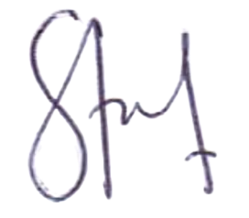

Sanjiwana Arjasakusuma

