

Publisher
Faculty of Geography, Universitas Gadjah Mada
Bulaksumur, Yogyakarta, Indonesia 55281
Email: ijg@ugm.ac.id Web: https://jurnal.ugm.ac.id/ijg

Statement of Originality and conflict of interest declaration

Title of the manuscript :
Lineament Extraction using Gravity Data in the Citarum Watershed

Authors:
1.Dr. Andi Agus Nur, M.T.
2.Gumilar Utamas Nugraha, S.Si., M.T.

As the corresponding author I certify that this manuscript is original and its publication does not infringe any copyright.
As the corresponding author I declare that the manuscript has not been previously published, in whole or in part in any other journal or scientific publishing company. Also the manuscript does not participate in any other publishing process. I also declare there is no conflict of interest.
As the corresponding author I declare that all persons listed hereafter were committed in the creation of the paper and were informed about their participation.

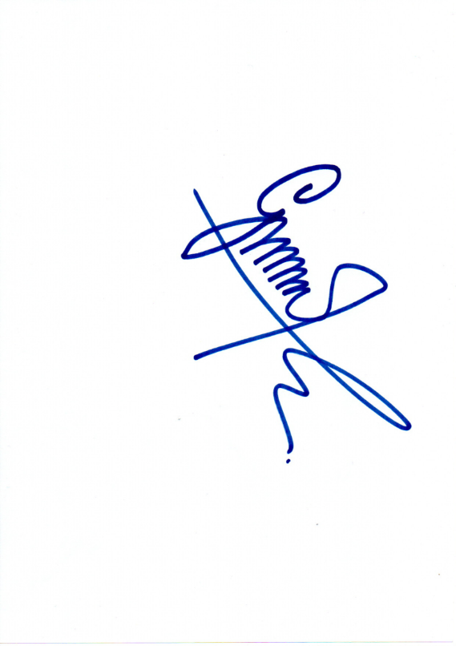
Bandung, December 11th 2019

Gumilar Utamas Nugraha, S.Si., M.T.

