RIVER FLOW MODELLING FOR SUSTAINABLE OPERATION
OF HYDROELECTRIC POWER PLANT IN THE
TALUDAA-GORONTALO WATERSHED
Sardi Salim^{1*}, Muchlis Polin^{2*}
¹Electrical Engineering Department, Universitas Negeri Gorontalo, Gorontalo,
Indonesia
² Information Systems Department, Universitas Negeri Gorontalo, Gorontalo,
Indonesia
Corresponding Author: sardi@ung.ac.id; mpolin@ung.ac.id
Abstract
Measurement of river flow discharge is generally the result of multiplying between the river cross-sectional area at the measurement point with the flow speed (Q = A.v m3/s). This approach cannot be used for planning needs in which changes in discharge values must be measurable or known at all times. Changes in weather and catchment area systems will directly affect the value of river flow. Planning errors will result in unsustainable and interrupted operations. Using the rainfall-runoff modeling technique, changes in the river discharge values could be known by the hydrograph output of the model. The purpose of this study was to carry out hydrological modeling techniques to obtain spatial and temporal river flow discharge in the watershed. The watershed system parameters: Watershed Area, Curve Number which represents land use and soil type, Time Lag as the delay between maximum rainfall and the occurrence of peak discharge, and Initial Abstraction which takes into account all losses before runoff occurs. Rainfall data were obtained from an ARR station installed around the watershed area and water level data was obtained through an AWLR station installed in the river at the debit measurement point. the Model analysis was carried out using HEC-HMS software. The dependable discharge for power plants was analyzed using the flow duration curve method. The results show that the rainfall-runoff hydrological modeling technique applied in the Taludaa-Gorontalo sub-watershed could help the hydroelectric power plant to operate continuously and sustainably.

Keywords: Modelling, hydrology, discharge, watershed, electric power

- Introduction
One of the problems often encountered in hydropower planning is the mismatch between the value of the actual river discharge and the potential discharge, which could be realised all the time to operate a plant (Tsai et al., 2016). Many electric power project planners rely on river flow studies by measuring the cross-sectional area of ​​a river (A) and water flow velocity (V) as components to determine river discharge (Q = A x V m³/sec). However, this method could only provide the discharge value at the time of measurement. Climate change that occurs over time in the catchment area or the value of river discharge in one year cannot be determined. Therefore, a built hydropower plant cannot operate at full capacity even though it does not rain (Amos et al, 2016). By contrast, power plant components could be damaged if the duration of heavy rain, which causes the river water to exceed the capacity of the river weir or water channel to the power plant, is prolonged. The mainstay discharge trends must be known to determine whether the river could be utilised to turn a power generator turbine constantly (Samora et al, 2016).
Therefore, a method is needed to assess whether a river flow can guarantee the operational continuity of hydroelectric power plant throughout the year based on weather characteristics and components of the catchment area system. Based on the concept of the hydrological cycle, rainwater that falls to the earth’s surface in the catchment area forms a runoff; some of which seeps underground, whereas some seeps deeper into the ground to form the base flow. Without rain, the underground water rises to form an underground flow and comes out as springs in the river flow (Rasmy et al, 2019). Given that the hydrological cycle is a closed system, the inputs are always the same as the water output. This phenomenon is known as water balance (Pamela J. et al, 2015). A river is the combined point of runoff from groundwater flow and rain that falls directly into a river’s water body.
Mishra (2013), examined watershed modeling with Curve Number (CN) parameters using rain duration data for 10 years, showing the results of river discharge throughout the year in different weather conditions. The study is very important and used by hydrologists and engineers to determine suitable locations for hydroelectric power plants. Derdour et al. (2013) used HEC-HMS modelling to predict surface runoff at the semi-arid region of Ain Sefra watershed in southwestern Algeria. The hydrologic losses and effective rainfall transformation were determined by using the SCS curve number and SCS unit hydrograph method respectively. Findings from the research indicated that the result is acceptable for simulating rainfall-runoff. Ningaraju et al. (2016) demonstrated that Soil Conservation Services Curve Number (SCS-CN) method could be well integrated with GIS to estimate runoff at the Kharadya mill watershed in India. The method could be used to improve land use planning and watershed management.
Based on the research results above, it can be concluded that SCS Curve Number hydrological modeling technique with hydrograph unit that describes the occurrence of river flow discharge over time is essential for hydrologists to use in power generation, irrigation needs, drinking water supply, and other water resource needs. Without data on the availability of river water volume/discharge over time, power plants, irrigation, and drinking water supply systems will not operate properly and sustainably.
This study used a hydrological modelling technique with the soil conservation service–curve number (SCS–CN) hydrological model, which identifies the parameters of the watershed system. The rain data used as input were retrieved from a rain station installed in the watershed area. Through HEC-HMS software analysis, a hydrograph and time series output data were generated. The river discharge value used for power generation energy was analysed using the flow duration curve (FDC) method. Based on the dependable discharge value and the estimated height of falling river water, the value of electrical energy which could be generated by the flow in the Taludaa Gorontalo River could be obtained by using the electrical power equation.

The purpose of this study is to model river flow energy using hydrological modeling techniques to obtain spatiotemporal river discharge characteristics, to ensure the sustainability of hydroelectric power plant operations throughout the year.

- Material and Methods
2.1 Research method and data
The research methods used in this study were field survey and hydrological modelling analysis. Hydrological modelling analysis was used to determine the value of river discharge for energy power generation, whereas field survey was performed to determine the actual conditions of the watershed in the field. Rainfall data, which were used as the main input to HEC-HMS, were obtained through the automatic rainfall recorder (ARR) rain station data logger installed in the Taludaa–Gorontalo watershed. Water level data were obtained from data loggers at the automatic water level recorder (AWLR) station installed at the observation point of the Taludaa River discharge. The condition of the watershed system parameters that is: watershed area, Curve Number as a component that represents land use and soil type, Time Lag as the delay between the maximum rainfall amount and the peak discharge and Initial Abstraction which is a parameter that accounts for all losses before runoff, was analysed with ArcGIS software using a topographic map as secondary data. The map was on a scale of 1:25,000 and was obtained from the Indonesian Geospatial Information Agency (year 2019). Data from Spot Satellite Imagery 6 and 7 from LAPAN Republik Indonesia (year 2018) were also used.

2.2 Hydrological modelling
Hydrological modelling simplifies of complex elements and components to facilitate the understanding of Earth’s hydrological phenomena. Hydrological models are a simple description of the actual hydrological system and are created to study the function and response of water catchment areas to various inputs. Through these models, hydrological events could be studied and then used to predict future hydrological events. Hydrological modelling can describe the process of rain that falls in the catchment area of the watershed and is processed in the catchment area system. It also produces hydrograph output from river flow rates.
As a modelling technique, SCS-CN was used in this study to analyse the occurrence of river flow discharge as a function of effective rainfall in catchment areas, land cover, land use and soil antecedent moisture (Andrzej W. et al, 2020). In this model, the land use function, soil type and initial moisture are represented by the curve number (CN) parameter. The CN value is determined by considering antecedent moisture condition (AMC) which is an index of basin wetness. The AMC value can be determined by an approach based on the amount of rain that falls before the CN calculation. (Silveira L. et al, 2000)
The CN value of a watershed can be estimated as a function of land use, soil type and soil moisture by using the SCS table and soil hydrology classification. For watersheds that have different soil types and land uses, the CN value is calculated as a CN composite using Equation (1).
$CN=\frac{\sum{A_{i}\left({CN}_{i}\right)}}{\sum{A_{i}}}$ (1)
where CN is the total composite value of the runoff volume calculated by HEC-HMS, i is the land usage index and soil type, CN_{i} is the CN value for the distribution of the watershed, and A_{i} is the area of the watershed.

2.3 HEC-HMS hydrological model
The hydrological model (i.e. HEC-HMS) was designed to simulate runoff on the basis of rainfall input in a watershed. Sub watershed parameters that were used as input in the HEC-HMS component consisted of Sub Basin, loss, transform and base flow. The SubBasin component was used to input parameters: sub watershed area, loss method, transform method and base flow method. In this process, the loss method used was the SCS–CN, the transform method used was the SCS unit hydrograph, and recession was used as the base flow method.
To calculate the volume of water infiltrated into the soil which is estimated from CN is the Equation (2) was used:
$S=25.4\left(\frac{1000}{CN-10}\right)$ (2)
where S is water infiltrated into the soil (mm). Given the relationship between S and a linear initial abstraction (I_{a}), I_{a} can be approximated by Equation (3).
$I_{a}=0.2S$ (3)
Time lag (TL) refers to the time difference between the peak of rain and the peak of the hydrograph; it is analysed on the basis of TL = 0.6 Tc. T_{c} is the concentration time required by water from the farthest place (upstream sub watershed) to the observation point of water flow (outlet). Tc is calculated using the Kirpich equation.
$T_{c}=0.01947\left(L^{0.77}s^{0.385}\right)$ (4)
where L is length of the main river basin, s is the slope of the watershed ($ΔH/L)$, and $ΔH$ is the difference in upstream and outlet heights. The main components needed as input for the sub-basic parameters in HEC-HMS are shown in Table 1.

Table 1. Components of sub-DAS parameters used as input for HEC-HMS
Component |  | Parameter
1. | Sub Basin | Area (km²)
2. | Loss | Initial abstraction (mm)  Curve Number  Impervious (%)
3. | Transform | Time Lag (min)
4. | Base Flow | Initial discharge (m³/s)  Recession constant  Flow (m³/s)

Hourly rainfall data at a certain time (forming 1 hydrograph curve of rain data) were input in the time series data manager component. Data were obtained from rain stations (ARR) installed in the watershed area. Through the HEC-HMS simulation process with watershed parameter components and rain data input, hydrograph output and river discharge values were obtained at a certain time (only forming 1 discharge hydrograph curve).
The modeling technique was carried out by inputting data from the watershed parameters analysis result and rainfall data for the watershed area in the HEC-HMS software. The modeling results would show river discharge data as a result of the hydrological process in the watershed system in hydrograph and time-series graphs of river flow over time. Considering that the simulation produced results that did not match real-world measurements, a model calibration process was needed.

2.4 Model calibration process
The model calibration process is needed to test the model simulation results (hydrograph output) in accordance with the actual river discharge (discharge from the observation point). Model calibration in HEC-HMS is conducted through the optimisation trial manager process. Data for field river discharge comparisons were obtained through direct observation/measurement at the discharge observation point. River discharge data were measured for several values from the minimum to the maximum water level at a particular time. Every measurement was adjusted to the water level value on the staff gauge.
Observed discharge data were recorded on the basis of the time and date of measurement and paired with the river stage data recorded by the AWLR logger installed in the river flow at the discharge observation site. By using the discharge rating curve method, data were paired to obtain a curved line equation (Y = XZ). By entering all the water level values in variable X, the Y value or the debit series value can be obtained as much as the water level data. The curve equation is shown in Figure 1.
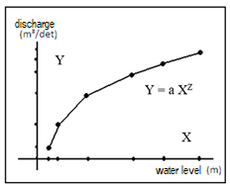

Figure 1. Curve of water level versus discharge

By using the rating curve, the river discharge time series data can be obtained for a certain period. In the HEC-HMS calibration process, the discharge data from the observations compere with the discharge model results occurring at the same time (one hydrograph curve). If the hydrograph of the discharge modelling results differed from the hydrograph discharge obtained from the measurement results (85%), then optimisation calibration procces, was performed by changing the value of the subwatershed parameter components (CN, TL and Ia) from the minimum up to the maximum value. After several optimisations, a model hydrograph that resembles the hydrograph of the observations was obtained, indicating that the model for obtaining river flow rates is acceptable. The component values of the sub watershed parameters resulting from changes can be used to simulate the discharge using time-series rain data input. The process of HEC-HMS optimisation with time series rain data input produces time-series river discharge data, which are the value of river discharge over time (temporal ratio).

2.5 River mainstay discharge analysis
The use of river discharge for power generation must meet reliability requirements where the river discharge value must always be within the determined threshold. The mainstay discharge needed for electric power generation is 85%–90%, which means that from the overall time series river flow events, a discharge rate of 85%–90%, which would be available for generating electricity, must be met.
The mainstay discharge was analysed using the flow duration curve (FDC) method. The mainstay, which is based on the frequency of events, was formulated through Equation (5) (Lei Ye et al, 2015)

$A=\frac{\left(n-q\right)}{n}100\%$ (5)
where n is the number of observations; q is the number of failures, specifically that of discharges smaller than the mainstay discharge. The FDC curve was created by sorting the discharge data from the largest data to the smallest data on the Y axis and creating a probability ranking of the number of events from 1%–100% on the X-axis. The probability of discharge for each percentage was calculated using Equation (6):
$P=100\left[M/\left(n+1\right)\right]$ (6)
where P is the probability of water discharge, M is the ranking position of debit data, and n is the total data.
The river mainstay discharge that was used to turn the electric generator turbine was 90% of the total available flow rate (time series). The 90% minimum mainstay discharge was determined on the basis of the height of the hydrograph, as shown in Figure 2.
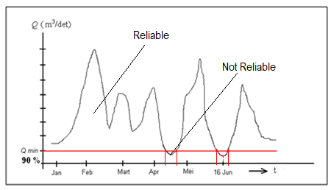

Figure 2. Determination of 90% main discharge

2.6 Head Analysis
The designed waterfall height determines the energy available to move the turbine in the power plant to be built. The location of the power plant construction was determined by analysing the slope in the watershed area. To obtain sufficient water flow for turning the turbine, a high enough slope must be found. The location selected for the power plant must not be too far from the water discharge measurement point. To obtain an adequate waterfall, an appropriate water channel must be built to produce the optimal volume of river flow to turn the power generator turbine. The value of water drop height (head) was determined by subtracting the height of the observation point and the height of the hydropower building point. The height of the location added with the height of the river after being dammed is the height of the waterfall (head) of the river. Head determination based on the assumed ideal field distance is shown in Figure 3.

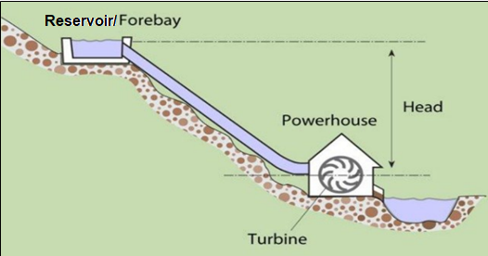
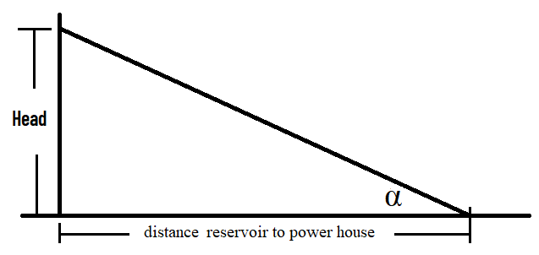

Figure 3. Determination of the head based on distance the reservoir to the power house

2.7 Analysis of water energy for hydroelectric power generation
Hydroelectric power generation is a form of energy conversion from hydropower with a certain height and discharges to electricity, using water turbines and generators. The power generated can be calculated by considering the efficiency of hydroelectric power, usually set at 75%. Equation (7) determines the value of electric power generated by hydropower in a river (Bertrand et al, 2018).
$P=9.81QHη_{e}$ (7)

where P is the theoretical power output (kW), H is the effective water fall (m), Q is the water discharge (m³/s), and $η_{e}$ is the efficiency of hydropower generator.

2.8 Research Uses and Novelty

- Results and discussion
3.1 Condition of the Taludaa–Gorontalo watershed
This study was conducted at the Taludaa–Gorontalo watershed, which was processed using ArcGis 10.5 based on data from topographic map with a scale of 1:250.000 (year 2019) and data from Spot Image 6 and 7 (year 2018), as shown in Figure 4. The ArcGis process calculated that the Taludaa watershed area is 8460.03 hectares or 84.60 km², and the length of the main river is 31.21 km. The topography of the Taludaa watershed is a plateau with a slope of more than 30%–45% and has a rough texture. The condition of vegetation cover in the Taludaa watershed is dominated by high-density vegetation, which is 81.97% of the Taludaa watershed area. Land use in the Taludaa watershed consists of forest (53.27%), residential (15.07%), dry agricultural land (18.56%) and others (13.20%). Land use greatly affects the characteristics of the river discharge hydrograph, especially at the peak of surface runoff.

3.2 Watershed Parameter
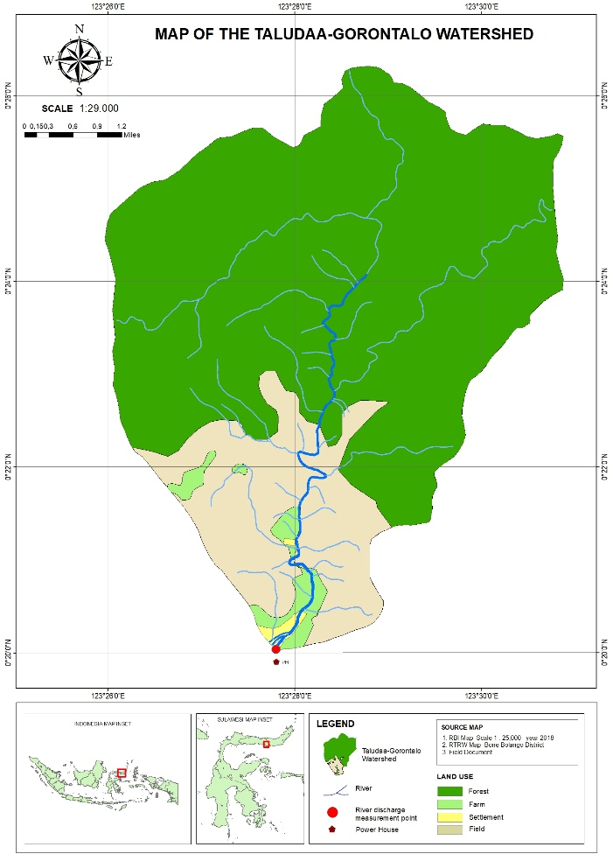
Analysis of the soil maps of the Taludaa watershed revealed three types of soil, namely, Alfisol, Inceptisol and Mollisol. In the soil texture classification (USDA), the three soil textures are categorised as muddy clay and loamy sand. The calculation of the CN value of the Taludaa watershed area based on land use, land cover and soil hydrology group produced composite CN, which is shown in Table 2. Based on the analysis of the SCS-CN model, the sub watershed components were sub-basin, loss, transform and base flow. The values of these components are shown in Table 3.

Figure 4. Map of the Taludaa–Gorontalo watershed

Table 2. Taludaa–Gorontalo watershed CN analysis
Land use type | Condition | Density (%) | spacious (km²) | Soil hydrology | CN | CN composite = 4 x 6
Settlement | 70% impermeable | 30% | 3.46 | C | 70 | 242.20
Forest | Ugly | 50% | 12.24 | C | 69 | 844.56
Agricultural farming | Ugly | < 25 % | 4.26 | C | 75 | 319.50
other areas of use | Medium | 30-70 % | 3.03 | B | 60 | 181.80
 |  |  | 22.99 |  |  | 1588.06
CN composite = 1588.06/ 22.99= 69.076
(Source: Analysis result using GIS, Year 2020)

Table 3. Taludaa watershed morphometry component analysis

Parameters of the watershed morphometry | Value
center of gravity | X=533,258,7636
 | Y=51,252,9415
Gradient | 18.3 %
Length of the main river | 9.996 km
Slope | 0.065
The river segment height | Upstream = 850 (m)
 | outlet = 100 (m)
(Source: Analysis result using GIS, Year 2020)

3.3 Rainfall data, observed discharge and watershed parameters
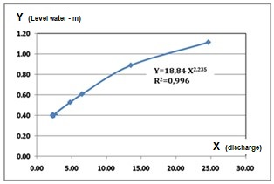
The rainfall data obtained from the rain station logger (ARR) installed in the Taludaa watershed and the water level data recorded by the AWLR station installed on the river. Through Microsoft Excel, discharge and water level data were plotted on a scatter plot; thus, a curve equation (Y = a X^{z}) was obtained, as shown in Figure 5. On the basis of the curve flow diagram, the value of Y = 18.84 X^{2,24} was obtained, with R² = 0.996. The river flow discharge value was obtained by entering the water level value, as shown in Table 4. On the basis of the curve flow equation with the river stage data pair (X variable) and measurement discharge (Y variable), the river flow time series value was obtained, that is, the discharge data on August 03, 04 Hours (12:00–16:00), which would be used for control specification needs in HEC-HMS. Data for the Taludaa sub watershed components were processed and calculated using ArcGis, as shown in Table 5.

Figure 5. Curve flow diagram to obtain the value of the equation Y = aX^{z}

Table 4. Water level pair data and observation discharge in the Taludaa River
No | Date, Year | Level Water (m) | Discharge (m³/s)
1 | 09/06-2020, 16.35 | 0.40 | 2.30
2 | 28/06-2020, 16.53 | 0.41 | 2.31
3 | 30/06-2020, 17.15 | 0.41 | 2.31
4 | 01/07-2020, 17.00 | 0.39 | 2.29
5 | 22/07-2020, 15.00 | 0.40 | 2.31
6 | 24/07-2020, 16.00 | 0.53 | 4.08
7 | 05/08-2020, 09.00 | 0.61 | 6.51
8 | 17/08-2020, 14.00 | 0.89 | 13.50
9 | 20/08-2020, 17.00 | 1.11 | 24.63
(Source: Measurement results, Year 2020)

Table 5. Taludaa watershed components
Component |  | Sub-watershed parameter | Value
1. | Sub Basin | Area (km²) | 22.99
2. | Loss  SCS Curve Number | Initial abstraction (mm)  Curve Number (AMC II)  Impervious area (%) | 15.23  69.08  2.30
3. | Transform  SCS Unit Hydrograph | Time Lag (min) | 83.00
4. | Base Flow | Initial discharge (M³/s)  Recession constant  Flow (m³/s) | 3.30  0.35  4.40
(Source: Analysis result, Year 2020)

3.3 Model analysis with HEC-HMS
The HEC-HMS process was performed by filling in the components which consist of basin model manager, meteorological basin manager, control specification manager, time-series data manager and paired data manager. The values entered into the ‘components’ menu of HEC-HMS are shown in Table 5. The HEC-HMS simulation result based on rain data, simulated discharge model and observed discharge on the 3rd of August 2020, 04:00–16:00 is shown in Figures 6 and 7.
Figure 7 shows that the Taludaa River discharge modelling results indicate a difference between the discharge model and the observed discharge, both for the discharge volume and the peak discharge. Therefore, calibrations must be performed. In HEC-HMS, the calibration process was conducted in the optimisation trial. To adjust the model discharge hydrograph, the value of sub-basin components/parameters (CN, Ia, TL and Rc) were adjusted from the minimum up to the maximum values.
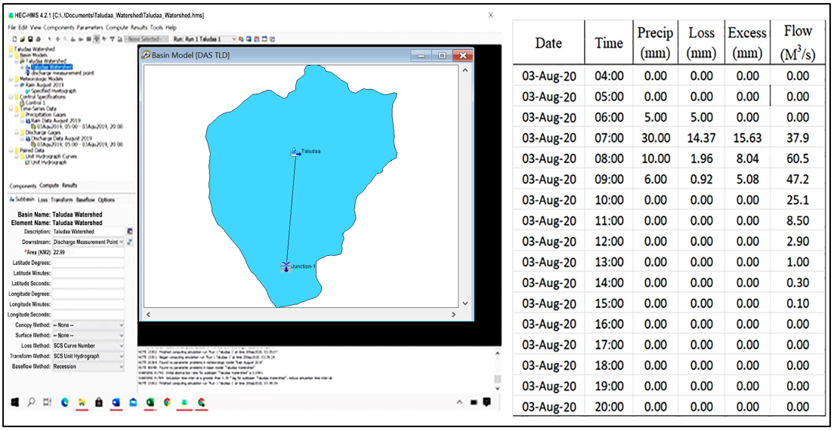

Figure 6. HEC-HMS model process for determining river discharge
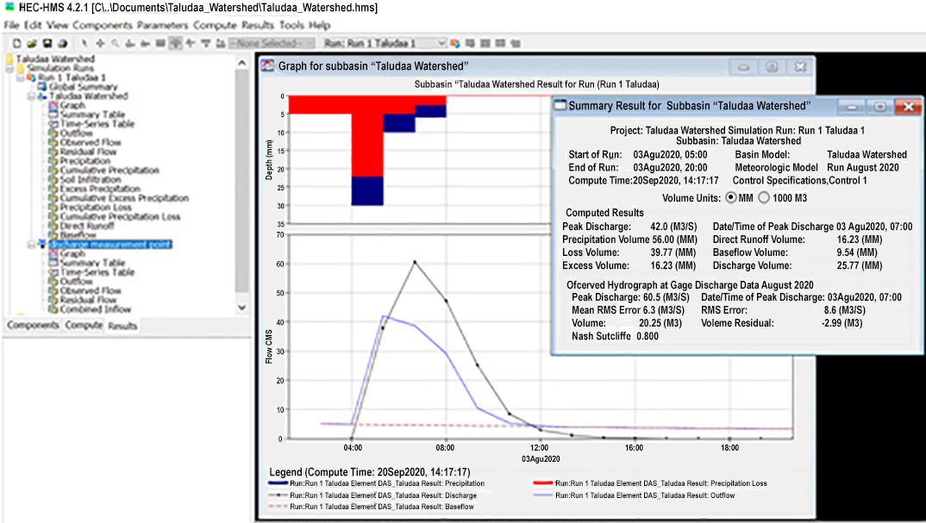

Figure 7. Simulation results of the modelling in HEC-HMS

Figure 7. The results of modelling rain into discharge with HEC-HMS
Optimisation was conducted by performing several optimisations of the sub watershed parameter values, as shown in Figure 8.

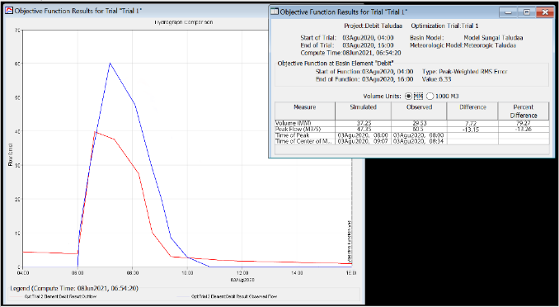
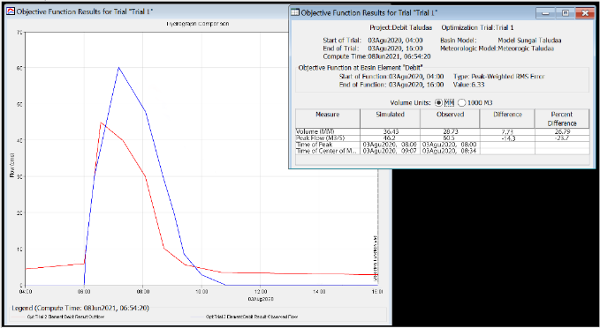

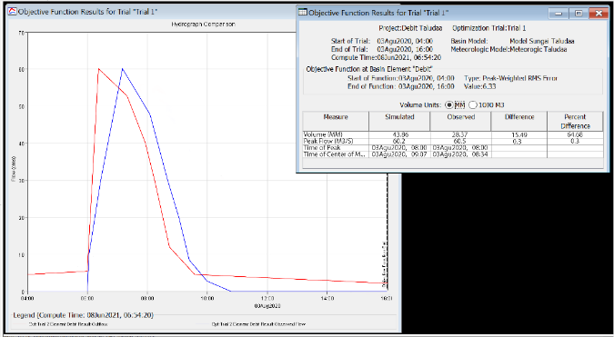
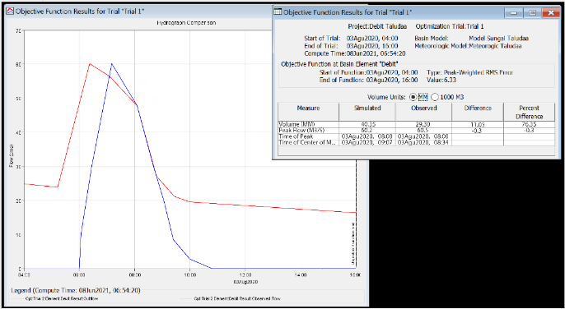
A B

C D
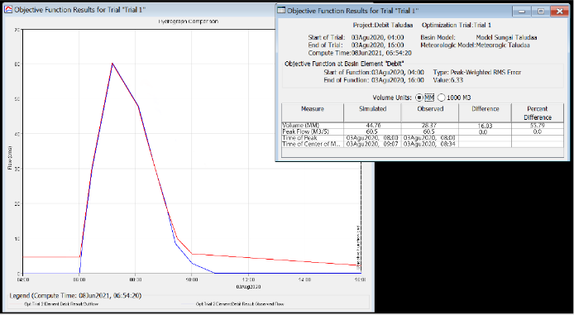

E
Figure 8. Result of the HEC-HMS optimisation process after several changes
in sub watershed parameters

The results of the optimisation process are shown in Figure 8. At point E, the model discharge hydrograph graph resembles the observation discharge hydrograph. Thus, the hydrological model to determine the discharge value of the Taludaa River is acceptable with the difference in flow volume = 44.76 mm and peak flow = 60.5 m³/s. The results of the change in the watershed parameter values are Initial Abstraction (Ia) = 15.23, Time Lag (TL) = 83, Curve Number (CN) = 66, Initial discharge (Id) = 3.3 and Recession constant (Rc) = 0.07.
To obtain the overall river discharge value (spatiotemporal), a simulation was conducted using the optimised parameter values and rainfall data between June and September 2020. The results of the HEC-HMS simulation process are shown in Figure 9.

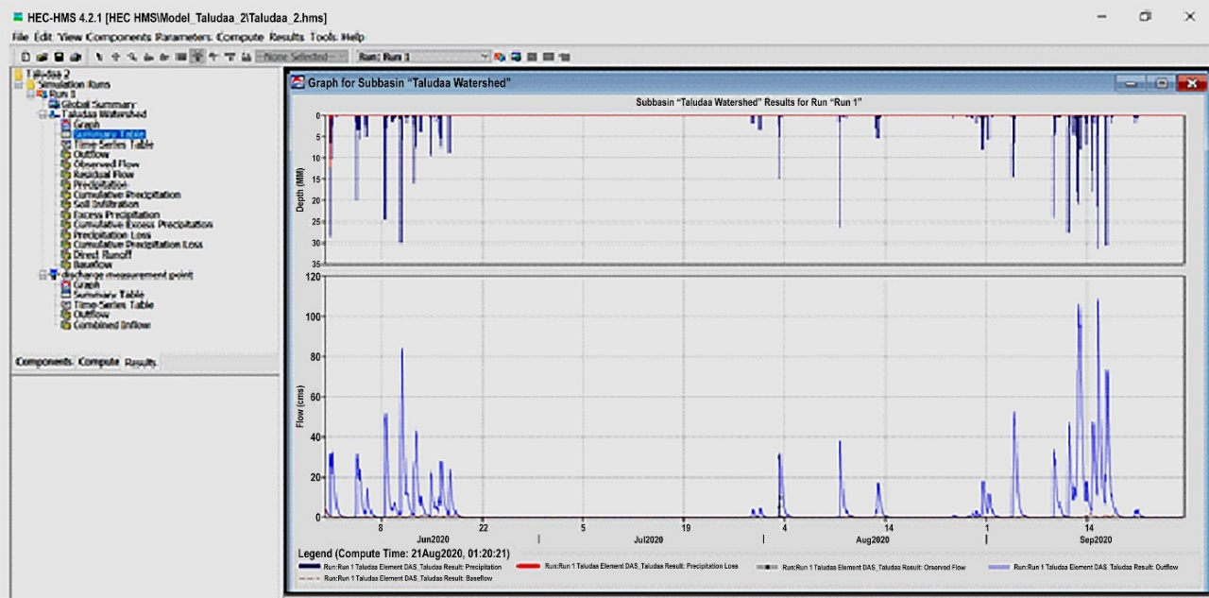

Figure 9. Taludaa River discharge hydrograph between June and September 2020 and
result of the HEC-HMS process

The Use of HEC-HMS hydrologic modelling as applied to Ain Sefra watershed located in southwestern Algeria to predict the surface runoff. The SCS curve number loss method was used to determine the hydrologic losses from the study area and SCS unit hydrograph method was used for effective rainfall transformation, get very satisfying results (Derdour et al, 2018).

3.4 Determination of the mainstay discharge of the Taludaa River Gorontalo
The results of mainstay discharge analysis using the FDC method based on the time series river discharge value from the model reveal that the mainstay river discharge value is = 10.1 m³/s. The process of determining the river’s mainstay discharge using the FDC method is shown in Figure 10.

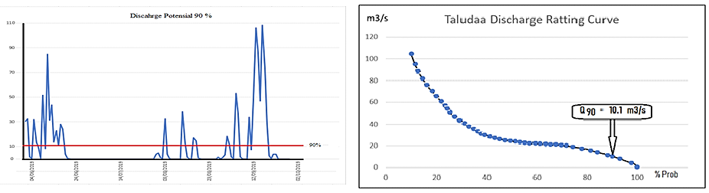

Figure 10. Determination of the river’s mainstay discharge using the FDC method

3.5 Electric power generation potential
Electric resource that can be generated in the Taludaa River can be estimated by measuring the value of the river’s mainstay discharge, the head value and the efficiency of the power plant. The height of the fall of the Taludaa River estimated on the basis of the morphometric conditions of the river is 3.25 m. If a dam is built with a height of 5 m, then the head would be 8.25 m. Let the estimated power plant efficiency be 75%; then, the electrical energy that can be obtained from the Taludaa River is

P = 9.8 x 10.1 x 8.25 x 75% = 612.438 kW.

To obtain additional power, microscale hydroelectric power plants can be built in parallel by utilising the wastewater from generator 1 to be used for generator 2 and so on. The output power of microscale hydroelectric power plants can also be increased by raising the value of the water drop height (head); the higher the water drop, the greater the electrical power generated by the hydroelectric power plant.

- Conclusion
The river flow rates in the Taludaa–Gorontalo watershed were analysed by transforming rain into streams using the SCS-CN model. The watershed parameter components that were used as inputs for the HEC-HMS hydrological model are as follows: maximum water retention potential (as an initial abstraction value [Ia] or water loss before runoff) = 18, the time between peak rainfall and peak discharge (determined by TL) = 60 min and CN which represent the conditions of land use in the watershed area and soil hydrology = 40.63 and Rc = 0.07. The determination of the river’s mainstay discharge using the FDC method resulted in a temporal ratio of the mainstay discharge of the Taludaa River (i.e. 10.1 m³/s). By damming the river, the value of the water drop height could be obtained (i.e. 8.25 m). Assuming that the power plant efficiency was 75%, the value of electric power that could be generated in the Taludaa River was 612.438 kW.
Power could be continuously generated even though the rain did not fall at certain times in the catchment area. This is because according to the analysis, in 2020, the Taludaa-Gorontalo river flow energy could be relied upon to generate electrical power.

References
Amos T., Kabo-Bah, Chuks. J, Nokoe K, Mulugetta Y, Obeng-Ofori D, and Akpoti K, “Multiyear rainfall and temperature trends in the Volta river basin and their potential impact on hydropower generation in Ghana,” Climate, vol. 4, no. 4, p. 49, 2016.
Andrzej Walegaa, Devendra M. Amatyab, Peter Caldwellc, Mariond Sudhanshu Panda, Assessment of storm direct runoff and peak flow rates using improved SCS-CN models for selected forested watersheds in the Southeastern United States, Journal of Hydrology: Regional Studies Volume 27, February 2020,
Derdour A, Bouanani A, Babahamed K, 2018, Modelling rainfall runoff relations using HEC-HMS in a semi-arid region: Case study in Ain Sefra watershed, Ksour Mountains (SW Algeria), Journal Of Water And Land Development, No. 36 (I–III): 45–55.
Lei Ye,Wei Ding, Xiaofan Zeng, Zhuohang Xin, Jian Wu and Chi Zhang, Inherent Relationship between Flow Duration Curves at Different Time Scales: A Perspective on Monthly Flow Data Utilization in Daily Flow Duration Curve Estimation, Journal MDPI Water Vol. 10, Issue 8, July 2018.
Mishra S.K, Gajbhiye S, Pandey A, September 2013, Estimation of design runoff curve numbers for Narmada watersheds (India), Journal of Applied Water Engineering and Research Vol. 1, No. 1, 69–79, 2013.
Ningaraju H.J, Ganesh Kumar S, Surendra H J, May 2016, Estimation of Runoff Using SCS-CN and GIS method in ungauged watershed: A case study of Kharadya mill watershed, India. International Journal of Advanced Engineering Research and Science (IJAERS) Vol-3, Issue-5 , May- 2016.
Pamela J. Edwards, Karl W.J. Williard, Jon E. Schoonover, Fundamentals of Watershed Hydrology, Journal of Contemporary Water Research & Education Volume 154, Issue1 April 2015.
Rasmy M, Sayama T, and Koike T, “Development of water and energy Budget-based Rainfall-Runoff-Inundation model (WEB-RRI) and its verification in the Kalu and Mundeni River Basins, Sri Lanka,” J. Hydrol., vol. 579, p. 124163, 2019.
Samora I, Manso P, Franca M.J, Schleiss A.J, and Ramos H.M, “Opportunity and economic feasibility of inline microhydropower units in water supply networks,” J. Water Resour. Plan. Manag., vol. 142, no. 11, p. 4016052, 2016.
Silveira L, F. Charbonnier, J.L. Genta, The antecedent soil moisture condition of the curve number procedure, Hydrological Sciences-Journal~des Sciences Hydrologiques, 45(i) February 2000.
Tsai Y.C, Chiu C.P, Ko F.K, Chen T.C, and Yang J.T, “Desalination plants and renewables combined to solve power and water issues,” Energy, vol. 113, pp. 1018–1030, 2016.

