**Potential Tourism Attraction of Cokro Caves, Gunungkidul Regency as a Special Interest Tourism Development Concept**

**Elisa Dwi Rohani1, Muhammad Baiquni2, Djoko Wijono3, John Soeprihanto4**

1 Faculty Graduate School,Universitas Gadjah Mada, elisa.dwi.rohani@ugm.ac.id

2 Faculty of Geography, Universitas Gadjah Mada, Indonesia, mbaiquni@ugm.ac.id

3 Faculty of Engineering, Universitas Gadjah Mada, Indonesia, djoko_wijono@ugm.ac.id

4 Faculty of Economics and Business, Universitas Gadjah Mada, Indonesia, [johnsuprihanto@ugm.ac.id](mailto:johnsuprihanto@ugm.ac.id)

**Abstract**

Special interest tourism has become a current tourism trend where special interest tourism is carried out to avoid mass tourism, in other words, special interest tourism is an alternative tourism activity. One of the types of pari tourist interest in lodging based potency of nature is pari tourist nature of geological-volcanic activities such as browsing Caves of nature ( cav ing ) as well as rock climbing . Cokro Cave is one of the tourist destinations in Gunung Kidul, which is formed from narrow cracks in limestone which are genetically controlled by geological structures forming an 18 m deep apitch. As a tourist destination, it is necessary to explore the potential that exists in Cokro Cave to be developed into sustainable special interest tourism. The purpose of this study is to describe the potential of Cokro Cave as a special interest tourism. The method used in this study is a literature study by utilizing the results of observations and the results of preliminary research conducted on objects which are then presented in a qualitative descriptive manner. From the results of preliminary research conducted, it is known that Cokro Cave has a good appeal to be used as a special interest tourist destination, but is quite vulnerable to damage because it needs attention to maintain the sustainability of this tourist destination. Based on these results, it can be concluded that the concept of developing Cokro Cave as a special interest tourism that can be applied is the management of special interest tourism by limiting the number of tourist visits in order to preserve the environment and collaborating with tourist attractions around and with pokdarwis management of the Cave Area.

**Keywords ; Development, Tourist Attraction, Special Interest Tourism, Caves, Tourist Destinations**

**Introduction**

Special interest tourism Special Interest Tourism (SIT) is considered to reflect the diversity of recreation interests that continue to rise from the recreational community of modern end (Douglas&Derret, 2001). One of the types of pari tourist interest in lodging based potency of nature is pari tourist interest in special nature of geological-volcanic. Types of volcanic geology natural attractions include exploration of natural caves ( cav ing ) and rock climbing . The cave is a natural underground cavity shaped including entrance ( entrance) , hall (hall) and the room (room / cubicle) that can be tracked by explorers (Rahmadi, 2007). Browsing Cave became one of the forms of tourism activities of special interest to the activity primarily is an adventure searches Cave that many emit energy and it contains an element of challenge, by thus required courage (Fandeli, 2002). Cave exploration has now become a special interest tourism activity with karst caves as a search area . One of the power appeal is due to the form of physical ( speleotherm ), the sights on the outside as well as the appeal of mystical (Floreal, 2009). Tourism activities that take advantage of the potential and beauty of the cave as a tourist attraction are called SpeleoTourism .

Indonesia is currently listed in the National Geopark Global Network since 20 September 2015. The designation of Gunung Sewu which is located in three different areas, namely Gunungkidul Regency, DIY Province, Wonogiri Regency, Central Java Province, and Pacitan Regency, East Java Province, as a member of the GGN is due to the fact that in this area there are quite a lot of caves. One Geoarea who were in the District of Gunung them as follows;

**Table 1.**

**Gunungkidul Regency Geosite Is A Member Of The**

**Global Geopark Network**

|  |  |
| --- | --- |
| **Geosite** | **Location** |
| Nglanggeran Ancient Volcano | Ds. Nglanggeran, Kec. peck |
| The precipitate Sea Shallow Sambipitu | Ds. Sambipitu, Kec. peck |
| Pindul Cave | Ds. Bejiharjo, Kec. Karangmojo |
| Kalisuci Complex | Ds. Matejo, district. Semanu |
| Luweng Jomblang | Ds. Matejo, district. Semanu |
| Siung-Wediombo beach area | district. Tepus (Siung) and Kec. Girisubo (Wediombo) |
| Sadeng Ancient Valley | district. Girisubo |
| Niagara Falls Bleberan | Ds. Bleberan, Kec. Playen |
| Area Beach Baron-Kukup-Krakal | Ds. Kemadang, Kec. Tanjungsari |
| Luweng Cokro | Ds. Umbulrejo, Kec. Ponjong |
| Ngingrong Cave | Ds. Mulo, District. Semanu |

Source: Application Dossier for Membership to UNESCO Global Geopark Network, 2013

In the Gunungkidul geoarea, there are 5 caves that are geosites, the five caves are Kalisuci Cave, Jomblang-Grubug Cave, Pindul Cave, Cokro Cave, and Ngingrong Cave or also called the Mulo Valley. The entire Caves of the geosite Mount Sewu UNESCO Geopark that have unique well as geology, karstologi, and speleology. However, the object of the cave tour in Indonesia when it has not been developed, managed, and maintained in accordance standards internationally such as in countries advanced, so has not been entered as a member of the World Association of Commercial Caves . Problems that are often ignored in the development and management of caves for tourism activities are the lack of attention to the carrying capacity of the cave, mapping of caves both inside and outside the cave, so that the concept of cave development for tourism does not pay attention to the characteristics of the cave. In addition, in an effort utilizing the cave for tourism are not based by an indication of the details as the basis for a good development that can be categorized as a cave for tourism en masse or for tourism of special interest.

**Methods**

This study uses a qualitative descriptive research approach related to the study of phenomena in more detail or distinguishing them from other phenomena. The reason for using a qualitative approach is based on the assumption that tourism is not enough to only be understood as a phenomenon but also must be analyzed realistically critically, and constructed locally and specifically (Denzin and Lincoln, 2009). This study was conducted to explain how the development of special interest tourism that occurred in the Potential of the Cave by utilizing the characteristics and uniqueness of the cave, but still paying attention to the preservation of the cave, as well as the role of local communities, government and stakeholders in tourism development.

**Result And Discussion**

**Special Interest Tours**

It is said that the old concept of special interest tourism to draft pari special interest tourism products to adopt this approach. Special interest tourism is tourism based on nature, and focuses on a series of products that can be developed around the various tourism activities undertaken in the setting of cultural, environmental, rural, urban , and more. Specially designed product development aims to attract tourists to the class above, which is able to generate revenue that high through the provision of the services individually.

According to Hacioglu and Avcikurt (2011) special interest tourism can be defined as a special form of tourism that focuses on one topic and organizes private tours including groups appointed by people who want to develop interests. Special interest tourism includes activities such as boat tours, cruises, train tours, trekking, hiking, golf, tennis, fishing, rafting, and bird watching. While Robinson and Novelli (2005) define special interest tourism as the development of the concept of tourism which is seen as a response to the negative effects of mass tourism ( mass tourism ).

Special interest tourism consists of various forms of special interest trips are different has been known as a market specialized for many years and is gaining popularity among the tourism industry. The product aspect approach in special interest tourism can be seen in the following figure ;

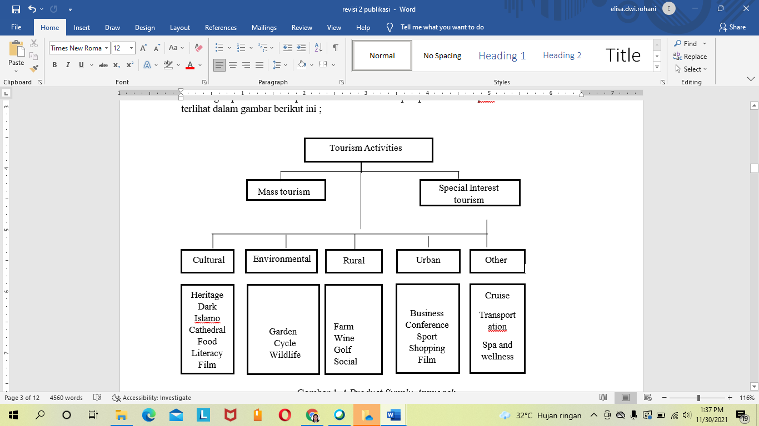

Figure 1 A Product Supply Approach

Source : Robinson and Novell (2005)

The picture above describes that tourism activities are for mass activities and special interests. Seen that special interest tourism pick the 5 categories namely pari tourist interest in particular based on culture, the environment, rural, urban, or other forms. The term 'special interest' should indicate that the tourist has a very specific purpose when visiting the attraction with the aim of satisfying his or her interest whether this relates to a hobby, curiosity or adventure challenge. In fact, no single traveler with a keen interest when visiting the attractions tours, but travelers will come to the destination specified hoping to enjoy a variety of experiences as a complement to the activity of tour main which had been planned.

**Cave Tourism (Speleotourism)**

Gema (2004) states that a cave is a naturally formed tunnel underground that can be traversed by humans. According Aristiyanto (2005), the cave is a form of ecosystem below the surface ( sub-surface ) that is unique in that a lot of attention of the biospeleologi to observe the area, because there is a difference with the life in the surface such as: 1) Communities are different to the surface, especially the atmosphere which wet, 2) environment that is wet without light, 3) Changes in physiological systems due to temperature, light, and a different pressure to the surface.

Cave is a place that has the power attraction of its own because it provides an element of adventure. Activity search caves including crawling, creeping, squatting, sometimes have to swim, as well as require a tool specifically as jummar, Croll, rope, carabiners and others provide challenges are different. All of these activities are carried out only with the help of lighting equipment owned by the searcher, which provides quite an interesting challenge to do (Mulyati, 2007). By since the tour of the cave can be developed as pari tourist interest in particular who has goals and objectives (Bahri, 1997), among others are;

1. Diversification (diversification) of tourism products , especially those based on nature and the environment
2. Utilizing source power of nature is optimal based on the principles principle of conservation
3. As a place for education, training, research and socialization of the speleology and tourism aspects of Caves
4. Mengembangankan object of tourist caves that meet the principles of planning in natural
5. Creating a society that respects and loves nature and the environment
6. Collecting the data and information of the cave that gives benefits to managers of attraction cave effectively and efficiently
7. Creating, developing and managing one of the caves into a model of which is based on aspects of the preservation of the environment and principles principles of ecosystem
8. Creating an integrated cave tourism object management system.

In addition , according Ko (2001) states the criteria cave for tourism interest in specialized least fulfilled of which are 1) the number of applicants that little in terms of this segment of the market rating specific, 2) Travel the risk is high, so that the required assurance of safety for tourists who will visit, 3) travel which has field level of difficulty that high, so travelers who will pay a visit to the tourist area of special interest having an excellent physical condition, 4) the state of the object that is still original, and 5) have special equipment and have a skill is high.

Speleo Tourism on a power pull, should pay attention to target travelers who will go. We recommend that a Speleo Tourism be made for special interest tourists with a fairly high price due to the following considerations :

1. Special interest tourists better understand and comprehend Speleo Tourism with good and capable of maintaining a source of power of nature that exist in comparison rating mass tourism are paying less attention to nature;
2. Special interest tourists prioritize education and conservation in their visits to Speleo Tourism, while mass tourism tourists only emphasize euphoria;
3. The contribution of the price which is quite high can be channeled to the preservation and protection (conservation) Speleo Tourism ;
4. A high enough price can avoid the type of tourists who come just to take photos or lack knowledge about conservation. Many of rating cut stalaktik and stalagmite due to ignorance them and cause changes or vandalism Speleo Tourism them. (Kusuma and Lutu, 2017)

**General Description**

Clark cave was first discovered by nature lovers from the community Acintyacunyata Speleological Club (ASC) in the year 1993 and in the year 2009 the cave is beginning to develop into a tourist attraction which is managed directly by the public local. Based on the shape of the entrance, Cokro Cave is a vertical cave with a score of three which has 2 entrances in the form of a karst window in the form of a well with a distance of 8 meters. The mouth of the first cave measures 1.5 m x 0.8 m, while the mouth of the second cave is narrower. Clark enters the cave access only through the mouth of the cave the second or the more little things is caused because the mouth of the cave pick the structure of the soil is rocky that is safe for dipijak, while the mouth of the cave first pick sturuktur thin soil, resulting in easy sliding. The following is a description of the Cokro Cave Trajectory Map

Figure 1

Cokro . Cave Trail Map

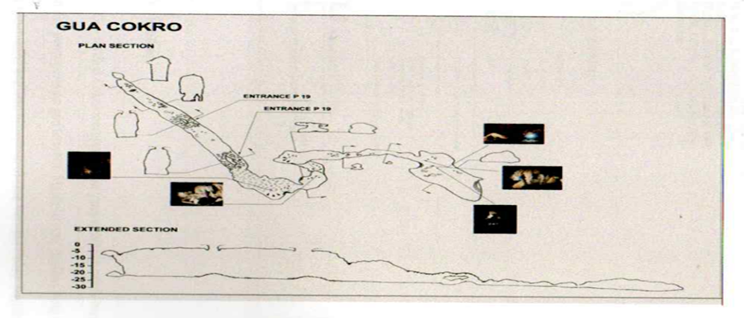

Source: Cokro Cave tourist attraction, 2021

Cokro Cave is a vertical cave with a depth of approximately 18 meters and has a cave mouth in the form of a well with a distance between wells of 8 meters. This cave has a long hallway reaching 218 meters, the hallway leading to the north is longer and ends in a Chamber (large room) measuring 25 x 40 meters with a height of about 25 meters. Chamber (space large) that are in the cave is inhabited by bats and birds Seriti (Fadlan, 2013). The conditions in Cokro Cave are slightly humid, this is due to the air circulation being not smooth due to the narrowing of the cave passage, so that exploring the cave with more than 10 people can make excessive use of oxygen and cause hyperventilation (lack of oxygen in the hallway). Caves Clark pick the ornaments very beautiful that can not be enjoyed by visitors of the wild open, in addition to the caves is having stalatit and stalamit twinkling and sparkling attached to the section below and the walls of the cave which portray the process of formation of the cave (Speleogenesisi).

Cokro Cave is a narrow crack in limestone that is genetically controlled by geological structures forming an 18 m deep apitch. The horizontal section is about 250 m long and a small space inside the bottom is filled with active cave ornaments. The ceiling of the cave is a habitat for bats. Visitors can explore the cave using a single rope, accompanied by a professional guide from the locals. This geological site has been managed and developed into a geotourism attraction by the people of Dusun Blimbing in the form of small groups. Cokro Cave is part of the Gunungkidul Geosite which is included in the Global Geopark Network (GGN) and is managed with the concept of special interest tourism. However, these two geosites have very different cave characters, vertical caves by offering a tourist attraction in the form of cave ornaments. Therefore, this cave has the concept of developing Cokro Cave into a special interest tourism based on the uniqueness of the cave.

**The Potential of Cokro Caves as a Special Interest Tourism Concept**

Cokro Cave was first discovered by the nature lovers community ASC (Acintyacunyata Speleogical Club) in 1993, which serves as an object of research and observation by nature lovers. In 2009 the manager of the Cokro Caves tourist attraction named Mekars (Karst and Cave Ecotourism Society) was formed. Cokro Cave comes from the word "Cakra" which means weapon. Based on the results of interviews with the chief manager of Cakro Cave, there was once a thief of household appliances and weapons such as kris, spears and others which were taken from people's homes. Because he was caught red-handed, the thief hid in the cave with the loot and committed suicide in the cave using the stolen weapon. So from there the cave was given the name Cokro Cave which was taken from the word weapon (Cakra). The tourism potentials that are the main attraction of Cokro Cave include:

1. Attraction

Cokro Cave, located in Blimbing Hamlet, Umbulrejo Village, Ponjong District, is a vertical cave with a depth of 18 meters which has two cave mouths in the form of wells with a distance between the wells of about 8 meters. Cokro Cave can only be accessed through the mouth of the smaller cave (the mouth of the second cave) because it has a strong soil structure so it is safe for footing, while the mouth of the first cave has a thin soil structure that makes it easy to slide. To increase the safety of the mouth of the first cave closed with a guardrail around the mouth of the cave. Cokro Cave has a length of 218 meters with a depth of 24 meters, only has one entrance and exit.

The main tourist attraction that tourists can do in Cokro Cave is to study the process of cave formation, get to know various types of cave ornaments and map caves. The process of the formation of the Cokro cave due to the entry of water into the ground flowing through the fracture field in the limestone layer to the surface river. The soluble minerals are eroded and the hole in the soil is getting bigger, so the surface river that erodes the riverbed and forms a new horizontal cave network. The ceiling above the cave will collapse and meet the old horizontal cave system and form a cave pit.

Another attraction that tourists can enjoy while in the cave is a large room (chamber) at the end of the cave measuring 1000 m² with a height of less than 25 m, inhabited by bats and seriti birds. In addition, in the cave there are various rock ornaments of stalagmite and stalactite rocks, pillars which are the meeting of stalagmites and stalactites into one, sparkling cave pearls attached to the bottom of the cave walls, flowstone (water stone) that resembles a lion statue.

Tourists not only do a cave exploration in Cokro Cave, but can also do a walk through the Gremeng cave which is still in the same area as the Kalisuci Cave. In addition, tourists who love photography can enjoy the beauty of nature by capturing the picture of the Cokro Caves area which offers views of hills overgrown with trees. Cokro Caves through the tourist village community also offers traditional art tourist attractions that can be displayed according to guest requests such as musical arts, campursari, reog, ketoprak, jathilan, and tek-tek. Although classified as a new tourism and not yet developed enough, Cokro Cave has been visited by a limited number of tourists, here are the data on the number of tourist visits in Cokro Cave

**Table 2**

**Number of Visitors to Cokro Caves**

|  |  |  |  |  |  |  |
| --- | --- | --- | --- | --- | --- | --- |
| Month | Year | | | | | |
| 2014 | 2015 | 2016 | 2017 | 2018 | 2019 |
| January | 16 | 0 | 19 | 4 | 0 | 0 |
| February | 37 | 44 | 0 | 6 | 5 | 9 |
| March | 29 | 0 | 0 | 6 | 2 | 6 |
| April | 43 | 0 | 13 | 26 | 12 | 12 |
| May | 30 | 22 | 6 | 20 | 7 | 5 |
| June | 30 | 0 | 54 | 3 | 6 | 7 |
| July | 0 | 0 | 0 | 0 | 1 | 0 |
| August | 0 | 13 | 0 | 7 | 25 | 9 |
| September | 0 | 0 | 9 | 0 | 11 | 0 |
| October | 0 | 11 | 0 | 9 | 16 | 1 |
| November | 33 | 0 | 9 | 2 | 10 | 10 |
| December | 0 | 0 | 0 | 6 | 14 | 0 |
| Amount | 218 | 90 | 110 | 89 | 109 | 59 |

Source ; Cokro Cave Manager, 2021

The table above shows the number of tourist visits since Cokro Cave was opened for tourism activities to date. It can be seen that the number of tourist visits to this geosite is not large enough and is not visited by tourists throughout the year. In 2020 to 2021 there will be no tourist visits due to the Covid 19 virus, which has a direct impact on the Cokro Cave tourist attraction. In addition, the majority of tourists who visit Cokro Cave are students who love nature, as well as tourists who have a special interest and interest in conducting research on the characteristics of the cave.

1. Accessibility

Cokro Cave is located in Blimbing Hamlet, 18 Km from Wonosari City which can be accessed by private vehicle. This tourist attraction is 52 Km from the city of Yogyakarta with a travel time of about 1.30 hours. Until now there is no public or special transportation available to this tourist attraction, so many tourists come using private vehicles.

Access to Cokro Cave is quite easy to reach with paved road conditions to reach Blimbing hamlet. While the condition of the road to the Cokro cave geosite is a cast road, with a width of 3 meters. But unfortunately, access roads to Cokro Cave are not all in good condition, some parts of the road are damaged. Although the path to Cokro Cave has been casted, the condition of the road is slippery during the rainy season, so it becomes an obstacle for visitors. Given the existence of the Cokro cave which is relatively remote, and the lack of promotion, so far not many tourists know that Blimbing village has the potential for vertical cave ridge tourism.

1. Amenity

Until now, the facilities and infrastructure available in Cokro Cave are still very limited. Due to limited funds owned by the manager so that the need for facilities and infrastructure is inadequate which has an impact on the quality standards of the facilities. The facilities and infrastructure available in Cokro Cave include bathrooms, mosques, directions, secretaries, caving equipment, resting huts, and tree planting areas.

The availability of facilities and infrastructure in the Cokro Caves area is still in poor condition and is not feasible, such as bathrooms and resting places. In addition, the condition of facilities and infrastructure is far from the location of the Cokro Cave and is close to residential areas. Therefore, it is necessary to develop supporting facilities and infrastructure around the Cokro Caves area. While adequate infrastructure in this tourist attraction is the availability of clean water from underground springs.

1. Institutional

Based on the Decree of the Head of the Tourism Office of Gunungkidul Regency NO.001/KPTS/2019 dated January 14, 2019 concerning the Inauguration of the Cokro Caves Mekars Tourism Awareness Group, Umbulrejo Village, Ponjong District, Gunungkidul Regency, decided and determined the formation of the Cokro Caves tourism awareness group located in the tourist destination of Caves. Cokro, Umbelrejo village. The Cokro Caves Mekars Tourism Awareness Group is required to comply with laws and regulations in managing tourism in Cokro Caves, as well as paying attention to environmental sustainability.

The Mekars group (the Cave and Karst Ecotourism Society) which manages the Cokro Cave tourist attraction consists of 17 local communities which was formed in 2009. The Mekars manager is responsible for everything in the Cokro Cave tourist attraction. and preserve the conditions inside and outside the cave environment, work as a tour guide, and maintain and use standard cave tracking equipment.

Since the opening of the Cokro Cave as a tourist attraction, the manager of the Cokro Cave tourist attraction has carried out various activities aimed at the progress and development of the Cokro Cave tourist attraction, namely by involving members in training and socialization of tour guides held by the Gunungkidul Regency Tourism Office. One of the trainings that the Mekars management and management members participated in was the cave search technique training which was held directly by the SAR team of Gunungkidul Regency, ASC Yogyakarta, and MAPALA from various visiting universities.

1. Cokro Cave tour package

Cokro Cave is currently managed by the “Mekars” group, which has compiled and sold cave tour packages. This tour package is offered to tourists who want to explore Cokro Caves. The price of this tour package is made based on the number of visitors with facilities in the form of a welcome drink and all cave exploration equipment as well as a guide. Cokro Cave tour packages are grouped into 3 as follows;

- Price IDR 1,000,000, for 10 people

- IDR 1,500,000, for 15 people

- Price IDR 2,000,000, for 20 people

In addition to tourists doing Cokro cave trekking activities, they can also do tourist activities to enjoy the natural beauty in Gremeng Cave by adding 35,000 fees. Gremeng Cave is a horizontal cave with water flowing on the surface. This cave has a length of 1 km which ends in Sumurup Cave. However, Gremeng Cave can only be traced during the dry season because during the rainy season the overflow of water causes the tracking path to be closed.

In addition, this Cokro Plus Cave tour package offers 2 different packages with added value offered in the form of a choice of village culinary packages and cultural arts attractions. This culinary Cokro Cave tour package is offered to tourists in the form of home-cooked food from the local community, with prices that are quite varied starting from Rp. 10,000 per tourist up to a price of Rp. 50,000 per tourist. The food menu offered can be adjusted according to tourist requests or follow a predetermined package. As well as cultural arts attractions. Tourists can not only do cave exploration and enjoy culinary delights but can also enjoy the performing arts of Reog, karawitan, bamboo orchestra, with varied prices depending on the type of tourist attraction presented.

**Collaborative Concept And Synergy With Other Tourist Destinations**

The concept of special interest tourism that can be applied in the Cokro Caves area is the management of special interest tourism by limiting the number of tourist visits in order to maintain environmental sustainability as well as collaboratively with tourist attractions around and with pokdarwis management of the Cave Area. Based on the description of the Cokro Cave development potential map below, it can be seen that priority 1 is in the Cokro cave area and Gremeng Cave - also connected to Banyu Sumurup, priority 2 is in the Lawa Cave area and Beton Source/ Simo reservoir, while the second priority is in the The Kalimati Pillar Caves - Telog Caves and Jelong Caves.

Figure 2

Cokro . Cave Development Potential Map

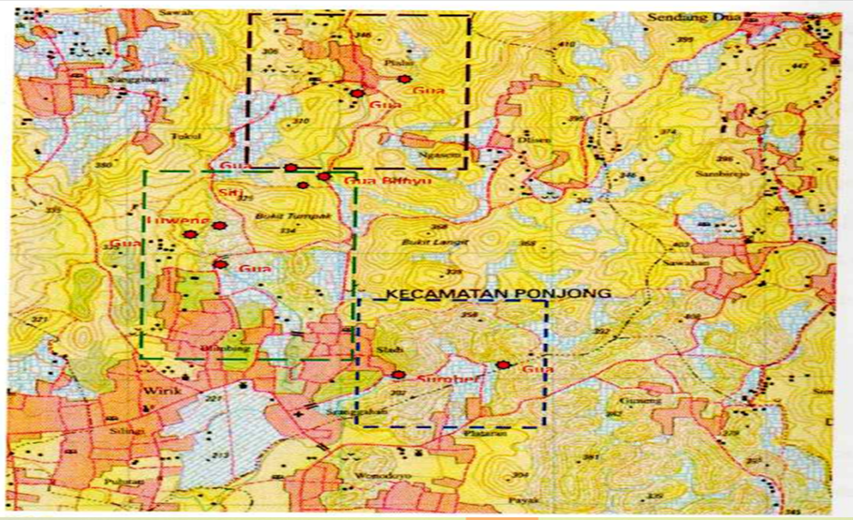

Source : Source : Cokro Cave tourism object manager, 2021

Collaborative Concepts and Synergy With tourism objects being the main consideration in managing Cokro Cave considering the condition and location of Cokro Caves which are close to other tourist attractions, so that the tourist attractions offered are more diverse and provide more experiences for tourists. This collaborative concept can be done by compiling a program of joint activities between tourist objects, including:

1. Exploration

The initial step taken by the Umbulrejo Tourism Village is to explore the natural potential in the Umbulrejo Tourism Village or often referred to as exploration. Identification of village potential through discussion with all village components from all walks of life. The potential that can become a commodity can vary from all aspects. It can be natural beauty, produce, richness of flora and fauna/biological, socio-cultural, community, tradition or things that are unique/distinctive that other regions do not have. This is done to ensure the superior potential that will be used as the main commodity. The need for a strong commitment from all village components to equalize opinions, perceptions and raise the potential of the village to become a tourist village. This commitment is the strongest support for the realization and sustainability of tourist villages. Identify the impact of both positive and negative impacts of a tourism activity according to the uniqueness of each village. Each village has its own characteristics which will produce different impacts from each other, especially socio-cultural changes. Strong commitment from all village components to cooperate with the Regional Government and if necessary to cooperate with the private sector. Identification is also the impact of working with the private sector. This includes budgeting for the development of tourist villages by using all existing economic resources. Prepare all sets of normative rules/regulations that are more aimed at overseeing the development of tourist villages and overseeing potential deviations that might occur. Regulations are prepared so that tourism activities and their impacts remain within the regulatory corridor as the legal umbrella.

2. Structuring the Tourist Destination Area

Structuring the area in tourist destinations is very important, because this is what will make a place famous. With the concept of Sapta Pesona, Umbulrejo Tourism Village will continue to make efforts to increase tourist attraction around the Umbulrejo Village tourist area.

3. Human Resources Improvement Training

Conducting trainings for all village components, including village governments on tourism management, how to manage tourist attractions, management of guests/visitors, as well as innovations that need to be developed considering that like other sectors the tourism sector also experiences fluctuations and can experience "saturation". Identify problems that can be obstacles to the development of village tourism potential, ranging from physical, non-physical or social, internal and external. Or it could be that if the problem is processed in a certain way, it can become a potential problem.

4. Making Tourism Village Tour Packages in collaboration with BUMDes Umbulrejo

Given the large number of tourism potentials in the Umbulrejo Tourism Village, it is necessary to make various kinds of tour packages that can accommodate all types of tourism, such as water tourism, cave/caving fringing, agricultural tourism, tracking, and others. The making of Umbulrejo Tourism Village tour packages will be carried out in collaboration with Umbulrejo Village BUMDes.

5. National Tourist Promotion

Promotions must be carried out so that tourists are more familiar with tourist destinations. Either manually / offline or online. It is done manually by promotion through brochures, tour packages and verbal promotions.

6.Improving Infrastructure and Facilities in Tourist Areas

Currently, the infrastructure and facilities in the Umbulrejo Tourism Village are still very minimal, so the participation of all stakeholders in the community and the government is very much needed. Therefore, Umbulrejo Tourism Village has a medium-term work program (1-3 years) to make efforts to improve infrastructure and facilities in tourist areas, both sourced from the surrounding community and seek funding sources in the form of cooperation proposals with the government or private parties.

7. Cooperating with Investors

In order to create a professional and highly competitive Tourism Village, Umbulrejo Tourism Village has a long-term (5-10 year) work program, namely collaborating with investors engaged in tourism to support business growth in the tourism sector, such as establishing resorts, lodging , hotels, and others which of course must consider tourism regulations and societal norms.

8. Promotion of Foreign Tourists

Umbulrejo Tourism Village has a tourist destination of Goa Cokro which is included in the Gunung Sewu UNESCO Global Geopark Network. Conservation tourism for research on the occurrence of beautiful stalactite and stalagmite ornaments in geology, and vertical cave caving, which is full of challenges, has the potential to attract tourist visits, both local and foreign tourists. Therefore, Umbulrejo Tourism Village has a long-term program and seeks to promote foreign tourists.

**Conclusion**

Special interest tourism consists of various forms of travel that have been known as specialty markets for many years and are gaining popularity among tourism industry players (Albani, 2011). One of the types of pari tourist interest in lodging based potency of nature is pari tourist interest in special nature of geological-volcanic activity of the mountain observation of the volcano, directly or indirectly, the exploration of natural Caves ( cav ing ) as well as rock climbing . Based on the results of the Cokro Cave research, the concept of special interest tourism that can be applied in the Cokro Caves area is the management of special interest tourism by limiting the number of tourist visits in order to maintain environmental sustainability and collaboratively with tourist attractions around and with pokdarwis management of the Cave Area. Based on the description of the Cokro Cave development potential map below, it can be seen that priority 1 is in the Cokro cave area and Gremeng Cave - also connected to Banyu Sumurup, priority 2 is in the Lawa Cave and Sumber Beton area / Simo reservoir, while the second priority is in the The Kalimati Pillar Caves - Telog Caves and Jelong Caves. This collaborative concept can be done by compiling a program of joint activities between tourist objects, including 1) Exploration, 2) Structuring Tourist Destination Areas, 3) Training to Improve Human Resources, 4) Making Tourism Village Tour Packages in collaboration with BUMDes Umbulrejo, 5) Tourist Promotion National, 6) Improvement of Infrastructure and Facilities in Tourism Areas. 7) Cooperating with Investors, 8) Promotion of International Tourists.

**References**

Badan Pusat Statistik Jawa Timur, 2013, Kabupaten dalam Angka. Lumajang.

Baiquni, M., 2004, Manajemen Strategis, Yogyakarta, Produk Kajian Pariwisata Sekolah Pasca Sarjana UGM

Buhalis, D, 2000, Marketing the Competitive Destination for the Future, Tourism Management, Vol.21 (1)

Burkart, A. J. dan Medlik, S, 1981, Tourism: Past, Present and Future, London: Heinemann

Butler. R.W, 1980, The Concept of Tourism Area Cycle of Evolution: Implications for the Management of Resources. The Canadian Geographer

Campbell, L and A. Vanio, 2003, Participatory Development and Community Based Conservation : opportunities Missed for Lessons Learend. Human Ecology

Cocharane, J., 1993, Tourism and Conservation in Indonesia and Malaysia dalam Tourism In South East Asia. Edited Hitchcock M, King, TV., and Parnwell M.J.G., Routledge Publisher. London

Cohen. Uphoff, 1997, Rural Development Participation : Concept and Measures For Project Design Implementation and Evaluation. New York : Rural Development Commite- Cornel University

Cooper.,C, 1993, Tourism Principles and Practice, London, Pitman Publishing

Damanik, J & Weber, 2007, Perencanaan Ekowisata dari Teori ke Aplikasi. Penerbit Andi, Yogyakarta

Damanik, J dan Teguh, 2012, Manajemen Destinasi Pariwisata. Kepel Press, Yogyakarta

Damanik, J. dan Weber, H.F, 2006, Perencanaan Ekowisata dari Teori ke Aplikasi, Andi Offset, Yogyakarta

Denzen, Norman & Lincoln, 2009, The Sage Handbook of Qualitative Research. Thaousand Oaks, CA

Direktorat Jendral Pariwisata, 1987, Mengenal Sepuluh Daerah Tujuan Wisata Indonesia, Jakarta, PT Grapik Grapos

Direktorat Jenderal pengembangan Destinasi Pariwisata Kementrian Kebudayaan dan Pariwisata, 2010 tentang Pedoman Pembentukan dan Pengembangan Destination Management Organization (DMO)

Edward Inskeep, 1991, Tourism Planning An Integrated and Sustainable Development Approach, New York

Fandeli, C., 1992, Analisis Mengenai Dampak Lingkungan Prinsip Dasar dan Pemadanannya dalam Pembangunan. Liberty, Yogyakarta

Fandeli, C., 2002, Perencanaan Kepariwisataan Alam. Fakultas Kehutanan Universitas Gadjah Mada, Yogyakarta

Fandeli, C., 2003, Dasar-Dasar Pengembangan Manajemen Kepariwisataan Alam. Penerbit Liberty, Yogyakarta

Fandeli, Chafid, Muhammad Nurdin, 2005, Pengembangan Ekowisata Berbasis Konservasi di Taman Nasional, Fakultas Kehutanan UGM-Puspar UGM- Kantor Kementrian Lingkungan Hidup

Fostering the Development of Tourism in Portugal, 2007, Strategic Plan For Tourism. Ministry of Economy and Innovation

Gunn, Clare, A, 1994, Tourism Planning: Basic, Concepts, and Cases. Taylor and Francis:Wachington DC

Gunn, Clare A. dan Var, T, 2002, Tourism Plaining, New York. Routledge

Hall, D and Richard, G, 2000, Tourism and Sustainable Community Development. London and New York: Routledge

Hall, C.M., and Weiler, B, 1992, What’s Special about Special Interest Tourist. Belhaven Press. London

Hidayati D., dkk, 2004, Ekowisata Pembelajaran dari Kalimantan Timur. Jakarta : Pusat Studi Harapan bekerjasama dengan LIPI

Hasan, Iqbal, 2006, Analisis Data Penelitian dengan Statistik. Bumi Aksara, Jakarta

Howard Newby, 2008 Sosiologi Politik Kontemporer, Prestasi Pustaka, Jakarta

Holloway J.C dan Robinson, 1995, Marketing for Tourism. Pearson Education Limited, UK

Inskeep, Edward, 1991, Tourism Planning An Integrated and Sustainable Development Apporoach, Van Nostrand Reinhold, New York

Irwanto. 2006, Focused Group Discussion, Yayasan Obor Indonesia, Jakarta

Kariamansyah, 1998, Studi Persepsi Masyarakat Terhadap Objek Wisata Alam Lawe Gurah, Taman Nasional Gunung Leuser Kutacane, Aceh Tenggara. Skripsi Fakultas Kehutanan UGM, Yogyakarta

Klodiana Gorica, Dorina Kripa, Edlira Luci, 2000, Romanian Economic and Business Review – Vol. 5, No. 2, Sustainable Tourism- A Dynamics Method for Destination Planning. Community approach: A case from south of Albania.

Kodyat, H, 1996, Sejarah Pariwisata dan Perkembangannya di Indonesia. Grasindo, Jakarta.

Kotler, Philip, 1999, Manajemen Pemasaran, Analisis Perencanaan Implementasi dan Pengendalian, Erlangga. Yogyakarta.

Kusmayadi, Sugiarto, 2000, Metodologi Penelitian dalam Bidang pariwisata. Gramedia Pustaka Utama, Jakarta.

Lickorish, Leonard J, 1997, An Introduction To Tourism. Butterworth-Heinemann, London.

Medlik dan Middleton, 1988, Operations Management in the Travel Industry, Middleton, Marketing in Travel & Tourism, 1988.

Miles, M.B & Huberman, A.M,1992, Analisis Data Kualitatif : Penerjemah Tjetjep Rohendi R. Universitas Indonesia Press.

Moh. Manshur Hidayat & Surochiem As ,2002, Artikel Maritim : Pokok-Pokok Strategi Pengembangan Masyarakat Pantai Dalam Mendorong Kemandirian Daerah, Ridev Institute Surabaya.

Mowforth, M dan I Munt, 1998, Tourism and Sustainability New Tourism in the World. London and New York, Routledge.

Nasution, S, 2000, Metode Research. Bumi Aksara, Jakarta.

Nuryanti, Wiendu, 1993, Concept, Perspective and Challenges, makalah bagian dari Laporan Konferensi Internasional mengenai Pariwisata Budaya. Yogyakarta: Gadjah Mada University Press.

Patilimi, H, 2007, Metode Penelitian Kualitatif. Bandung, Alfabeta.

Paul H. Landis, Rural Life in Process, 1991 Second Edition, Second Impresson

Pearce, P.L & Ross G.F, 1991, Tourism Impect and Community perceptions : An equity-social representational persepektive. Australian Psychologist.

Permenhut No.P. 56/Menhut-II/2006 tentang Pedoman Zonasi Taman Nasional

Pitana, I. G dan Gayatri, 2005, Sosiologi Pariwisata. Andi, Yogyakarta.

Pitana I. G, 2009, Pengantar Ilmu Pariwisata. Andi, Yogyakarta.

Pitirim A. Sorokin dan Carle C. Zimmerman, T.L. Smith & P.E. Zop, 1970, Sosiologi Pedesaan.

Plog,S.C, 1991, Leisure Travel : Making It Grown Market. Canada, John Wiley & Sons, Inc.

Robert Christie Mill dan Alastair M. Morrison (1984 : xvii), The Tourism System : An Introduction Text.

Roger, Everett,M., 1969, Modernization Among Peasants: The Impact of Communication; New York-Sydney: Holt,Rinehart and Winston,Inc.

Ross, G,F, 1994, The Psychology of Tourism, Melbourne, Hospatility Press.

Roucek, Joseph S dan Roland L. Warren, 1961, Sociology: an Introduction, Edisi Cetakan 4, New Jersey, Penerbit Little, Brown and co.

Smith, Stephen L.S, 1998, Tourism Analysis: A Handbook, Harlow, England: Longman Group.

Soemarwoto, Otto, 1985, Ekologi, Lingkungan Hidup dan Pembangunan. Jakarta, Djambatan.

Soerjono Soekanto, 1994, Sosiologi Suatu Pengantar. Jakarta, Rajawali.

Sugiyono, 2005, Statistika Untuk Penelitian. Bandung, CV Alvabeta.

Sudjana, Nana, 2001Penelitian dan Penilaian Pendidikan. Sinar Baru, Bandung.

Sukarsa, I.M., 1999, Pengantar Pariwisata, Badan Kerjasama Perguruan Tinggi Negeri Dirjen Dikti Depdikbud.

Spillane, J, 1987, Ekonomi Pariwisata: Sejarah dan Prospeknya, Kanisius, Yogyakarta,

Soekadijo, 1996, Anatomi Pariwisata. PT. Gramedia Pustaka Utama, Jakarta.

Suansri, 2003, Community Based Tourism Handbook, Bangkok: Responsible Ecological Social Tour

Sugianto, Mikael, 2007, 36 jam Belajar Komputer SPSS 15. Elex Media Komputindo, Jakarta.

Suyanto, Bagong, 2005, Metode Penelitian Sosial: Bergabai Alternatif Pendekatan. Jakarta : Prenada Media.

Swarbooke, J, 1999, Sustainable Tourism Manajemen. CABAI Publishing. London.

Undang-Undang Republik Indonesia No. 5 tahun 1990 tentang Konservasi Sumber Daya Alam Hayati dan Ekosistemnya.

UNDP and WTO, 1981, Tourism Development Plan for Nusa Tenggara, Indonesia. Madrid: World Tourism Organization.

Voase Richard, 1995, Tourism : The Human Perspective. London : British Library Cataloguing in Publication data.

Van Harssel, 2005, Fundamentals of Destination Management and Marketing. Michigan, the United states of America : Educational Institute American Hotel & Lodging Association.

Wahab, Salah, 1975, Tourism Management. London: Tourism International Press.

Wahyudi R, 1995, Metode Penelitian Bidang Sosial, Yogyakarta.

|  |
| --- |
|  |

Weiler, B and Hall, 1992, C.M.Special Interest tourism, Behaven Press, London, UK.

Whelan, T, 1991, Nature Tourism. Island Press, Washington DC.

Yusuf, S, 2005, Psikologi Perkembangan Anak dan Remaja. Bandung : Balai Pustaka Jakarta.

Yoeti, 1996, Pengantar Ilmu Pariwisata. Angkasa, Bandung.