Decadal Remote Sensing Analysis of Seagrass Changes in Palu Bay, Central Sulawesi

Supplementary Material – Visual Record

1. Description of the six field study sites

Station 1.
Site: Kabonga Kecil, Donggala District.
Brief description:
Dense residential development along the coast, no remaining mangrove ecosystem, fringing coral reef, around 125 m from the Kabonga tourism view-point (anjungan) seafront development.
Station 2.
Site: Kabonga Kecil, Donggala District.
Brief description:
Dense residential development behind the fringing mangrove ecosystem. Mangrove island separated from the shore and fringing coral reefs.
Station 3.
Site: Levuto Island, Kabonga Besar, Donggala District
Brief description:
No residential development, mangrove and coral reef ecosystems present.
Station 4.
Site: Kabonga besar, Donggala District
Brief description:
No residential development, the area is used for mangrove tourism. Fringin coral reefs present, relatively sheltered due to the small islands in front of the site.
Station 5.
Site: Baiya, Palu City
Brief description:
Relatively sparse residential development, area used for coastal/beach tourism, mangroves and fringing coral reefs present.
Station 6.
Site: Mamboro, Palu City
Brief description:
Limited residential development, shrimp hatchery belonging to the Provincial Marine and Fisheries Service, no mangroves. Fringing reef prior to 2018 tsunami.

2. Participatory Rapid Appraisal (PRA)

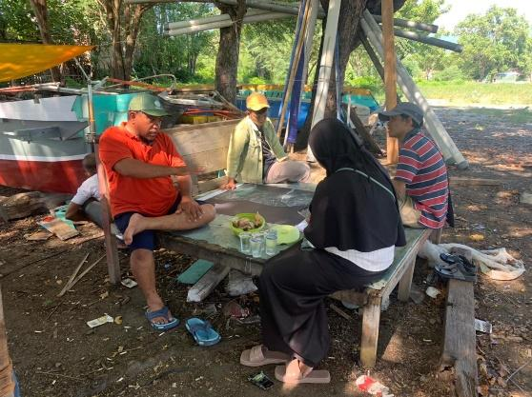  PRA activities in Mamboro Village | 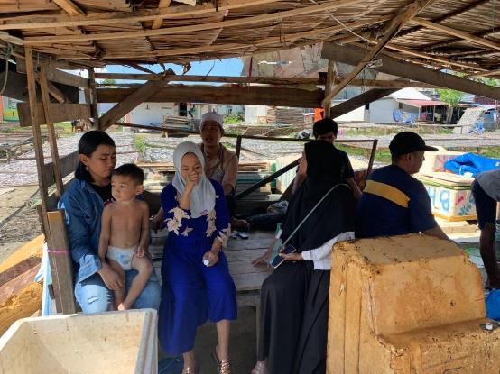  PRA activities in Taipa Village
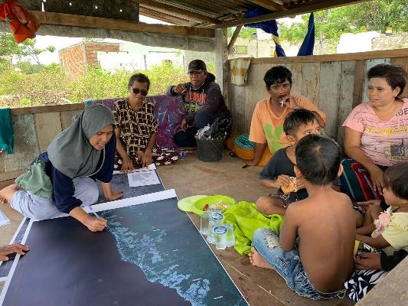  PRA activities in Buluri Village | 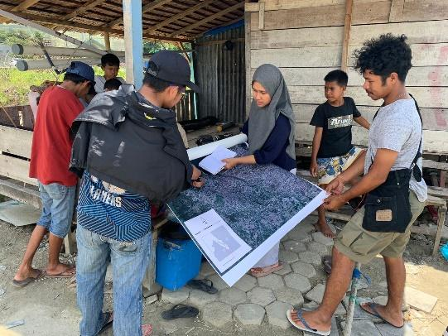  PRA activities in Silae Village

3. Examples of anthropogenic impacts in Palu Bay
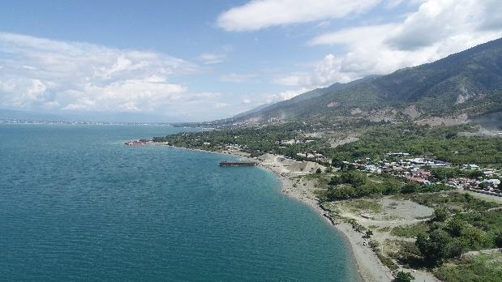  Several anthropogenic activities along Donggala Regency to Palu City | 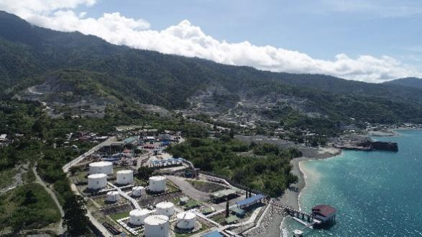  Numerous anthropogenic activities in Donggala Regency (western zone)
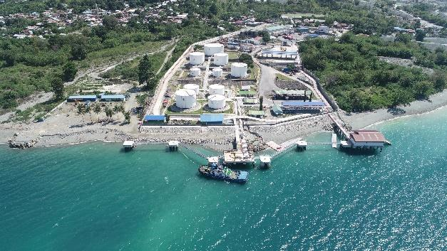  Anthropogenic activities in the form of coastal stockpiling for Pertamina ship docks in Loli Saluran Village (western zone) | 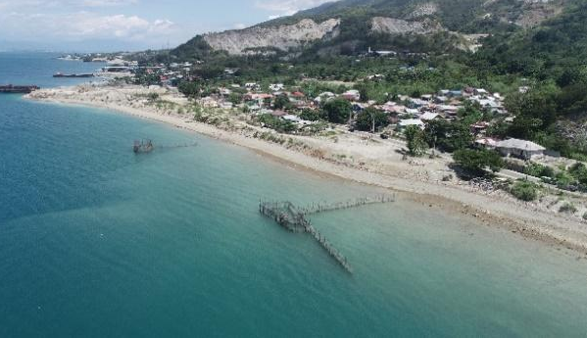  Anthropogenic activities in the form of rock mining and coastal stockpiling in Donggala Regency of western zone
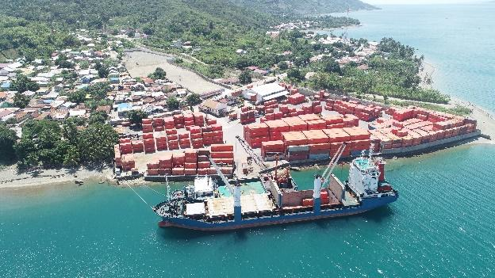  Anthropogenic activities in the form of coastal stockpiling for container ship docks in Loli Tasiburi Village (western zone) | 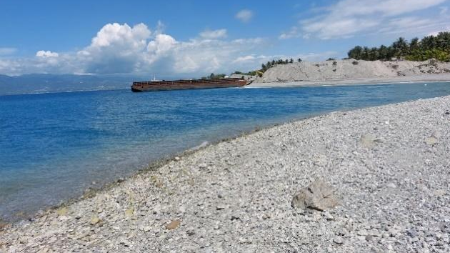  Anthropogenic activities in the form of coastal stockpiling for the construction of a barge dock in coastal of Palu Bay (western zone)
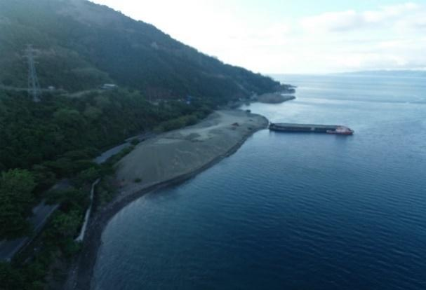  Anthropogenic activities in the form of coastal stockpiling for the construction of a barge dock in Palu Bay of western zone | 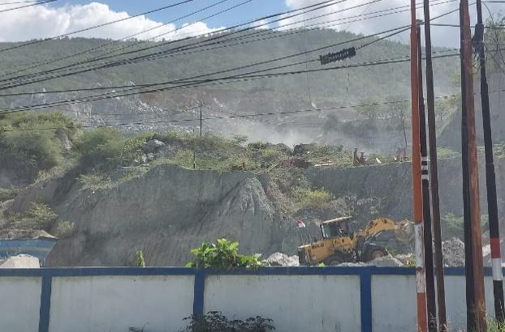  Rock mining activities in Watusampu Village (western zone)

4. Subsidence from the 2018 earthquake
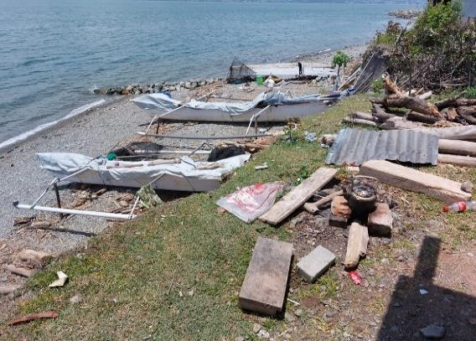  Buluri Village (Musayyadah Tis'in) | Silae Village (Patria & Putra, 2020)

5. Confusion Matrix

 | Live coral |  | Dead coral | Seagrass | Sand | Number of rows |  | User Accuracy
Live coral | 5 |  | 0 | 2 | 0 |  | 7 | 71.43
Dead coral | 1 |  | 5 | 0 | 3 |  | 9 | 55.56
Seagrass | 1 |  | 2 | 18 | 0 |  | 21 | 85.71
Sand | 0 |  | 0 | 3 | 28 |  | 31 | 90.32
Number of rows | 7 |  | 7 | 23 | 31 |  | 70
Producer accuracy | 71.43 |  | 71.43 | 78.26 | 90.32
Overall accuracy K |  | 80%

