**Sijori-GT Economic Cooperation for Three Decades: Examining Malaysia’s and Singapore’s FDI Commitments to Riau Islands**

**La Ode Nazaruddin[1]\***

# *Ministry of Industry, Indonesia*

# Qisthina Aulia

# *Polytechnic of Correctional Science at Ministry of Law and Human Rights, Indonesia*

# 

|  |
| --- |
| **Abstract** The Singapore-Johor-Riau Growth Triangle (Sijori-GT) was initiated by the government of Singapore, Malaysia, and Indonesia in 1989. It took advantage of complementarities among the involved regions. The peripheral regions were expected to reap benefits and gain spillovers from the extended metropolitan region of Singapore. In the age 30 years of the growth triangle, many scholars found great progress and challenges of the subregional economic cooperation such as unbalanced development and the assumably weak commitment of the participating countries in the Riau Islands. This research has the aim to investigate the tenable commitments of Singapore's and Malaysia's Foreign Direct Investment (FDI) in the Riau Islands. Using statistical data from Indonesia's Ministry of Investment from 1990 to 2020, this study compared FDI in Riau Islands by origin, and Singapore's and Malaysia's FDI by sector and subsector. The data was analyzed using the independent sample t-test for two-variable comparison and analysis of variance (posthoc test) for multiple-variable comparison. Finally, this study found that: firstly, the investment of Singapore was larger than that of Malaysia in the Riau Islands; secondly, Singapore specialized in its investment in the manufacturing sector having a better comparative advantage while Malaysia specialized in its investment in the non-manufacturing sector with potential assumed capabilities in halal-related sectors. The lesson-learned from Singaporean and Malaysian case is that dependence will determine the long-run commitment in subregional cooperation.  **Keywords:** Sijori-GT; Subregional Cooperation; FDI; extended metropolitan region; halal market |

**Introduction**

At the end of 1989, the Government of Indonesia (GoI), Singapore, and Malaysia signed Singapore-Johor-Riau Growth Triangle (Sijori-GT) and formalized it on December 17, 1994 (HistorySG, 1989). The subregional economic cooperation covered Singapore, Johor in Malaysia, and some regencies/cities in Indonesia's Riau Province. At the beginning of the 2000s, the regencies/cities were consolidated into a new province of Riau Islands, separated from Riau Province. The emergence of subregional economic cooperation is due to "complementarities" among the participating countries and "spillover effects" from "the extended metropolitan region" (Kakazu, 1999). For three decades, the economies within the subregion developed well in terms of their GDP and GDRP (BPS, 1991, 2021; BPSRiauIslands, 2004; World Bank, n.d.; Xiaodong, 2019).

As a complementarity concept (Kakazu, 1999), the economic development within the subregion was contributed by Foreign Direct Investment (FDI) from non-and participating countries. Many other researchers conducted studies on investment and economic development of the growth triangle. For example, Ooi (1995) studied spatial impacts of the growth triangle including FDI. Wadley and Parasati (2000) studied political commitments and capacity for subregional investment and trade among Indonesia, Malaysia, and Singapore. Hutchinson and van Grunsven (2018), van Grunsven and Hutchinson (2014, 2017) found the ups and downs of Singaporean investment in Batam since the beginning of Sijori-GT cooperation. Using qualitative methods, Xiaodong (2019) conducted a study on FDI within the subregion by the participating countries of Sijori-GT and found the unresolved/unsatisfactory issues of the subregional cooperation.

Based on the previous findings, authors found a research gap and three reasons for doing this study. The first is a study comparing Singapore's, Malaysia's, and other countries' FDI within the Riau Islands to investigate the extent of Singapore's and Malaysia's investment commitments. The second is the study to compare Singapore's FDI in the electrical/electronic industry and other manufacturing industries to examine in which sector Singapore mostly invested in the province following the exit of Singapore's electrical and electronic industry from Batam due to the high cost of doing business and the change of Singaporean's policy (Hutchinson & van Grunsven, 2018; van Grunsven, & Hutchinson, 2014, 2017). The third is a study comparing Singapore's and Malaysia's FDI in the manufacturing sector and those in the non-manufacturing sector in Riau Islands. This study would prove Xiaodong's findings (2019) arguing that Singapore preferred FDI in the non-manufacturing sector to that in the manufacturing sector.

In response to the aforementioned opportunities, challenges, and research gap, this study proposed the following research question: Did the partner countries of Sijori-GT maintain their commitments to invest in Indonesia's Riau Islands? In which sectors and sub-sectors did Singapore and Malaysia specialize their investments? This paper has the aim to investigate Singapore's and Malaysia's tenable FDI commitments and specializations in Indonesia's Riau Islands. This study would conclude the commitments and specializations of the partner countries for three decades of economic cooperation. The later sections of this paper were structured as follows. The literature review and phenomenon of Sijori-GT were covered in the second section. The research method was covered in the third section. The findings of this research were in the fourth section. The conclusion, research implication, and further suggestions were in the last section.

**Sijori-GT Economic Cooperation**

As mentioned earlier, Sijori-GT was announced in 1989 and formalized in 1994 (HistorySG, 1989). The cooperation involved Singapore as a city-state, Johor in Malaysia, Riau (formerly), and Riau Islands (HistorySG, 1989). The subregional cooperation was originated from the comparative advantage of the participating regions/countries such as a comparative advantage in the electronic, oil, maritime, logistics, telecommunication, tourism, R&D, and agribusiness sector (Table 1).

Table 1. *Comparative Advantages of Regions within Sijori-GT*

| **Sector** | **Singapore** | **Riau Islands and Johor** |
| --- | --- | --- |
| **Electronics** | The primary regional basis for the manufacturing industry; main offices for international procurements. | Lower costs of labor/land for labor/land-intensive assembly operations. |
| **Oil** | Refining/petrochemical processing, trade, storage, and distribution. | Riau Islands (e.g., Karimun Islands) is an environmentally isolated space for oil storage. |
| **Maritime Service** | Having complete structures of ship-building industry, and reparation and maintenance. | Riau Islands and Johor offers places for shipbuilding industries, maintenance, and reparation services. |
| **Distribution and Telecommunication** | Having world-class IT infrastructures and a wide range of business services; operational headquarters for many large MNCs. | Many manufacturing, marketing, procurement companies, and technical support by MNCs need coordination. |
| **Logistics and Distribution** | Excellent transportation and telecommunication facilities and logistics management service. | The range of export activities of manufacturing industries needs transportation and logistics management support. |
| **R&D** | The large pool of R&D scientists and engineers; having training facilities for R&D human resources and its supporting infrastructures. | MNCs' products need the applied R&D and design for domestic market adaptations; MNCs’ operations need R&D process improvement |
| **Tourism** | The excellent gateway for air travel; emerging regional sea-cruise center; cosmopolitan shopping center; multicultural city. | Abundant leisure resources such as beach resorts, golf courses, etc; cultural diversity. |
| **Agribusiness** | Capable R&D for food processing industries and biotechnology. | Abundant land resources for agricultural and animal husbandry. |

(Source: Kakazu, 1999)

Due to limited land amidst a high growth population, Singapore then relocated its companies to Riau Islands and Johor. Thus, Sijori-GT cooperation is also called an "extended metropolitan region" (Kakazu 1999; Mcgee and Greenberg 1992; Macleod and McGee 1996). Singapore’s population density in 1990 was 4.5 million people per sq km of land area while Riau’s population density in 1990 was 35 people per sq km of land area. In 2018, Singapore’s population density was 7.9 million people per sq km of land area while Riau Islands’ population density in 2020 was 252 people per sq km of land area (Table 2). Due to Sijori-GT economic cooperation, Riau Islands' and Johor's GDP increased. Riau Islands and Johor increasingly shared their GRDP with the national GDP. Singapore's and Riau Islands' GDP per capita also increased. However, GDP growth for all of the regions in Sijori-GT grew slowly since 1994. Singapore's and Riau Islands' growth of GDP/GRDP per capita grew slowly (Table 2).

Table 2. *Performances of Countries and Regions within Sijori-GT*

| **Country/Region** | **1994** | **2019** | **Region** | **1994** | **2019** |
| --- | --- | --- | --- | --- | --- |
| 1. **Singapore** | | | 1. **Riau Islands (Indonesia)** | | |
| 1. GDP (current, US$ trillion) | 73.7 | 372.06 | 1. GRDP (current, IDR trillion) | 32.8* | 267.7 |
| 1. GDP growth (annual %) | 11.1 | 0.73 | 1. Growth of GRDP (annual, constant, %) | 6.5** | 4.84 |
| 1. Share of total national GDP (%) | 1.6 | 1.7 |
| 1. GDP per capita (current, US$   million) | 21.6 | 65.23 | 1. GRDP per capita (current, IDR million) | 28.1* | 122.2 |
| 1. Growth of GDP per capita (annual %) | 7.7 | (0.41) | 1. Growth of GRDP per capita (constant, %) | 4.3** | 2.3 |
| 1. Population (million) | 3.4 | 5.7 | 1. Population (million) | 1.3******* | 2.1*** |
| 1. Population density (million people per sq kmof land area) | 4.5****** | 7.9***** | 1. Population density (people per sq km of land area) | 15******* | 252*** |
| 1. **Johor (Malaysia)** | | | 1. **Riau\*\*\*\*** | | |
| 1. GRDP (current, RM billion) | 16.6 | 119.8 | 1. GRDP (current, IDR trillion) | 18.2 | 760.6 |
| 1. Growth of GRDP (constant 2005, %) | 9.6 | 6.2 | 1. Growth of GRDP (annual, constant, %) | 4.2 | 2.8 |
| 1. Share of total national GDP (%) | 6.3 | 8.2 | 1. Share of total national GDP (%) | 4.8 | 4.7 |
| 1. GRDP per capita (current, IDR million) | 4.9 | 109.0 |
| 1. Growth of GRDP per capita (constant, %) | 0.7 | 0.5 |
| 1. Population (million) | 3.8 | 6.4*** |
|  |  | 1. Population density (people per sq km of land area) | 35****** | 73*** |

*Data in 2003; **data in 2004; ***data in 2020; ****Authors included Riau’s data because Riau Islands was part of Riau Province in the period of formalization of Sijori-GT cooperation in 1994; ***** data in 2018; ******data in 1990; *******data in 2005.

Source : Authors’ compilation, based on Xiaodong (2019), WorldBank (n.d.), (BPS, 1990, 1991, 1992, 1996, 2007, 2021; BPSRiauIslands, 2004, 2021).

**Methods**

This paper has the aim to investigate Singapore’s and Malaysia’s FDI commitments and specializations in Indonesia's Riau Islands under Sijori-GT economic cooperation. Authors initially presented the data in line charts to demonstrate and describe annual patterns of FDI variables. In this study, authors conducted hypothesis testing. The procedures of the hypothesis testing varies (Lind et al 2018; Cleff, 2019). The authors then adjusted the steps, as follows: stating the null and alternate hypotheses, collecting data, selecting a level of significance, identifying the test statistic, formulating a decision rule, making a decision, and interpreting the results. The first step was to state the H0 and H1. Authors formulated 9 hypotheses, that was developed based on research questions.

***Hypotheses on FDI by Origin***

In this section, authors developed 3 hypotheses to examine the role of Singapore and Malaysia in the Riau Islands. This study considered the following variables (i.e., total, manufacturing, and non-manufacturing FDI) to see the role of each partner country in total FDI and two major categories of FDI. To do that authors also considered investments from East Asian Countries (i.e., China, Hong Kong, Taiwan, and South Korea) and the United States (US). Authors then compared Singapore's investment with Malaysia's and other countries' investments. Authors also compared Malaysia's investment with Singapore's and other countries' investments.

***Hypothesis 1:***

H0: Singapore’s/Malaysia’s total FDI in Riau Islands is not significantly different from the total FDI from other countries.

H1: Singapore’s/Malaysia’s total FDI in Riau Islands is significantly different from the total FDI from other countries.

***Hypothesis 2:***

H0: Singapore’s/Malaysia’s manufacturing FDI in Riau Islands is not significantly different from manufacturing FDI from other countries.

H1: Singapore’s/Malaysia’s manufacturing FDI in Riau Islands is significantly different from manufacturing FDI from other countries.

***Hypothesis 3:***

H0: Singapore’s/Malaysia’s non-manufacturing FDI in Riau Islands is not significantly different from non-manufacturing FDI from other countries.

H1: Singapore’s/Malaysia’s non-manufacturing FDI in Riau Islands is significantly different from non-manufacturing FDI from other countries.

***Hypotheses on Singapore’s and Malaysia’s FDI by Sectors and Sub-Sectors***

After conducting a hypothesis analysis for total FDI and two major categories of FDI for partner countries, authors did a more detailed analysis by comparing two major categories of FDI (non- and manufacturing sector) only for each partner country. Authors also considered certain manufacturing and tertiary sub-sectors only for each partner country to see specializations in their investments. The reasons for selecting the sectors and sub-sectors were described as follows. Firstly, Singapore's FDI in equipment, machinery, electrical and electronic industry was considered because Singapore developed the technologies and industries and has a competitive advantage in the sectors that contributed to Singaporean economic growth (Kakazu, 1999; Macleod and McGee, 1996; Vu, 2013). Secondly, Singapore's and Malaysia's FDI in logistics and communication were considered because Riau Islands need better transportation and logistics management to support trade and manufacturing activities (Kakazu, 1999). Thirdly, Malaysia's FDI in the food industry was considered because Malaysia has a good reputation in the halal industry and was ranked as top 1 in the global Islamic economy indicator in at least three years (2018, 2019, and 2010). Based on the above consideration, authors then formulated the following hypotheses.

***Hypothesis 4:***

H0: Singapore’s manufacturing FDI in Riau Islands is not significantly different from its FDI in the non-manufacturing sector.

H1: Singapore’s manufacturing FDI in Riau Islands is significantly different from its FDI in the non-manufacturing sector.

***Hypothesis 5:***

H0: Singapore’s FDI in equipment, machinery, electrical and electronic industry in Riau Islands is not significantly different from its FDI in other manufacturing subsectors.

H1: Singapore's FDI in equipment, machinery, electrical and electronic industry in the Riau islands is significantly different from its FDI in other manufacturing subsectors.

***Hypothesis 6:***

H0: Singapore's FDI in logistics and communication in the Riau islands is not significantly different from its FDI in other tertiary subsectors.

H1: Singapore’s FDI in logistics and communication in Riau Islands is significantly different from its FDI in other tertiary subsectors.

***Hypothesis 7:***

H0: Malaysia’s manufacturing FDI in Riau Islands is not significantly different from its FDI in the non-manufacturing sector.

H1: Malaysia’s manufacturing FDI in Riau Islands is significantly different from its FDI in the non-manufacturing sector.

***Hypothesis 8:***

H0: Malaysia's FDI in the food industry in Riau Islands is not significantly different from its FDI in other manufacturing subsectors.

H1: Malaysia's FDI in the food industry in Riau Islands is significantly different from its FDI in other manufacturing subsectors.

***Hypothesis 9:***

H0: Malaysia’s FDI in logistics and communication in Riau Islands is not significantly different from its FDI in other tertiary subsectors.

H1: Malaysia's FDI in logistics and communication in Riau Islands is significantly different from its FDI in other tertiary subsectors.

To provide the answers to the hypotheses, authors collected time-series data from 1990 to 2020 from Indonesia's Ministry of Investment, Investment Coordinating Board formerly (NSWiMinistryofInvestment, n.d.), and thus data categorization in statistical analysis followed the categorization made by the Ministry of Investment. The data covered FDIs in Riau Islands by country origin, sectors, and subsectors. To prove the hypotheses, authors decided on the level of significance ⍺ = 0.05 level or 5%. Then authors used a t-test (independent sample t-test) for two-variable comparison and analysis of variance (posthoc tests) for multiple-variable comparison. The null hypotheses would be rejected if the computed values were less than the level of significance of 0.05 for a two-tailed test.

**FDI in Riau Islands by Origin**

Singapore's total FDI in Riau Islands was huge, that is USD 5.7 billion from 1990 to 2020, and the first largest investor after Sijori-GT cooperation. Singapore firstly invested in the non-manufacturing sector. Malaysia's total FDI in Riau Islands was USD 431.6 million from 1998 to 2020 and thus less than the total FDI from the group of East Asian Countries. Malaysia's total FDI surpassed the total FDI from East Asian Countries only in 2000, 2008-2009, 2011-2012, and 2017. However, Malaysia's total FDI in Riau Islands was greater than the USA's total FDI (Figure 1).

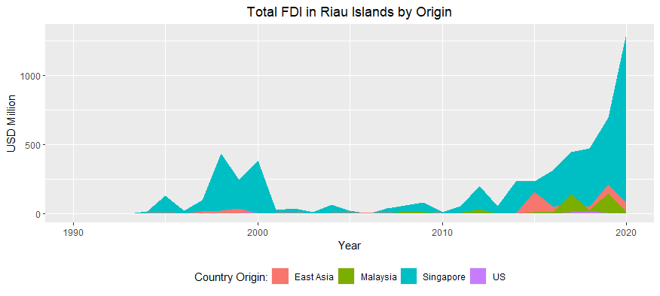

*Figure 1.* Total FDI by Country Origin in Riau Islands

(Source: Authors’ compilation based on data from NSWi Ministry of Investment (n.d.))

One-way ANOVA test (posthoc test) was conducted by comparing total FDI by country origin in Riau Islands. The output of the posthoc test (Tukey HSD) demonstrates that the comparison between total FDI from Singapore and other countries has the computed Sig values of 0.000 for all, which are less than the 0.05 significance level (Table 3). Thus, authors accepted H1, that is Singapore’s total FDI in Riau Islands is significantly different from other countries’ total FDI under Hypothesis 1. The mean difference is positive, meaning the mean of Singapore’s total FDI was larger than the mean of total FDI from other countries.

For the one-way ANOVA test of Malaysia's total investment, authors did not consider a comparison between Malaysia and Singapore because it was already described in the Singaporean case to avoid redundancy. Instead, authors compared Malaysia’s total investment with East Asian Countries’ and US’ total investment that the computed Sig values are greater than the 0.05 significance level (Table 3), meaning authors failed to reject H0, that is Malaysia's total FDI is not significantly different from the total FDI from other countries (Hypothesis 1). The mean difference is negative for East Asian Countries, meaning the mean of Malaysia’s total investment was less than the means of total investment from East Asian countries. The mean difference is positive for the US, meaning the mean of Malaysia's total investment was greater than the mean of the US' total investment.

Table 3. *The output of the ANOVA Test (Post-Hoc Test: Tukey HSD) for Mean Comparison of FDIs in Riau Islands by Country Origin*

| **Treatment** | **Control Group** | **Mean Difference (Thousand USD)** | **Std Error** | **Sig** |
| --- | --- | --- | --- | --- |
| Total FDI in Riau Islands by Origin | | | | |
| Singapore  (n: 31) | East Asia (n: 31)  Malaysia (n: 31)  US (n: 24) | 158727.79*  170480.84*  181285.24* | 36813.75  36813.75  39406.76 | .000  .000  .000 |
| Malaysia  (n: 31) | Singapore (n: 31)  East Asia (n: 31)  US (n: 24) | -170480.84*  -11753.05  10804.40 | 36813.75  36813.75  39406.76 | .000  .989  .993 |
| Manufacturing FDI in Riau Islands by Origin | | | | |
| Singapore  (n: 31) | East Asia (n: 31)  Malaysia (n: 31)  US (n: 18) | 86457.93*  101101.12*  101476.56* | 29913.44  29913.44  34899.01 | .024  .006  .023 |
| Malaysia  (n: 31) | Singapore (n: 31)  East Asia (n: 31)  US (n: 18) | -101101.12*  -14643.18  375.45 | 29913.44  29913.44  34899.01 | .006  .961  1.000 |
| Non Manufacturing FDI in Riau Islands by Origin | | | | |
| Singapore  (n: 31) | East Asia (n: 31)  Malaysia (n: 31)  US (n: 18) | 72269.86*  69379.73*  79198.69* | 14895.59  14895.59  14895.59 | .000  .000  .000 |
| Malaysia  (n: 31) | Singapore (n: 31)  East Asia (n: 31)  US (n: 18) | -69379.73*  2890.13  9818.96 | 14895.59  14895.59  14895.59 | .000  .997  .912 |

*The mean difference is significant at the 0.05 level

Singapore's manufacturing FDI in Riau Islands was USD 3.2 billion from 1990 to 2020 and thus larger than other countries' manufacturing FDI. Singapore and South Korea initially invested in the manufacturing sector in Riau Islands in 1992. It was the first investment in the manufacturing sector since the announcement of Sijori-GT economic cooperation in 1989. Singapore invested in the textile industry and South Korea invested in the non-metal mineral industry. Singapore kept a high investment commitment in the manufacturing sector till 2020. In addition, Malaysia's manufacturing FDI was USD 108.8 million from 1998 to 2020 (Figure 2).

One-way ANOVA test (posthoc test) was conducted by comparing manufacturing FDI by country origin in Riau Islands. The output of the posthoc test (Tukey HSD) demonstrates that the Sig values (0.024, 0.006, and 0.02) for comparison between manufacturing FDI from Singapore and other countries are less than the 0.05 significance level (Table 3), meaning authors accepted H1, that is Singapore’s manufacturing FDI in Riau Islands is significantly different from manufacturing FDI from other countries (Hypothesis 2). The mean difference is positive, meaning the mean of Singapore's manufacturing FDI was larger than the mean of other countries' manufacturing FDI.

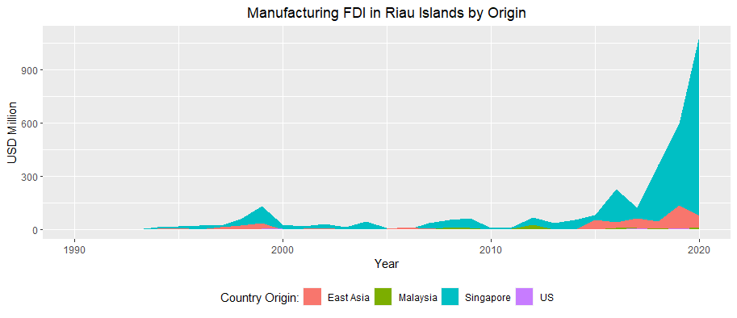

*Figure 2.* Manufacturing FDI by Country Origin in Riau Islands

(Source: Authors’ compilation, based on data from NSWi Ministry of Investment (n.d.))

For the one-way ANOVA test of Malaysia's manufacturing investment, authors did not consider the comparison between Malaysia and Singapore to avoid redundancy, similar to the total FDI case. Instead, authors compared Malaysia’s manufacturing investment with East Asian Countries’ and US’ manufacturing investment that the computed Sig values are greater than the 0.05 significance level (Table 3), meaning authors failed to reject H0, that is Malaysia's manufacturing FDI is not significantly different from the manufacturing FDI from other countries (Hypothesis 2). The mean difference is negative for East Asian Countries, meaning the mean of Malaysia’s manufacturing investment was less than the means of manufacturing investment from East Asian countries. The mean difference is positive for the US, meaning the mean of Malaysia's manufacturing investment was greater than the mean of the US' manufacturing investment.

In the non-manufacturing sector, Singapore's FDI played a significant role in the economic development of the Riau Islands. Singapore's non-manufacturing FDI was USD 2.4 billion from 1990 to 2020. In the early decade of the growth triangle, Singapore's non-manufacturing investment hiked up and left other countries' FDI behind. In 2019, Singapore's non-manufacturing FDI (USD 99 million) was less than Malaysia's non-manufacturing FDI (USD 141 million) but Singapore's manufacturing FDI continued to be higher than that of Malaysia in 2020. In 1994, Hong Kong invested in the non-manufacturing sector (i.e., the trade and reparation subsector), which was earlier than that of Malaysia. Investment in the non-manufacturing sector from Malaysia (i.e., hotel and restaurant subsector with an investment value of USD 4.8 million) was firstly initiated in 1999. Malaysia's non-manufacturing investment then surpassed investment in the same sector from East Asian Countries in 1999, 2008, 2011-2013, 2017-2019. Thus, Malaysia's non-manufacturing FDI was USD 322.8 million from 1999 to 2020 (Figure 3).

One-way ANOVA test (posthoc test) was conducted by comparing non-manufacturing FDI by country origin in Riau Islands. The output of the posthoc test (Tukey HSD) demonstrates that the Sig values for comparison between non-manufacturing FDI from Singapore and other countries are 0.000, which is less than the 0.05 significance level (Table 3), meaning we accepted H1, that is Singapore’s non-manufacturing FDI in Riau Islands is significantly different from non-manufacturing FDI from other countries under Hypothesis 3. The mean difference is positive, meaning the mean of Singapore’s non-manufacturing FDI was larger than the means of non-manufacturing FDI from other countries.

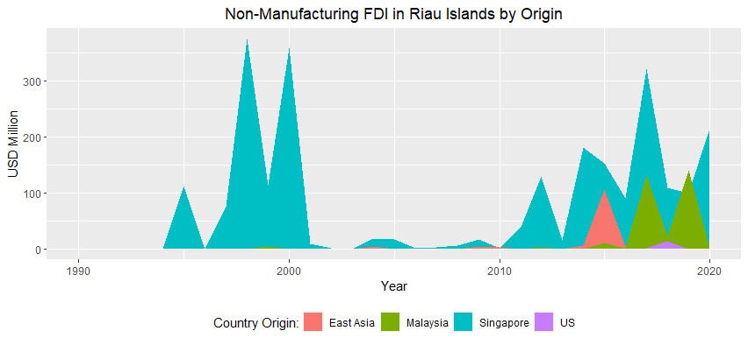

*Figure 3.* Non-Manufacturing FDI by Country Origin in Riau Islands

(Source: Authors’ compilation based on data from NSWi Ministry of Investment (n.d.))

For the one-way ANOVA test of Malaysia's non-manufacturing investment, authors only compared Malaysia's non-manufacturing investment with East Asian Countries' and US' non-manufacturing investments that the computed Sig values are greater than the 0.05 significance level (Table 3). It means authors failed to reject H0, that is Malaysia's non-manufacturing FDI is not significantly different from the non-manufacturing FDI of other countries (Hypothesis 3). The mean difference is positive for East Asian Countries and the US, meaning the mean of Malaysia's non-manufacturing investment was greater than the means of non-manufacturing investment from East Asian countries and the US.

The Singaporean and Malaysian case implies that the extent of dependence determines investment volume. Singapore itself depends heavily on its extended metropolitan regions due to land scarcity (Kakazu, 1999; Macleod & McGee 1996) while Malaysia does not depend much on the land of the Riau Islands because Malaysia still has potential areas to be developed like Iskandar City in Johor (Iskandar Regional Development Authority, n.d.). The strategic position of Iskandar City enables the city to maximize the economic potential of Singapore where both regions are connected by a causeway (Rizzo & Glasson, 2012). In addition, Singapore has a competitive advantage in two major sectors yet specializes in the manufacturing sector while Malaysia only has a competitive advantage and specializes in the non-manufacturing sector.

**Singapore’s and Malaysia’s Sectoral FDIs in Riau Islands**

***Singapore’s Sectoral FDIs***

Data from Indonesia’s Ministry of Investment demonstrated that Singapore did not invest much in Riau Islands at the beginning of the subregional cooperation. In 1990 and 1991, Singapore did not invest in the manufacturing sector in Riau Islands. Moreover, Singapore did not invest in the non-manufacturing sector in Riau Island in 1990, 1992, 1993. Singapore's FDI in the non-manufacturing sector was initially USD 759 thousand in 1991.

Singapore's FDI in the manufacturing sector in Riau Islands began to increase in 1993 while Singapore's FDI in the non-manufacturing sector began to increase in 1994. Singapore's FDI in Riau Islands was dominated by the non-manufacturing sector till 2001. Domination of Singapore's FDI in the non-manufacturing sector was continued from 2011 to 2017 with a decline in 2013 and 2016. After 2017, Singapore invested more in the manufacturing sector. In 2020, for instance, Singapore's manufacturing FDI was USD 1.09 billion, the highest since the establishment of Sijori-GT (Figure 4).

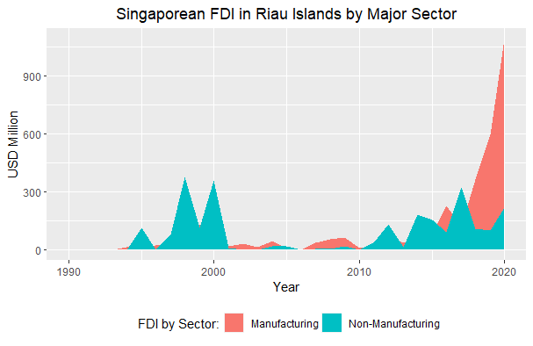

*Figure 4*. Singapore’s Sectoral FDIs in Riau Islands

(Source: Authors’ compilation based on data from NSWi Ministry of Investment (n.d.))

The independent sample t-test was conducted to compare Singapore's sectoral FDIs in Riau Islands. The computed F value of manufacturing and non-manufacturing FDI in the Riau Islands under the assumption of equal variances (Levene’s test) is 1.209 and the p-value is 0.276, which is greater than the 0.05 significance level. It means that the variances of Singapore’s manufacturing and non-manufacturing FDI are not significantly different.

Table 4. *The output of the Independent Sample t-Test for Mean Comparison of Singapore’s Sectoral FDIs in the Riau Islands*

|  |  |  |  |  |  |  |  |
| --- | --- | --- | --- | --- | --- | --- | --- |
| Parameter | | Levene’s test | | The t-test for equality means | | | |
| F | Sig | t | Sig (2-tailed) | Mean Diff (Thousand USD) | Std. Error Diff |
| Singapore’s Sectoral FDI in Riau Islands | | | | | | | |
| Manufacturing (n: 31) vs Non-Manufacturing (n: 31) | Equal variances assumed | 1.209 | .276 | .561 | .577 | 24817.06 | 44207.98 |
| Equal variances not assumed |  |  | .561 | .577 | 24817.06 | 44207.98 |

The authors then analyzed the t-test for equality means without the assumption of equal variances. The computed t value is 0.561 and the computed p-value was 0.561, which is greater than the 0.05 significance level (Table 4). Thus, authors failed to reject H0, that is Singapore's manufacturing FDI in the Riau islands is not significantly different from Singapore’s non-manufacturing FDI (Hypothesis 4). The positive mean differences show that Singapore's investment in the manufacturing sector was greater than that in the non-manufacturing sector. The statistical result is true because Singapore invested USD 3.2 billion in the manufacturing sector and USD 2.4 billion in the non-manufacturing sector from 1990 to 2020. Therefore, these findings did not confirm the previous study by Xiaodong (2019) arguing that Singapore tends to invest more in the tertiary sector.

In the early decade of the subregional cooperation, Singapore mostly invested in six major manufacturing subsectors. The first is the equipment, machinery, electrical and electronic industry in Riau Islands. Despite its value under USD 100 million, Singapore's FDI in this subsector continued to increase till 2020. It seems Singapore maintained the stability of investment in this subsector. The second is motor vehicles other transport equipment industries. The highest investment in this subsector only took place in 1999. After the year, the investment never reached USD 60 million (Figure 5). The third is the rubber and plastic industry with the lowest value of investment till 2015. After 2015, Singapore invested more in this subsector mainly in 2016 and 2020. The fourth is an investment in the metal industry (not machinery electronic industry) in 1997. The investment in this subsector began to hike up in 2016 and reached USD 784 million in 2020. The fifth is an investment in the chemical and pharmaceutical industry in 1999 that was kept low. The highest investment only took place in 2018, which is USD 161 million. The sixth is an investment in the food industry, firstly initiated in 2000 and reaching a value of more than USD 150 million only in 2020 (Figure 5).

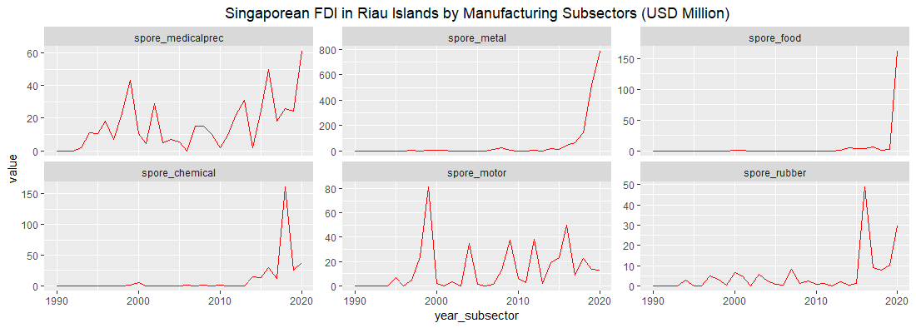

*Figure 5.* Singapore’s FDI in Manufacturing Subsectors in Riau Islands

(Source: Authors’ compilation based on data from NSWi Ministry of Investment (n.d))

One-way ANOVA test (posthoc test) was conducted by comparing Singapore's FDI in manufacturing subsectors in Riau Islands. Authors did not use the output of Tukey HSD under the posthoc test. Instead, authors used the output of Games-Howell under the posthoc test for better results. The output of the Games-Howell test demonstrates that the computed Sig value of 0.023 is less than 0.05 (Table 5) for comparison between Singapore's FDI in equipment, machinery, electrical and electronic industry, and Singapore's FDI in rubber and plastics industry in Riau Islands. Thus, authors accepted H1, that is Singapore’s FDI in equipment, machinery, electrical and electronic industry in Riau islands is significantly different from Singapore’s FDI in other manufacturing subsectors for at least one subsector (Hypothesis 5). The statistical results also show that the variable of equipment, machinery, electrical and electronic industry has positive mean difference with variable food, motor vehicle and other transport equipment, rubber and plastics industries. It means that Singapore's investment in equipment, machinery, electrical and electronic industry was larger than its investment in food, motor vehicle and other transport equipment, rubber, and plastics industries.

Table 5. *The output of the ANOVA Test (Post-Hoc Test: Games-Howell) for Mean Comparison of Singapore’s Sub-Sectoral FDIs in the Riau Islands*

|  |  |  |  |  |  |  |
| --- | --- | --- | --- | --- | --- | --- |
| **Treatment** | **Control Group** | **Mean Difference**  **(Thousand USD)** | **Std Error** | | **Sig** | |
| Singapore’s FDI in Riau Islands by Manufacturing Sub-Sector | | | | | |
| Medical Press. & Optical Instruments, Watches & Clock, Machinery, electrical and Electronic Industry (n: 27) | Metal Industry (n: 21) | -60228.07 | 43191.94 | .730 | |
| Food Industry (n: 11) | 1201.69 | 14732.85 | 1.000 | |
| Chemical and Pharmaceutical Industry (n: 15) | -2307.39 | 10945.12 | 1.000 | |
| Motor Vehicles and Other Transport Equipment Industry (n: 24) | 871.27 | 4947.41 | 1.000 | |
| Rubber and Plastics Industry (n: 25) | 11776.54* | 3590.48 | .023 | |
| Singapore’s FDI in Riau Islands by Tertiary Sub-Sector | | | | | |
| Logistics & Communication (n: 13) | Hotel & Restaurant (n: 16) | -47587.94* | 18615.73 | .045 | |
| Real Estate, Ind. Estate & Business Activities (n: 14) | -21517.03 | 26873.94 | .708 | |

*The mean difference is significant at the 0.05 level

Based on an analysis of manufacturing sub-sectors, this research did not confirm the previous findings from van Grunsven and Hutchinson (2014, 2017), and Hutchinson and van Grunsven (2018) that Batam encountered a decline in the number of establishments in the electrical and electronics industry. Even if many companies exited from Batam, Singapore’s FDI in equipment, machinery, electrical and electronic industry in Riau Islands continued to rise. For instance, in 2020 Singapore's investment in this subsector was more than USD 60 million, the highest investment from the country since the Sijori-GT announcement.

The statistical results in Table 5 show that the variable of equipment, machinery, electrical and electronic industry has a negative mean difference with variable metal, chemical and pharmaceutical industries. It means that Singapore's investment in metal, chemical and pharmaceutical industries was larger than its investment in equipment, machinery, electrical and electronic industries. It implies that Singapore needs more land for its land-intensive industries such as metal, chemical, and pharmaceutical industries (Kakazu, 1999; Macleod and McGee, 1996) amidst land scarcity in Singapore due to population growth and metropolitan development (see Table 2). In addition, Singapore invested in the equipment, machinery, electrical and electronic industry because it has comparative advantages in the subsectors (UNCTAD, n.d.).

In explaining tertiary subsectors, authors analyzed three major subsectors, having a large value of the total investment, that is 1) hotel and restaurant; 2) real and industrial estate, and business activities; and 3) logistics (transport and storage) and communication. Singapore invested more in hotels and restaurants in Riau Islands and less in logistics and communication, real and industrial estate, and business activities. The highest value of investment in real and industrial estate and business activities (USD 360 million) only took place in 1998. The highest value of Singapore's FDI in logistics and communication (USD 115 million) also took place only in 2014 (Figure 6).

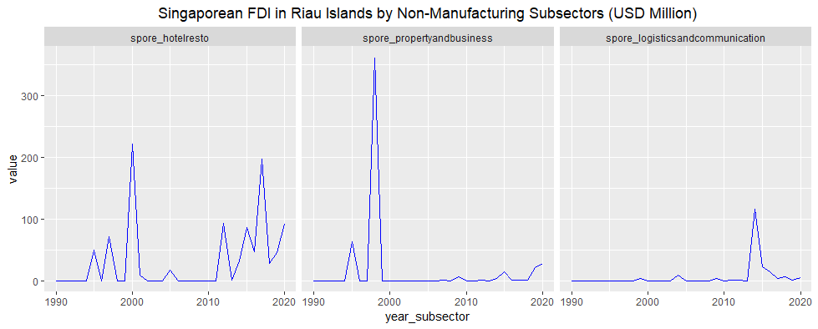

*Figure 6*. Singapore's FDI in Riau Islands by the Non-Manufacturing Subsectors

(Source: Authors’ compilation based on data from NSWi Ministry of Investment (n.d.))

The output of the Games-Howell test (Table 5) demonstrates that the computed Sig value of 0.045 is less than 0.05 for comparison between Singapore's FDI in logistics and communication, and hotels and restaurants in Riau Islands (with a negative mean difference). Thus, authors accepted H1, that is Singapore's FDI in logistics and communication in Riau Islands is significantly different from Singapore's FDI in other tertiary subsectors (Hypothesis 6). The mean difference is negative for all variables in tertiary sub-sectors, meaning the means of the hotel and restaurant, real estate, industrial estate, and business activities were larger than the mean of the logistics and communication sector. It was confirmed by Grundy-Warr and Perry (2001) that Singaporean companies, such as Gallant Venture and Keppel Group, invested in the tourism sector in Bintan and Batam in response to subregional cooperation between Indonesia and Singapore and the high demand for leisure in Riau Islands by Singaporean residents. Gallant Venture, for example, developed business in the field of utilities, resort operations, property development beside manufacturing industries and industrial parks in Batam and Bintan Island (Gallant Venture, n.d.).

***Malaysia’s Sectoral FDI’s***

Data from Indonesia's Ministry of Investment demonstrated that Malaysia began to invest in Riau Islands in 1998. It was almost ten years since the announcement of Sijori-GT in 1989. Initially, Malaysia invested in Riau Islands in equipment, machinery, the electrical and electronic industry which was followed by investment in the tertiary sector in 1999. In 2000, Malaysia invested in equipment, machinery, electrical and electronic sectors again and invested in the rubber and plastic sector in 2001. From 2002 to 2005, Malaysia did not invest in Riau Islands. Malaysia's manufacturing FDI then surpassed its FDI in non-manufacturing from 2007 to 2012. However, Malaysia largely invested in the non-manufacturing sector in Riau Islands from 2015 to 2019, making its investment in the non-manufacturing sector surpassed its manufacturing FDI (Figure 7).

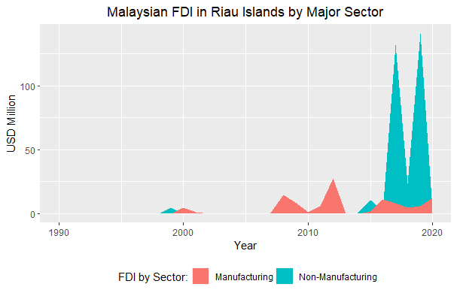

*Figure 7*. Malaysia's Sectoral FDIs in Riau Islands (Left)

(Source: Authors’ compilation based on data from NSWi Ministry of Investment (n.d.))

The independent sample t-test was conducted to compare Malaysia's FDI in the manufacturing and non-manufacturing sector in Riau Islands. The computed F value of manufacturing and non-manufacturing FDI in the Riau Islands under the assumption of equal variances (Levene’s test) is 5.745 and the p-value is 0.020, which is less than the 0.05 significance level (Table 6), meaning variances of Malaysia’s manufacturing and non-manufacturing FDI are significantly different. Thus, authors accepted H1, that is Malaysia's manufacturing FDI in the Riau islands is significantly different from Malaysia’s non-manufacturing FDI (Hypothesis 7). The negative mean differences show that Malaysia's investment in the non-manufacturing sector was greater than that in the manufacturing sector. It is true because Malaysia invested USD 108.8 million in the manufacturing sector and USD 322.8 million in the non-manufacturing sector from 1998 to 2020.

Table 6. *The output of the Independent Sample t-Test for Mean Comparison of Malaysia’s Sectoral FDIs in the Riau Islands*

|  |  |  |  |  |  |  |  |
| --- | --- | --- | --- | --- | --- | --- | --- |
| Parameter | | Levene’s test | | The t-test for equality means | | | |
| F | Sig | t | Sig (2-tailed) | Mean Diff (Thousand USD) | Std. Error Diff |
| Malaysia’s Sectoral FDI in Riau Islands | | | | | | | |
| Manufacturing (n: 31) vs Non-Manufacturing (n: 31) | Equal variances assumed | 5.745 | .020 | -1.112 | .271 | -6904.32* | 6211.51 |
| Equal variances not assumed |  |  | -1.112 | .275 | -6904.32 | 6211.51 |

*The mean difference is significant at the 0.05 level

As stated earlier, Malaysia firstly invested USD 133 thousand in medical precision, optical instruments watch, and clocks, machinery, electrical and electronic industry in 1998. Malaysia then invested USD 4.5 million in the same sector in 2000 and USD 11.5 million in 2008. In 2020, Malaysia invested again in the sector by USD 9.3 million, lower than the investment in 2008. The second manufacturing subsector that Malaysia invested in plastics and rubber industry. Malaysia invested USD 1 million in 2001. In 2007 and 2009, Malaysia invested in the subsector but it was less than USD 1 million. Malaysia invested again by USD 1 million, USD 4.6 million, and USD 1.7 million respectively in 2011, 2019, and 2020 (Figure 8).

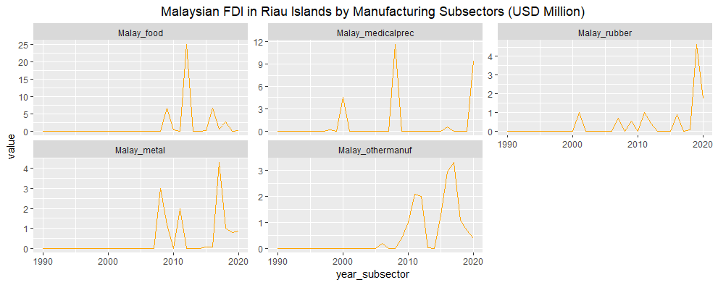

*Figure 8.*Malaysia’s FDI in Manufacturing Subsectors in Riau Islands

(Source: Author’s compilation based on data from NSWi Ministry of Investment (n.d.))

In 2006, Malaysia invested in the third manufacturing subsector, that is motor vehicles and other transport equipment industries. In this paper, authors categorized the subsector into other manufacturing subsectors. Intensive investment in other manufacturing subsectors began in 2009. After that, Malaysia did not invest in this subsector only in 2014. In 2008, Malaysia invested USD 3 million in the metal industry in Riau Islands but the highest value of FDI in this subsector took place in 2014 (USD 4 million). In 2009, Malaysia invested USD 6 million in the food industry but the highest investment took place in 2012 (USD 25 million). After the year, FDI in the food industry decreased (Figure 8).

A one-way ANOVA test (posthoc test) was conducted by comparing FDI among manufacturing subsectors. The output of the posthoc test (Tukey HSD) demonstrates the computed Sig values of other manufacturing subsectors are less than the 0.05 significance level (Table 7). Thus, authors accepted H1, that is Malaysia's FDI in the food industry in the Riau islands is significantly different from Malaysia’s FDI in other manufacturing subsectors for at least one (Hypothesis 8). The positive mean differences show that Malaysia's investment in the food industry was greater than that in equipment, machinery, electronics, rubber and plastic, metal (not machinery and electronic), and other manufacturing subsectors.

Malaysia invested in the food industry because it has comparative advantages in the subsectors (UNCTAD, n.d.). In addition, Malaysia invested more in the halal-related industry to take advantage of the huge halal market in Riau Islands, having a somewhat large population (Table 2), and in Indonesia, having the large Muslim population in the world (Pew Research Center, 2015) with higher demand for halal food (SalaamGateway, 2020).

Table 7. *The output of the ANOVA Test (Post-Hoc Test: Tukey HSD) for Mean Comparison of Malaysia’s Sub-Sectoral FDIs in the Riau Islands*

|  |  |  |  |  |
| --- | --- | --- | --- | --- |
| **Treatment** | **Control Group** | **Mean Difference**  **(Thousand USD)** | **Std Error** | **Sig** |
| Malaysia’s FDI in Riau Islands by Manufacturing Sub-Sector | | | | |
| Food Industry (n: 9) | Medical Precision. & Optical Instruments, Watches & Clock, Machinery, and Electronics Industry (n: 9) | 1772.01 | 1579.22 | .794 |
| Rubber and Plastics Industry (n: 11) | 3680.73 | 1505.73 | .116 |
| Metal Industry (not machinery and electronic industry) (n: 12) | 3566.51 | 1477.23 | .124 |
| Others (n: 31) | 4180.90* | 1268.46 | .013 |
| Malaysia’s FDI in Riau Islands by Tertiary Sub-Sector | | | | |
| Logistics & Communication  (n: 6) | Trade and Reparation (n: 12) | 22030.12 | 10138.23 | .144 |
| Real Estate, Industrial Estate & Business Activities (n: 7) | 23149.28 | 11280.78 | .183 |
| Others (n: 31) | 28953.72* | 9043.50 | .012 |

*The mean difference is significant at the 0.05 level

The large investment of Malaysia in the food sector offers three opportunities for Indonesia. Firstly, Malaysian food manufacturing companies in Riau Islands must be well informed about the halal standard implemented by the Malaysian Halal Authority and thus will contribute to the export expansion of halal products in ASEAN countries. That is because the Malaysian Halal Standard (MS 1500:2009) and certification are recognized not only in Malaysia but also in some other ASEAN countries (Lin, 2017). The reputation of Malaysian halal standards is even recognized as better standards, proven by Malaysia's position in the global Islamic economy indicator as to the top 3 halal food industries in the world for at least 2018, 2019, 2020 while Indonesia's rank was below Malaysia in same years (DinarStandard, 2019, 2020; ThomsonReuters, 2018). Secondly, Malaysian companies will participate in and shape the domestic halal supply chain, as pointed out by Tieman (2011). Thirdly, some Malaysian companies in Riau Islands are certainly subsidiaries of large companies based in Malaysia and thus will shape the global halal value chain, as pointed out by Tieman (2011).

In tertiary subsectors, Malaysia initially invested in the hotel and restaurant subsector (USD 4.8 million) in Riau Islands in 1999. In this paper, authors categorized the subsector into other tertiary subsector. Then the country invested in trade and reparation (USD 99 thousand) in 2008. Malaysia next invested in other subsectors (USD 111 thousand) in 2011. In 2015, Malaysia invested in logistics (transport and storage) and communication (USD 4 million) and property (real and industrial estate), and business activities (USD 3.9), as presented in Figure 9.

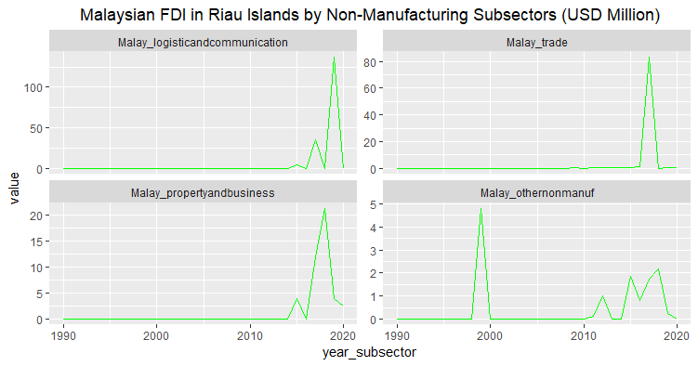

*Figure 9.*Malaysia's FDI in Non-Manufacturing Subsectors in Riau Islands

(Source: Authors’ compilation based on data from NSWi Ministry of Investment (n.d.))

One-way ANOVA test (posthoc test) was conducted by comparing FDI among tertiary subsectors. The output of the posthoc test (Tukey HSD) demonstrates that the computed Sig values of other tertiary subsectors (0.012) are less than the 0.05 significance level (Table 7). Thus, authors accepted H1, that is Malaysia's FDI in logistics and communication in Riau Islands is significantly different from Malaysia’s FDI in other tertiary subsectors for at least one subsector (Hypothesis 9). The positive mean differences show that Malaysia's investment in logistics and communications was greater than that in trade and reparation, real estate, industrial estate and business activities, and other tertiary sub-sectors. The Malaysian investment in logistics companies in Riau Islands, that may apply the halal standard, will probably strengthen the halal supply chain (Tieman, 2011) in the province.

**Conclusion**

This study reached the concussion that Singapore generally has a strong commitment to investing in Riau Islands. Singapore's investment commitment was stronger than Malaysia's, East Asian Countries', and US' investment commitment. Malaysia's total and manufacturing FDI were greater than those of the USA. In the non-manufacturing sector, Malaysia's FDI was greater than FDI from the USA and East Asian Countries. The research findings demonstrated that in terms of the value of the investment, Singapore specialized in the manufacturing sector while Malaysia specialized in the non-manufacturing sector. Even if Malaysia specialized in the non-manufacturing sector, Singapore's investment value in the non-manufacturing sector was much higher than that of Malaysia.

This research implies that dependence determines the long-run investment commitment. Singapore highly depends on Riau Islands, as its extended metropolitan region, not only for its land-intensive industries and natural resource exploitation but also for the provision of leisure amenities for its residents (Grundy-Warr & Perry, 2001; Kakazu, 1999; Macleod and McGee, 1996). Authors assumed that Malaysia's non-manufacturing investment in Riau Islands is not a land-intensive business. A large amount of Malaysia's non-manufacturing investment in Riau was caused by factors that are not related to lands and unable to be identified in this research. Therefore, Malaysia does not depend much on the land of the Riau Islands because Malaysia still has potential areas to be developed.

Singapore invested in the sub-sector of medical precision and optical instrument, watch and clock, machinery, electrical and electronic industry because it has comparative advantages in the subsectors (UNCTAD, n.d.). Malaysia also invested in food subsectors due to having comparative advantages in the subsectors (UNCTAD, n.d.) and took the advantage of the halal market (Pew Research Center, 2015; SalaamGateway, 2020). Singapore invested in hotels and restaurants to take the opportunity of leisure business that many Singaporean residents spent their weekends in the Riau Islands (Grundy-Warr& Perry, 2001). Malaysia invested more in logistics and communication probably due to taking advantage of the halal market and supply chain (Pew Research Center, 2015; SalaamGateway, 2020; Tieman, 2011).

The findings of this research also imply that Indonesian central and local authorities must keep the price of land and rent of industrial estate competitive to attract investment in hi-tech and land-intensive industries from Singapore having a scarcity of land and from other countries. JETRO found that the prices of industrial estate lands in Batam is less competitive than those in other cities in Indonesia and other ASEAN countries (JETRO, 2016, 2021). In addition, to reap the benefit of cross-border halal trade and Malaysian Companies' export access, it is essential to provide better halal-related services for halal-related companies in Riau Islands. Improvement of halal-related services in Indonesia is enabled by the 2021 Government Regulation on Halal Product Assurance, as a derivative of the 2020 Law on Job Creation (GoI, 2021).

This paper then suggested at least two necessary researches in the future. The first is the importance of doing research on FDI in primary, secondary, and tertiary subsectors by country origin (Singapore, Malaysia, and some other countries) in the Riau Islands and other provinces in Indonesia to investigate more findings from Grunsven and Hutchinson (2014 and 2017) and Hutchinson and Grunsven (2018) because this study only covered sub sectoral FDIs from Singapore and Malaysia. The second is that the research on the impact of extended metropolitan regions on manufacturing development in the neighboring cities of Singapore should be conducted in the future to provide more information about the difference in industrial development in the periphery of Singapore and to develop the previous findings from Kakazu (1999), Mcgee and Greenberg (1992), and Macleod and McGee (1996).

**References**

BPS. (1990). Statistik Indonesia 1990. Book, 1–593.

BPS. (1991). Statistical Yearbook of Indonesia 1990.

BPS. (1992). Statistical Yearbook of Indonesia 1991.

BPS. (1996). Statistical Yearbook of Indonesia 1995.

BPS. (2007). Statistical Yearbook of Indonesia 2007.

BPS. (2021). Statistical Yearbook of Indonesia 2021.

BPSRiauIslands. (2004). Kepulauan Riau in Figures 2003.

BPSRiauIslands. (2021). Kepulauan Riau in Figure 2021.

Cleff, T. (2019). Applied Statistics and Multivariate Data Analysis for Business and Economics. In Applied Statistics and Multivariate Data Analysis for Business and Economics. <https://doi.org/10.1007/978-3-030-17767-6>

DepartmentofStatisticsSingapura. (n.d.). Merchandise Trade: Merchandise Trade by Commodity Section/Division. <https://www.singstat.gov.sg/>

DinarStandard. (2019). 2019/2020 State of the Global Islamic Economy Report: Driving the Islamic Economy Revolution 4.0. <https://www.salaamgateway.com/specialcoverage/SGIE19-20>

DinarStandard. (2020). 2020/2021 State of the Global Islamic Economy Report: Thriving in Uncertainty. <https://www.salaamgateway.com/specialcoverage/SGIE20-21>

Gallant Venture. (n.d.). Corporate Info: Business Structure. <http://www.gallantventure.com/>

GoI. (20921). PP No. 39 Tahun 2021 tentang Penyelenggaraan Bidang Jaminan Produk Halal. Governemnt of Indonesia.

Grundy-Warr, C., & Perry, M. (2001). Tourism in an Inter-State Borderland: The Case of the Indonesian-Singapore Cooperation. In K. C. Teo, P., Chang, T.C., & Ho (Ed.), Interconnected Worlds: Tourism in Southeast Asia (pp. 64–83). Pergamon.

HistorySG. (1989). The formation of the SijoriGrowth Triangle is Announced on December 20, 1989. <https://eresources.nlb.gov.sg/history/events/bd4d0374-63ae-49fe-95c8-2210b3b0ac59>

Hutchinson, F.E., & van Grunsven, L. (2018). Industry dynamics in Growth Triangles: the E&E industry in SIJORI 25 years on. Asian-Pacific Economic Literature, 32(2), 42–63. <https://doi.org/10.1111/apel.12235>

Iskandar Regional Development Authority. (n.d.). Iskandar Malaysia Smart City. Iskandar Regional Development Authority. <https://www.google.com/url?sa=t&rct=j&q=&esrc=s&source=web&cd=&cad=rja&uact=8&ved=2ahUKEwj-nIuij4v1AhXdxjgGHYhqCV8QFnoECAYQAQ&url=https%3A%2F%2Fiskandarmalaysia.com.my%2FSCIM%2Fdownload%2Fimsc_booklet.pdf&usg=AOvVaw2ZK7pqmJQTI6xmeF7mn3Uq>

JETRO. (2016). Survey of Investment Related Costs in Asia and Oceania 2015/2016 (in Japanese). <https://www.jetro.go.jp/world/search/cost_result?countryId%5B%5D=600&countryId%5B%5D=650&countryId%5B%5D=700>

JETRO. (2021). Survey of Investment Related Costs in Asia and Oceania 2020/2021 (in Japanese). <https://www.jetro.go.jp/world/search/cost_result?countryId%5B%5D=600&countryId%5B%5D=650&countryId%5B%5D=700>

Kakazu, H. (1999). Growth Triangles in Asia: A New Approach to Regional Cooperation (No. 9; Politics and International Relation Series 1999-03).

Lin, J. (2017, April 29). Malaysia heads Southeast Asia halal market standards: Malaysia leads the Southeast Asia region in halal product certification. Taiwan News. <https://www.taiwannews.com.tw/en/news/3151971>

Lind, D.A., Marchal W.G., & Wathen, S.A. (2018). Statistical Techniques in Business and Economics. McGraw-Hill Education.

Macleod, S., & McGee, T.G. (1996). The Singapore-Johore-Riau Growth triangle: An emerging extended metropolitan region. In Fu-chen Lo and Yue-man Yeung (Ed.), Emerging world cities in Pacific Asia. United Nations University Press. <https://archive.unu.edu/unupress/unupbooks/uu11ee/uu11ee00.htm>

Mcgee, T. G., & Greenberg, C. (1992). The emergence of extended metropolitan regions in ASEAN: towards the year 2000. ASEAN Economic Bulletin, 9(1), 22–44. <https://doi.org/10.1355/AE9-1B>

NSWiMinistryofInvestment. (n.d.). Perkembangan Investasi 1990-2020. <https://nswi.bkpm.go.id/data_statistik>

Ooi, G. L. (1995). The Indonesia-Malaysia-Singapore Growth Triangle: Sub-regional economic cooperation and integration. GeoJournal, 36(4), 337–344. <https://doi.org/10.1007/BF00807948>

Pew Research Center. (2015). Population Growth Projections, 2010-2050 - Why Muslims Are Rising Fastest and the Unaffiliated Are Shrinking as a Share of the World’s Population. The Future of World Religions. <https://www.pewforum.org/2015/04/02/religious-projections-2010-2050/%0A>

Rizzo, A., & Glasson, J. (2012). City Profile: Iskandar Malaysia. Cities, 29(6), 417–427. <https://doi.org/10.1016/j.cities.2011.03.003>

SalaamGateway. (2020). Halal food industry: 2019-20 "momentous" with the launch of new national strategies. <https://www.salaamgateway.com/story/halal-food-industry-2019-20-momentus-period-with-launch-of-many-new-national-halal-strategies>

ThomsonReuters. (2018). 2018/2019 State of the Global Islamic Economy Report: An Inclusive Ethical Economy. <https://www.salaamgateway.com/reports/report-state-of-the-global-islamic-economy-201819>

Tieman, M. (2011). The application of Halal in supply chain management: in‐depth interviews. Journal of Islamic Marketing, 2(2), 186–195. <https://doi.org/https://doi.org/10.1108/17590831111139893>

UNCTAD. (n.d.). International Merchandise Trade Report: Revealed comparative advantage index. UNCTAD Statistics. <https://unctadstat.unctad.org/wds/TableViewer/dimView.aspx>

van Grunsven, L., & Hutchinson, F.E. (2014). The Evolution of the Electronics Industry in the SIJORI Cross-Border Region. ISEAS Yusof Ishak Institute. <http://hdl.handle.net/11540/6720>.

van Grunsven, L., & Hutchinson, F.E. (2017). The evolution of the electronics industry on Batam Island (Riau Islands Province, Indonesia): an evolutionary trajectory contributing to regional resilience? GeoJournal, 82(3), 475–492. <https://doi.org/10.1007/s10708-015-9692-9>

Vu, K. M. (2013). Information and Communication Technology (ICT) and Singapore’s economic growth. Information Economics and Policy, 25(4), 284–300. <https://doi.org/https://doi.org/10.1016/j.infoecopol.2013.08.002>

Wadley, D., & Parasati, H. (2000). Inside South East Asia’s Growth Triangles. 85(4), 323–334.

World Bank. (n.d.). World Development Indicator. <https://data.worldbank.org/indicator/>

Xiaodong, X. (2019). The SIJORI Growth Triangle: Progress, Problems, and Prospect. Journal of Maritime Studies and National Integration, 3(1), 1–13. https://doi.org/10.14710/jmsni.v3i1.4473

1. * **Corresponding email:** laodenaz@gmail.com & laodenaz@kemenperin.go.id.

   The Article has also been accepted to the Conference on Transformation of Asia-Pacific Regions: Exploring New Directions in Economy, Environment, and Society, on April 30-May 2, 2022 at National Dong Hwa University, Hualien, Taiwan.