STATEMENT OF ORIGINALITY AGRO EKONOMI
Title of Manuscript | : | The Implementation of Indonesian Sustainable Palm Oil (ISPO) on Oil Palm Plantations Smallholders in Kumai District, Central Kalimantan Province.
Authors | : | - Holpu Ronal Ambarita  - Any Suryantini  - Dwidjono Hadi Darwanto

As the authors, we certify that this manuscript is original and its publication does not infringe any copyright and it has not been previously published (in whole or in part in any other journal or scientific publishing company or it does not participate in any other publishing process). We also declare that all person listed hereafter were committed in the creation of the paper and were informed about their participation.
Yogyakarta, September 29th 2021
Name of the authors | Signature
1st author  Holpu Ronal Ambarita | 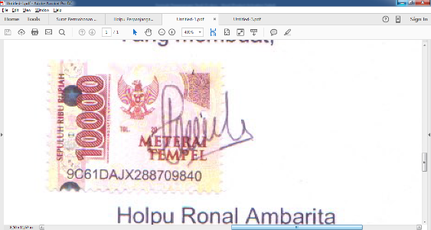
2nd author  Any Suryantini | 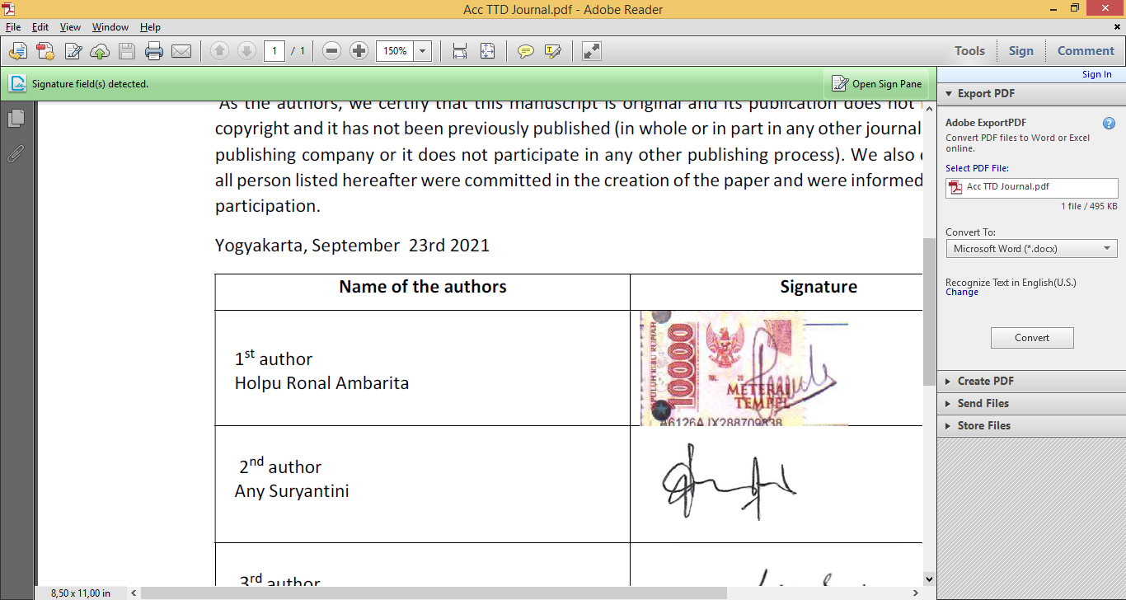
3rd author  Dwidjono Hadi Darwanto | 

