STATEMENT OF ORIGINALITY AGRO EKONOMI

Title of Manuscript | : | Unraveling The Interplay Among Inflation, Rice Prices, And Farmers Exchange Rate In Indonesia
Authors | : | - Avi Budi Setiawan  - Mochammad Yusuf  - Sucihatiningsih Dian Wisika Prajanti  - Farhan Hadi Prasetyo  - Prasetyo Ari Bowo

As the authors, we certify that this manuscript is original and its publication does not infringe any copyright and it has not been previously published (in whole or in part in any other journal or scientific publishing company or it does not participate in any other publishing process.
We also declare that all persons listed hereafter were committed in the creation of the paper and were informed about their participation.
City, Date
Name of the authors | Signature
Avi Budi Setiawan | 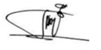
Mochammad Yusuf | 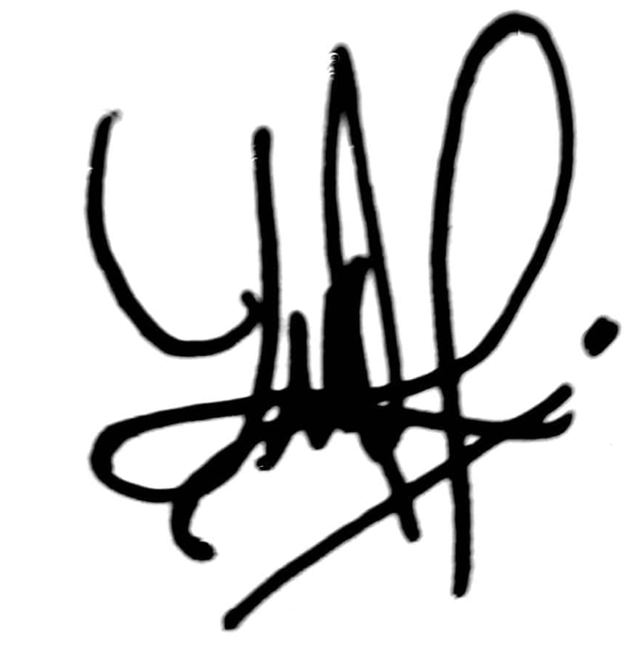
Sucihatiningsih Dian Wisika Prajanti | 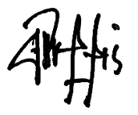
Farhan Hadi Prasetyo | 
Prasetyo Ari Bowo | 