Nasiri’s Flash Flood Analysis
IS. Hidayatulloh
Department of Civil and Environmental Engineering, Gadjah Mada University, Yogyakarta, INDONESIA
penafsir_mimpi@yahoo.com
AP. Rahardjo
Associate Professor of Civil Engineering, Gadjah Mada University, Yogyakarta, INDONESIA
adam.pamudji.r@gmail.com
BA. Kironoto
Professor of Civil Engineering, Gadjah Mada University, Yogyakarta, INDONESIA
kironoto@tsipil.ugm.ac.id
ABSTRACT
Nasiri lays in the Luhu village, Huamual district, West Seram regency, Maluku province. Nasiri experienced in flash flood on August 1st 2012 which never been happened before. There is no rainfall station and water level recorder at that time. It is rather difficult to find out the cause. And yet Nasiri river is only 8 meters wide. The research starts with identifying baseflow, soil characteristics, learning flood video record, routing the river reach, finding the nearest rainfall station, and also interviewing some peoples there. Field data area complemented with satellite radars. AutoCAD 2007, IFAS 2.0.1.2, Geostudio 2004, ArcGIS 10.2, HEC-HMS 4.2.1, and HEC-RAS 5.0.3 are used to perform simulations of natural river with and without precipitation calibration, and also with and without landslide dam in the river. HEC-RAS is subject to perform 2 (two) dimensional flood routing. The result is fairly satisfied. Nasiri watershed was experiencing in flash flood caused by 2 (two) landslide dams which collapse in 2 (two) different times. The first landslide dam is 7.55 meters high which collapse at 09:52 (UTC+9) with 83.58 cum of peak discharge. The second landslide dam is 8.91 meters high which collapse at 14:24 (UTC+9) with 54.16 cum of peak discharge.
Keywords: Nasiri, flood, landslide dam, two dimensional routing, HEC-RAS 5.0.3.

FLOODS AND LANDSLIDES
Floods and landslides are the most frequent disasters in Indonesia. Based on data and information from BNPB (2017), recorded 1,481 times of disaster from January to July 2017. Flood and landslide disaster has contributed 3.17% of total disaster incidents with locations spread throughout Indonesia. It caused 19 people died and disappeared, 37 people were injured, 163 houses were severely damaged, 4,438 houses were slightly damaged, and 105,768 people suffered and displaced. Given the significant number of victims, research on these disasters is indispensable as a mitigation effort.

NASIRI’S LOCATION
Nasiri is located on a peninsula that has a land width of ±5 km. Geographically, Nasiri lies at 3º20'25.80"- 3º20'37.18" S and 127º56'14.22"- 127º56'27.62" E. Nasiri is a small village with length of east-west ±500 meters and long north-south ±300 meters. Hamlet of Lirang in the north, hamlet of Talaga Kambelu in the west, and to the east by the hills.
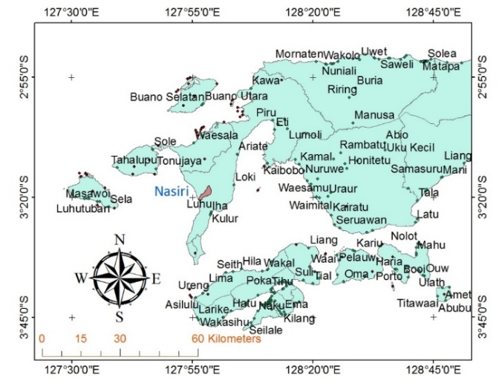
Figure 1. Nasiri’s location.
Nasiri was flash flooded on August 1st 2012. It was the only flood that ever happened. And yet this paper will analyze the flash flood events chronologically.

research flow chart
Because of there are so many variables in this research, we use a simple flow chart to analyze.
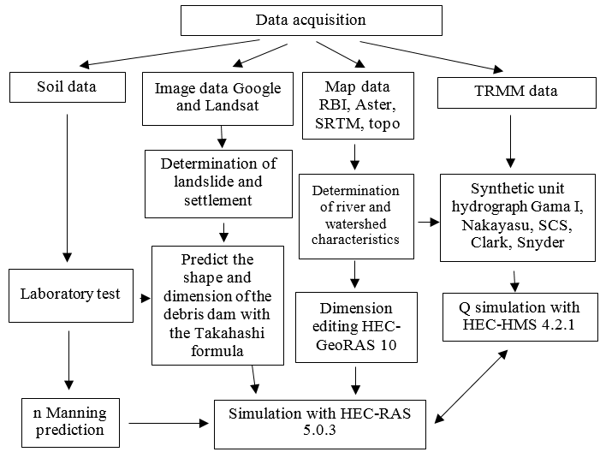
Figure 2. Flow chart for this research.

SOIL INVESTIGATION
Some samples of soil are tested in the Gadjah Mada University’s laboratory. Those samples are taken from several place in Nasiri as shown in Figure 3. Sieve analysis showed that the soil contains 70% of sand. The most appropriate SCS-CN classification is B (after Nearing et al, 1996).
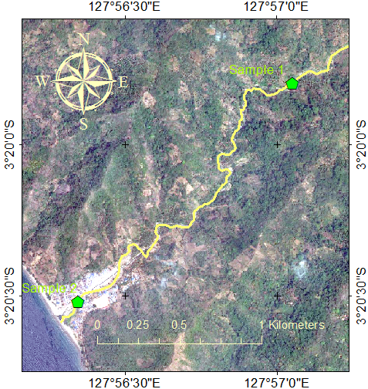
Figure 3. Soil samples data acquisition place.
The composite value for CN B in Nasiri is 59.457. And the result from the laboratory is listed in Table 1.

Table 1. Manning’s n value prediction
Method | Sample 1 | Sample 2
Strickler (1923) | 0.046 | 0.046
MPM (1948) | 0.054 | 0.057
Julien (2002) | 0.074; 0.058; 0.054 | 0.073; 0.062; 0.056

SATELLITE IMAGES
Google satellites recorded an avalanche and river flow path in the Nasiri’s upstream. It lies ±1.5 km from the people settlements at the altitude of +53 mdpl. Figure 2 is evidence of an avalanche on the river bank. While Figure 3 is 3 (three) locations that allegedly occurred landslide. Landsat images cannot display clearly because of it’s 30x30 meters resolution.
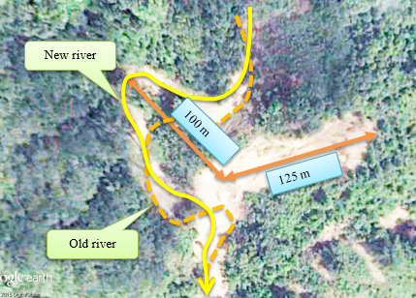
Figure 4. Image from google satellite on October 8th 2012.
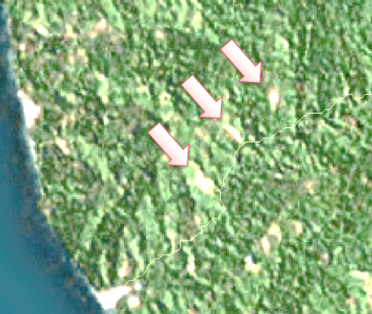
Nasiri hamlet
Figure 5. Image from ArcGIS online imagery.

dsm and dtm comparison
ASTER (1 arc-second), SRTM (1 arc-second), and RBI (Indonesian Topographical Map with 25 meters of contour interval) are compared to the ground survey mapping. By means of Nash-Sutcliffe (1970) index, the comparison result is show in Table 2. Choosing the GPS-TOPO map is more accurate for river reach, while SRTM is useful for watershed elevation. ArcHydro version 2 is used to create watershed delineation and river reach confluences. To improve the accuracy of river reach elevations and population settlements, researchers added 2,500 points based on documentation and tracing on the ground to obtain DEM with a resolution of 1 x 1 meter.
Table 2. Nash-Sutcliffe index of DSM/DTM elevation
ASTER | SRTM | RBI | GPS-TOPO
-1.618 | 0.703 | 0.322 | 0.938

Table 3. Watershed characteristics comparison
Parameter | ASTER | SRTM | RBI
Area (km²) | 10.523 | 10.551 | 10.492
River length (km) | 7.965 | 8.201 | 7.902
River slope (m/m) | 0.092 | 0.089 | 0.105
River confluence | 20 | 21 | 45
Min. elev. (m) | 0 | 8 | 3.694
Max. elev. (m) | 916 | 931 | 903.673

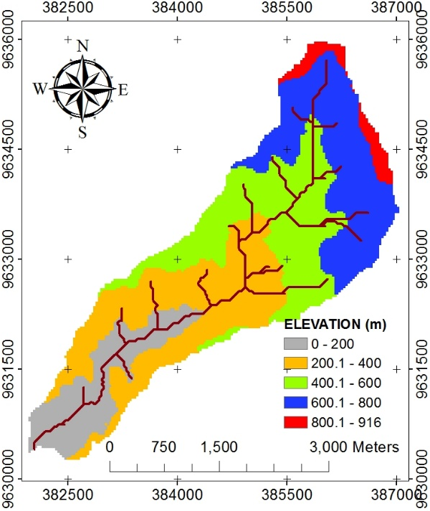
Figure 6. ASTER watershed (2011).
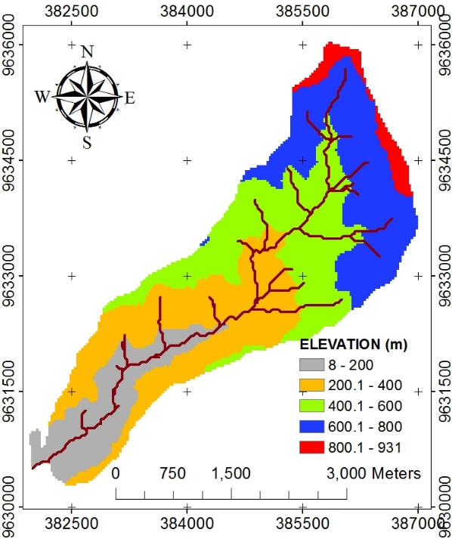
Figure 7. SRTM watershed (2014).
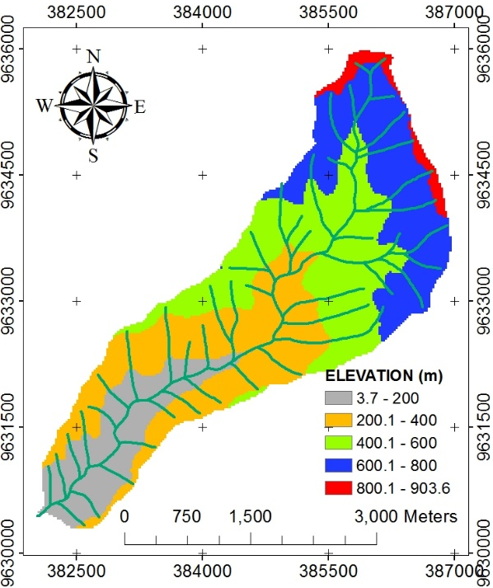
Figure 8. RBI watershed (2009).

landslide dam dimension prediction
The dimensions of landslide dams can be predicted with empirical model of Takahashi (2007).
$L_{B}=\frac{W}{\cos{θ}}+\frac{V\cos{θ}}{2BW}K$ (1)
$L_{T}=\frac{W}{\cos{θ}}-\frac{V\cos{θ}}{2BW}K$ (2)
$K=\frac{\cos{θ}}{tan⁡(φ+θ)}+\sin{θ}+\frac{sin⁡(90°+φ)}{sin⁡(φ-θ)}$ (3)
$D_{max}=\frac{2V}{B(L_{B}+L_{T})}$ (4)
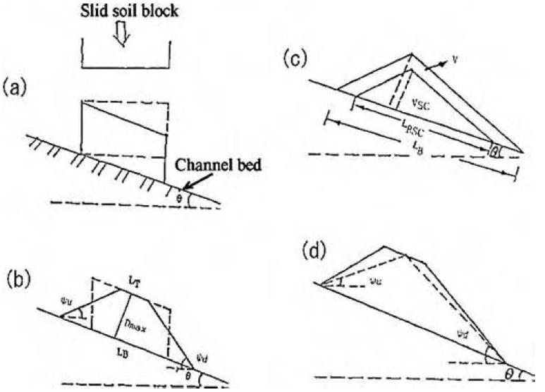
Figure 9. Landslide dam transformation (Takahashi, 2007)
Preliminary prediction of landslide dam dimension is presented in Table 4. The value will be tested in the HEC-RAS simulation. While the prediction of landslide location that form the natural dam presented in Figure 10.
Table 4. Landslide dam dimension prediction
Parameters | Dimension
Parameters | Up (3) | Middle (2) | Bottom (1)
L_{T} (m) | 24.60 | 0.02 | 27.26
L_{B} (m) | 75.53 | 26.70 | 49.75
D_{max} (m) | 16.98 | 8.96 | 7.55
θ (°) | 0.53 | 0.69 | 0.86
ψ_{u} (°) | -0.10 | -0.09 | -0.56
ψ_{d} (°) | 0.95 | 1.27 | 1.15
Elev. (m) | +101.87 | +78.53 | +53.23

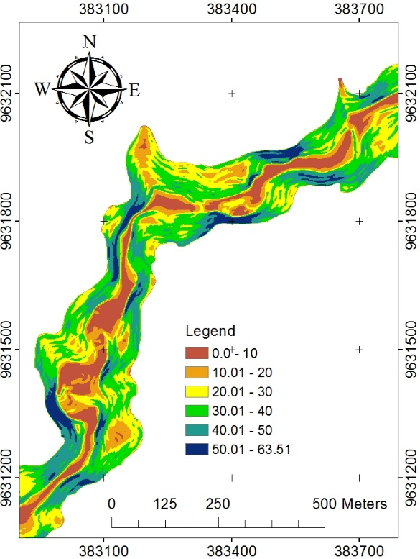
Landslide 1
Landslide 3
Landslide 2
Figure 10. Slope (°) and landslide dam location.

landslide dam stability factor
The dimensions of landslide dams were tested for stability with GEOSTUDIO 2004. Material models are using Mohr-Coulomb (Parry, 2004).
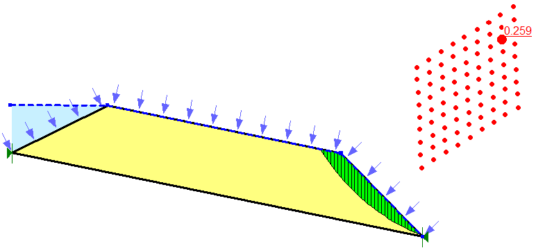
Figure 11. Landslide 1 model.
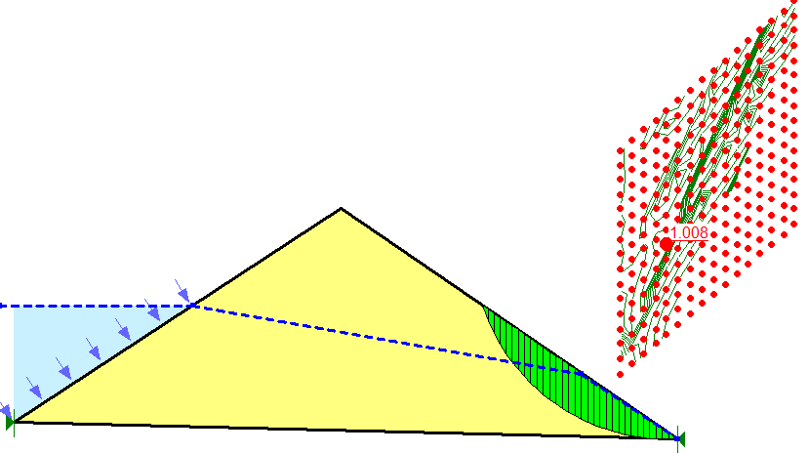
Figure 12. Landslide 2 model.
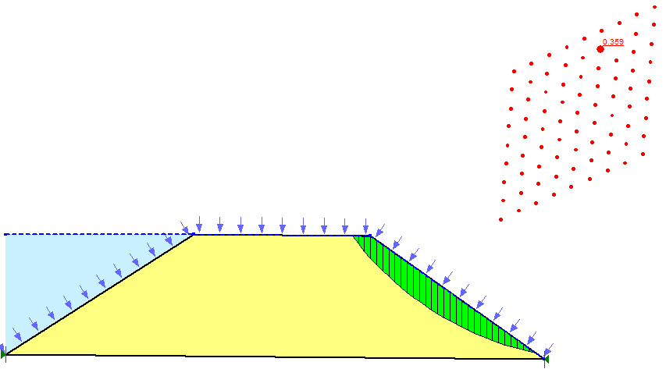
Figure 13. Landslide 3 model.
Table 5. Failure type of each landslide model
Landslide | 1 | 2 | 3
Elev. invert (m) | +53.23 | +78.53 | +101.87
Shape | trapezoidal | triangle | trapezoidal
Failure type | overtopping | piping | overtopping
Elev. failure (m) | +60.78 | +85.95 | +123.89

Nasiri’s RESIDENT Documentary
A resident was documenting the flood events with his phone video camera. It was a very rough video, but it can illustrate the magnitude of the flood. From Figure 4 it appeared that flood flow was very fast (±5.4 m/sec), muddy, swept away trees, and have destroyed many houses. Predicted discharge is 54.16 m³/sec at 14:38 PM (UTC+9).

Figure 14. Video recording during flood.
Flood modeling which done with HEC-RAS and HEC-HMS will be adjusted with oral information obtained on 13-20 July 2014 from several Nasiri’s residents. Resume information is like the following table.
Table 6. Nasiri’s resident oral information
Date | Information
7/27-7/29/2012 | There was no landslide in river reach.
7/31/2012 | The rain started in the afternoon and lasted continuously until the evening.
8/1/2012 | The rain still lasts until night. There was a flash flood at 10:00 AM (UTC+9). The turbid flood waters carry trunks of trees, mud, and rocks. The riverbed changed direction and crashed 61 buildings to shreds. The flood waters receded for several hours, but rose again in the afternoon. Toward late at night, the river water has subsided to normal.
8/2-4/ 2012 | The weather was sunny and reportedly no rain. The river water gradually changes its turbidity level to normal again.

precipitation data
The most popular satellite precipitation data which use widely in Indonesia is TRMM 3B42RT version 7. In Maluku Province, the monthly data correlation is 0.78 and looks underestimate when compared to ground rainfall data (Mamenun et al, 2014). In Lohiatala, a rainfall station which lies ±43 km from Nasiri, TRMM is still underestimated at main rainfall months (July-August). TRMM recorded only 88% of total precipitation amount. While in Patimura, a rainfall station which lies ±44 km from Nasiri, TRMM has a good monthly correlation of 0.95.
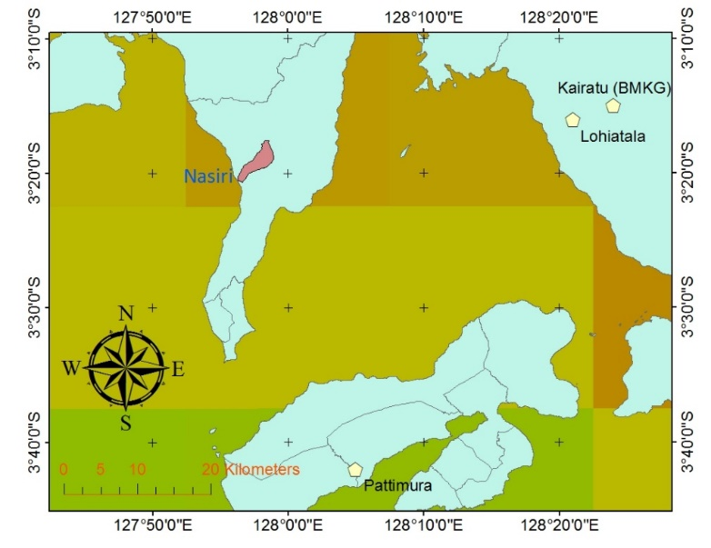
Figure 15. TRMM grid compare to rainfall station position.
Table 7. TRMM precipitation data
Date (WIT) | TRMM 3B42RT v.7 (mm) | Calibrated (mm)
19-Jul-12 | 1,3363 | 1,5056
20-Jul-12 | 117,3647 | 132,2320
21-Jul-12 | 1,0137 | 1,1421
22-Jul-12 | 8,3404 | 9,3969
23-Jul-12 | 0,0000 | 0,0000
24-Jul-12 | 0,0461 | 0,0519
25-Jul-12 | 0,0000 | 0,0000
26-Jul-12 | 0,0000 | 0,0000
27-Jul-12 | 0,0000 | 0,0000
28-Jul-12 | 0,4147 | 0,4672
29-Jul-12 | 0,0000 | 0,0000
30-Jul-12 | 1,0137 | 1,1421
31-Jul-12 | 55,9406 | 63,0269
1-Aug-12 | 199,3790 | 224,6355
2-Aug-12 | 12,1467 | 13,6854
3-Aug-12 | 0,0000 | 0,0000
4-Aug-12 | 0,0000 | 0,0000

According to the rainfall data in Patimura station, the highest rainfall was recorded at 263 mm on June 28th, 2007. The highest rainfall in the Lohiatala station was 372 mm on January 2nd, 2009. The highest rain sequence ever in the Nasiri basin was based on the 1998- 2014 is like the following table.
Table 8. Highest precipitation in Nasiri (TRMM)
No | Date (UTC) | Intensity (mm)
1 | 2010:08:04 | 226,1490
2 | 2010:06:16 | 183,1170
3 | 2011:06:05 | 174,8410
4 | 2012:08:01 | 141,5310
5 | 2012:06:08 | 137,8500
6 | 2008:08:04 | 137,4230
7 | 2011:05:19 | 127,1720
8 | 2004:02:18 | 119,7370
9 | 1999:07:03 | 113,5920
10 | 2012:07:31 | 113,3560

The precipitation that occurred on August 1st, 2012 is in fourth rank. While on August 4th, 2010, there was no flood in Nasiri. On June 8th, 2012 there had also been no flood. This showed that rainfall is not the main factor as the cause of flood incident on August 1st, 2012.

natural river FLOW HYDROGRAPH
Five instantaneous unit hydrograph are compared to view the peak flood at 10:00 AM on August 1st, 2012. HEC-HMS simulation result without landslide dam is shown in Table 9.
Table 9. Peak flow from IUH
IUH | Peak flow (m³/sec) | Time (UTC+9)
Gama I (Sri Harto, 1985) | 36.587 | 09:24
Nakayasu (1951) | 40.206 | 09:00
SCS (Snider, 1972) | 42.032 | 09:20
Snyder (1938) | 43.192 | 09:04
Clark (1945) | 43.273 | 09:06

Figure 16. Hourly hydrograph at August 1st, 2012.
There is a gap between those IUH and Table 6. Peak flow was occurred at 09:00 till 09:24 while Nasiri’s resident said flood hit at 10:00. Approximated peak flow was >60 m³/sec while Figure 16 says different results. There must be two landslides in river upstream. First, before 10:00 AM and the second is before 14:38 PM.

Calibrating manning roughness coefficients
Several n value from Table 1 are simulated in HEC-RAS 5.0.3. Full momentum equations are applied in this case. These equations are (Brunner, 2016) listed here.
$\frac{∂u}{∂t}+u\frac{∂u}{∂x}+v\frac{∂u}{∂y}=-g\frac{∂H}{∂x}+v_{t}\left(\frac{∂^{2}u}{∂x^{2}}+\frac{∂^{2}u}{∂y^{2}}\right)-c_{f}u+fv$ (5)
$\frac{∂v}{∂t}+u\frac{∂v}{∂x}+v\frac{∂v}{∂y}=-g\frac{∂H}{∂y}+v_{t}\left(\frac{∂^{2}v}{∂x^{2}}+\frac{∂^{2}v}{∂y^{2}}\right)-c_{f}v+fu$ (6)
Table 10. Index of Nash-Sutcliffe for Flood Plain
n Manning | 0.046 | 0.056 | 0.057 | 0.062 | 0.073
Index $η$ | 0.454 | 0.977 | 0.995 | 0.943 | 0.638

Figure 17. Rating curve for velocity.
From some of the Manning n values, it can be calculated the most ideal value for settlements and river channel by rating curves. From Table 10, the value of n = 0.057 (MPM, 1948) is the best and the maximum debit at 10:00 (UTC+9) is 83.58 m³/sec. As for the river channel corresponding to the information in Section 9 is 0.018.

Compatibility of Runoff Volume
From July 19th, 2012 to August 4th, 2012 obtained predicted volume of 4,538,304 m³. The calculated results from several Ia-CN value are listed in Table 11. The ideal value of Ia-CN are listed in Table 12.
Table 11. Runoff volume comparison from standard and calibrated precipitation (x1000 m³)
CN | Ia = 0,05 |  | Ia = 0,10 |  | Ia = 0,15 |  | Ia = 0,20
CN | standard | calibrated | standard | calibrated | standard | calibrated | standard | calibrated
45 | 3203.8 | 3626.9 | 3076.1 | 3494.9 | 2950.0 | 3364.1 | 2825.6 | 3234.6
50 | 3421.8 | 3866.2 | 3311.5 | 3752.9 | 3202.1 | 3640.3 | 3093.7 | 3528.5
55 | 3629.7 | 4091.9 | 3535.5 | 3995.6 | 3441.7 | 3899.7 | 3348.5 | 3804.3
60 | 3828.0 | 4304.9 | 3748.6 | 4224.1 | 3669.3 | 4143.5 | 3590.4 | 4063.1
65 | 4017.5 | 4506.3 | 3951.5 | 4439.5 | 3885.6 | 4372.8 | 3757.4 | 4242.9
70 | 4198.6 | 4697.1 | 4144.9 | 4642.9 | 4091.3 | 4588.8 | 4037.8 | 4534.8

Table 12. Ideal value of Ia-CN for Nasiri
Ia | 0.05 | 0.10 | 0.15
CN | 65.838 | 67.428 | 68.831

Time of the First Landslide
Four location are set as calibration points (see Figure 18). The four calibration points have the value as shown in Table 13. The entire HEC-RAS simulation was performed over 36,800 cells measuring 3x3 meters and at 0.3 second calculation time interval.
Table 13. Flow depth at peak flood
No | Location | Depth
1 | School | 1.0 meter
2 | House 1 | 0.8 meter
3 | House 2 | 0.7 meter
4 | Mosque | 0.5 meter

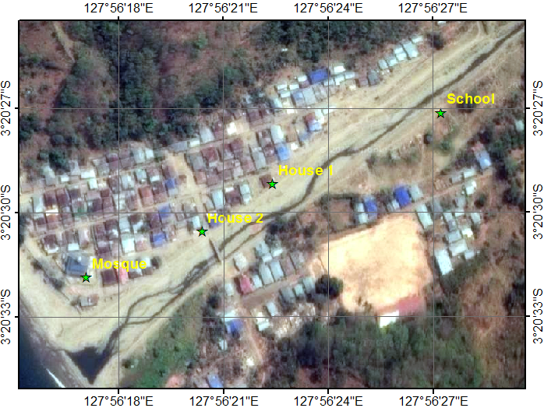
Figure 18. Calibration points.
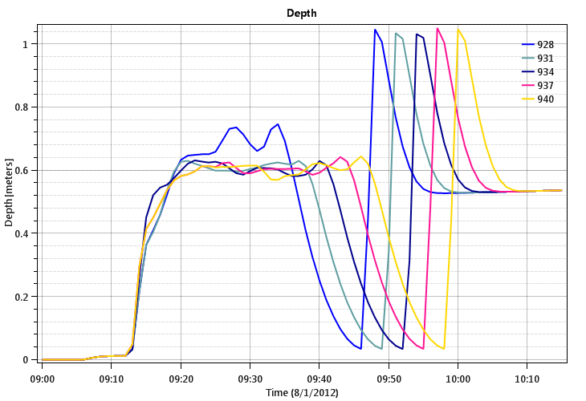
Figure 19. Flow depth at school caused by landslide dam (1) from 09:28 to 09:40 with Von Thun and Gillette (1990) breach formula.
Table 14. Flow depth caused by landslide dam (1) (meter)
Formula | Time | School | House 1 | House 2 | Mosque | Velocity (m/sec)
McDonald and Monopolis (1984) | 9:33 | 0.870 | 0.848 | 0.583 | 0.332 | 3.075
Froehlich (1995) | 9:37 | 0.930 | 0.903 | 0.603 | 0.349 | 3.214
Froehlich (2008) | 9:37 | 0.965 | 0.899 | 0.598 | 0.353 | 3.273
Von Thun and Gillette (1990) | 9:40 | 1.001 | 0.925 | 0.649 | 0.362 | 3.269
Xu & Zhang (2009) | 9:37 | 0.921 | 0.895 | 0.575 | 0.349 | 3.175
Table 15. Index η from landslide dam (1)
Formula | McDonald (1984) | Froehlich (1995) | Froehlich (2008) | Von Thun (1990) | Xu & Zhang (2009)
Index η | 0.531 | 0.631 | 0.670 | 0.714 | 0.587

From the above table, it can be concluded that there was an avalanche in the river channel at elevation of +53.23 as high as 7.55 meters at 09:40 and began to collapse at 09:52. The most appropriate breach formula is Von Thun and Gillette (1990).

Time for the Second Landslide
Analog by way of the first landslide, then calculated also for flood at 14:38. The central landslide as high as 8.96 meters at the +78.53 elevation is simulated in HEC-RAS. From the HEC-HMS simulation without a landslide dam, the Nasiri river only supplies 16 - 20 m³/sec of discharge at 14:00 - 15:00. In contrast to the lower landslides seen quite clearly from Google Earth imagery, the central landslide is not clearly visible from satellite imagery. So it takes several times the experiment of the dimension of the middle landslide. The experiment of the landslide dimension should refer to the potential avalanche area seen from ArcGIS imagery online imagery.
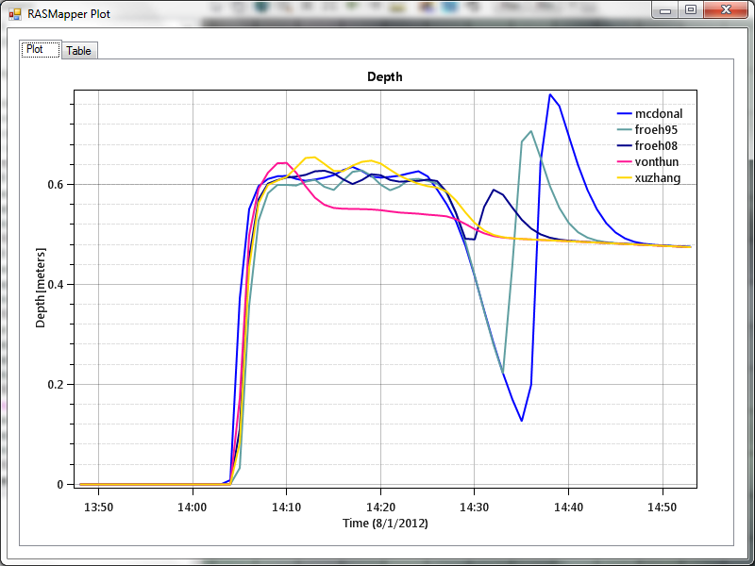
Figure 20. Flow depth at school caused by landslide dam (2).
Of the five methods of collapse, it appears that MacDonald and Langridge-Monopolis (1984) and Froehlich (1995) could potentially be the best method of collapse. However, because the volume equilibrium method of Takahashi (2007) did not allow for a landslide dam higher than 8.96 meters, the best collapse formula was MacDonald and Langridge-Monopolis (1984). To determine the most optimal dimension of landslide dam, we try 5 (five) dimensions that allegedly approach the value of flood calibration. The results obtained are listed in Table 17.
Table 16. Dimension prediction of landslide dam (2)
Parameters | 1 | 2 | 3 | 4 | 5
L_{T} (m) | 0.02 | 0.09 | 0.23 | 0.36 | 0.50
L_{B} (m) | 26.70 | 26.61 | 26.48 | 26.34 | 26.20
D_{maks} (m) | 8.96 | 8.91 | 8.82 | 8.73 | 8.64
θ (°) | 0.69 | 0.69 | 0.69 | 0.69 | 0.69
ψ_{u} (°) | -0.09 | -0.09 | -0.09 | -0.10 | -0.10
ψ_{d} (°) | 1.27 | 1.27 | 1.27 | 1.27 | 1.27
River invert (m) | +78.5 | +78.5 | +78.5 | +78.5 | +78.5

Table 17. Flood depth from second avalanche
Height (m) | Time | School | House 1 | House 2 | Mosque | Velocity (m/sec)
8.96 | 14:18 | 0.768 | 0.790 | 0.516 | 0.313 | 2.509
8.91 | 14:19 | 0.753 | 0.748 | 0.475 | 0.302 | 3.048
8.82 | 14:19 | 0.741 | 0.746 | 0.463 | 0.296 | 3.025
8.73 | 14:19 | 0.741 | 0.744 | 0.463 | 0.296 | 3.025
8.64 | 14:19 | 0.728 | 0.737 | 0.454 | 0.292 | 3.006
Table 18. Index η for landslide dam (2)
Height (meters) | 8.96 | 8.91 | 8.82 | 8.73 | 8.64
Index η | 0.970 | 0.999 | 0.998 | 0.998 | 0.993

From the table above it can be concluded that there was an avalanche in the river channel at +78.53 elevation as high as 8.91 meters at 14:19 and began to collapse at 14:24. The flood hazard map from the HEC-RAS simulation could be seen in Figure 21.
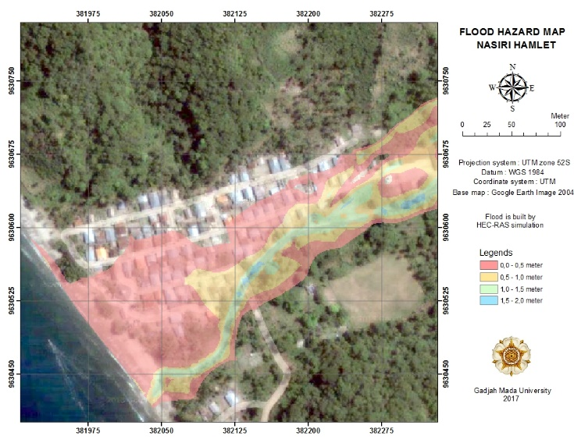
Figure 21. Flood hazard map at Nasiri.

CONCLUSIONS
Only 46 houses are free from floods or about 47% of the total settlements area. The chronological flow of flood events in Nasiri watershed is as follows.
July 31st, 2012 at 17:00, it started to rain in the afternoon.
August 1st, 2012
09:40 First landslide dam formed at +53.23 elevation as high as 7.55 meters.

09:52 First landslide dam collapsed.

10:00 First flood came into the settlements and destroyed 61 houses. Peak discharge is 83.58 m³/sec.

14:19 Second landslide dam formed at +78.53 elevation as high as 8.91 meters.

14:24 Second landslide dam collapsed.

14:38 Second flood came into the settlements. Peak discharge is 54.16 m³/sec.

21:00 The rain stopped and the flow began to recede.

Acknowledgments
The authors would like to thank to Gadjah Mada University for funding this project as a part of capacity development on natural disaster risk management for communities in small islands.

References
BNPB. 2017. (online). (http://dibi.bnpb.go.id accessed August 18th, 2017)
Brunner, Gary W. (2016). HEC-RAS, River Analysis System Hydraulic Reference Manual. Davis: US Army Corps of Engineers Hydrologic Engineering Center.
Froehlich, David C. (1995). “Embankment Dam Breach Parameters Revisited.” ASCE: Water Resources Engineering Proceedings.
Froehlich, David C. (2008). “Embankment Dam Breach Parameters and Their Uncertainties.” J. Hydraul. Eng. 2008.134:1708-1721.
Julien, Pierre Y. (2002). River Mechanics. Cambridge University Press.
Mamenun; Pawitan, Hidayat; and Sophaheluwakan, Ardhasena. (2014). “Validasi dan Koreksi Data Satelit TRMM Pada Tiga Pola Hujan di Indonesia.” Puslitbang BMKG: Jurnal Meteorologi dan Geofisika Vol 15, No 1.
Meyer-Peter, E and Müller, R. (1948). “Formulas for bed-load transport.” Prosiding 2nd Meeting IAHR. Stockholm.
McDonald, Thomas C and Langridge-Monopolis, Jennifer. (1984). “Breaching Characteristics of Dam Failures.” J. Hydraul. Eng. 1984.110:567-586.
Nash, JE dan Sutcliffe, JV. (1970). “River flow forecasting through conceptual models. Part 1: Discussion of Principles.” Journal of Hydrology 10 (1970) 282-290 Amsterdam: North-Holland Publishing Co.
Nearing, MA; Liu, BY; Risse, LM; dan Zhang, X. (1996). “Curve numbers and Green-Ampt effective hydraulic conductivities.” Water Resources Bulletin Vol. 32 No. 1, February 1996.
Parry, RHG. (2004). Mohr Circles, Stress Paths and Geotechnics. New Fetter Lane, London: Spon Press.
Strickler. (1923). “Contributions to the Question of a Velocity Formula and Roughness Data for Streams, Channels and Closed Pipelines (translated by Thomas Roesgen and William R. Brownlie).” Pasadena: California Institute of Technology.
Takahashi, Tamotsu. (2007). Debris Flow: Mechanics, Prediction, and Counter measures. Leiden: CRC Press/Balkema.
Xu, Y and Zhang, LM. (2009). “Breaching Parameters for Earth and Rockfill Dams.” J. Geotech. Geoenviron. Eng. 2009.135:1957-1970.

