Dry Reagen DPPH
Strawberry Juice Quersetin
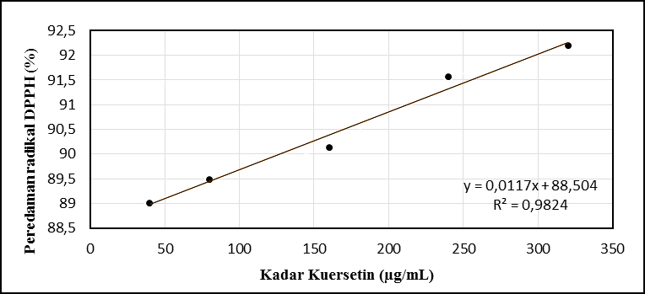
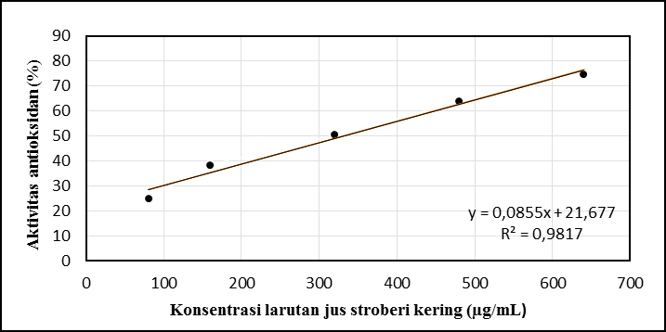

Standard Curve of strawberry juice [flavonoid]
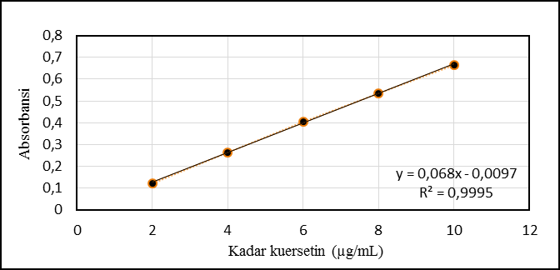
Standard Curve of strawberry juice emulgel [flavonoid]
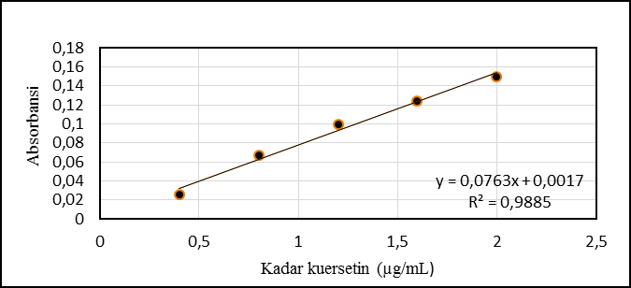
Standard Curve of flavonoid in media PBS pH 7,4
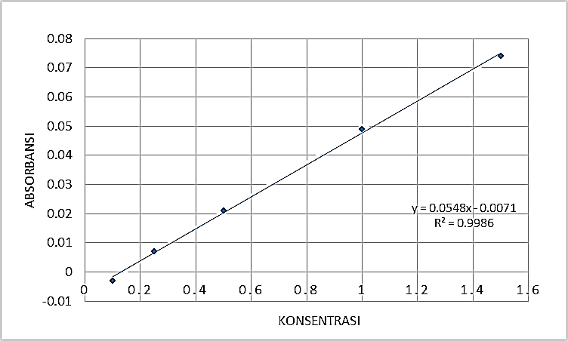
Formula of strawberry juice emulgel
Tahap pembuatan | Bahan | Komposisi (% b/v)
Fase primer Emulsi a/m | Fase Air* | 12,0
Fase primer Emulsi a/m | Asam Benzoat | 0,1
Fase primer Emulsi a/m | Jus stroberi Kering | 1,0
Fase primer Emulsi a/m | Span 80 | 8,0
Fase primer Emulsi a/m | Croduret 50 ss | 8,0
Fase primer Emulsi a/m | Propilen glikol | 8,0
Fase primer Emulsi a/m | Isopropil miristat | 18,9
Fase Sekunder Hidrogel | Poligel Ca | 1,5
Fase Sekunder Hidrogel | Dapar sitrat pH 5,4 | 55,0
 | TEA | 1,5
 | Tween 80 | 2,0
TOTAL |  | 100,0

