

COPYRIGHT TRANSFER AGREEMENT FORM

Jurnal Ilmu Pertanian (Agricultural Science) requires a copyright transfer agreement from the authors for the article submitted and published to Jurnal Ilmu Pertanian. Please complete and return this form:
Article Title | : EVALUATION OF THE CROSS BETWEEN LOCAL RICE AND DROUGHT-TOLERANT
 | RICE USING SIMPLE SEQUENCE REPEAT (SSR) MOLECULAR MARKERS
Author (s) | : 1. Aditya Wahyudhi,
- Lintang Restu Pratiwi
- Panjisakti Basunanda

- I/we have read and agree with the term and conditions of this agreement, I/we hereby transfer all copyrights in and relating to the above-named manuscript in all form and media now or hereafter known, to the Jurnal Ilmu Pertanian (Agricultural Science) effective from the data stated below. I/we acknowledge that the Jurnal Ilmu Pertanian (Agricultural Science) are relaying on this agreement in publishing this manuscript.
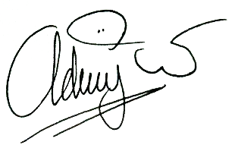
- I/we declare that this article has not already been published elsewhere (except in abstract form or as part of a lecture, review, or thesis), not being submitted for publication elsewhere. All co-authors have agreed to publish in this journal and has a real contribution in the research and preparation of the manuscript. I/we also declare that there is no conflict of interest of this article.

Signature of copyright owner (s):
Name of co-authors | Aditya Wahyudhi
Date | 17 Juni 2020

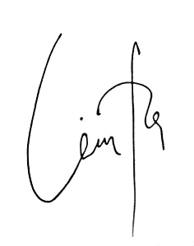
Signature of copyright owner (s):
Name first authors | Aditya Wahyudhi
Date | 17 Juni 2020

Signature of copyright owner (s):
Name second authors | Lintang Restu Pratiwi
Date | 17 Juni 2020

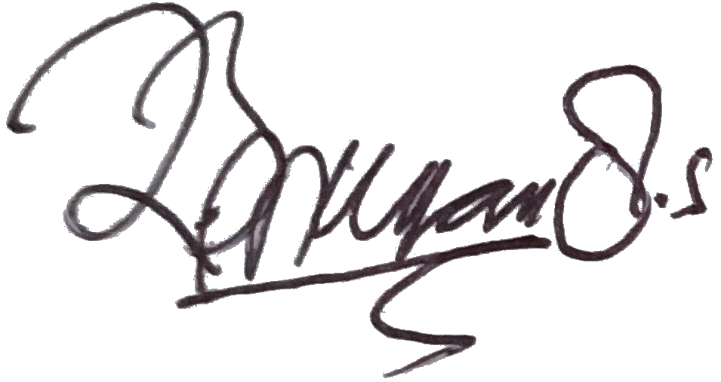

Signature of copyright owner (s):
Name third authors | Panjisakti Basunanda
Date | 20 Juni 2020

Signature of copyright owner (s):
Name fourth authors
Date

Signature of copyright owner (s):
Name fifth authors
Date

