

COPYRIGHT TRANSFER AGREEMENT FORM

Jurnal Ilmu Pertanian (Agricultural Science) requires a copyright transfer agreement from the authors for the article submitted and published to Jurnal Ilmu Pertanian. Please complete and return this form:
Article Title | : Rutaceae: the Conservation at Eka Karya Bali Botanic Garden and its Antifungal Activity
Author (s) | : I Putu Agus Hendra Wibawa, Arrohmatus Syafaqoh Li’aini, Putri Sri Andila, Frelyta Ainuz Zahro’

- I/we have read and agree with the term and conditions of this agreement, I/we hereby transfer all copyrights in and relating to the above-named manuscript in all form and media now or hereafter known, to the Jurnal Ilmu Pertanian (Agricultural Science) effective from the data stated below. I/we acknowledge that the Jurnal Ilmu Pertanian (Agricultural Science) are relaying on this agreement in publishing this manuscript.
- I/we declare that this article has not already been published elsewhere (except in abstract form or as part of a lecture, review, or thesis), not being submitted for publication elsewhere. All co-authors have agreed to publish in this journal and has a real contribution in the research and preparation of the manuscript. I/we also declare that there is no conflict of interest of this article.

Signature of copyright owner (s): | 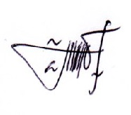
Name of co-authors | Arrohmatus Syafaqoh Li’aini
Date | October, 2nd 2020

Signature of copyright owner (s): | 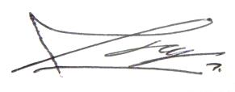
Name first authors | I Putu Agus Hendra Wibawa
Date | October, 2nd 2020

Signature of copyright owner (s):
Name second authors | Arrohmatus Syafaqoh Li’aini
Date | October, 2nd 2020

Signature of copyright owner (s): | 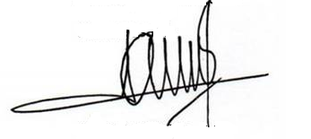
Name third authors | Putri Sri Andila
Date | October, 2nd 2020

Signature of copyright owner (s): | 
Name fourth authors | Frelyta Ainuz Zahro’
Date | October, 2nd 2020

