Morpho-Ecotype Characterization of Superior Local Durian (Durio zibethinus L.) in Jember Regency
Vega Kartika Sari ^{1⁎}, Halimatus Sa’diyah², Basuki Basuki³

¹Program Study of Agronomy, Faculty of Agriculture, University of Jember, Jl. Kalimantan No.37 Kampus Tegalboto, Jember, East Java 68121

²Program Study of Agronomy, Faculty of Agriculture, University of Jember, Jl. Kalimantan No.37 Kampus Tegalboto, Jember, East Java 68121

³ Program Study of Soil Science, Faculty of Agriculture, University of Jember, Jl. Kalimantan No.37 Kampus Tegalboto, Jember, East Java 68121

* Corresponding author. Tel.: 085790878584. Email address: vegakartikas@unej.ac.id

Abstract
Jember Regency is located on the slopes of Mount Raung and Mount Argopuro. Several areas such as Panti District and Sumberjambe District are known as durian centers. To find out the potential diversity of durian in the area, it is necessary to characterize the main potential superior durian trees that are known in the local community. The Panti District, on the slopes of Mount Argopuro, and the Sumberjambe District, on the slopes of Mount Raung, were the specific locations where this exploratory investigation was carried out between April and July 2023 in the Jember Regency. Morphological characterization was carried out based on the durian description preparation guide. Ecological observations including topography, soil type and climate were also carried out. Morphological observational data were analyzed in clusters, while ecological data were presented descriptively. The results of cluster analysis showed that 10 local durian accessions from Panti had a similarity level of 66%. The highest similarity between Montong Belanda and Gendon durians (75%). Local durian from Sumberjambe showed 64% similarity from 10 durian accessions. The Si Sukun durian differed significantly from the other accessions, whereas the LK 1 and LK 4 durians shared 85% similarity.
Keywords:
Local Durian, Superior, Morphology, Ecology, Jember Regency

Indonesia is one of the centers of durian diversity in the world (Belgis et al. 2016). Durian is known as the King of Fruit, an exotic tropical fruit with a unique taste and aroma. Durian fruit production in 2021 will reach 1.35 million tonnes, including the top five leading fruit commodities after bananas, pineapples, mangoes, and oranges (BPS 2021). East Java Province is one of the largest durian producing regions, with a total production of 276,426 tonnes (24.20%), followed by Central Java, West Java, North Sumatra, and other provinces.
Specific natural conditions, such as the Besuki residential area in East Java, which is surrounded by several mountains, have led to the development of a distinctive flora (Rusmiati et al. 2013). Some of these mountains are Mount Raung, Mount Argopuro, and Mount Ijen. Banyuwangi Regency, located on the slopes of Mount Ijen, has been known as an area with red durian fruit as its superior fruit (Basuki et al. 2022). Jember Regency is located on the slopes of Mount Raung and Mount Argopuro, where several areas, such as Panti District and Sumberjambe District, are known as durian centers in Jember Regency.
Durian has various morphological characters (Sundari et al. 2015). The diversity of durian in taste, aroma, texture, and color of the fruit flesh as well as in the shape and size of the fruit (Belgis et al. 2016). Local durians on the slopes of Mount Raung and Mount Argopuro may have distinct advantages, both in morphological characteristics and the chemical content of the fruit. Until 2019, 104 superior durian varieties had been registered at the Ministry of Agriculture, and there were still many candidates for varieties that had not been registered that had advantages (Directorate General of Horticulture 2019). Determination of superior varieties begins with morphological characterization.
The aim of this study was to explore local durians on the slopes of Mount Argopuro and Mount Raung. The superior potential of the local durians obtained will be characterized by their morphology and ecology. The morphological and ecological characteristics of each type of local durian fruit with superior potential will be an important source of information in the management of local durian fruit plants.
An exploratory research conducted by survey method to Panti District and Sumberjambe District in Jember Regency, East Java Province, Indonesia. Panti District is on the slopes of Mount Argopuro, while Sumberjambe District is on the slopes of Mount Raung (Figure 1).
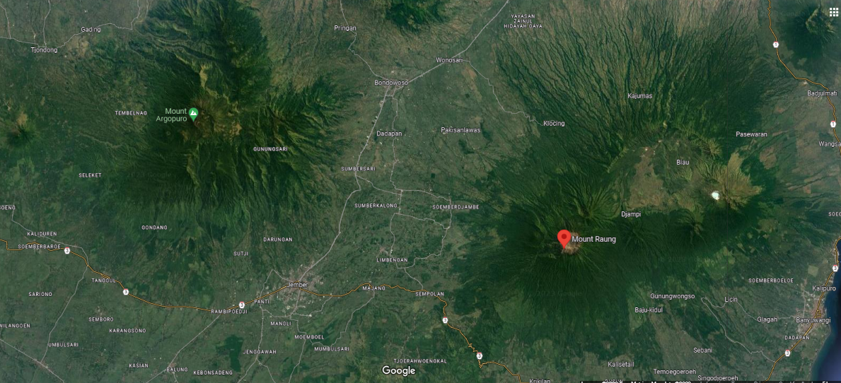

Figure 1. The Study Area of Durian Plants Used in Jember Regency, East Java, Indonesia

Observation of land characteristics is divided into environment and soil. Observed environmental characteristics include slopes and rainfall. Slopes were analyzed using DEM data analysis, while rainfall was analyzed from several rainfall stations at the study site. Rainfall is taken from data for the last 10 years. The soil characteristics observed were previously taken from soil samples from the sampling results with a soil depth of 30–40 cm from the soil surface. Parameters observed included pH using the 1:5 sample and water ratio method, C-Organic using the Walkey & Black method, total soil N using the Kjeldahl method, phosphate using the Olsen method, cations and CEC using the 1 N ammonium acetate extract method, pH 7, and texture with the pipette method.
The sampling technique was purposive sampling. The selected durian trees are more than 30 years old and are known to have high productivity and superior fruit quality, based on information from durian sellers, durian tree owners, and local agricultural extension workers. The vegetative parts of the durian plant were observed (trees, branches, and leaves) using the Descriptors for Durio guidelines issued by IPGRI. The Global Positioning System (GPS) is also used to obtain location information. Morphological observations included 10 durian tree characters and 18 durian leaf characters. Ecological observations include soil conditions, topography, and climate at the site. Microclimate data was obtained from nearby weather stations.
Data were analyzed by cluster using the Gower distance with average linkage program in PAST software. Cluster analysis resulting from morphological observations was also used in the study of Hariyono et al. (2022) to estimate morphological diversity in arrowroot plants resulting from exploration. F test on Minitab 14 software is used to determine the effect of the environment on morphological characters. According to Neter et al. (1985), F test is often used to determine the variance of two groups.
A horticultural plant known as durian is categorized as an annual plant (Hafif 2014). The habitat in which it grows has a significant impact on the taste and fat content. The majority of durian plants are found on the sides of volcanic mountains, and there is a significant association between the appropriateness of the land and that level of suitability (correlation value: > 0.7). There are 181 mountains in East Java that are more than 1,000 meters above sea level, and 7 of the mountains, including Mount Argopura, Mount Raung, Mount Baluran, Mount Ijen, Mount Lemongan, Mount Bromo, and Mount Semeru, are located in a horseshoe-shaped region.
The existence of adjacent mountains, and their environmental characteristics are not the same. In comparison to Mount Argopura, which is 3,088 meters above sea level, Mount Raung is 3,344 meters high (Basuki et al. 2022). The topographic relief formed on the slopes of Argopura 6 is topographically dominated by very steep topography (40-60%) with an area of ​​7,538.68 ha and sloping topography with an area dominating the second (3,759.95 ha) (Figure 2). On the slopes of Mount Argopura, there is 13.53 mm of rainfall each year on average. The research region is defined as having a C climatic type (wet), which has 4-5 dry months and 6-7 wet months, according to the Smith Ferguson climate classification. Mid-May to mid-October are the dry months (Figure 3). The soil formed on the slopes of Mount Argopura is dominated by the Inceptisol, Andisol, and Ultisol orders with seven great soil groups (Figure 4).
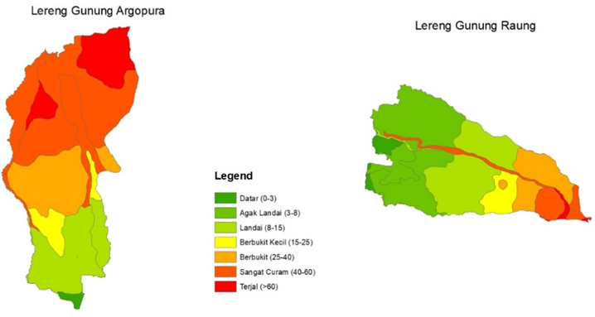
(a) (b)
Figure 2. Geological formations (a) the southern slope of Mount Argopura, (b) the western slope of Mount Raung
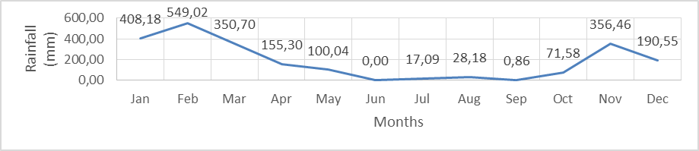
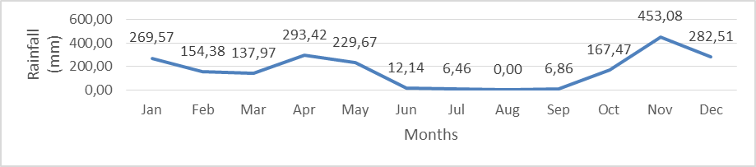

Figure 3. Distribution of annual rainfall on the slopes of Mount Argopura (top) and Mount Raung (bottom)
Seven reliefs (flat, slightly sloping, sloping, little hills, hilly, extremely steep, and steep) can be found on Mount Raung's slopes (Basuki et al. 2022). The 5461.68 hectares of Mount Raung's slopes have a topographic gradient of 3–8% (Fig. 2). The second dominant relief has an area of 3884.04 ha and is gradually sloping (8–15%). The average annual rainfall is 2227.98 mm. The slopes of Mount Raung are classified by Smirt-Ferguson as having a mild climate with an average There are 3–4 dry months and 8–9 wet months per year (Figure 3). The three orders—Andisols, Inceptisols, and Entisols—into which the soil types are subdivided are shown in Figure 4.

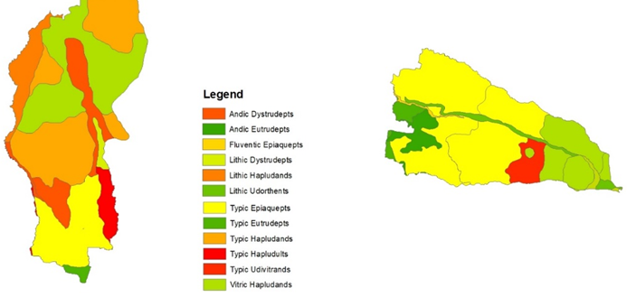

(a) (b)
Figure 4. Soil type (a) the southern slope of Mount Argopura, (b) the western slope of Mount Raung
The five variables that contribute to the formation of soil interact to create the features of soil (Neswati et al. 2019; Szalai et al. 2021; Bölscher et al. 2021). The soil characteristics, both physical and chemical, fluctuate depending on the topographical relief, height, rainfall, and type of soil generated at the study location (Table 1). Table 1 demonstrates that the predominant soil texture is clay, which is made up of 20% sand, 40% silt, and 40% clay. The soil's volume weight on Mount Argopura's slopes ranges from 1.03 to 1.05 g/cm3, with an average of 1.04 g/cm3. The hydrogen potential (pH) of soil is determined by the weathering effects of soil-forming elements (Da Costa et al. 2015; Neswati et al. 2019; Zhong et al. 2019; Alaboz et al. 2021). The results of weathering soil-forming materials result in soils with slightly acidic hydrogen potential (pH) (6.10), very low available phosphate (2.58 ppm), medium category exchangeable cations, particularly potassium (K), (0.42 Me/100g), and high cation exchange capacity (CEC) of 32.38 Me/100g. On the slopes of Mount Argopura, the organic matter produced by the weathering of vegetation organic material is still low (1.94%) and inversely proportional to the total soil nitrogen value, which is moderate (0.28%). With a score of 6.93, the breakdown of organic matter on Mount Argopura's slopes falls into the low category. The amount of soil moisture, the type of litter, the nutrients that support the organic matter, and many other factors affect how quickly organic matter decomposes (Wang et al. 2022; Baskan et al. 2016; Soetriono et al. 2023; Hajduk et al. 2015).
Table 1. Soil characteristics of the slopes of Mount Argopuro and the slopes of Mount Raung
No | Parameter | Unit | Value
No | Parameter | Unit | The slopes of Mount Argopuro |  | The slopes of Mount Raung
1 | pH 1:5 | - | 6,10 | Slightly acid | 5,63 | Slightly acid
2 | C-Organic | % | 1,94 | Low | 3,33 | High
3 | N Total | % | 0,28 | Mid | 0,10 | Low
4 | P₂O₅ | Ppm | 3,58 | Very low | 5,06 | Low
5 | K | Me/100g | 0,42 | Mid | 0,17 | Low
6 | CEC | Me/100g | 32,38 | High | 40,05 | Very high
8 | C/N ratio | - | 6,93 | Low | 33,3 | Very high
9 | BV | g/cm3 | 1,04 | - | 1,15 | -
10 | Teksture
 | Sand | % | 20 | - | 10 | -
 | Silt | % | 40 | - | 50 | -
 | Clay | % | 40 | - | 40 | -
 |  |  | Clay | - | Silty Clay | -

The slopes of Mount Raung have a soil type that is dominated by inceptisol soil with a slightly acidic, pH value of 5.63 (Table 1). Other soil chemical characteristics that are formed, such as P2O5 is in the low category (5.05 ppm), potassium exchangeable is low (0.17 Me/100g), and CEC being in the very high category (40.05 Me/100g). The level of decomposition on the slopes of Mount Raung is in the high category with a C/N ratio of 33.3, where the C-Organic value is high (3.33%), and total soil nitrogen is in the low category (0.10%). The Raung slope is seen from the physical characteristics of the soil, it is included in the silty clay soil texture category. Silty clay is a soil texture composed of 10% sand, 50% silt, and 40% clay, so the volume weight is 1.15 g/cm3.
The soil texture of the G. Argopuro and Raung slopes contains clay, and silt and sand in equal proportions. According to Karim et al (2017), this soil texture is very suitable for durian plants. Soil pH from both locations is slightly acidic. According to Mansur (2007), the durian habitat studied also has a clay type with a slightly acidic pH.
Based on Figure 5, the morphological similarity of the 10 local durian varieties from Slope Mount Argopuro is 66%, or the level of dissimilarity is 34%. This indicates the great level of local durian diversity observed in Panti District on the slopes of Mount Argopuro. In line with the research results of Mustikarini et al (2017), the results of exploration and characterization of durian on South Bangka Island, from 27 accessions formed 5 clusters with a similarity level of 60%. Two major groups were established from the dendogram analysis's findings: group I, which included eight varieties of durian, and group II, which included two varieties, Gendon and Montong Belanda (MB).
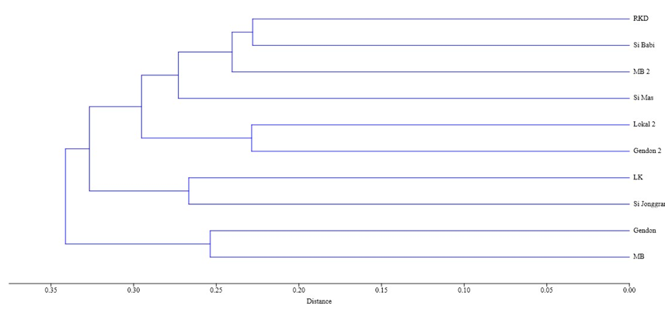
II
I

I
II
III

Figure 5. Dendogram of local durian plants from the slopes of Mount Argopuro

Group I was made up of eight durian accessions that came from two distinct but nearby locales. Susilawati and Sabran (2018) found that genotypes from the same region are not always in the same group, indicating that genotypes from various regions might also be in the same group. Meanwhile, in group II, the two local durian accessions had many morphological similarities compared to the other 8 types, and were in the same location, namely in Pakis Village. The degree of kinship depends on the degree of morphological similarity (Susilawati & Sabran 2018).
Local durians on the slopes of Mount Raung have a variety that is not too different from durians from the slopes of Mount Argopuro. The diversity of local durians in the District of Sumberjambe Slopes of Mount Raung shows high diversity. The dissimilarity of the 10 accessions based on the dendrogram formed was 36% or 64% similarity (Figure 6). According to Hu et al. (2014) and Pereira et al. (2015), the genetic diversity of a species in a population is a consequence of its sexual reproduction system. Handayani (2016) added that the genetic diversity of durian from Kalimantan has high diversity because durian is a cross-pollinated and open plant that originates from random mating between other genotypes.
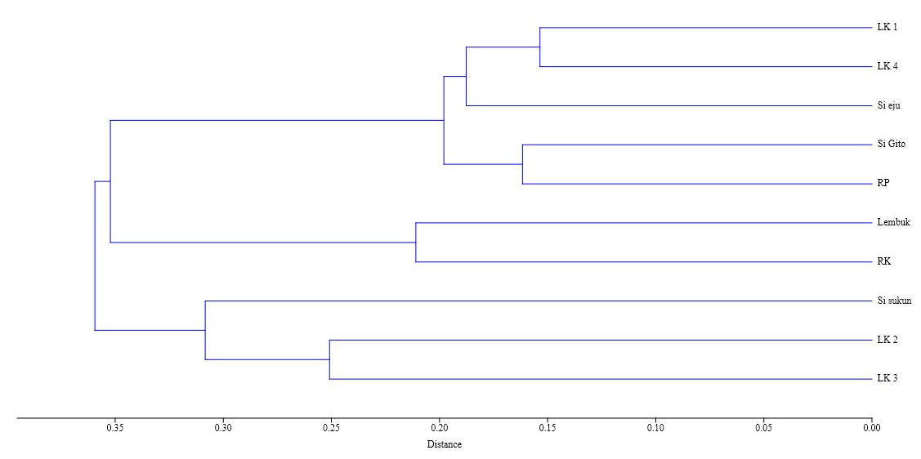
I
II
III

Figure 6. Dendogram of local durian plants from the slopes of Mount Raung

Table 2. F test on the morphological quantitative characters of local durian in 2 ecotypes in Jember Regency
Quantitative Morphological Character | LHD | PHD | LTD | PTD | LB | TB | UT
F test | ns | ns | ns | ns | ns | * | ns
Notes: LHD: width of leaf blade; PHD: blade length; LTD: petiole width; PTD: petiole length; LB: leaf width; TB: stem height; UT: plant age; *: significantly different on the F test 0.05; ns: not significantly different.

Seven quantitative morphological characters were observed, including stems, branches, and leaves. One of these characters, the durian plant's height, tended to vary depending on the ecotype, while the other six did not differ significantly (Table 2). Numerous genes regulate quantitative character. The growth characteristic of plant height is affected by numerous genes as well as environmental factors. The environment has a significant impact on how plants grow. In line with the findings of a study by Handayani and Ismadi (2018), which revealed variations in plant height between durian accessions in two separate sub-districts in the North Aceh District. Different planting timings and environmental factors like sunlight and soil qualities might contribute to variations in plant height.
Variations in the degree of similarity or dissimilarity caused by variations in the morphology of plants, including qualitative and quantitative characteristics, which are regulated by genetics and the environment. Plants require specific conditions in order to express their genetic potential (Handayani & Ismadi, 2018). Weaknesses of morphological markers are affected by plant growth and environmental changes. It can be difficult to differentiate between genotypes since their morphology is similar even though they are distinct. Besides, due to self-incompatibility, durian plants have a high level of variety and undergo a significant amount of cross-pollination (Indriyani et al. 2012). Plant breeding activities are greatly enhanced by the availability of genetic resources (Lestari et al. 2016). This information on morphological variation may serve as the basis for future development and preservation.
The degree of similarity among the ten prospective superior local durians from Panti, on the slopes of Mount Argopuro, is 66%, which is not significantly different from the level of similarity among the local durians from Sumberjambe, on the slopes of Mount Raung, at 64%. The most similar durians were Montong Belanda and Gendon from Panti (75%), while those from Sumberjambe were closest to LK 1 and LK 4 durians (85%).
Author contribution
List the contribution of each author: VKS designed the research and wrote the manuscript, HS tabulated and analyzed the data morphology and wrote the interpretation, B analyzed the data of ecology and designed the maps.

Acknowledgments
The author would like to thank the Center for Research and Community Service at the University of Jember for providing the opportunity to develop knowledge through Penelitian Dosen Pemula, Funding Sources from DIPA 2023 according to assignment letter number: 3434/UN25.3.1/LT/2023.

Conflict of Interest
The authors declare that there is no conflict of interest regarding research or funding in this paper.

References
Alaboz, P. et al., 2021. Digital mapping of soil erodibility factors based on decision tree using geostatistical approaches in terrestrial ecosystem. Catena, 207(August). doi: 10.1016/j.catena.2021.105634.
Baskan, O., Dengiz, O. & Gunturk, A., 2016. Effects of toposequence and land use-land cover on the spatial distribution of soil properties. Environmental Earth Sciences, 75(5), pp.1–10. doi: 10.1007/s12665-016-5301-6.
Basuki, B., Mandala, M., et al., 2022. Evaluation of the suitability of a sugarcane plant in mount argopura’s volcanic land using a geographic information system. Jurnal Ilmiah Rekayasa Pertanian dan Biosistem, 10(1), pp.145–160. doi: 10.29303/jrpb.v10i1.315.
Basuki, B., Budiman, S. arif, et al., 2022. Soil Damage Potential Index Based on Weighting Scoring Analysis and Utilization of Geographical Information Systems. Jurnal Teknik Pertanian Lampung (Journal of Agricultural Engineering), (Vol 11, No 4 (2022): Desember 2022), pp.601–616. Available at: https://jurnal.fp.unila.ac.id/index.php/JTP/article/view/6095/pdf.
Belgis, M., Wijaya, C.H., Apriyantono, A., Kusbiantoro, B., and Yuliana, N.D. 2016. Physichemical differences and sensory profiling of six lai (Durio kutejensis) and four durian (Durio zibethinus) cultivars indigenous Indonesia. Inter. Food Research Journal , 23(4): 1466 -1473.
Bölscher, T. et al., 2021. Changes in pore networks and readily dispersible soil following structure liming of clay soils. Geoderma, 390(September 2020). doi: 10.1016/j.geoderma.2021.114948.
BPS. 2021. Produksi Tanaman Buah-Buahan. 2021. https://www.bps.go.id/indicator/55/62/1/produksi-tanaman-buah-buahan.html Diakses 27-01-2023
Da Costa, P.Y.D. et al., 2015. Old landscapes, pre-weathered materials, and pedogenesis in tropical Africa: How can the time factor of soil formation be assessed in these regions? Quaternary International, 376, pp.47–74. doi: 10.1016/j.quaint.2014.04.062.
Direktorat Jenderal Hortikultura. 2019. Surplus 735 ton, Durian Lokal Targetkan Ekspansi Ekspor. https://hortikultura.pertanian.go.id/?p=4131 Diakses 27-01-2023
Hafif, B., 2014. Keragaan Lahan Sub-Optimal dan Perbaikan Produktivitas Melalui Kebijakan Daerah di Lampung. Pengembangan Teknologi Pertanian Politeknik Negeri Lampung, (2013), pp.7–16.
Hajduk, E., Właśniewski, S. & Szpunar-Krok, E., 2015. Influence of legume crops on content of organic carbon in sandy soil. Soil Science Annual, 66(2), pp.52–56. doi: 10.1515/ssa-2015-0019.
Handayani, F. 2016. Genetic diversity of Lai (Durio kutejensis [Hassk.] Becc.) based on morphological and inter-simple sequence repeat markers. Tesis S2, University of Gadjah Mada.
Handayani, R. S. dan Ismadi. 2018. Inventory and Morphological Characterization of Durian (Durio Zibethinus) in Langkahan and Sawang Sub-District of North Aceh Indonesia. In Proceedings of MICoMS 2017 (Vol. 1, pp. 601-608). Emerald Publishing Limited.
Hu, Y., Xie, X., Wang, L., Zhang, H., Yang, J. & Li, Y. 2014. Genetic variation in cultivated Rheum tanguticum populations. Genetics and Molecular Biology, 37 (3), 540–548. doi:10.1590/S141547572014000400010.
Indriyani, N.L.P., Hadiati, I., Nasution, S., Sudjijo, E. and Irawati, Y. 2012. “Maternal and Paternal Effect on the Characters of durian (Durio zibethinus Murr.) Fruit from Cross-pollination”. Journal of Fruit and Ornamental Plant Research, Vol. 20, No. 2, pp. 23–33.
Karim, H., Zhiddiq, S., Suprapta. 2017. Potential Land for Durian Plant (Durio Zibethinus Murr) In Mungkajang Sub-District Palopo City. UNM Geographic Journal. 1(1):48-54
Lestari, P., Wikan, D., Rosdianti, I. and Sabran, M. 2016. “Morphological Variability of Indonesian Rice Germplasm and the Associated SNP Markers”. Emirates Journal of Food and Agriculture, Vol. 28, No. 9, pp. 660–670.
Mansur, M. 2007. Penelitian Ekologi Jenis Durian (Durio spp.) di Desa Intuh Lingau, Kalimantan Timur. Jurnal Teknologi Lingkungan, 8(3).
Neswati, R., Lopulisa, C. & Adzima, A.F., 2019. Characterization and Classification of Soils from Different Topographic Positions under Sugarcane Plantation in South Sulawesi, Indonesia. Journal of Tropical Soils, 24(2), p.93. doi: 10.5400/jts.2019.v24i2.93-100.
Neter, J.W. Wasserman and M.H. Kutner. 1985. Applied Linear Statistical Models, Second Edition. Irwin, Inc.
Pereira, D.A., Correa, R.X. & Oliveira, A.C. 2015. Molecular genetic diversity and differentiation of populations of ‘somnus’ passion fruit trees (Passiflora setacea DC): Implications for conservation and pre-breeding. Biochemical Systematic and Ecology, 59, 12–21. doi: 10.1016/j.bse.2014.12.020.
Rusmiati, R., Ashari, S., Widodo, M.A., Bansir,L., Mulyanto, E. 2013. Eksplorasi, Inventarisasi, dan Karakterisasi Durian Merah Banyuwangi. Prosiding Semirata FMIPA Universitas Lampung. pp. 293-299.
Soetriono, S. et al., 2023. The effectiveness of giving organic matter to the productivity of tomato plants The Effectiveness Of Giving Organic Matter To The Productivity Of Tomato Plants. AIP Conference Proceedings, 020014(January), pp.020014-1-020014–6.
Sundari, E.L., Arumingtyas, L., Hakim and R. Azrianingsih. 2015. Exploration and Morphological Character Identification of Local Durian (Durio zibenthinus Murr.) from Tidore Island, North Maluku. Internattional Conference on Global Resource Conservation (ICGRC). Proceeding of 6th ICGRC.p. 1 -4
Susilawati, dan Sabran. 2018. Karakterisasi Morfologi Durian (Durio zibethinus) Lokal Asal Kabupaten Katingan. Bul.Plasma Nutfah 24(2): 107-114.
Szalai, Z. et al., 2021. Accelerated soil development due to seasonal water-saturation under hydric conditions. Geoderma, 401(June). doi: 10.1016/j.geoderma.2021.115328.
Wang, Q. et al., 2022. Runoff and nutrient losses in alfalfa (Medicago sativa L) production with tied-ridge-furrow rainwater harvesting on sloping land. International Soil and Water Conservation Research, 10(2), pp.308–323. doi: 10.1016/j.iswcr.2021.09.005.
Zhong, Q. et al., 2019. The influence of climate, topography, parent material and vegetation on soil nitrogen fractions. Catena, 175(December 2018), pp.329–338. doi: 10.1016/j.catena.2018.12.027.

