**New Distribution of the Hourglass Toad (*Leptophryne borbonica*) in Bromo Tengger Semeru National Park**

Berry FakhryHanifa1, Muhamad AslamFadhilah1,Muhammad AsmuniHasyim1*,* Sandra Rafika Devi2\**,* Luhur Septiadi3

1 Biology Study Program. Faculty of Science and Technology, Universitas Islam Negeri Maulana Malik Ibrahim Malang, Malang, East Java 65144, Indonesia

2 Faculty of Biology, Universitas Gadjah Mada, D.I. Yogyakarta 55281, Indonesia

3 Wildlife Conservation Society – Indonesia Program, Bogor, West Java 16128, Indonesia

*Corresponding author. Tel.: +6289686140608. Email address: [sandrarafika23@gmail.com](mailto:sandrarafika23@gmail.com)

**Abstract**

The Hourglass Toad (*Leptophryne borbonica*) is an amphibian species known for its sensitivity to environmental changes, primarily residing in pristine primary forests. Within the expansive Bromo Tengger Semeru National Park (BTSNP), which boasts vast tracts of undisturbed primary forests, new occurrences of *Leptophryne borbonica* have been discovered for a second time in another region of BTSNP. This discovery is located in the BTNSP core area. This research provides the newest finding of *L. borbonica* in East Java and insights into the habitat assessment and potential food preferences of *Leptophryne borbonica* within Bromo Tengger Semeru National Park. The present study was conducted from February to March 2022. A Visual encounter survey was conducted to collect the specimens and employ a quantitative descriptive approach. The methodology involved the examination of morphology and meristics in *L. borbonica* specimens. The findings revealed a new distribution of *L. borbonica* in the Block Ireng-Ireng Bromo Tengger Semeru National Park, Lumajang Regency. Habitat assessment and potential food indicated stable values. Despite its protected status within the conservation environment of Bromo Tengger Semeru National Park, continued vigilance is essential due to the species’ heightened sensitivity to environmental fluctuations and vulnerability to volcanic threats.

Keywords:

*Leptophryne borbonica*, New Distribution, Taman Nasional Bromo Tengger Semeru

The Bromo Tengger Semeru Mountains area is a natural preserve that maintains its biodiversity, yet it needs comprehensive data on its animal population, especially amphibians. This circumstance presents a significant opportunity to explore and comprehend the diversity within the Bromo Tengger Semeru National Park (*TNBTS*) and its surrounding areas (BBTNBTS 2010). TNBTS encompasses various forms of biodiversity and is vital in conserving fauna populations. It holds many mysteries and lack of data, particularly in the case of reptiles and amphibians; a species of amphibian was recently discovered as a new distribution record while our team explored the pristine forest area in Blok Ireng-Ireng station, namely *Leptophryne borbonica* (Astriyantika et al. 2014).

The *Leptophryne* genus has three species: *Leptophryne cruentata*, *Leptophryne javanica*, and *Leptophryne borbonica*. The species *Leptophryne cruentata*, or the bleeding toad, is only distributed in West Java and Central Java (Mumpuni 2001). Hence, it is in the Critically Endangered (CR) conservation status (IUCN SSC Amphibian Specialist Group 2019). The bleeding toad is now included in the IUCN Red List as CR A2ac or Critically Endangered (Kusrini et al. 2019). At the same time, *L. javanica* was discovered in 2018 and is strictly distributed in West Java and Central Java.

Research related to *L. borbonica* has begun to be studied in more depth since the discovery of a new population distribution record of the Genus Leptophryne at the Guci tourist site, the northern foot of Mount Slamet, Central Java, Indonesia (Mumpuni 2014). The discovery of a record for the distribution of Leptophryne in the Guci area resulted in the discovery of a new species of Leptophryne, which was initially thought to be *L. cruentata*, but upon closer examination, the specimens collected from the foot of Mount Slamet were of a different species and named *L. javanica* (Hamidy et al. 2018).

The discovery of new Leptophryne populations continued in 2019 when our team found two *L. borbonica* populations in East Java, to be precise in the Coban Cinde and Coban Siuk natural tourism areas, Malang district (Erfanda et al. 2019). This discovery was the latest finding on the distribution of the easternmost *L. borbonica* species on Java Island at that time. Furthermore, we later found a new population in the core area of Bromo Tengger Semeru National Park, East Java, which we are still studying. We also found significant differences in morphometrics and webbing formulas in the three East Java populations. The latest finding of *L. borbonica*, which we received information from research colleagues in East Java, is that a new population was also found in an area further east than what our team had found before. From this information, it can be concluded temporarily that the potential presence of *L. borbonica* is still very high, especially on Java Island, and several findings indicate significant morphological differences. Coupled with *L. borbonica* found on the islands of Sumatra and Kalimantan, whose identity remains unclear (Chan & Grismer 2019): (Hamidy et al. 2019). Thus, this species must be studied more deeply.

*Leptophryne borbonica* (Tschudi, 1838), or the hourglass toad, is a relatively small toad with an hourglass pattern on its dorsal part (Ardiansyah et al.2014). This species is widely distributed in Kalimantan, Sumatra, Peninsular Malaysia, and Java Island, with the type locality being West Java. It was also recorded on Mount Tengger, though the location needed to be specified (Iskandar & Erdelen 2006). In research on the distribution of hourglass toads in the East Java region of the Tengger Mountains, the results showed that information related to isolated *Leptophryne borbonica* populations is very vulnerable to ecological disturbances, future ecotourism development, infectious diseases, population loss, and local extinction (Erfanda et al. 2019). Therefore, it is fascinating to conduct further research regarding vegetation assessment and potential food preferences in different populations within the same type of mountain, namely the Bromo Tengger Semeru Mountains.

Research on amphibian diversity has predominantly focused on unveiling cryptic species. At the same time, investigations into other facets of biodiversity, such as habitat assessment and potential food, have progressed slowly and received limited attention (Iskandar 2020). However, it is essential to note that amphibians worldwide encounter a series of direct threats to their long-term survival (Anthony 2006). They are considered more endangered and are experiencing more rapid population declines than birds and mammals, necessitating urgent global conservation efforts. Many amphibians in Java inhabit specific micro-habitats, lack reported life histories, are highly sensitive to environmental changes, and are susceptible to local extinction.

Consequently, long-term monitoring is essential to ensure the sustainability of their populations. Given the need for more information, conducting a population ecology study focusing on habitat assessment and potential food preferences of *Leptophryne borbonica* in Bromo Tengger Semeru National Park is imperative. Thus, we aim to record the new distribution of *L. borbonica* in the easternmost part of Java and provide the habitat assessment and potential food in the habitat.

This research was conducted from February to March 2022 by collecting specimens of *Leptophryne borbonica* downstream of the Ireng-Ireng River, located within SPTN Region III of Bromo Tengger Semeru National Park, Senduro District, Lumajang Regency, East Java Province (BBTNBTS 2010). The Ireng-Ireng River is at coordinates 8°06'08"S and 113°04'39"E. The East slope of Semeru mountain within the Watu Tulis Block, part of the Ireng-Ireng River at Bromo Tengger Semeru National Park (TNBTS), has an elevation of 1,200 m.a.s.l.

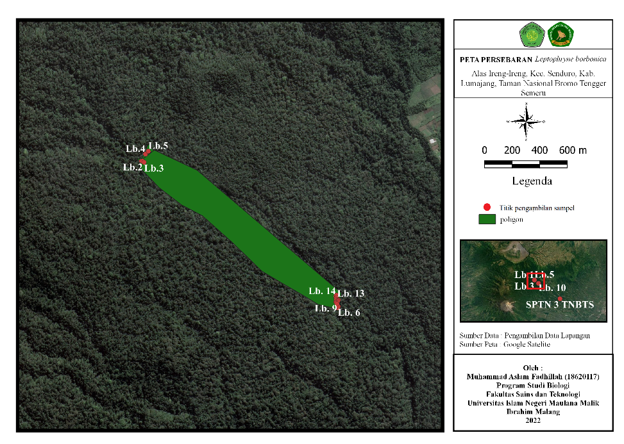

**Figure 1.** Location of the Ireng-Ireng Block (QGis, 2022).

*Leptophryne borbonica* sampling in the field was carried out at night in predetermined locations using a virtual encounter survey. A total of 45 individuals, consisting of 36 males and nine females, were collected, recorded, and stored for preservation. Specimens were selected from 1 adult male and one adult female; *L. borbonica* is adult (SVL: >20 mm). Several stages were subsequently undertaken to preserve them (Matsui 1984). *First*, specimens were euthanized by injecting 70% alcohol solution into the heart. *Second*, specimens were set in a specific condition to ensure durability and longevity, facilitating observation. They were covered with tissue and sprayed with a 10% formaldehyde solution. Afterward, they were left for 12 hours. *Third*, storing and cataloging were performed by placing specimens in bottles containing 70% alcohol. Field numbers and details were also recorded on specimen cards and catalogs (Erfanda et al. 2019). Morphometric data were measured using digital calipers, following the methods described by Hamidy et al. (2018) and Watters et al. (2016). Measurement results were digitally recorded using the *Procreate* software.

Data collection related to habitat assessment involved observing vegetation from the Ireng-Ireng River to the bridge (200-300 meters) through purposive sampling survey activities. Exploratory data collection techniques were employed, including direct exploration and documentation methods. The researcher aimed to gather comprehensive information about the plant species at each observation location (Arini & Kinho 2012; Andries et al. 2022).

Data collection regarding potential food was accomplished using insect traps (Pitfall Traps) and hand sorting. Pitfall traps were used to capture ground-surface insects. Fifteen plots, spaced 10 meters apart and divided into three sets with three repetitions, were used to install Pitfall traps. Subsequently, the collected samples underwent initial hand sorting.

Morphological data, habitat assessment, and potential food were analyzed descriptively and qualitatively. Morphological data on *Leptophryne borbonica*, for which morphometric and meristic information had been obtained, were presented in tables and figures and subsequently compared with supporting references. Habitat assessment data included species names, families, and habitats, along with their role in maintaining the survival of *Leptophryne borbonica*. Potential food data were analyzed for diversity, richness, and density indices to determine the community's overall health and nutrition availability for *Leptophryne borbonica* in the Ireng-Ireng Block, Bromo Tengger Semeru National Park.

Morphologically, the hourglass toad (*Leptophryne borbonica*) in the Ireng-Ireng Bromo Tengger Semeru National Park exhibits several distinctive characteristics. These include a slender body structure with a snout-vent length (SVL) ranging from 20 to 26 mm in males and 30 to 40 mm in females. The dorsal aspect features a black triangular mark with a rough skin texture and black spots on a light brown body, as depicted in Figures 2 (A) and (B). The tympanum is not visible, and the snout protrudes upwards. The orbital region displays a horizontal pupil, while the supra labial region showcases black and white striped motifs and faint parathyroid glands, as shown in Figure 2 (C). The skin from the cloaca to the supra-orbital region appears rough and wrinkled. The ventral portion is predominantly white, with black markings on the sub-labial region (Figure 2 (D)). The dorsal surface of the femur displays brown coloring with black spots, transitioning to red from the femur to the ventral tibia. The digits of the hand terminate in rounded, lumpy tubercles, as depicted in Figure 2 (E), while the metatarsals of the legs appear red. The swimming membrane spans 5 mm on each digit and features black tubercles. Some fresh specimens showed greenish coloration in the dorsum area (Figure 2 (F)).

Meristically, the hourglass toad (*Leptophryne borbonica*) in the Ireng-Ireng Block of Bromo Tengger Semeru National Park exhibits distinct leg webbing patterns (refer to Table 2), which vary between male and female specimens. For male samples from the Ireng-Ireng River population, the membrane formula/webbing formula yielded the following results: (I 0-1 II 0-2½ III 2-2½ IV 3½-1 V) when considering the outer to inner digits. On the other hand, female samples from the Ireng-Ireng River population exhibited the following webbing formula: (I 0-1 II 0-2½ III 2-2½ IV 3½-1 V).

**Table 1.** The webbing formula of the hourglass toad (*Leptophryne borbonica*) in the Ireng-Ireng, Bromo Tengger Semeru National Park

|  |  |  |
| --- | --- | --- |
| **Webbing formula** | **Documentation** |  |
|  |  | Male  (I 0-1 II 0-2½ III 2-2½ IV 3½-1 V). |
|  |  | Female  (I 0-1 II 0-2½ III 2-2½ IV 3½-1 V). |

**Table 2.** *Leptophryne borbonica* membrane formula in the Ireng-Ireng, Bromo Tengger Semeru National Park.

|  |  |  |  |
| --- | --- | --- | --- |
| **No** | **Location** | **Male/Female** | **Webbing formula** |
| 1. | Alas Ieng-Ireng | Female | I 0-1 II 0-2½ III 2-2½ IV 3½-1 V |
| 2. | Alas Ireng-Ireng | Male | I 0-1 II 0-2½ III 2-2½ IV 3½-1 V |

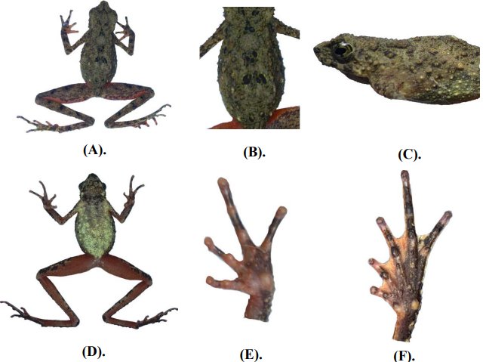

**Figure 2.** Dorsum and ventral views (left side), and lateral view of the head, ventral surface of the left hindlimb, and left forelimb (right side) of male *Leptophryne borbonica* from the slopes of the Southwest of Tengger Mountain. (Photographed by Muhamad Aslam Fadhillah).

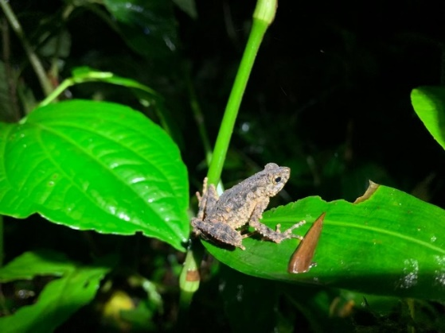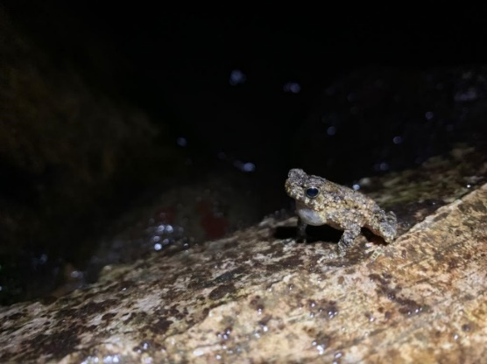

**Figure 3**. Life photograph of adult male of *Leptophryne borbonica* from Iren-Ireng, Bromo Tenegger Semeru National Park (Photographed by Muhamad Aslam Fadhillah).

Based on the information provided above, most morphological characteristics align with the description of *L. borbonica*, as documented by Inger & Stuebing(2005), Erfanda et al (2019), and Hamidy et al (2018). Hourglass toads are typically tiny, with males having a snout-vent length (SVL) of approximately 23.5 mm and an average SVL of 26.10 mm for the species. They exhibit a slender body habitus characterized by long forelegs and short hind legs, with no discernible bone crest. The snout protrudes slightly above the mouth in profile, and the tip digits are rounded rather than expanded. Parathyroid glands are indistinct, and a distinctive black hourglass mark is on the dorsum. Tympanum and a median singular vocal sac with a vocal slit are evident in males. The skin exhibits a wrinkled texture, covering all body regions, including the forefoot and hindfoot dorsal surface, while the supratympanic fold is notably absent. In terms of coloration, they feature a mottled brown back adorned with black spots on the head, back, and limbs. The groin and ventral surfaces of the fore and hind legs display a reddish hue, with reddish webbing on the back and belly. The abdomen typically exhibits a brownish hue with black and white markings. The chest and throat are blackish, and the limbs bear a distinct black line on the back and a black line on the upper lip. A netted black pattern marks their golden iris. Notably, there is no black triangle marking behind the eye, in contrast to the observations made by Iskandar (1998), who reported black triangles on several specimens from different regions.

**Table 3.** Habitat Parameters of research locations in the Ireng-Ireng, Bromo Tengger Semeru National Park

|  |  |  |
| --- | --- | --- |
| **Repetition** | **Physical Parameters** | |
|  | **Temperature** | **Humidity** |
| Upstream | 21.8°C | 93 % |
| Downstream | 24.5°C | 94 % |

Based on the results of environmental factor measurements during the research (see Table 3), the air temperature at the research location ranged from 21.8°C to 24.5°C, with humidity levels at 93-94%. Amphibians exhibit a wide temperature tolerance range, leading to varying requirements among species. They can inhabit temperatures ranging from -0°C to 40°C (Stebbinset al. 2021). Meanwhile, species from the same genus, namely *Leptophryne javanica*, are typically found in environments with temperatures ranging from 15°C to 19.3°C and water temperatures of 16°C to 18.7°C. Water temperature significantly influences both physiological and biological processes. Biologically, it affects metabolism, growth, behavior, interspecific competition, susceptibility to disease, and organism mortality (Coutant 1999). Physically, it can impact the concentration of dissolved gases (Beschta et al*.* 1987). *Leptophryne borbonica*, or the hourglass toad, is not considered an actual aquatic toad and spends most of its life near water bodies. Iskandar reported that this toad is commonly found near clear, slow-flowing rivers (Iskandar 1998). A positive correlation exists between the abundance of *L. borbonica* and temperature, albeit weak. Amphibians exhibit specific temperature tolerances and tend to occupy habitats within ranges that support their survival (Freda & Dunson 1986). Anurans, in particular, require higher humidity levels compared to reptiles and other terrestrial animals (Ludwig 1945). Amphibians possess permeable skin that must remain moist, making some anuran species highly dependent on aquatic habitats for survival (Becker et al. 2007; Silva et al. 2014). Furthermore, appropriate temperature significantly influences metabolic processes, growth, and defense mechanisms against disease (Coutant 1999). It also plays a vital role in anuran communication, thereby contributing to the success of their reproductive processes (Duellman & Trueb 1994); Oseen & Wassersug 2002); Wong et al.2004).

**Table 4.** Vegetation found in the *Leptophryne borbonica* encounter area in the Ireng-Ireng, Bromo Tengger Semeru National Park

|  |  |
| --- | --- |
| **Family** | **Species** |
| [Asteraceae](https://id.wikipedia.org/wiki/Asteraceae) | *Ageratum*conyzoidesL. |
|  | *Ageratina riparia* |
|  | *Ageratum conyzoides* |
| Begoniaceae | *Begonia formosana* |
| [Dryopteridaceae](https://en.wikipedia.org/wiki/Dryopteridaceae) | *Dryopteris filix-mas* |
| Araceae | *Homalomena* sp. |
| [Balsaminaceae](https://id.wikipedia.org/wiki/Balsaminaceae) | *Impatiens hawkeri* |
| [Euphorbiaceae](https://id.wikipedia.org/wiki/Euphorbiaceae) | *Mallotus barbatus* |
| [Rubiaceae](https://en.wikipedia.org/wiki/Rubiaceae) | *Mitragyna speciosa* |
| [Urticaceae](https://id.wikipedia.org/wiki/Urticaceae) | *Pilea melastomoides* |
| [Plantaginaceae](https://id.wikipedia.org/wiki/Plantaginaceae) | *Plantago major* L. |
| [Araceae](https://en.wikipedia.org/wiki/Araceae) | *Schismatoglottis asperata* |
| Selaginellaaceae | *Selaginella mayeri* |

Besides directly affecting *L. borbonica*, physical factors also influence the vegetation near its habitats. This research also documented the types of vegetation thriving in areas where *L. borbonica* was encountered. It is significant, given that vegetation is crucial in providing shelter for *L. borbonica*, protecting them from predators and UV radiation, and serving as a food source. The protection offered by forest canopy cover also has repercussions for aquatic microhabitats, as it prevents excessive solar radiation from reaching the water surface (Paul & Gwynn-Jones 2003). The vegetation identified in this study was riparian vegetation, which typically grows alongside water bodies. Decades ago, it was established that the riverside zone is a refuge for biodiversity and productivity, making it pivotal in land resource and wildlife management. In addition, riverine forest canopies play a crucial role in conserving amphibian diversity, particularly for species specialized in forest habitats (Lipinski et al. 2016; Provete et al. 2014; Popescu et al. 2012; Skelly et al. 2002; Lemckert 1999). Hence, forest vegetation structure is considered a key indicator of biodiversity (Guo et al. 2017), and the present research established a relevant noteworthy correlation.

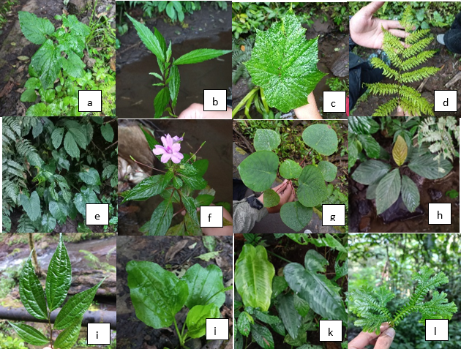

**Figure 4**. a) *Ageratum*conyzoidesL b) *Ageratina riparia* c)*Begonia formosana* d) *Dryopteris filix-mas* e) *Homalomena* sp. f) *Impatiens hawkeri* g) *Mallotus barbatus* h) *Mitragyna speciosa* i) *Pilea melastomoides* j) *Plantago major* L. k) *Schismatoglottis asperata* i) *Selaginella mayeri*

Some of the identified vegetation species included: a) *Ageratum conyzoides* L., b) *Ageratina riparia*, c) *Ageratum conyzoides*, d) *Begonia formosana*, e) *Dryopteris filix-mas,* f) *Homalomena* sp., g) *Impatiens hawkeri,* h) *Mallotus barbatus*, i) *Mitragyna speciosa*, j) *Pilea melastomoides,* k) *Plantago major* L., l) *Schismatoglottis asperata*, and m) *Selaginella mayer*. Some L. *borbonica* are often found attached to low-lying leaves near rivers. In contrast, others are located on the soil surface or rocks near watercourses, and some even inhabit the watercourses themselves (Iskandar 1998). *Leptophryne borbonica* primarily selects rocks and leaves as substrates for its activities. Many anuran species commonly use substrate as camouflage to deceive predators, preferring those with similar colors to their bodies.

The availability of food sources is one factor that determines a species' viability in nature. *Leptophryne borbonica*, an insect-eating animal, primarily consumes small arthropods. Observation data on *L. borbonica*’s food availability in the Bromo Tengger Semeru National Park indicated criteria similar to those obtained using pitfall and hand-sorting methods. In the pitfall method, 491 arthropods were collected, resulting in a diversity index of 1.447, a species evenness index of 0.1932 (in the low category), and a medium species richness index of 3.389. Meanwhile, the hand-sorting method yielded 88 types of arthropods with a diversity index of 2.039, a medium evenness index of 0.5485, and a medium richness index of 2.904.

**Table 5**. The Arthropod family was discovered using the pitfall method in the *Laptophryne borbonica* encounter area in Ireng-Ireng Bromo Tengger Semeru National Park

**Table 6.** Arthropod family found by hand-sorted method in the *Laptophryne borbonica* encounter area in the Ireng-Ireng area of ​​Bromo Tengger Semeru National Park

**Table 7**. Arthropod Ecological Index as potential food preference for *Leptophryne borbonica* in Bromo Tengger Semeru National Park

|  |  |  |
| --- | --- | --- |
| **Index** | **Metode** | |
| **Pitfall** | **Hand Sorted** |
| **Total** | 491 | 88 |
| **Shannon Wiener** | 1.447 | 2.039 |
| **Evenness** | 0.1932 | 0.5485 |
| **Margalef** | 3.389 | 2.904 |

The greater the diversity, richness, and evenness of ground surface insect species in a given land area, the more stable the forest ecosystem. Dominant orders in the pitfall trap method included *Entomobryomorpha* (with 228 individuals, all from the genus *Homidia*), *Amphipoda* (with 180 individuals, all from the genus *Telirus*), *Orthoptera* (with 27 individuals, all from the genus *Gryllus*), and *Hymenoptera* (with 27 individuals, consisting of the genus *Dorymyrmex* [8 individuals], *Formica* [4 individuals], *Bothroponera* [1 individual], *Camponotus* [1 individual], *Aphaenogaster* [9 individuals], *Monomorium* [3 individuals], and *Paratrechina* [1 individual]. In the hand-sorting method, dominant orders included *Amphipoda* (40 individuals, all from the genus *Talitrus*) and *Hymenoptera* (17 individuals, including five individuals of *Aphaenogaster*, two individuals of *Dorymyrmex*, four individuals of *Brachyponera*, five individuals of *Prenolepis* and one individual of *Formica*). However, amphibians selectively choose their food based on the available options within their habitat niche. Hence, they can differentiate between different types of prey (Freed, 1982). Food preference in amphibians is often linked to their morphology, physiological characteristics, and behavior (Solé 2010). Food availability, particularly from the orders *Hymenoptera* and *Orthoptera*, is crucial for maintaining the presence of *L. borbonica* in this niche. Research on *L. cruentata* suggests that their diet predominantly comprises *Hymenoptera* (ants) at 60.38% and *Orthoptera* at 6.60% (Freed 1982). It is worth noting that most members of the *Hymenoptera* order are active explorers, both aerial and terrestrial (Silva et al. 2014; Jaapar et al. 2018).

**Author contribution**

BFH, MAH, and LS contributed concepts, ideas, research funds, and research equipment, MAF collected data, data preservation, and analysis, and SRD collected data, and wrote the original draft.

**Acknowledgments**

We would like to thank to Balai Besar Taman Nasional Bromo Tengger Semeru (BBBTSNP) for giving us permission to conduct this research SI.08/T.8/BIDTEK/BIDTEK.1/DIK/3/2022, as well as to BTSNP officer who help us in preparing field study and provide lodging. This study was supported by “Maliki Herpetology Society” and “Ecology Team” of Biology Department, Universitas Islam Negeri Maulana Malik Ibrahim Malang, especially C. R. Achmad, M. N. Riskananda, M. N. Izzulhaq, B. Syamsiyah, M. M. Fatansyah, D. R. Azizi, M. A. Hasanuddin, M. W. Nauval, K. Rimakhusshofa, S. Hana, M. R. Ridho, N. A. Azizah, A. A. Mustofa, I. Nurdhiana, A. M. S. P. Soeprijadi, Dzulqarnain, Fikron, A. P. Baihaqi, F. A. Afifuddin, F. Hidayat, and A. Maghfironi, M. H. Ilyasa, F.N. Rahmania, L.F. Dina. We thank IDEAWILD for providing the equipment used in the study. This study was financially supported by Litapdimas of Kementerian Agama Republik Indonesia Research Grant (Registration no: 221140000059527 to Berry F. Hanifa; Registration no: 221140000059528 to Muhammad. A. Hasyim), and the Rufford Small Grant for Nature Conservation (Project ID: 36547-1 to Luhur Septiadi).

**Conflict of Interest**

All authors declare no conflict of interests.

**References**

Andries, A. E., Koneri, R., & Maabuat, P. V. 2022. Inventarisasi Tumbuhan Paku di Ruang Terbuka Hijau Kampus Universitas Sam Ratulangi Manado, Sulawesi Utara. *JURNAL BIOS LOGOS*, *12*(2), 140-148. <https://doi.org/10.35799/jbl.v12i2.42343>

Anthony, B. et al. 2006. Threatened amphibians of the world. Barcelona, Lynx Edicions, pp 106–113

Ardiansyah, D. et al. 2014. Kelimpahan Kodok Jam Pasir Leptophryne borbonica di Sepanjang Aliran Sungai Cisuren, Bodogol, Taman Nasional Gunung Gede Pangrango. *Bioma*, *10*(2), 11. <https://doi.org/10.21009/bioma10(2).2>

Arini, D. I. D., & Kinho, J. 2012. Keragaman Jenis Tumbuhan Paku Di Cagar Alam Gunung Ambang Sulawesi Utara. Info BPK Manado 2 (1): 17- 40.

Astriyantika, M., Aried, H., & Sunarminto, T. 2014. Studi Konservasi Sumberdaya Alam Hayati Pada Masyarakat Tengger Di Resort Ranu Pani, Taman Nasional Bromo Tengger Semeru. *Media Konservasi*, *19*(1), 1–11. <https://doi.org/10.29244/medkon.19.1>

BBTNBTS. 2010. *Laporan Inventarisasi Flora Fauna Di Taman Nasional Bromo Tengger Semeru.* Malang : Balai Besar Taman Nasional Bromo Tengger Semeru

Becker, C. G. et al. 2007. Habitat split and the global decline of amphibians. Science, 318(5857), 1775–1777. <https://doi.org/10.1126/science.1149374>

Beschta, R. L., Bilby, R. E., Brown, G. W., Holtby, L. B., & Hofstra, T. D. (1987). Stream temperature and aquatic habitat: fisheries and forestry interactions. Streamside Management: Forestry and Fishery Interactions, 57, 191–232.

Chan, K. O., & Grismer, L. L. (2019). To split or not to split? Multilocus phylogeny and molecular species delimitation of southeast Asian toads (family: Bufonidae). *BMC Evolutionary Biology*, *19*, 1-12.

Coutant, C. C. (1999). Perspectives on temperature in the Pacific Northwest’s fresh waters. Oak Ridge National Lab., TN (US).

Duellman, W. E., & Trueb, L. (1994). Biology of amphibians. Johns Hopkins University Press

Erfanda, M. P., Septiadi, L., Devi, S. R., & Hanifa, B. F. 2019. Distribution Record of Leptophryne borbonica (Tschudi, 1838) (Anura: Bufonidae) from Malang, East Java: Description, Microhabitat, and Possible Threats. *Journal of Tropical Biodiversity and Biotechnology*, *4*(2), 82. [doi.org/10.22146/jtbb.45355](https://doi.org/10.22146/jtbb.45355).

Freda, J., & Dunson, W. A. 1986. Effects of low pH and other chemical variables on the local distribution of amphibians. Copeia, 454–466.

Freed, A. N. 1982. A treefrog’s menu: selection for an evening’s meal. Oecologia, 53, 20–6. doi.org/10.1007/BF00377131

Guo, X. et al. 2017. Regional mapping of vegetation structure for biodiversity monitoring using airborne lidar data. Ecol Inform. 38, 50–61. [doi.org/10.1016/j.ecoinf.2017.01.005](https://doi.org/10.1016/j.ecoinf.2017.01.005)

Hamidy, A. et al. 2018. Detection of Cryptic taxa in the genus Leptophryne (Fitzinger, 1843) (Amphibia; Bufonidae) and the description of a new species from Java, Indonesia. Zootaxa, 4450(4), 427-44. doi: [10.11646/zootaxa.4450.4.2](https://doi.org/10.11646/zootaxa.4450.4.2)

Inger, R.F., & Stuebing, R.B. 2005. Panduan Lapangan Katak-katak Borneo [Field Guide of Borneo Frog]. Kinabalu. Natural History Publications.

Iskandar, D. T., & Erdelen, W. R. 2006. Conservation of amphibians and reptiles in Indonesia: issues and problems. *Amphibian and reptile conservation*, *4*(1), 60-87.

Iskandar, D.T. 2020. Tropical biodiversity with special emphasis on characteristic species. AIP Conference Proceedings **2231**(1): 020004. doi.org/10.1063/5.0007501

Iskandar, D.T., 1998, The Amphibians of Java and Bali. Jakarta. Research and Development Centre for Biology-LIPI. Bogor

IUCN SSC Amphibian Specialist Group. 2019. *Leptophryne cruentata*. *The IUCN Red List of Threatened Species* 2019: e.T138045255A3020276. <https://dx.doi.org/10.2305/IUCN.UK.2019-1.RLTS.T138045255A3020276.en>. Accessed on 26 September 2023.

Jaapar, M. F., Jajuli, R., Mispan, M. R., & Ghani, I. A. 2018. Foraging behavior of stingless bee Heterotrigona itama (Cockerell, 1918) (Hymenoptera: Apidae: Meliponini). AIP Conference Proceedings, 1940(April). [doi.org/10.1063/1.5027952](https://doi.org/10.1063/1.5027952)

Kusrini, M. D., Denok, R., & Fitri, A. 2019. Usulan Perlindungan Kodok Merah. *Konservasi Sumberdaya Hutan & Ekosiwata IPB*, 1–5.

Lemckert, F. 1999. Impacts of selective logging on frogs in a forested area of northern New South Wales. Biol. Conserv. 89, 321–328. doi.org/10.1016/S0006- 3207(98)00117-7.

Lipinski, V.M., Santos, T.G., Schuch, A.P. 2016. An UV-sensitive anuran species as an indicator of environmental quality of the Southern Atlantic rainforest. Journal of Photochem Photobiol B. 165, 174–181. [doi.org/10.1016/j.jphotobiol.2016. 10.025](https://doi.org/10.1016/j.jphotobiol.2016.%2010.025).

Ludwig, D. 1945. The effects of atmospheric humidity on animal life. Physiological Zoology, 18(2), 103–135. doi.org/10.1086/physzool.18.2.30151858

Matsui, M. 1984. Morphometric variation analyses and revision of the Japanese toads (Genus Bufo, Bufonidae). *Contributions from the Biological Laboratory, Kyoto University*, *26*(3-4), 209-428.

Mumpuni, M., 2001, Keanekaragaman Herpetofauna di Taman Nasional Gunung Halimun, Jawa Barat [Herpetofauna diversity in Gunung Halimun National Park, West Java], Berita Biologi, 5(6), 711-720. doi.org/10.14203/beritabiologi.v5i6.1078

Mumpuni, M. 2014. Keragaman Amfibi dan Catatan Baru Katak di Kawasan Wisata Guci, Provinsi Jawa Tengah [Amphibian Diversity and New Records of Frogs in the Guci Tourist Area, Central Java Province], Zoo Indonesia, 23(1), 13 –19. doi.org/10.52508/zi.v23i1.366

Oseen, K. L., & Wassersug, R. J. 2002. Environmental factors influencing calling in sympatric anurans. Oecologia, 133(4), 616–625. doi.org/10.1007/s00442-002-1067-5

Paul, N. D., & Gwynn-Jones, D. 2003. Ecological roles of solar UV radiation: towards an integrated approach. *Trends in Ecology & Evolution*, *18*(1), 48-55. doi.org/10.1016/S0169-5347(02)00014-9

Popescu, V.D., Patrick, D.A., Hunter, M.L., Calhoun, A.J.K. 2012. The role of forest harvesting and subsequent vegetative regrowth in determining patterns of amphibian habitat use. For. Ecol. Manag. 270, 163–174. doi.org/10.1016/j.foreco.2012. 01.027.

Provete, D.B, et al. 2014. Broad-scale spatial patterns of canopy cover and pond morphology affect the structure of a Neotropical amphibian metacommunity. Hydrobiologia 734, 69–79. doi.org/10.1007/s10750-014-1870-0

Silva, A. G, et al. 2014. Foraging distance of Melipona subnitida Ducke (Hymenoptera: Apidae). Sociobiology, 61(4), 494–501. [doi.org/10.13102/sociobiology. v61i4.494-501](https://doi.org/10.13102/sociobiology.%20v61i4.494-501)

Skelly, D.K., Freidenberg, L.K., Kiesecker, J.M., 2002. Forest canopy and the performance of larval amphibians. Ecology 83, 983–992. doi.org/10.1890/0012- 9658(2002)083[0983:FCATPO]2.0.CO;2

Solé, M., & Rödder, D. 2010. Dietary assessments of adult amphibians. *Amphibian ecology and conservation: a handbook of techniques. Oxford University Press, Oxford*, 167-184. doi.org/10.1093/oso/9780199541188.003.0010

Stebbins, R. C., & Cohen, N. W. 2021. *A natural history of amphibians*. Princeten. Princeton University Press.

Watters, J. L., Cummings, S. T., Flanagan, R. L., & Siler, C. D. 2016. Review of morphometric measurements used in anuran species descriptions and recommendations for a standardized approach. *Zootaxa*, *4072*(4), 477–495. [doi.org/10.11646/zootaxa.4072.4.6](https://doi.org/10.11646/zootaxa.4072.4.6)

Wong, B., Cowling, A. N. N., Cunningham, R. B., & Donnelly, C. F. (2004). Do temperature and social environment interact to affect call rate in frogs (Crinia signifera)? Austral Ecology, 29(2), 209–214. doi.org/10.1111/j.1442-9993.2004.tb00312.x