Lampiran 1. Tabel kemelimpahan spesies ostracoda pada 25 sampel di daerah penelitian.
Kode Sampel | Sampel 2 | Sampel 3 | Sampel 5 | Sampel 6 | Sampel 7 | Sampel 15 | Sampel 21 | Sampel 22 | Sampel 25 | Sampel 27 | Sampel 28 | Sampel 29 | Sampel 32 | Sampel 43 | Sampel 45 | Sampel 48 | Sampel 51 | Sampel 54 | Sampel 57 | Sampel 65 | Sampel 66 | Sampel 68 | Sampel 70 | Sampel 73 | Sampel 74
Kedalaman (m) | 25 | 50 | 45 | 30 | 30 | 15 | 30 | 35 | 20 | 25 | 35 | 50 | 10 | 30 | 30 | 10 | 25 | 20 | 15 | 20 | 30 | 25 | 35 | 30 | 20
Cytherella_semitalis | - | - | 4 | 28 | 11 | 2 | 4 | 1 | 31 | 1 | - | - | 22 | - | - | 12 | - | - | 22 | 17 | 7 | - | 1 | - | -
Cytherella_sp.1 | 3 | 3 | 2 | 5 | 2 |  |  | 1 | 10 |  |  | 3 | 4 |  |  | 7 |  | 6 | 12 | 9 | 2 |  | 1
Cytherella_sp.2 | 5 | 3 | 4 | 9 | 13 |  | 5 | 3 | 14 |  |  | 2 | 3 |  | 1 | 6 |  | 2 | 6 | 5 | 3 |  | 2 | 1
Cytherella_sp.3 | 4 | 12 | 5 | 10 | 13 |  | 2 | 1 | 4 | 3 |  |  | 1 |  |  | 7 |  |  | 1 | 2 | 9
Cytherella_sp.4 | 7 | 1 | 2 | 2 | 1 |  |  |  | 8 |  |  |  | 1 |  |  | 7 |  | 2 | 2 | 2 | 4
Cytherelloidea_leroyi | 1 | 1 | 3 | 2 | 2 |  |  | 1 | 5 | 1 |  | 1 | 3 |  |  |  |  |  | 3 |  | 2 |  | 1 | 1
Cytherelloidea_excavata | 1 |  | 4 | 6 | 5 | 2 |  | 2 | 1 |  | 2 |  | 1 |  |  | 2 |  |  | 2 |  | 1
Cytherelloidea_sp. | 5 | 5 | 22 | 37 | 24 |  |  | 10 | 10 | 1 | 2 | 4 | 15 |  |  | 9 |  | 3 | 4 | 1 | 17 |  | 4 | 4
Bairdopillata_paraalcyonicola | 4 | 11 | 16 | 4 | 17 |  | 13 | 5 |  | 2 | 7 | 2 | 1 | 8 | 33 |  | 48 | 37 |  |  | 31 | 7 | 13 | 13 | 17
Bairdopillata_paracratericola | 11 | 3 | 10 | 9 | 2 |  | 8 | 22 | 2 | 8 |  | 1 | 1 |  |  |  |  | 2 |  |  | 8 |  |  |  | 2
Paranesidea_sp. | 3 | 43 | 5 | 2 |  | 1 | 11 | 7 |  | 4 | 19 | 24 |  | 15 | 32 |  | 63 | 58 |  |  | 20 | 8 | 12 | 19 | 20
Macrocypris_decora | 2 | 1 | 1 |  | 7 |  | 1 |  | 1 | 1 |  |  |  |  | 4 | 3 | 1 | 12 | 6 |  |  |  |  |  | 1
Paracypris_cf._P.nuda | 4 |  | 2 |  | 2 |  | 1 | 5 | 5 | 1 |  |  | 12 |  | 1 |  |  | 11 | 8 | 3 | 6 |  |  | 1
Phlyctenophora_orientalis | 33 |  | 2 |  | 3 |  | 5 | 49 | 57 | 17 | 1 | 1 | 59 |  | 4 | 8 |  | 52 | 97 | 18 | 19 |  |  | 2
Aglaiocyrpis sp. |  | 1 | 1 | 1 |  |  |  |  | 1 | 1 |  |  | 22 |  |  | 2 |  |  | 4 |  | 1
Parakrithella |  | 6 | 28 | 26 | 14 |  | 9 |  |  | 14 | 2 | 2 |  | 5 | 1 | 5 |  |  |  | 1 | 10 |  |  | 8 | 6
Neomonoceratina indonesiana | 13 | 7 | 25 | 16 | 8 |  | 7 | 8 | 11 | 18 | 7 |  | 15 | 2 | 1 | 33 | 2 | 1 | 14 | 2 | 6 |  |  | 7
Bythoceratina multiplex | 2 |  | 2 | 1 | 5 |  | 1 | 1 | 1 | 1 |  | 1 | 1 |  | 1 |  | 1 |  | 1 |  | 2
Bythocythere |  |  | 1 |  | 1 |  |  | 1 |  | 6 | 2 | 1 |  |  | 2 |  | 6 | 4 |  |  | 1 | 10 | 3 |  | 5
Pseudopsammocythero c.f. |  |  | 2 | 1 |  |  |  |  | 1 |  |  | 1 | 1 |  |  |  |  |  |  | 1 | 1
Cytheropteron sp. | 5 | 4 | 4 | 5 | 6 |  | 1 | 9 | 7 | 8 | 3 |  | 2 |  |  | 1 | 1 | 4 | 2 |  | 1 |  | 1 | 2
Loxoconcha sp. 1 |  | 4 | 5 | 11 | 1 |  | 66 | 1 |  | 79 | 20 | 13 | 1 | 21 | 12 | 12 | 15 | 9 |  | 1 | 1 | 5 | 7 | 9 | 21
Loxoconcha sp. 2 |  |  |  |  |  |  | 1 | 1 |  |  |  |  |  |  |  |  | 1 | 4 |  |  |  |  |  |  | 1
Hemicythere sp. | 1 |  | 2 | 2 | 1 |  | 3 |  |  | 2 |  |  | 4 |  |  | 3 |  |  | 5 | 3 | 1
Keijia sp. | 7 | 4 | 5 | 14 | 9 |  | 28 | 4 | 26 | 19 | 23 | 3 | 37 | 3 | 16 | 20 | 1 | 2 | 8 | 2 | 5 | 3 |  | 2 | 6
Caudites sp. | 7 | 2 | 17 | 9 | 8 |  | 8 | 3 |  | 6 | 4 | 2 |  | 3 | 4 | 1 | 1 | 8 | 1 |  | 1 |  | 2 | 4 | 3
Actinocytheresis scutigera | 2 |  |  | 1 | 3 | 1 | 1 | 3 | 21 |  |  |  | 8 | 1 |  | 10 |  | 5 | 21 |  | 12
Stigmatocythere bona | 6 | 2 | 8 | 7 | 10 | 5 | 4 | 2 | 1 | 5 | 1 |  | 2 |  | 12 | 15 |  |  |  |  |  |  |  |  | 2
Keijella multisulcus | 29 | 1 |  | 2 | 28 | 2 |  | 15 | 20 | 12 | 3 | 1 | 4 |  | 2 | 18 |  |  | 14 |  | 17 |  | 3 | 2
Borneocythere pouncipunctata | 2 |  | 3 |  | 3 |  | 1 | 14 |  |  |  |  | 1 |  |  |  |  |  |  |  | 6
Pistocythereis euplectella | 85 | 22 | 19 | 20 | 53 | 3 | 21 | 70 | 12 | 16 | 14 | 7 | 4 | 6 | 16 | 8 | 7 | 35 | 5 | 1 | 50 | 3 | 22 | 20
Neocytheretta spongiosa | 5 |  | 3 | 6 | 5 | 1 |  | 22 | 3 |  |  |  | 15 |  |  | 3 |  |  | 5 |  | 9
Neocytheretta novella | 13 | 2 | 8 | 11 | 6 | 6 | 1 | 7 | 13 |  | 1 |  | 3 |  | 1 | 4 |  | 5 | 34 | 4 | 8 |  | 1
Xestoleberis sp. |  | 1 | 2 | 1 |  |  | 3 |  | 1 |  | 1 |  |  |  | 4 | 2 |  | 6 |  | 4 | 3 |  | 2 | 4 | 6
Foveoleberis cypraeoides | 19 | 37 | 60 | 36 | 10 |  | 15 | 23 | 4 | 19 | 13 | 19 |  | 5 | 30 | 5 | 22 | 14 | 9 |  | 19 |  | 7 | 8 | 18
Trachyleberis militaris | 4 |  | 7 | 3 | 11 |  |  |  | 4 | 3 | 1 |  | 3 | 3 |  | 2 |  | 1 | 4 |  | 2
Mutilus sp. | 6 | 1 | 13 | 6 | 9 |  | 33 | 1 |  | 42 | 14 |  |  |  | 2 | 3 | 5 | 8 |  | 1 | 1 | 4 | 1 | 0 | 12
Paracytheridea | 1 |  |  | 2 |  |  | 1 |  | 1 | 5 | 2 |  |  |  | 1 |  |  |  |  |  |  |  |  |  | 4
Echinocytheresis sp. 1 |  |  |  |  |  |  |  |  | 1 |  |  | 5 |  | 2 |  | 1 | 12 | 5 |  |  | 5 |  | 3 |  | 1
Echinocytheresis sp. 2 | 3 |  | 1 |  |  |  | 4 | 4 |  | 5 | 5 |  | 1 | 1 | 5 |  |  |  |  |  | 1 |  |  | 2 | 7
Miocyprideis | 1 |  |  |  |  |  | 1 |  |  |  |  |  | 35 | 1 | 1 | 2 |  | 1 | 2 |  | 1
Unidentified species | 6 |  | 2 | 5 | 7 | 1 | 1 | 4 | 24 |  |  |  | 18 | 1 |  | 4 |  | 3 | 8 | 1 | 7

Lampiran 2. Kenampakan spesies ostracoda yang ditemukan pada pengamatan mikroskopis
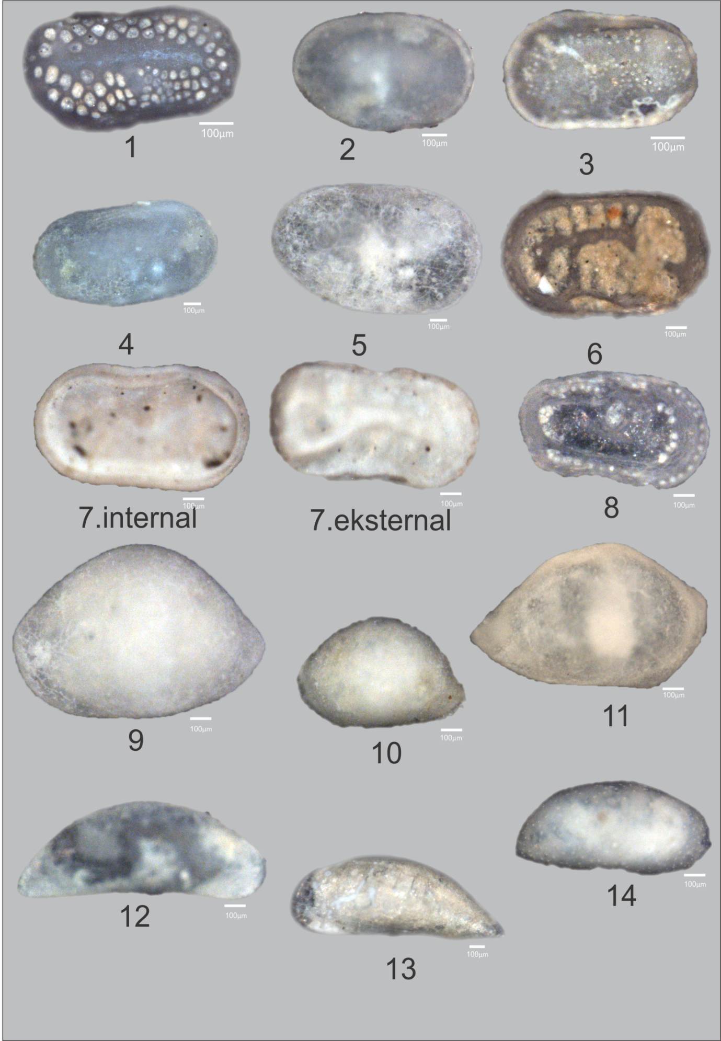
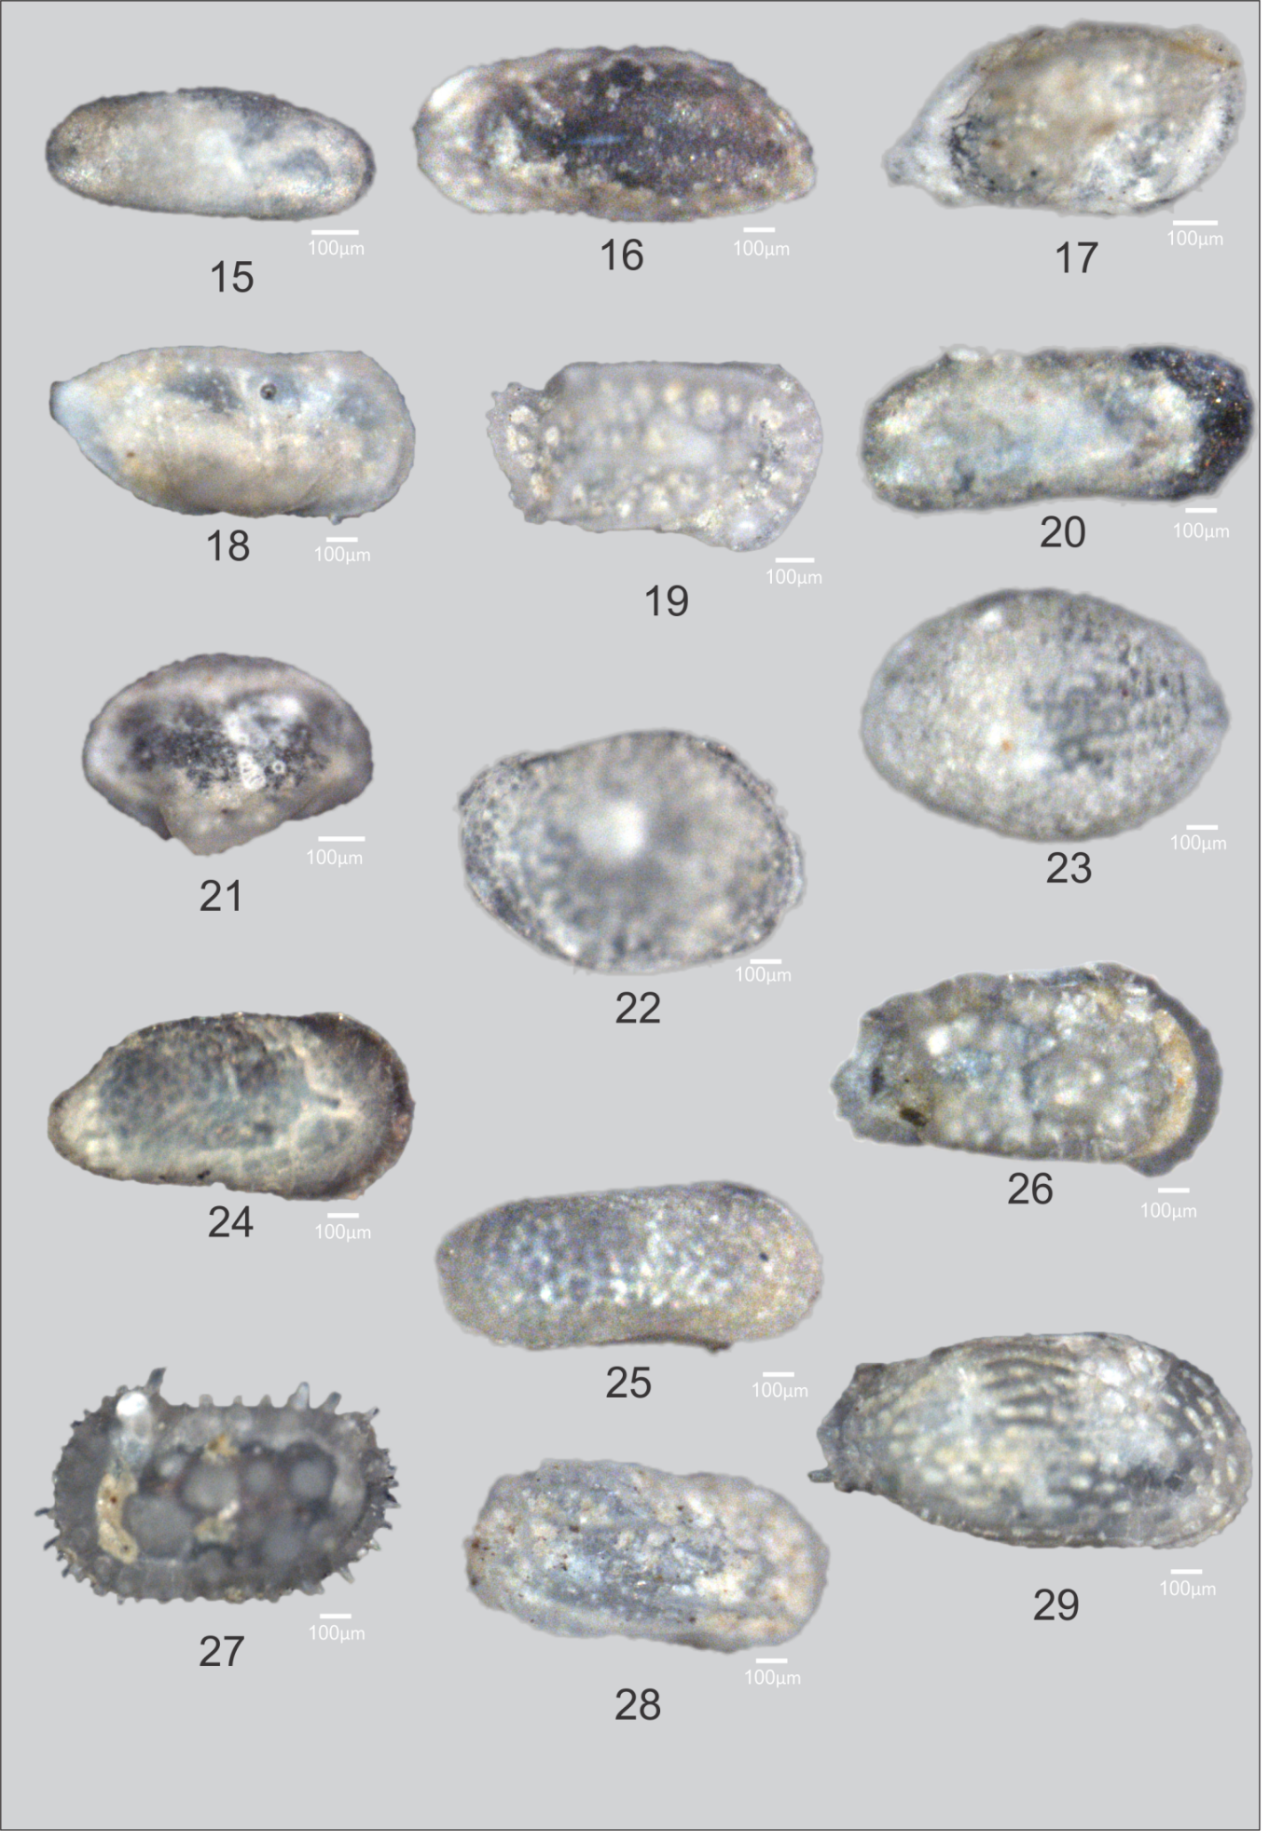
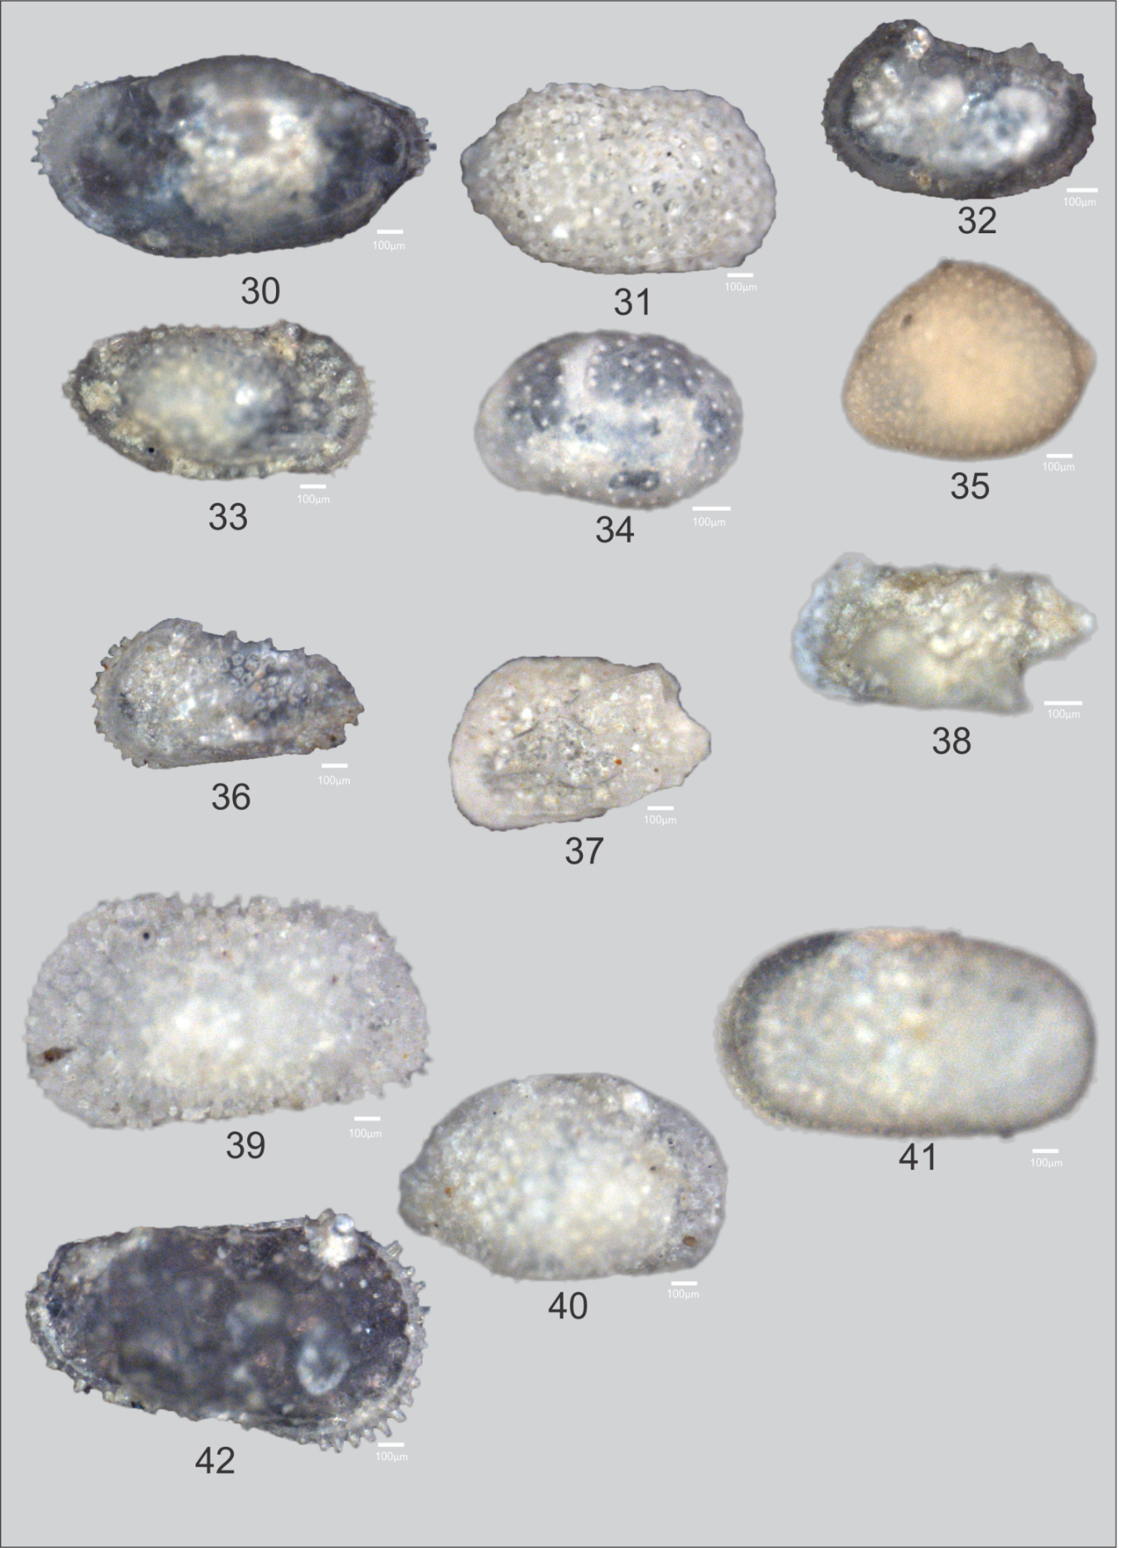
Keterangan:
No gambar | Genus/spesies | No gambar | Genus/spesies
1 | Cytherella semitalis | 22 | Loxoconcha sp. 1
2 | Cytherella sp. 1 | 23 | Loxoconcha sp. 2
3 | Cytherella sp. 2 | 24 | Hemicythere sp.
4 | Cytherella sp. 3 | 25 | Keijia sp.
5 | Cytherella sp. 4 | 26 | Caudites sp.
6 | Cytherelloidea leroyi | 27 | Actinocytheresis scutigera
7 | Cytherelloidea excavata | 28 | Stigmatocythere bona
8 | Cytherelloidea sp. | 29 | Keijella multisulcus
9 | Bairdopillata paraalcyonicoda | 30 | Borneocythere pouncipunctata
10 | Bairdopillata paracratericola | 31 | Pistocythereis euplectella
11 | Paranesidea sp. | 32 | Neocytheretta spongiosa
12 | Macrocypris decora | 33 | Neocytheretta novella
13 | Paracypris cf. P.nuda | 34 | Xestoleberis sp.
14 | Phlyctenophora orientalis | 35 | Foveoleberis cypraeoides
15 | Aglaiocyrpis sp. | 36 | Trachyleberis militaris
16 | Parakrithella | 37 | Mutilus sp.
17 | Neomonoceratina indonesiana | 38 | Paracytheridea
18 | Bythoceratina multiplex | 39 | Echinocytheresis sp. 1
19 | Bythocythere | 40 | Echinocytheresis sp. 2
20 | Pseudopsammocythero c.f. | 41 | Miocyprideis
21 | Cytheropteron sp. | 42 | Unidentified species

