Enhancing Aesthetic from Growth Modification
Himawan Halim*
Ivan A. Halim**

Abstract
Introduction: Alteration of maxillary growth, improvement in mandibular growth and position, and change in dental and muscular relationships especially changing in aesthetic profile are the expected effects of these appliances. The use of Bionator appliance, is a widely used functional appliance for the management of Class II malocclusion. Diagnosis and etiology: An Indonesian boy aged 12 years 2 months, was in normal and healthy health condition and motivated for treatment with the chief complaint of protruded maxillary anterior teeth and a receding mandibula. He was introverted and had poor self-esteem, despite his normal medical history. He had a Class II Division 1 malocclusion (bilateral full Class II molars and canines) with a 10-mm overjet. He is in a mixed dentition stages with all compliment of his teeth. Treatment result: The patient was treated in two phases treatment. First phase was to correct skeletal discrepancy and second phase was to correct tooth discrepancy. At the end of phase I treatment, after 10 months of treatment using Bionator appliance, the patient's mandible was positioned forward (change ANB angle from 7.56⁰ to 2.30⁰), and the profile was greatly improved (E-line). His molar and canine relationships is a Class I. His profile become straight and more favorable. Conclusion: Early treatment using functional appliance therapy can reduce the severity of a Class II skeletal pattern and instant changed in facial and dental appearance.

- Introduction
Functional appliances have been used for many years in the treatment of Class II malocclusions¹. Alteration of maxillary growth, improvement in mandibular growth and position, and change in dental and muscular relationships especially changing in aesthetic profile are the expected effects of these appliances. The use of Bionator appliance, is a widely used functional appliance for the management of Class II malocclusion in my practice². The appliance can be worn most of the time, with the advantage of allowing nearly a full range of mandibular movement, easy acclimation, reasonable speech, and instance change in aesthetic profile. Its popularity comes also from its high patient acceptability due to easy wearing of the appliance and its ability to produce rapid results especially changing in aesthetic. Functional appliance therapy is followed by comprehensive fixed-appliance therapy with or without extractions.
- Diagnosis and Etiology
An Indonesian boy aged 12 years 2 months, was in normal and healthy health condition and motivated for treatment with the chief complaint of protruded maxillary anterior teeth and a receding mandibula. He was introverted and had poor self-esteem, despite his normal medical history. He inherited this from his father side, in which his father had a similar profile of protruded maxillary anterior teeth. No chin.
The facial photographs indicated a convex facial appearance, protruded lips, mixed dentition, and moderate exposure of the maxillary incisors (Fig 1). He had a normal range of mandibular motion and no TMD problems. The midline of the mandible was shifted 2 mm to the right. Other intraoral findings included gingivitis of the incisors and a short lingual frenum. He had a Class II Division 1 malocclusion (bilateral full Class II molars and canines) with a 10-mm overjet. The cephalometric analysis confirmed a skeletal Class II jaw relationship with a retrognathic mandible and a steep mandibular plane angle. Additionally, the maxillary and mandibular incisors were labially inclined (Fig 2). The lateral cephalometric (Fig 3; Table 1) analysis indicated a skeletal Class II jaw (ANB, 7.56⁰; Wits, 2.32 mm). He is in a mixed dentition stages with all compliments of his teeth (Fig 3).

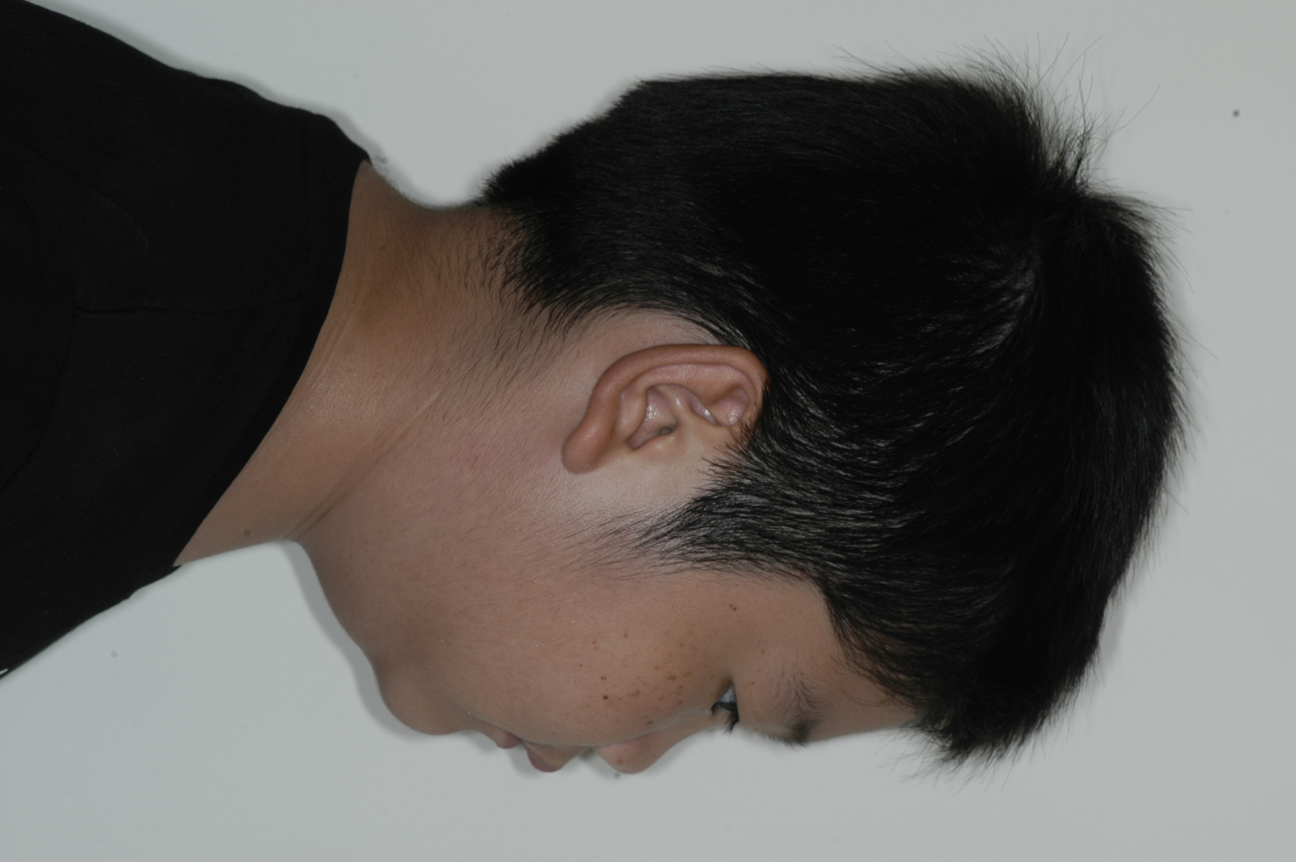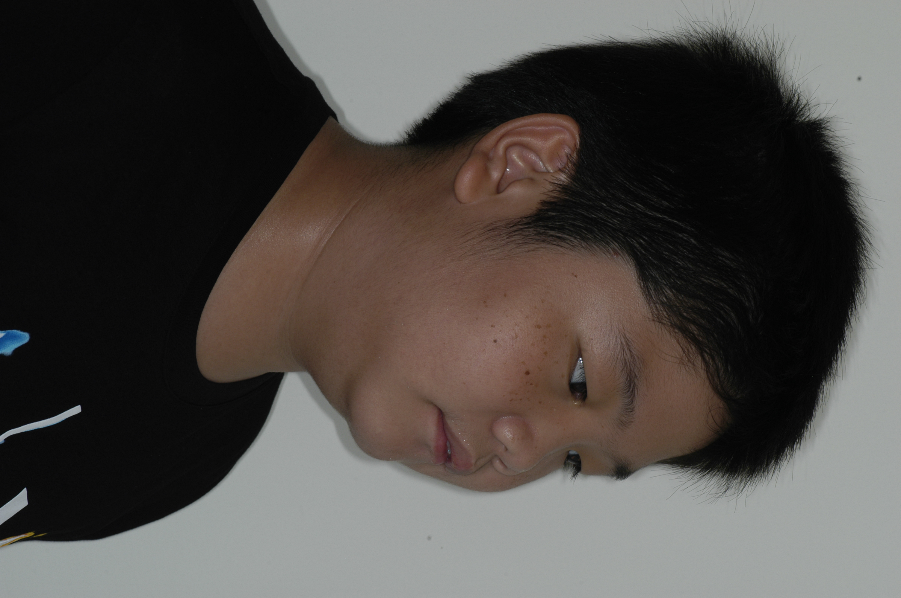
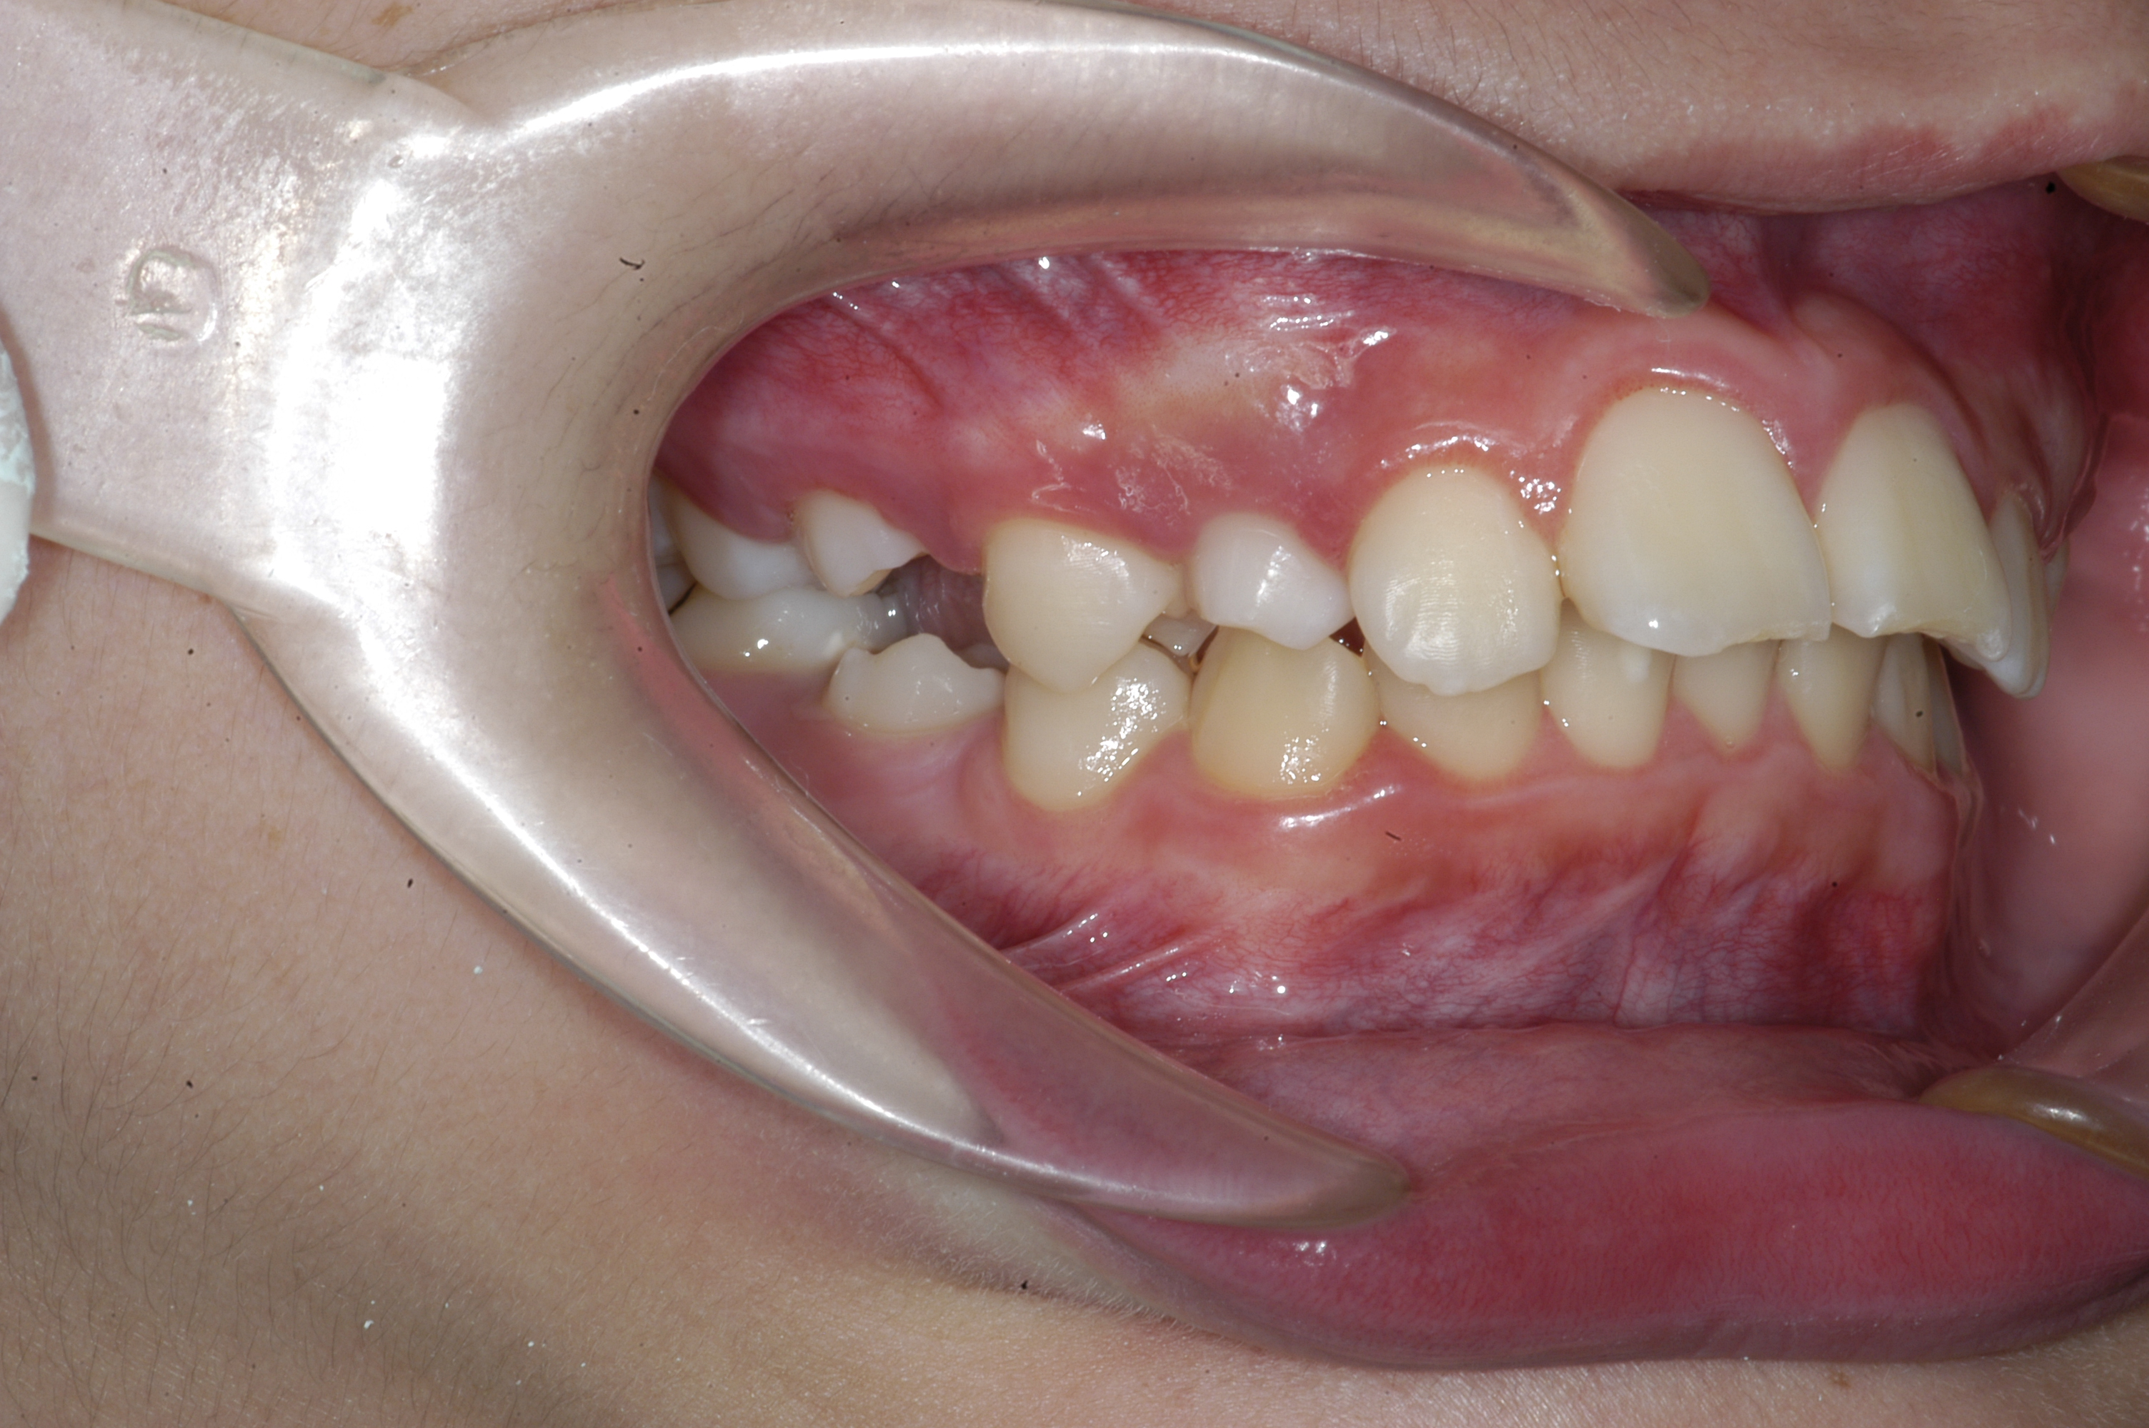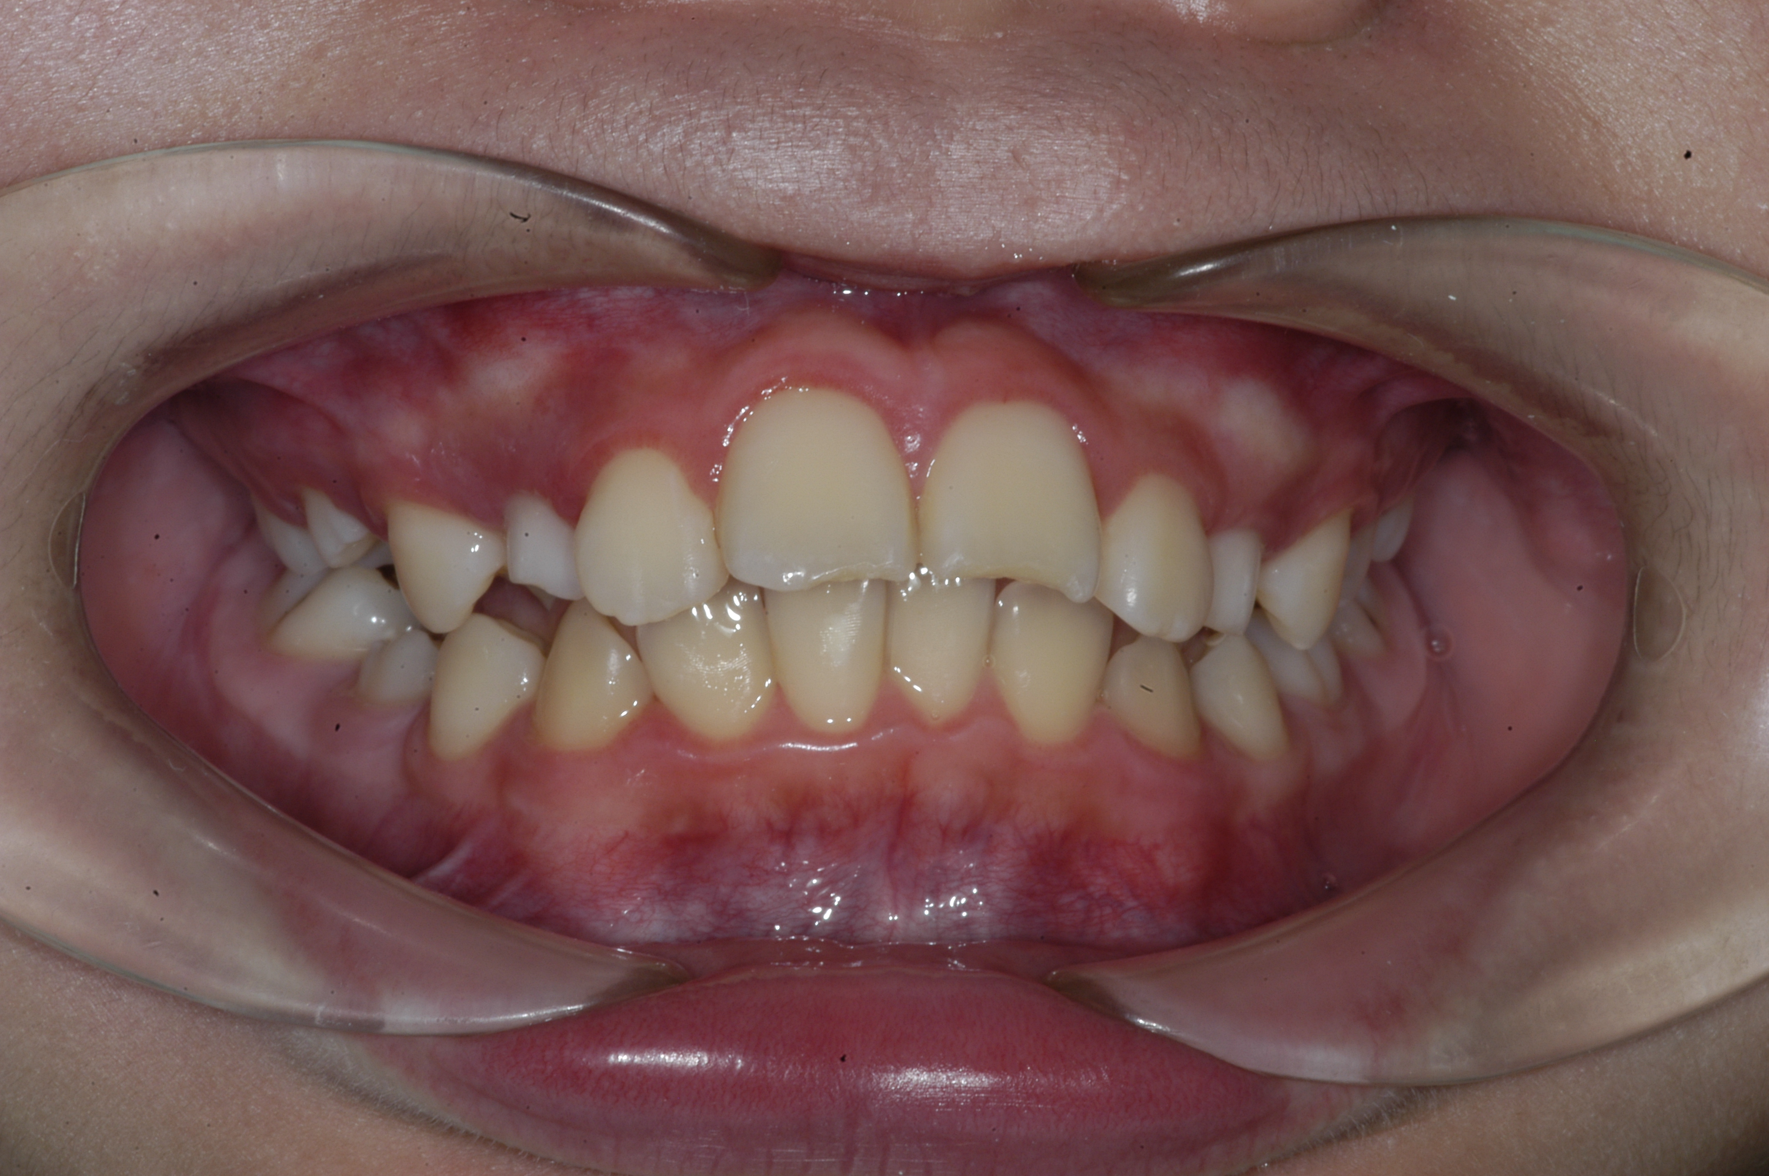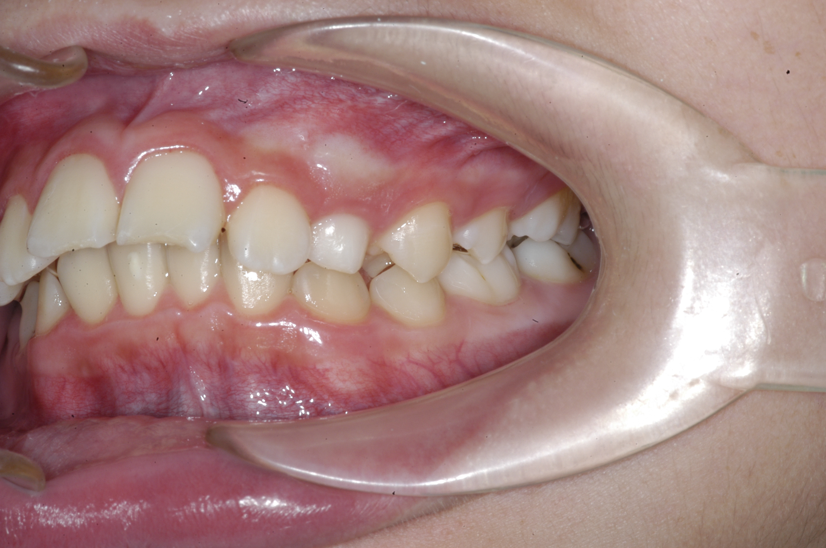
Figure 1. Pretreatment facial and intraoral photograph

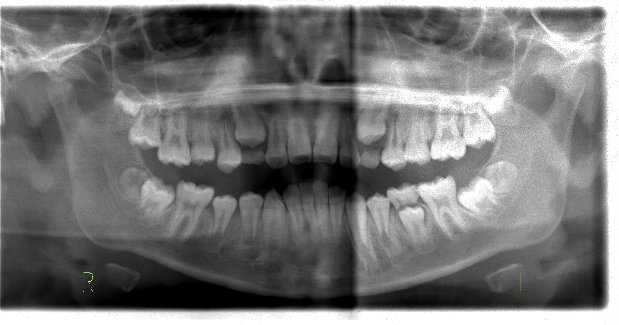
Figure 2. Pre-treatment panoramic radiograph
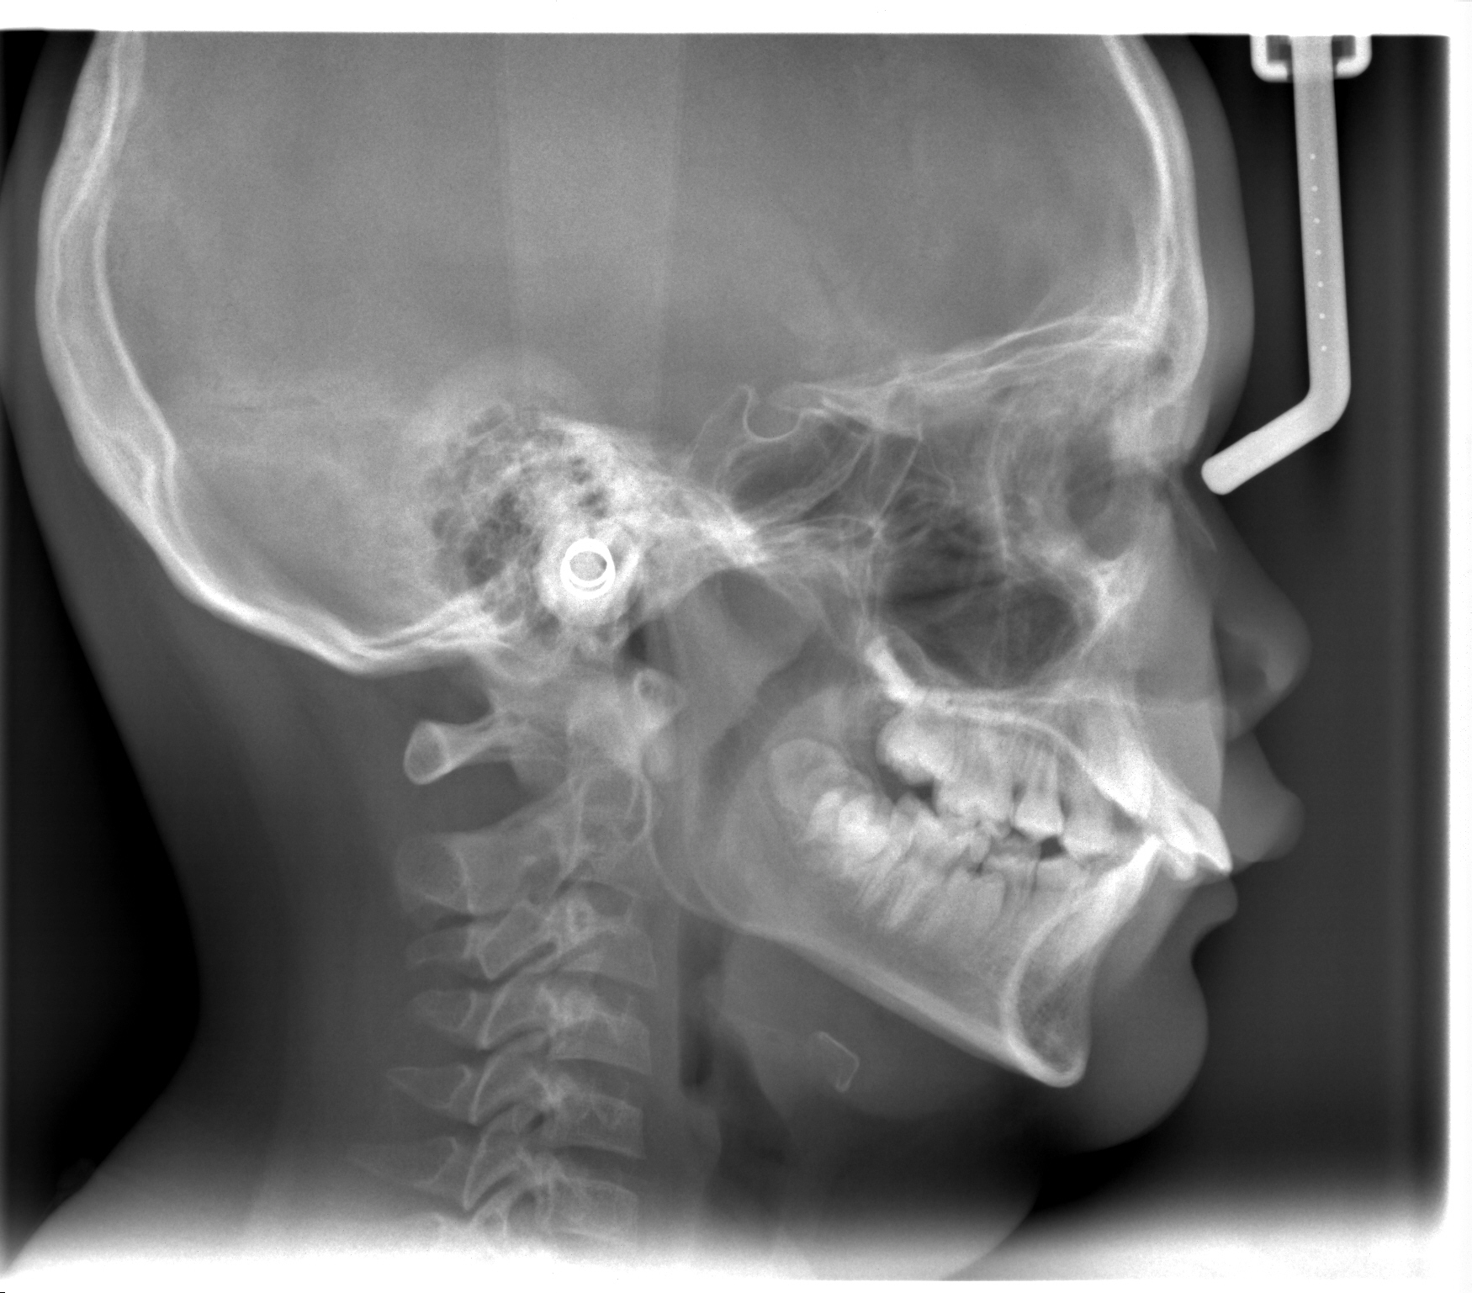
Figure3. Pretreatment Cephalometry Radiograph

- Treatment Objectives
The treatment objectives of this patient were two phases of treatment, where phase one is to correct the skeletal Class II malocclusion (retrognathic mandible), improve his overjet and overbite, solve the dental crowding, and improve his facial appearance instantly. Second phase using fixed appliances to correct his occlusion³.
  - Treatment Progress
A Class II patient had skeletal imbalance, can be corrected in the mixed dentition with early or phase 1 treatment. The Bionator appliance was used with the mandibular expander activated once every 4 weeks after an adaptation period of 10 days. The patient was instructed to wear the Bionator appliance for 24 hours a day, except during eating and brushing. During the phase 1 treatment, the Bionator appliance was adjusted every month to guide the mandible forward. The patient was initially seen 10 days after the first visit, then monthly so that the Bionator appliance could be adjusted for retention and stability as needed. After using the Bionator appliance for 10 months plus retention for 2 months, phase 2 treatment begins with the use of fixed appliances to improve the relationship between the teeth. The second phase treatment takes about 10 months (Fig.7-9).
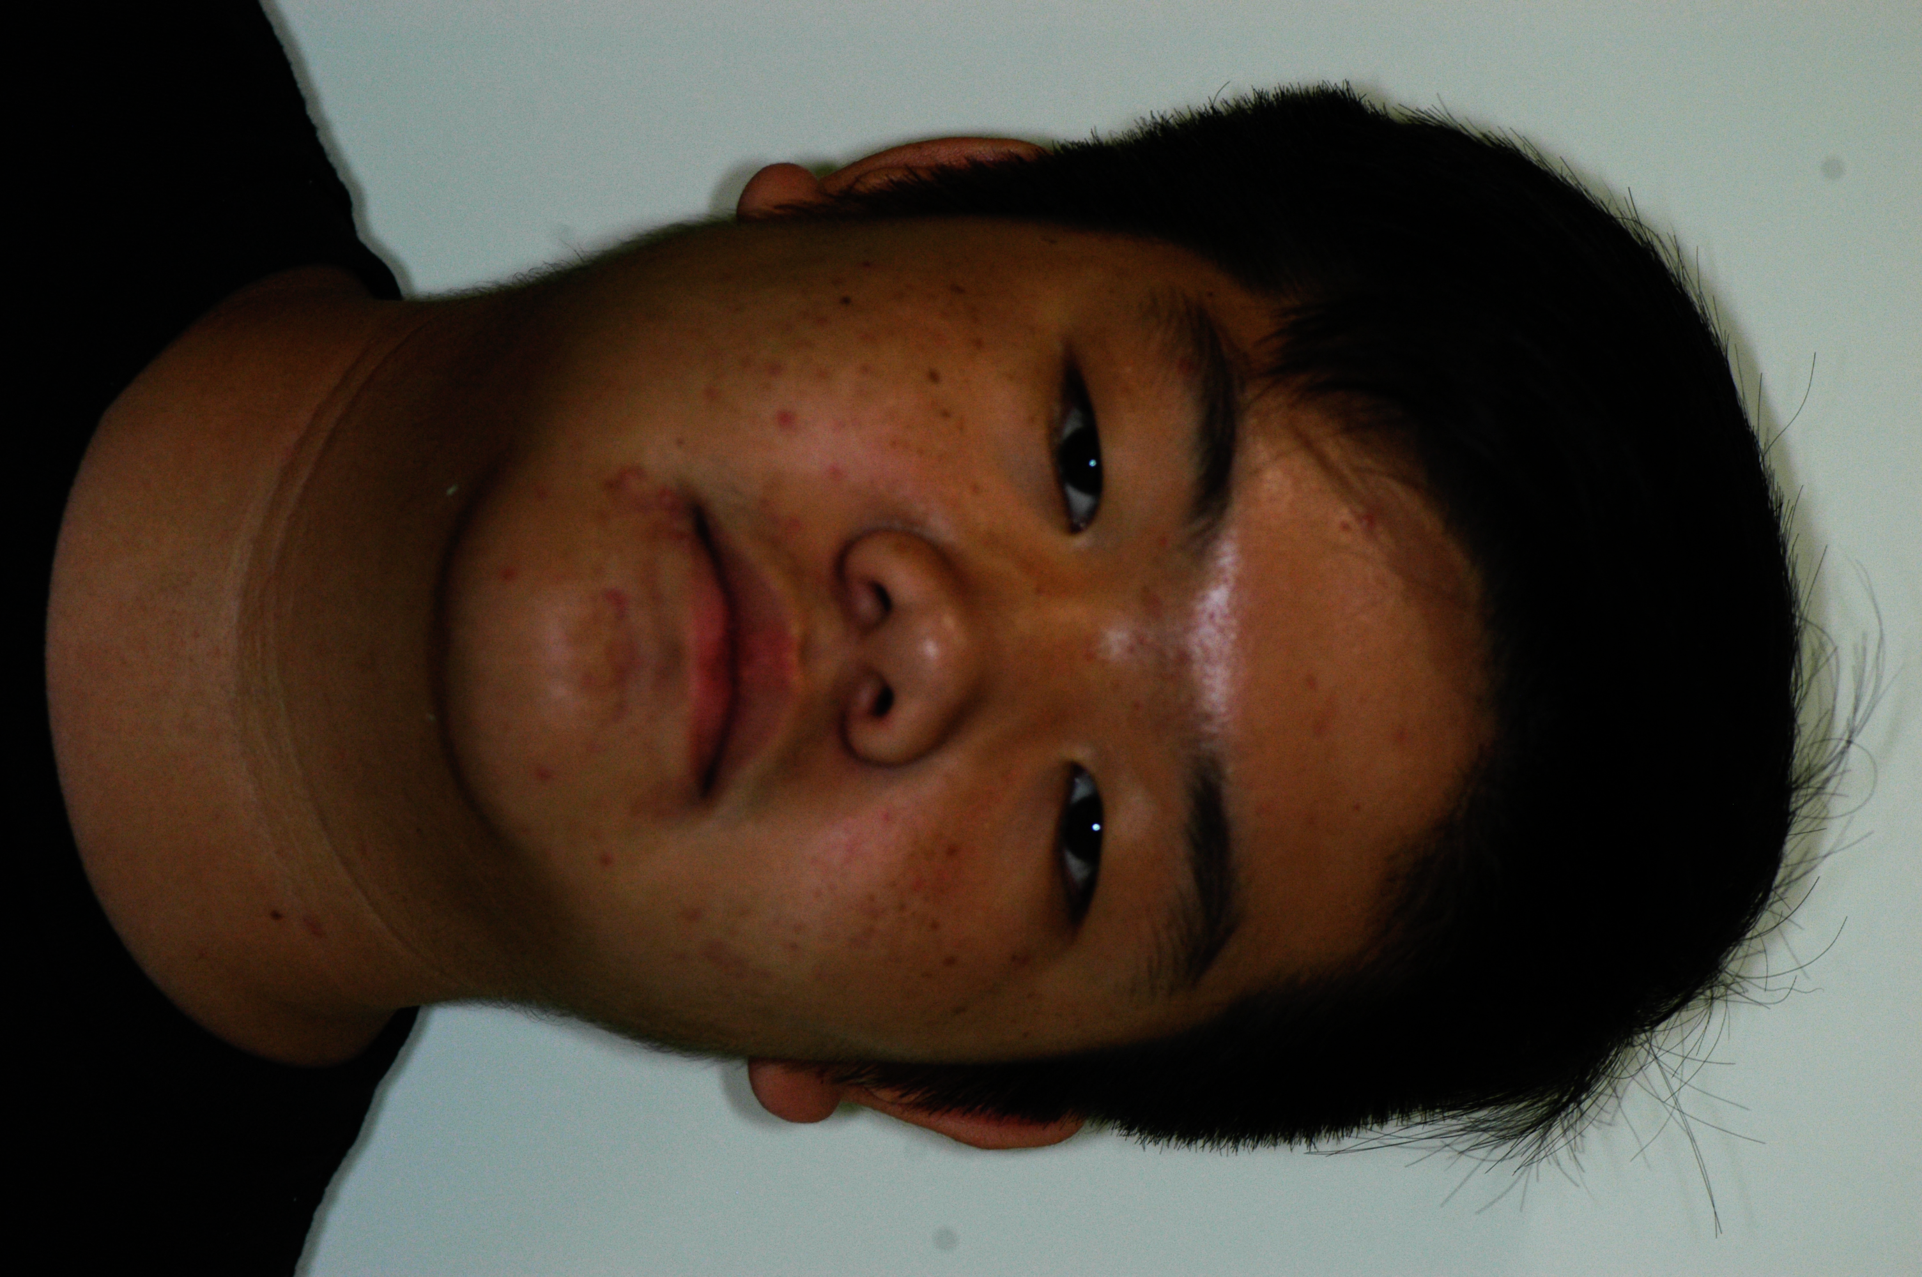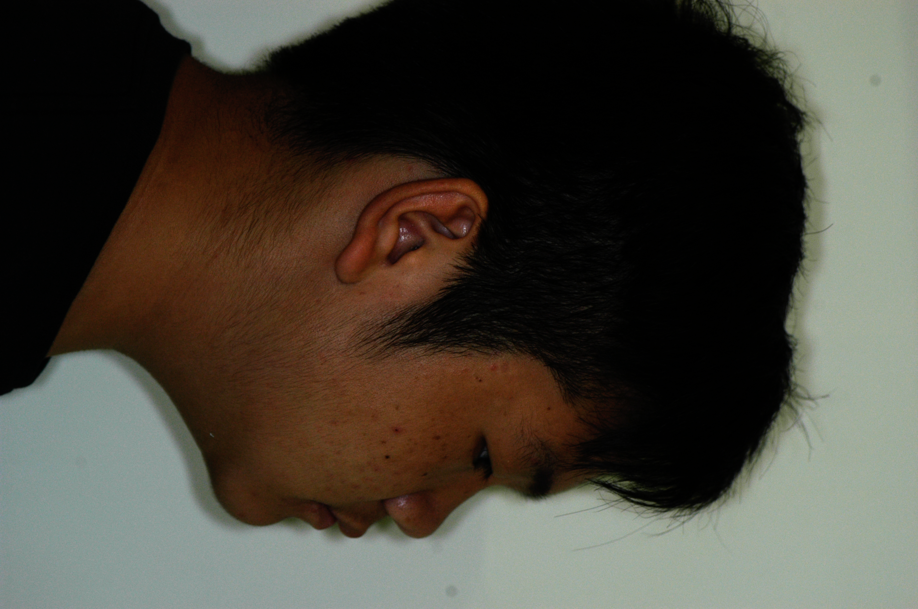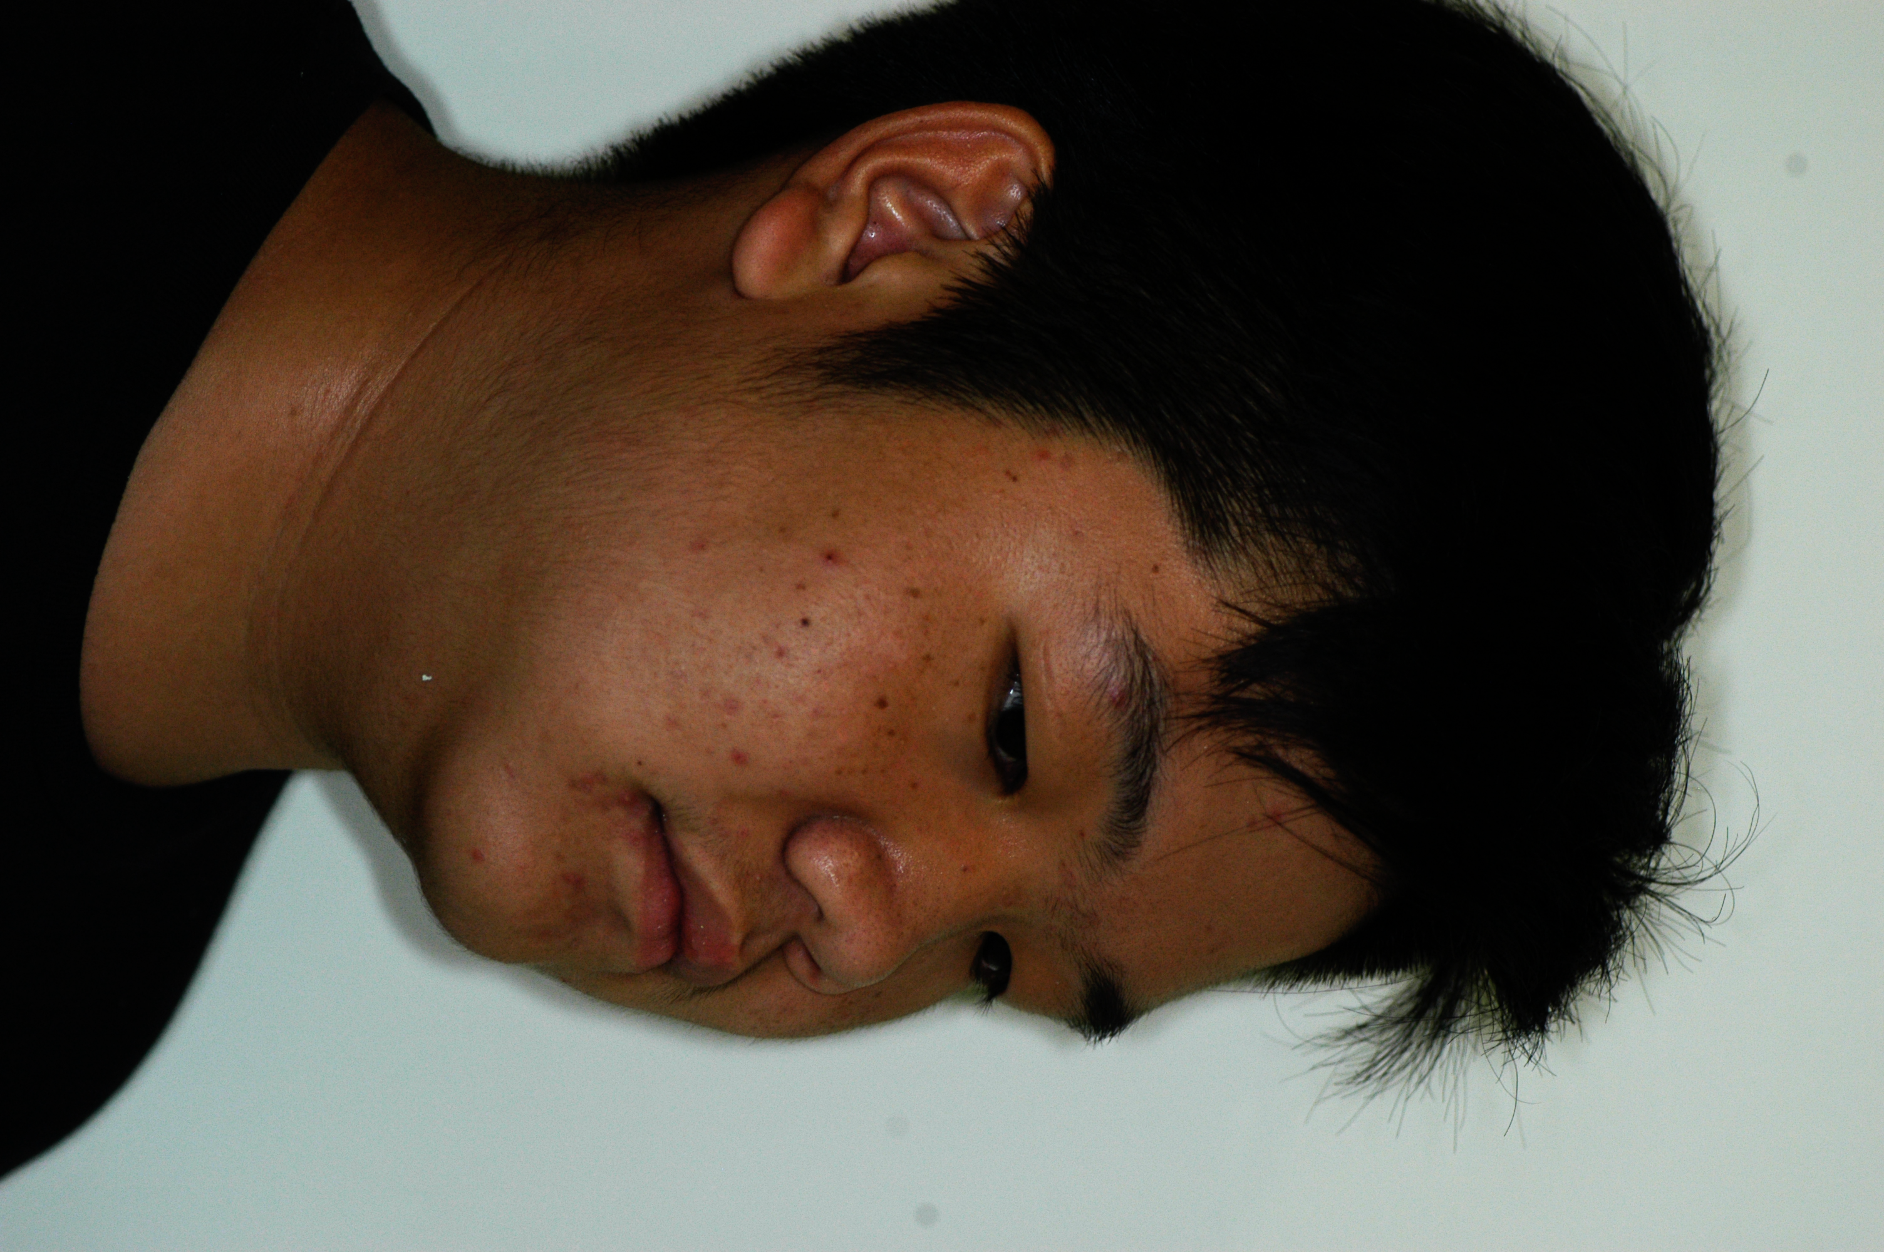
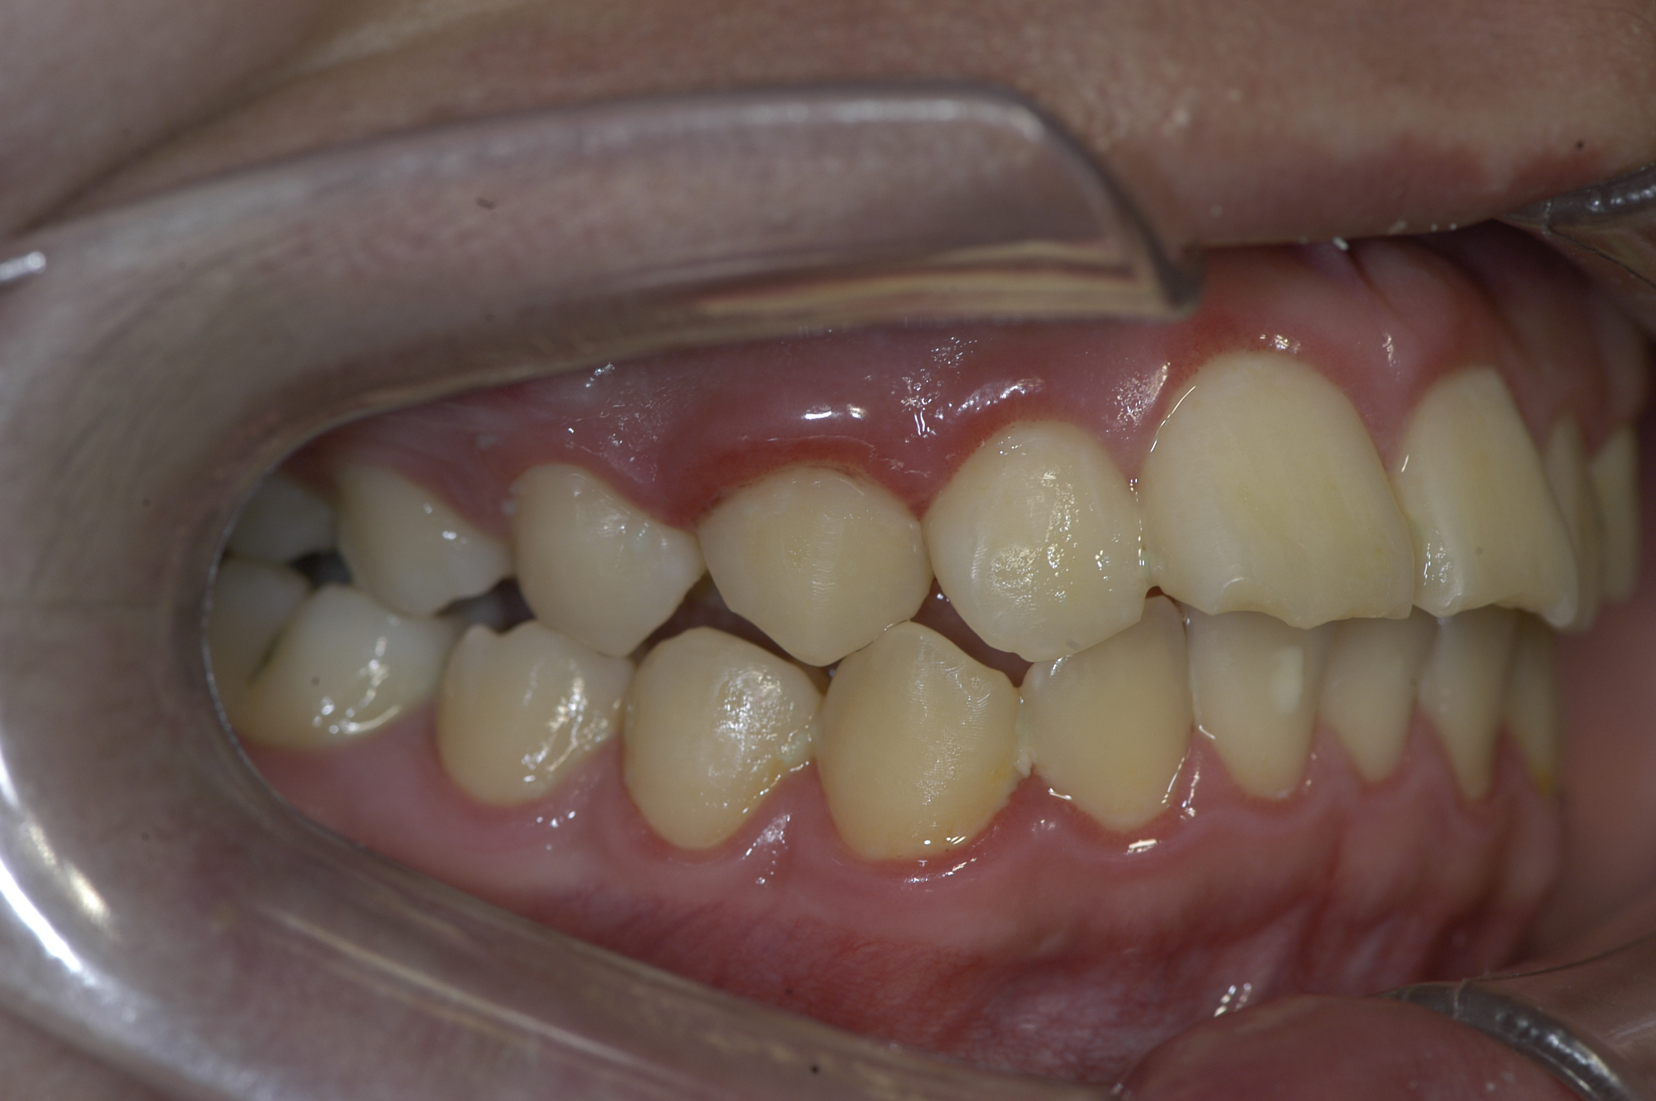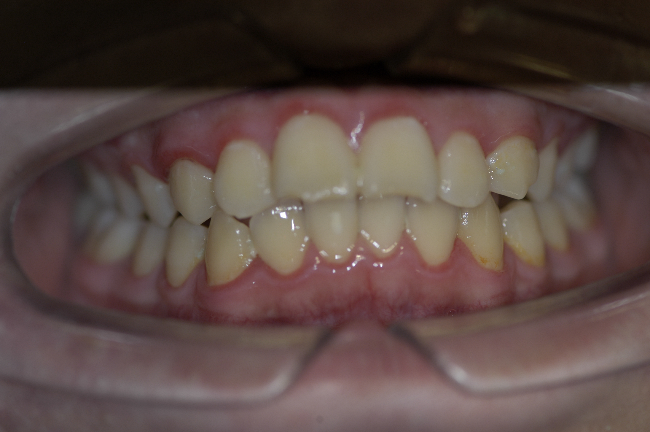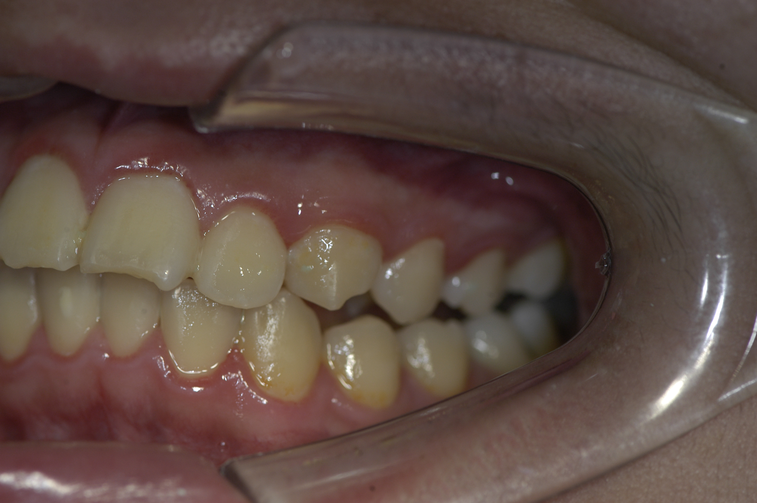
Figure 4. Intermediate facial and intraoral photograph

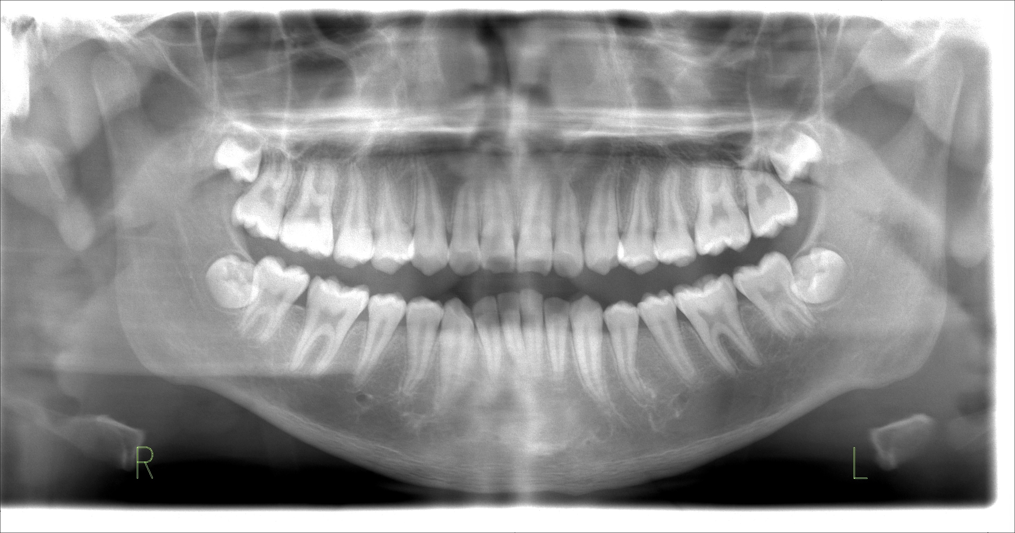
Figure 5. Intermediate panoramic radiograph

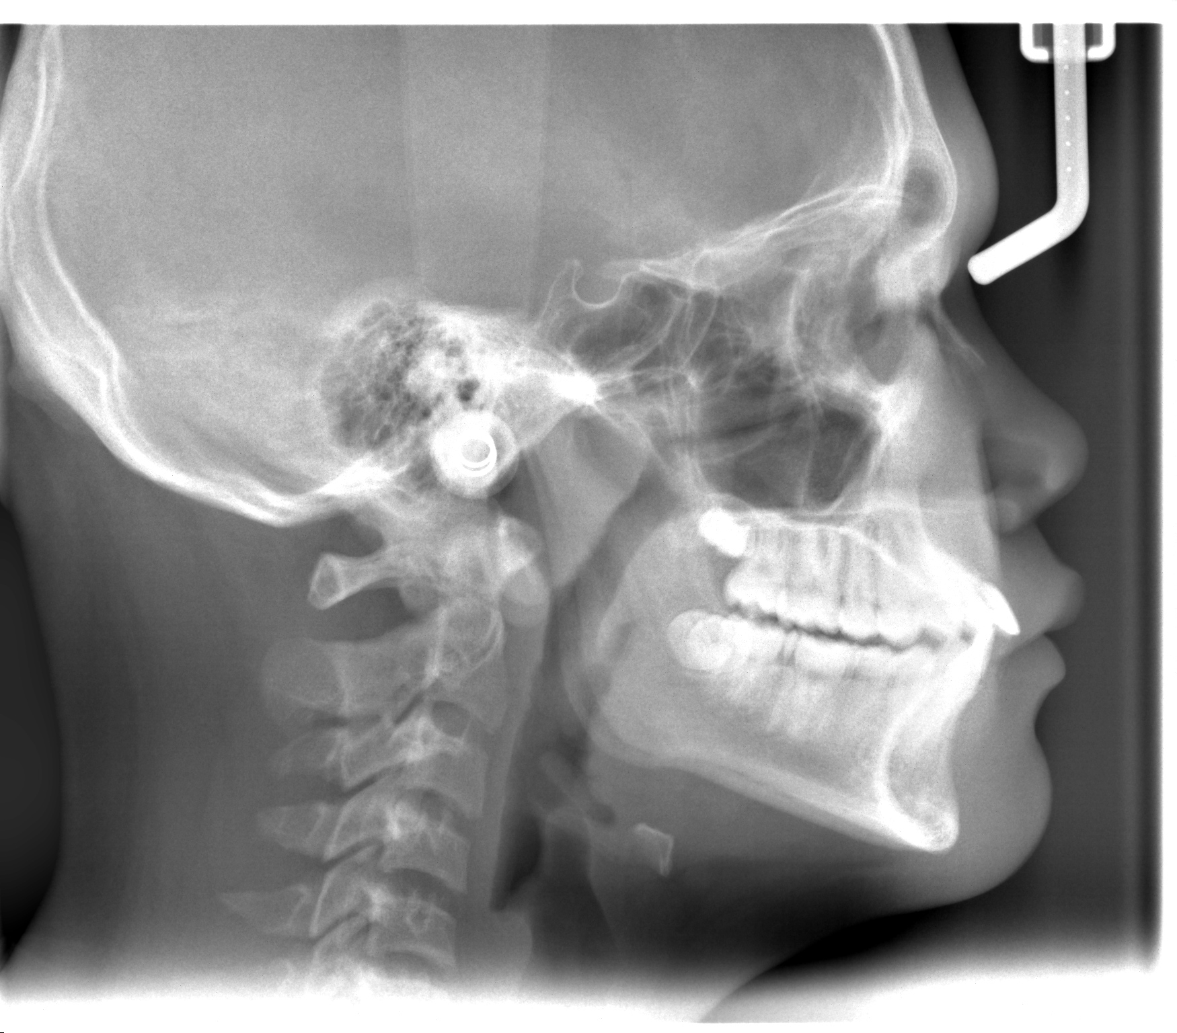
Figure 6. Intermediate cephalometry radiograph

  - Treatment results
The patient was treated in two phases treatment. First phase was to correct skeletal discrepancy and second phase was to correct tooth discrepancy. At the end of phase I treatment, after 10 months of treatment using a Bionator appliance, the patient's mandible was positioned forward, and the profile was greatly improved (Fig 4). His molar and canine relationships is a Class I. His profile become straight and more favorable. A skeletal anteroposterior reduction was significant with 5.26⁰ change in the ANB angle, facial angle, wits, mandibular arc, mandibular body length, e line and finally z angle (Table 1). The soft tissue profile become much better was showed by E line value of the upper lip become smaller and for lower lip become bigger the value. The intraoral examination showed an improvement of the deep overbite and large overjet, lingually inclined maxillary anterior teeth and a mesial relationship of the first permanent molars and canines. Enhancing instan profile Aesthetic from Growth Modification (Fig4).

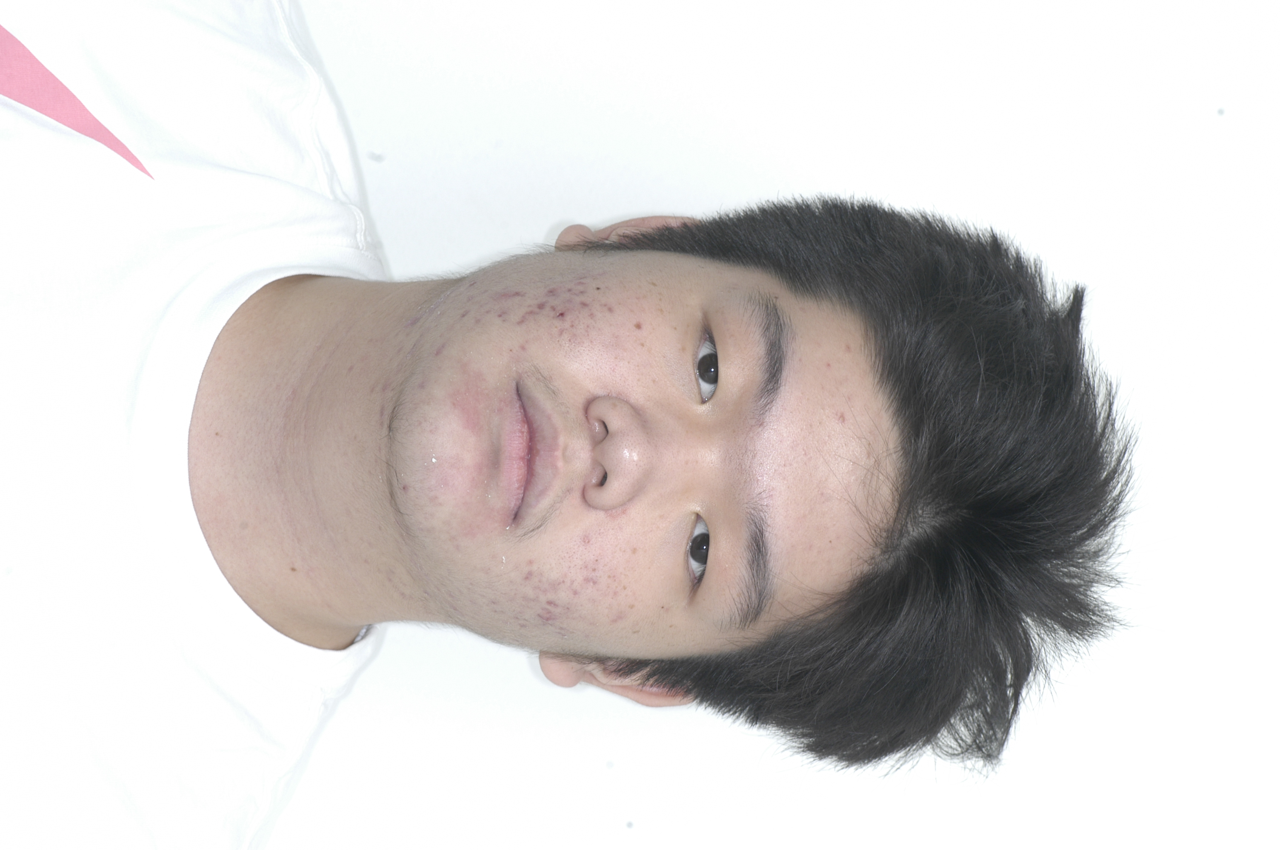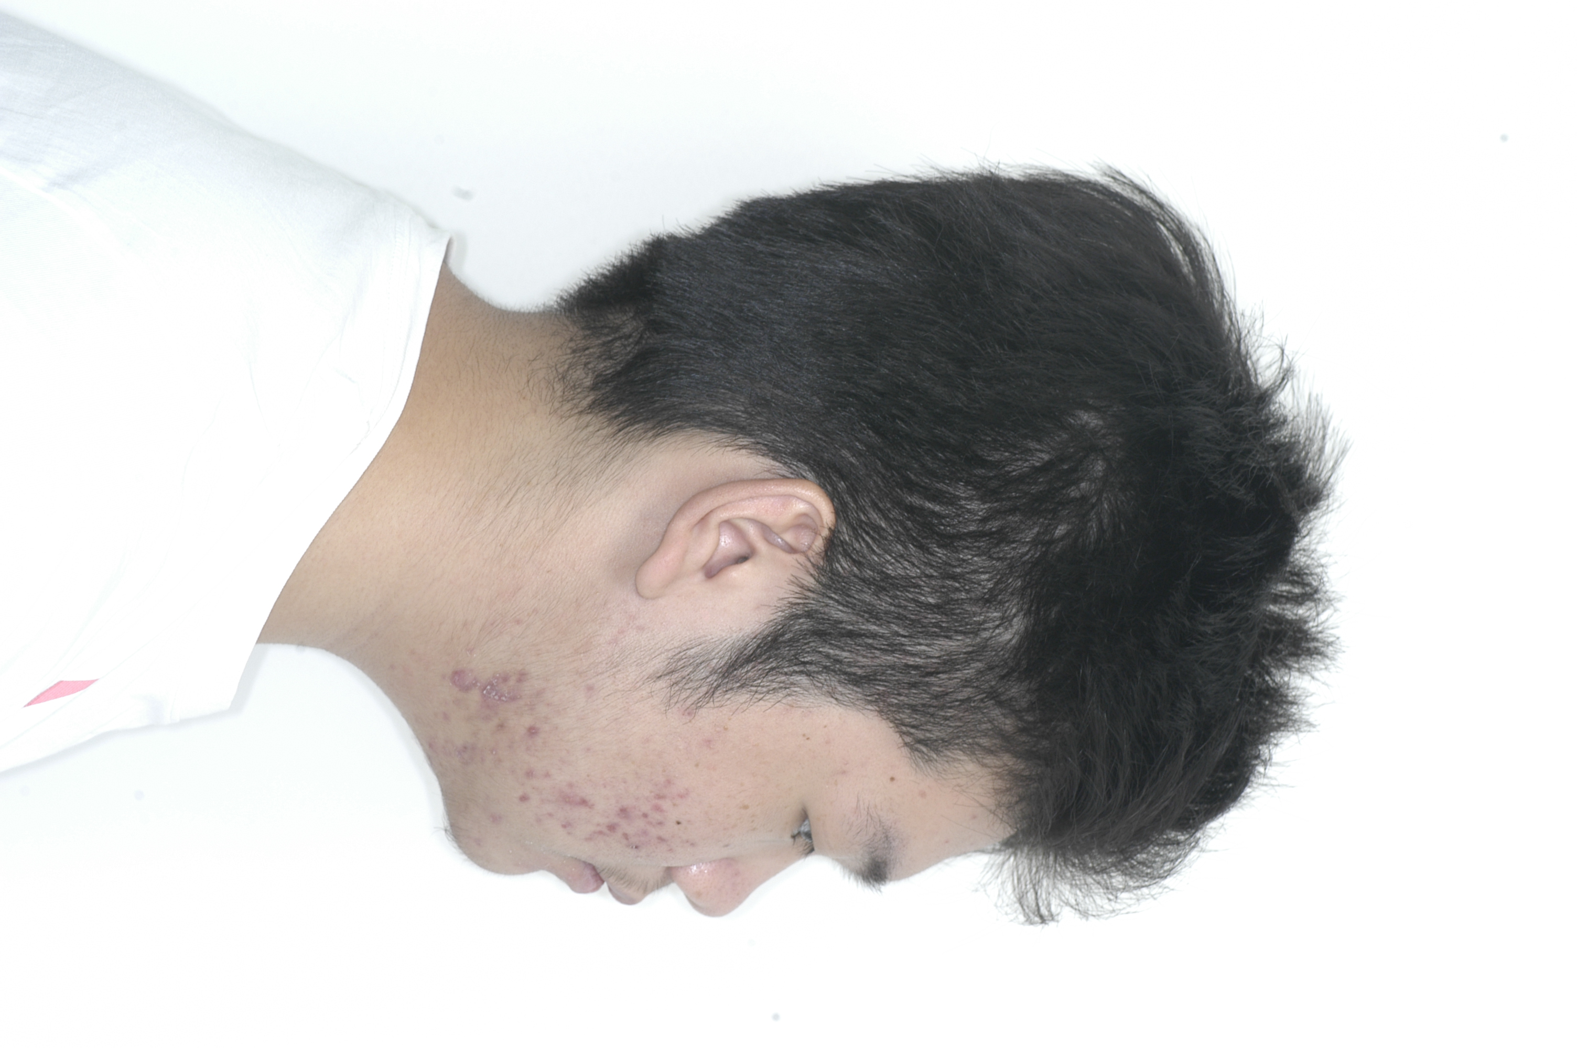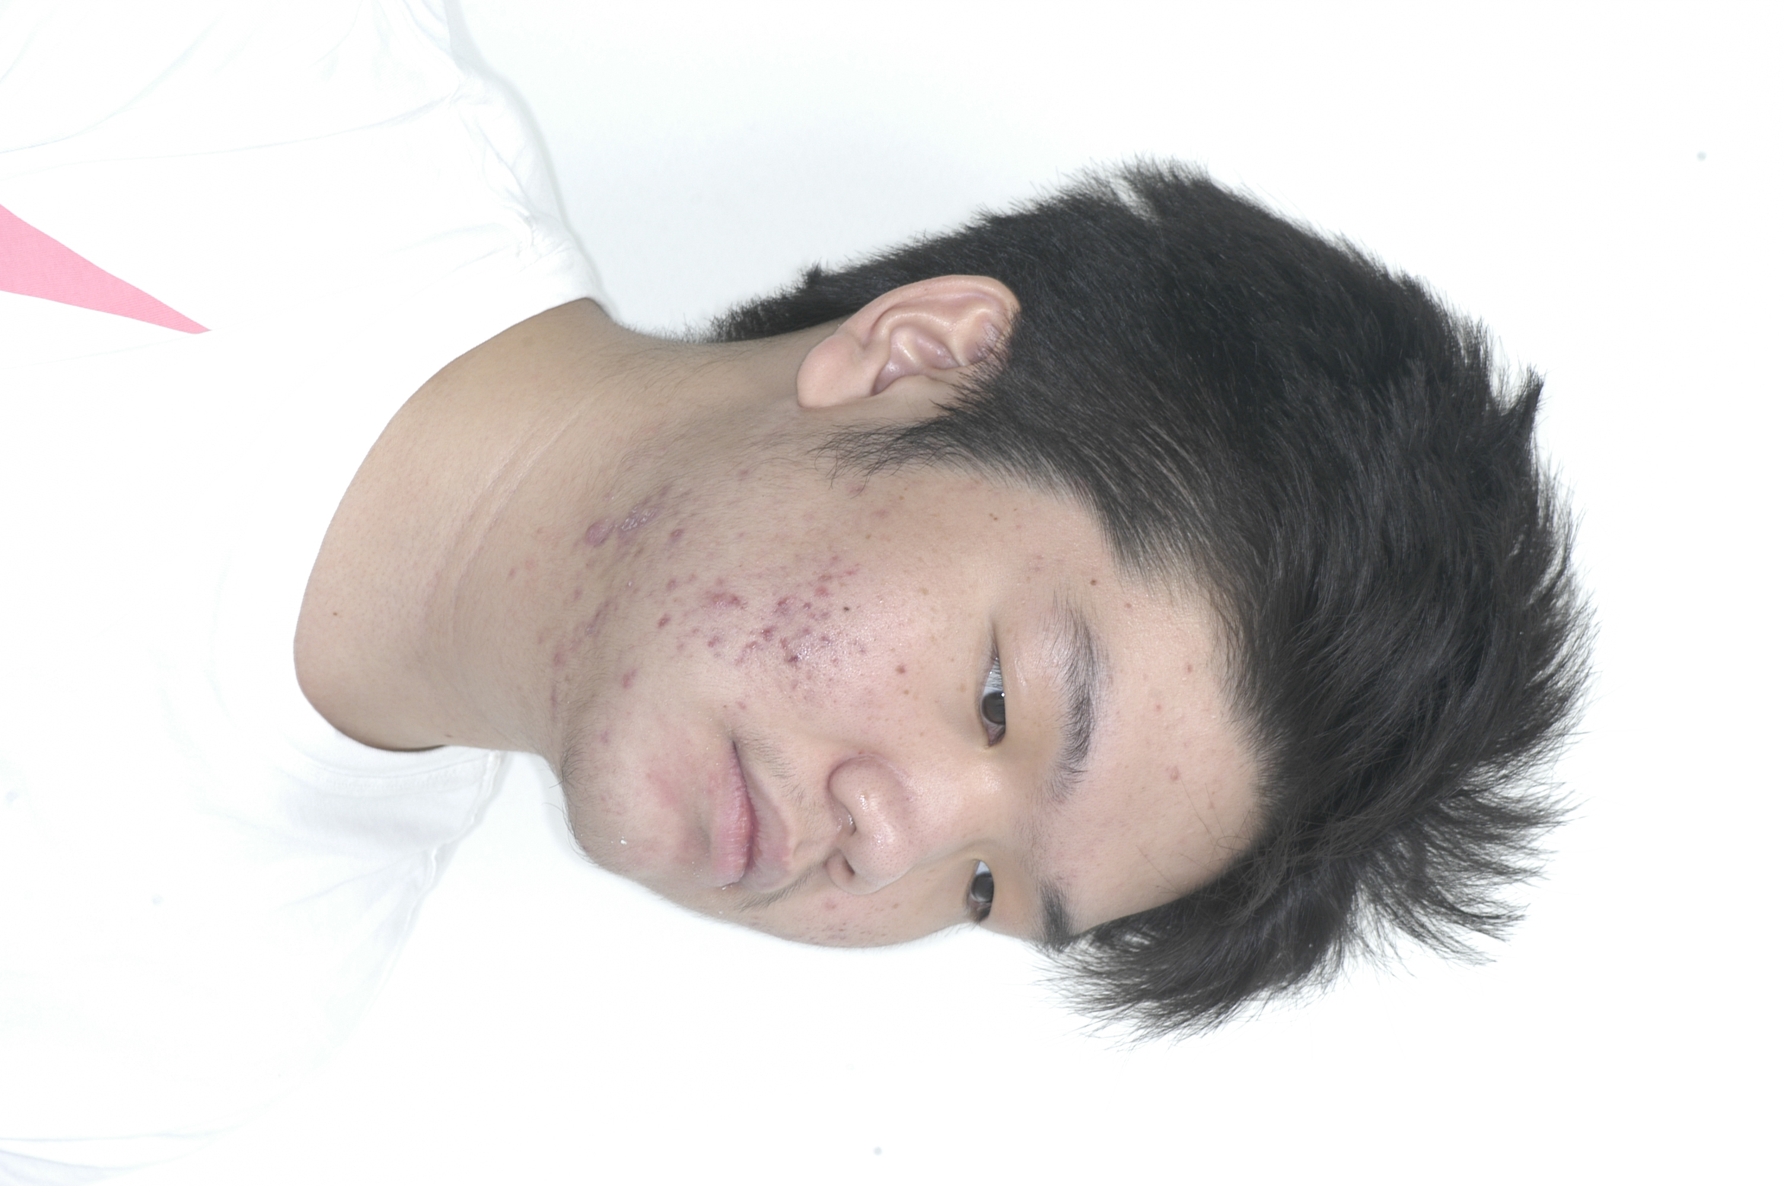
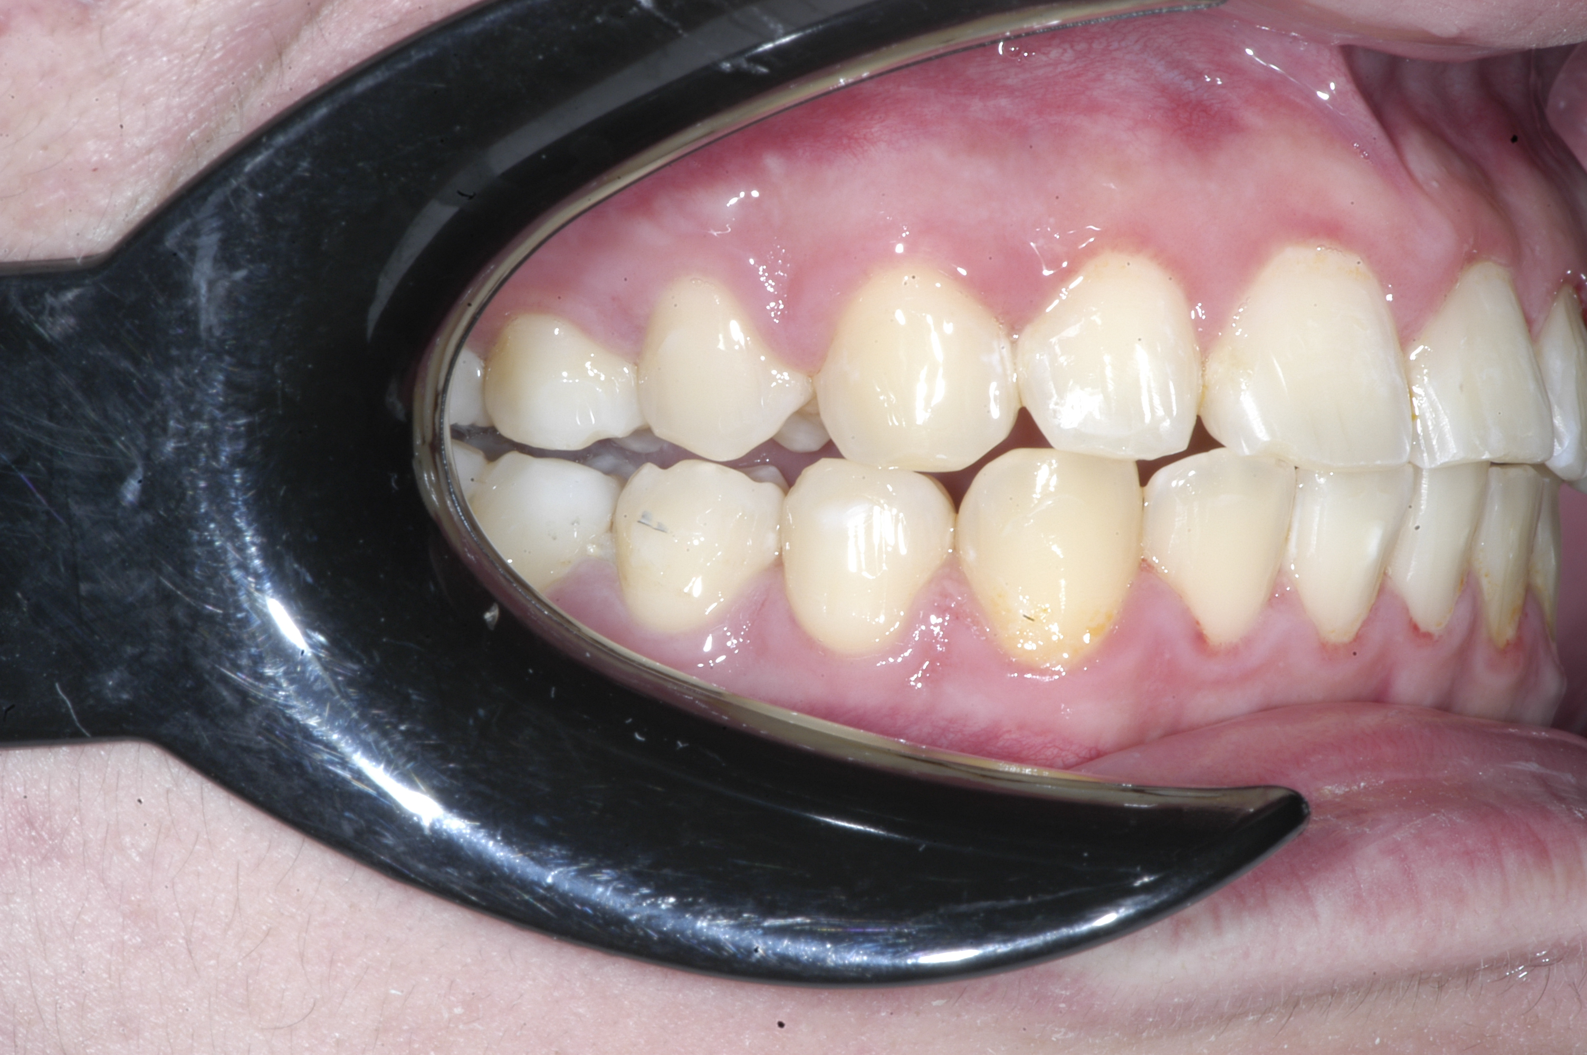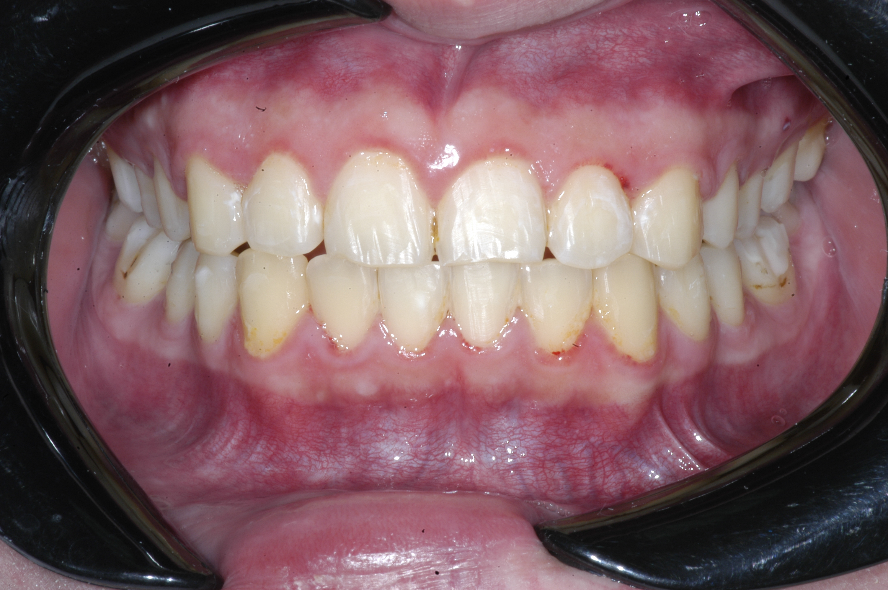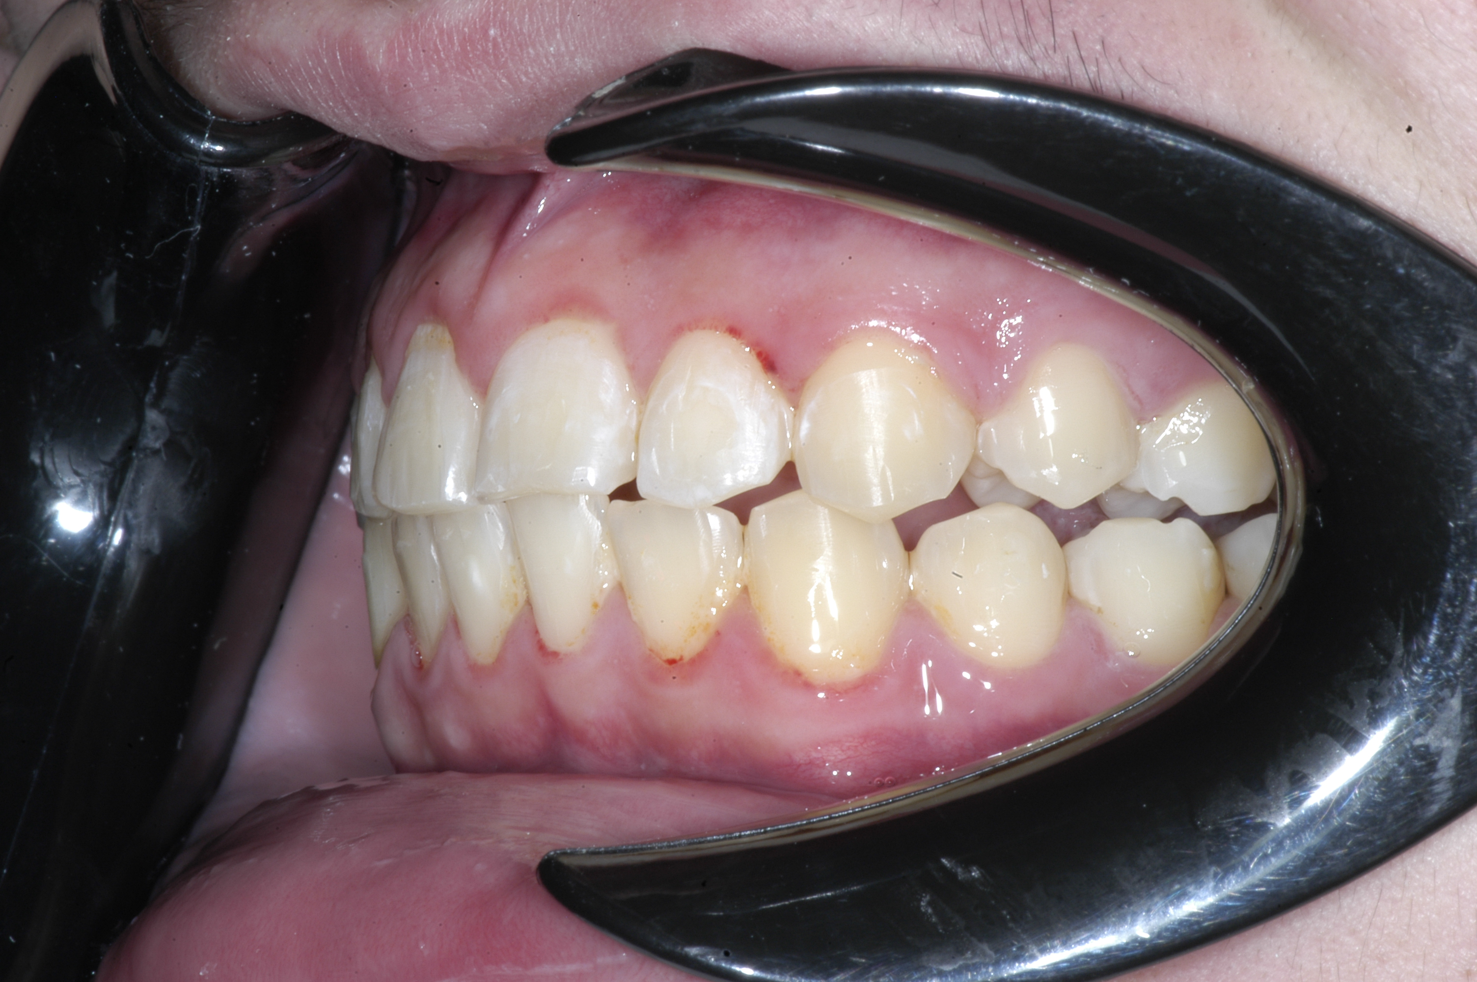
Figure 7. Post treatment intra and extra oral photographs

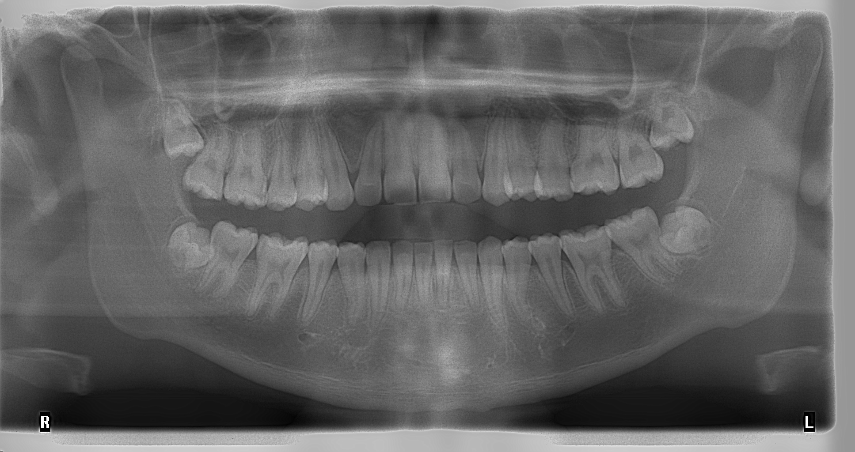
Figure 8. Post treatment panoramic radiograph

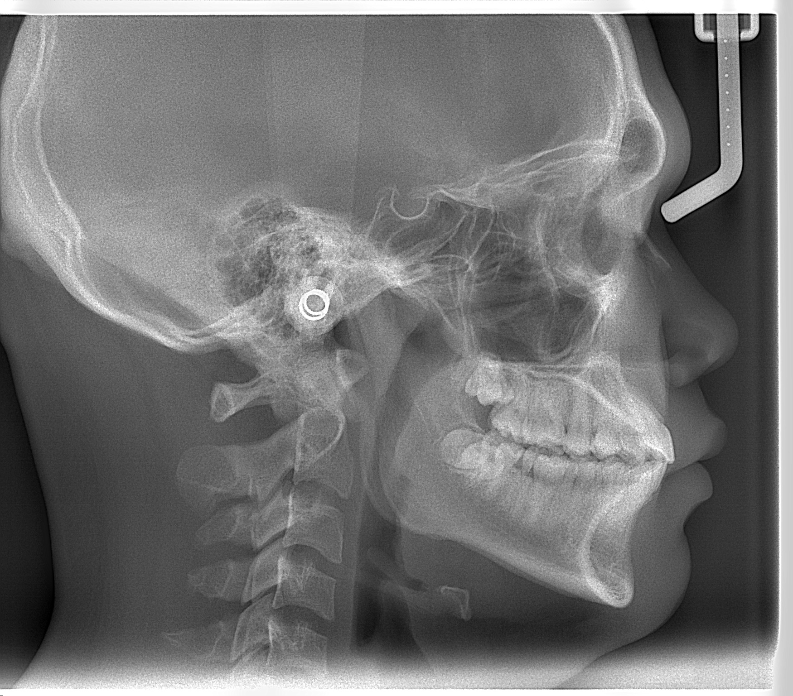
Figure 9. Post treatment cephalometric radiograph

Table 1. Analysis Cephalometry
No | Measurements | Value 1 | Value 2 | Value 3
1. | SNA | 92.89 | 92.56 | 92.51
2. | SNB | 85.32 | 90.26 | 90.01
3. | ANB | 7.56 | 2.30 | 2.50
4. | Facial Angle | 88.11 | 91.55 | 91.80
5. | Wits | 2.32 | -1.94 | -1.24
6. | Mandibular Arc | 23.43 | 33.79 | 34.10
7. | Mand Body Length | 70.58 | 81.52 | 82.22
8. | E line to Upper | 8.34 | 5.51 | 4.79
9. | E line to Lower | 0.81 | 2.41 | 2.10
10. | Z Angle | 72.28 | 79.64 | 78.01

After 10 months of treatment using Bionator appliance, the patient's mandible was positioned forward, and the profile was greatly improved (Fig 4). His molar and canine relationships is a Class I. His profile become straight and more favorable. A skeletal anteroposterior reduction was significant with 5.26 change in the ANB angle because the SNB angle had increase from 85.32⁰ to 90.26⁰ (Table 1). Inclination of the maxillary anterior teeth more up and overbite and overjet become normal.
After active treatment (the end of second phase), a normal occlusion with overbite and overjet was achieved. The patient profile changed from convex to straight. Lip protrusion was also improved. The molar and canine relationship was neutroclusions, good alignment and correction of the dental midline were achieved (Fig 7).

- Discussion
Oral habits are a common problem during childhood; they can include mouth breathing, tongue thrusting, thump sucking, and lip biting.⁴⁻⁵If oral habits is persistent, it may be one of etiologic factor for abnormal dentofacial growth. Mouth breathing has been reported to have serious effects on the development of occlusions and skeleton by way of altering muscular balance.⁶⁻⁸Previous studies had confirmed that mouth breathing causes a narrower maxillary width, big overjet, and high palatal vault. ⁹⁻¹²
Early treatment is usually carried out in Class II malocclusion cases with the aim of improving skeletal jaw relations by altering the growth pattern. Growth modification in cases of Class II malocclusion can be done either by using headgear to prevent forward movement of maxilla or by using a functional appliance to increase mandibular length.¹³⁻²¹In the United states the frequent approach to growth modification has been extraoral force (headgear) to restrict or redirect the growth of the upper jaw. At the same time, the European approach has more generally using Myofunctional appliances to redirect forward positioning of the mandibular. Class II malocclusion becomes apparent in the mixed dentition period, try to reduce big overjet using modify jaw growth modification. Facial and dental appearance will directly improve (Fig4).
In 1981, McNamara¹⁸ showed that up to 85% of patients with Class II malocclusion have some component of mandibular deficiency underlying the skeletal Class II discrepancy.¹⁸ In growing patients, growth modification is a feasible and more conservative approach, which is more appealing than camouflage, because ideally, the skeletal discrepancy should be addressed for optimal treatment results. It can be seen in this case that there is a significant change in the ANB angle from 7.56⁰ to 2.30⁰. Functional appliances are used to treat skeletal Class II problems due to mandibular deficiency in growing patients.²²When growth of the patient is over, then the treatment of patients with skeletal Class II malocclusion ranges from dental compensation, including camouflage by extractions, to surgical management. Removable functional appliance therapy depends totally on the patient's cooperation, which is complicated by appliance bulkiness. Fixed functional appliances suffer many other drawbacks including difficult fabrication, easy breakage, and tissue irritation.²²⁻²⁴
Bionator appliances is less bulky and less discomfort than other functional appliances such as Frankel. The amount of mandibular advancement used small increments to avoid straining of lateral pterygoids muscles.²⁵Bigliazzi et al²⁶evaluated the long-term effects of a Bionator in growing patients with mandibular retrusion and concluded that a Bionator could induce skeletal and dentoalveolar shape changes. Significant changes were seen in mandibular length, mandibular arc, E line in addition to changes in ANB angle (Table1).

- Conclusion
Early treatment using functional appliance therapy can reduce the severity of a Class II skeletal pattern and instant changed in facial and dental appearance, preventing incisal trauma and rebuilding confidence. A Class II skeletal pattern can be corrected if treatment started at right time, and other factors such patient cooperation and management must also be consider.

References
- Tauscher U. A growth-related concept for skeletal Class II treatment. Am J Orthod 1978;74:258-75.
- Illing H, Morris D, Lee R. A prospective evaluation of bass, bionator and twin block appliances. Part I—the hard tissues. Eur J Orthod 1998;20 :501-16.
- Tulloch JFC, Phillips C, Proffit WR. Benefit of early Class II treat- ment: progress report of a two-phase randomized clinical trial. Am J Orthod Dentofacial Orthop1998;113 :62-72.
- Garde JB, Suryavanshi RK, Jawale BA, Deshmukh, Dadhe DP, Suryavanshi MK. An epidemiological study to know the prevalence of deleterious oral habits among 6-12year old children. J Int Oral Health 2014; 6: 39-43.
- Urzal V, Braga AC, Ferreira AP. Oral habits as risk factors for anterior open bite in the deciduous and mixed dentition cross sectional study. Eur J Pediatr Dent 2013; 14: 299-302.
- Souki BQ, Pimenta GB, Souki MQ, Franco LP, Becker HM, Pinto JA. Prevalence of malocclusion among mouth breathing children: do expectations meet reality? Int J PediatrOtorhinolaryngol 2009; 73: 767-73.
- Paul JL, Nanda RS. Effect of mouth breathing on dental occlusion. Angle Orthod 1973; 43: 201-6.
- Smith RA. Etiology of Angle Class II Division 1 malocclusion. Angle Orthod 1939; 9: 15-9.
- Cattoni DM, Fernandes FD, Di Francesco RC, LatorreMdo R. Characteristics of the stomatognathic system of mouth breathing children: anthroscopic approach. Pro Fono 2007; 19: 347-51.
- Bacor SF, Enlow DH, Pontes P, De Biase NG. Craniofacial growth variations in nasal breathing, oral breathing and tracheaotomized children. Am JOrthodDentofacOrthop 2011; 140: 486-92.
- Bresolin D, Shapiro PA, Shapiro GG, Chapko MK, Dassel S. Mouth breathing in allergic children: its relationship to dentofacial development. Am J Orthod 1983; 83: 334-40.
- PetracconeCaixeta AC, Andrade L Jr, Bahia Junqueira Pereira T, Franco LP, Becker HM, Souki BQ. Dental arch dimensional changes after adenotonsillectomy in prepubertal children. Am J Orthod Dentofacial Orthop 2014; 145: 461-8.
- Tulloch JFC, Medland W, Tuncay OC. Methods used to evaluate growth modification in Class I1 malocclusion. Am J OrthodDentofacOrthop 1990;98 :340-7.
- Schiavoni R, Grenga V, Macri V. Treatment of Class II high angle malocclusions with the Herbst appliance: a cephalometric investigation. Am J OrthodDentofacOrthop 1992;102 :393-409
- Firouz M, Zernik J, Nanda R. Dental and orthopedic effects of high-pull headgear in treatment of Class II, Division 1 malocclusion. Am J OrthodDentofacOrthop 1992;102 :197-205.
- Nelson C, Harkness M, Herbisson P. Mandibular changes during functional appliance treatment. Am J OrthodDentofacOrthop 1993;104 :153-61.
- Ghafari J, Jacobsson-Hunt U, Shofer FS, Laster LL. Changes in arch width in earlytreatment of Class II, Division 1 malocclusions. Am J OrthodDentofacOrthop 1994;106: 496-502
- McNamara JAJr. Components of Class II Malocclusion in children 8-10 years of age. Angle Orthod 198; 51: 177-202.
- Tulloch JF, Proffit WR, Phillips C. Outcomes in a 2-phase randomized clinical trial of early Class II treatment. Am J Orthod Dentofacial Orthop 2004;125: 657-67.
- Dolce C,McGorray SP, Brazeau L, King GJ, Wheeler TT. Timing of Class II treatment: skeletal changes comparing 1-phase and 2-phase treatment. Am J Orthod Dentofacial Orthop 2007;132 :481-9.
- Luke LS, Atchison KA, White SC. Consistency of patient classification in orthodontic diagnosis and treatment planning. Angle Orthod 1998;68 :513-20.
- Chen JY, Will LA, Niederman R. Analysis of efficacy of functional appliances on mandibular growths. Am J Orthod Dentofacial Orthop 2002; 122: 470-6.
- Prateek S, Sanddhya J. Fixed fuctional appliances: an overview. Int J Curr Res 2017; 9: 470407-14.
- Ozbilek S, Gungor AY, Celik S. Effects of skeletally anchored Class II elastic: a pilot study and new approach for treating Class II malocclusion. Angle Orthod 2017; 87; 505-12.
- Ishizaki K, Suzuki K, Mito T, Tanaka EM, Sato S. Morphologic, functional and occlusal characterization of mandibular lateral displacement malocclusion. Am J Orthod Dentofacial Orthop 2010; 137: 454-55.
- Uzumez S, Uysal T Sari Z, Basciftci FA, Karaan AL, Guray E. The effect of early preorthodontic trainer treatment on Class II division 1 patients. Angle Orthod 2004; 74: 605-9.

Himawan Halim, DMD, MS, PhD, FICD
¹Faculty of Dentistry, Universitas Trisakti, Jakarta, Indonesia.
ORCID: https://orcid.org/0000-0002-9941-2894
Email: himawan@trisakti.ac.id

Ivan A. Halim, DMD, MPH, MS, FICD
²Researcher, Postgraduate Orthodontic Program, Arizona School of Dentistry & Oral Health, A.T. Still University, Mesa, Arizona
³PhD candidate, Faculty of Dentistry, Universitas Padjajaran, Bandung, Indonesia
ORCID: https://orcid.org/0000-0002-9657-3377

