Implementation of Advanced Coal-Biomass Blending and Fuel Stock Management at Pelabuhan Ratu Power Plant

H.T. Nurahman^{1, *} and H. Hermawan²
¹Primary Energy Dept. PT. PLN Indonesia Power, Pelabuhan Ratu Power Generation Unit Indonesia
²Engineering Dept. PT. PLN Indonesia Power, Pelabuhan Ratu Power Generation Unit Indonesia
*E-mail: herowiko@plnindonesiapower.co.id

Abstract
The issue of climate change is of particular concern to countries around the world, including Indonesia. Many efforts are being and will be made to contribute to addressing climate change issues. Pelabuhan Ratu Power Plant (3 x 350 MW) belongs to PT PLN Indonesia Power. In line with the PLN Transformation (GREEN aspect) and the PT PLN Indonesia Power program ("Green Boosters"), Pelabuhan Ratu Power Plant contributes to produce low-carbon sustainable energy by cofiring biomass (sawdust). There are two main challenges in implementing cofiring. The first is the poor biomass handling and blending methods that are typically used in power plants. The second is the low calorific value of coal and biomass blending due to the improper blending process. To overcome these challenges, Pelabuhan Ratu Power Plant has developed an advanced coal-biomass blending and fuel stock management digitalization. By applying advanced method of coal-biomass blend, the biomass utilization (total, monthly average, and daily average) increased significantly in 2022 and 2023. Total biomass utilization increased up to 171% and still possible to be higher. The green energy production increased up to 255% and GHG emission reduced up to 255%. The fuel stock management provides optimal blending recommendations as operators' guidelines. As a result, potential derating loss due to low calorific value of blended products can be reduced by 59.9%.

Keywords: low carbon sustainable energy, biomass cofiring, blending, fuel stock management, digitalization

Abstrak
Masalah perubahan iklim menjadi perhatian utama bagi negara-negara di seluruh dunia, termasuk Indonesia. Banyak upaya yang sedang dan akan dilakukan untuk membantu mengatasi masalah perubahan iklim ini. Pembangkit Listrik Pelabuhan Ratu (3 x 350 MW) dimiliki oleh PT PLN Indonesia Power. Sejalan dengan Transformasi PLN (GREEN aspect) dan PT PLN Indonesia Power program "Green Boosters", Pembangkit Listrik Pelabuhan Ratu turut berkontribusi dalam menghasilkan energi berkelanjutan rendah karbon dengan menggunakan biomassa (swadust). Terdapat dua tantangan utama dalam menerapkan penggunaan biomassa. Pertama adalah metode penanganan dan pencampuran biomassa yang kurang efektif yang biasanya digunakan dalam pembangkit listrik. Kedua adalah nilai kalor rendah dari campuran batubara dan biomassa karena proses pencampuran yang tidak tepat. Untuk mengatasi tantangan ini, Pembangkit Listrik Pelabuhan Ratu telah mengembangkan digitalisasi manajemen pencampuran batubara-biomassa dan manajemen stok bahan bakar yang canggih. Dengan menerapkan metode pencampuran batubara-biomassa yang lebih maju, penggunaan biomassa (total, rata-rata bulanan, dan rata-rata harian) meningkat secara signifikan pada tahun 2022 dan 2023. Penggunaan total biomassa meningkat hingga 171% dan masih mungkin untuk ditingkatkan lebih lanjut. Produksi energi hijau meningkat hingga 255% dan emisi gas rumah kaca dapat dikurangi hingga 255%. Manajemen stok bahan bakar memberikan rekomendasi pencampuran optimal sebagai panduan bagi operator. Sebagai hasilnya, potensi kerugian derating akibat nilai kalor rendah dari produk campuran dapat dikurangi hingga 59,9%.

Kata kunci : energi berkelanjutan rendah karbon, pencampuran biomassa, pencampuran, manajemen stok bahan bakar, digitalisasi

- INTRODUCTION
In recent years, the topic of global warming has gained the most traction in public discourse. Oil, gas, and coal make up 84% of the world's energy requirements. For a very long time, it has been thought that the usage of fossil fuels and human dependence have major effects on climate change (Pang, 2014). The 2015 Paris Agreement was adopted by signatory nations to the UNFCCC (United Nations Framework Convention on Climate Change) at the 21st Climate Change Conference (COP21) in Paris, France. The major goals of the agreement are to keep the increase in global temperature below 2°C from pre-industrial levels and work towards keeping it below 1.5°C. Every nation has made a commitment to cutting greenhouse gas (GHG) emissions and taking other actions in response to the effects of climate change. By 2060, Net Zero Emission (NZE) is the desired outcome (UNFCC, 2015).
Biomass has been recognized as a potential energy source for the future (Klass, 1998). A renewable energy source utilized to lower greenhouse gas emissions is biomass (Bhuiyan dkk., 2018). In coal-fired power plants, biomass has long been used as a cofiring fuel, and the use is growing (Bhuiyan dkk., 2018; Barnes, 2015; Gil dan Rubiera, 2019). About 10% of the world's total energy demand is currently met by biomass use, and this percentage is expected to rise (Stenström, 2006).
PT. PLN is committed to optimizing fuel costs and supporting the energy transition through a cofiring program with a target of 23% NRE by 2025. Biomass cofiring is one of the breakthrough programs of the government and PT. PLN (Persero) to support the advancement of the renewable energy mix in Indonesia. Pelabuhan Ratu uses sawdust as coal co- firing. Based on the PLN's Cofiring roadmap as shown in Figure 1, Coal-Fired Power plants designated as Cofiring plants will be given continuous targets to support the achievement of net zero emissions in 2060. Of course, a breakthrough is needed to support the target set.

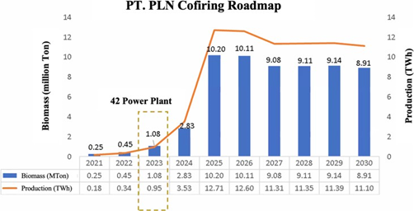
Figure 1. PT. PLN (Persero) cofiring roadmap
Pelabuhan Ratu Power Plant has been conducting a cofiring program since 2021, but the sawdust combustion test was done at the end of 2020. The sawdust combustion test was carried out on December 10, 2020, and Go Live Cofiring started on May 29, 2021, with 3-5% sawdust. Figure 2 shows the conventional blending method in Pelabuhan Ratu Power Plant. Pelabuhan Ratu uses sawdust as coal cofiring, because there are many wood processing industries around Pelabuhan Ratu that produce large amounts of wood waste. The wood waste is very potential for cofiring material. Sawdust from wood waste is tested in the laboratory and the results are suitable for cofiring.

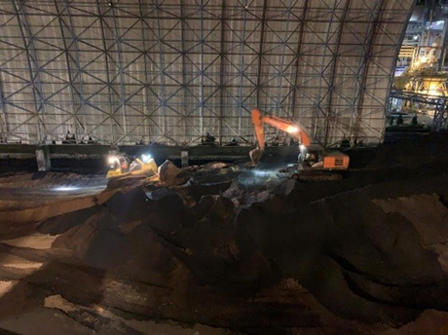
Figure 2. Coal-biomass blending in the coal yard
The old conventional blending gives several disadvantages, such as difficult handling with heavy equipment, low flexibility of cofiring execution (strict time- based), high additional cost for heavy equipment (approx. USD 158,509.23), long blending process duration (5 hours per day), and inhomogeneous & inconsistent of the blended product, and pulverizer blocking (8 events in 2021 equivalent to losses USD 164,876.10). In addition, low calorific value of the blended product during cofiring and lack of fuel stock management, leading to the derating of electricity generation (11,320 MWh in 2021). Therefore, digitized fuel stock management was developed to overcome this problem.
Incorrect determination of the blending ratio and calorific value of blended products will greatly impact electricity generation. Figure 3 shows that there is a difference between estimated calorific value of coal blending and lab test result in the period of 2016-2018. During this period, the average deviation value was 6.43% or blending accuracy is 93.57%. The allowable deviation is 2%. If it is below the power plant's demand, there will be derating due to under-calorie, while conversely, if it is above the demand, there will be the inefficiency of boiler combustion due to over-calorie and operational impacts such as overheating in the boiler. In 2021, there was a derating of electricity generation by 11,320 MWh because of low calorific value of blending result and lack of fuel stock management.

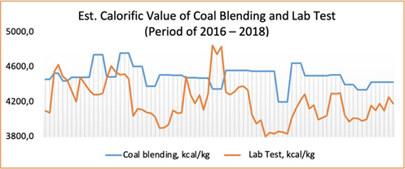
Figure 3. Estimated Value of Coal Blending and Lab Test (period of 2016 – 2018)
Pelabuhan Ratu Power Plant is committed to achieve the yearly target of biomass utilization of 27,000 ton and MWh green production of 13,858 MWh. The blending method should be able to support target achievement. Thus, advance coal-biomas blend was developed and implemented to give higher flexibility & reliability of cofiring program execution. In 2021, there was a derating of electricity generation by 11,320 MWh because of low calorific value of blending result and lack of fuel stock management. In 2022, the derating should be lower than last year record.
This work aims to overcome the problems that occur when doing conventional blending methods so that biomass usage and green energy production can be increased. Fuel stock management aims to improve the accuracy of coal and biomass blending so that derating of electricity generation can be avoided.

- METHODS

Conventional Method
The percentage of sawdust cofiring is about 3-5%. At that time, the blending of coal and biomass used conventional methods. Figure 4. (a) shows that coal and sawdust are placed in a dedicated area in the fuel yard, and coal-sawdust mixing is carried out with the help of heavy equipment such as excavators and bulldozers. The amount of coal and sawdust composition has been determined according to the plan.

Advance Method
In early 2022, Pelabuhan Ratu Power Plant conducted an experiment of innovation on the coal-biomass blending method in the belt conveyor. The unblended biomass remained in the dedicated fuel yard. Unblended biomass is reclaimed straight from the dedicated biomass area using the Stacker Reclaimer (line B). Meanwhile, conveyor belt line A was filled with coal. Each belt conveyor line is equipped with a belt scale (flow rate sensor). The coal and biomass ratio can be adjusted by regulating the flow rate of each line. Coal and biomass blend and mix at the Retractable Head Pulley (RHP) as shown in Figure 4. (b).
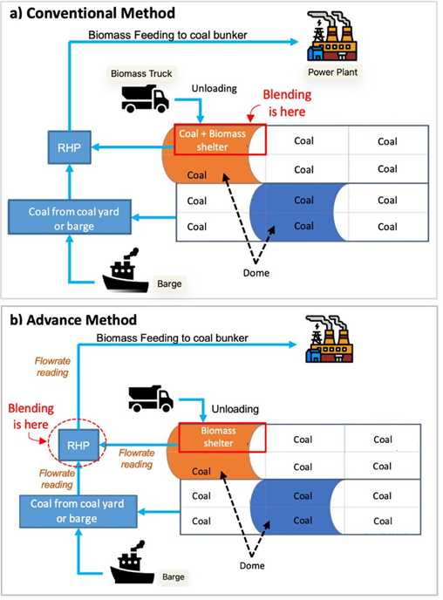
Figure 4. Schematic of (a) Conventional Method and (b) Advance Method

Fuel Stock Management
Fuel stock management digitalization was developed to ensure an accurate & precise blending ratio and uniformity in the selection of coal to be blended with biomass. It’s known that the characteristics of each coal and biomass are critical factors in determining the blending ratio. Therefore, we developed a web-based application to monitor in real-time the condition of coal and biomass for each supplier. The dashboard is shown in Figure 5. This application uses a genetic algorithm to find the best composition of two types of coal and biomass that will be blended. The variables used in the algorithm are calorific value, total moisture (TM), total sulfur (TS), and ash content.
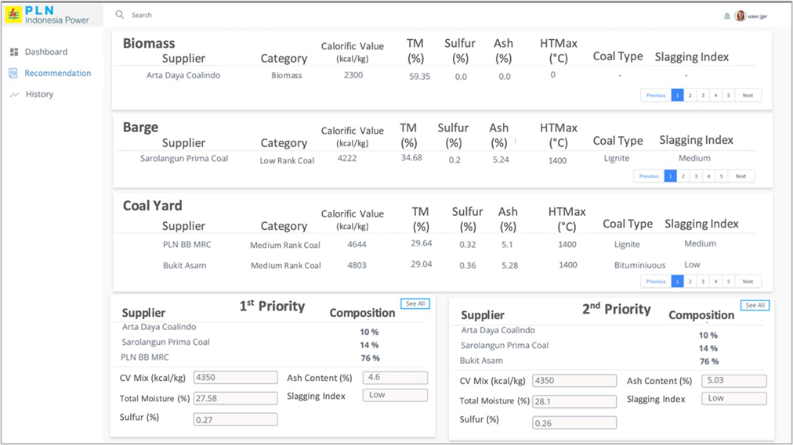
Figure 5. Fuel stock management dashboard

Data Acquisiton & Calculation
While using the conventional method, the weight of biomass is calculated based on the estimated unloading load of biomass from the truck. With the advanced method, the biomass weight is easily calculated with a flow meter installed on the belt conveyor. Blending quality monitoring was done by real-time monitoring of coal bunker feeding process with online analyzers and real-time SFC monitoring.
GHG is consist of CO2, CH4, and N2O gases (IPCC, 2006). GHG emission reduction can be calculated based on MWh green production each year. GHG emission are calculated using emission factors referring to the 2006 IPCC Guidelines for National Greenhouse Gas Inventories and Guidelines for Greenhouse Gas Inventory Calculation and Reporting (from Ministry of Energy and Mineral Resources). There are three Tiers presented in the 2006 IPCC Guidelines for estimating emissions from fossil fuel combustion. In addition a Reference Approach is presented. The Tier-1 method is fuel- based, since emissions from all sources of combustion can be estimated on the basis of the quantities of fuel combusted (usually from national energy statistics) and average emission factors. Tier-1 emission factors are available for all relevant direct greenhouse gases.

- RESULT & DISCUSSION

Biomass Utilization
After implementation of advance coal-biomass blend, there was a significant increase in biomass utilization as shown in Figure 6. Compared to daily average of biomass utilization in 2021, realization in 2022 and 2023 was increased by 157% and 276%, respectively. Meanwhile, the monthly average biomass utilization in 2022 and 2023 increased by 109% and 133%, respectively, compared to the 2021 realization. Annual biomass utilization in 2022 far exceeded that of 2021 or increased by 171%. As of June 20, 2023, the 2023 usage has exceeded the 2021 usage, which is 99.5% higher.
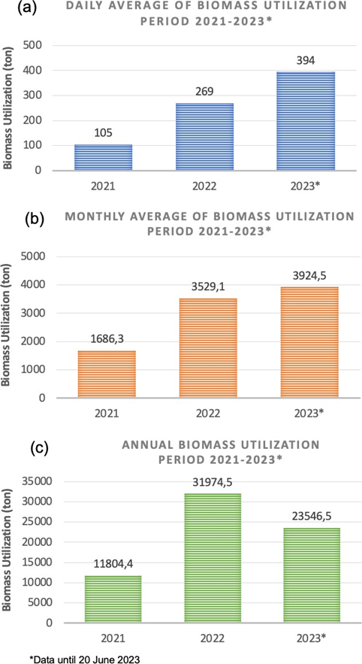
Figure 6. Chart of (a) daily average, (b) monthly average, and (c) annual biomass utilization

It should be noted that the data for 2023 is up to June 20, 2023 and there is still a possibility to increase biomass utilization until the end of the year.

Green Energy Production
Green energy production is a key indicator of the success of biomass cofiring. With the innovations that have been made since 2022, there has been a significant increase in green energy production. Green energy production in 2022 increased 127% from 2021, while in 2023 it increased 255% from 2021 as shown in Figure 7.

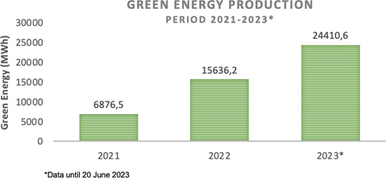
Figure 7. Green energy production by the year

Green House Gases Emission
With the ability to use more biomass, GHG emissions can be reduced. The higher the green energy production, the higher the GHG emission reduction. GHG emissions in 2022 and 2023 are reduced by 127.4% and 255%, respectively, compared to 2021. Figure 8 shows that the advanced method can help reduce GHG emissions in coal-fired power plants and support the net zero emission target.

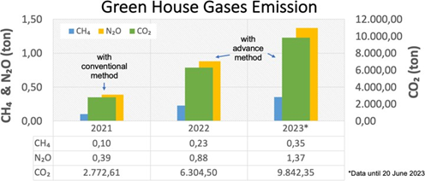
Figure 8. Comparison of GHG emission reduction by the year

Blending Accuracy
The previous Figure 3 shows that the blending accuracy is very poor. The deviation reached 6.43% (maximum allowable 2%) and the accuracy was only 93.57%. Proper fuel blending planning through fuel stock management applications and blending quality monitoring can minimize derating. Blending quality monitoring was done by real-time monitoring of coal bunker feeding process with online analyzers and real-time SFC monitoring. Blending accuracy increased from 93.57% to 98.5%. From the Figure 9, it can be seen that the calorific value based on the estimation from fuel stock management is very close to the actual calorific value from the test results in the lab.
The higher use of biomass will be a challenge to maintain the quality of blending results. Fuel stock management can help us maintain blending quality and accuracy. As a result, derating loss can be avoided. Derating loss occurs due to the low calorific value of the fuel.
In 2021, the total biomass utilization is 11,804 tons. However, in that year, there was a derating loss of 11,320 MWh due to Low CV. With advanced methods and fuel stock management, the total biomass utilization can be increased significantly without the risk of derating loss. This is proven in 2022, the biomass utilized was 31,974.5 tons (171% higher), but the derating loss dropped to 4,538 MWh or 59.9% lower than in 2021 as shown in Figure 10.

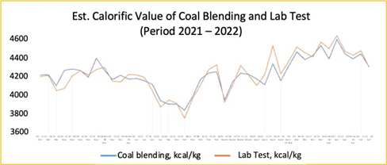
Figure 9. Estimated Value of Coal Blending and Lab Test (period of 2021 – 2022)

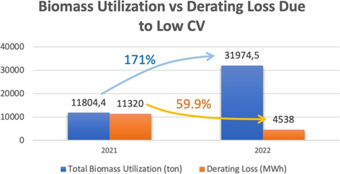
Figure 10. Total biomass utilization (ton) versus derating loss
- CONCLUSION
Based on the work that has been done, conclusions can be drawn, as follows:
- Based on the implementation of this new method innovation in blending biomass and coal, it can increase:
  - biomass utilization in 2022 increased by 171% compared to 2021, while biomass utilization in the first semester of 2023 was already 99.5% higher than the realization of 2021.
  - average monthly utilization in 2022 increased by 157% compared to 2021, and the first semester of 2023 was 99% higher than 2021.
  - green energy production in 2022 increased by 127% compared to 2021, and the first semester of 2023 was 255% higher than 2021.
  - Flexibility in terms of execution time of biomass and coal blending.
- With the implementation of this innovation, equipment disturbances arising from inhomogeneous blending of coal and biomass can be minimized. In this case, blocking mill disturbance can be reduced from 8 disturbances to 0 (zero) disturbances.
- The implementation of this innovation can also normalize the operator's workload in terms of time and resources.
- This innovation also supports the reduction of Greenhouse Gas (GHG) emissions including CO2, CH4, and N2O. From the calculation of GHG emissions in 2021 and 2022, greenhouse gas emissions in 2022 also decreased by 127.4% from 2021. Meanwhile, greenhouse gas emissions in 2023 decreased by 255% from 2021.

- ACKNOWLEDGEMENT
This paper is produced based on an innovation project that has been carried out at Pelabuhan Ratu Power Plant. The innovation project is fully supported by PT. PLN Indonesia Power. All data included in this paper has been approved by the company for publication.

- REFERENCE
A.A. Bhuiyan, A. S. Blicblau, A. K. M. S. Islam, dan J. Naser, 2018. A review on thermo-chemical characteristics of coal/biomass co-firing in industrial furnace. Journal of the Energy Institute, Vol. 91, pp. 1–18.
D. L. Klass, Biomass for renewable energy, fuels, and chemicals. Academic Press, San Diego, 1998.
D.I. Barnes, 2015. Understanding pulverised coal, biomass and waste combustion – A brief overview. Applied Thermal Engineering, Vol. 74, pp. 89–95.
IPCC, 2006 IPCC Guidelines for National Greenhouse Gas Inventories. IPCC, 2006. [Online]. Available: https://www.ipcc-nggip.iges.or.jp/public/2006gl/vol2.html
M. V. Gil dan F. Rubiera, Coal and biomass cofiring: Fundamentals and future trends. In: New Trends in Coal Conversion, 2019.
S. Pang, Biomass drying for an Integrated Bioenergy Plant,” in Handbook of Industrial Drying, 4th ed.New York: CRC Press, 2014.
S. Stenström, 2017. Drying of biofuels from the forest—A review. Drying Technology, Vol. 35, pp. 1167–1181.
UNFCC, The Paris Agreement, 2015. https://unfccc.int/process-and-meetings/the-paris-agreement (diakses 17 April 2023)

Artikel ini dipresentasikan dalam Science Technology and Management Meetup (STEM MEET UP) 2023, PT. PLN Indonesia Power, 21-23 November 2023 di Batam, Kepulauan Riau.

