A Linear Regression Modeling Analysis of the Energy, Water, and Chemical Consumption in the Operating Configuration at 740 MW Priok Combined Cycle Power Plant[1]

R. Muhammad*, A. Rahman and M.F Jamil

Indonesia Power Priok PGU Perusahaan Listrik Negara Jakarta, Indonesia

*E-mail: rhn.mhmd@gmail.com

**Abstract**

In realizing efficient energy use, the Government of Indonesia has issued a National Energy Policy in Government Regulation (Peraturan Pemerintah) No. 70 of 2009 concerning Energy Conservation, PT PLN Indonesia Power Priok Unit has carried out efficient operational activities. Therefore, to support the company's sustainability and operational performance, especially in terms of efficiency and operational activities, it is necessary to evaluate the process of energy use. The Combine Cycle Power Plant (CCPP) has several operating configurations according to the gas turbine, heat recovery steam generator (HRSG), and steam turbine amount. CCPP Priok Blok 3 operates full-block 2-2-1 or half-block 1-1-1, which means one gas turbine, HRSG, and steam turbine. This configuration of operation impacts the use of energy, water, and chemicals. For this reason, this project aims to model the use of energy, water, and chemicals using linear regression to determine which operating configurations are highly effective in using energy, water, and chemicals. The result of this linear regression modeling is that at the peak load, operation GT2 (gas turbine 2) is more energy efficient, 1.93% more efficient than GT1, than GT1 (gas turbine 1). At the minimum load, GT1 is 9.36% more energy efficient than GT2. At the same time, the water consumption of GT2 is 35.01% more efficient than that of GT1.

***Keywords***: modeling, energy, chemicals, water

**Abstrak**

Untuk mendukung penggunaan energi yang efisien, Pemerintah Indonesia telah menerbitkan Kebijakan Energi Nasional dalam Peraturan Pemerintah No. 70 tahun 2009 tentang Konservasi Energi. Unit PT PLN Indonesia Power Priok telah melakukan kegiatan operasional yang efisien. Oleh karena itu, guna mendukung keberlanjutan perusahaan dan kinerja operasionalnya, terutama dalam hal efisiensi dan kegiatan operasional, diperlukan evaluasi terhadap proses penggunaan energi. *Combine Cycle Power Plant* (CCPP) memiliki beberapa konfigurasi operasi sesuai dengan jumlah turbin gas, *heat recovery steam generator* (HRSG), dan turbin uap. CCPP Priok Blok 3 beroperasi dengan konfigurasi full-block 2-2-1 atau half-block 1-1-1, yang berarti satu turbin gas, HRSG, dan turbin uap. Konfigurasi operasi ini berdampak pada penggunaan energi, air, dan bahan kimia. Oleh karena itu, proyek ini bertujuan untuk memodelkan penggunaan energi, air, dan bahan kimia menggunakan regresi linear untuk menentukan konfigurasi operasi mana yang sangat efektif dalam penggunaan energi, air, dan bahan kimia. Hasil dari pemodelan regresi linear ini menunjukkan bahwa pada beban puncak, operasi *gas turbine* 2 (GT2) lebih efisien secara energi, 1,93% lebih efisien daripada *gas turbine* 1 (GT1). Pada beban minimum, GT1 lebih efisien secara energi 9,36% dibandingkan dengan GT2. Pada saat yang sama, konsumsi air GT2 35,01% lebih efisien dibandingkan dengan GT1.

***Kata kunci*** : pemodelan, energi, bahan kimia, air

1. INTRODUCTION

PLN Indonesia Power, as a subsidiary of PLN, has a combined cycle Power Plant with an installed power of 2723 megawatts in Tanjung Priok Jakarta, Indonesia. Priok Combine Cycle Power Plant has four blocks, one of which is a 740 MW (Melky, 2022). Using as little energy, water, and chemical consumption as possible in the energy industry is the goal of the world's industry. The relationship between energy use, water consumption, and chemical consumption has received special attention from researchers and policymakers (Liet al., 2022; Ali, 2020). The primary fuel for the power plant is natural gas obtained from the Floating Storage & Regasification Unit (FSRU) owned by PT Nusantara Regas and from PT Perusahaan Gas Negara (PGN). The fuel will be used in the gas turbine to produce electricity. Then for the steam cycle, the plant requires pure water taken directly from the Kalijapat River. The desalination plant will remove the salt content in the water, and then the water treatment plant will remove the mineral content and become make-up water (Wang, 2019). Water is essential for power plants because it is the primary raw material in making steam for the operation of the steam turbine. Water quality in power plant is the main factor of equipment reliability (Erlangga et al., 2017). Standard water quality can ensure performance of equipment and minimize equipment damage, especially from corrosion make-up water used as a working medium for steam turbines has several requirements: a maximum conductivity of 0.5 µs/cm, water pH 6.5-7.5, and a silica (SiO2) content of not more than 10 ppb (Pan and Xu, 2022).

In realizing efficient energy use, the Government of Indonesia has issued a National Energy Policy in Government Regulation (Peraturan Pemerintah) No. 5 of 2006, Energy Law No. 30 of 2007, and Government Regulation No. 70 of 2009 concerning Energy Conservation. Based on company policies and commitments as well as to support and fulfill government policies, PT PLN Indonesia Power Priok Power Generation Unit has carried out efficient operational activities. Therefore, to support the company's sustainability and operational performance, especially in terms of efficiency and operational activities, it is necessary to evaluate the process of energy use.

The power plant operation requires detailed calculations regarding energy, water, and chemicals for evaluation and planning in the next operation. There are many methods for evaluating the operation of a power plant. An example is simulating generator components to become a new cycle based on work principles to optimize the objective function (Mehrpanahi et al., 2019). Other research also analyzed the performance of the 740 MW combined cycle power plant on configuration operating and loading using heat rate gap analysis, which yielded that the 1-1-1 configuration operating is more suitable for middle to lower loads between 130-350 MW, while the 2- 2-1 operating pattern is more suitable for medium to upper loads between 350-750 MW (Fahlevy et al., 2019). On the other hand, the regression method has also become popular in several studies to carry out analyses between variables. The relationship between the variables can be positive or negative, linear or non-linear in regression (Foonget al., 2018). Meanwhile, research using the linear regression method clearly states that estimates of additional power and electrical energy to meet customer needs in the future can be estimated using this method (Mawartika and Kesuma, 2022; Syafruddin et al., 2014). Outside the technical discussion, to predict the number of sales (Indarwati et al., 2019; Najla and Fitrianah, 2019; Herwanto et al., 2019) and cases of disease spread (Kurniawan and Kokanda, 2021), we can use the linear regression method.

The linear regression method in power plants obtains power plant performance at 7.35 MW geothermal plants. Consequently, the regression linear method can estimate the performance of a geothermal power plant and find the degradation of plant performance of a geothermal power plant (Karadaset al., 2015). This research begins by collecting historical data on the power plant in energy, water, and chemicals use when operating on a half-block 1-1-1 configuration (1 gas turbine - 1 heat recovery steam generator - 1 steam turbine) and full- block 2-2-1 (2 gas turbine - 2 heat recovery steam generator - 1 steam turbine). By using the linear regression method, the basis for many analyses (Hoffman, 2018), the data become a model to conclude the most efficient use of energy, water, and chemicals and create a baseline for evaluating the recommendations.

1. BASIC PRINCIPLE AND REGRESSION LINIER MODELING

## Basic Principles of Combine Cycled Power Plant

A combined-cycle power plant is an electrical power plant in which a gas turbine and a steam turbine are used in combination to achieve greater efficiency than would be possible independently. A combined cycle has an efficiency of 55%, which is greater than the efficiency of a steam turbine power plant, which is about 35%. (Breeze, 2016). This means that a significant amount of the latent energy of the fuel ends up being wasted. Much of this wasted energy ends up as thermal energy in the hot exhaust gases from the combustion process. There are many different configurations for CCPP, but typically each gas turbine has its own associated HRSG, and multiple HRSG supply steam to one or more steam turbines. For example, two gas turbines, two HRSG, and one steam turbine operated.

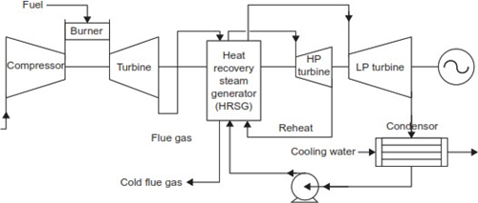

Figure 1. Schematic of a combined cycle power plant.

LNG (liquified natural gas) as fuel is contacted with compressed air in the combusting chamber to produce pressurized hot gas for rotating gas turbines. Flue gas from gas turbines is used as fuel to produce steam at the HRSG (heat recovery steam generator). HRSG is a heat exchanger called a boiler. It creates steam for the steam turbine by passing the hot exhaust gas flow from a gas turbine or combustion engine through banks of heat exchanger tubes. The HRSG produces superheated steam that rotates the HP (high pressure) steam turbine, and the HRSG then reheats the steam to rotate the LP (low pressure) steam turbine. The steam is converted to a liquid phase as water in the condenser. Furthermore, it is pumped to the HRSG to generate continuous steam. The system is called closed-loop.

Steam is continuously needed in the CCPP cycle, so sufficient and appropriate water is needed. The schematic of a combined cycle power plant is shown in Figure 1. Water is obtained from the purification process at the desalination plant and water treatment plant. Then, the water will be collected in the tank. Due to the continuous use of water, it is necessary to optimize the use of water. Besides pure water producing steam, seawater cools the condenser, heat exchanger, and machines in CCPP. Using seawater in the condenser will undoubtedly result in a water-scale buildup over time (Muhammad and Yulianto, 2023). The use of chemicals is necessary to maintain water quality in the steam turbine system and cooling system so that they do not experience system damage.

Measurement is needed to represent the plant's performance in operating the Combine Cycle Power Plant. One of these measurements uses heat rate. Heat rate is a measure of power plant efficiency (Equations 1 and 2), defined as thermal input divided by thermal content of output; a lower heat rate correlates with a higher efficiency power plant (Grubert, 2020).

$Heat Rate=\frac{Heat Input (kcal)}{Power Generation (kWh)}$ (1)

$Heat Rate=\frac{ 860 kcal X 100\%}{Efficiency (\%)}$ (2)

## Regression Linear

Linear regression is one of the methods used to forecast quality and quantity characteristics. The linear regression method typically uses two parameters with linear relationships. In regression modeling, there are two kinds of variables: dependent variables (a variable that is influenced by or whose value depends on other variables) and independent variables (a variable that is suspected to affect the dependent variable) (Permai and Tanty, 2018). Regression analysis serves the major purposes of description, control, and prediction. Linear regression can be calculated using Equations (3) to (5):

$a=\frac{(∑ y)(∑ x2)-(∑ x)(∑ xy)}{n\left(∑ x2\right)-(∑ x)2}$ (3)

$b=\frac{n(∑ xy)-(∑ x)(∑ y)}{n\left(∑ x2\right)-(∑ x)2}$ (4)

$y = a + b. x$ (5)

On the other hand, different prediction models have used sensitivity analysis and other data processing and variable selection methods to make their predictions more accurate. Finding the coefficient (R2), mean absolute deviation (MAD), mean squared error (MSE), root mean square error (RMSE), and mean absolute percentage error (MAPE) (M. S. Manzar *et al.,* 2022)are some ways to measure the performance of a model. The determination coefficient (R2) can be calculated using Equation (6):

$R^{2}=1\frac{Σ_{i=1}^{N}{(x-y)}^{2}}{Σ_{i=1}^{N}{(x-x)}^{2}}$ (6)

For a particular endogenous construct to be considered adequate, R2 values must be equal to or greater than 0.10 (R.F. Falk, 1992). However, other references suggested that R2 values for endogenous latent variables are assessed as follows: 0.26 is substantial, 0.13 is moderate, and 0.02 is weak (J. Cohen, 1988). If the R2 is in the range 0–0.25, the regression model is not significant. If the R2 is in the range of 0.25–0.64, the regression model should be interpreted with caution. If the R2 is in the range of 0.64–1, the regression model is strongly significant [9].

MAD, or mean absolute deviation, measures the prediction accuracy by averaging the absolute value of each error. It is particularly helpful when measuring prediction errors that have the same unit. The lower value of MAD indicates higher accuracy (I. Veza *et al.*, 2021). MAD can be calculated using Equation (7):

${{MAD= }_{\frac{1}{N}}Σ}_{i=1}^{N}|x-y|$ (7)

MSE, or mean square error, is the average of the square of the difference between the real and predicted values. It is used to determine how close the predictions are to actual values. It is sensitive to outliers and punishes larger errors more (I. Veza *et al.*, 2021). The value of MSE close to zero indicates forecasting results appropriate to actual data. MSE can be calculated using Equation (8):

${{MSE= }_{\frac{1}{N}}Σ}_{i=1}^{N}{(x-y)}^{2}$ (8)

RMSE, or root mean square error, is simply the square root of the mean square error (MSE), where RMSE can be calculated using Equation (9):

$RMSE=\sqrt{\frac{Σ_{i=1}^{N}{(x-y)}^{2}}{N}}$ (9)

MAPE, or mean absolute percentage error, is one of the most extensively used measures for checking prediction accuracy. It is scale-independent and can be used to compare series on different scales (I. Veza *et al.*, 2021). The prediction results are good if the MAPE value is less than 10% [13]. MAPE can be calculated using Equation (10):

$MAPE=\left\{\frac{100}{N}\left[Σ_{i=1}^{N}\left|\frac{x-y}{x}\right|\right]\right\}\%$ (10)

## Data Reprocessing and Modeling

In analyzing large amounts of data, data preprocessing is a method to prepare data. Data preprocessing can be very challenging, given the complexity and relatively poor data quality. Data preprocessing is an indispensable step in knowledge discovery and research from operational data (Fan et al., 2021). Following are the steps of data reprocessing:

* + Data cleaning: The first step when preprocessing data is data cleaning. That is, the raw data needs to be re- selected. Then, delete or eliminate incomplete, irrelevant, inaccurate or outlier data. By doing this stage, it will be clear when analyzing the data (H. Henderi dan R.L. Wanda, 2017).
  + Data reduction: On time series data, usually the data is obtained within a very tight period; for that, data reduction is needed to facilitate the analysis process.
  + Data scaling: Data scaling is often needed to ensure the validity of predictive modeling, especially when the input variables have different scales.
  + Data transformation: The following process is data transformation. As explained above, data will be taken from various sources with different formats. All data must be equated to simplify the analysis process (Ribeiro et al., 2015).
  + Data partitioning: Data partitioning aims to divide the whole data into several groups for in-depth analysis.

After doing data reprocessing, data modeling is the process of producing descriptive diagrams of the relationship between the various types of information to be displayed.

There are three types of data modeling based on the model level, as follows:

* Conceptual : These models are typically created by business and data architecture stakeholders. It aims to extend, organize, and define business concepts and rules.
* Logical : Architects and business analysts create these models. The goal is to develop a regulatory technical map and data structure.
* Physical : Developers usually make this model. The goal is the actual implementation of the database

1. METHODOLOGY

This research uses primary data obtained from an Accessory Station (ACS), which is a piece of equipment that saves and manages various equipment data over the long term and interfaces with printers and other peripherals. As with the OPS, the ACS runs on Windows. Data was collected from 10 parameters. The samples used are 12,232 samples from June 2022 until June 2023. The data will be processed in stages according to the vertical bending process workflow in Figure 2.

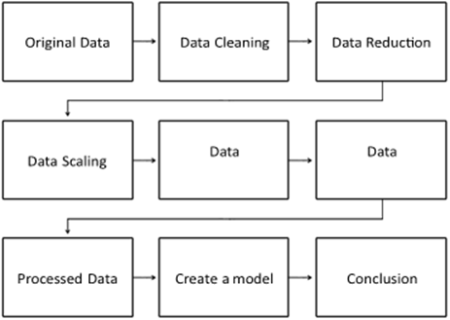

Figure 2. Schematic of a creating data modeling

After getting the original data, the first step is data cleaning. Permissible values for heatrate in CCPP are above 3440 kcal/kWh, or 25% efficiency. Values that do not match NaN (Not a Number) with the criteria will be deleted. The data generated by ACS is in the form of a time series with a span of 1 minute for one year, so the data can be reduced according to the loading pattern that occurs. The data will be divided into three main subjects, namely data on GT1, GT2, and block load.

Based on energy efficiency, water, and chemical consumption cases, this research uses nine independent variables (X1, X2, X3, X4, X5, X6, X7, X8, and X9) and one dependent variable (Y1). Here are the variables:

X1 = Load Gas Turbine 1

X2 = Load Gas Turbine 2

X3 = Block Load (2-2-1)

X4 = Water Consumption GT 1

X5 = Water Consumption GT 2

X6 = Water Consumption (2-2-1)

X7 = Chemical Consumption GT 1

X8 = Chemical Consumption GT 2

X9 = Chemical Consumption (2-2-1)

Y1 = Gross Heat Rate

Table 1. Models code from variables

|  |  |  |
| --- | --- | --- |
| **Independent** | **Dependent** | **Models Code** |
| Load Gas Turbine 1 | Gross Heat Rate | B1 |
| Load Gas Turbine 2 | Gross Heat Rate | B2 |
| Block Load (2-2-1) | Gross Heat Rate | B3 |
| Water Consumption GT 1 | Gross Heat Rate | W1 |
| Water Consumption GT 2 | Gross Heat Rate | W2 |
| Water Consumption (2-2-1) | Gross Heat Rate | W3 |
| Chemical Consumption GT 1 | Gross Heat Rate | C1 |
| Chemical Consumption GT 2 | Gross Heat Rate | C2 |
| Chemical Consumption (2-2-1) | Gross Heat Rate | C3 |

This research will divide nine models from the variables above, as shown in Table 1 that will be analyzed using linear regression. The result is that by knowing the equation, it will be known under what conditions the generator operating configuration will have the most efficient energy and optimal use of water and chemistry. Furthermore, the data is processed using linear regression modeling. Results from the models were shown to obtain the best model using RMSE, MAD, MSE, and MAPE criteria. The linear regression method was chosen because the analysis is easy, fast, and can represent the data. This method can also be used as an early classification of existing data to be used as material for rapid evaluation. After doing linear regression modeling on the variables, by looking at the value of R2, the linear equation will be interpreted according to the operational activities of the plant, and the linear equation can be used as a baseline for calculating the difference in energy use, water use, and chemical use. If the value of R2 does not meet the requirements, then the linear regression will be interpreted as relevant only to the operational activities of the plant. Table 2. shows the range of data for each variable (min, max, mean, and standard deviation).

Table 2. Variable range

|  |  |  |  |  |  |  |
| --- | --- | --- | --- | --- | --- | --- |
| Measured Variable June 2022 – June 2023 | | | | | | |
| **Group** | **Variables** | **Unit** | **For The total 12,232 Input** | | | |
|  |  |  | *Min* | *Max* | *Mean* | *Std Deviation* |
| Independent | Load Gas Turbine 1 | MW | 177.81 | 342.46 | 231.20 | 34.70 |
|  | Load Gas Turbine 2 | MW | 184.17 | 338.66 | 237.85 | 40.77 |
|  | Block Load (2-2-1) | MW | 259.52 | 692.01 | 467.23 | 80.81 |
|  | Water Consumption GT 1 | M3 | 100 | 1118.3 | 424.6 | 224.39 |
|  | Water Consumption GT 2 | M3 | 119.8 | 1045.53 | 498.88 | 218.68 |
|  | Water Consumption (2-2-1) | M3 | 125.2 | 1337.9 | 524.81 | 246.94 |
|  | Chemical Consumption GT 1 | kg | 2.74 | 20.76 | 11.81 | 4.09 |
|  | Chemical Consumption GT 2 | kg | 3 | 14.98 | 7.79 | 2.65 |
|  | Chemical Consumption (2-2-1) | kg | 3.72 | 30 | 10.73 | 6.06 |
| Dependent | Gross Heat Rate | kcal/kWh | 1327.59 | 2426.29 | 1703.38 | 81.27 |

1. RESULT AND DISCUSSION

In this research, linear models were built, tested, and compared using all independent variables. The data was processed using a standard program for data analysis in Microsoft Excel. The dependent variable was the gross heat rate. Then the independent variables load gas turbine 1, load gas turbine 2, block load (2-2-1), water consumption GT1, water consumption GT2, water consumption (2-2-1), chemical consumption GT1, chemical consumption GT2, and chemical consumption (2-2-1) represented energy, water consumption, and chemical consumption, which was a controlled variable. The variables were analyzed from June 2022 to June 2023. The scatter plots of the models are shown in Figure 3 and described in Table 3.



Figure 3. Plots of the models. Gross plant Heat rate Vs Load gas Turbine 1 (B1), Gross Plant Heat rate VS Load Gas Turbine 2 (B2), Gross Plant Heat rate VS Block Load (2-2-1) (B3), Gross Plant Heat rate VS Water Consumption Gas Turbine 1 (W1), Gross Plant Heat rate VS Water Consumption Gas Turbine 2 (W2), Gross Plant Heat rate VS Water Consumption Block Load (2-2-1) (W3), Gross Plant Heat rate VS Chemical Consumption Gas Turbine 1 (C1), Gross Plant Heat rate VS Chemical Consumption Gas Turbine 2 (C2), and Gross Plant Heat rate VS Chemical Consumption Block Load (2-2-1) (C3)

Table 3. Regression linnier equations and criterias model

|  |  |  |  |  |  |  |
| --- | --- | --- | --- | --- | --- | --- |
| **MODELS** | **EQUATIONS** | **R2** | **CRITERIA** | | | |
| *RMSE* | *MAD* | *MSE* | *MAPE (%)* |
| B1 | y = -0.8993x + 1891.1 | 0.802 | 15.50 | 13.02 | 240.38 | 0.77 |
| B2 | y = -2.0753x + 2265.1 | 0.8223 | 39.34 | 32.69 | 1547.13 | 1.85 |
| B3 | y = -0.2762x + 1771.3 | 0.7126 | 14.17 | 11.08 | 200.86 | 0.77 |
| W1 | y = 0.5195x + 1537.4 | 0.716 | 73.26 | 61.22 | 5341.23 | 3.51 |
| W2 | y = 0.4552x + 1598.8 | 0.713 | 63.05 | 49.74 | 3956.83 | 2.71 |
| W3 | y = 0.5783 + 1445.2 | 0.743 | 83.15 | 63.75 | 6877.40 | 3.63 |
| C1 | y = -4.2889x + 1831.2 | 0.0159 | 138.17 | 89.50 | 18978.23 | 4.98 |
| C2 | y = -6.4396x + 1815.8 | 0.0418 | 81.72 | 61.09 | 6600.98 | 3.47 |
| C3 | y = -4.3619x +1832.4 | 0.0311 | 147.70 | 105.25 | 21642.50 | 5.66 |

Table. 3 shows that the R2 values that meet the requirements above the strong R2 of 0.64 (N.S.Foong *et al.*, 2018) are the B1, B2, B3, W1, W2, and W3 models (energy consumption and water consumption), while the C1, C2, and C3 (chemical consumption) models are categorized as weak data based on the R2 value. For this reason, the model with a substantial R2 will be used as a baseline to determine the most efficient use of energy and water. Figure 4. shows that three models have excellent R2 values, so they can be used as baselines to measure the performance of each model. Half-block loads, namely models B1 and B2, have loads with the same performance (representation of heat rate) at loads of around 218–222MW. Nevertheless, after contact, there is a difference in performance at peak loads in the range of 344 MW.

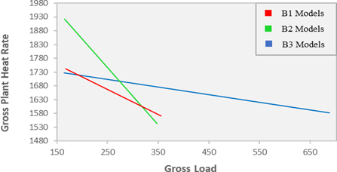

Figure 4. Energy baseline comparassion

Model B1 has a heat rate value of 1581.74 kcal/kWh, and model B2 has a heat rate value of 1551.2 kcal/kWh at peak load; this happens because there are many operating variables such as operating hours, overhaul schedule, and operation configuration so that each unit has different characteristics even though the generating units are twins. Compared model B1 has a heat rate value of 1581.74 kcal/kWh and model B2 has a heat rate value of 1551.2 kcal/kWh. When compared to the B3 model at peak load (740 MW), the block load has a heat rate performance of 1566.89 kcal/kWh. If the combined cycle power plant is operated at minimum load with a half- block (1-1-1) based on Figure 4., then the GT1 unit with B1 modeling will have better performance compared to GT2 with B2 mode; this is because GT2 is almost approaching the overhaul period as shown in the Figure 5. so that its performance decrease. At a low load (165 MW), modeling B1 has a heat rate of 1742.72 kcal/kWh and modeling B2 has a heat rate of 1922.68 kcal/kWh.

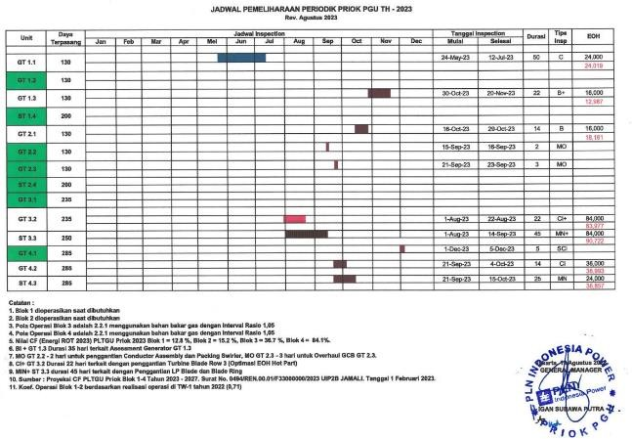

Figure 5. Overhaul schedule

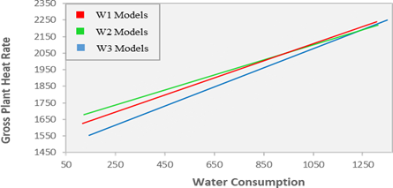

Figure 6. Water consumption baseline comparassion

Figure 6. shows the baseline for modeling water consumption as an independent variable and heat rate as the dependent variable. The W1, W2, and W3 models have relatively high R2 and are in the vital data category to be used as a baseline. Figure 6. shows that all model baseline lines have almost similar gradients so that water consumption in any operating configuration has similar characteristics. W3 modeling shows that the full-block operation (2-2-1) will consume more water than the GT1 and GT2 half-block operations because the full-block operation runs both GT- HRSG, so water consumption will increase. If we compare the operating configurations of the half-block GT1 and GT2 at the same heat rate of around 1680 kcal/kWh (representation of the load Figure 3.), then the GT1 with the W1 model consumes 274.49 m3 of water. The GT2 with the W2 model consumes 178.4 m3; this happened because there was much damage to the feed water system in GT1, such as a leak in the high-pressure water valve (HP CV), an abnormal water spray valve, and leaks in the valve gland packing, as shown in Figure 7.

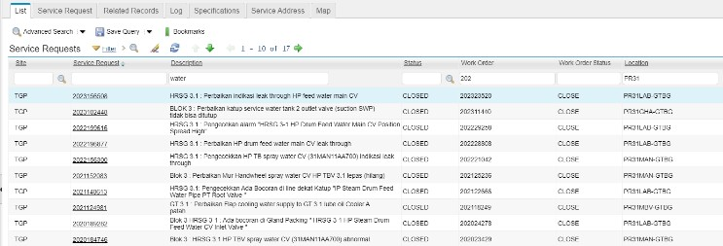

Figure 7. Service request GT1

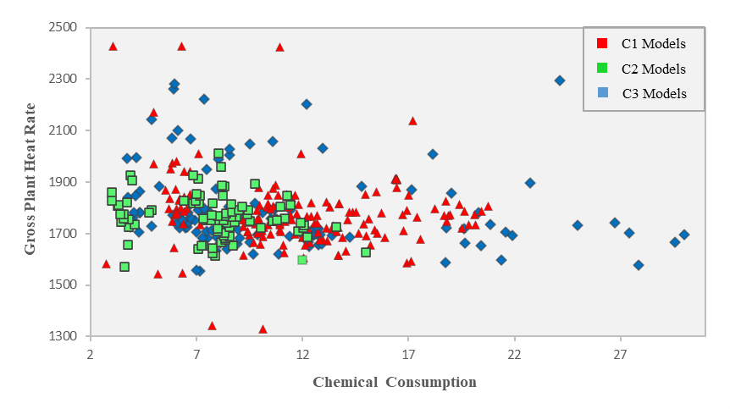

Figure 8. Chemical consumption scatter plot

In modeling, C1, C2, and C3 (chemical consumption) produce very low R2 values, and this is due to the relatively constant use of chemicals under any performance conditions in the power plant. They are shown in Figure 8 that chemical modeling C1, C2, and C3 is presented as one to determine the concentration of data. Use data concentration of chemical consumption; the average chemical consumption for GT1 is 11.81 kg, GT2 is 7.8 kg, and the block load is 10.73 kg.

1. CONCLUSION

This paper demonstrates the use of linear regression in energy use, water consumption, and chemical consumption in power plants by making models for analysis. With one year and 12,232 from June 2022 until June 2023, total data shows that the B1, B2, B3 (energy) and W1, W2, and W3 (water consumption) models have good R-square values. A good R2 value indicates that variable X changes affect variable Y, so this modeling can be used as an analysis and forecast. All models analyzed have a mean absolute percentage error (MAPE) value below 10%. MAPE with a low presentation indicates that if the regression analysis is used as a forecast, it will produce good results. Based on the energy baseline in Figure 4 of half-block operation at peak load GT2, represented by modeling B2, it has a lower heat rate value of 1.93% than B1 modeling. When operating the peak load on the half-block GT1 configuration compared to operating the full-block represented by B3 modeling, it turns out that the full-block has a lower heat rate of 0.94%.

At low loads, the half-block operation has a relatively large difference in heat rate. GT1 operation at low load shown in B1 modeling has a lower heat rate of 9.36% than GT2 operation in B2 modeling. Based on Figure 6, at a heat rate of 1690 kcal/kWh, it was found that the use of water in the GT2 half-block operation with W2 modeling was 35.01% more efficient compared to operating the half-block with GT1 modeling W1.

Based on this study, this paper concludes that the most efficient use of energy is the GT1 or B1 model for the baseload and GT2 or B2 for the peak load. If consuming water becomes a priority, the GT2 or W2 model is more efficient than the GT1 or W1 model. Energy efficiency and water consumption can be achieved by coordinating intermediate loads on all generating units because the results of the modeling do not show any significant gaps. This model can be a baseline reference for operating intermediate loads or the power plant configuration at the 740 MW Priok Combined Cycle Power Plant to get more efficiency. Power plant data, as has been done in research using the linear regression method, can be done on other power plants. It has been proven that linear regression analysis can be done quickly by getting a satisfactory R-squared value. The results of linear regression analysis can be used as an initial reference in mapping plant conditions.

1. REFERENCES

A. Kurniawan and K. Kokanda, 2021. Penerapan Simple linear regression untuk memprediksi jumlah kasus Covid di Indonesia. *Journal of Digital Ecosystem for Natural Sustainability*, Vol. 1, pp. 67-72.

A. Mehrpanahi, S. Nikbakht Naserabad, dan G. Ahmadi, 2019. Multi-objective linear regression based optimization of full repowering a single pressure steam power plant. *Energy*, Vol. 179, pp. 1017– 1035.

A. Ribeiro, A. Silva, dan A. R. da Silva, 2015. Data modeling and data analytics: A survey from a big data perspective. *Journal of Software Engineering and Applications*, Vol. 8, pp. 617–634.

C. Fan, M. Chen, X. Wang, J. Wang, dan B. Huang, 2021. A review on data preprocessing techniques toward efficient and reliable knowledge discovery from building operational data. *Frontiers in Energy Research*, Vol. 9, 652801.

E. Erlangga, A. Sandra, F. Azharuddin, K. S. Gunawan, dan T. R. Biyanto, 2017. Adjustment of logic operational of chemical injection pump in PH control of water steam cycle to improve steam turbine 5.8 Reliability of power plant PT. PJB UP Muara Tawar. *IOSR Journal of Electrical and Electronics Engineering*, Vol. 12, pp. 4–9.

E. Grubert, 2020. Same-plant trends in capacity factor and heat rate for US power plants, 2001–2018. *IOP SciNotes*, Vol. 1, p. 024007.

G. A. Najla and D. Fitrianah, 2019. Penerapan metode regresi linear untuk prediksi penjualan properti pada PT XYZ. *Jurnal Telematika*, Vol. 14, pp. 79–85.

H. Henderi and R.L. Wanda, 2017. Preprocessing data untuk sistem peramalan tingkat kedisiplinan mahasiswa. *Neliti, Innovative Creative and Information Technology,* Vol. 3, pp. 296-308.

H. Pan and X. Xu, 2022. Research on Factors Affecting Boiler Feedwater Quality and Its Improvement. *Open Journal of Applied Sciences*, Vol. 12, pp. 901–911.

H. W. Herwanto, T. Widiyaningtyas, and P. Indriana, 2019. Penerapan algoritme linear regression untuk prediksi hasil panen tanaman padi. *Jurnal Nasional Teknik Elektro and Teknologi Informasi*, Vol. 8, pp. 364-370.

I. Veza, Irianto, H. Panchal, P.A. Paristiawan, M. Idris, I.M.R. Fattah, N.R. Putra, and R. Silambarasan, 2022. Improved prediction accuracy of biomass heating value using proximate analysis with various ANN training algorithms. *Results in Engineering*, Vol. 16, p. 100688.

J. Cohen, Statistical power analysis for the behavioral sciences, Lawrence Erlbaum Associates Publishers, New York, 1988.

J. I. E. Hoffman, Variations based on linear regression. In: *Biostatistics for Medical and Biomedical Practitioners*, Elsevier, 2015.

L. J. Li, G. Y. Qiu, and C. H. Yan, 2022. Relationship between water use and energy generation from different power generation types in a megacity facing water shortages: A case study in Shenzhen. *Water*, Vol. 14, p. 14203226.

M. Karadas, H. M. Celik, U. Serpen, and M. Toksoy, 2015. Multiple regression analysis of performance parameters of a binary cycle geothermal power plant. *Geothermics*, Vol. 54, pp. 68–75.

M. R. Fahlevy, D. Mardiansah, and D. P. Jannus, 2019. Analisa performa PLTGU kapasitas 740 MW terhadap pola operasi and pembebanan menggunakan heat rate gap analysis. *Proceedings Seminar Nasional Teknik Mesin Politeknik Negeri Jakarta*, pp. 1199–1207.

M.S. Manzar, M. Benaafi, R. Costache, O. Alagha, N.D. Mu'azu, M. Zubair, J. Abdullahi, and S.I. Abba, 2022. New generation neurocomputing learning coupled with a hybrid neuro-fuzzy model for quantifying water quality index variable: A case study from Saudi Arabia. *Ecological Informatics*, Vol. 70, p. 101696.

M. Syafruddin, L. Hakim, and D. Despa, 2014. Metode Regresi Linier untuk Prediksi KebutuhanEnergi Listrik Jangka Panjang (Studi Kasus Provinsi Lampung). *Jurnal Informatika dan Teknik Elektro Terapan*, Vol 2.

N. Set Foong, C. Yee Ming, C. Pei Eng, and N. Kok Shien, 2018. An insight of linear regression analysis. *Scientific Research Journal*, Vol . 15, pp. 1-16.

P. Breeze, Combined Cycle Power Plants. In: *Gas-Turbine Power Generation*, Elsevier, 2016.

R. F. Falk, 1992, *A Primer for Soft Modeling*, 1st ed. University of Akron Press, Ohio, 1992.

R. Muhammad and S. Yulianto, 2023. Penerapan pemrograman python dalam menentukan waktu overhoul kondensor turbin uap. *Jurnal Konversi Energi dan Manufaktur*, Vol. 8, pp. 49–57.

R. Melky, 2022. *Pengelolaan Lingkungan Berkelanjutan PT Indonesia Power Priok POMU*.

S. D. Permai and H. Tanty, Linear regression model using bayesian approach for energy performance of residential building. In: *Procedia Computer Science*, Elsevier, 2018.

S. W. Mohammed Ali, N. Vahedi, C. Romero, and A. Oztekin, 2020. An optimization for water requirement in natural gas combined cycle power plants equipped with once-through and hybrid cooling systems and carbon capture unit. *Water- Energy Nexus*, Vol. 3, pp. 117–134.

T. Indarwati, T. Irawati, and E. Rimawati, 2019. Penggunaan metode linear regression untuk prediksi penjualan smartphone. *Jurnal Teknologi Informasi dan Komunikasi*, Vol. 6, pp. 1-6.

Y.E.B. Mawartika and H.D. Kesuma, 2022. Implementasi simple linear regression untuk meramalkan perkembangan pelanggan PLN. *Jurnal Ilmiah Binary STMIK Bina Nusantara Jaya*, Vol. 4, pp. 10-16.

Z. Wang, Water treatment equipment and system. In: *Design of Solar Thermal Power Plants*, Chemical Industry Press, 2019.

1. Artikel ini dipresentasikan dalam *Science Technology and Management Meetup* (STEM MEET UP) 2023, PT. PLN Indonesia Power, 21-23 November 2023 di Batam, Kepulauan Riau.